**What this project does?**

**This project demonstrates how to use URL Rewriting to create and maintain HTTP session in servlet JSP project.**

**Before going forward please go through theory part of how to maintain HTTP Session in JSP Servlet Notes .**

**How to create this project??**

**This is non maven 'Dynamic web project'.**

Refer file 'CreatingDynamicWebProjectForServletJSPInEclipse.docx' in 'ServletDemo' project folder for getting more details about how to create 'Dynamic web project' in eclipse.

**This project is partial xml based i.e. servlet files in controller package are declared with @WebServlet annotation and only welcome files are mapped in web.xml.**

**Note that this project is possible with pure annotation based approach by removing web.xml file. You can try it out with little R & D.**

**First of all carefully study the project structure of this project (i.e. 'Dynamic Web Project')**

Especially src folder, Web Content folder(where welcome files are stored and web.xml file. Their location and structure.)

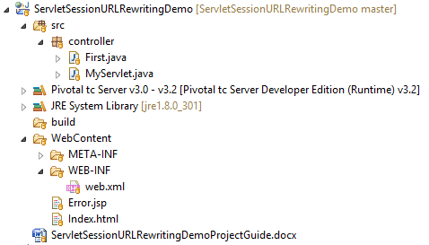

**Study following files very carefully:**

**1. web.xml:** This is deployment descriptor file for the given project. But as this is partial xml based project, it only contains welcome file list.

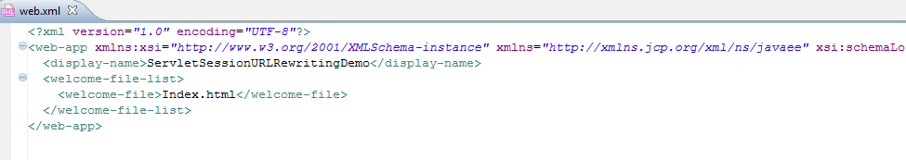

**2. Servlets** of this projects are in 'controller' package. We have mapped them with help of annotation hence their mapping are not present in web.xml

**Now here are two servlets viz. MyServlet.java and First.java

**MyServlet contains core operation**. It verifies user input and if password of the user matches with particular condition it appends URL with username and redirect it to First.java servelt . If there is any other password other than specified, then it redirects to Error.jsp page.

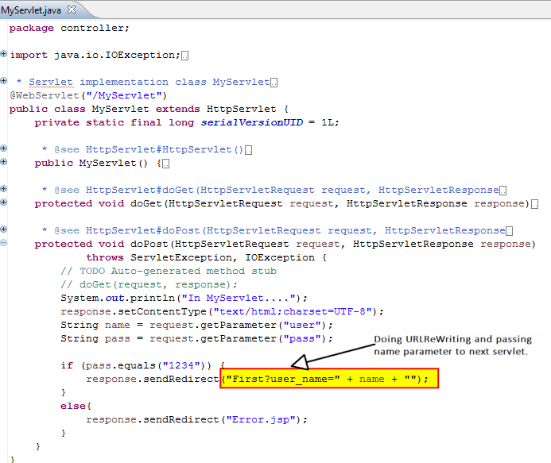

First.java servlet reads the appends user name from the URL and displays welcome message on the console

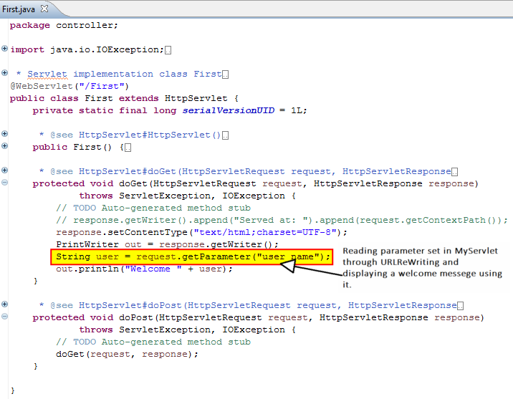

Running the application:

Right click on the application->Run As->Run on server->Select server-> Select application

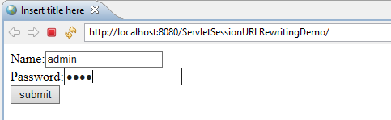

Enter Name as amin and Password as 1234 and click submit.

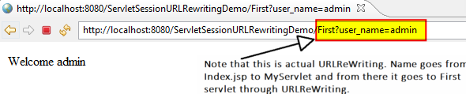

If we enter any other credential as password as follows, it leads to Error.jsp page.

