Steps:

## Step1: Go to <https://start.spring.io/>

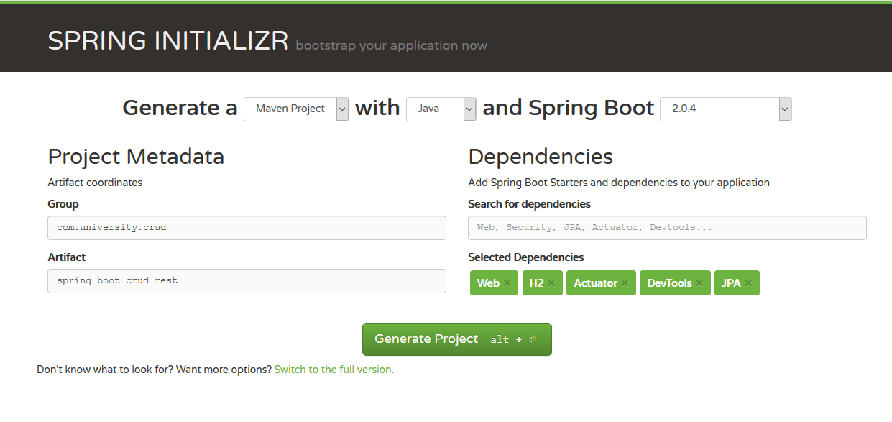

## Step2 : Make it as a git repo and push it to SCM

* Git init
* Git add remote
* Git push

## Step 3: Build ,run and import as Maven Project

* mvnw.bat clean install
* mvnw.bat spring-boot:run
* Import to eclipse/STS

## Step4: Understand the Effective dependencies

* transitive dependencies
* how starters are working
* How Spring boot is opinionated

## Step5: Generate autoconfig report

* debug=true in application.properties