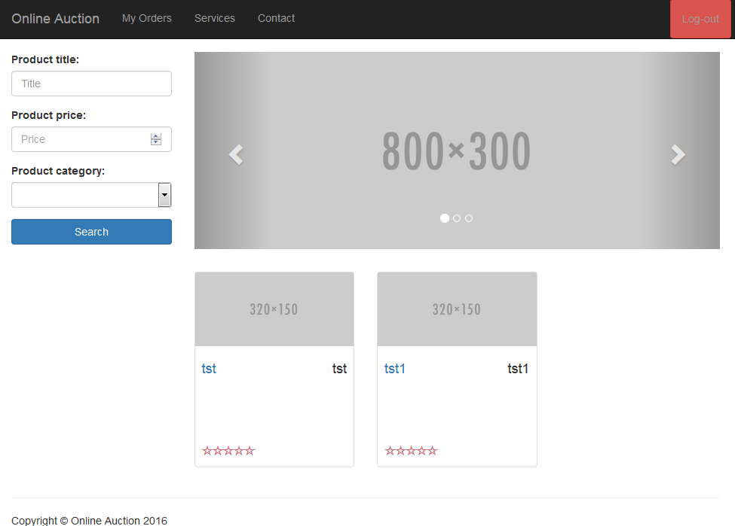 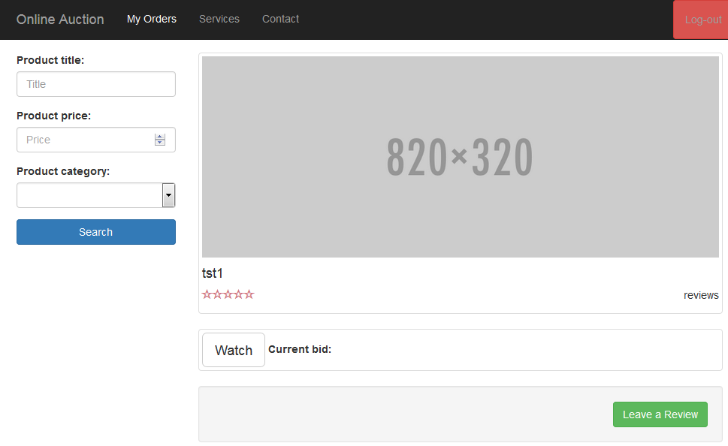

CarouselComponenCarouselComponent

t

**>**

ProductItemComponent

Home.ts

**>**

product-item/product-item.html

***<router-outlet></router-outlet>***

**<auction-navbar>**

**<auction-search>**

<auction-footer>

product-detail/product-detail.html

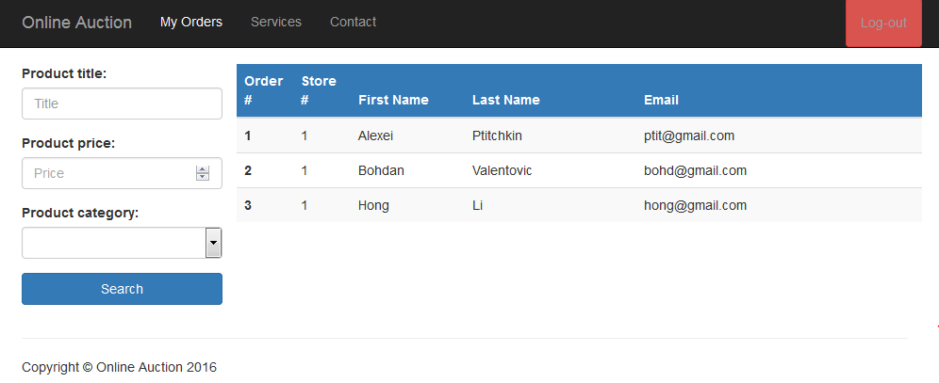

order-detail\order-detail.html