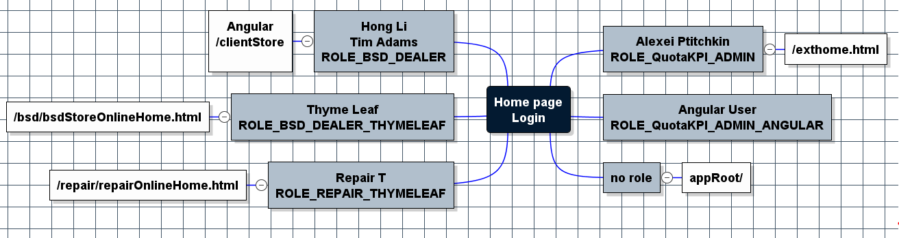

# 

Angular BSD store

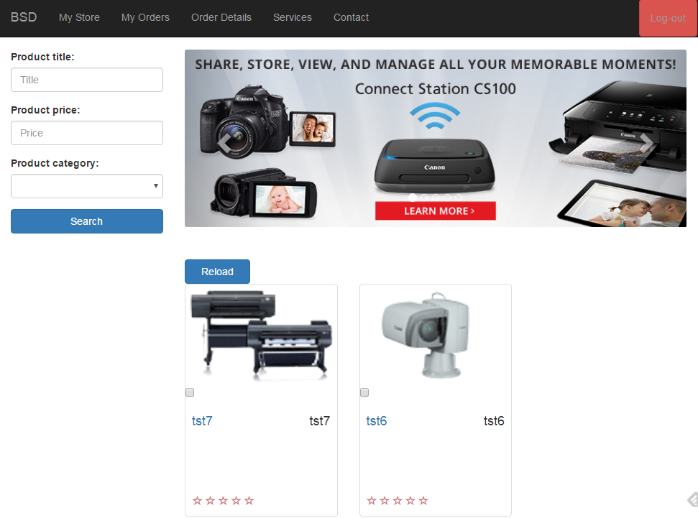

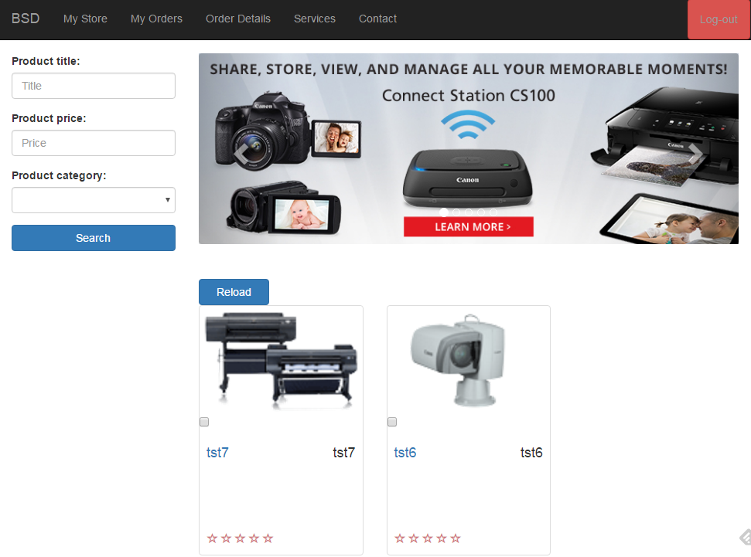

app/components/application/application.html

<**auction-navbar**>

**router-outlet**

**home.html**

**auction-search**

**auction-carousel**

<**div *ngFor="let product of products | async"**>

**auction-product-item**