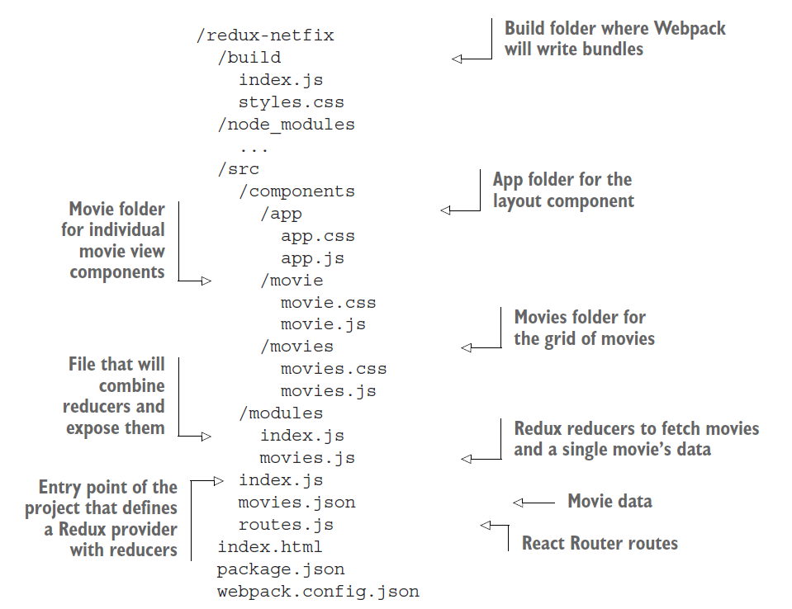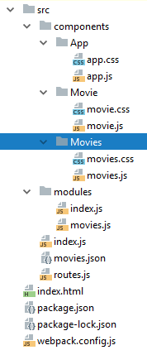

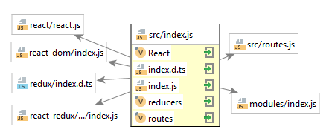

src/index.js

|  |
| --- |
| **const React** = require(**'react'**) **const** { **render** } = require(**'react-dom'**) **const** { **Provider** } = require(**'react-redux'**) **const** { createStore } = require(**'redux'**) **const reducers** = require(**'./modules'**) **const routes** = require(**'./routes.js'**)  **module**.**exports** = **render**((  <**Provider store=**{createStore(**reducers**)}>  {**routes**}  </**Provider**> ), ***document***.getElementById(**'app'**)) |

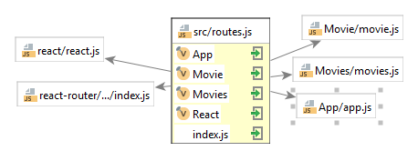

src/routes.js

|  |
| --- |
| **const App** = require(**'components/app/app'**) **const Movies** = require(**'components/movies/movies.js'**) **const Movie** = require(**'components/movie/movie.js'**)  **module**.**exports** = (  <**Router history=**{browserHistory}>  <**Route path="/" component=**{**App**}>  <**IndexRoute component=**{**Movies**} />  <**Route path="movies" component=**{**Movies**}>  <**Route path=":id" component=**{**Movie**} />  </**Route**>  </**Route**>  </**Router**> ) |

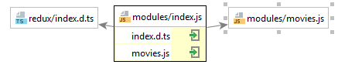

src/modules/index.js

|  |
| --- |
| **const** { *combineReducers* } = require(**'redux'**) **const** {  reducer: **movies** } = require(**'./movies'**)  **module**.**exports** = *combineReducers*({  **movies** }) |

src/modules/movies.js

|  |
| --- |
| **const** FETCH_MOVIES = **'movies/FETCH_MOVIES' const** FETCH_MOVIE = **'movies/FETCH_MOVIE'  module**.**exports** = {  fetchMoviesActionCreator: (movies) => ({**type**: FETCH_MOVIES,movies}),  fetchMovieActionCreator: (index) => ({**type**: FETCH_MOVIE,index}),  **reducer**: **handleActions**({  [FETCH_MOVIES]: (state, action) => ({...state,**all**: action.**movies**}),  [FETCH_MOVIE]: (state, action) => ({...state,**current**: state.**all**[action.**index** - 1]})  }, {  **movies**: [],  **movie**: {}  }) } |

App.js

|  |
| --- |
| **class** App **extends React**.*Component* {  render() {  **const** {  children  } = **this**.**props   return** (  <**div className=**{styles.app}>  {children}  </**div**>  )  } }  **module**.**exports** = **connect**()(App) |