Design Structure

Design of AnyChange follows a Model-View-Controller(MVC) architecture. Model layer represents the entities that are persistent across the application, controller layer is responsible for running the business logic of the application by using the model entities and view layer represents the user interface.
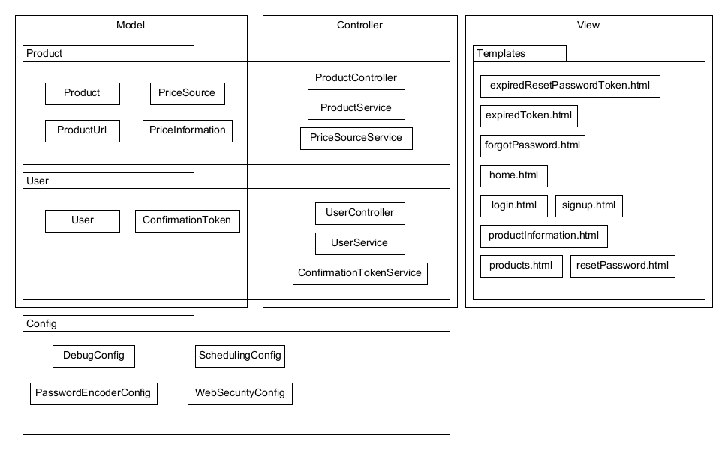
Subsystems

There are 4 packages that make up the application. They are:
- Product
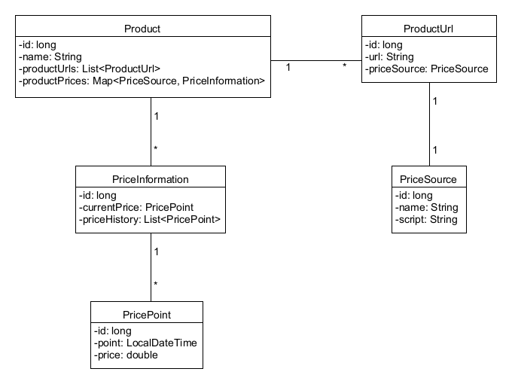
  - This package is responsible for the logic around dealing with products registered to the system, it serves the user product information, it updates the current product prices across registered price sources and it enables user to monitor specific products.
- User
  - This package is responsible for the user management logic. It enables registration, confirmation of user activities and authentication.
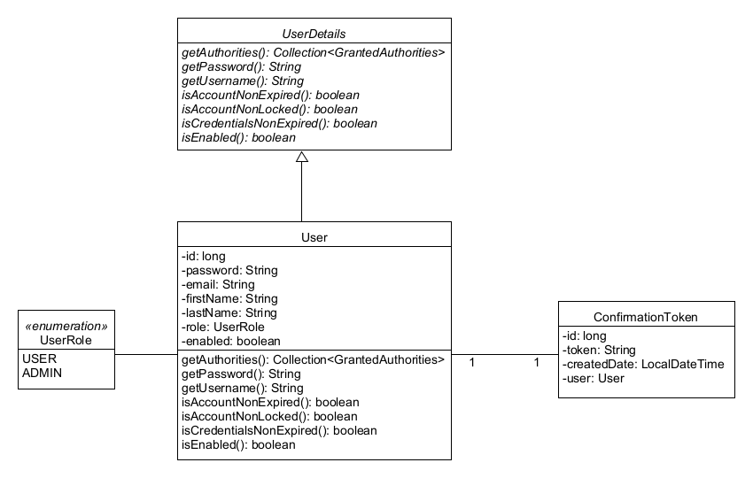
- Config
  - This package is responsible for application-wide configurations that are enabled by Spring-Boot framework.
- Templates
  - This package contains Thymeleaf templates that are used for the user interface.

Requirement Realizations

UC1-Register to System

Register:
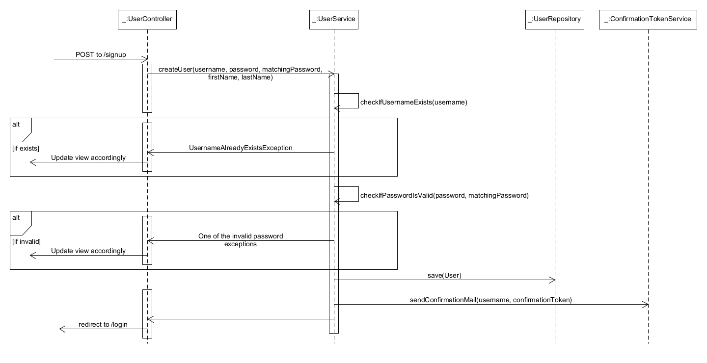

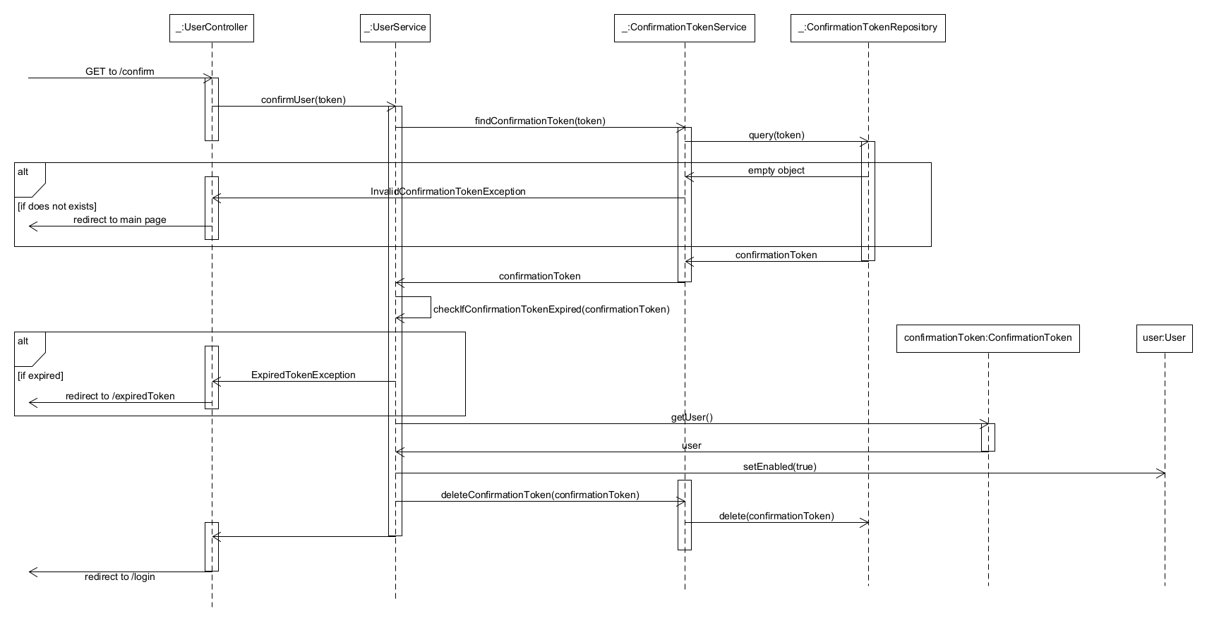
Confirmation Process:

Manage Product:

