

Report Title

REPORT SUBTITLE

Name | Course Title | Date

# Client-Side Technologies

There are many different client-side technologies that must be considered. The application type must first be decided, and then suitable frameworks for building the application can be considered.

## Application Type

There are several different types of application to be considered. These are Native, Hybrid, Single Page, and Progressive Web applications.

### Native

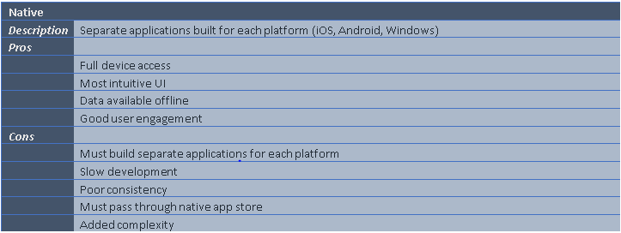

### Hybrid

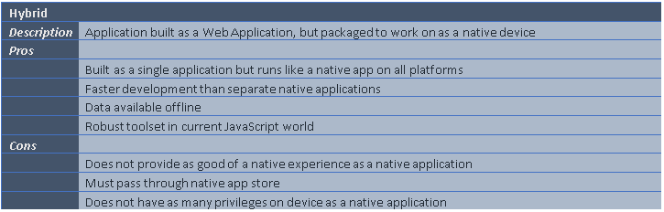

### Single Page

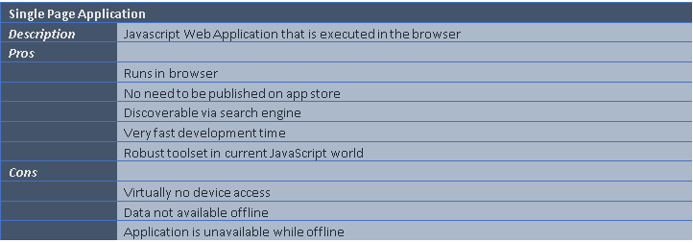

### Progressive Web

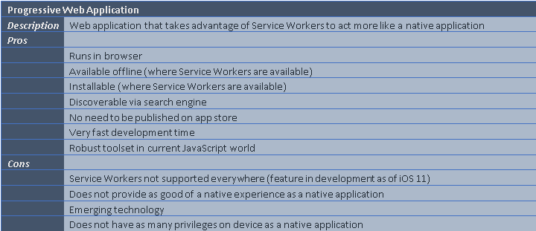

### Chosen Solution

I decided to go with a Progressive Web Application as it seemed that it would support rapid development. It also provides an advantage of being built with almost the simplicity of a Single Page Application, but almost the native features of a Native Application. This felt like a good balance between the two