Networks Assignment 3
selective repeat

Mohamed Ramadan
Marwan Mohamed
Ahmed Osama
Outline

1. Problem overview
2. Data structures used
3. Main functions
4. Analysis

Problem Overview

In this lab we’re required to implement reliable data transfer using selective repeat algorithm. Selective repeats uses windows to keep track of unacked buffer and to buffer them at the user. In our implementation, the server has two main threads: sender, receiver. Sender tracks any new or timed out packets and sends them. Receiver on the other hand keeps track of received acks and marks acked packets and moves window. Bold lines of the algorithms is described below:

sender_core_thread:
if(new packet):
send packet and set its timer
if(timed out packet):
resend packet and call congestion control
receiver_core_thread:
if(received ack is in our window and packet is unacked):
calculate rtt
call congestion control
while(packet at the beginning of the window is acked):
move window accordingly

also in our client we only have one thread for receiving data:

receiver_core_thread:
if(received packet is in window):
send ack and store packet in file
else if (received packet is before window beginning):
send ack //our ack didn’t reach server

also congestion control is added to make window size dynamic
the following diagram describes congestion control in tcp:
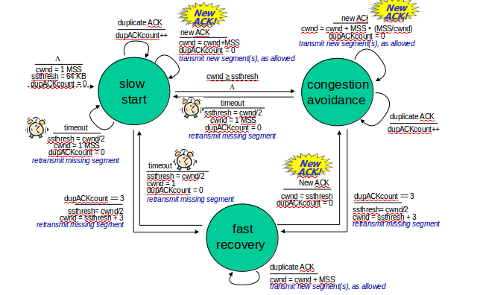
Data Structures Used:
packets:
an object used to represent window, it has all the packets currently in window
packet:
object representing packet by its timeout and if it’s acked
packet_data:
object representing data for every packet
file:
used to represent file data we’re sending and receiving
sender:
represents each server by its port, send base, next seqnum, rtt, ssthresh, cwnd and receiver/sender threads

Main Functions:

utilities:
makepkt(data, seqnum): encapsulates data into packet with seqnum and checksum

checkvalid(pkt): assures that packet is valid using its checksum

server:
run_server(): main thread for server, which represents the welcoming threads, upon connection this thread dispatches connection threads for each connection

connection_handler(): this function is called for every new file request, it sends the file size to the client as well as the file itself

client:
client_main(): this function runs a client to request file from the server and download it to local directory

sender:
send_buf(msg): stores the message in packet queue and waits until it’s sent then return

send_file(file): divides file into chunks and stores the in sender queue and waits until it’s all sent

receiver_kernel(): the receiver_core_thread described above

sender_core(): sender_core_thread described above

update_timeout(new rtt): updates the current timeout value using moving average and variance

cc_timeout(): congestion control action when timeout event happens,

Analysis:
- tests added for stop/wait protocol with dynamic rtt
- test added to this phase for calculating time with different plp

