中南大学

Web应用开发技术
实验报告

姓 名： | 李东烜,高楠
学 号： | 8209180632, XXXXXXX
班 级： | 软件工程1901,1902
指导老师： | 宋 铁
完成时间：
分 数：
批阅日期：
实验一 基于MVC用JSP/Servlet实现JPetStore

- 实验内容——基本任务。
- 商品展示业务模块，包括大类Category、小类Product和具体商品Item的展示和搜索功能。
  - 大类Category

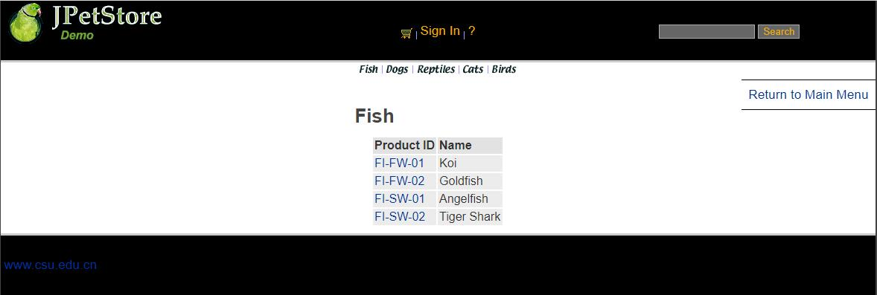

大类Category先实现Category.jsp进行大类的具体展示，利用jsp中c:foreach语法对每个大类进行展示，具体类的ID利用a标签进行跳转到小类进行查看，接下来实现domain层的Category.java，完成大类的基础设计，接下来实现persistence中的数据库连接层，先写DAO定义所有接口，再写实现的Implement方法，对数据库进行操作；再写一个Category的Service类，可以在Servlet层中调用该类的相关方法进行进一步操作，最后完成ViewCategoryServlet对jsp页面与业务层进行连接跳转。

web.Servlet中的ViewCategoryServlet：
public class ViewCategoryServlet extends HttpServlet {
private static final String VIEW_CATEGORY = "/WEB-INF/jsp/catalog/Category.jsp";
private String categoryId;
protected void doPost(HttpServletRequest request, HttpServletResponse response) throws ServletException, IOException {
doGet(request, response);
}
protected void doGet(HttpServletRequest request, HttpServletResponse response) throws ServletException, IOException {
categoryId = request.getParameter("categoryId");
CatalogService service = new CatalogService();
Category category = service.getCategory(categoryId);
List<Product> productList = service.getProductListByCategory(categoryId);
//保存数据
HttpSession session = request.getSession();
session.setAttribute("category", category);
session.setAttribute("productList", productList);
//跳转页面
request.getRequestDispatcher(VIEW_CATEGORY).forward(request, response);
}
  - 小类Product

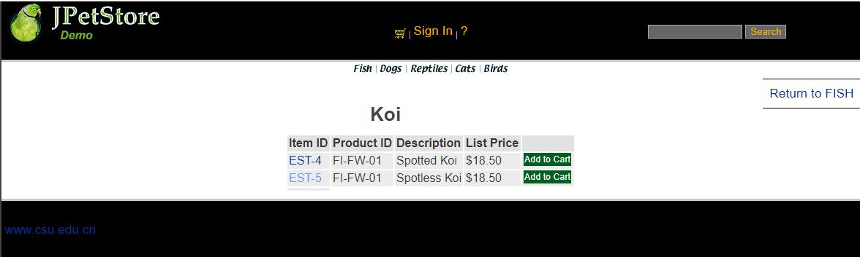

小类Product先完善Product.jsp，主要是通过productId对产品类进行信息展示，之后再实现Product.java，接下进行ProductDAOImpl数据库的连接进行编写，最后完成Servlet的编写。

ViewProductServlet代码：
public class ViewProductServlet extends HttpServlet {
private static final String VIEW_PRODUCT = "/WEB-INF/jsp/catalog/Product.jsp";
private String productId;
protected void doGet(HttpServletRequest request, HttpServletResponse response) throws ServletException, IOException {
productId = request.getParameter("productId");
CatalogService service = new CatalogService();
Product product = service.getProduct(productId);
List<Item> itemList = service.getItemListByProduct(productId);
HttpSession session = request.getSession();
session.setAttribute("product", product);
session.setAttribute("itemList", itemList);
request.getRequestDispatcher(VIEW_PRODUCT).forward(request, response);
}
}

1.3具体商品Item

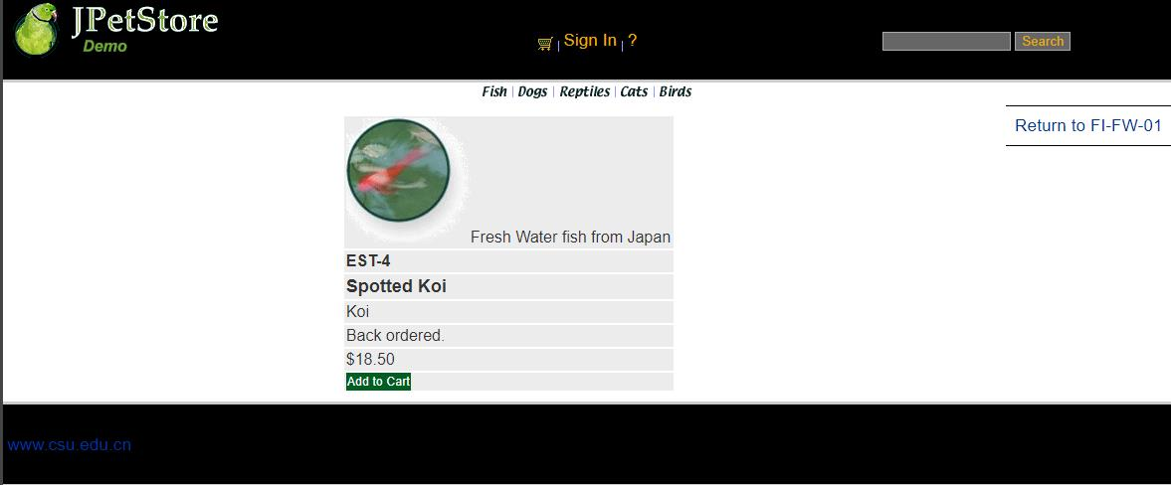

用户点击产品后进入查看具体商品，完善Item.jsp，Copy代码模版中的Item.java，实现ItemDAOImpl的具体数据库连接操作，完成最后的Servlet连接。

ViewItemServlet：
public class ViewItemServlet extends HttpServlet {
private static final String VIEW_ITEM = "/WEB-INF/jsp/catalog/Item.jsp";
private String itemId;
protected void doPost(HttpServletRequest request, HttpServletResponse response) throws ServletException, IOException {
doGet(request, response);
}
protected void doGet(HttpServletRequest request, HttpServletResponse response) throws ServletException, IOException {
itemId = request.getParameter("itemId");
CatalogService service = new CatalogService();
Item item = service.getItem(itemId);
HttpSession session = request.getSession();
session.setAttribute("item", item);
request.getRequestDispatcher(VIEW_ITEM).forward(request, response);
}
}

1.4搜索功能

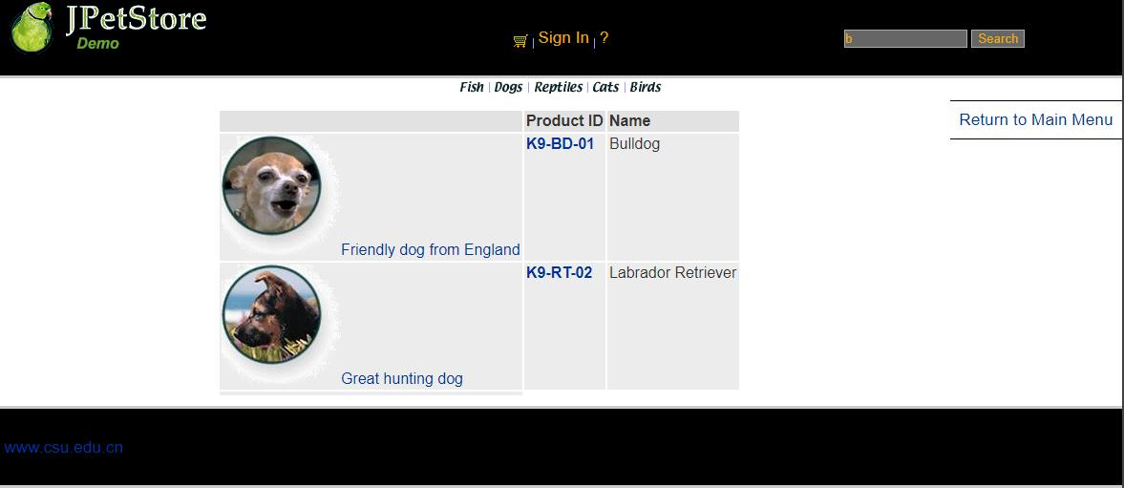

搜索功能先完善显示的SearchProducts.jsp，接下直接进行SearchProductServlet编写和配置，通过获得输入的关键字再通过CatalogService的方法进行查找并显示。

SearchProductServlet：
public class SearchProductServlet extends HttpServlet {
private static final String SEARCH_PRODUCTS = "/WEB-INF/jsp/catalog/SearchProducts.jsp";
private String keyword;
protected void doPost(HttpServletRequest request, HttpServletResponse response) throws ServletException, IOException {
doGet(request, response);
}
protected void doGet(HttpServletRequest request, HttpServletResponse response) throws ServletException, IOException {
keyword = request.getParameter("keyword");
//request.setAttribute("keyword", keyword);
CatalogService service = new CatalogService();
List<Product> productList = service.searchProductList(keyword);
//保存数据
HttpSession session = request.getSession();
session.setAttribute("keyword", keyword);
session.setAttribute("productList", productList);
//跳转页面
request.getRequestDispatcher(SEARCH_PRODUCTS).forward(request, response);
}
}

- 用户管理业务模块，包括用户注册、登录、修改用户信息、查询用户相关订单等业务功能。

2.1用户注册

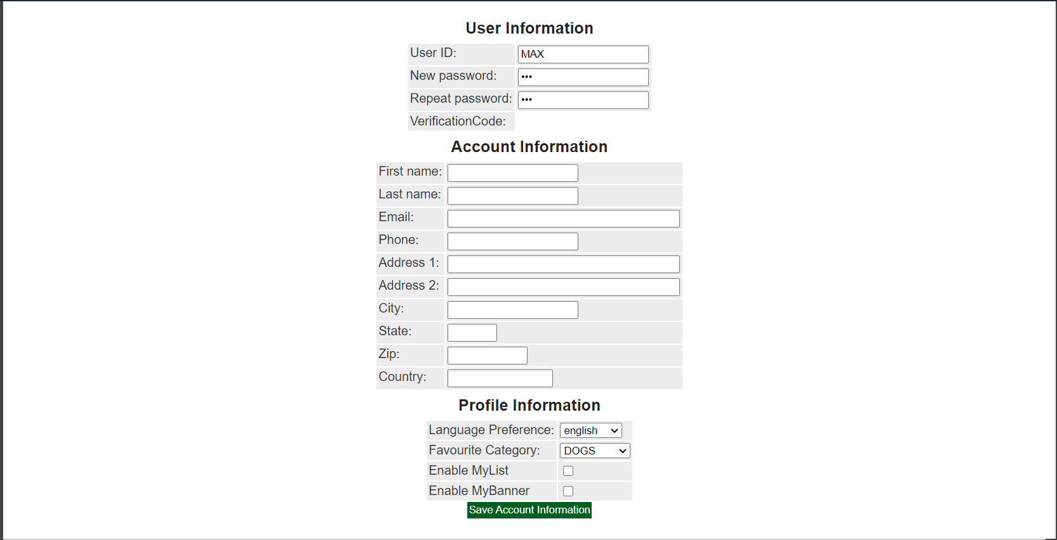

用户注册时，需要一个全新的包含用户所有信息的输入界面即NewAccountForm.jsp，之后需要先进行设计NewAccountFormServlet，该Servlet的功能仅为实现用户点击注册后跳转用户输入新账号信息的表格，接下实现Account.java，完成Account的基础功能，之后进行AccountDAO接口定义以及完成AccountDAOImpl连接数据库的实现，接下来完成AccountService的编写，之后进行NewAccountServlet配置，获取网页界面的信息，赋值给一个新账号，再将该账号插入到数据库中。

AccountService：
public class AccountService {
private AccountDAO accountDAO;
public AccountService(){
accountDAO = new AccountDAOImpl();
}
public Account getAccount(String username) {
return accountDAO.getAccountByUsername(username);
}
public Account getAccount(String username, String password) {
Account account = new Account();
account.setUsername(username);
account.setPassword(password);
return accountDAO.getAccountByUsernameAndPassword(account);
}
public void insertAccount(Account account) {
accountDAO.insertAccount(account);
accountDAO.insertProfile(account);
accountDAO.insertSignon(account);
}
public void updateAccount(Account account) {
accountDAO.updateAccount(account);
accountDAO.updateProfile(account);
if (account.getPassword() != null && account.getPassword().length() > 0) {
accountDAO.updateSignon(account);
}
}
}

NewAccountServlet：
public class NewAccountServlet extends HttpServlet {
private static final String MAIN = "/WEB-INF/jsp/catalog/Main.jsp";
private static final String NEWACCOUNTFORM = "/WEB-INF/jsp/account/NewAccountForm.jsp";
private Account account;
private Account account1;
private AccountService accountService;
protected void doPost(HttpServletRequest request, HttpServletResponse response) throws ServletException, IOException {
doGet(request, response);
}
protected void doGet(HttpServletRequest request, HttpServletResponse response) throws ServletException, IOException {
HttpSession session = request.getSession();
account = (Account) session.getAttribute("account");
account = null;
session.setAttribute("account", account);
//获得输入的验证码值
String value1=request.getParameter("vCode");
/*获取图片的值*/
String value2=(String)session.getAttribute("checkcode");
Boolean isSame = false;
/*对比两个值（字母不区分大小写）*/
if(value2.equalsIgnoreCase(value1)){
isSame = true;
}
String username = request.getParameter("username");
String password = request.getParameter("password");
String firstName = request.getParameter("firstName");
String lastName = request.getParameter("lastName");
String email = request.getParameter("email");
String phone = request.getParameter("phone");
String address1 = request.getParameter("address1");
String address2 = request.getParameter("address2");
String city = request.getParameter("city");
String state = request.getParameter("state");
String zip = request.getParameter("zip");
String country = request.getParameter("country");
String languagePreference = request.getParameter("languagePreference");
String favouriteCategoryId = request.getParameter("favouriteCategoryId");
String listOption = request.getParameter("listOption");
String bannerOption = request.getParameter("bannerOption");
account1 = new Account();
account1.setUsername(username);
account1.setPassword(password);
account1.setFirstName(firstName);
account1.setLastName(lastName);
account1.setEmail(email);
account1.setPhone(phone);
account1.setAddress1(address1);
account1.setAddress2(address2);
account1.setCity(city);
account1.setState(state);
account1.setZip(zip);
account1.setCountry(country);
account1.setLanguagePreference(languagePreference);
account1.setFavouriteCategoryId(favouriteCategoryId);
account1.setListOption(Boolean.parseBoolean(listOption));
account1.setBannerOption(Boolean.parseBoolean(bannerOption));
if(isSame){
accountService = new AccountService();
accountService.insertAccount(account1);
if(account1 != null){
request.getRequestDispatcher(MAIN).forward(request, response);
}else{
session.setAttribute("messageAccount", "Invalid Verification Code.");
if(account1 != null){
request.getRequestDispatcher(NEWACCOUNTFORM).forward(request, response);
}
}
}

2.2用户登录

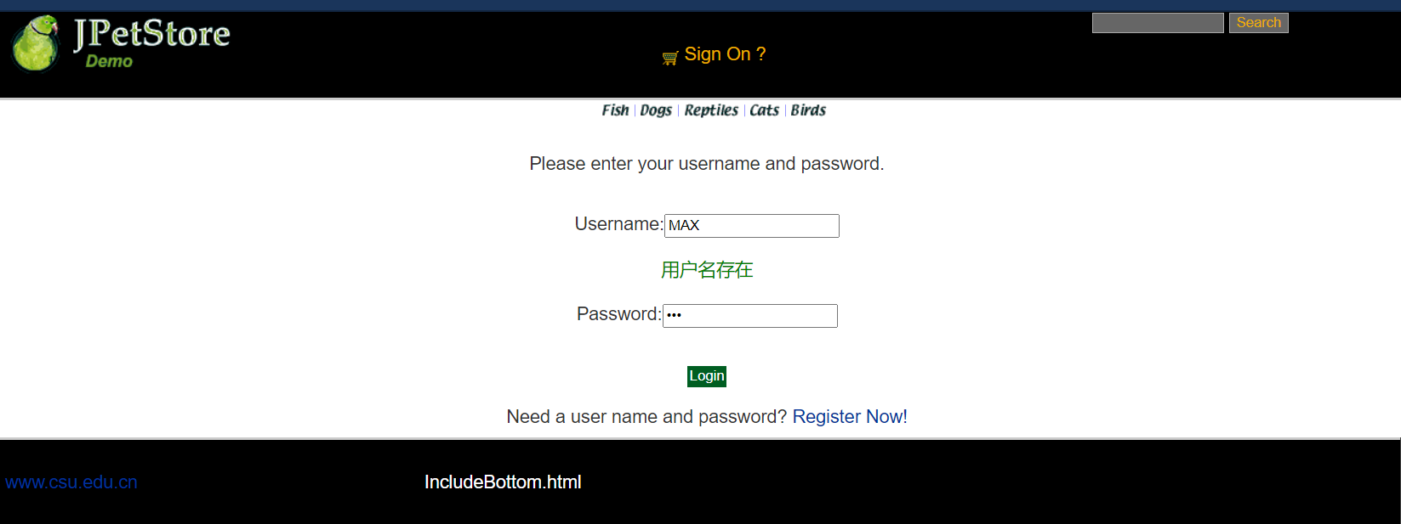

用户登录先完成SignonForm.jsp，能够使用户输入登入的账号与密码，接下来先用一个Servlet实现SignOnFormServlet实现点击登录时网页跳转到用户输入账号密码的界面，接下来使用SignOnServlet实现获取用户的账号密码对数据库进行核查，如果存在则登录，反之则给予一定的错误信息提示。

SignOnFormServlet：
public class SignOnFormServlet extends HttpServlet {
private static final String SIGNONFORM = "/WEB-INF/jsp/account/SignonForm.jsp";
private Account account;
protected void doPost(HttpServletRequest request, HttpServletResponse response) throws ServletException, IOException {
doGet(request, response);
}
protected void doGet(HttpServletRequest request, HttpServletResponse response) throws ServletException, IOException {
HttpSession session = request.getSession();
account = (Account)session.getAttribute("account");
request.getRequestDispatcher(SIGNONFORM).forward(request, response);
}
}

SignOnServlet：
public class SignOnServlet extends HttpServlet {
private static final String MAIN = "/WEB-INF/jsp/catalog/Main.jsp";
private static final String SIGNONFORM = "/WEB-INF/jsp/account/SignonForm.jsp";
private Account account;
private AccountService accountService;
protected void doPost(HttpServletRequest request, HttpServletResponse response) throws ServletException, IOException {
doGet(request, response);
}
protected void doGet(HttpServletRequest request, HttpServletResponse response) throws ServletException, IOException {
String username = request.getParameter("username");
String password = request.getParameter("password");
accountService = new AccountService();
account = accountService.getAccount(username, password);
HttpSession session = request.getSession();
session.setAttribute("account", account);
//获得输入的验证码值
String value1=request.getParameter("vCode");
/*获取图片的值*/
String value2=(String)session.getAttribute("checkcode");
Boolean isSame = false;
/*对比两个值（字母不区分大小写）*/
if(value2.equalsIgnoreCase(value1)){
isSame = true;
}
if (account == null || !isSame){
if(!isSame){
session.setAttribute("messageSignOn", "Invalid Verification Code. Signon failed.");
}else{
session.setAttribute("messageSignOn", "Invalid username or password. Signon failed.");
}
session.setAttribute("account", null);
request.getRequestDispatcher(SIGNONFORM).forward(request, response);
}else{
account.setPassword(null);
request.getRequestDispatcher(MAIN).forward(request, response);
}
}
}

2.3用户修改信息

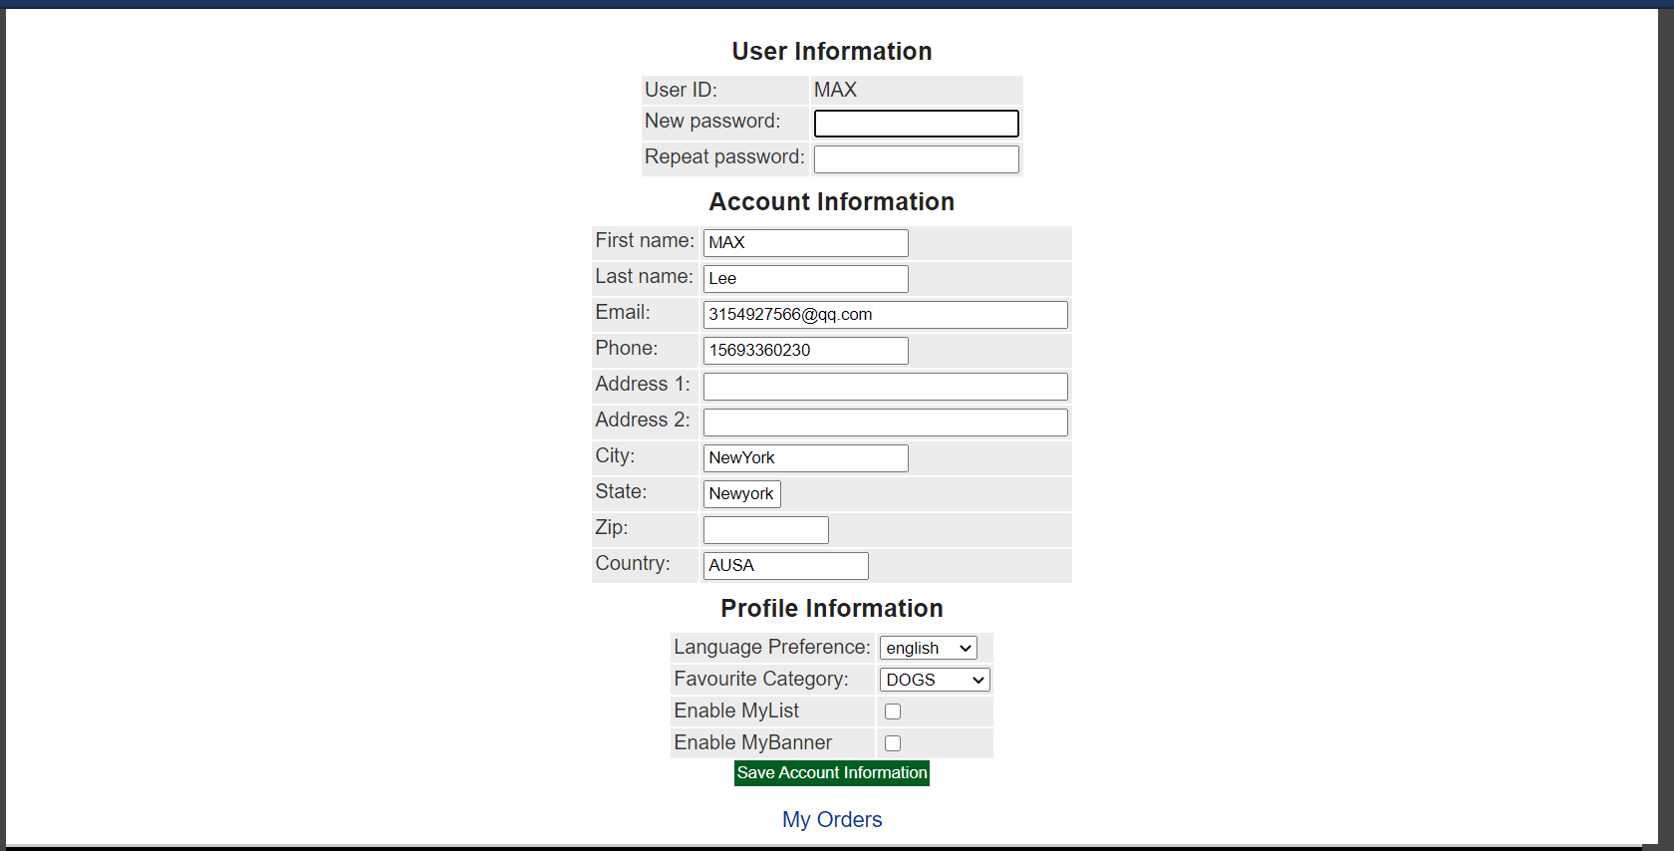

修改个人账号信息也就是进行个人信息查看，同时可以进行修改，修改后点击Save Account Information即可获取新的用户信息，之后进行数据库信息更新。

EditAccountServlet：
public class EditAccountServlet extends HttpServlet {
private static final String EDITACOUNT = "/WEB-INF/jsp/account/EditAccountForm.jsp";
protected void doPost(HttpServletRequest request, HttpServletResponse response) throws ServletException, IOException {
doGet(request, response);
}
protected void doGet(HttpServletRequest request, HttpServletResponse response) throws ServletException, IOException {
request.getRequestDispatcher(EDITACOUNT).forward(request, response);
}
}

SaveAccountServlet：
public class SaveAccountServlet extends HttpServlet {
private static final String EDITACOUNT = "/WEB-INF/jsp/account/EditAccountForm.jsp";
private Account account;
private AccountService accountService;
protected void doPost(HttpServletRequest request, HttpServletResponse response) throws ServletException, IOException {
doGet(request, response);
}
protected void doGet(HttpServletRequest request, HttpServletResponse response) throws ServletException, IOException {
HttpSession session = request.getSession();
account = (Account) session.getAttribute("account");
String username = account.getUsername();
String password = request.getParameter("password");
String firstName = request.getParameter("firstName");
String lastName = request.getParameter("lastName");
String email = request.getParameter("email");
String phone = request.getParameter("phone");
String address1 = request.getParameter("address1");
String address2 = request.getParameter("address2");
String city = request.getParameter("city");
String state = request.getParameter("state");
String zip = request.getParameter("zip");
String country = request.getParameter("country");
String languagePreference = request.getParameter("languagePreference");
String favouriteCategoryId = request.getParameter("favouriteCategoryId");
String listOption = request.getParameter("listOption");
String bannerOption = request.getParameter("bannerOption");
account.setUsername(username);
account.setPassword(password);
account.setFirstName(firstName);
account.setLastName(lastName);
account.setEmail(email);
account.setPhone(phone);
account.setAddress1(address1);
account.setAddress2(address2);
account.setCity(city);
account.setState(state);
account.setZip(zip);
account.setCountry(country);
account.setLanguagePreference(languagePreference);
account.setFavouriteCategoryId(favouriteCategoryId);
account.setListOption(Boolean.parseBoolean(listOption));
account.setBannerOption(Boolean.parseBoolean(bannerOption));
accountService = new AccountService();
accountService.updateAccount(account);
session.setAttribute("account", account);
request.getRequestDispatcher(EDITACOUNT).forward(request, response);
}
}

2.4查询订单

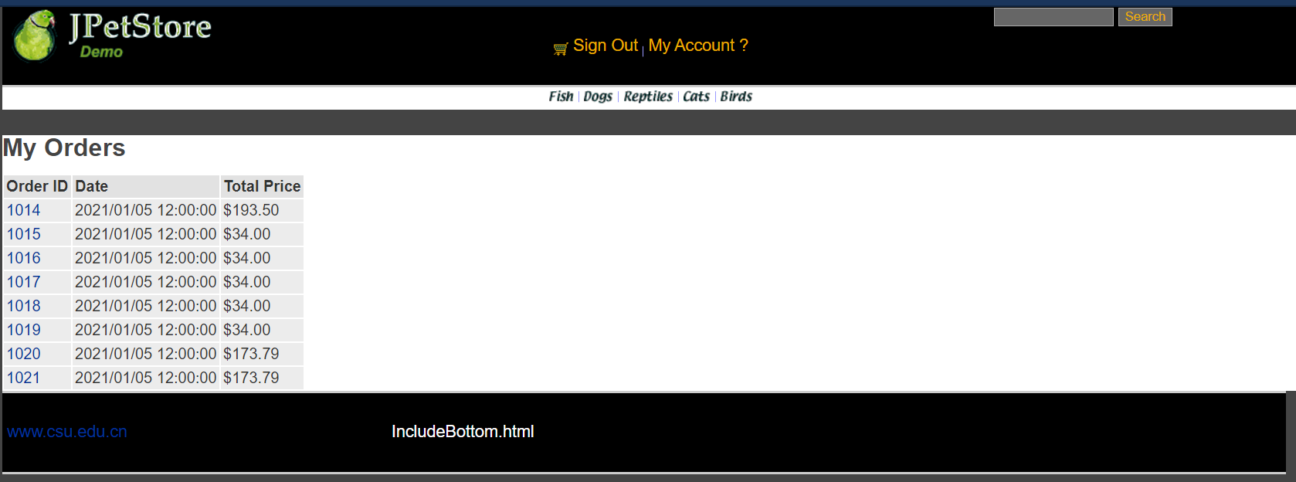

账户订单查看，先完成ListOrders.jsp的实现，接下来实现Order.java的基础模块，创建OrderDAO接口，完成数据库的具体操作OrderDAOImpl，接下来实现OrderService，成功完成业务层调用，最后完成ViewListOrderServlet实现用户可以从数据库中查看到自己的订单信息。

OrderService
public class OrderService {
private ItemDAO itemDAO;
private OrderDAO orderDAO;
private SequenceDAO sequenceDAO;
private LineItemDAO lineItemDAO;
public OrderService(){
itemDAO = new ItemDAOImpl();
orderDAO = new OrderDAOImpl();
sequenceDAO = new SequenceDAOImpl();
lineItemDAO = new LineItemDAOImpl();
}
public void insertOrder(Order order) {
order.setOrderId(getNextId("ordernum"));
for (int i = 0; i < order.getLineItems().size(); i++) {
LineItem lineItem = (LineItem) order.getLineItems().get(i);
String itemId = lineItem.getItemId();
Integer increment = new Integer(lineItem.getQuantity());
Map<String, Object> param = new HashMap<String, Object>(2);
param.put("itemId", itemId);
param.put("increment", increment);
itemDAO.updateInventoryQuantity(param);
}
orderDAO.insertOrder(order);
orderDAO.insertOrderStatus(order);
for (int i = 0; i < order.getLineItems().size(); i++) {
LineItem lineItem = (LineItem) order.getLineItems().get(i);
lineItem.setOrderId(order.getOrderId());
lineItemDAO.insertLineItem(lineItem);
}
}
public Order getOrder(int orderId) {
Order order = orderDAO.getOrder(orderId);
order.setLineItems(lineItemDAO.getLineItemsByOrderId(orderId));
for (int i = 0; i < order.getLineItems().size(); i++) {
LineItem lineItem = (LineItem) order.getLineItems().get(i);
Item item = itemDAO.getItem(lineItem.getItemId());
item.setQuantity(itemDAO.getInventoryQuantity(lineItem.getItemId()));
lineItem.setItem(item);
}
return order;
}
public List<Order> getOrdersByUsername(String username) {
return orderDAO.getOrdersByUsername(username);
}
public int getNextId(String name) {
Sequence sequence = new Sequence(name, -1);
sequence = sequenceDAO.getSequence(sequence);
if (sequence == null) {
throw new RuntimeException("Error: A null sequence was returned from the database (could not get next " + name
+ " sequence).");
}
Sequence parameterObject = new Sequence(name, sequence.getNextId() + 1);
sequenceDAO.updateSequence(parameterObject);
return sequence.getNextId();
}
}

ViewListServlet：
public class ViewListOrderServlet extends HttpServlet {
private static final String VIEWLISTORDER = "/WEB-INF/jsp/order/ListOrders.jsp";
private String username;
private OrderService orderService;
private List<Order> orderList = new ArrayList<Order>();
protected void doPost(HttpServletRequest request, HttpServletResponse response) throws ServletException, IOException {
doGet(request, response);
}
protected void doGet(HttpServletRequest request, HttpServletResponse response) throws ServletException, IOException {
username = request.getParameter("username");
orderService = new OrderService();
orderList = orderService.getOrdersByUsername(username);
HttpSession session = request.getSession();
session.setAttribute("orderList", orderList);
//HttpSession session = request.getSession();
Account account = (Account)session.getAttribute("account");
request.getRequestDispatcher(VIEWLISTORDER).forward(request, response);
}
}
- 订单管理模块，包括购物车管理、新增订单、地址信息等业务功能。

3.1添加商品到购物车

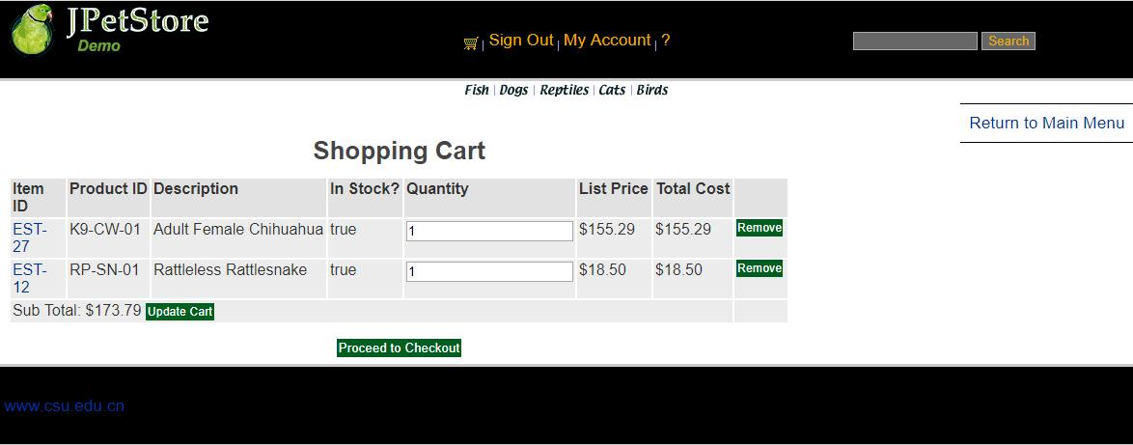

先实现Cart.jsp，能够在网页显示购物车栏目信息，接下来具体实现Cart.java使得用户可以创建Cart类，最后创建AddItemToCartServlet，当用户在浏览商品界面时，点击Add to Cart时可以将该商品加入到购物车中并显示相关信息。

AddItemToCartServlet
public class AddItemToCartServlet extends HttpServlet {
//Servlet的功能即负责中转
//1.处理完请求后的跳转页面
private static final String VIEW_CART = "/WEB-INF/jsp/cart/Cart.jsp";
//2.定义处理该请求所需要的数据
private String workingItemId;
private Cart cart; //购物车
//3.是否需要调用业务逻辑层
private CatalogService catalogService;
protected void doPost(HttpServletRequest request, HttpServletResponse response) throws ServletException, IOException {
doGet(request, response);
}
protected void doGet(HttpServletRequest request, HttpServletResponse response) throws ServletException, IOException {
workingItemId = request.getParameter("workingItemId");
Account account;
//从对话中，获取购物车
HttpSession session = request.getSession();
cart = (Cart)session.getAttribute("cart");
account = (Account)session.getAttribute("account");
if(cart == null){
//第一次使用购物车
cart = new Cart();
}
if(cart.containsItemId(workingItemId)){
//已有该物品，数量加一
cart.incrementQuantityByItemId(workingItemId);
}else{
catalogService = new CatalogService();
boolean isInStock = catalogService.isItemInStock(workingItemId);
Item item = catalogService.getItem(workingItemId);
cart.addItem(item, isInStock);
session.setAttribute("cart", cart);
request.getRequestDispatcher(VIEW_CART).forward(request, response);
}
}
}

3.2更改购物车商品的数量信息

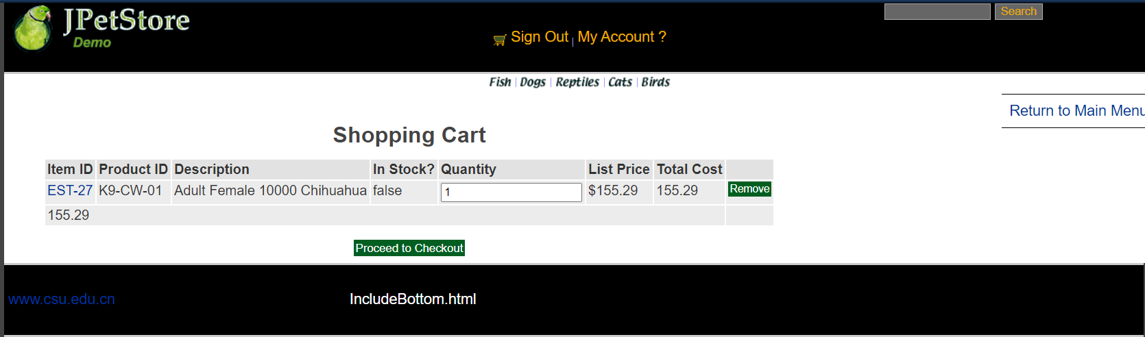

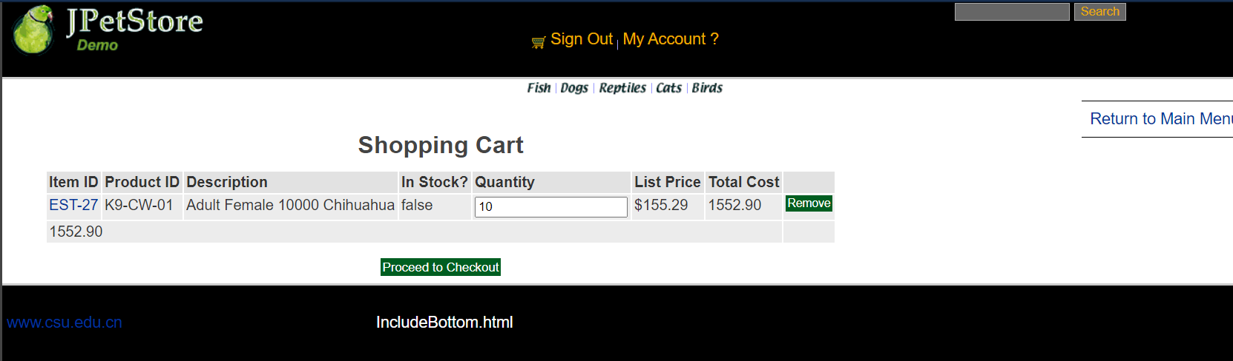

在购物车的数量栏输入想要更改后的商品数量，点击Update Cart即可更新购物车中的商品数量、总价。点击之后利用UpdateCartQuantitiesServlet实现信息更新以及页面更新，传递商品的数量信息获取后进行相关操作。

UpdateCartQuantitiesServlet：
public class UpdateCartQuantitiesServlet extends HttpServlet {
private static final String VIEW_CART = "/WEB-INF/jsp/cart/Cart.jsp";
private String workingItemId;
private Cart cart;
protected void doPost(HttpServletRequest request, HttpServletResponse response) throws ServletException, IOException {
doGet(request, response);
}
protected void doGet(HttpServletRequest request, HttpServletResponse response) throws ServletException, IOException {
workingItemId = request.getParameter("workingItemId");
CatalogService catalogService = new CatalogService();
//从对话中，获取购物车
HttpSession session = request.getSession();
cart = (Cart)session.getAttribute("cart");
Iterator<CartItem> cartItemIterator = cart.getAllCartItems();
while (cartItemIterator.hasNext()){
//产品数量增加
CartItem cartItem = (CartItem)cartItemIterator.next();
String itemId = cartItem.getItem().getItemId();
try {
int quantity = Integer.parseInt((String) request.getParameter(itemId));
cart.setQuantityByItemId(itemId, quantity);
if (quantity < 1) {
cartItemIterator.remove();
}
} catch (Exception e) {
//ignore parse exceptions on purpose
e.printStackTrace();
}
//CartItem cartItem = cartItemIterator.next();
//cartItem.incrementQuantity();
}
session.setAttribute("cart", cart);
request.getRequestDispatcher(VIEW_CART).forward(request, response);
}
}

3.3移除购物车中的商品

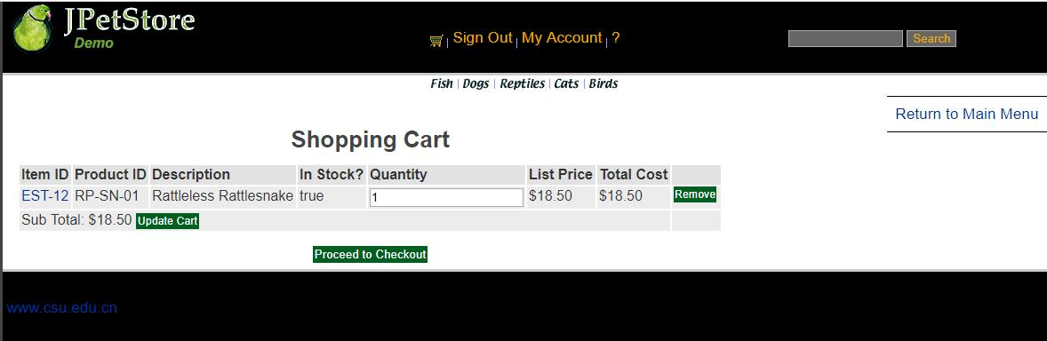

点击购物车中Remove按钮，获取购物车中的信息，之后进入RemoveItemFromCartServlet进行删除操作，并更新该购物车中的信息，如果误操作，则提示该误操作信息。

RemoveItemFromCartServlet：
public class RemoveItemFromCartServlet extends HttpServlet {
private static final String VIEW_CART = "/WEB-INF/jsp/cart/Cart.jsp";
private static final String ERROR = "/WEB-INF/jsp/common/Error.jsp";
private String workingItemId;
private Cart cart;
protected void doPost(HttpServletRequest request, HttpServletResponse response) throws ServletException, IOException {
doGet(request, response);
}
protected void doGet(HttpServletRequest request, HttpServletResponse response) throws ServletException, IOException {
workingItemId = request.getParameter("workingItemId");
HttpSession session = request.getSession();
cart = (Cart)session.getAttribute("cart");
Item item = cart.removeItemById(workingItemId);
if(item == null) {
session.setAttribute("message", "Attempted to remove null CartItem from Cart.");
request.getRequestDispatcher(ERROR).forward(request, response);
}else{
request.getRequestDispatcher(VIEW_CART).forward(request, response);
}
}
}

3.4新增订单——跳转到查看寄件人与收件人地址

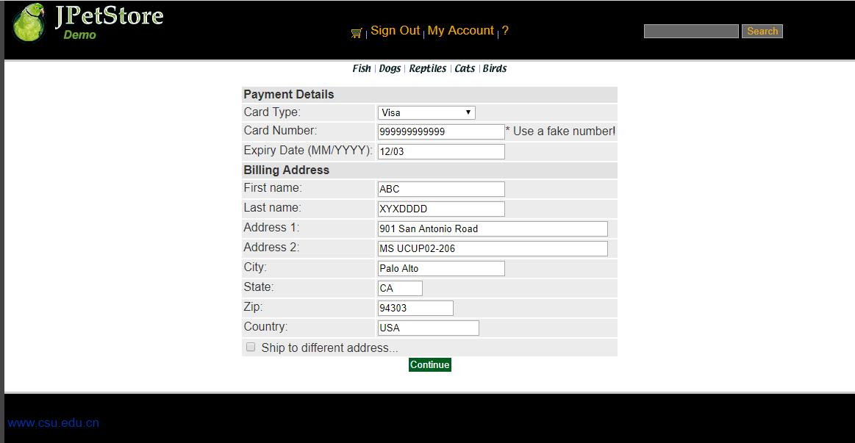

生成订单界面，包括修改地址信息时共有四个页面，第一个页面是购买方的支付与寄件地址信息确认，即NewOrderForm.jsp，接下来确认后是发货人地址与收货人地址信息确认（ConfirmOrder.jsp），或者点击修改地址即可通过ShippingFormServlet进行跳转到修改收件人地址界面，最后点击Comfirm之后即可生成最终订单（ViewOrder.jsp）。

第一个页面在购物车点击Proceed to Checkout之后利用NewOrderFormServlet进行跳转到地址信息显示界面。

NewOrderFormServlet:
public class NewOrderFormServlet extends HttpServlet {
private static final String NEW_ORDER = "/WEB-INF/jsp/order/NewOrderForm.jsp";
private static final String SIGNONFORM = "/WEB-INF/jsp/account/SignonForm.jsp";
private static final String ERROR = "/WEB-INF/jsp/common/Error.jsp";
private Account account;
private Order order;
private Cart cart;
protected void doPost(HttpServletRequest request, HttpServletResponse response) throws ServletException, IOException {
doGet(request, response);
}
protected void doGet(HttpServletRequest request, HttpServletResponse response) throws ServletException, IOException {
HttpSession session = request.getSession();
account = (Account)session.getAttribute("account");
cart = (Cart)session.getAttribute("cart");
if (account == null){
session.setAttribute("message", "You must sign on before attempting to check out. Please sign on and try checking out again.");
request.getRequestDispatcher(SIGNONFORM).forward(request, response);
} else if(cart != null){
order = new Order();
order.initOrder(account, cart);
session.setAttribute("order", order);
request.getRequestDispatcher(NEW_ORDER).forward(request, response);
}else{
session.setAttribute("message", "An order could not be created because a cart could not be found.");
request.getRequestDispatcher(ERROR).forward(request, response);
}
}
}

3.5新增订单——地址信息即修改收件人地址

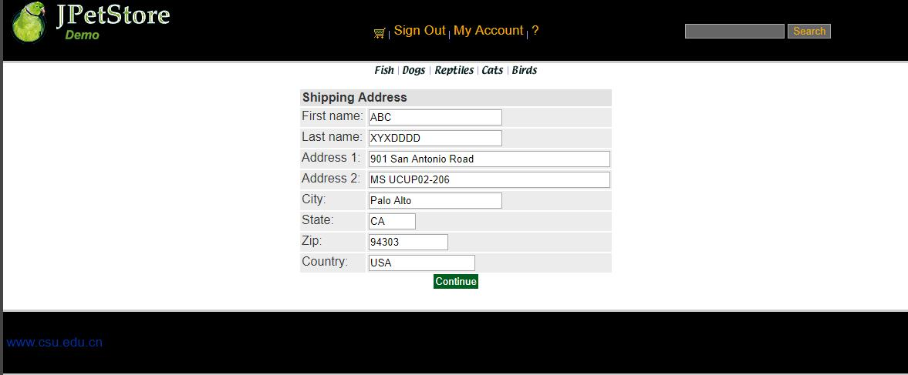

在生成订单的第一个界面时有个更改地址的选择框，选择之后点击Continue即可利用ShippingFormServlet跳转到更改收件人地址的界面ShippingForm.jsp,接下里可以进行收货人地址信息更改，再利用ShippingAdressServlet进行数据更新存入数据库接下来使用。

ShippingFormServlet：
public class ShippingFormServlet extends HttpServlet {
private static final String SHIPPINGFORM = "/WEB-INF/jsp/order/ShippingForm.jsp";
private static final String SIGNONFORM = "/WEB-INF/jsp/account/SignonForm.jsp";
private Account account;
protected void doPost(HttpServletRequest request, HttpServletResponse response) throws ServletException, IOException {
doGet(request, response);
}
protected void doGet(HttpServletRequest request, HttpServletResponse response) throws ServletException, IOException {
HttpSession session = request.getSession();
account = (Account)session.getAttribute("account");
if (account == null){
request.getRequestDispatcher(SIGNONFORM).forward(request, response);
} else{
request.getRequestDispatcher(SHIPPINGFORM).forward(request, response);
}
}
}

ShippingAdressServlet：
public class ShippingAddressServlet extends HttpServlet {
private static final String CONFIRM_ORDER_FORM = "/WEB-INF/jsp/order/ConfirmOrder.jsp";
private Order order;
private String shipToFirstName;
private String shipToLastName;
private String shipAddress1;
private String shipAddress2;
private String shipCity;
private String shipState;
private String shipZip;
private String shipCountry;
protected void doPost(HttpServletRequest request, HttpServletResponse response) throws ServletException, IOException {
doGet(request, response);
}
protected void doGet(HttpServletRequest request, HttpServletResponse response) throws ServletException, IOException {
shipToFirstName = request.getParameter("shipToFirstName");
shipToLastName = request.getParameter("shipToLastName");
shipAddress1 = request.getParameter("shipAddress1");
shipAddress2 = request.getParameter("shipAddress2");
shipCity = request.getParameter("shipCity");
shipState = request.getParameter("shipState");
shipZip = request.getParameter("shipZip");
shipCountry = request.getParameter("shipCountry");
HttpSession session = request.getSession();
order = (Order)session.getAttribute("order");
order.setShipToFirstName(shipToFirstName);
order.setShipToLastName(shipToLastName);
order.setShipAddress1(shipAddress1);
order.setShipAddress2(shipAddress2);
order.setShipCity(shipCity);
order.setShipState(shipState);
order.setShipZip(shipZip);
order.setCourier(shipCountry);
session.setAttribute("order", order);
Account account = (Account)session.getAttribute("account");
request.getRequestDispatcher(CONFIRM_ORDER_FORM).forward(request, response);
}
}

3.6新增订单——确定订单信息

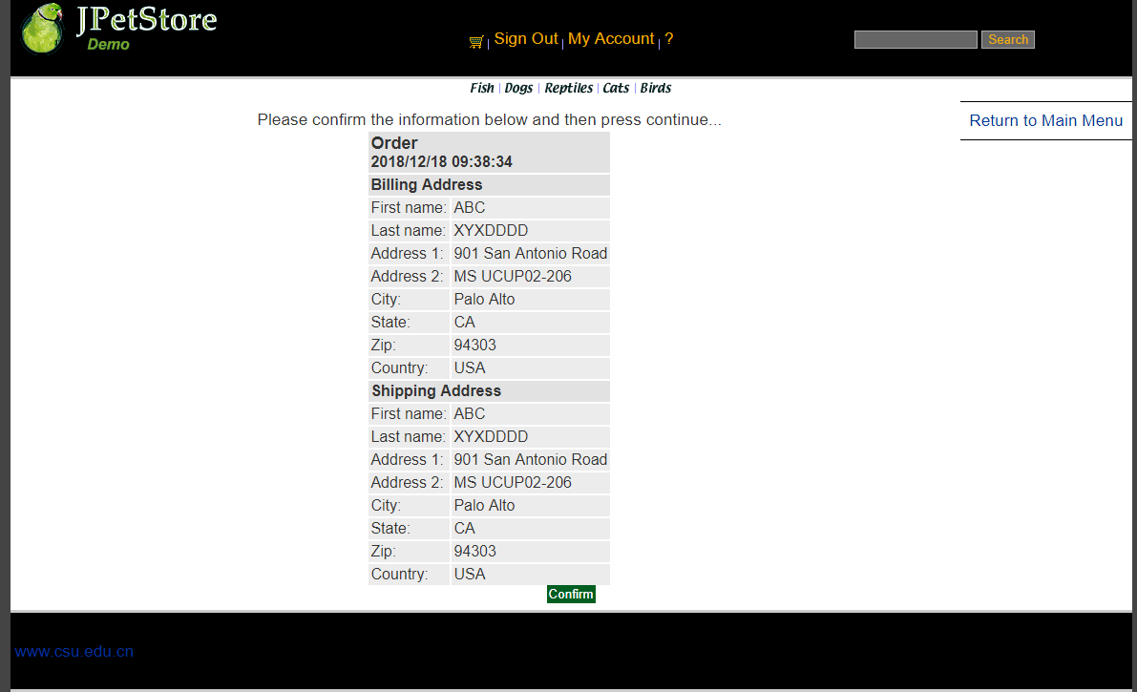

在第一个地址页面后点击Continue进入第二个地址查看界面（ConfirmOrderFormServlet），确认订单信息的正误。

public class ConfirmOrderFormServlet extends HttpServlet {
private static final String CONFIRM_ORDER_FORM = "/WEB-INF/jsp/order/ConfirmOrder.jsp";
private static final String SHIPPINGFORM = "/WEB-INF/jsp/order/ShippingForm.jsp";
protected void doPost(HttpServletRequest request, HttpServletResponse response) throws ServletException, IOException {
doGet(request, response);
}
protected void doGet(HttpServletRequest request, HttpServletResponse response) throws ServletException, IOException {
shippingAddressRequired = request.getParameter("shippingAddressRequired");
order = new Order();
HttpSession session = request.getSession();
order = (Order)session.getAttribute("order");
Account account = (Account)session.getAttribute("account");
if (shippingAddressRequired == null){
request.getRequestDispatcher(CONFIRM_ORDER_FORM).forward(request, response);
}
else{
shippingAddressRequired = null;
request.getRequestDispatcher(SHIPPINGFORM).forward(request, response);
}
}
}

3.7新增订单——生成最终订单

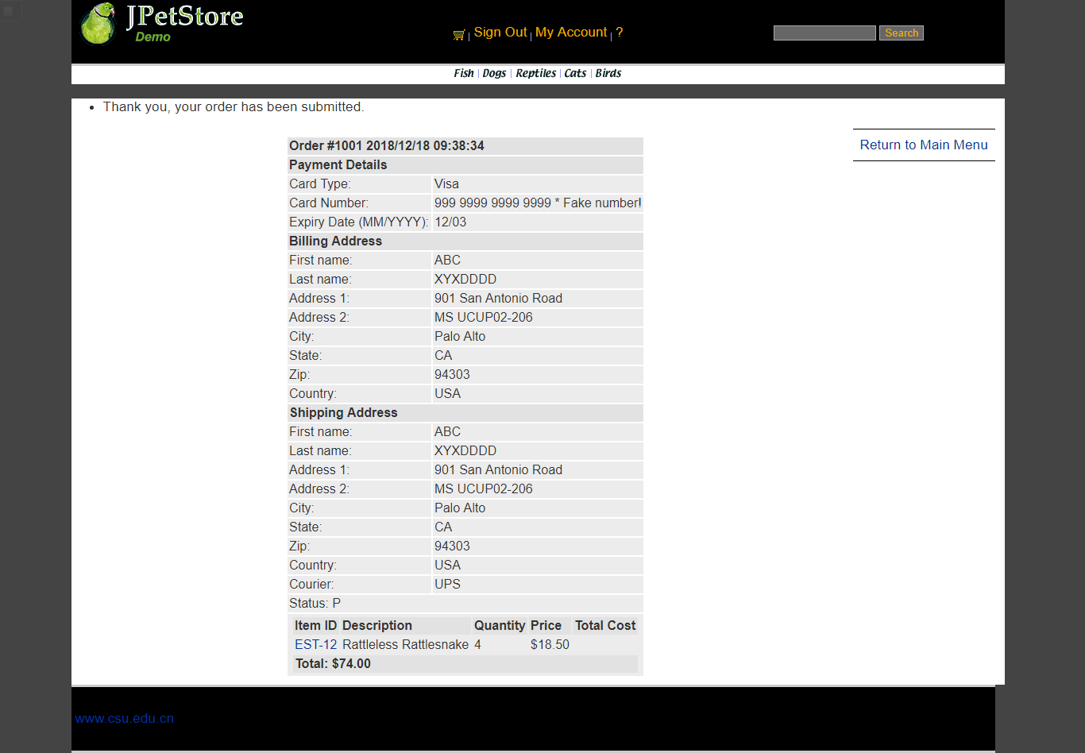

最终即可通过ViewOrderServlet生成最终的订单，包含地址信息、商品清单等信息。

ViewOrderServlet：
public class ViewOrderServlet extends HttpServlet {
private static final String VIEWORDER = "/WEB-INF/jsp/order/ViewOrder.jsp";
private static final String ERROR = "/WEB-INF/jsp/common/Error.jsp";
private Order order;
private OrderService orderService;
private Cart cart;
protected void doPost(HttpServletRequest request, HttpServletResponse response) throws ServletException, IOException {
doGet(request, response);
}
protected void doGet(HttpServletRequest request, HttpServletResponse response) throws ServletException, IOException {
HttpSession session = request.getSession();
order = (Order) session.getAttribute("order");
cart = (Cart) session.getAttribute("cart");
if (order != null) {
orderService = new OrderService();
orderService.insertOrder(order);
session.setAttribute("order", order);
//清空购物车
cart = null;
session.setAttribute("cart", cart);
session.setAttribute("message", "Thank you, your order has been submitted.");
request.getRequestDispatcher(VIEWORDER).forward(request, response);
} else {
session.setAttribute("message", "An error occurred processing your order (order was null).");
request.getRequestDispatcher(ERROR).forward(request, response);
}
}
}

- 实验内容——扩展任务。
- 添加验证码功能：在用户注册和用户登录模块中添加验证码功能。
- 购物车功能：原项目中购物车为内存购物车，即将用户相关的购物车存储在session中；在数据库中添加购物车表，将购物车数据持久化，以便用户下次登录时可查看或修改自己的购物车数据。
- 日志功能：数据库中添加日志信息表，给项目添加日志功能，用户登录后记录用户行为，比如浏览了哪些商品、将商品添加进购物车、生成订单等。
//以上两个扩展任务，除用界面截图和核心代码展示功能完成情况外，验证码功能还需说明验证码的基本原理和实现方案，日志功能需描述项目所完成的功能情况（能记录哪些日志、怎么记录等）。
- 日志功能：数据库中添加日志信息表，给项目添加日志功能，用户登录后记录用户行为，比如浏览了哪些商品、将商品添加进购物车、生成订单等。
3.1截图展示
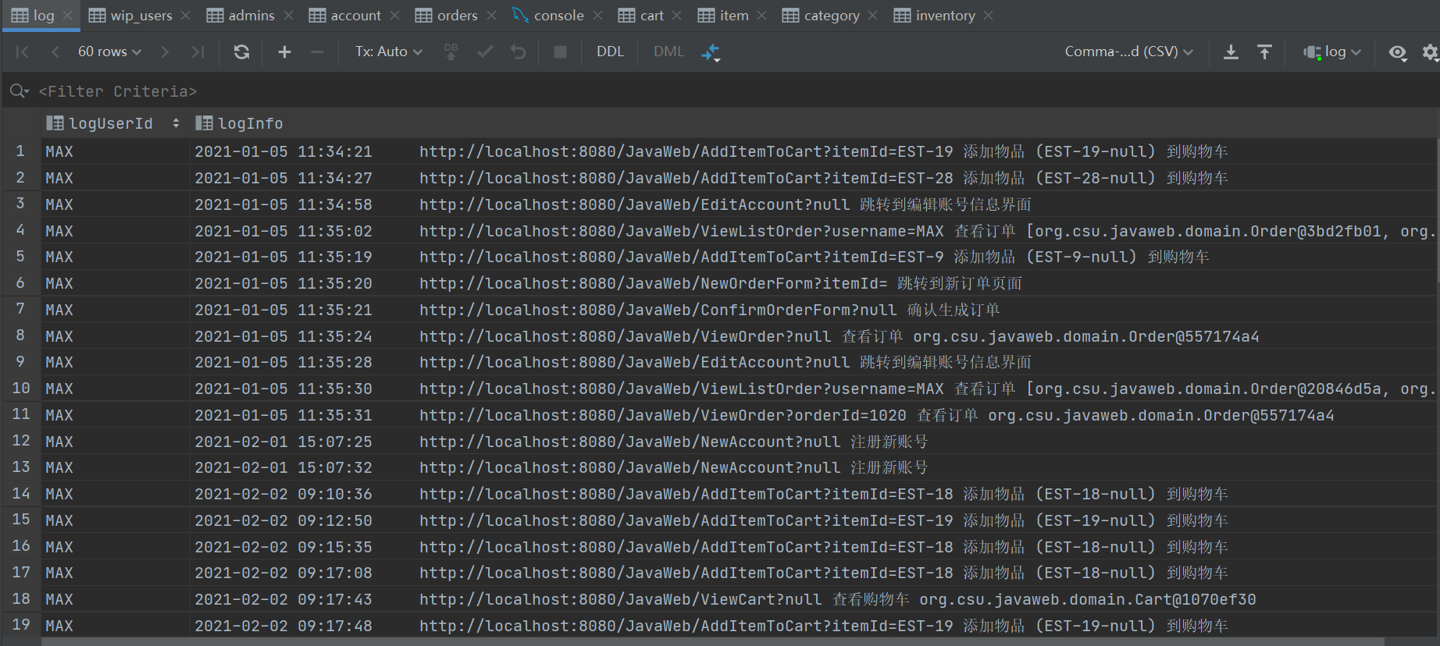

3.2记录内容
用户账号、跳转时间、当前操作页面的网址、具体操作页面的名字、操作的商品信息、设计者自定义的具体操作说明。

3.3记录实现方法
利用Log.java和HTTPServletRequest的各种方法获取当前页面跳转时的用户账号、跳转时间、当前操作页面的网址、具体操作页面的名字、操作的商品信息，再加上自定义的具体操作说明，传输给LogService的相关方法即可将其插入到数据库中记录下来。
在每次页面跳转之前先获取当前对话中用户是否已登录，如果账号不为空，那么进行获取日志记录操作，并插入到数据库中，之后正常跳转。
如果用户未登录则不记录该操作。

3.4核心代码
Log.java:
public class Log {
public final static int OUT_CONSOLE=1;
public final static int OUT_FILE=2;
public final static int OUT_BOTH=3;
public final static int DEBUG_LEVEL=0;
public final static int LOG_LEVEL=3;
public final static int INFO_LEVEL=6;
public final static int WARN_LEVEL=9;
public final static int ERROR_LEVEL=12;
public final static int FATAL_LEVEL=15;
protected static int level=DEBUG_LEVEL;// 输出的级别开关，高于指定级别的输出
protected static int out=OUT_CONSOLE; //输出模式，输出到控制台，文件或者都输出
public static String logdir="log"; // 保存日志文件的目录
protected static BufferedWriter bw =null;
protected static String currentDate = "";
protected static Date data=null;
protected static StringBuilder bb=new StringBuilder();
protected static String marsk=" [ERROE] ";
/**
* 日志函数，不受 level 限制，始终打印，最高级别
* @param s
*/
synchronized public static String log(Object ...s) {
bb.delete(0, bb.length());
bb.append(time());
bb.append(marsk);
// 获取调用的位置
//StackTraceElement[] stack = new Exception().getStackTrace();
//bb.append(stack[2].getClassName().replaceAll("\\$\n.$", ""));
bb.append(" ");
/*
bb.append("::");
bb.append(stack[2].getMethodName());
bb.append("()第[");
bb.append(stack[2].getLineNumber());
bb.append("]行： ");
*/
for(Object str : s) {
bb.append(str);
bb.append(" ");
}
//out(bb.toString());
return bb.toString();
}
public static String logInfomation(Object ...s){
marsk = " ";
return log(s);
}
/*
public static void debug(Object ...s) {
if(level<=DEBUG_LEVEL) {
marsk=" [DEBUG] ";
log(s);
}
}
public static void info(Object ...s) {
if(level<=INFO_LEVEL){
marsk=" [INFO ] ";
log(s);
}
}
public static void warn(Object ...s) {
if(level<=WARN_LEVEL){
marsk=" [WARN ] ";
log(s);
}
}
public static void error(Object ...s) {
if(level<=ERROR_LEVEL){
marsk=" [ERROR] ";
log(s);
}
}
public static void fatal(Object ...s) {
if(level<=FATAL_LEVEL){
//marsk=" [FATAL] ";
marsk = " ";
log(s);
}
}
protected static void out(String s) {
if(out==OUT_BOTH) {
System.out.println(s);
tofile(s);
}else if(out==OUT_FILE) {
tofile(s);
}else if(out==OUT_CONSOLE) {
System.out.println(s);
}
}
protected static void tofile(String s) {
getWriter();
try {
bw.newLine();
bw.write(s);
bw.flush();
}catch(Exception e) {
}
}
*/
protected static BufferedWriter getWriter() {
if(currentDate.equals(new SimpleDateFormat("dd").format(data))) {
return bw;
}
File fi=new File(logdir
+File.separator+new SimpleDateFormat("yyyy年").format(data)
+File.separator+new SimpleDateFormat("MM月").format(data)
+File.separator+new SimpleDateFormat("dd").format(data)+"日.log");
try {
if(!fi.exists()) {
if(!fi.getParentFile().exists())
fi.getParentFile().mkdirs();
fi.createNewFile();
}
FileOutputStream fiou = new FileOutputStream(fi,true);
OutputStreamWriter opw = new OutputStreamWriter(fiou, "UTF-8");
bw= new BufferedWriter(opw);
}catch(Exception e) {
}
return bw;
}
protected static String time() {
data = new Date();
return new SimpleDateFormat("yyyy-MM-dd HH:mm:ss").format(data);
}
/**
* 初始化
* @param out_put_level 日志输出等级,只输出较高等级的 debug < info < warn < error < fatal
* @param out2where 输出到哪里 OUT_CONSOLE仅仅控制台输出,OUT_FILE仅仅输出到文件,OUT_BOTH均输出
* @param log_dir 日志保存到哪里
*/
public static void init(int out_put_level,int out2where,String log_dir) {
level = out_put_level;
out = out2where;
logdir = log_dir;
}
public static void main(String[] args) {
//Log.debug("这是一个错误","可变长参数","无需拼接字符串");
}
}

LogService:
public class LogService {
Log log;
private LogDAO logDAO;
public LogService(){
log = new Log();
logDAO = new LogDAOImpl();
}
public String logInfo(Object ...s){
return log.logInfomation(s);
}
public void insertLogInfo(String username, String logInfo){
logDAO.insertLog(username, logInfo);
}
}

每个Servlet中页面跳转之前添加如下代码：
HttpSession session = request.getSession();
Account account = (Account)session.getAttribute("account");
if(account != null){
HttpServletRequest httpRequest= request;
String strBackUrl = "http://" + request.getServerName() + ":" + request.getServerPort()
+ httpRequest.getContextPath() + httpRequest.getServletPath() + "?" + (httpRequest.getQueryString());
LogService logService = new LogService();
//最后加入的信息“XXXXX”应当为该界面的信息以及一些商品信息
String logInfo = logService.logInfo(" ") + strBackUrl + " XXXXX";
logService.insertLogInfo(account.getUsername(), logInfo);
}

- 小组成员分工及实验总结
- 小组分工：

李东烜为组长,组员为高楠.在项目一开始的进程中,两位成员各自开展项目进度,到后来开始合并两个人的项目,并且由李东烜来完成拓展的日志模块的功能.
- 实验总结

实验一的主要过程都是跟着老师的视频来做,基本上在前面的servlet和jsp没有什么问题出现,在做拓展内容的时候遇到了几个问题,第一就是对于购物车的

实验二 使用AJAX和jQuery改善用户体验
- 实验内容——基本任务。
- 账号管理模块。在新建账号和修改账号信息页面上用AJAX技术进行表单验证，如“判断用户名是否已存在”等功能。
- 查询商品模块。在主页面右上角的查询商品功能中添加自动补全功能。
- 购物车模块。在购物车模块中修改购买数量时，通过AJAX修改购物车信息。
  - 用户名验证

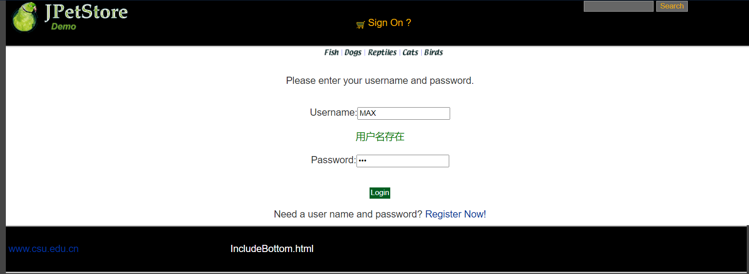
首先在jsp页面中使用传统的HTML绑定方法使得其能够运行js事务即检测用户名是否已存在，接下来在js代码中通过XML异步通信技术，将该用户名传到servlet中调用业务逻辑功能访问数据库判断该有户名是否已存在，从servlet中返回一个用户区别用户名是否已存在的变量到js中，再到js中根据该变量的值进行相应的输出，即该用户已存在或者可用。
核心源代码：
jsp：
<input type="text" name="username" id="username" onblur="usernameIsExist();"/>
<div id="usernameMsg"></div>
<script type="text/javascript" src="${pageContext.request.contextPath }/js/register.js"></script>

js：
function createXMLHttpRequest(){
…………
}
function usernameIsExist() {
var username = document.getElementById('username').value;
sendRequest("usernameIsExistServlet?username=" + username);
}
function sendRequest(url) {
…………
}
function processResponse() {
if (xmlHttpRequest.readyState == 4) {
if (xmlHttpRequest.status == 200) {
var responseInfo = xmlHttpRequest.responseXML.getElementsByTagName("msg")[0].firstChild.data;
var div1 = document.getElementById('usernameMsg');
if (responseInfo == "Exist") {
div1.innerHTML = "<font color='red'>用户名已存在</font>";
} else {
div1.innerHTML = "<font color='green'>用户名可用</font>";
}
}
}
}

servlet：
tring username = request.getParameter("username");
Account account = new Account();
account.setUsername(username);
AccountService accountService = new AccountService();
response.setContentType("text/xml");
PrintWriter out = response.getWriter();
if(accountService.getAccount(account.getUsername()) != null){
out.println("<msg>Exist</msg>");
}else {
out.println("<msg>NotExist</msg>");
}
out.flush();
out.close();
  - 查询商品模块。在主页面右上角的查询商品功能中添加自动补全功能。

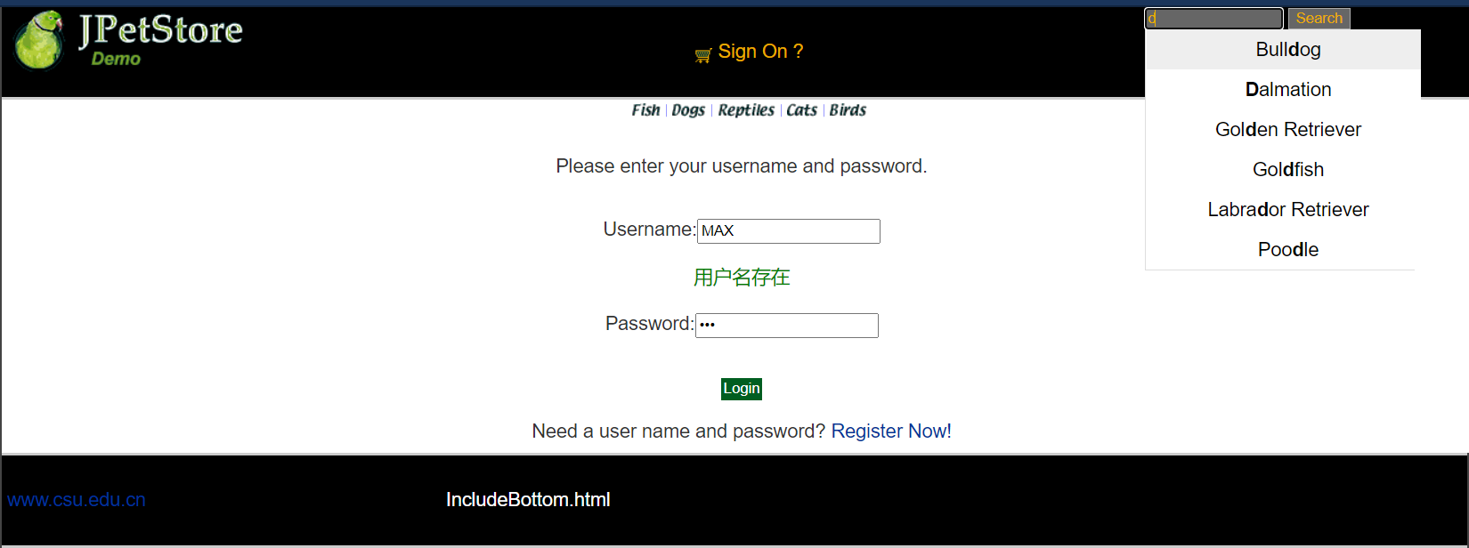
查询商品的自动补全功能基本设计流程是一样，本功能的难点在于js中对搜索到的结果的样式和事务处理。
首先在jsp中引入该js文件，接下来js中首先进行获取搜索关键字，然后通过servlet层获取所有的结果，并将结果以字符串的形式返回到js中，最后，js则将结果转化为数组形式然后通过相对应的样式显示在搜索框下方。
js中还需要处理的是对于搜索到的结果进行样式匹配加以区分，当加入关键字或者删除关键字时，搜索到的结果要及时进行变更，搜索栏得到结果中包含的关键字需要进行加粗的样式处理从而能够区分开。

核心源代码：
css：
div.wrap{
width: 240px;
margin: 20px auto 0 auto;
}
.auto-inp{
width: 240px;
height: 36px;
padding-left: .5em;
border-radius: 2px;
border: 1px solid #dedede;
color: #666;
outline: none;
}
.auto{
width: 240px;
border: 1px solid #dedede;
border-top: none;
position: absolute;
}
.auto_out{
width: 238px;
height: 36px;
line-height: 36px;
padding-left: .5em;
color: #000;
background: #fff;
overflow: hidden;
white-space: nowrap;
-o-text-overflow: ellipsis;
text-overflow: ellipsis;
}
.auto_out.on{
background: #eee;
cursor: pointer;
}
.hidden{
display: none;
}

js：
Array.prototype.unique = function(){
this.sort();
var res = [];
var json = {};
for (var i = 0; i < this.length; i++) {
if(!json[this[i]]){
res.push(this[i]);
json[this[i]] = 1;
}
}
return res;
}
// 对样式操作
var setClass = {
hasClass: function(elements,cName){ // 判断是否含有某个class
if(elements.className.match(new RegExp( "(\\s|^)" + cName + "(\\s|$)") ))
return true;
else
return false;
},
addClass: function(elements,cName){ // 添加class
if( !this.hasClass( elements,cName ) ){
elements.className += " " + cName;
};
},
removeClass: function(elements,cName){ // 移除某个class
if( this.hasClass( elements,cName ) ){
elements.className = elements.className.replace( new RegExp( "(\\s|^)" + cName + "(\\s|$)" )," " );
}
}
}
var Bind = function(This){
return function(){
This.init();
}
}
function AutoComplete(keyword,auto,arr) {
this.obj = document.getElementById(keyword);
this.autoObj = document.getElementById(auto);
this.search_value = ""; //当前的搜索输入值
this.index = -1; //当前选中的DIV的索引
this.value_arr = arr; //数据库中供检索的值 不包含重复值
}
AutoComplete.prototype = {
// 初始化
init: function(){
var This = this;
setClass.removeClass(This.autoObj,"hidden");
this.autoObj.style.left = this.obj.offsetLeft + "px";
this.autoObj.style.top = this.obj.offsetTop + this.obj.offsetHeight + "px";
},
//删除自动完成需要的所有DIV
deleteDIV: function(){
while(this.autoObj.hasChildNodes()){
this.autoObj.removeChild(this.autoObj.firstChild);
}
setClass.addClass(this.autoObj,"hidden");
},
autoOnmouseover: function(index){
if(index != this.index){
setClass.addClass(this.autoObj.children[index],"on");
setClass.removeClass(this.autoObj.children[this.index],"on");
this.index = index;
}
},
setValue: function(This){
return function(){
This.obj.value = this.seq;
setClass.addClass(This.autoObj,"hidden");
}
},
// 响应键盘
pressKey: function(event){
var code = event.keyCode;
var length = this.autoObj.children.length;
if(code == 38){ //↑
setClass.removeClass(this.autoObj.children[this.index],"on");
this.index--;
if(this.index < 0){
this.index = length - 1;
}
setClass.addClass(this.autoObj.children[this.index],"on");
this.obj.value = this.autoObj.children[this.index].seq;
}else if(code == 40){ //↓
setClass.removeClass(this.autoObj.children[this.index],"on");
this.index++;
if(this.index > length-1){
this.index = 0;
}
setClass.addClass(this.autoObj.children[this.index],"on");
this.obj.value = this.autoObj.children[this.index].seq;
}else{ //回车
this.obj.value = this.autoObj.children[this.index].seq;
setClass.addClass(this.autoObj,"hidden");
this.index = -1;
}
},
// 程序入口
start: function(event){
event = event || window.event;
var code = event.keyCode;
var This = this;
if(code != 13 && code != 38 && code != 40){
this.init();
this.deleteDIV();
this.search_value = this.obj.value;
var valueArr = this.value_arr.unique();
//去掉前后空格不能为空
if(this.obj.value.replace(/(^\s*)|(\s*$)/g,"") == ""){ return;}
//判断数组中是否含有输入的关键字
try{
var reg = new RegExp("("+ this.obj.value +")","i"); //输入"aaa" 则 reg = /(aaa)/i
}catch(e){
alert(e.message);
}
var div_index = 0; //记录匹配索引个数
for (var i = 0; i < valueArr.length; i++) {
if(reg.test(valueArr[i])){
var div = document.createElement("div");
div.className = "auto_out";
div.seq = valueArr[i];
div.index = div_index;
div.innerHTML = valueArr[i].replace(reg,"<strong>$1</strong>");
this.autoObj.appendChild(div);
setClass.removeClass(this.autoObj,"hidden");
div_index++;
if(div_index == 1) {
setClass.addClass(this.autoObj.firstChild,"on");
this.index = 0;
}
div.onmouseover = function(){
This.autoOnmouseover(this.index);
}
div.onclick = this.setValue(This);
}
}
}else{
this.pressKey(event);
}
window.onresize = Bind(This);
}
}
var xmlHttpRequest;
function createXMLHttpRequest(){
……
}
var keyword = document.getElementById('keyword').value;
sendRequest("findResultServlet?keyword=" + keyword);
function sendRequest(url) {
……
}
function processResponse() {
if (xmlHttpRequest.readyState == 4) {
if (xmlHttpRequest.status == 200) {
var resp = xmlHttpRequest.responseText;
var array = resp.split(",");
var autoComplete = new AutoComplete("keyword","auto",array);
document.getElementById("keyword").onkeyup = function(event){
autoComplete.start(event);
}
}
}
}

servlet：
//获取搜索框输入的内容
String keyword = request.getParameter("keyword");
//向server层调用相应的业务
CatalogService service = new CatalogService();
List<Product> productList = service.searchProductList(keyword);
response.setContentType("text/xml");
PrintWriter out = response.getWriter();
//返回结果
String res = "";
for(int i=0; i<productList.size(); i++){
if(i>0){
res += "," + productList.get(i);
}else{
res += productList.get(i);
}
}
out.write(res);
out.flush();
out.close();

  - 在购物车模块中修改购买数量时，通过AJAX修改购物车信息，而不再要求用点击更新按钮才能更新商品信息。

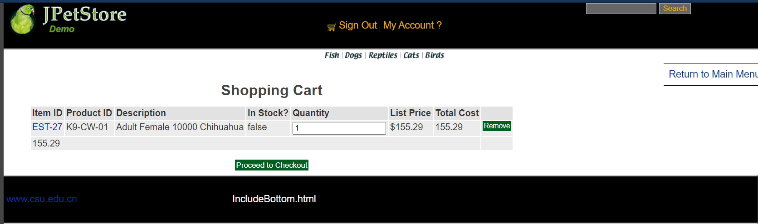

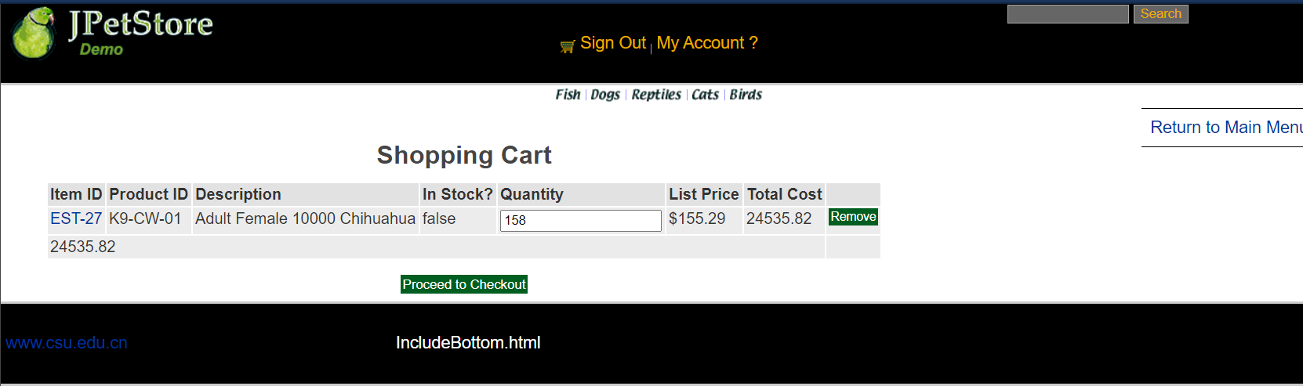
购物车修改数量功能改善前是需要用户点击更新按钮，商品相关信息才会更新。通过AJAX功能改善后用户在数量框输入相应数量后，鼠标离开输入框，商品相对应的数量、总价等信息即会发生改变。
首先，在jsp页面中设置对应的id用户获取js操作的节点，通过HTML绑定调用js中的功能，接下来，在js页面中回去更改商品的数量值，调用servlet更改相对应的信息并将更改后的信息通过字符串传输回来，再在js中对字符串进行处理并显示到jsp页面上。

核心源代码：
jsp：
<input type="text" id="quantity" onblur="updateCart();" name="${cartItem.item.itemId}" value="${cartItem.quantity}">
<script type="text/javascript" src="${pageContext.request.contextPath }/js/updateCart.js"></script>

js：
function createXMLHttpRequest(){
……
}
function updateCart() {
var quantity = document.getElementById("quantity").value;
sendRequest("updateCartJSServlet?quantity="+ quantity);
}
function sendRequest(url) {
……
}
function processResponse() {
if (xmlHttpRequest.readyState == 4) {
if (xmlHttpRequest.status == 200) {
var resp = xmlHttpRequest.responseText;
var array = resp.split(",");
var quantity = document.getElementById("quantity");
var total = document.getElementById("total");
var subtotal = document.getElementById("subtotal");
quantity.innerText = array[0];
total.innerText = array[1];
subtotal.innerText = array[2];
}
}
}

servlet：
//从对话中，获取购物车
HttpSession session = request.getSession();
cart = (Cart)session.getAttribute("cart");
Iterator<CartItem> cartItemIterator = cart.getAllCartItems();
while (cartItemIterator.hasNext()) {
//产品数量增加
CartItem cartItem = (CartItem) cartItemIterator.next();
String itemId = cartItem.getItem().getItemId();
try {
int quantity = Integer.parseInt((String) request.getParameter("quantity"));
cart.setQuantityByItemId(itemId, quantity);
if (quantity < 1) {
cartItemIterator.remove();
}
} catch (Exception e) {
e.printStackTrace();
}
}
session.setAttribute("cart", cart);
Cart cart2 = (Cart)session.getAttribute("cart");
Iterator<CartItem> cartItemIterator2 = cart2.getAllCartItems();
String quantityAll = "";
while (cartItemIterator2.hasNext()) {
//产品数量增加
CartItem cartItem2 = cartItemIterator2.next();
int quantity2 = cartItem2.getQuantity();
quantityAll += quantity2 + "," + cartItem2.getTotal() + "," + cart2.getSubTotal();
}
response.setContentType("text/xml");
PrintWriter out = response.getWriter();
out.write(quantityAll);

- 实验内容——选做任务。
- 商品展示模块。在首页展示商品的图片上添加AJAX效果，即当鼠标移到某个商品图片上时，用悬浮窗展示该类型商品的信息。

无
- 订单模块。通过选项卡或模版内容实现订单多个信息部分的录入，不需要页面跳转，在一个页面完成订单所有内容的录入。

无
- 其他效果：可自行选择其他UI模版，或选择其他功能点进行用户体验的优化。
无
//以上为选做任务，没有完成填无
//完成了选做任务或其他特效的，除用界面截图和核心代码展示功能完成情况外，还需说明基本原理、实现方案和是否使用框架等。
- 小组成员分工及实验总结
- 小组分工：

项目有三个模块的工作,分别为账号验证,查询商品和购物车模块,组长李东烜完成了账号验证和购物车数量修改的功能,高楠完成了查询商品模块.因为查询商品不仅需要在js和jsp中对于相应的查询结果进行显示,更重要的是还要和css斗智斗勇.
- 实验总结

实验总结记录实验过程遇到的问题和解决的方法，以及心得体会，字数不少于500字。

实验中遇到了两个比较重要的问题:一个是在更改购物车模块的时候发现的id重复的问题,另一个是搜索模块中的css问题(主要表现为查询的结果不展示).

第一个问题相对来说容易解决一点,因为是一个很明显的逻辑错误,当购物车中有两件商品的时候,更改商品的数量会导致商品的总价为第一个商品的两倍总价.导致这个问题的原因是最开始在实验一里面使用的cart.jsp,在显示购物车中的商品的时候用了C:foreach这个标签,而在循环内容中,商品的div的id值重复了,导致了传到后端的值只有第一个商品的,所以解决方法是给id值后面加上当前循环的次数,然后在后端再用正则表达式分开.

第二个问题是搜索框的搜索结果不显示,问题出在css上面,虽然解决方法并不困难,但是问题主要在于当时没有发现哪里出了岔子,刚开始以为是数据没有传到后端,经过排查发现搜索到的数据的确传到前端了,但是不知道为什么写的css被屏蔽掉了(打开chorme的f12发现写的css属性没有使用,但是好在chorme直接就可以在浏览器里面改css,所以很快把这个问题解决了.

