docker –version

docker-compose –version

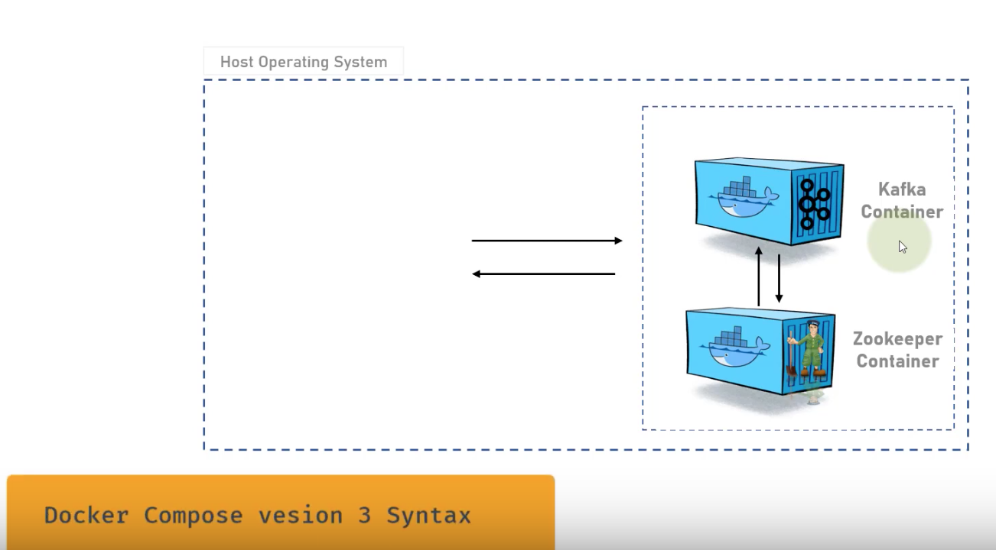

Create a installation folder name kafka-installation in desktop

cd kafka-installation

touch docker-compose.yml

in docker-compose we need to define **Zookeeper** and **Kafka** Containers.

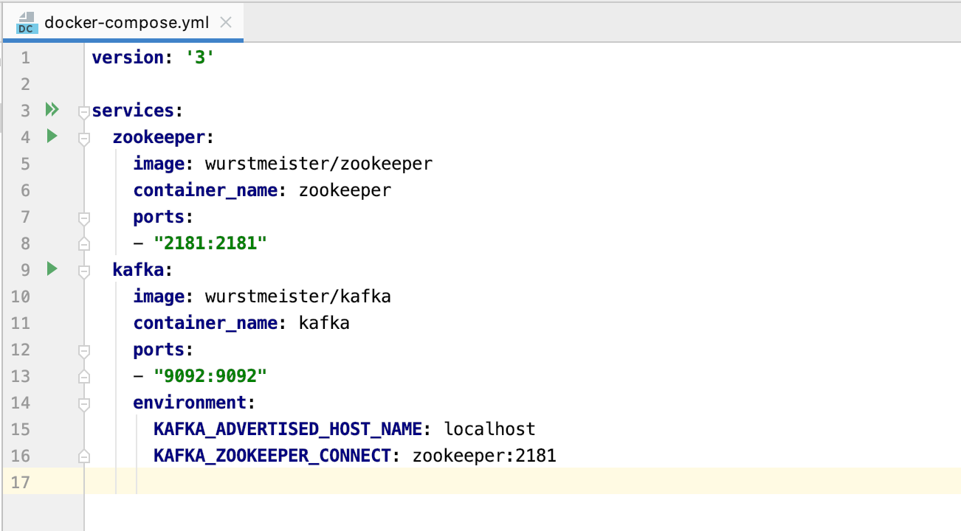

docker-compose -f docker-compose.yml up

or

docker-compose -f docker-compose.yml up -d //background mode

docker-compose down //stop all the services of compose file

Go inside docker container

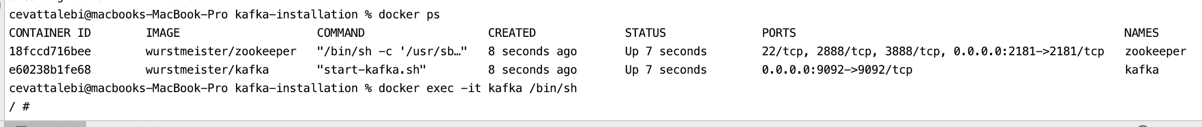

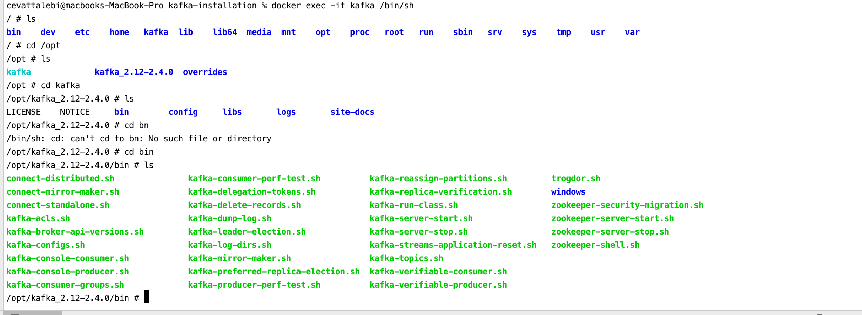

Kafka Topic creation/Listing

