Assessment # and title |  |  | C-WT-AT3-PROJ |  |  | Web Technologies – Final Project
Lecturer name |  |  | Amir Khan
Student name |  |  | Javad Tehrani
Student ID number |  |  | J215798
Telephone contact number |  |  | 64563301
Email |  |  | J215798@tafe.wa.edu.au
By completing and submitting this signed form to my lecturer, I am stating that:
- The attached submission is completely my own work
- I have correctly cited all sources of information used in this work (if required)
- I have kept a copy of this assessment (where practicable)
- I understand a copy of my assessment will be kept by the NMTAFE for their records
- I understand my assessment may be selected for use in the NMTAFE’s validation and audit process to ensure student assessment meets requirements
Student Signature |  | Student to fill this section out |  |  |  |  | Date | Student to fill this section out
Assessors please note: Where verbal clarification has been sought from a student to gather additional assessment evidence from an assessment item, question/s and response/s must be recorded, signed, and dated by the assessor, against the relevant assessment item/s.
NB: Feedback will be given via Blackboard when possible.
Assessment type (þ):
☐ | Questioning (Oral/Written) |  |  | ☐ | 3rd Party Report |  |  |  | ☒ | Practical Demonstration
☒ | Other – Project/Portfolio (please specify on the right):

Contents
Assessment Steps 9
Complete the Front Page 9
Setting Up for the Final Project 10
Setting up Version Control 11
Setting up Version Control 11
Initial Design Layout 12
Initial Design Layout 13
Convert the Wireframes to Figma 14
Convert the Wireframes to Figma 15
Determine your Site Colour Scheme 16
What are your selected colours? 18
Creating you Project Pages 19
Demonstrate to Assessor on GitHub Pages 20
Submission of Portfolio Work 21
Appendix A: Code Style Guidelines 22
Appendix B: Naming Conventions 23
HTML, CSS and JS Files and folders 23
File extensions 23
Appendix C: PROJECT Folder Structure 24
Appendix D: Useful Resources 25
Appendix E: SETTING UP TAILWIND 26
Appendix F: using .gitignore files 28

Assessment Due Date
This assessment is split into components that have several due dates.
This component of the Portfolio of Work is due:
- Week 18 at 17:30 (5.30PM) on day of scheduled lecture
These are also shown in the Learning and Assessment Plan.
Also, refer to Blackboard for most accurate dates, which may alter due to unforeseen circumstances.
We also will endeavour to update these document(s) at the same time.

Required Resources
The base requirements this assessment task, are listed below. They are listed as common (for both PC and Mac), and for the individual operating systems.

Common:
- Access to Office 365 & Microsoft Word
- WebStorm, PhpStorm
- Access to Figma.com for diagrams
- Access to TAFE Web Site Hosting (located on dev.ScreenCraft.net.au)
- WinSCP for deployment of site
- Git for version control, GitHub account for
- Web Browsers (Must have at least TWO different rendering engines)
  - Chromium based: Edge, Chrome,
  - Firefox
  - Opera
  - Safari
Use of some of these items may not be used in this part of the assessment task..
Instructions
Follow the steps listed in this assessment item.
Submission of the documentation, code, and associated items is at the end of each part of the portfolio.
Provide evidence in the form of scanned documentation, completed assessment documents, screenshots, screencasts and other formats as required in this assessment.

Site Structure Requirements
All files must apply the naming conventions outlined in Appendix B: Naming Conventions.
Code must apply suitable code style as advised in Appendix A: Code Style Guidelines.
The project has a defined structure outlined in the Appendix C: Project Folder Structure.
For content specifications begin by reviewing the Assessment/Development Process area
Code Storage
This assessment requires you to setup and use a private GitHub repository which is shared with your lecturer and contains you code and live site deployment.
Professional Code and Documentation Requirements
This document contains appendices that cover the professional requirements when creating files, code, project structures and more.
Important:
You are only allowed to use Vanilla JavaScript, Tailwind CSS and Font Awesome Free. Configuration and other details are given in this assessment.
This means that you may not employ frameworks such as Bootstrap, jQuery, Vue, React et al in your work.
Use of any LLM’s (AI) is this assessment is forbidden

Assessment Development Process
To complete this assessment, you will design and build a Portfolio site to display & showcase your current & future coding.
You will design several pages, and create the layout for the home page, with your code being version controlled as you progress.
- Initial project setup,
- Version control,
- Wireframe designs,
- Use of imagery,
- HTML, CSS & JavaScript
- Use of Tailwind
- Test HTML is displayed as expected using at least two different browsers with different web rendering engines.
- Compress and submit your work.
Important:
Your site must:
- be fully responsive
- contain all the required elements
- have a “mobile first” CSS design.
- in all Tailwind components have semantic HTML elements so <div> elements must be updated.

Assessment Steps
Complete the steps in the order given.
STEP | Task to perform
1 | Complete the Front Page
01 | Setting up Version Control  - Create a new Project and initialise version control using GIT.  - Create a file called: Project-ReadMe.md to explain what the project is about.  - Create the project file & folder structure in Appendix C  - Commit to version control, push to your git pages as needed.  - Create a .gitignore that ignores the node_modules and .idea folders (see instructions in appendix on how to do this in WebStorm)  You are now ready to continue with the portfolio.  Use a commit message based on the one below (note this is incomplete):  - “feat(project): Version Control setup”  Push the code to your private remote repository.
A01 | Setting up Version Control  Add screen shots of your Project-ReadMe & .gitignore files:  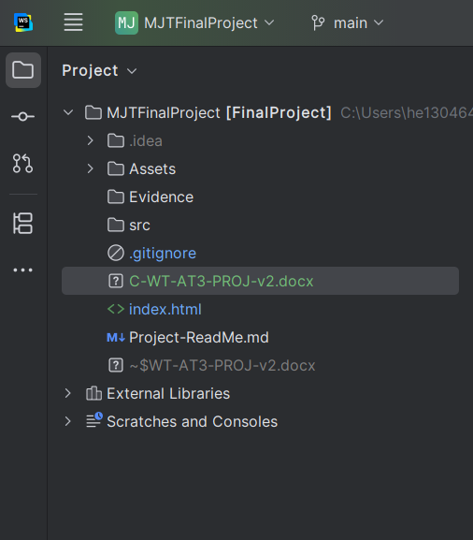
2 | Initial Design Layout  At this point you are required to sketch wireframes of each page of your final project onto Paper.  These sketches should outline all the major HTML sections for each of the 6 pages in the site structure.  For example, here are some sketched wireframes that have been created by lecturing staff for various purposes:  Page sections can be named, images, forms, buttons & other semantic HTML items must be indicated & be hand drawn wireframes.  Important: these wireframes must be viewed, approved & signed off by your lecturer.  Once completed add images of each wireframe drawings to this section of the assessment document & add them to your evidence folder.
  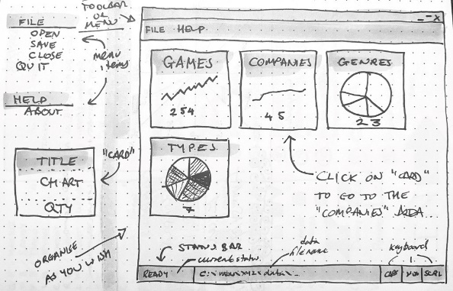 | 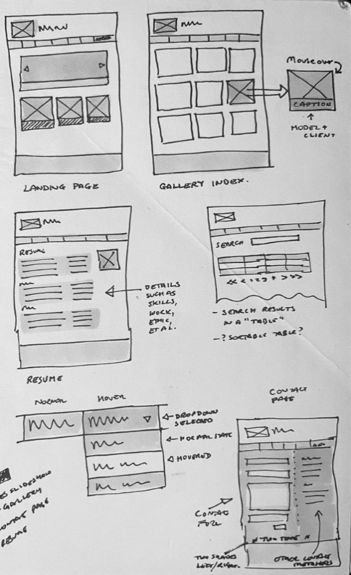
  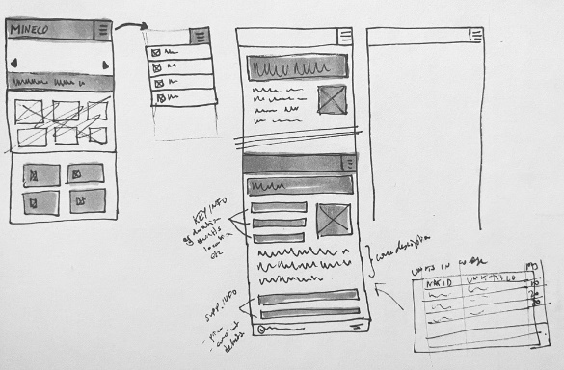
1 | Initial Design Layout  Add images of the approved wireframes for each page:  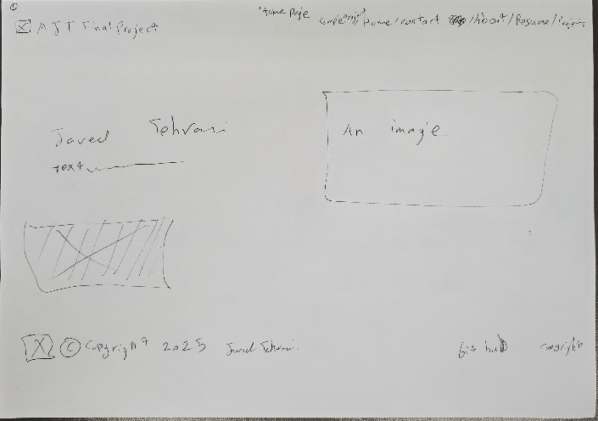  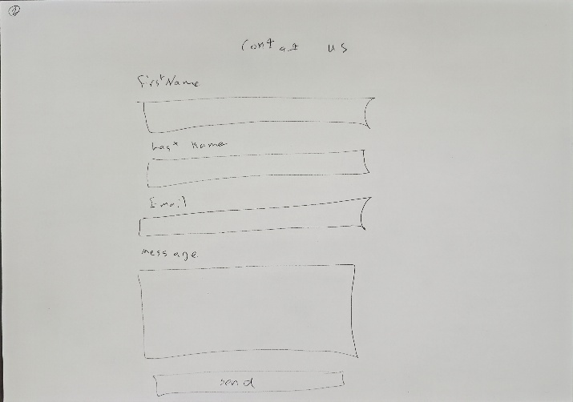  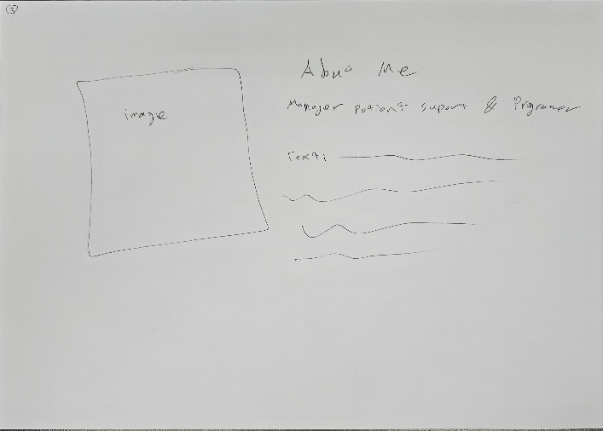  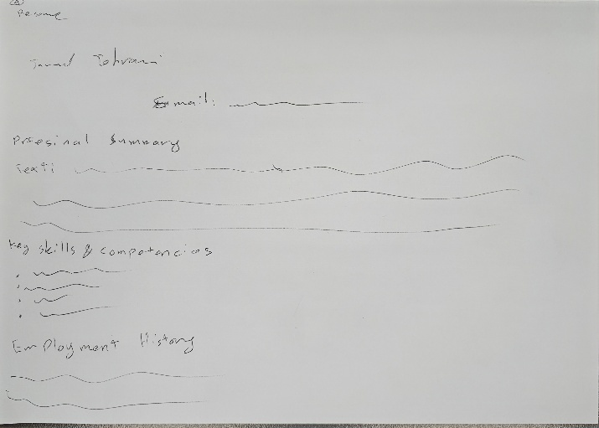  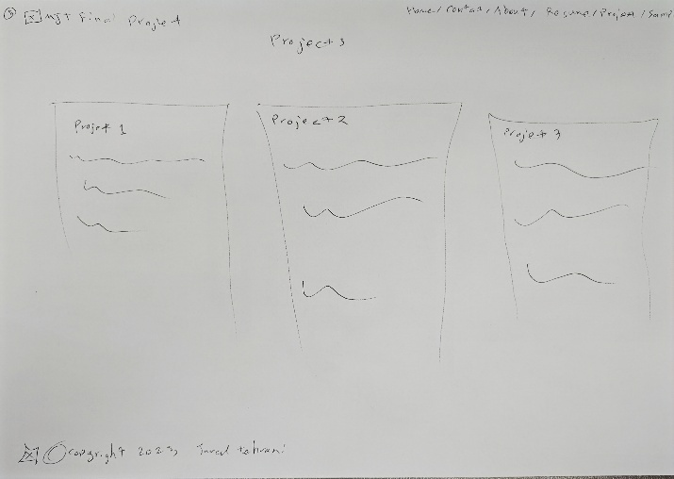
2 | Convert the Wireframes to Figma  Use Figma to create a GREY BLOCK version of each if the approved pages.  Here is an example:  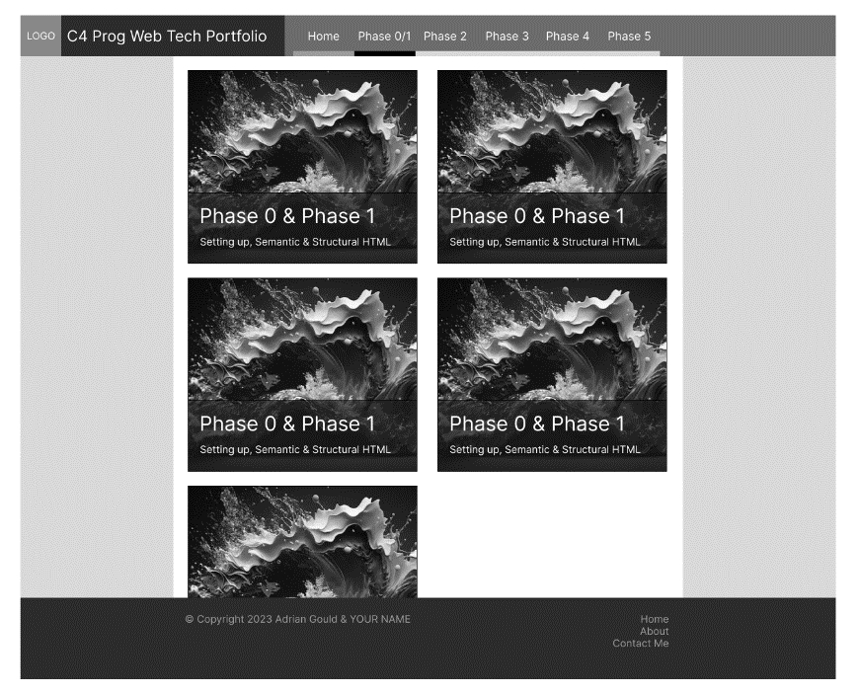  Export these pages as PNG and/or PDF and add these to your evidence folder.  Important: these Figma images must be included in your blackboard submission.
2 | Convert the Wireframes to Figma  Add images of the approved wireframes for each page  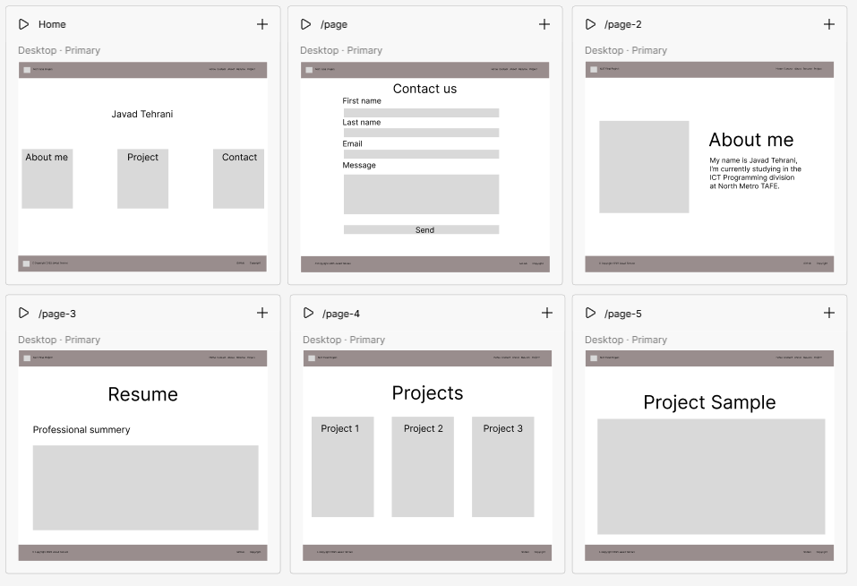
3 | Determine your Site Colour Scheme  You should determine up to FOUR colours besides Black and White for your site design.  The site https://components.dev.screencraft.net.au has the TailwindCSS colours plus many more that have been created and added to the list.  To obtain your base colours, you may use a web application such as the ones listed below to create tints and shades of the colours you have selected.  Colour, Tint & Shade Schemer Apps (all retrieved 28/8/23):  - https://coolors.co/  - https://uicolors.app/create  - https://www.tailwindshades.com/  - https://www.flatuicolorpicker.com/  - https://colorswall.com/  - https://www.colourlovers.com/  Edit the Project-ReadMe.md file and add the BASE colour details to a new section:  Colour Scheme  Create a table in the Project-ReadMe.md using the following basic pattern (Copy this text into your Project-ReadMe.md for a head-start).  | Name | RGB | HEX |  |----------|----------------|----------|  | black | 0, 0, 0 | #000000 |  | white | 255, 255, 255 | #FFFFFF |  | name 1 | rrr, ggg, bbb | #RRGGBB |  | name 2 | rrr, ggg, bbb | #RRGGBB |  | name 3 | rrr, ggg, bbb | #RRGGBB |  | name 4 | rrr, ggg, bbb | #RRGGBB |  The section should have a table that shows the name (as you are giving it, the RGB value and the HEX value).  Edit the rrr, ggg, bbb to show the decimal values and RRGGBB to show the HEX values.  Add the changed/added files to version control.  Add the colours to the table on the next page.  Use a commit message based on the one below (note this is incomplete):  - “feat: add colour scheme for site”  Push the code to your private remote repository.
3 | What are your selected colours?  Provide the RGB and HEX versions of the colours.  Tab between cells, and tab on last cell to add new row.  Use the fill tool to color final column.
  Name for Colour | RGB  (rrr, ggg, bbb) | HEX (#rrggbb) | Sample
  EXAMPLE COLOUR | 107,6,102 | #6B0666
  white | 255, 255, 255 | #ffffff
  black | 0, 0, 0 | #000000
  light page background | 249, 250, 251 | #F9FAFB
  card background | 243, 244, 246 | #F3F4F6
  primary text | 17, 24, 39 | #111827
  accent blue (links) | 96, 165, 250 | #60A5FA
4 | Creating your Project Pages  - Create the HTML, CSS and any required JS for the pages.  - Each page must be checked into version control during this process.  - Push pages to GitHub as required.  Use the following (semantic) commit message format when creating the page.  - “feat(page_name): commit message”  If fixing a bug later use  - “fix(page_name): name of bug being fixed”  Pages will be created in the following order:  - Home page  - Contact page  - About page  - Resumé page  - Projects page  - Sample project page(s)  During this process you may use the https://components.dev.screencraft.net.au website to provide help when laying out some of the components of your page.  Important: you must use the correct semantic structural elements when creating your pages.
5 | Page specifications  2 of the specified pages should contain the following:  Sample Project Page  Working example of the phase 4 Ninja API form  Contact Page  - Responsive contact form with name, email & message fields  - JavaScript Validation of the form using only vanilla jS and Regex patterns to match user input against a pattern for each field.  - Submission button which only submits once validation is complete  - JavaScript in a separate file (not contained in the HTML file  - For an example of layout and validation behaviour see the image below:  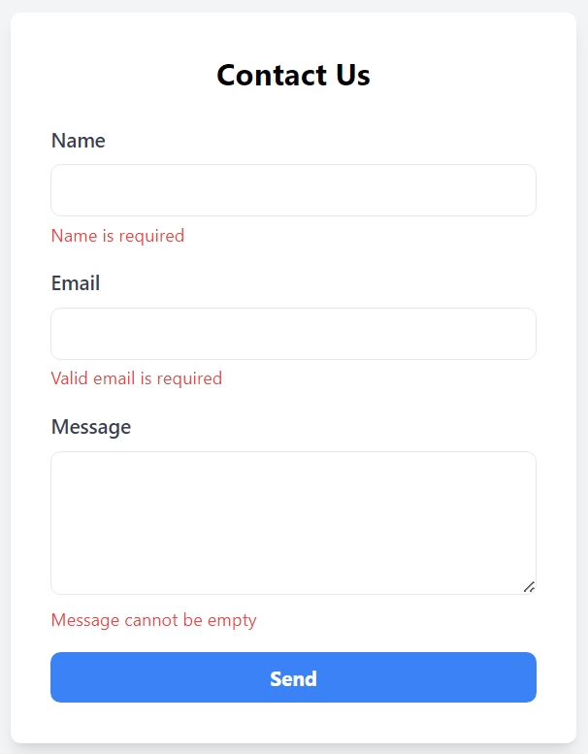
6 | Displaying your Project on GitHub Pages  The final stage is to publish your portfolio site on GitHub pages.  Use the resource below to update your GitHub repository settings.  https://docs.github.com/en/pages/getting-started-with-github-pages/creating-a-github-pages-site  Obtain the assessors feedback, update your work as required based on their feedback, ensuring all changes are notes as semantic commits using the “fix:…” tag at the start.
7 | Demonstrate to Assessor on GitHub Pages  What is the URL of your projects GitHub repository?  https://github.com/JavadTe/MJTFinalProject.git  What is the URL of your GitHub Pages site for the project?  https://javadte.github.io/MJTFinalProject/
12 | Validating the CSS  Use the WC3 Validation engine to verify your HTML & CSS. Use ES Lint to validate your JavaScript  Copy the evidence for validity into the evidence folder inside phase 4.
12 | Add 3 screenshots of you validating the HTML,CSS & JS code.  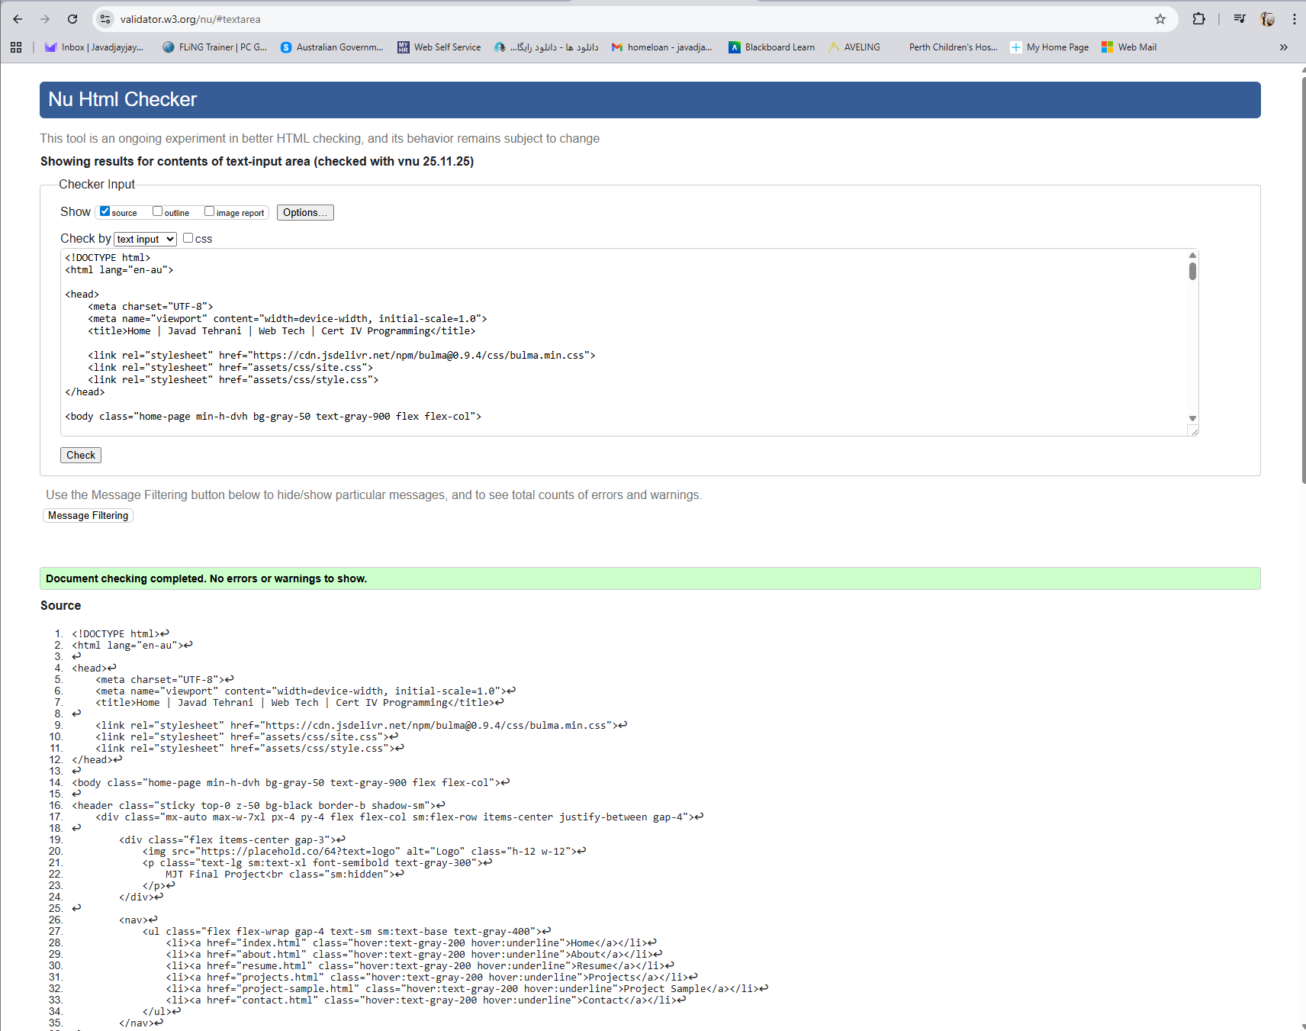  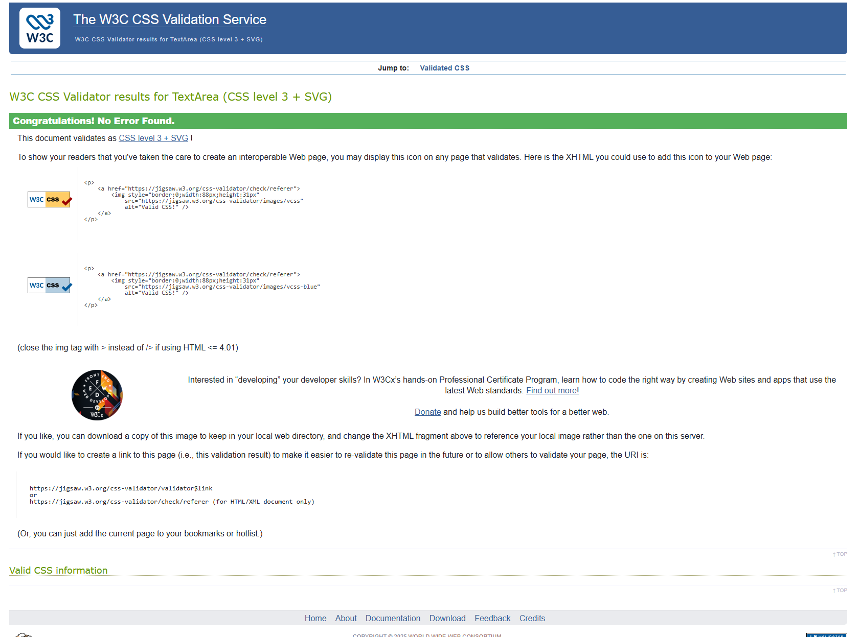  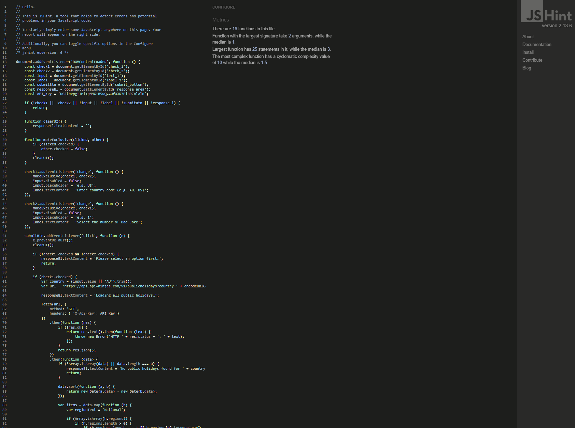
END | Submission of Portfolio Work  To submit the portfolio, do the following:  - Save this document with your answers.  - Compress the portfolio folder including all of your code  - Open Blackboard, locate and open the Phase 2 assessment  - Upload this completed assessment document.  - Upload the Word Document  Upload the compressed site files.

Appendix A: Code Style Guidelines
The following guidelines should be applied to your code as it is developed.
Many may be applied via the use of WebStorm, VS Code or similar plugins and code formatting.

HTML Code
Please refer to the Google Style guide:
- https://google.github.io/styleguide/htmlcssguide.html
Note that PhpStorm and WebStorm will format code to their own standard, which is acceptable.

JavaScript
Refer to the Google JS Style guide:
- https://google.github.io/styleguide/jsguide.html
Note that PhpStorm and WebStorm will format code to their own standard, which is acceptable.

JSON Code
JSON should be formatted in an appropriate manner.

Readability Counts
- Zen of Python

Appendix B: Naming Conventions

HTML, CSS and JS Files and folders
- No spaces.
- Alpha-numeric characters only except minus/hyphen (-) and full stop (.).
- All lowercase letters.
- Use hyphens (dash) between words.

File extensions
The following file extensions must be used:
HTML pages | .html
JS | .js
CSS | .css
PHP | .php
Node | .js
React | .jsx
Python | .py
JSON | .json
XML | .xml

Appendix C: PROJECT Folder Structure
The diagram below outlines a folder structure for the final project

Appendix D: Useful Resources
The following links may be of use when developing this stage of the portfolio.
- https://components.dev.screencraft.net.au
- https://tw-elements.com/
- https://www.hyperui.dev/
- https://merakiui.com/
- https://wickedblocks.dev/
Also check https://diigo.com/user/Ady_Gould and search for TailwindCSS.
We STRONGLY recommend that you DO NOT mix and match component libraries.
We STRONGLY recommend that you modify the source code provided by any resource to be semantically well structured. For example, replace a div that is being used for a navigation with the appropriate semantic element.

Appendix E: SETTING UP TAILWIND
Once the terminal is open, and you are in the correct folder, verify that the following are available on your system by using the following commands:
NodeJS: node --version
NPM: npm --version
NPX: npx –version
Any version of NodeJS after 16 is suitable, and any version of NPM/NPX after 8 should also be suitable.
If an error occurs it means that Node and NPM are not installed. You will need to rectify this before continuing.

Node is Ready…
Given that Node is available, and NPM/NPX are also working, we now start the TailwindCSS installation and “development” process.
Enter the following commands:
Install Tailwind: npm install -D tailwindcss
Initialise Tailwind: npx tailwindcss init
In your editor search for and edit the tailwind.config.js file which will be in the root of the project.
Make sure that the lines in this file now read:
/** @type {import('tailwindcss').Config} */
module.exports = {
content: [
'./*.html',
],
theme: {
extend: {},
},
plugins: [],
};
This configuration scans all .html files in the root of the project for any HTML files that contain any Tailwind Classes in the code.

Create an Input CSS file
Next create a folder called src in the root by using the command:
mkdir src
Then, in your editor create a new CSS file in this src folder and call it “input.css”. Case will be important in following commands.
Now execute the following command (this is a SINGLE LINE):
npx tailwindcss
-i ./src/input.css
-o ./assets/css/site.css
--watch
The command is on a single line, but to make it easier to read it is shown split over multiple lines.
Choosing Tailwind Components
Samples components are provided for you at the link below:
https://components.dev.screencraft.net.au
It is advised that you have a look at the page source code and the JS console to see how the page is structured and if errors occur in the provided content.

Appendix F: using .gitignore files
You can find further information on how set up and use the .gitignore file for your operating system or IDE here:
- https://docs.github.com/en/get-started/getting-started-with-git/ignoring-files
- https://github.com/github/gitignore
- https://www.toptal.com/developers/gitignore

