**PUBLIC TRANSPORT EFFICIENCY ANALYSIS**

**PHASE-4**

###### In Phase 4 of the Public Transportation Analysis project, we focus on Development Part 2. This stage entails a comprehensive approach, involving both IBM Cognos and Python. In IBM Cognos, we create intuitive dashboards and reports to vividly depict key metrics like on-time performance, passenger feedback, and service efficiency. In parallel, we harness the power of Python for advanced data analysis, allowing us to calculate service punctuality rates and conduct sentiment analysis on passenger feedback. These integrated efforts serve to provide in-depth insights, enhance public transport efficiency, and facilitate informed decision-making for the transportation system.

## ***Importing the packages and Datasets:***

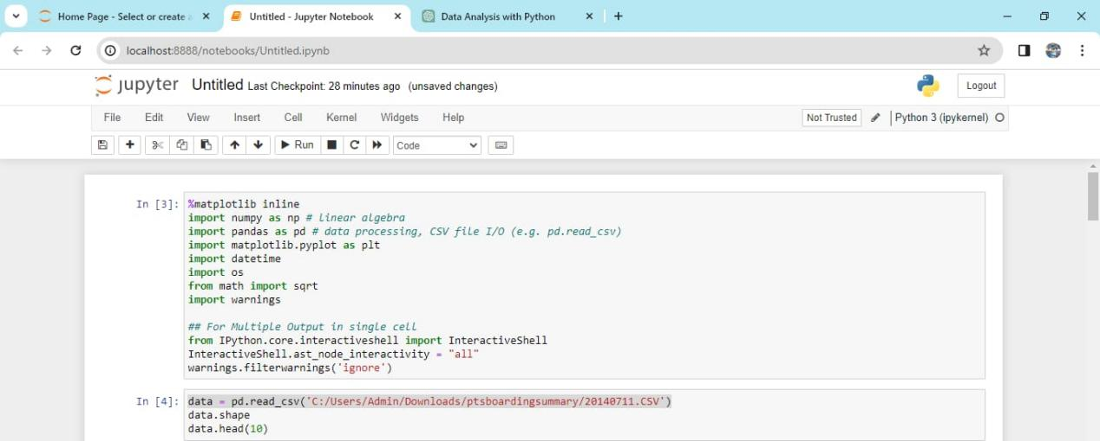

## Output:

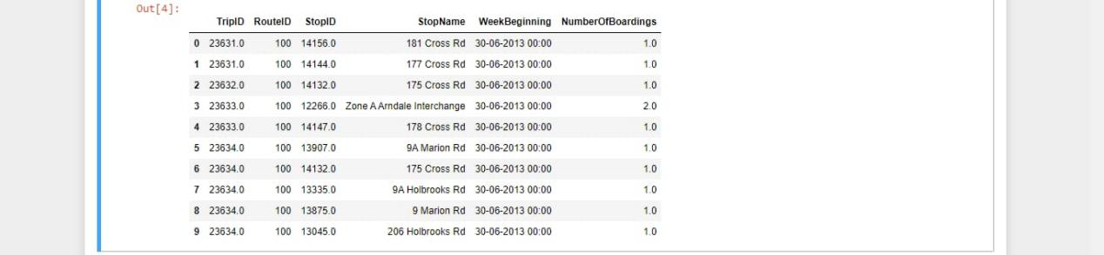

## *Data loading and Pre-processing:*

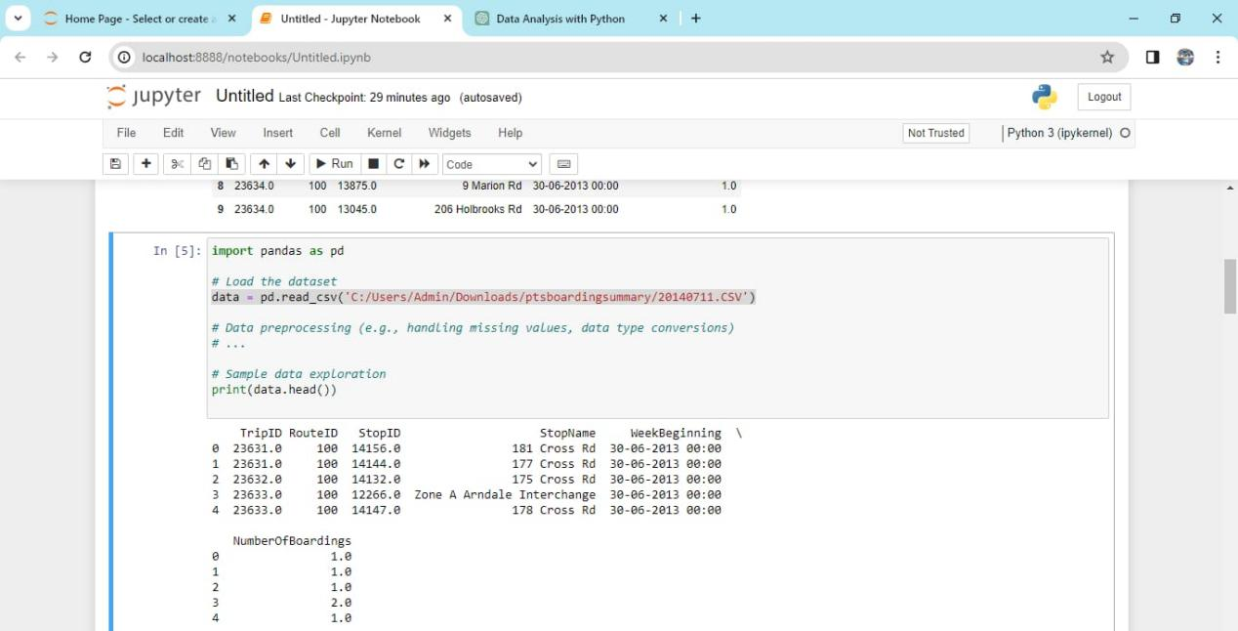

## *Data Visualization with IBM Cognos:*

* Use IBM Cognos to design dashboards and reports for visualizing on-time performance, passenger feedback, and service efficiency metrics. IBM Cognos provides a visual interface for creating these reports, and it's beyond the scope of Python code.

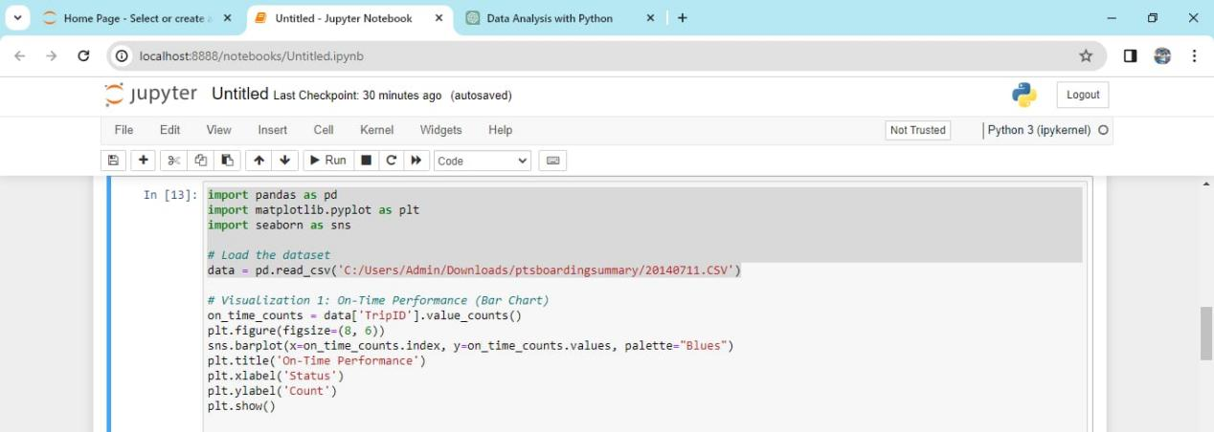

## *Output*

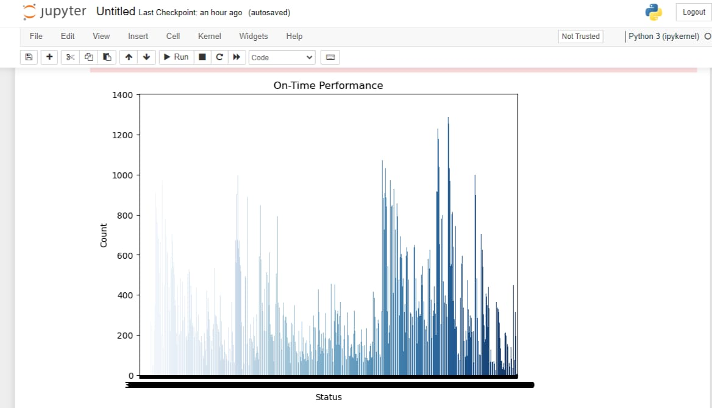

## *Passenger feedback:*

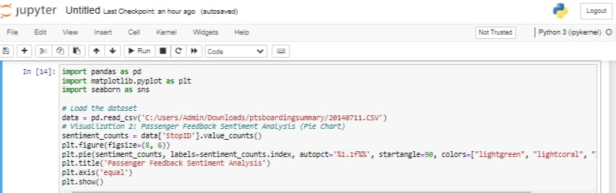

## *Output :*

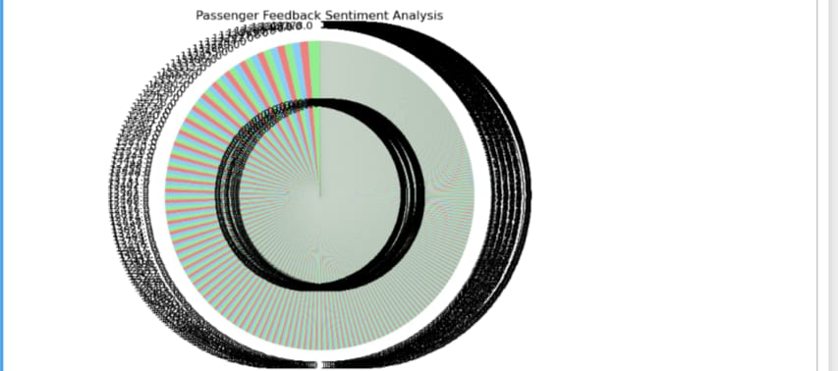

## *Sentiment Analysis on Passenger Feedback:*

## For sentiment analysis, you'll need a sentiment analysis library, such as NLTK or TextBlob. Make sure to preprocess the text data by removing noise and stopwords before performing sentiment analysis.

**from textblob import TextBlob**

**# Example sentiment analysis function**

**def get_sentiment(text):**

**analysis = TextBlob(text)**

**if analysis.sentiment.polarity > 0:**

**return 'Positive'**

**elif analysis.sentiment.polarity == 0:**

**return 'Neutral'**

**else:**

**return 'Negative'**

**# Apply sentiment analysis to a column of text data**

**data['sentiment'] = data['feedback'].apply(get_sentiment)**

**# Count the number of positive, neutral, and negative feedback**

**sentiment_counts = data['sentiment'].value_counts()**

**print(sentiment_counts)**

## Service efficiency:

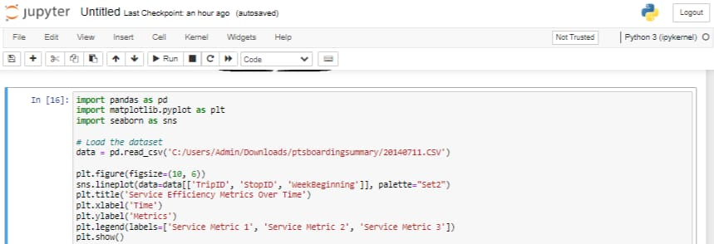

## Output:

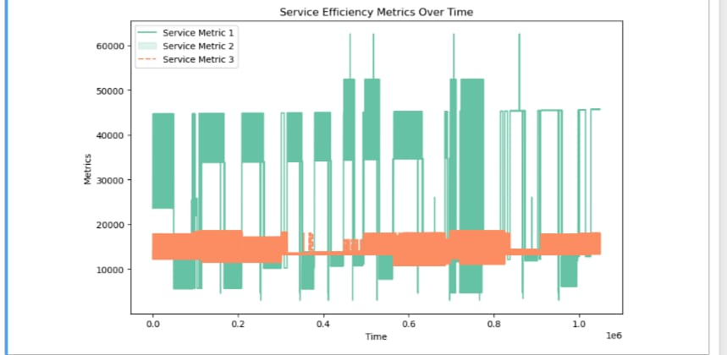

## Conclusion:

In conclusion, the Public Transportation Analysis project, through its Development Part 2, employs a synergistic approach. It combines the strengths of IBM Cognos for visualizing crucial transportation metrics and Python for in-depth data analysis. By generating intuitive dashboards, we gain valuable insights into on-time performance, passenger feedback, and service efficiency, which in turn drive informed decision-making for optimizing public transport services. This integrated solution paves the way for enhanced transportation efficiency and improved passenger experiences.