

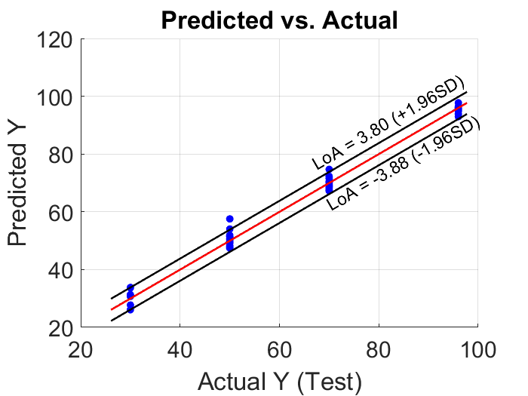

Test RMSEP: 1.95

R2: 0.99



Interp. RMSEP: 3.90

R2: 0.99