Docker –-version

Docker info

Docker pull ubuntu

Docker images

Docker run -it ubuntu bash

Docker ps

Docker ps -a

Docker stop <container id>

Docker rm <container id or name>

Docker exec -it < container_id > bash

Docker logs <container id or name>

New --- docker network create <network name>

Docker network ls

Docker inspect nginx

Docker run -d -p 80:80 -–name my_nginx nginx

DOCK_BUILD :

app.py

Dockerfile

=> Reqirements.txt

Dockerfile =>

From python

Workdir /dock_build/

Copy requirements.txt .

Run pip install -r requirements.txt

Copy . .

Expose 5010

Cmd [“python” , “ app.py” ]

app.py =>

From flask import Flask

app=Flask(__name__)

@app.route(‘/’)

Def hello():

return “Hello , world from Flask !”

If __name__== ”__main__”:

app.run(host=’0.0.0.0’ ,port=5010)

Requirements.txt =>

Flask

Commands :

docker build -t myflask.docker:desktop-linux

docker run -p 5010:5010 myflask

Running on browser check e.g : 127.0.0.1:5010

ON DOCKER NEW IMAGE IS GENERATED “myflask”

docker ps

docker ps -a

docker images

1. Create a project folder
2. Create a Dockerfile.

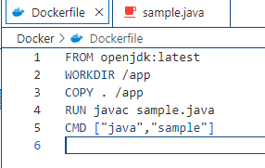

1. Create a java file.

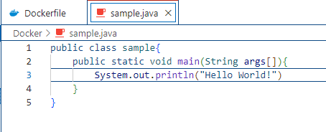

1. Compile and Run the java project

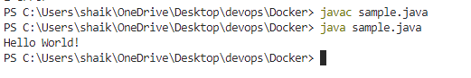

1. Build the docker Image.

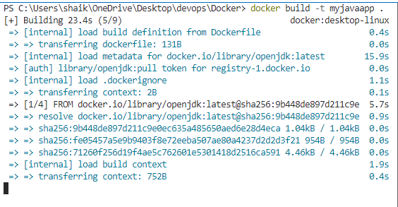

1. The Image has been created successfully

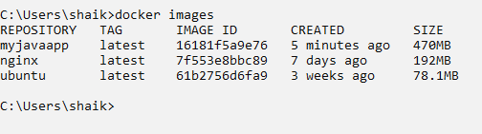

1. Run the Docker Container

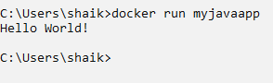

1. List the Docker Images and container.

