Assignment # 2

# **Task 1**

## Histogram for dataset 1

Priority is plotted on the x-axis and count of number of bugs of particular priority are plotted on the y-axis. This histogram shows the number of bugs having a similar priority level represented by a separate bar.

Insights: **There are more number of bugs of priority 4 that are reported than of priority 1.**

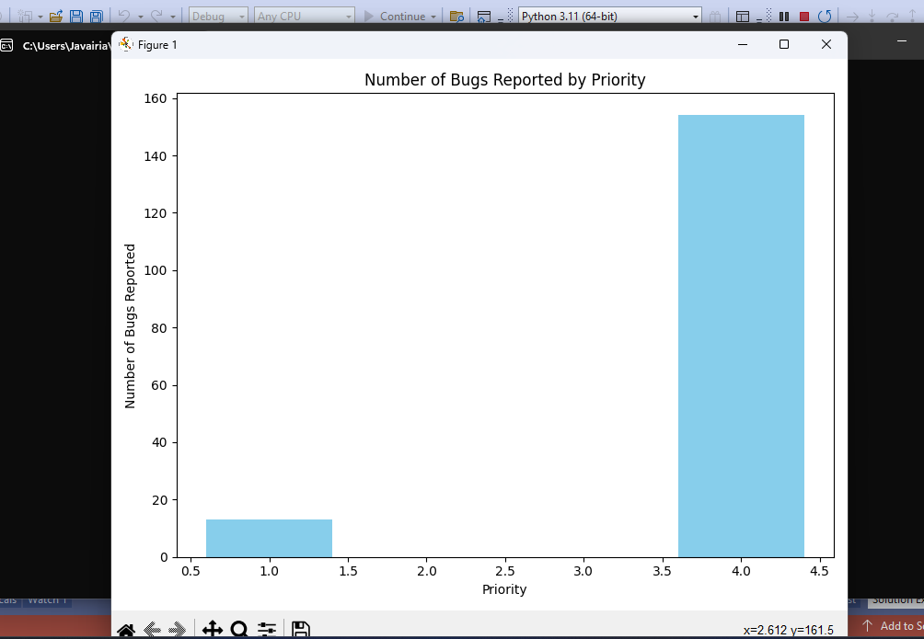

## Histogram for dataset 2

Priority is plotted on the x-axis and count of number of IDS of particular priority are plotted on the y-axis.This histogram shows the number of Ids having a similar priority level represented by a separate bar. **Here High value is represented by 5.**

Insights: **There are more number of bugs of priority 4 that are reported than of priority 5 (High Priority) and priority 1. The least number of bugs are of Priority 1.**

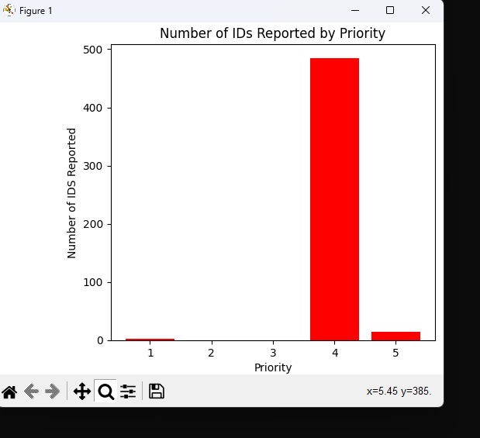

## Histogram for dataset 3

Priority is plotted on the x-axis and count of number of bugs of particular priority are plotted on the y-axis. This histogram shows the number of bugs having a similar priority level represented by a separate bar**. Histograms are plotted for each module of dataset 3**

Insights: **Major Bugs > Minor Bugs > Critical Priority Bugs > Trivial Bugs > Blocker Bugs**

### Module All

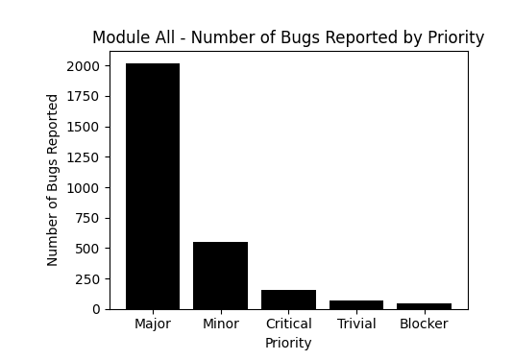

### Module A

Insights: **Major Bugs > Critical Priority Bugs > Blocker Bugs > Minor Bugs > Trivial Bugs**

### 

### Module C

Insights: **Major Bugs > Minor Bugs > Critical Priority Bugs > Trivial Bugs > Blocker Bugs**

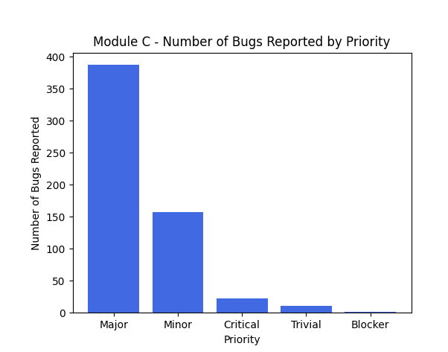

### Module D

Insights: **Major Bugs > Minor Bugs > Trivial Bugs > Critical Priority Bugs > Blocker Bugs**

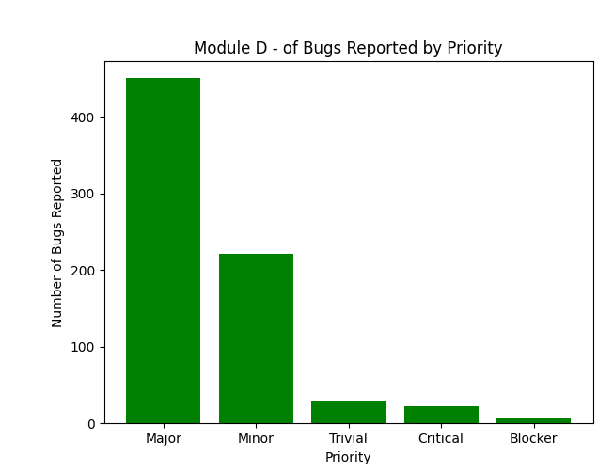

### Module W

Insights: **Major Bugs > Minor Bugs > Trivial Bugs > Critical Priority Bugs > Blocker Bugs**

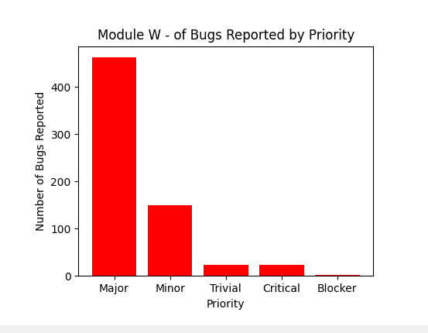

# Task 2

## Pareto chart for dataset 3

Insights: It is a pareto chart which shows the number of bugs in descending order for each module

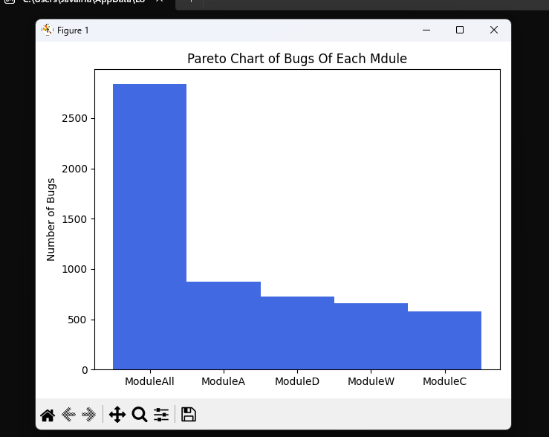

# Task 3

## Percent delinquent fixes month-wise for dataset 2

Formula used is, PDF = (Number of fixes that exceeded the response time criteria by severity level/number of fixes delivered in a specified time) *100 %

Insights: The units for PDF is %. Month-Wise Pdf is presented.

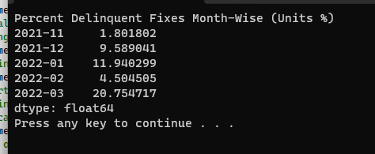

## Percent delinquent fixes month-wise for dataset 3

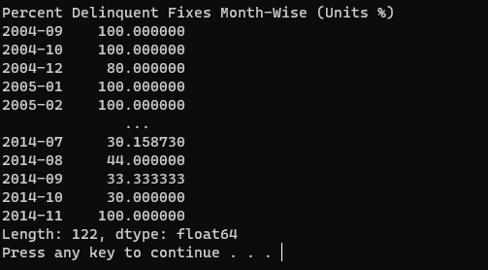

# Task 4

## Run chart of percent delinquent fixes for dataset 3

Insights: y-axis labels pdf (%) and x-axis labels year-month. Run Time chart is presented for calculated pdfs.

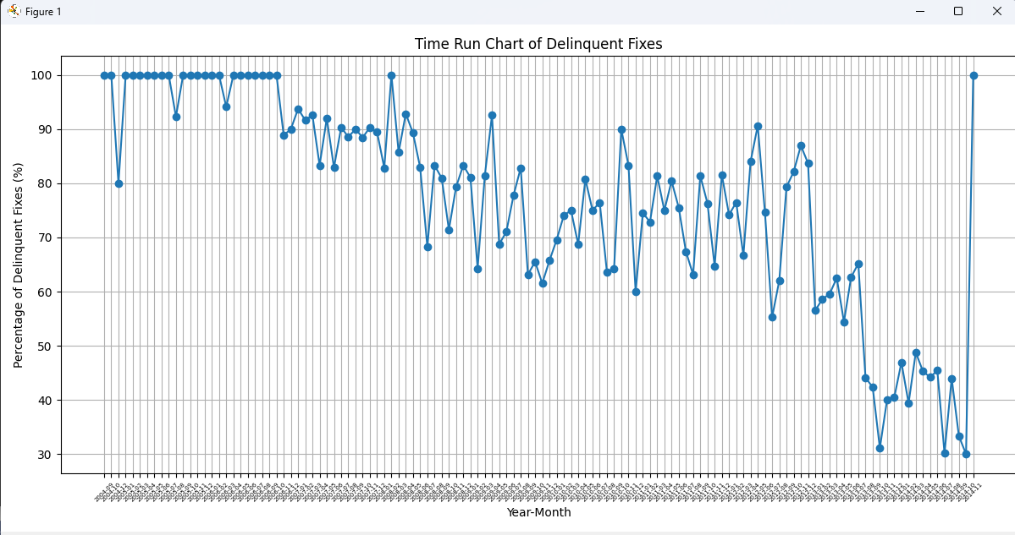

# Task 5

## Control chart for pdf of dataset 3

Insights: y-axis labels pdf (%) and x-axis labels month. Control chart is presented for calculated pdfs.

Formulas used are:

UpperControlLimit = mean + 2 * StandardDeviation

LowerControlLimit = mean - 2 * StandardDeviation

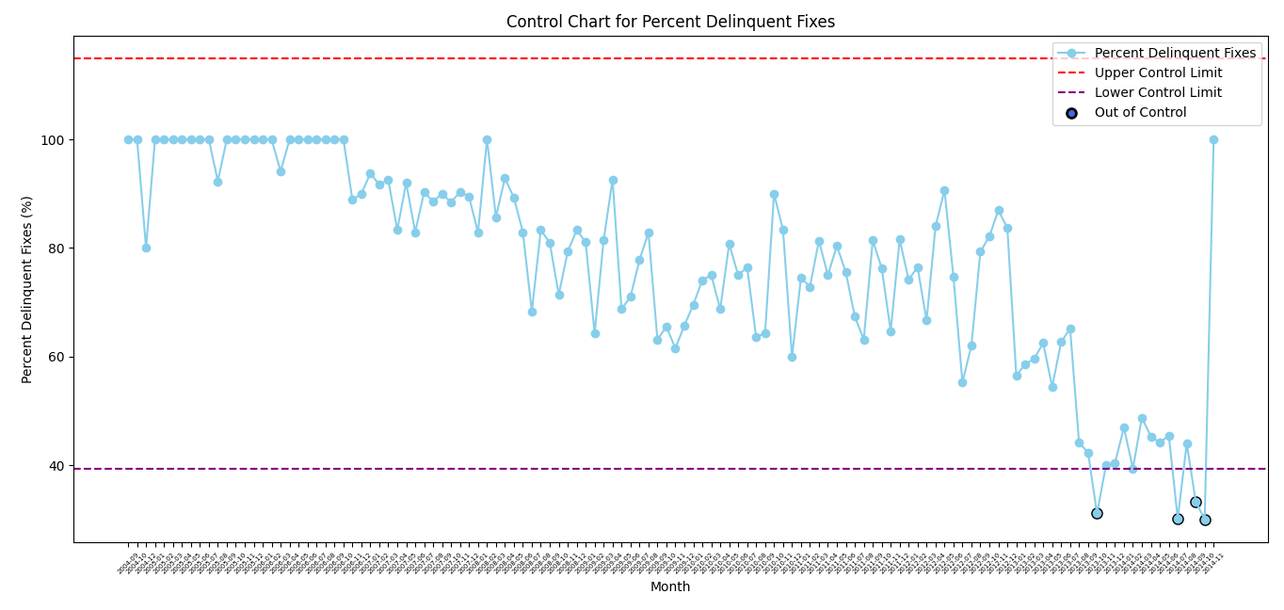

**Out of bound values are highlighted by an edge color black around them**

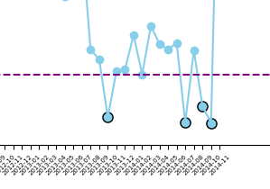

# Task 6

## Schedule Estimation Accuracy for dataset 2

Insights: It is calculated using the formula:

**SEA= spent_time/estimated_time**

With proper error handling (to avoid exceptions when estimated_time=0)

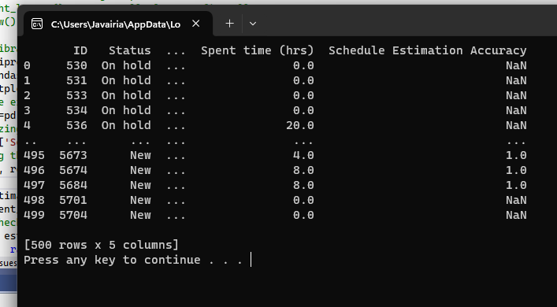

# Task 7

## Fix response time of dataset 2

Insights: Calculated by, **mean** time of all problems from open to closed

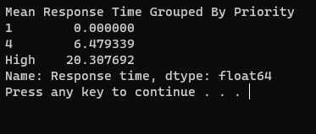

## Fix response time of dataset 3 and all modules

Insights: Calculated by, **median** time of all problems from open to closed, because outliers were affecting the value of mean.

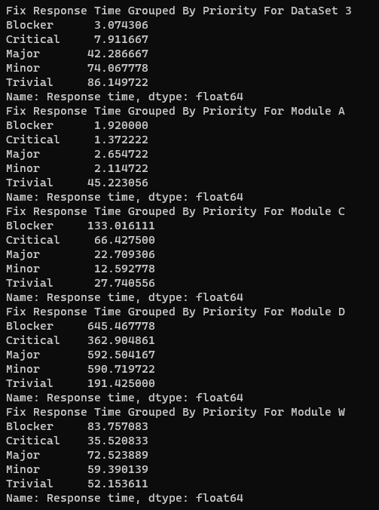

# Task 8

Insights: Formula used is: BMI= (Number of problems Closed during a month/ Number of problems arrived during a month) *100 %

## BMI for dataset 2

Insights: No problems are closed in any month that’s why it is giving NaN as no value is present

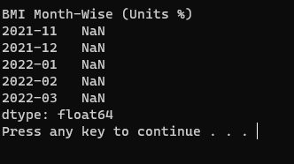

## BMI for dataset 3

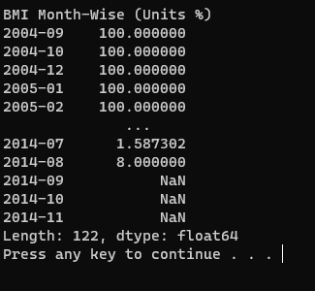

# Task 9

## **Pareto chart with bugs given to each assignee**

Insights: It represents the number of bugs assigned to each assignee. Since the assignees are too many. the x-axis labels are not clear however on runtime the values can be seen by moving the cursor over the pareto chart. Also in the attached snapshot assignee and the bugs assigned to them are represented in the bottom right corner. **Person 531 assigned 147 bugs to resolve.**

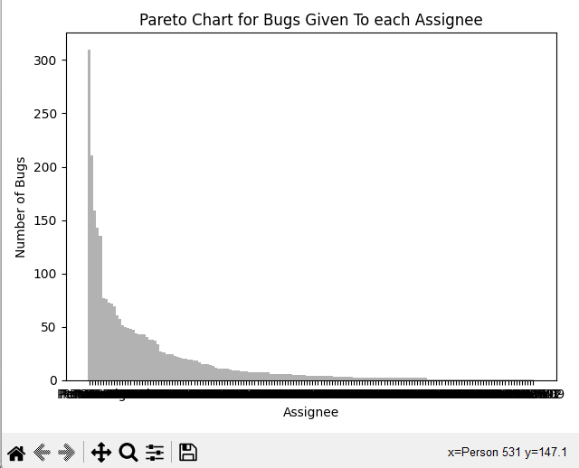

# Task 10

## **Pareto chart with bugs of status not closed given to each assignee**

Insights: It represents the number of bugs assigned to each assignee whose status is not closed. Since the assignees are too many. the x-axis labels are not clear however on runtime the values can be seen by moving the cursor over the pareto chart. Also in the attached snapshot assignee and the bugs assigned to them are represented in the bottom right corner. **Person 43 assigned 28 bugs to resolve.**

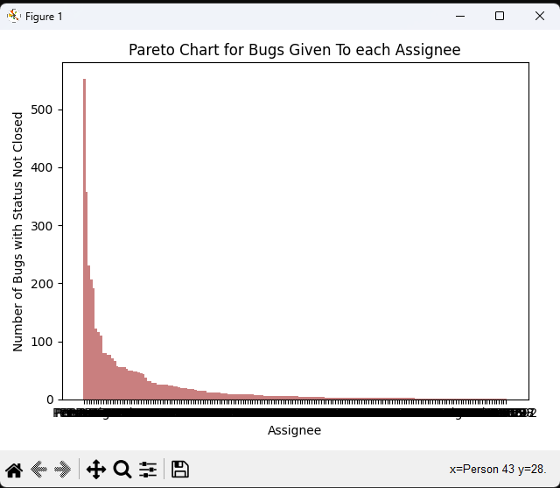

# Task 11

## Percentage and proportion of actual defects (BUGS) in dataset 3 and all modules

Insights: Formula used are Proportion= (Number of Actual Defects/ Number of Actual Defects+ Number of other customer problems)

Percentage = (Number of Actual Defects/ Number of Actual Defects+ Number of other customer problems) *100%

# 

**Group Members:**

Javaria Shabbir (21L-6053)

Harris Khalid (21L-5808)