Team “Gardenia”

JavaScript team-project. Building a JavaScript based game.

# Members

* Yavor Mitev (email: [yavor2000@yahoo.com](mailto:yavor2000@yahoo.com))
* Vassil Nikov (email: [vassiln@yahoo.com](mailto:vassiln@yahoo.com))
* Petko Pasev (email: [orb_77@mail.bg](mailto:orb_77@mail.bg))
* Nadezhda Vassova (email: [nadezhda_vassova@dir.bg](mailto:nadezhda_vassova@dir.bg))

Name of the game: Falling student:

Source code location: <https://github.com/Javascript-Teamwork>

The game is also available for playing online [here](http://vknikov.softuni-friends.org/student/).

Screenshot from the game:

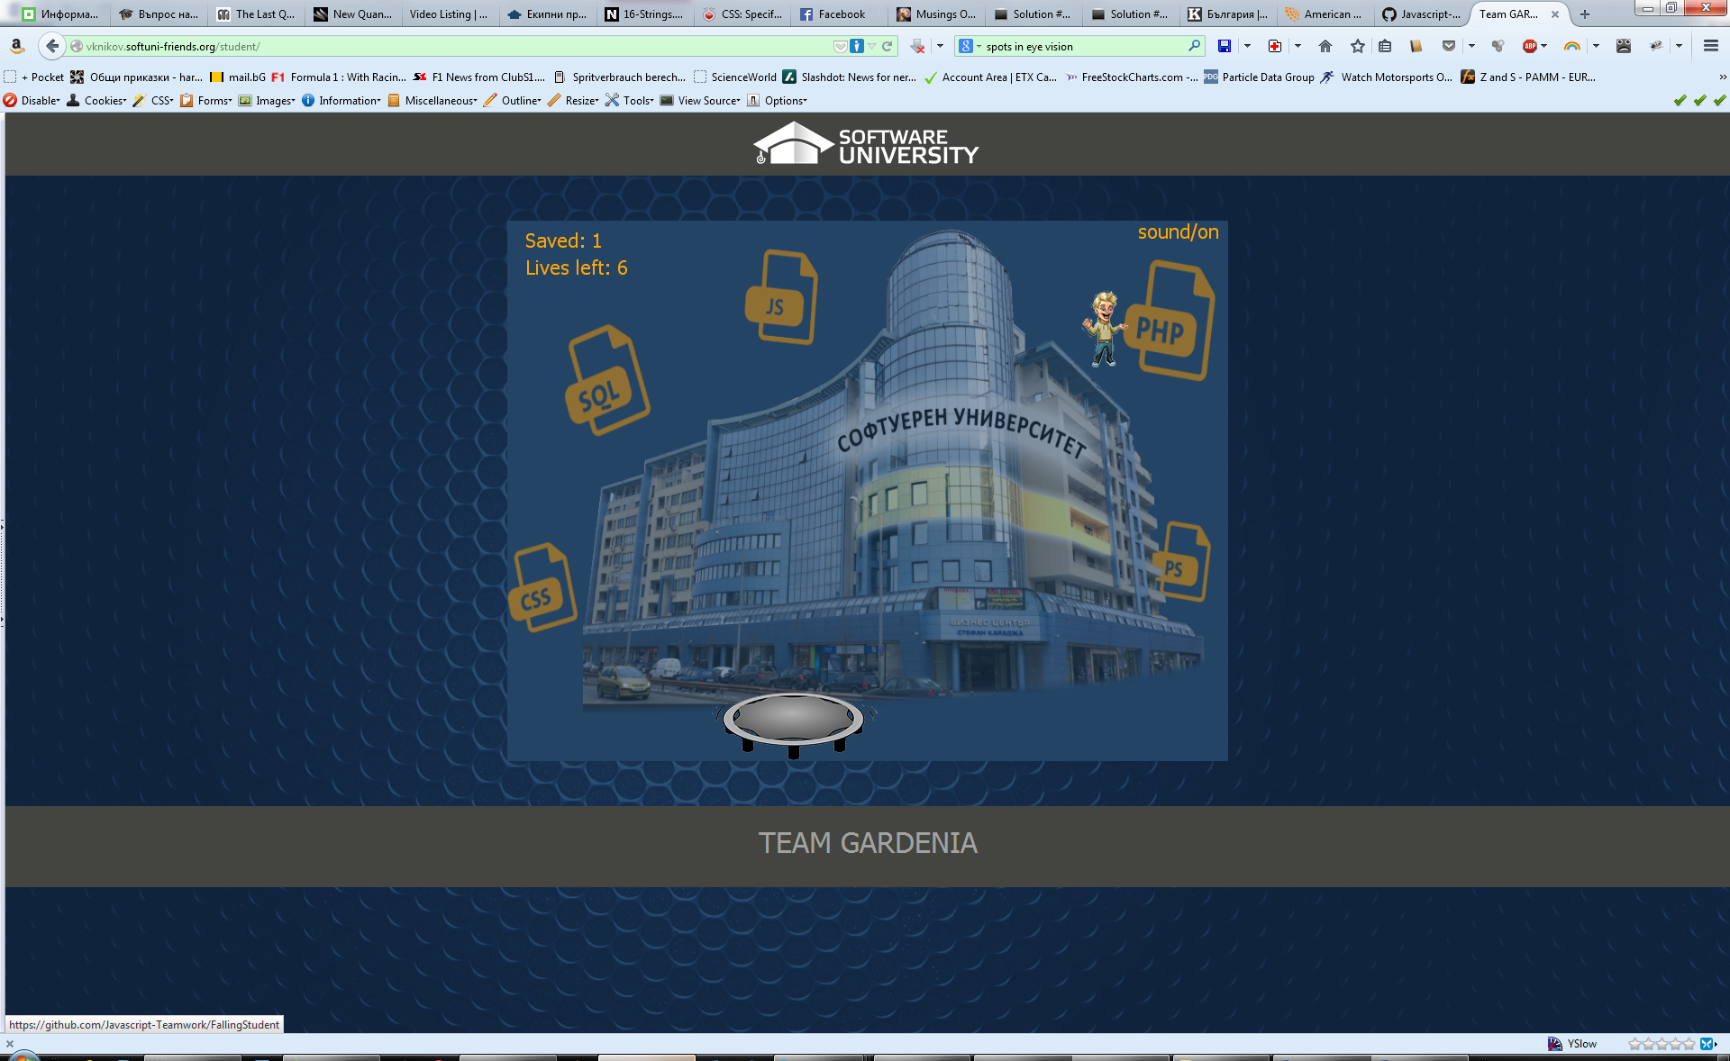

Basic concept of the game: The purpose is to save the “falling student” with the trampoline at the bottom. You can move the trampoline with the arrow keys. Over time the speed of the game will gradually increase (making the game more difficult to play). You can gain more lives by catching up the head of Svetlin Nakov.