1. Upload folder in chrome browser

* More tools/extensions
* Enable developer mode (top right)
* Click “Load unpacked” button(top left)

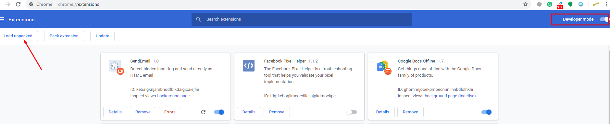

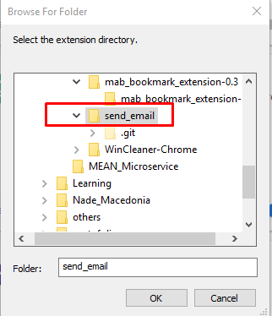

* Click “send_email” folder and click “OK” button

1. Testing chrome extension with correct data

* Go to the source folder and double click “hidden_input_tag.html” that includes hidden div
* Then run chrome extension

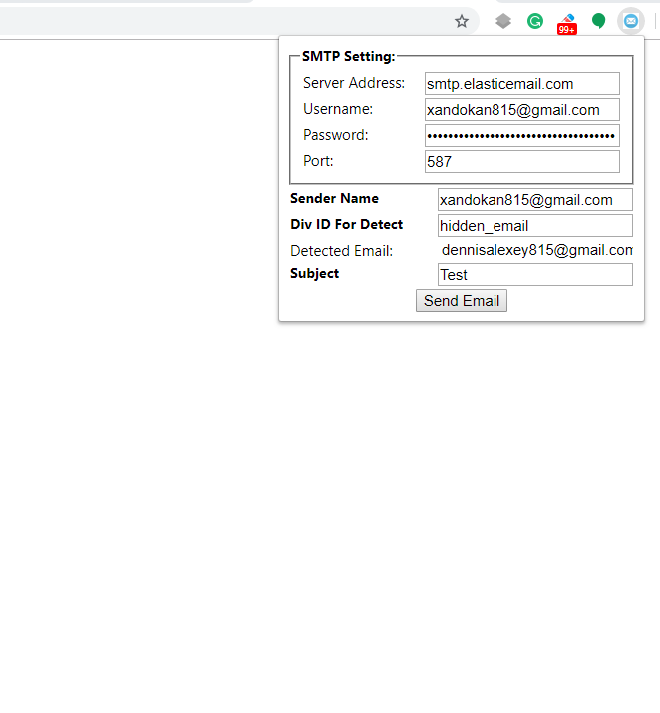

**exchange hidden email to your own gmail in hidden div tag (hidden_input_tag.html) and try to test it