Coupon-Product-Spring-Cloud-Flow
Coupon-Services:
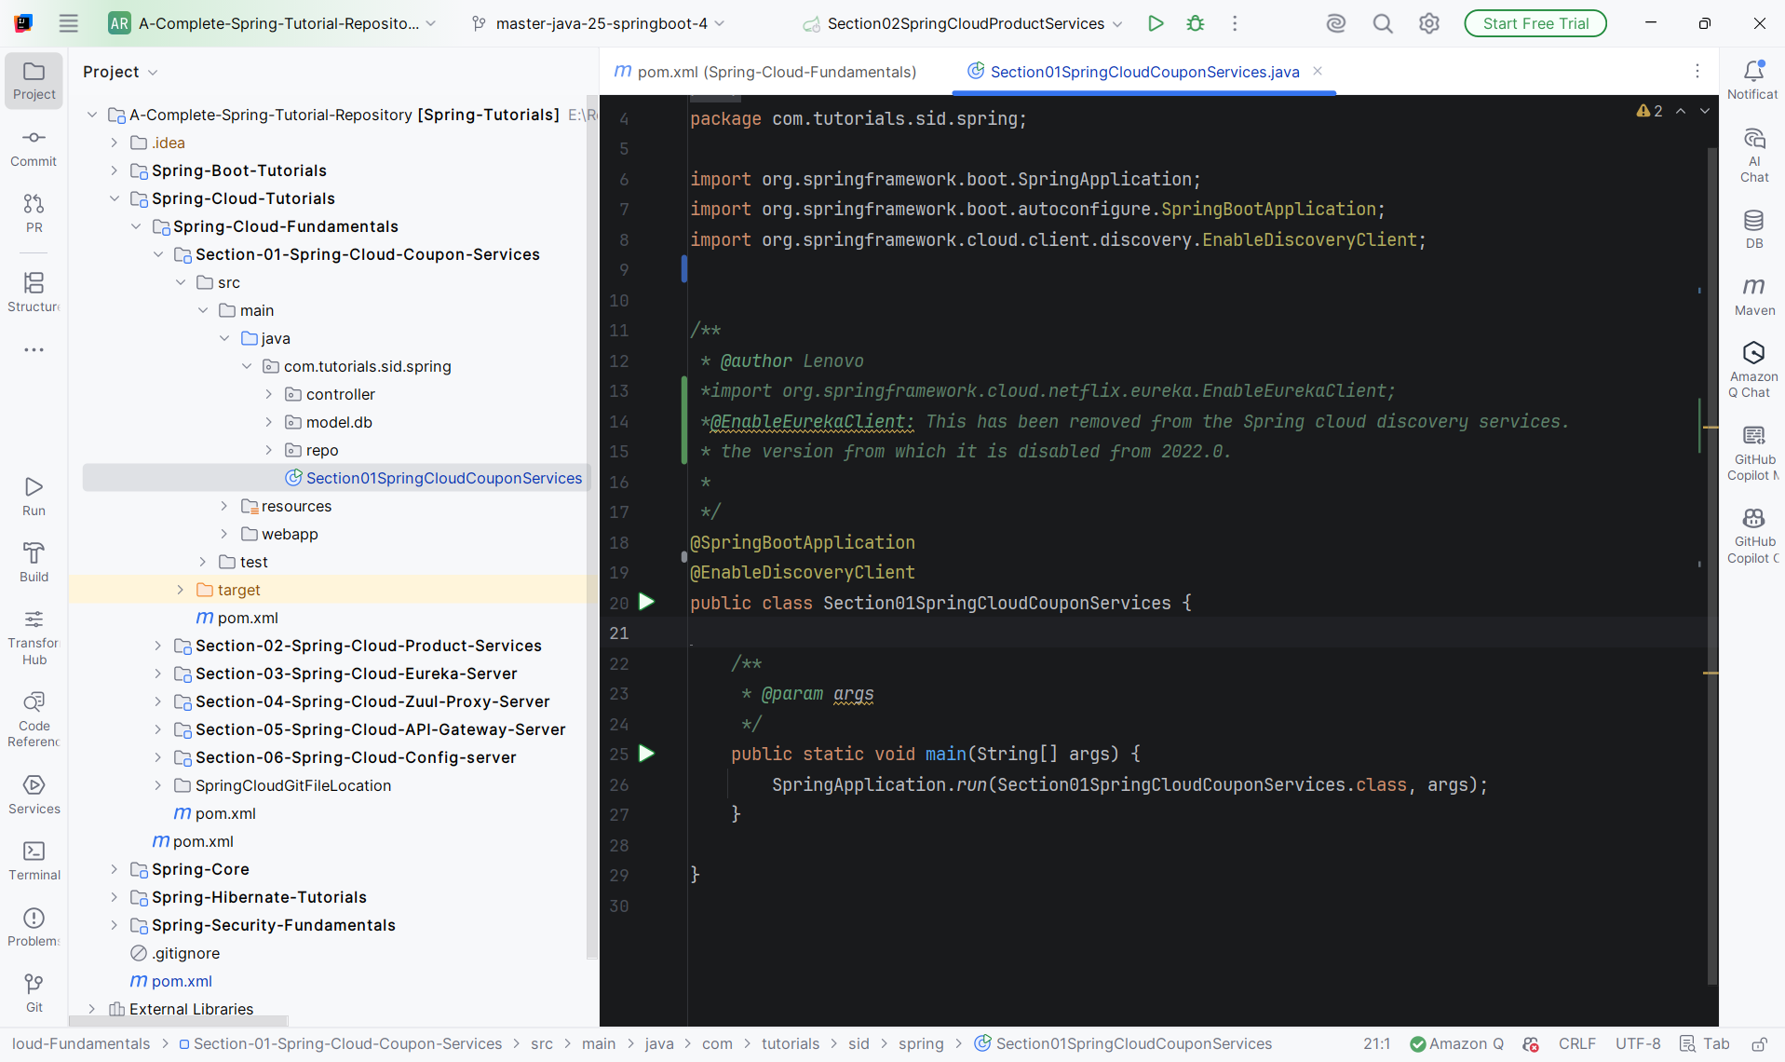
Proprty:
spring.datasource.url=jdbc:mysql://127.0.0.1:3306/mydb
spring.datasource.driver-class-name=com.mysql.cj.jdbc.Driver
spring.datasource.username=root
spring.datasource.password=root
#jpa configuration
spring.jpa.show-sql=true
spring.jpa.properties.hibernate.format_sql=true
spring.jpa.properties.hibernate.dialect=org.hibernate.dialect.MySQL8Dialect
spring.jpa.hibernate.ddl-auto=update
spring.jpa.generate-ddl=true
server.port=8080
server.servlet.context-path=/couponcart
spring.application.name=coupon-services
Dependency:
After creating the Eureak server we can add the below dependency to the project:
<dependency>
<groupId>org.springframework.cloud</groupId>
<artifactId>spring-cloud-starter-netflix-eureka-client</artifactId>
</dependency>
Main Class to be annotated with:
@EnableDiscoveryClient
Proprty:
spring.cloud.discovery.enabled=true
eureka.client.service-url.defaultZone=http://localhost:8761/eureka/
# register this service with Eureka
eureka.client.register-with-eureka=true
# fetch the registry of other services
eureka.client.fetch-registry=true
#The instance id is the combination of the application name and the port number.
#This will be used by Eureka to identify the instance which will help in load balancing and discovery the services.
eureka.instance.instance-id=${spring.application.name}:${server.port}
eureka.instance.prefer-ip-address=true
eureka.instance.hostname=localhost
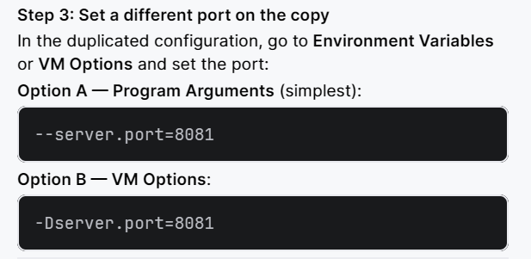

Product-Services:
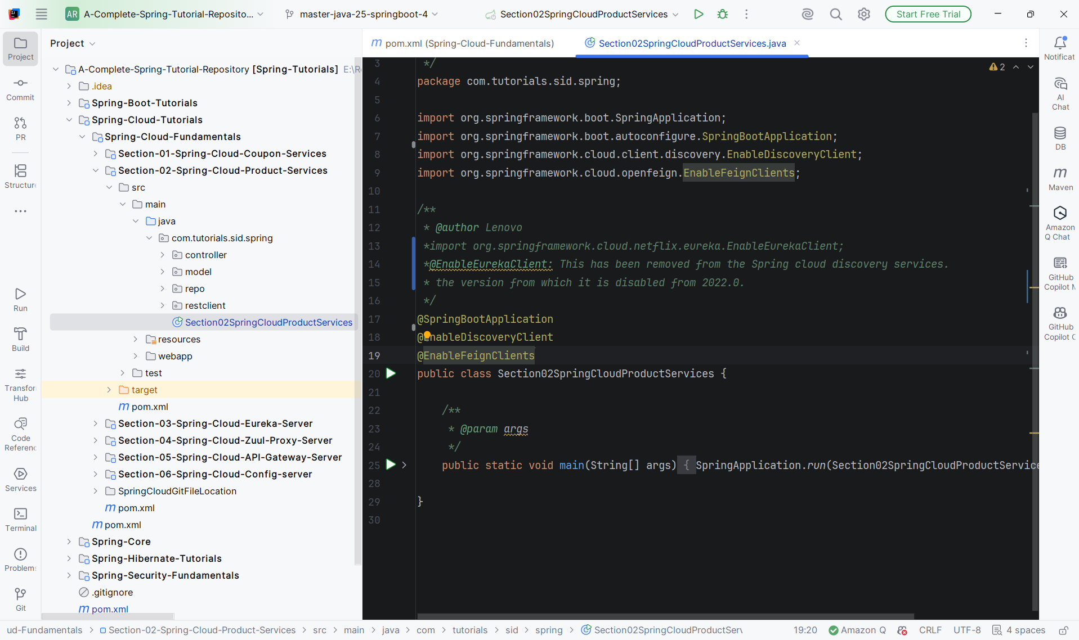
Proprty:
spring.datasource.url=jdbc:mysql://127.0.0.1:3306/mydb
spring.datasource.driver-class-name=com.mysql.cj.jdbc.Driver
spring.datasource.username=root
spring.datasource.password=root
#jpa configuration
spring.jpa.show-sql=true
spring.jpa.properties.hibernate.format_sql=true
spring.jpa.properties.hibernate.dialect=org.hibernate.dialect.MySQL8Dialect
spring.jpa.hibernate.ddl-auto=update
spring.jpa.generate-ddl=true
server.port=9090
server.servlet.context-path=/productcart
spring.application.name=product-services
Dependency:
After creating the Eureak server we can add the below dependency to the project:
<dependency>
<groupId>org.springframework.cloud</groupId>
<artifactId>spring-cloud-starter-netflix-eureka-client</artifactId>
</dependency>
Main Class to be annotated with:
@EnableDiscoveryClient
Proprty:
spring.cloud.discovery.enabled=true
eureka.client.service-url.defaultZone=http://localhost:8761/eureka/
# register this service with Eureka
eureka.client.register-with-eureka=true
# fetch the registry of other services
eureka.client.fetch-registry=true
#The instance id is the combination of the application name and the port number.
#This will be used by Eureka to identify the instance which will help in load balancing and discovery the services.
eureka.instance.instance-id=${spring.application.name}:${server.port}
eureka.instance.prefer-ip-address=true
eureka.instance.hostname=localhost
Main Class to be annotated with:
@EnableFeignClients
@FeignClient("COUPON-SERVICES")
public interface IFeignCouponClient {
@GetMapping("/couponcart/couponapi/getcoupon/{couponCode}")
public Coupon getCoupon(@PathVariable("couponCode") String couponCode);
}
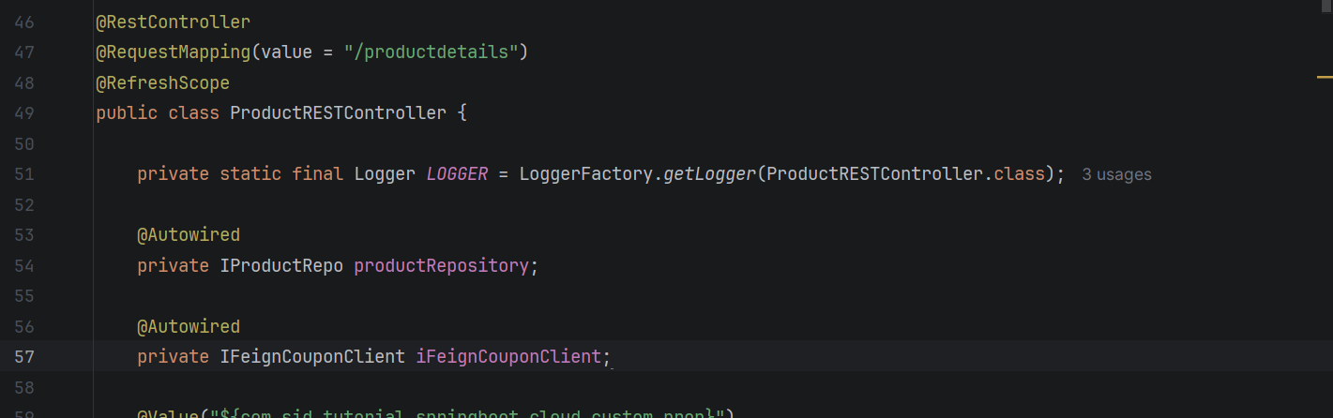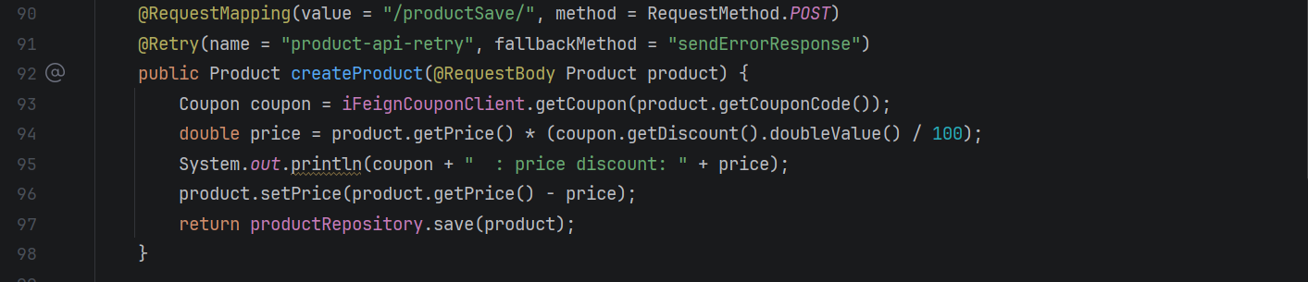
Dependency:
<dependency>
<groupId>org.springframework.cloud</groupId>
<artifactId>spring-cloud-starter-loadbalancer</artifactId>
</dependency>
After API-Gateway Registration:
@FeignClient("APIGATEWAY-SERVICES")
public interface IFeignCouponClient {
@GetMapping("/couponcart/couponapi/getcoupon/{couponCode}")
public Coupon getCoupon(@PathVariable("couponCode") String couponCode);
}

Eureak-Server-Services:
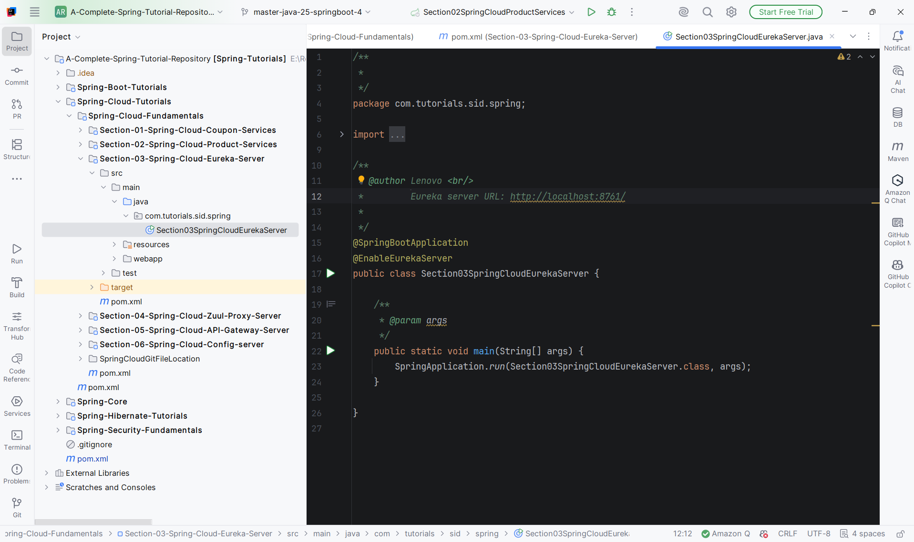
Dependency:
<dependency>
<groupId>org.springframework.cloud</groupId>
<artifactId>spring-cloud-starter-netflix-eureka-server</artifactId>
</dependency>
Main Class to be annotated with:
@EnableEurekaServer
Proprty:
server.port=8761
eureka.client.register-with-eureka=false
eureka.client.fetch-registry=false
URL: http://localhost:8761/
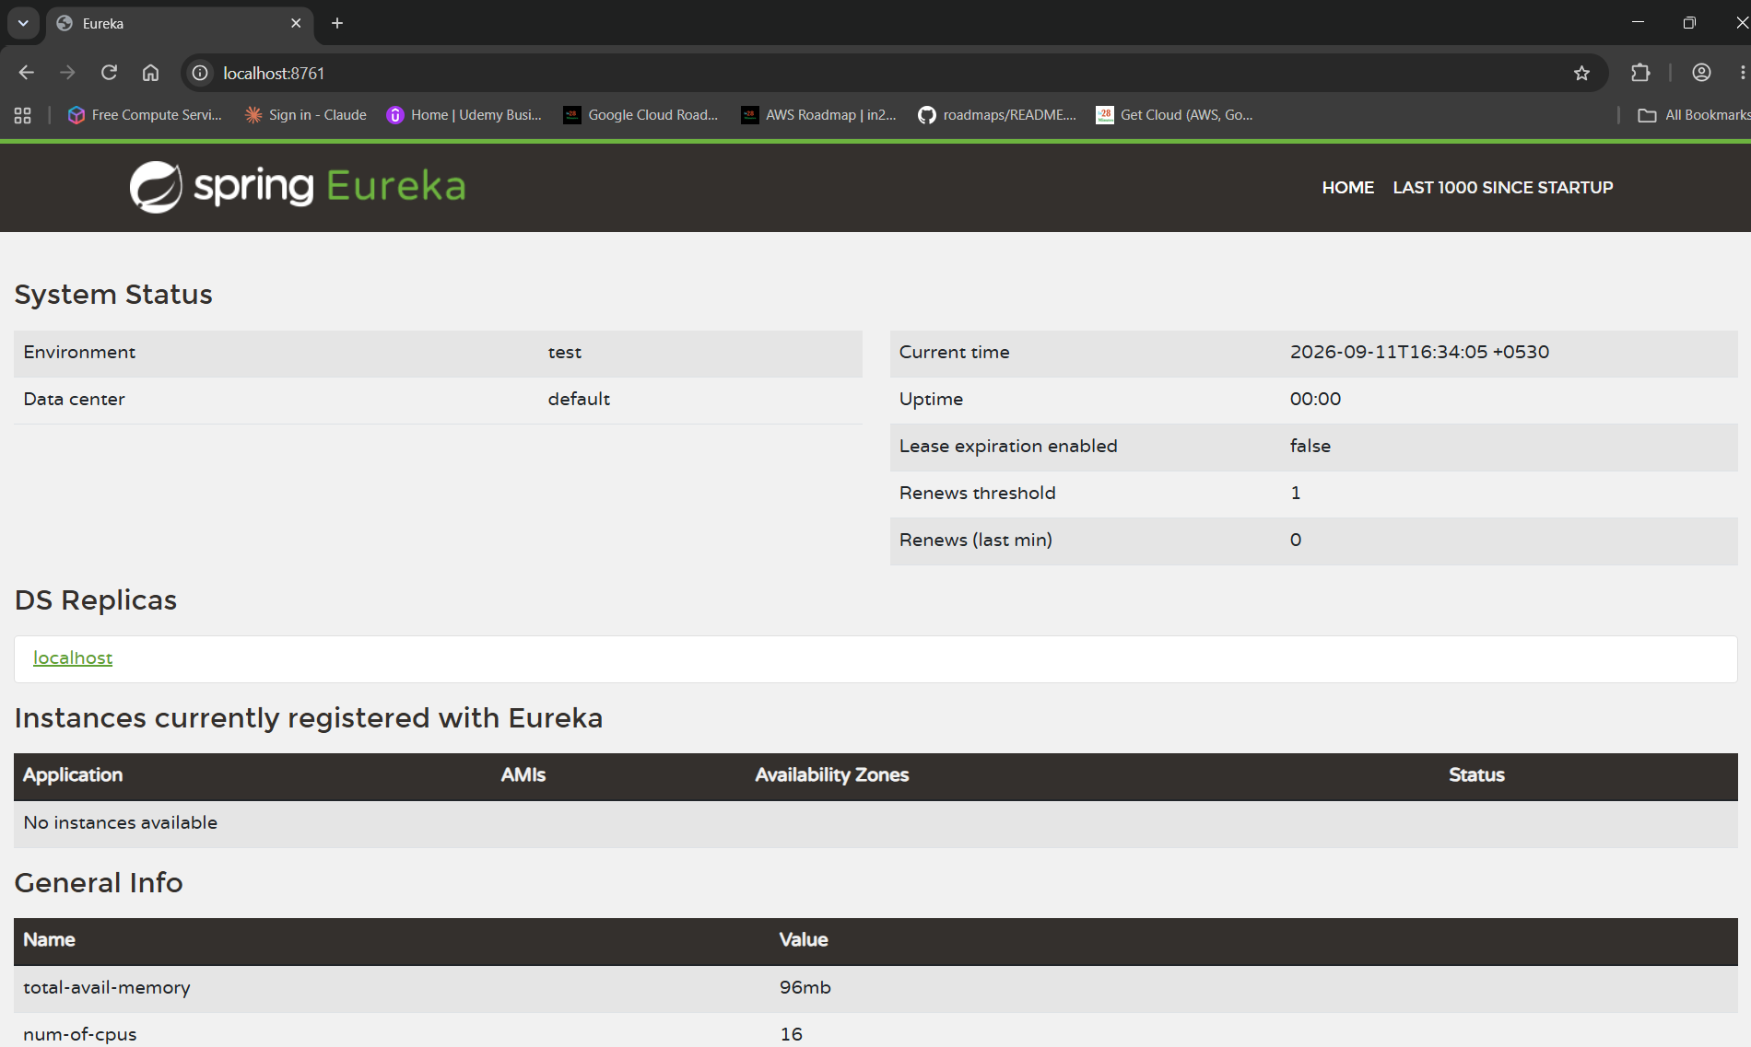
After Registry:
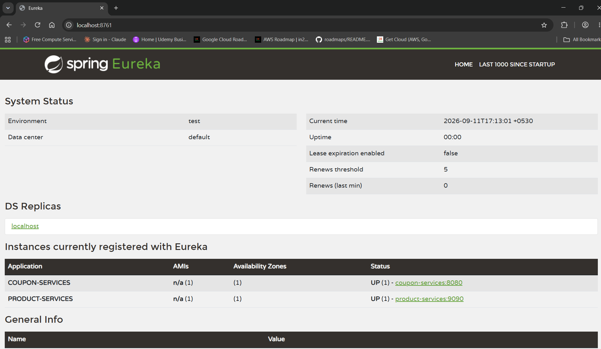
After multiple instance creation:
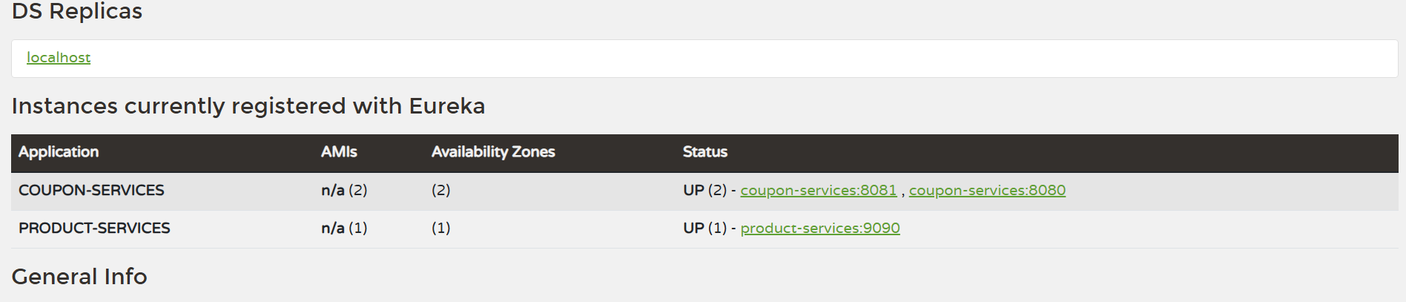

API-Gateway-Server-Services:
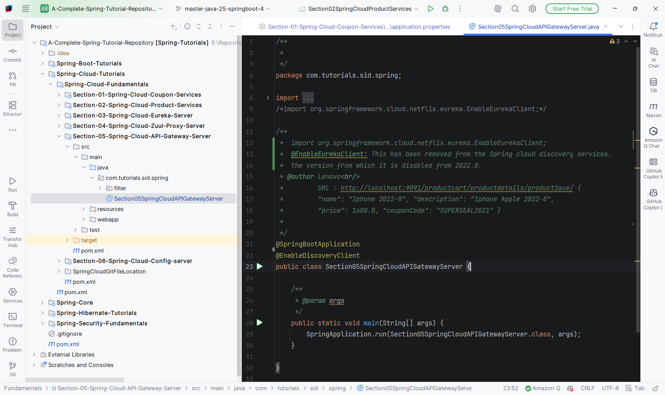
Dependency:
Old dependency
<dependency>
<groupId>org.springframework.cloud</groupId>
<artifactId>spring-cloud-starter-gateway</artifactId>
</dependency>
Latest Dependency
<dependency>
<groupId>org.springframework.cloud</groupId>
<artifactId>spring-cloud-starter-gateway-server-webflux</artifactId>
</dependency>
<dependency>
<groupId>org.springframework.cloud</groupId>
<artifactId>spring-cloud-starter-netflix-eureka-client</artifactId>
</dependency>
Main Class to be annotated with:
@EnableDiscoveryClient
Proprty:
server.port=9091
spring.application.name=apigateway-services
eureka.client.service-url.defaultZone=http://localhost:8761/eureka/
eureka.client.register-with-eureka=true
eureka.client.fetch-registry=true
eureka.instance.prefer-ip-address=true
eureka.instance.hostname=localhost
spring.cloud.discovery.enabled=true
#spring.cloud.gateway.discovery.locator.enabled=true
#spring.cloud.gateway.discovery.locator.lower-case-service-name=true
#===========================================================
# With discovery locator enabled, explicit routes below are NOT needed.
# The gateway will auto-create routes for all services registered in Eureka.
# Example auto-generated routes:
# /coupon-services/** → lb://coupon-services
# /product-services/** → lb://product-services
#===========================================================
This is old code
spring.cloud.gateway.routes[0].id=productModule
spring.cloud.gateway.routes[0].uri=lb://PRODUCT-SERVICES
spring.cloud.gateway.routes[0].predicates[0]=Path=/productcart/productdetails/**
spring.cloud.gateway.routes[1].id=productModuleRaw
spring.cloud.gateway.routes[1].uri=lb://product-services
spring.cloud.gateway.routes[1].predicates[0]=Path=/productcart/**
spring.cloud.gateway.routes[2].id=couponModule
spring.cloud.gateway.routes[2].uri=lb://COUPON-SERVICES
spring.cloud.gateway.routes[2].predicates[0]=Path=/couponcart/couponapi/**
#===========================================================
#With latest version
spring.cloud.gateway.server.webflux.routes[0].id=productModule
spring.cloud.gateway.server.webflux.routes[0].uri=lb://PRODUCT-SERVICES
spring.cloud.gateway.server.webflux.routes[0].predicates[0]=Path=/productcart/productdetails/**
#spring.cloud.gateway.server.webflux.routes[1].id=productModuleRaw
#spring.cloud.gateway.server.webflux.routes[1].uri=lb://product-services
#spring.cloud.gateway.server.webflux.routes[1].predicates[0]=Path=/productcart/**
spring.cloud.gateway.server.webflux.routes[1].id=couponModule
spring.cloud.gateway.server.webflux.routes[1].uri=lb://COUPON-SERVICES
spring.cloud.gateway.server.webflux.routes[1].predicates[0]=Path=/couponcart/couponapi/**

URL: http://localhost:8761/
After Registry:
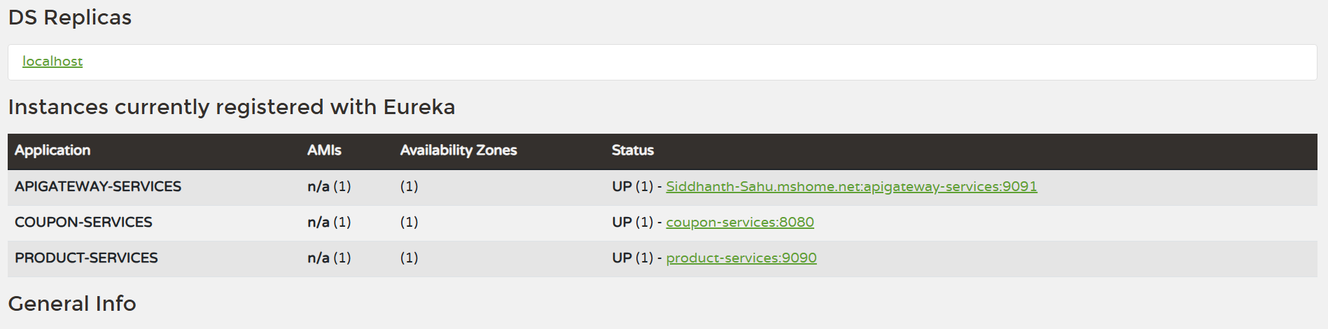
URL: http://localhost:9091/productcart/productdetails/productSave/
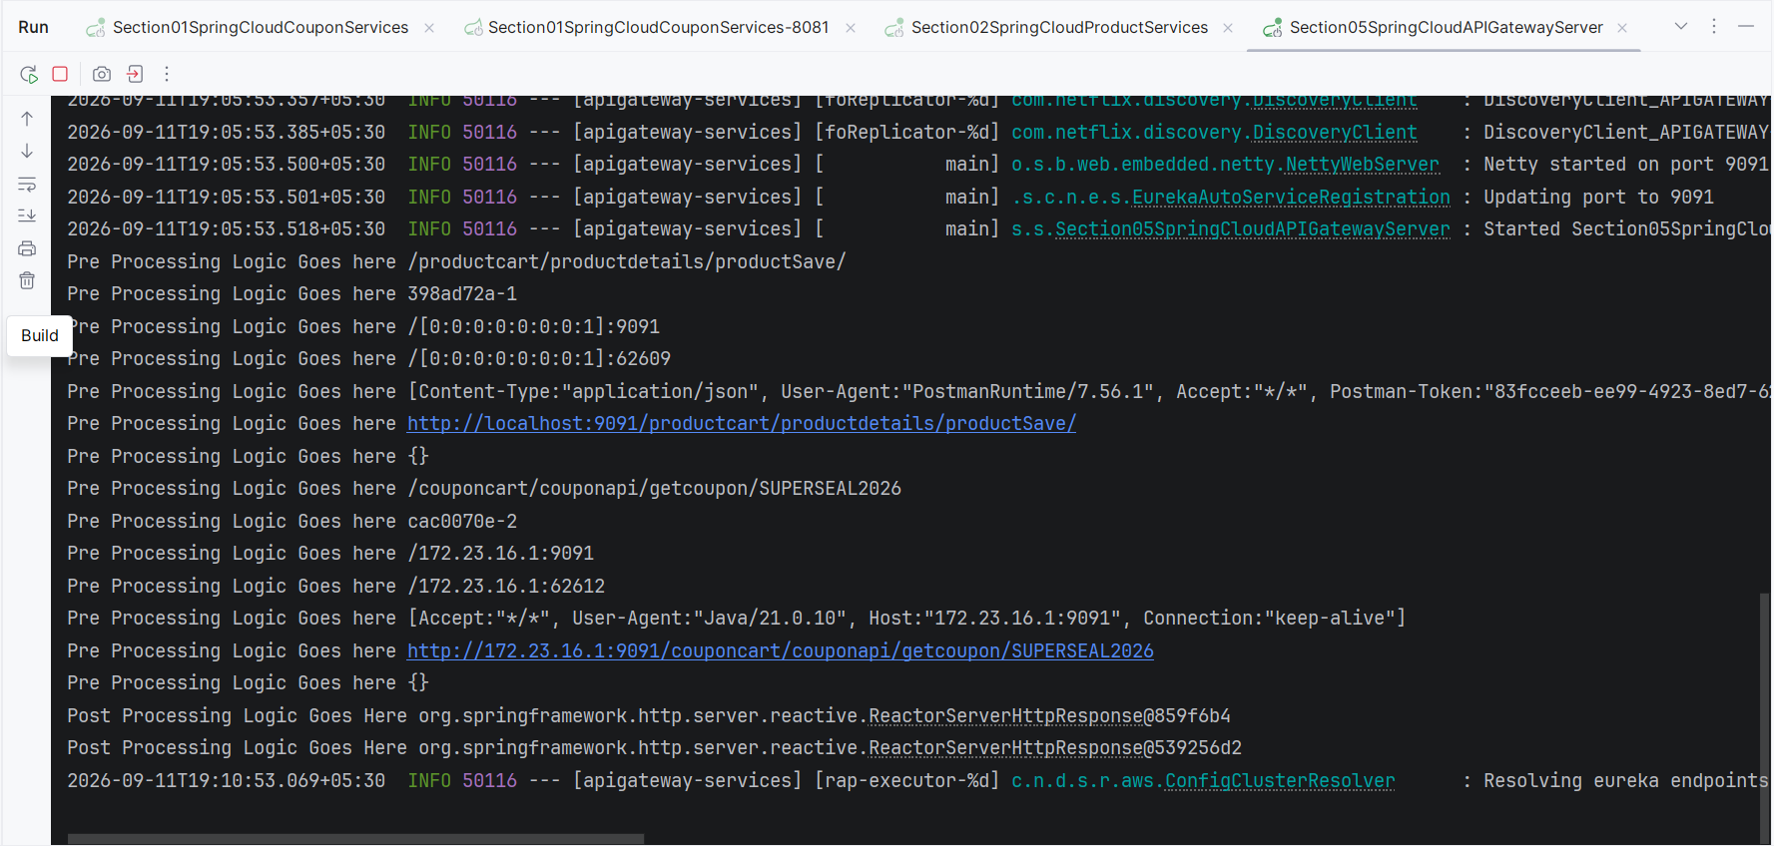
URL: http://localhost:9091/productcart/productdetails/productSave/
if i have multiple instances of coupon-services will this work?
Yes, Option 2 works perfectly with multiple instances. The lb:// prefix is the key.
spring.cloud.gateway.server.webflux.routes[1].uri=lb://COUPON-SERVICES
lb:// means load balanced — the gateway uses Eureka's registry to find all instances of COUPON-SERVICES and automatically load balances across them using round-robin by default.
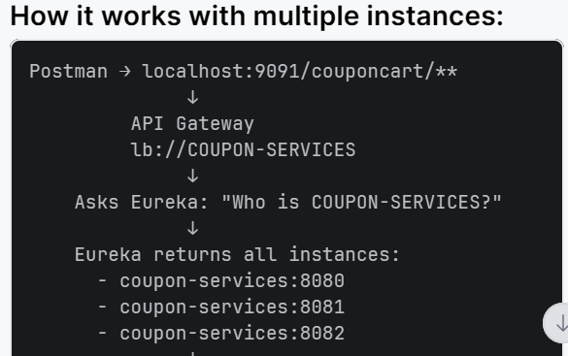
The property will be
spring.cloud.gateway.server.webflux.discovery.locator.enabled=true
spring.cloud.gateway.server.webflux.discovery.locator.lower-case-service-name=true
#===========================================================
# With discovery locator enabled, explicit routes below are NOT needed.
# The gateway will auto-create routes for all services registered in Eureka.
# Example auto-generated routes:
# /coupon-services/** → lb://coupon-services
# /product-services/** → lb://product-services
#===========================================================
#You're using Spring Cloud 2025.0.3. In this version:
#•spring-cloud-starter-gateway now contains two modules:
#◦spring-cloud-gateway-server-webflux (reactive, the standard one)
#◦spring-cloud-gateway-server-mvc (servlet-based, newer option)
#•The old property prefix spring.cloud.gateway.routes[*] was renamed to
# spring.cloud.gateway.server.webflux.routes[*]
#•Also, route index must be contiguous — you have [0], skip [1], then [2],
# which causes the "left unbound" binding failure
#===========================================================
spring.cloud.gateway.server.webflux.routes[0].id=productModule
spring.cloud.gateway.server.webflux.routes[0].uri=lb://PRODUCT-SERVICES
spring.cloud.gateway.server.webflux.routes[0].predicates[0]=Path=/productcart/productdetails/**
spring.cloud.gateway.server.webflux.routes[1].id=couponModule
spring.cloud.gateway.server.webflux.routes[1].uri=lb://COUPON-SERVICES
spring.cloud.gateway.server.webflux.routes[1].predicates[0]=Path=/couponcart/couponapi/**

Resilience4j
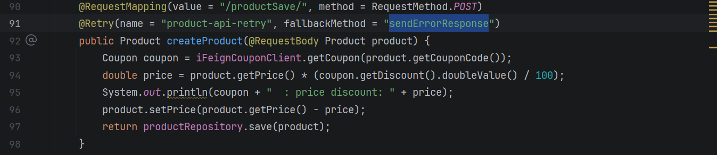
Dependency:
<dependency>
<groupId>org.springframework.boot</groupId>
<artifactId>spring-boot-starter-actuator</artifactId>
</dependency>
<!-- https://mvnrepository.com/artifact/io.github.resilience4j/resilience4j-spring-boot2 -->
<dependency>
<groupId>io.github.resilience4j</groupId>
<artifactId>resilience4j-spring-boot2</artifactId>
</dependency>
Signature:
@Retry(name = "product-api-retry", fallbackMethod = "sendErrorResponse")
Property:
resilience4j.retry.instances.product-api-retry.max-attempts=2
resilience4j.retry.instances.product-api-retry.wait-duration=3s
management.endpoint.health.show-details=always
management.endpoints.web.exposure.include=*

Sleuth: Responsible to adding tracing id and maintaining those trace-Id for each request.
Zipkin: Responsible to aggregating those trace-id and display in Dashboard.

