1) What is Spring Cloud?

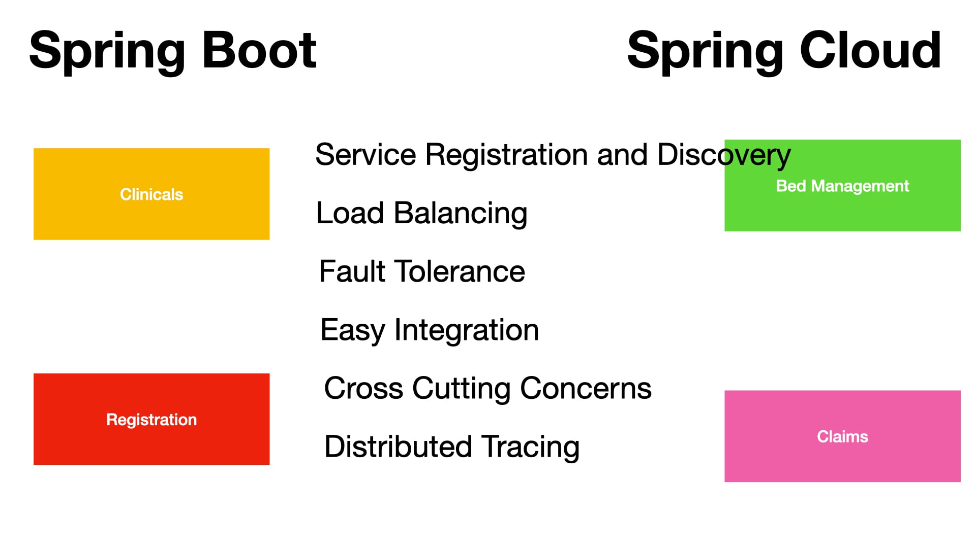

When we implement microservices using the modules provided by Spring Boot , there will be several non-functional requirements for these microservices as below -
Service Registration and Discovery - Each microservice will have to register itself with a centralized server so that the other microservices will be able to discover that particular micro service and communicate with it dynamically. Without that each microservice will be tightly coupled to another microservice it is using.
Load balancing - As the load to our microservices increases, there should be multiple instances of the same microservice running on different servers and the load should be balanced/distributed.
Fault Tolerant - If something goes wrong in one of these microservices then entire systems should not come down.They should be fault tolerant and handle the faults gracefully.
Easy integration - They should be able to communicate with each other easily through restful client API.
Cross cutting concerns - Are common requirements across microservices like security , authentication, authorization , logging etc . Instead of repeating those cross cutting concerns across these microservices we should have one place where we can address them.
Distributed Tracing - As the requests go from one microservice to another , we should be able to trace how the requests are going and how the responses are coming back.When something goes wrong we can exactly pinpoint where it went wrong using distributed tracing .
All these are not available in Spring Boot.That is where the Spring Cloud comes in. Spring cloud is a collection of open source components that help us implement all these non functional requirements and more.
Service registration and discovery is provided by Eureka
Load Balancing is provided by Ribbon
Fault tolerance is provided Hystrix
Feign Client which will help us create restful clients in a super easy way
The cross cutting concerns are configured using a Zuul proxy gateway .Whatever is common across our microservices we can implement them in a single place in a single Zuul Server.
Sleuth allows us to do distributed tracing as the requests go from one micro service to another.
We use Sleuth and Zipkin together. Zipkin will give us a dashboard where we can see and track the requests from one micro service to another.

2) What is Eureka and how do we use it?
There will be multiple Microservices that require or communicate with each other through Restful calls . To do that the consumers will have to know the URL, the port number etc in order to communicate with the appropriate microservice.
This will be very hard to maintain as there could be multiple instances of the same microservices running. That is where spring cloud offers naming services or a naming server called Eureka. Micro services will register themselves as soon as they start or come up .They will register using an application name or application ID which is a unique Id for each application and also the URL that is required to communicate with them.
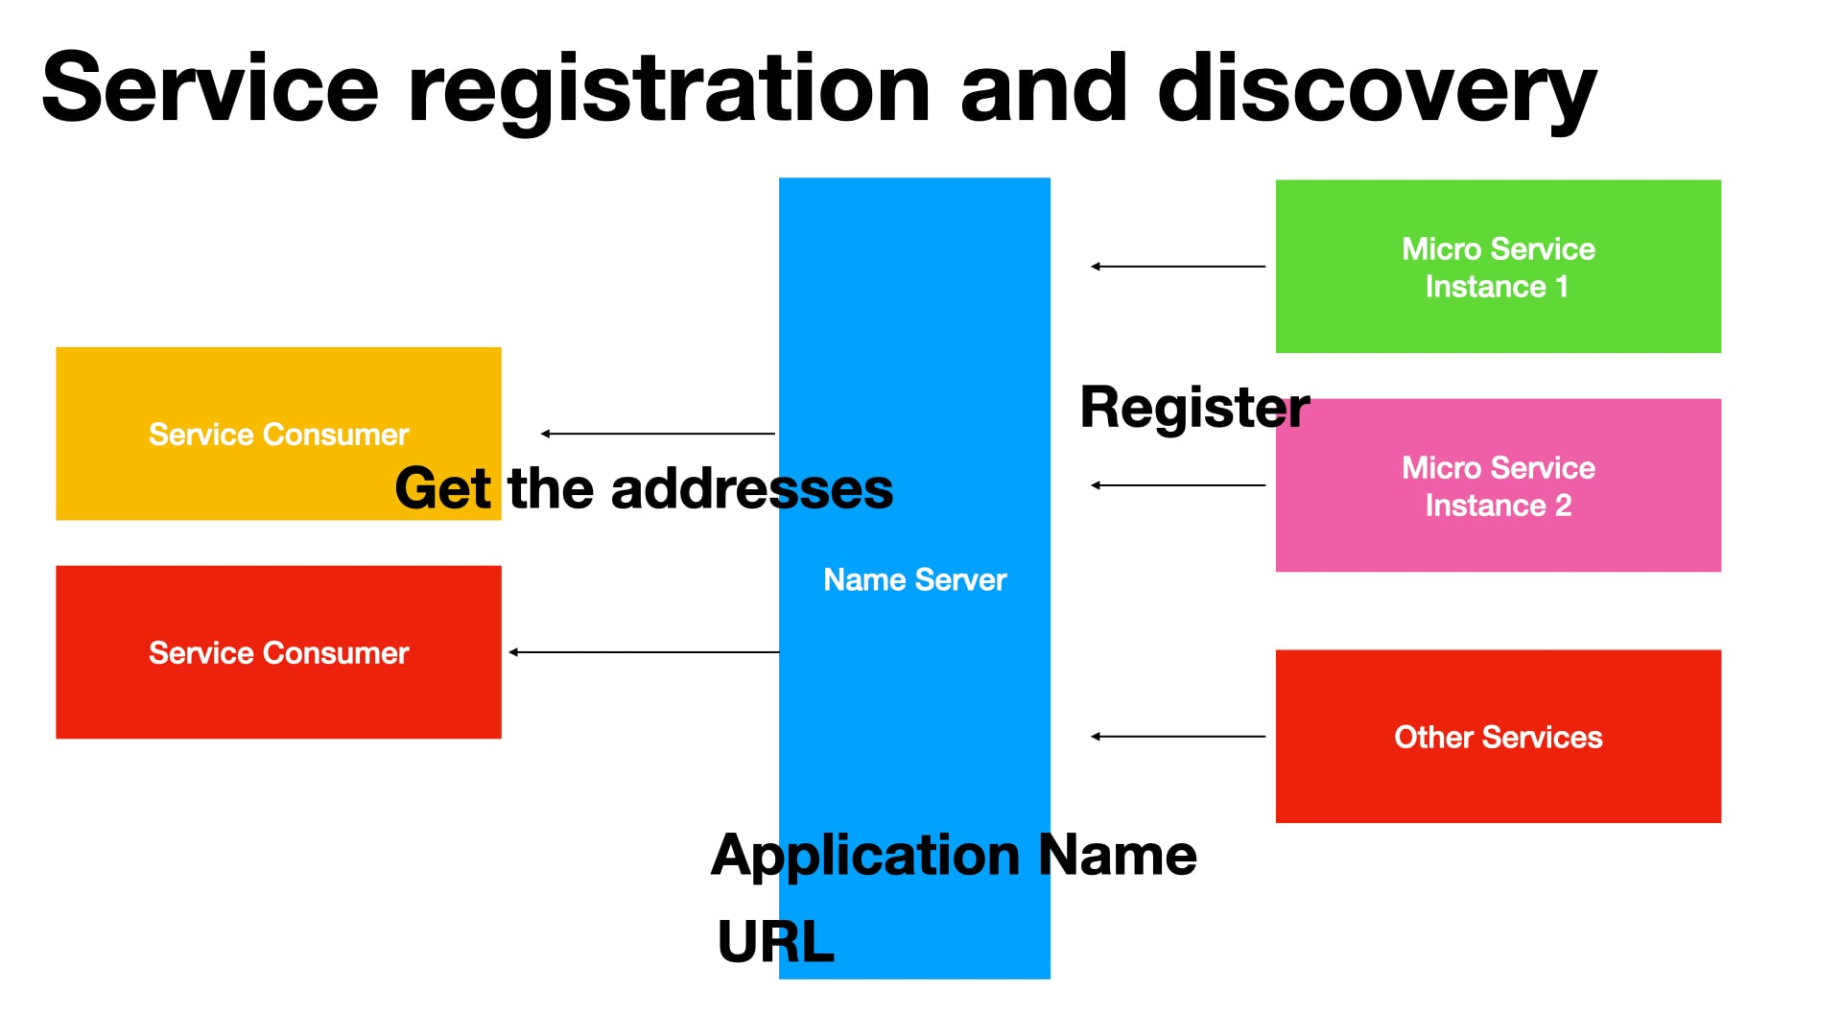

Service consumers when they come up can communicate with the naming server to fetch those details based on just the application name. As long as the consumers know the unique application ID of the provider microservice they can fetch the URL and Port number.
All that communication details will be maintained by the Eureka server .Eureka server will decouple these microservices and they can communicate with any other microservice through registration and discovery without maintaining any URL,Port Etc that are required otherwise.
We'll be registering our applications to start with the Eureka server .

How to use Eureka?
Create an Eureka server of our own .Create a project with the Eureka Server dependency from Spring cloud starters from Netflix

<dependency>
<groupId>org.springframework.cloud</groupId>
<artifactId>spring-cloud-starter-netflix-eureka-server</artifactId>
</dependency>
And on the Application class of this project add @EnableEurekaServer annotation that tells spring that this particular project is a Eureka Server

And on the clients we use the following:
<dependency>
<groupId>org.springframework.cloud</groupId>
<artifactId>spring-cloud-starter-netflix-eureka-client</artifactId>
</dependency>

@EnableEurekaClient

spring.application.name=coupon-service
eureka.client.service-url.defaultZone=http://localhost:8761/eureka/
Once you do that and you start your application automatically these applications will register themselves with the Eureka server using the application name which we provide in the application or properties.

And then other micro services can use this name and communicate with that particular micro service. We provide the Eureka server URL as a property in the client projects as well.

3) What is Ribbon or What and how to use client side load balancing?

As the number of requests to our micro services increase we will be scaling our application across different servers.There will be multiple instances of the same microservice running on different servers so that the client can make calls to one of these instances as required.
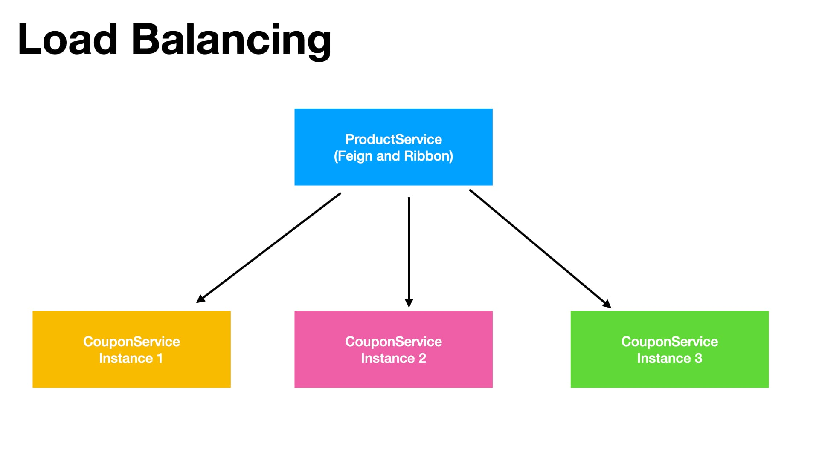

Client side Load balancing is done using Ribbon from Spring cloud .Feign client also a Spring Cloud component which allows easy Rest Client creation works with Ribbon and the load will be balanced from the client side itself.The client will decide to which instance the request should go to.
Configuring Ribbon is easy in the pom.xml.Just Add
<dependency>
<groupId>org.springframework.cloud</groupId>
<artifactId>spring-cloud-starter-netflix-ribbon</artifactId>
</dependency>

4) What is Zuul Proxy

There will be some non-functional requirements that are common across micro services.
For example security where the client needs to authenticate and authorize with a particular microservice ,tracing where we need to trace the request as it goes from one micro service to another, service aggregation, i.e if we have calls that need to go from the client to multiple micro services . Instead of the client making those separate calls we can have a service aggregator component in one place that can make all those calls .For example Rate Limits.If you want to charge your client based on the request like Amazon or Microsoft azure cloud you can apply all those rate limits.If we have a centralized place so all these non-functional requirements that are common across microservices can go into each micro service which will repeat the same code the same components across microservices are we can put these cross cutting concerns in one place and that is where the Zuul proxy component of spring cloud comes in.

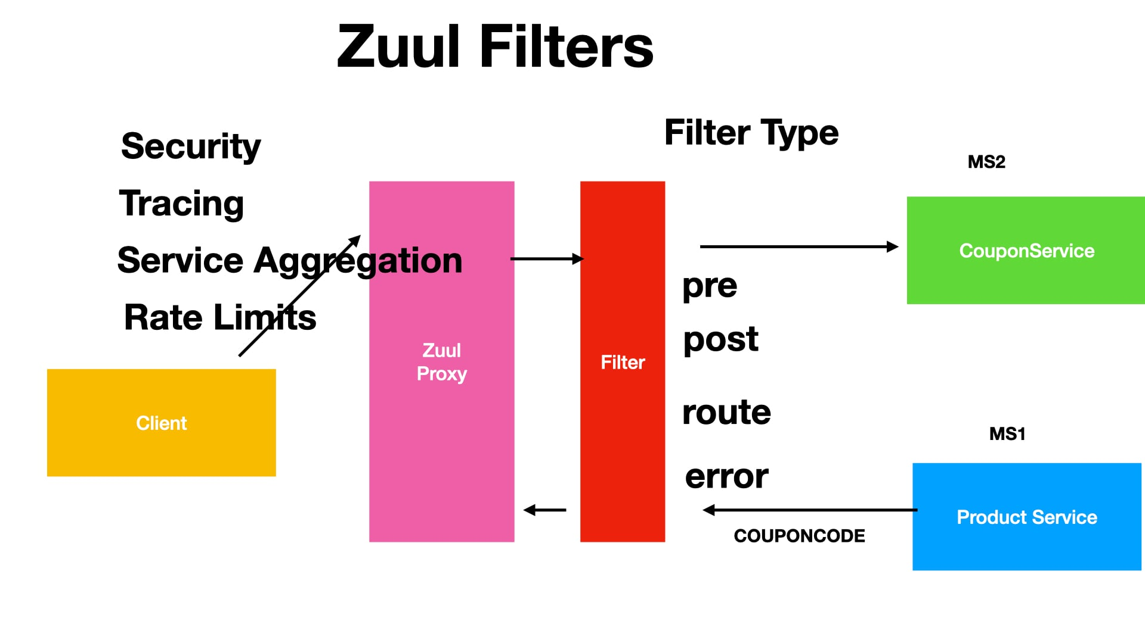

Once we create a Zuul proxy server all the requests will route through the Zuul proxy gateway the client requests will go through the Zuul proxy .We can implement Security, Tracing , Service aggregation and all that inside the Zuul proxy .
We create a Zuul proxy server just like Eureka Server . Add Netflix Zuul dependency and then it will register itself with Eureka . Zuul will be just like any other micro service; it will register itself with Eureka when it starts and other microservices can start using it.
5) What is Hystrix
When we implement micro services architecture there will be a lot of microservices running.And if one of these micro services goes down for some reason the entire system should not collapse.The errors should be handled gracefully and the minimum functionality should be delivered to the end user.That is where this spring cloud hystrix component comes in and it provides fault tolerance capabilities.

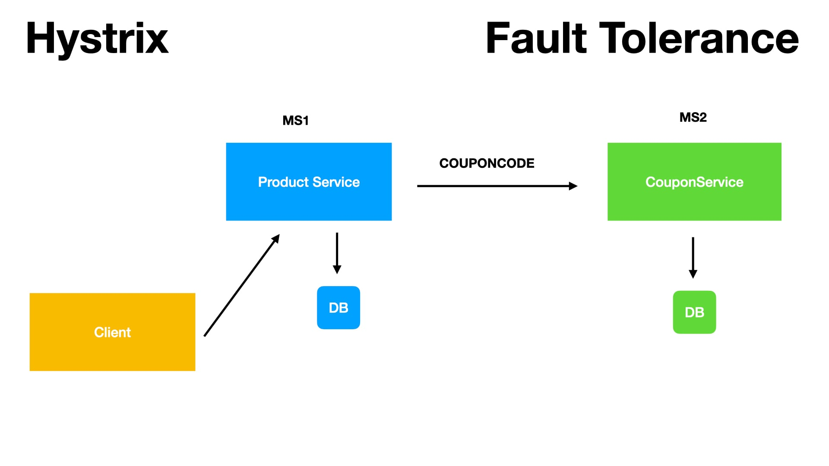

Steps to use Hystrix:
Add Hystrix dependency to the project
<dependency>
<groupId>org.springframework.cloud</groupId>
<artifactId>spring-cloud-starter-netflix-hystrix</artifactId>
</dependency>

Second Step enable hystrix by using the following on application class

@EnableHystrix

Create a Fault tolerant method in the REST controllers

public Product sendErrorResponse(Product product) {
…….
And use it on a method where the fault might occur

@HystrixCommand(fallbackMethod = "sendErrorResponse")
@RequestMapping(value = "/products", method = RequestMethod.POST)
public Product create(@RequestBody Product product)

When something goes wrong inside of this method this is the fault tolerant method that will be invoked by Hystrix and whatever response this method returns that will be sent back to the client .

Hystrix also offers a super cool dashboard. To us it we add the following to pom.xml

<dependency>
<groupId>org.springframework.cloud</groupId>
<artifactId>spring-cloud-starter-netflix-hystrix-dashboard</artifactId>
</dependency>

Add @EnableHystrixDashboard on the Application class

Hystrix metrics can then be seen on the hystrix dashboard from a browser.

5) What are Sleuth and Zipkin
It is very important that we should be able to trace the microservices requests as they flow from one service to another and if they fail where exactly they failed.Sleuth and Zipkin provide these distributor tracing capabilities.

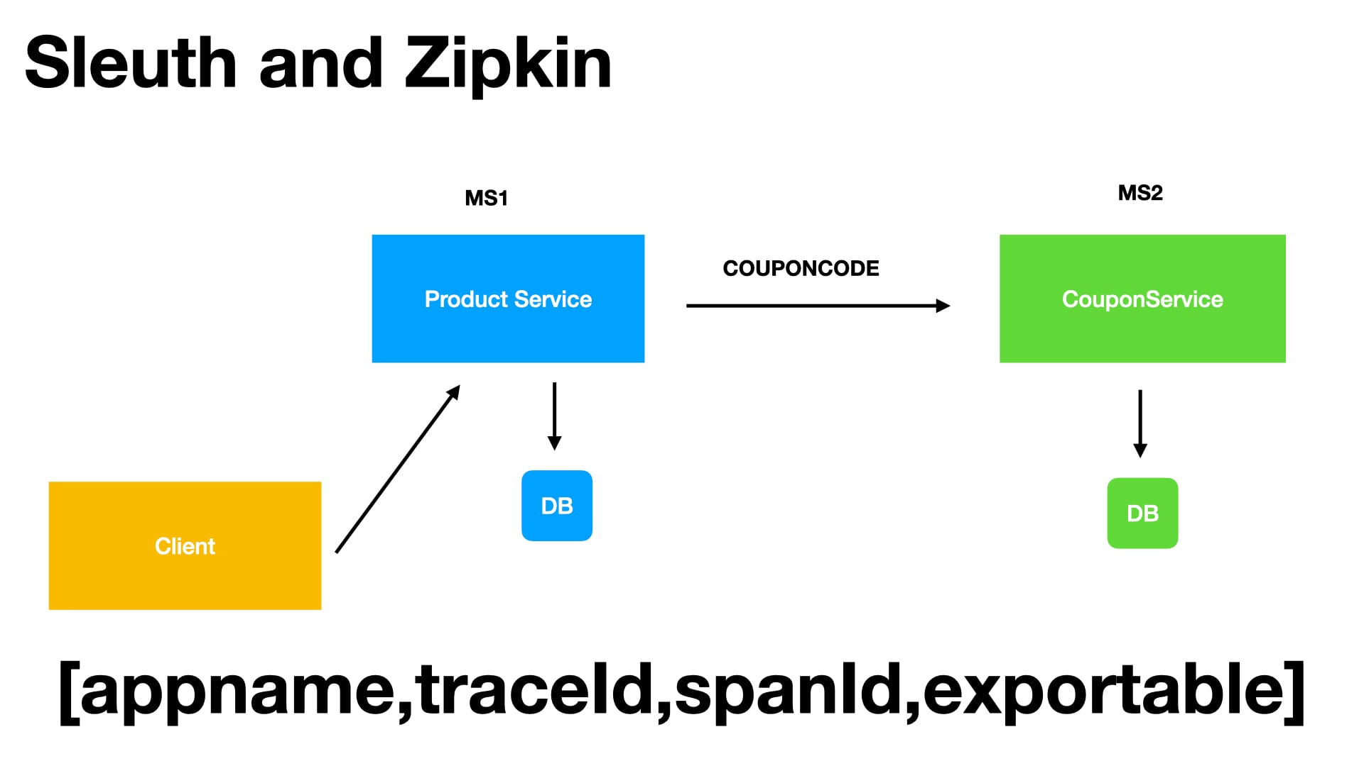
As our requests flow from micro service to another Sleuth is responsible for adding a trace id for these requests.That trace id will show up in the logs .That way we can track our request across micro services and we can easily figure out where things are going wrong if they do.
Zipkin is responsible for providing a dashboard where all traces by sleuth are exported and it will display them beautifully.

To use Sleuth just add the following to pom
<dependency>
<groupId>org.springframework.cloud</groupId>
<artifactId>spring-cloud-starter-sleuth</artifactId>
</dependency>

And for Zipkin add
<dependency>
<groupId>org.springframework.cloud</groupId>
<artifactId>spring-cloud-starter-zipkin</artifactId>
</dependency>
Download and run Zipkin server
curl -sSL https://zipkin.io/quickstart.sh | bash -s

java -jar zipkin.jar

6) How to use Centralized Configuration
Every Microservice application will have associated configuration.This could be the database connection information , the message broker information if it is a messaging application and application specific configuration as well.And this information will be different for different environments.
On a local developer's machine a database that he wants to connect is different from the one dev environment shared by all the developers and the testing team will have their own database servers their own message brokers and also application specific configuration.Same with staging before our application is pushed to production finally the production will have its own set of databases, message brokers etc. Each application can have multiple configurations as well, not just one.So it is our responsibility to make sure the right configuration information is being pushed across these environments.
That is where centralized configuration comes in to make our job as a developer easy. Spring cloud provides a Configuration Server. All the micro service applications will ask this configuration server for the configuration information for a particular environment. On dev environments the configuration server is responsible for giving them the development specific configuration , which will have the dev specific databases , dev specific JMS brokers etc. And if they're deployed to staging or production the appropriate configuration should be given by this configuration server.
How will the configuration server know the correct configuration for an environment?
We will push all the configuration to the GIT repository. The configuration server knows how to connect to the GIT or SVN repository and it will pull the configuration information and share it across the microservices.We'll be simply creating the configuration as developers. We can do it on the local machine and it is our responsibility to put that configuration into this GIT repository.
All the microservices will have the configuration available . The configuration server is responsible for maintaining and handing over the correct configuration for a correct micros service.

7) What is Spring Cloud Bus
When configurations are updated on the fly those changes will not be loaded by the microservice applications running until we restart the application or use a spring boot actuator refresh url for each micro service.Once you enable the spring cloud bus , with a single refresh at the cloud bus level all the micro services will get the latest configuration values that are updated.Spring cloud bus uses messaging brokers to communicate these changes to the applications.

