29. Create a SAM Project
1. can we create a spring boot application using sam cli command?
Ans: Yes, but with an important detail: The standard sam init command does not natively include a dedicated Spring Boot boilerplate template out of the box. By default, running sam init and selecting Java will generate a plain, lightweight Java project using the standard AWS Lambda SDK.
However, you can absolutely create and deploy a Spring Boot application (typically using Spring Cloud Function or the AWS Serverless Java Container) via the AWS SAM CLI using custom templates or by adapting a default structure.
/>sam init --location gh:maciejwalkowiak/aws-sam-spring-cloud-function-template
Sam init | sam init --location gh:maciejwalkowiak/aws-sam-spring-cloud-function-template
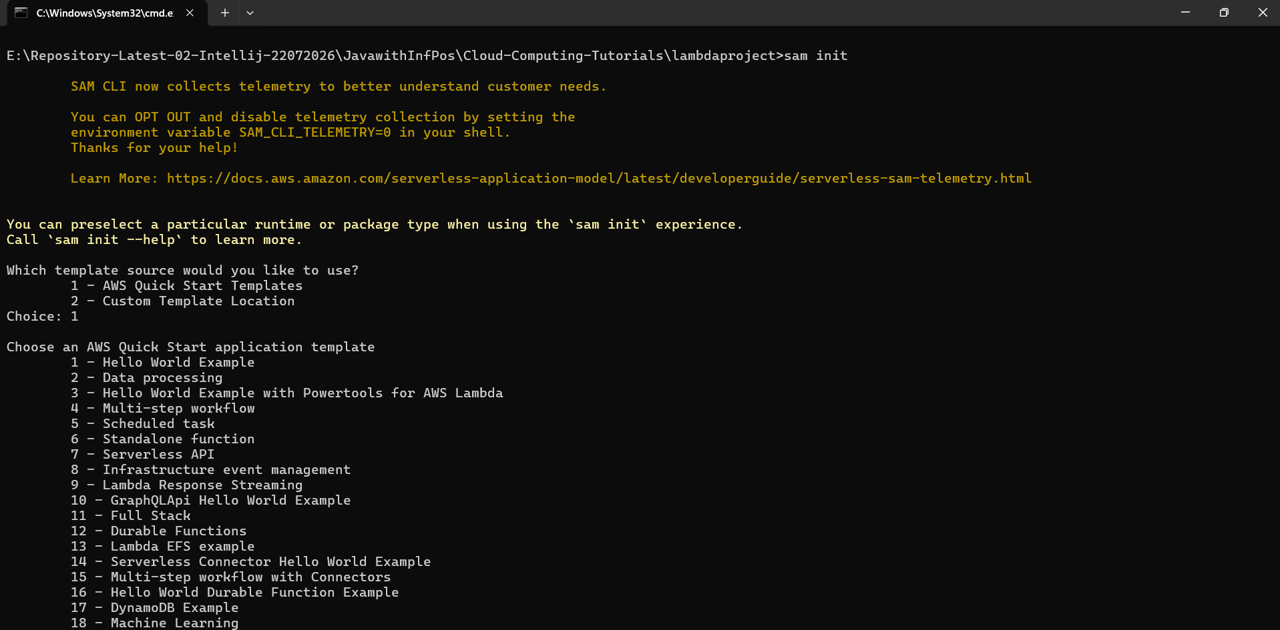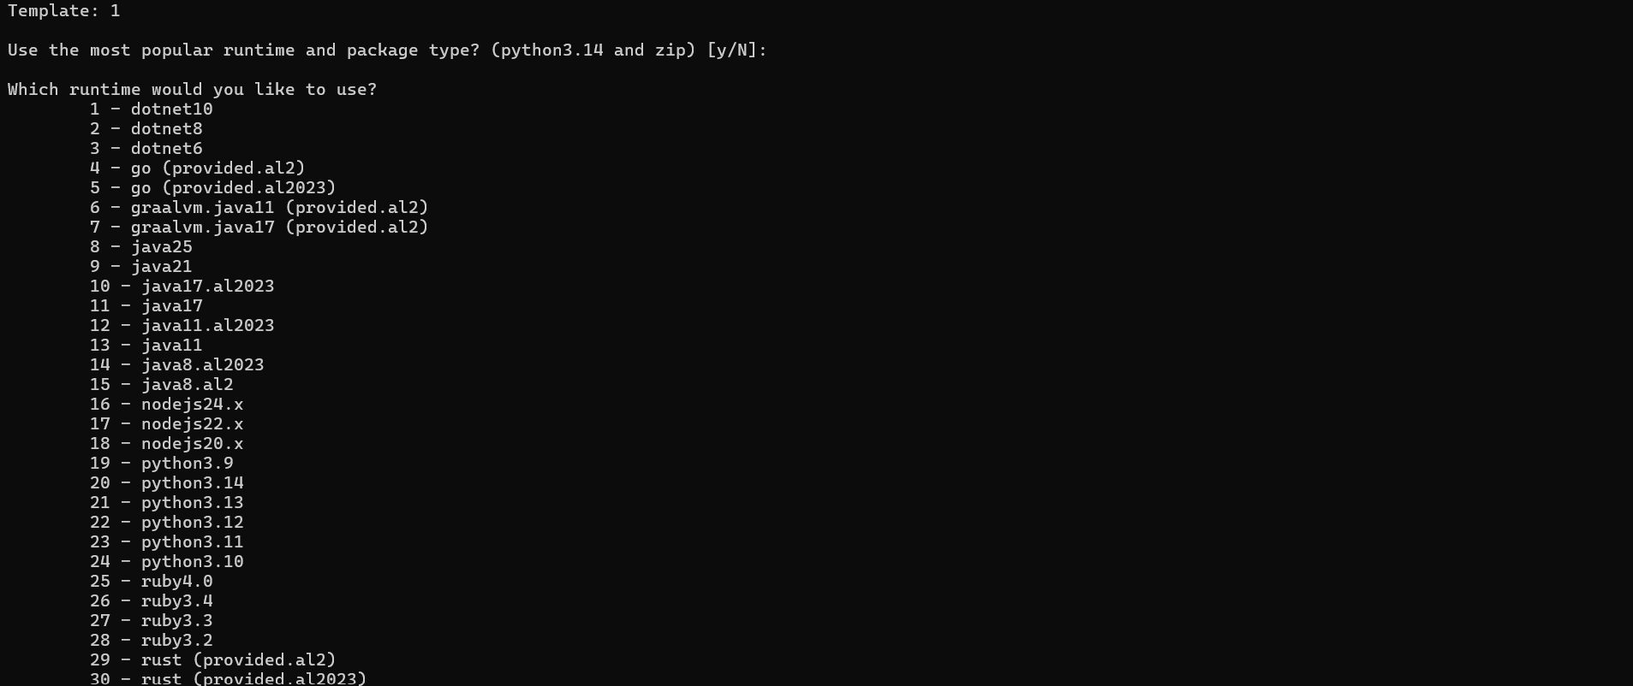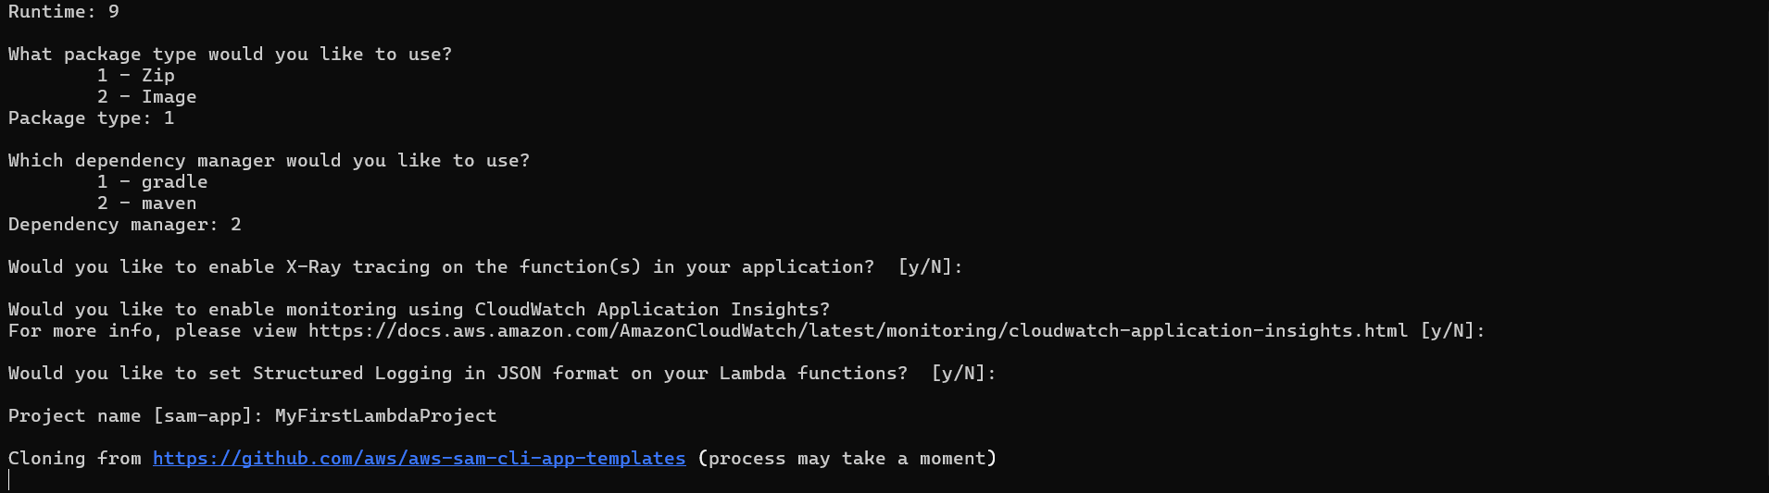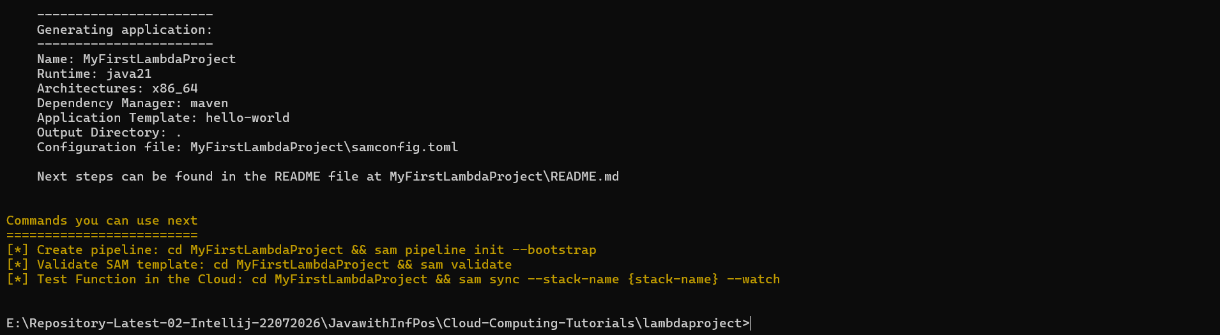 | 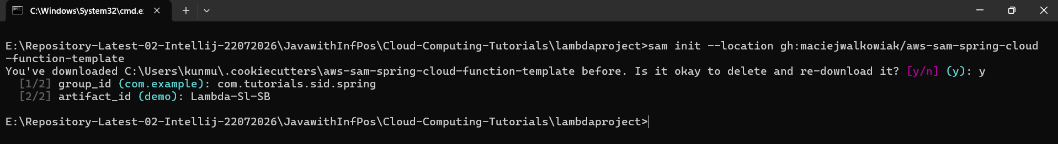  group_id (com.example): com.tutorials.sid.spring  artifact_id (demo): Lambda-Sl-SB  Note: if the artifact_id is too long then use the small name.

\>sam build
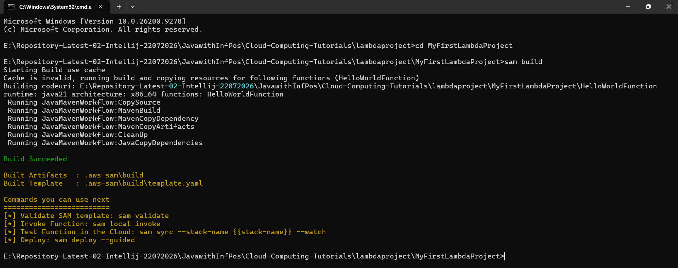
AWS Lambda for Spring Boot application.
https://www.baeldung.com/spring-boot-aws-lambda
https://collin-smith.medium.com/creating-a-java-21-spring-boot-3-application-on-aws-lambda-48be652fc93f
https://docs.spring.io/spring-cloud-function/reference/adapters/aws-intro.html
\>sam deploy –guided
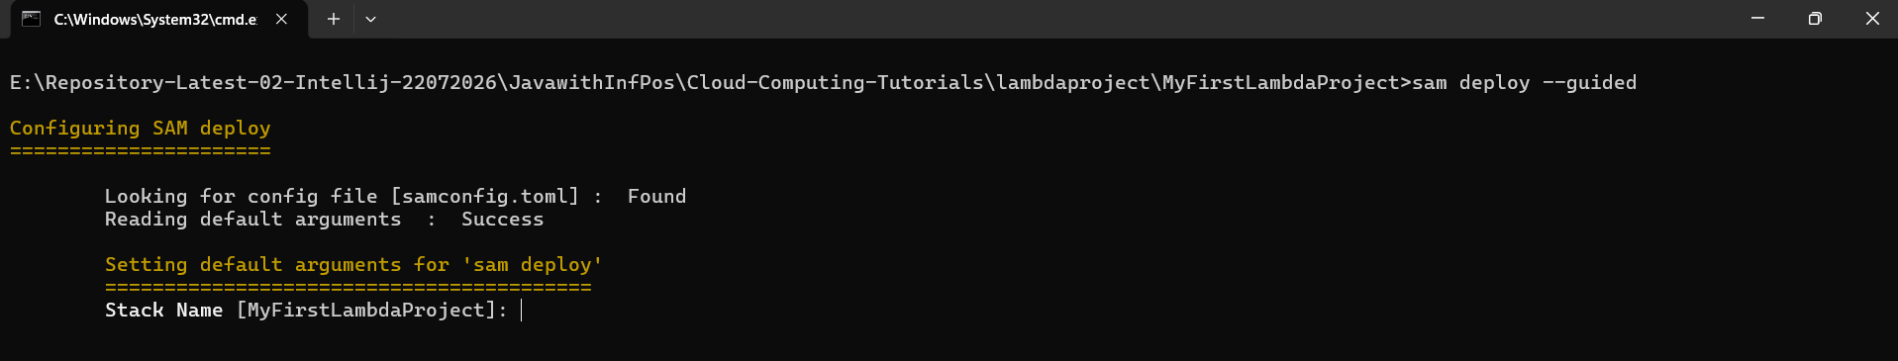
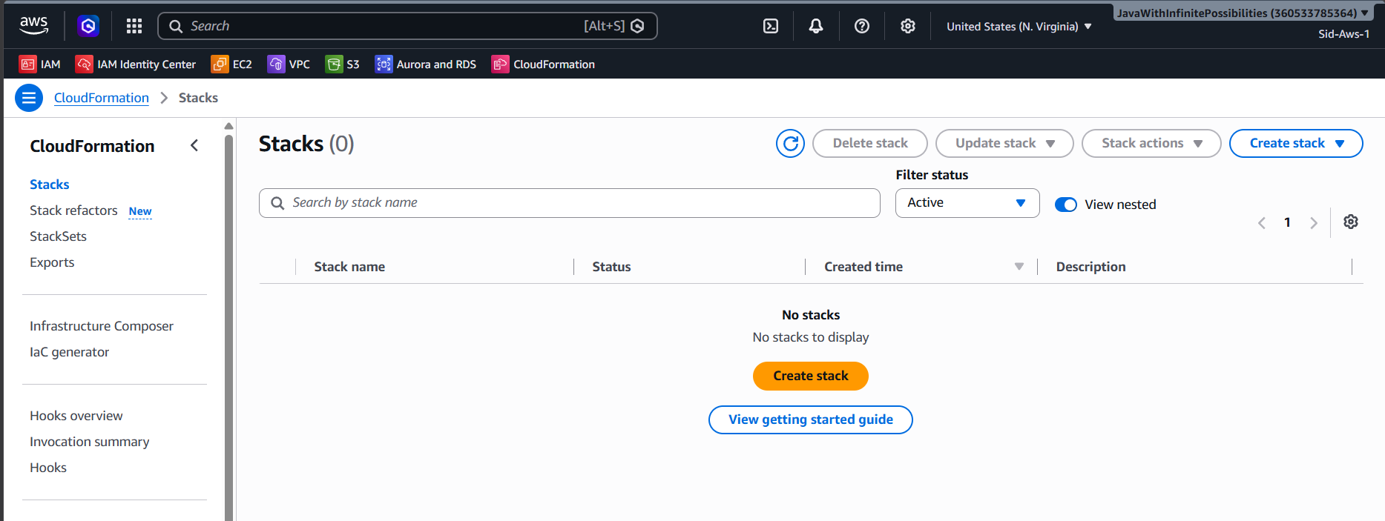
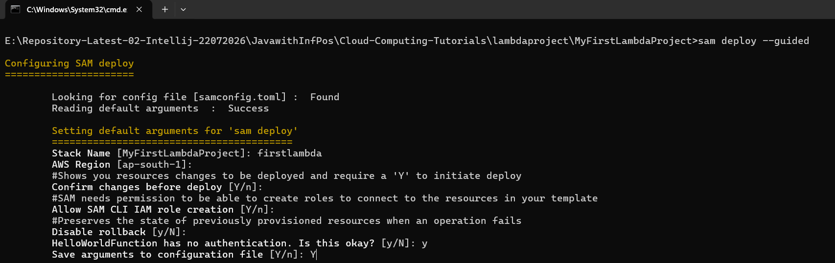

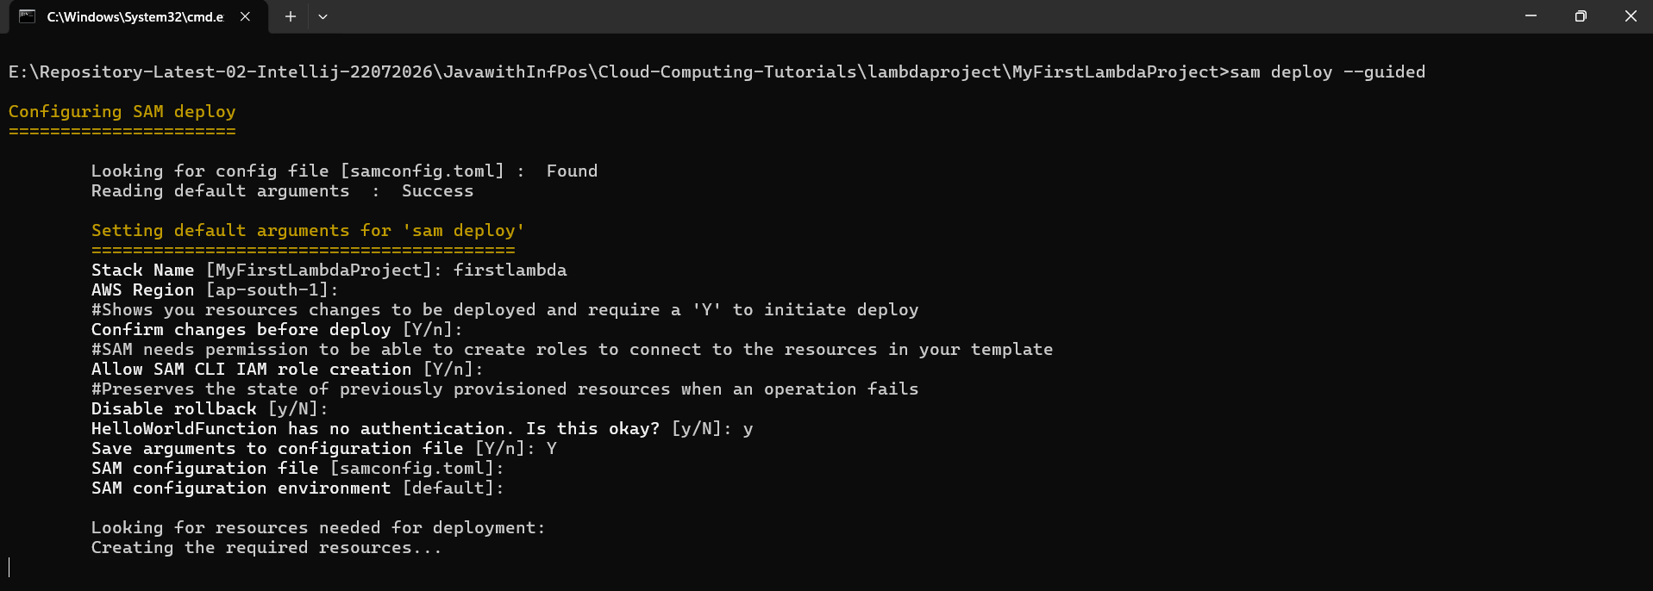
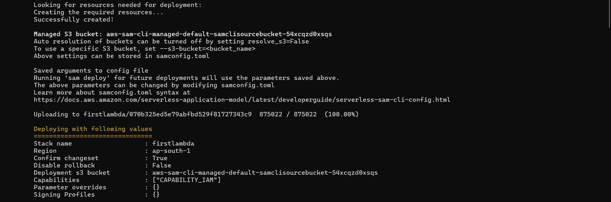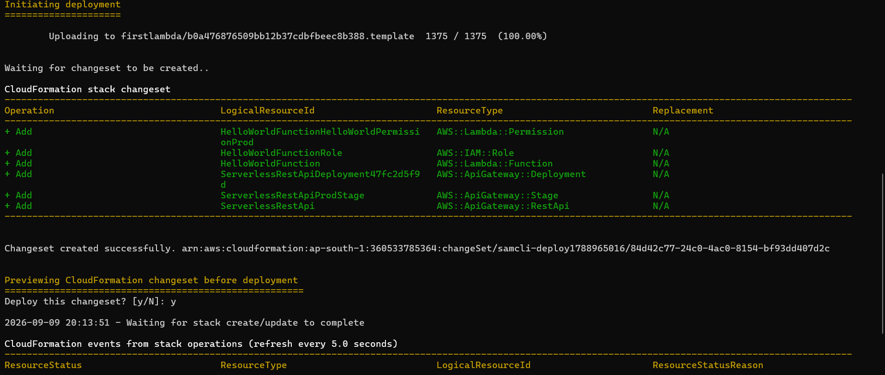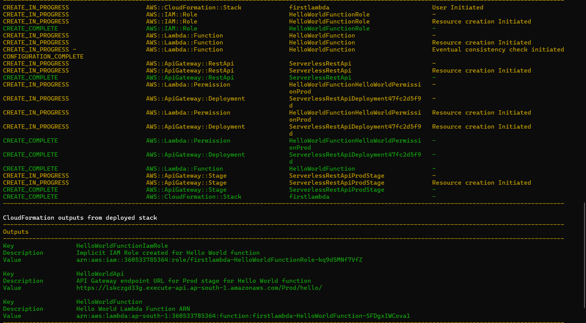
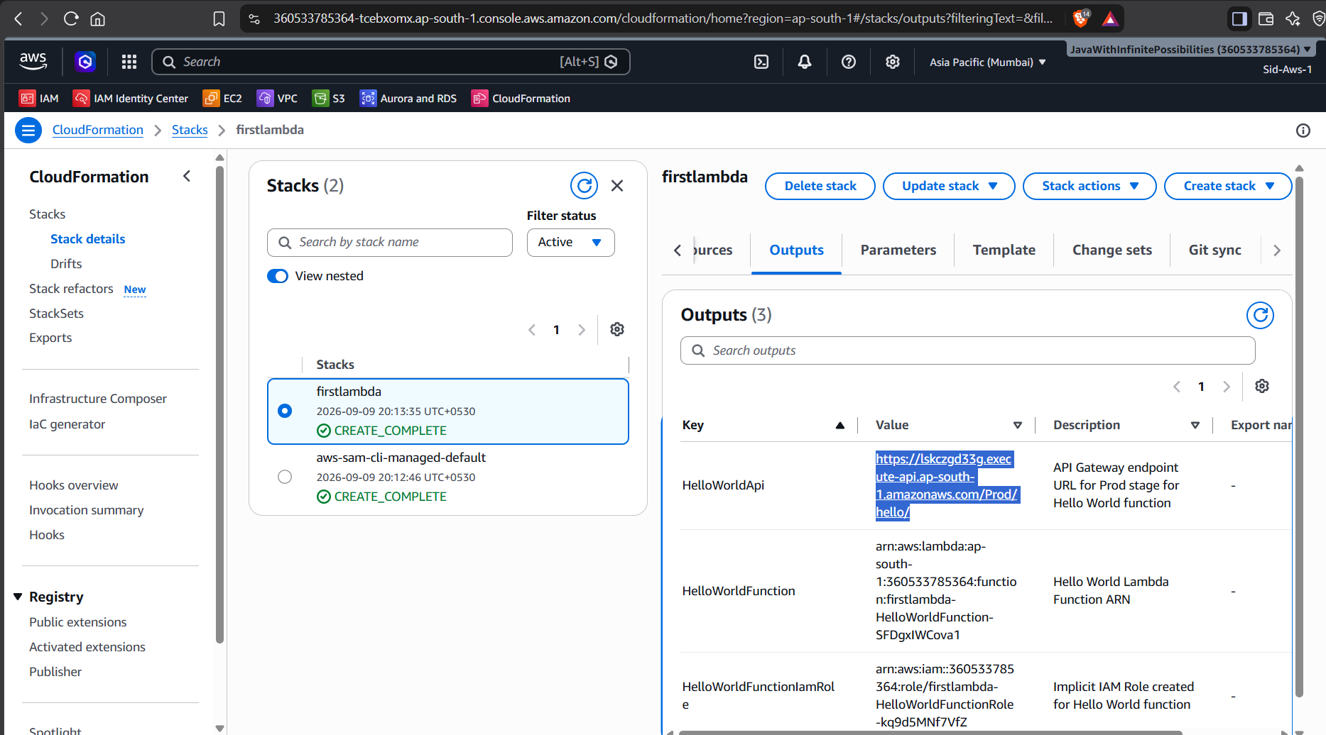
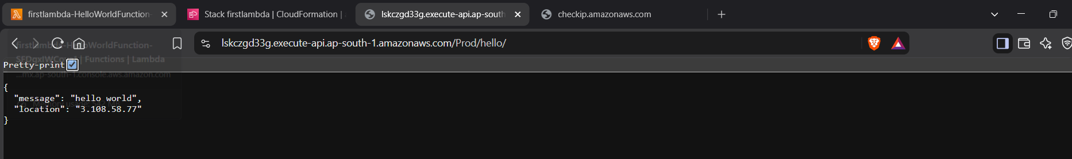
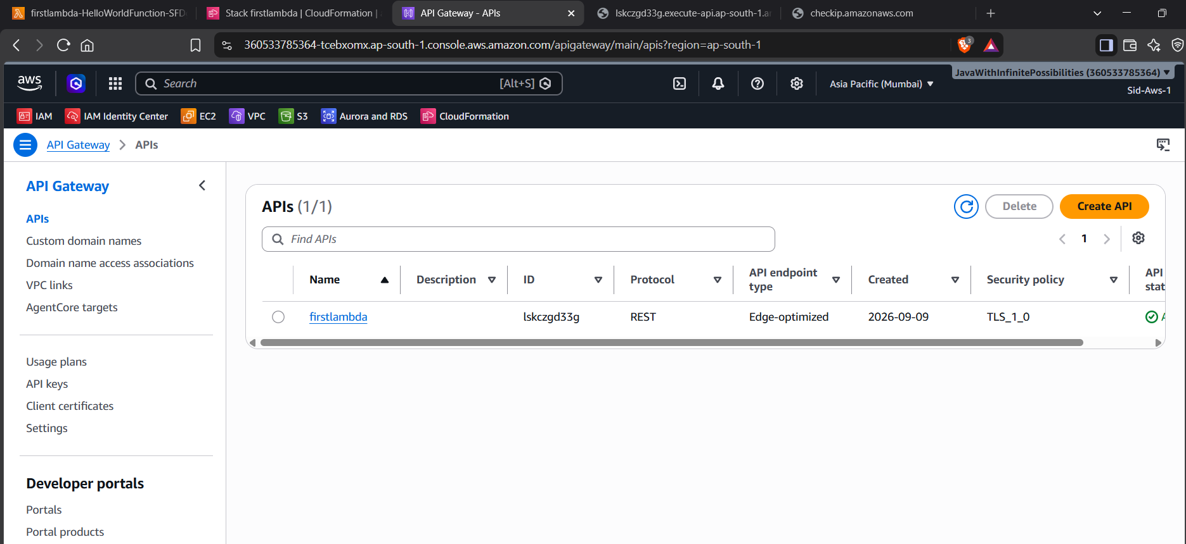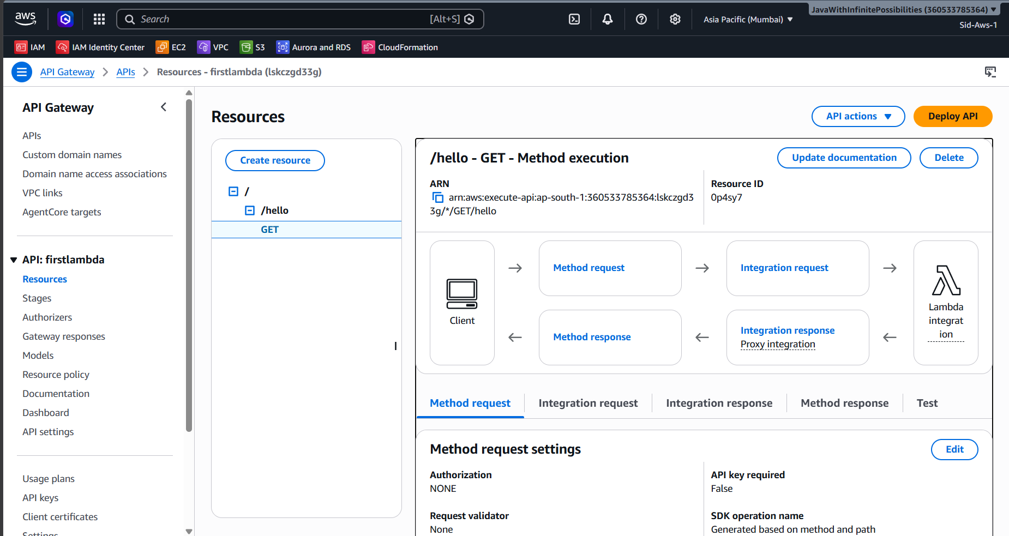
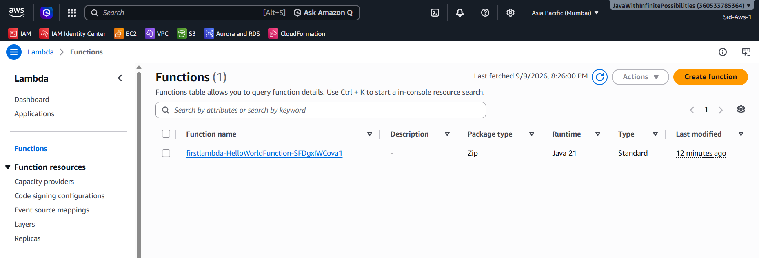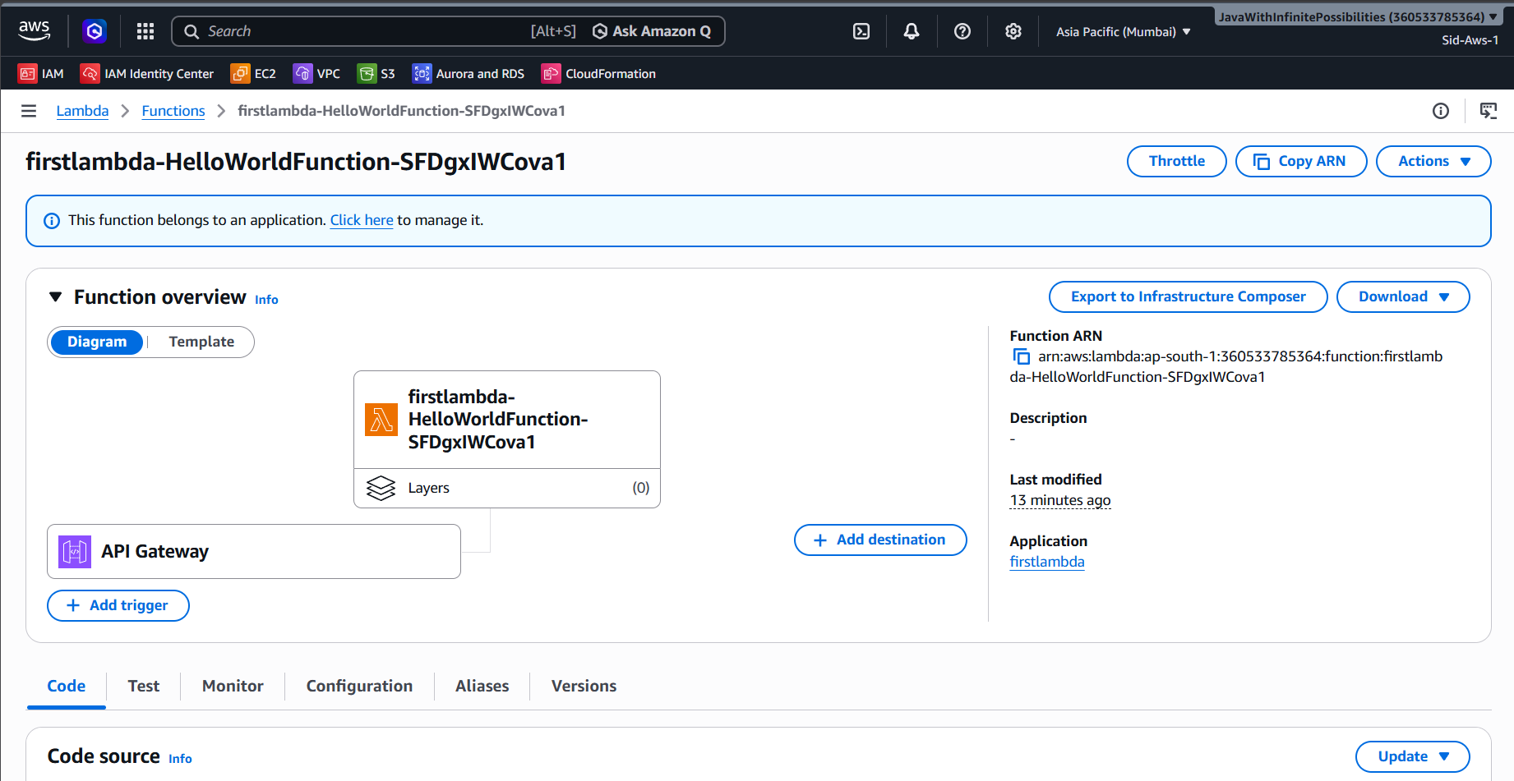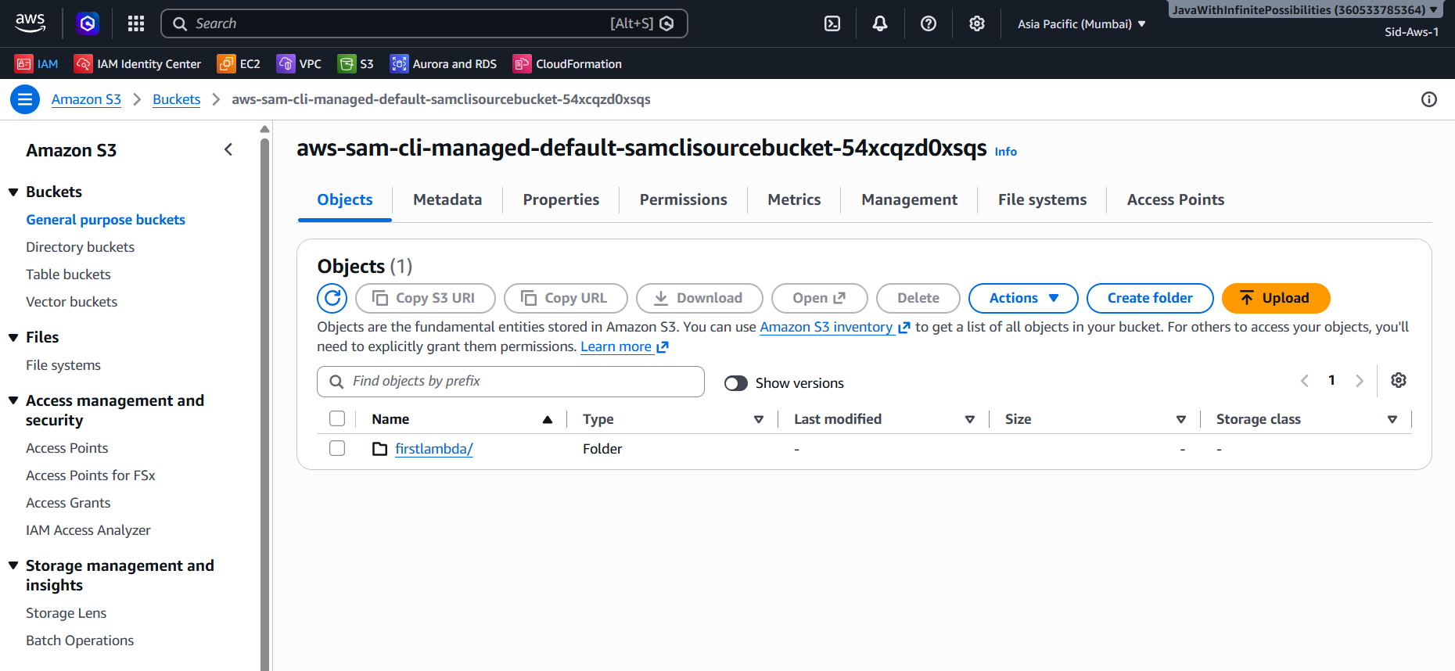

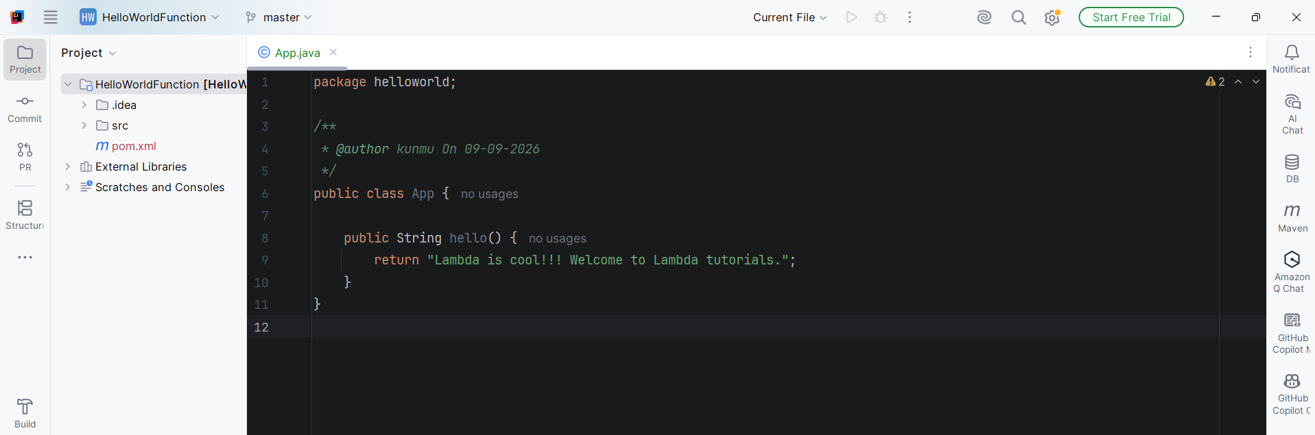
With the latest change
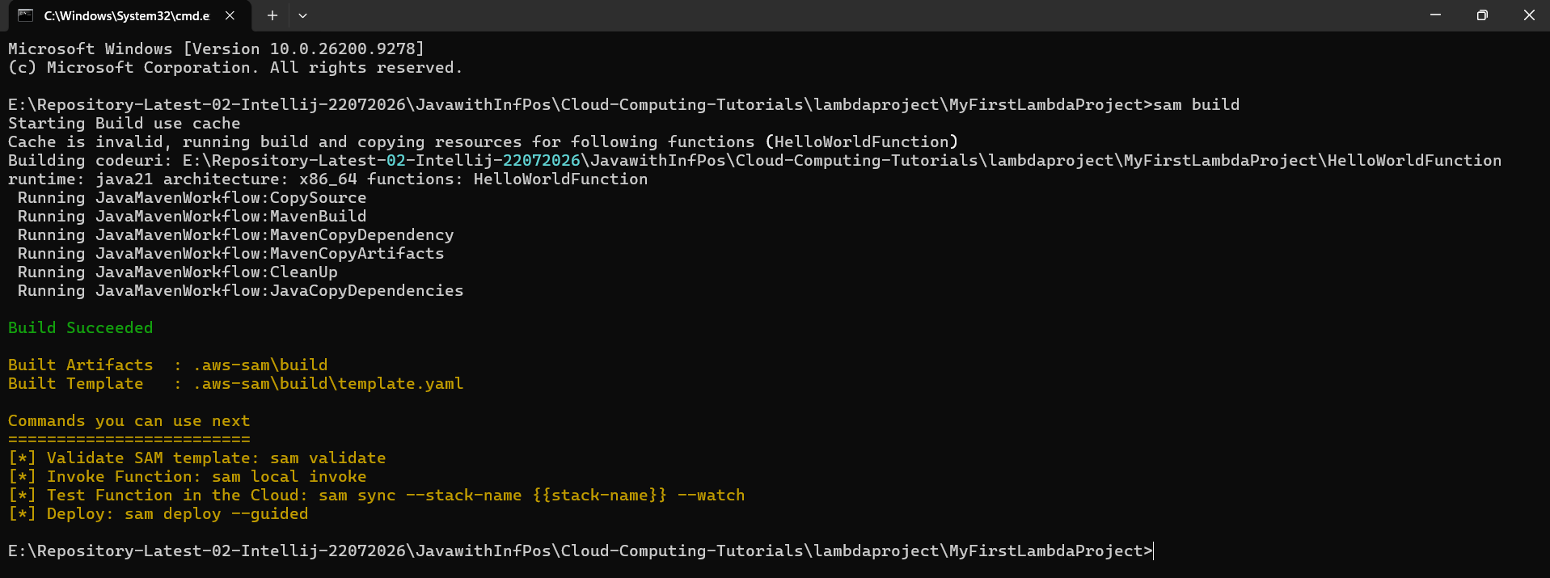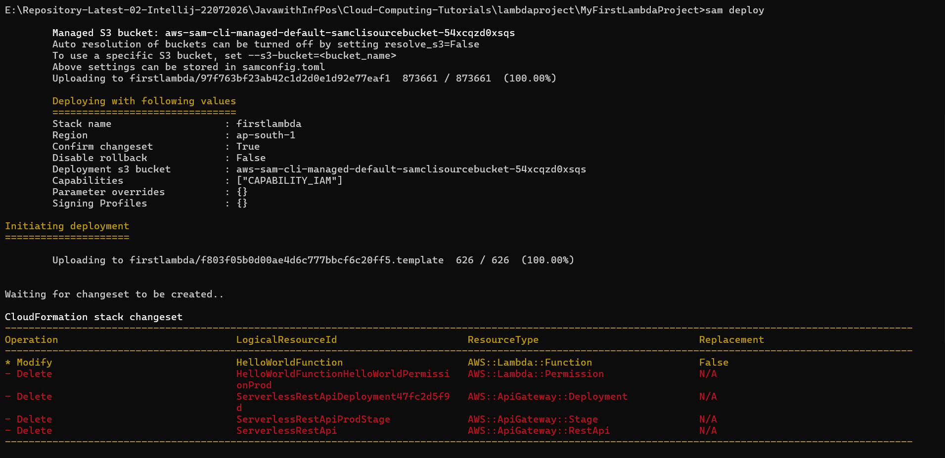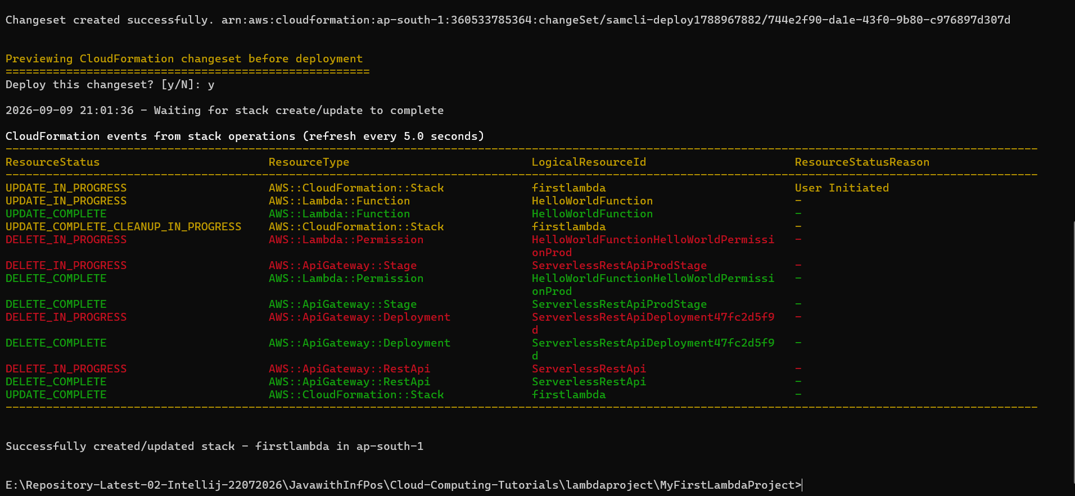
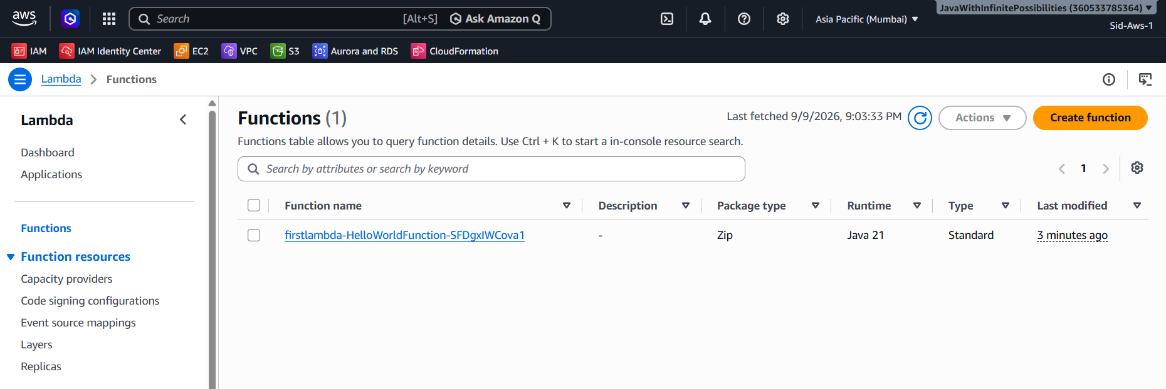
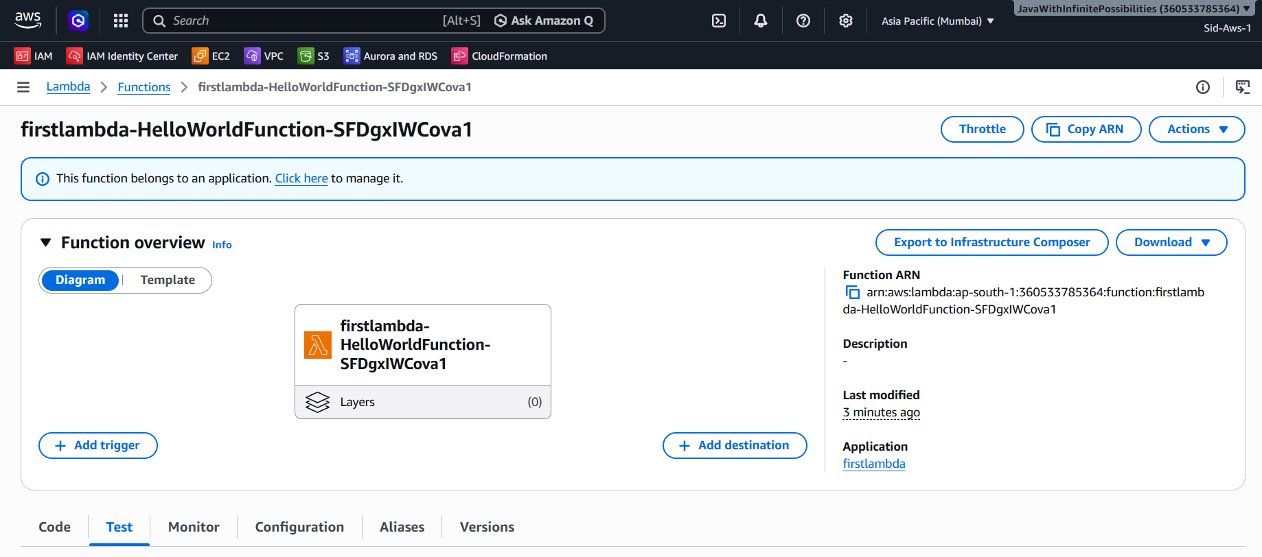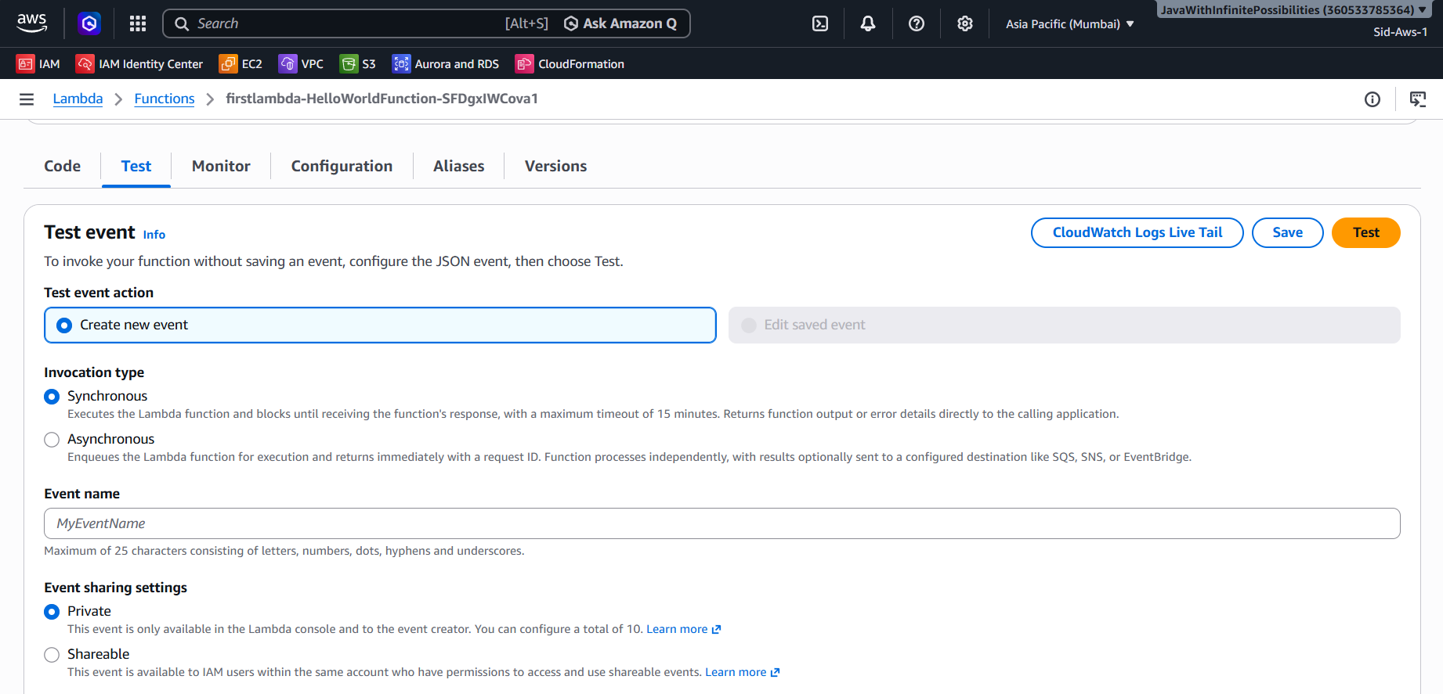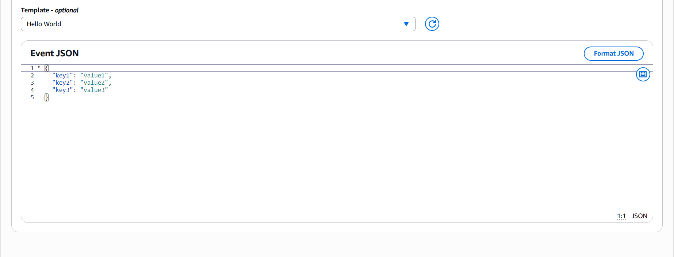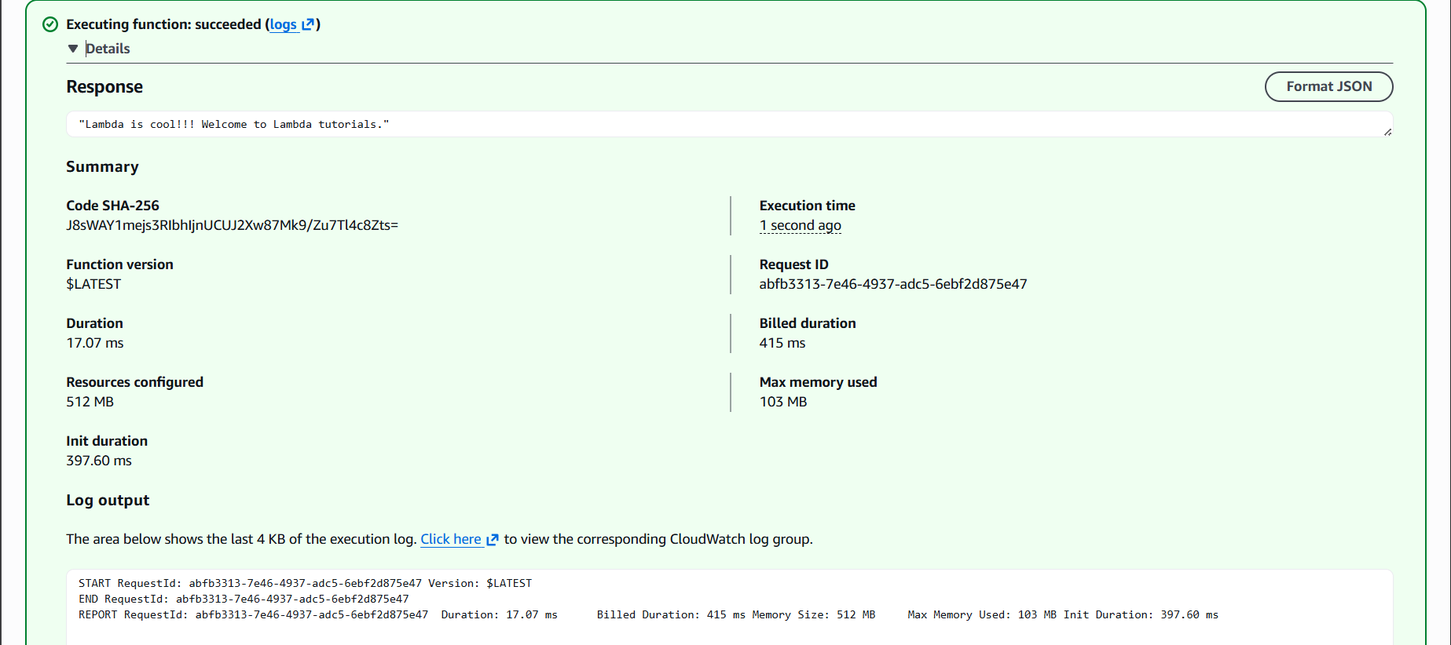
With Parameter:
