16. AWS Identity and Access Management (IAM)
Authentication: Authentication is nothing but the validating the person so that’s essentially proving that you are who you say you are. Example: User name and password.
Authorization: Authorization is where we either are allowed or denied access to resources.
1.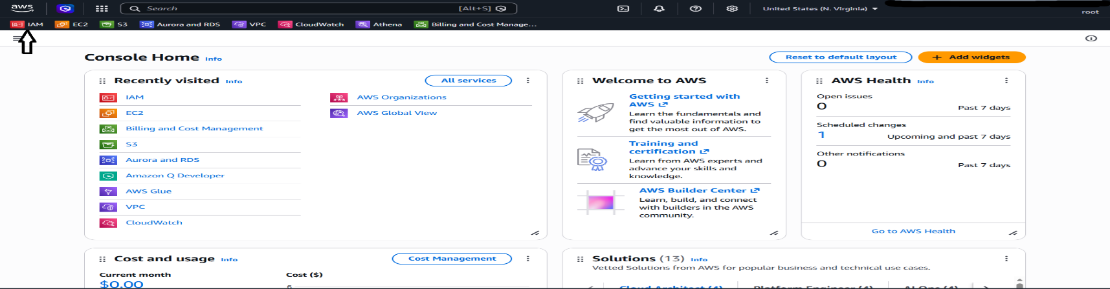
2.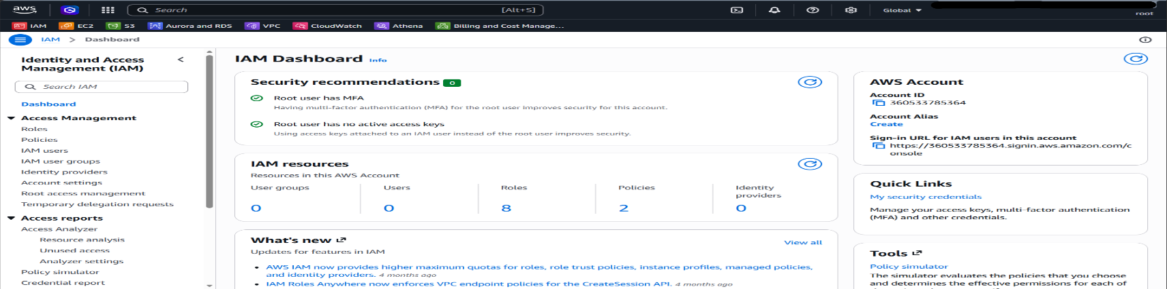
3.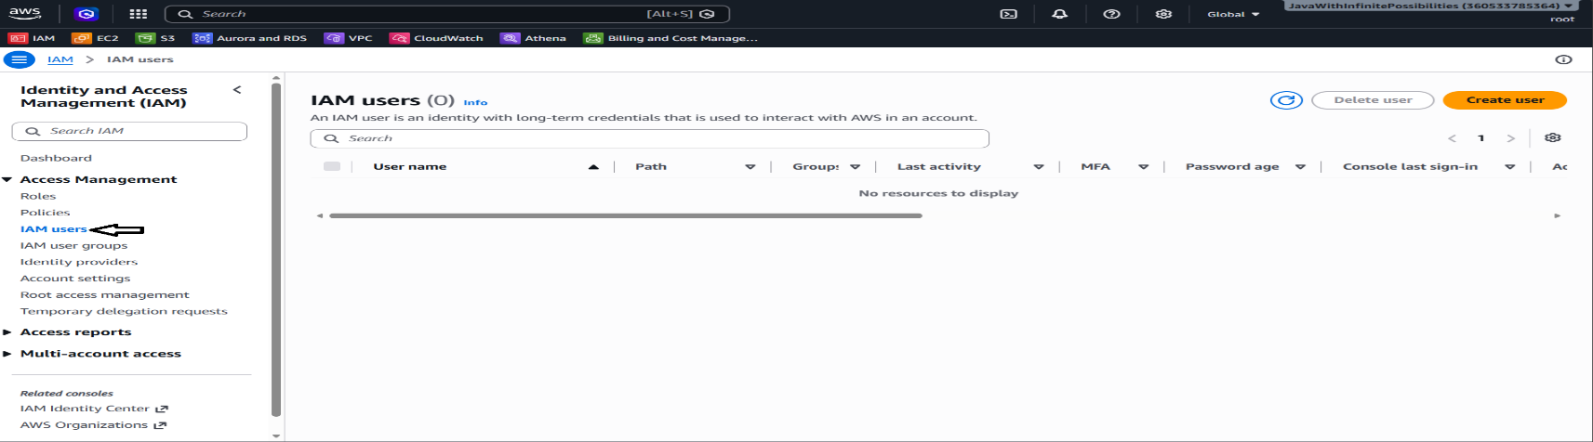
4.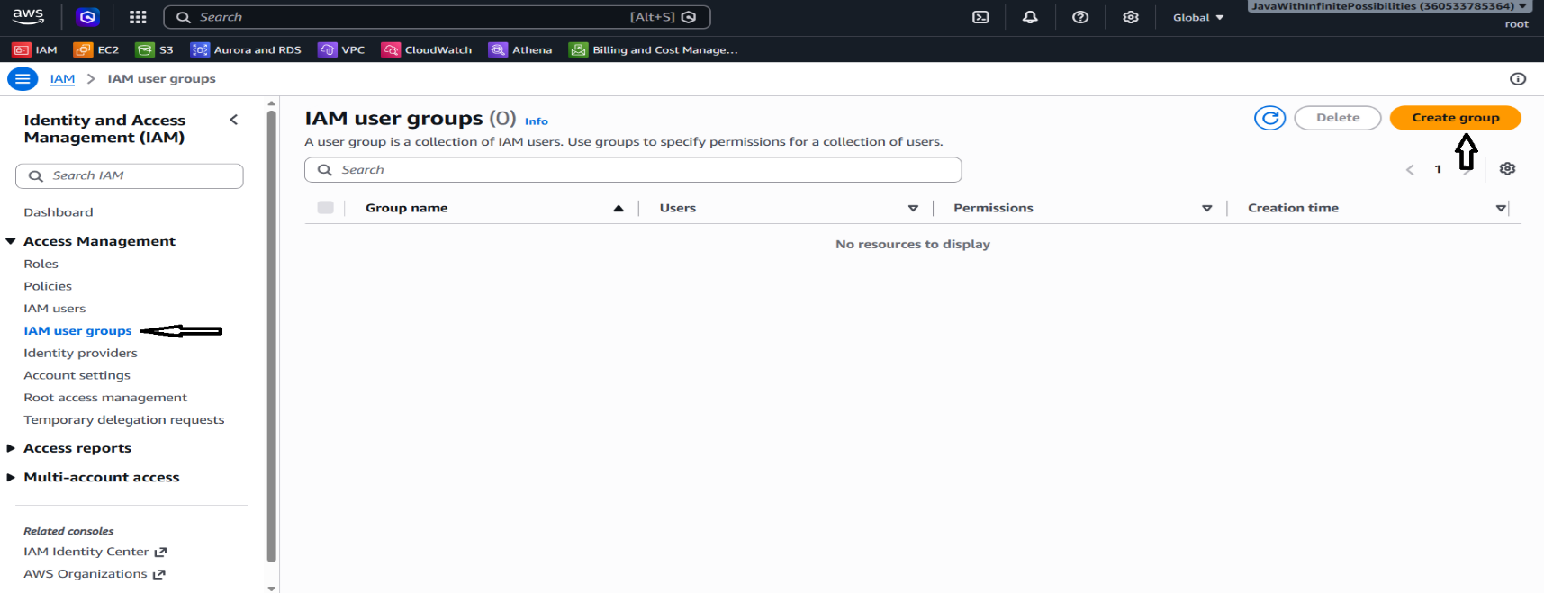
5.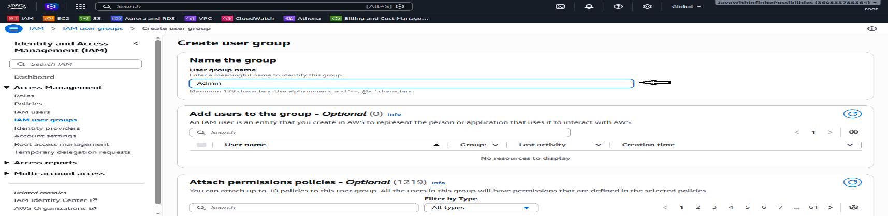
6. Admin policy which is a predefined policy.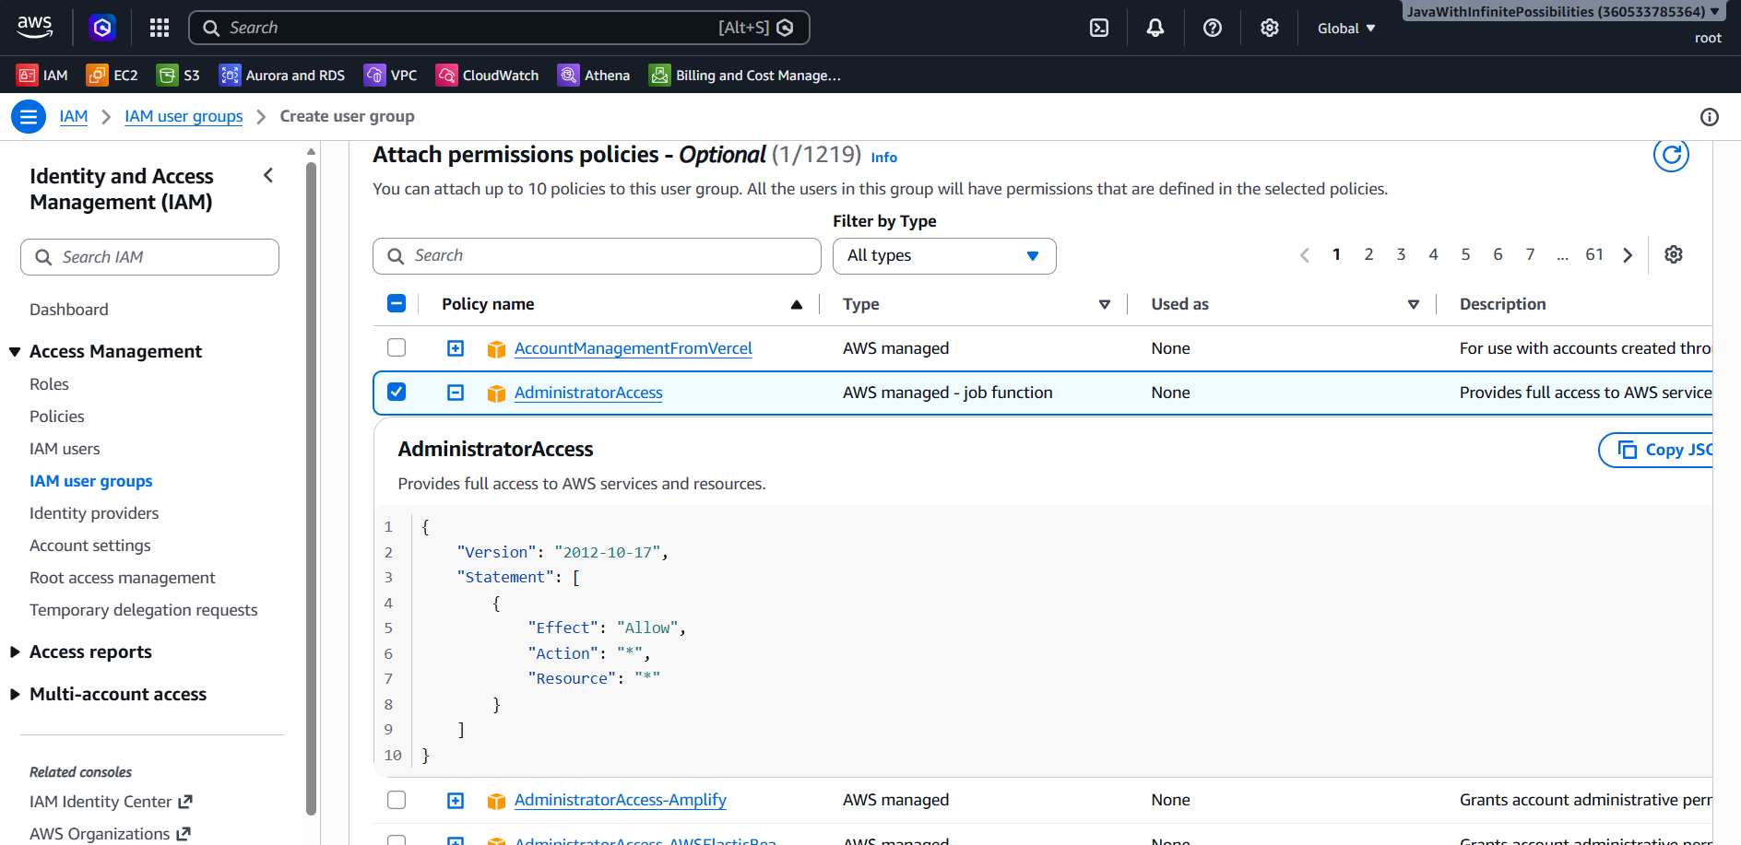
7.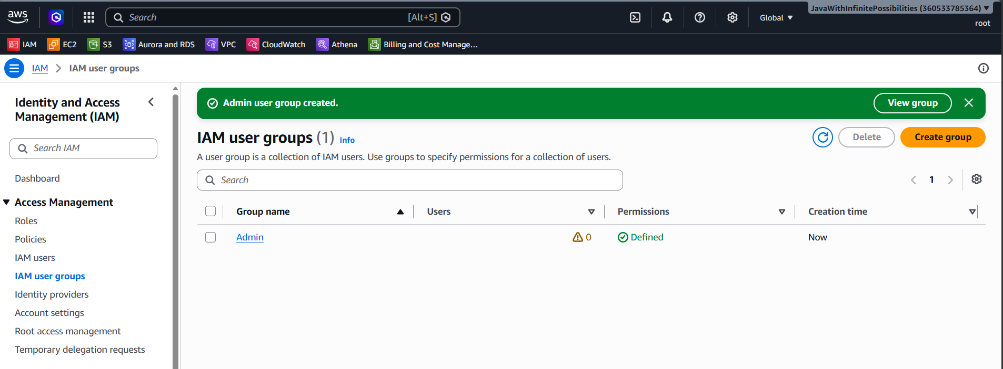
8.IAM USER: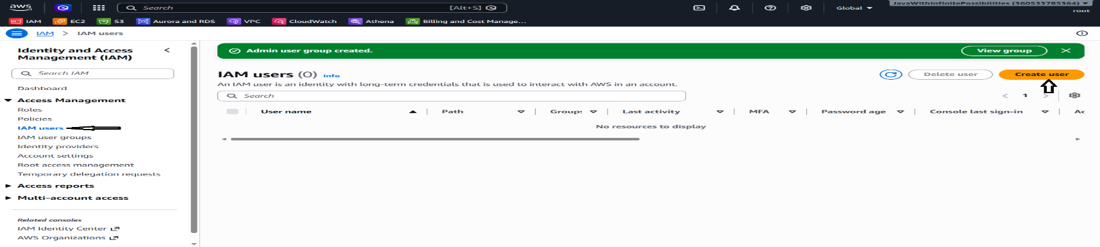
9.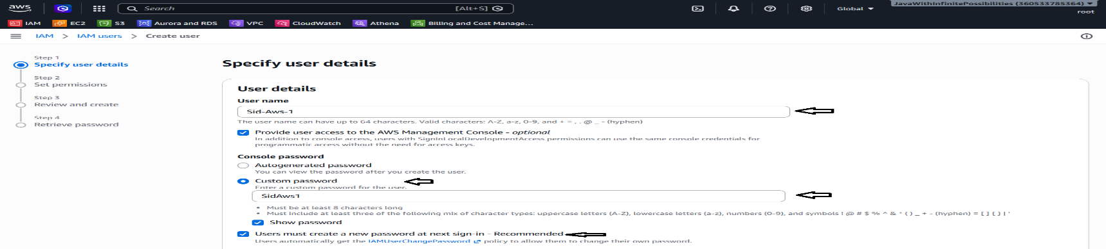
10. 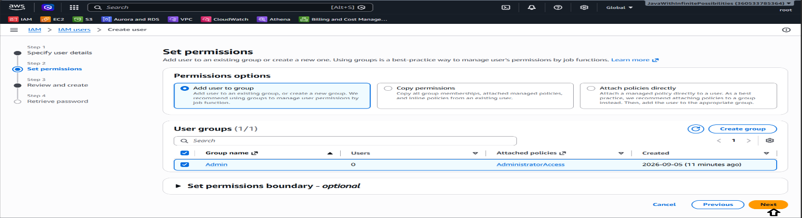
11.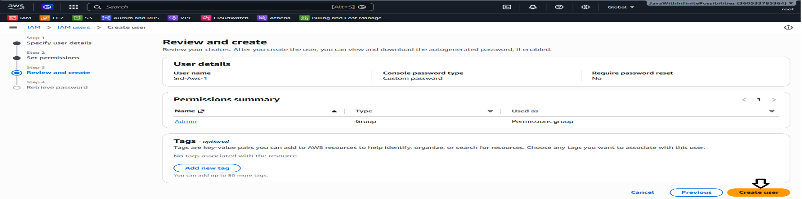
12. User: Sid-Aws-11313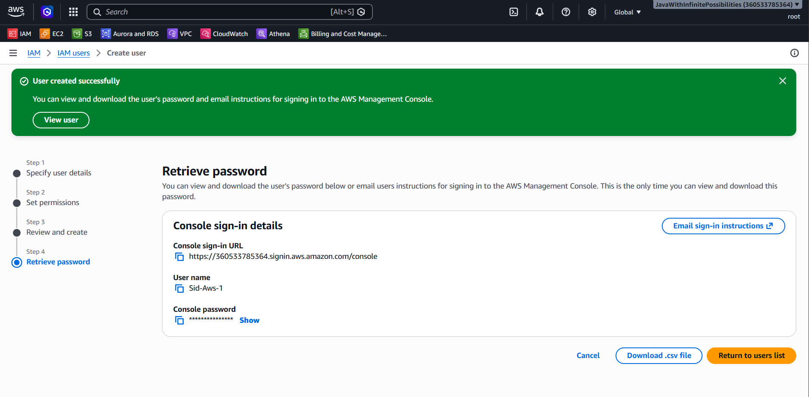
13. 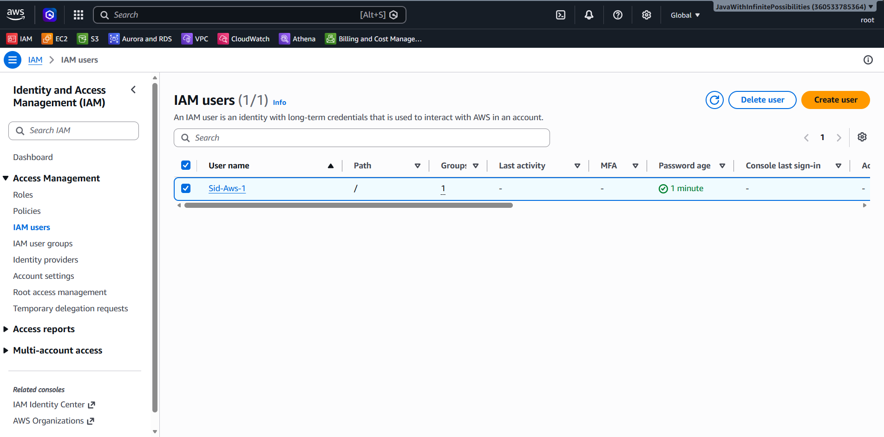
14.Login as IAM User: Account ID :<Parent Account Id> IAM User Name: Sid-Aws-1
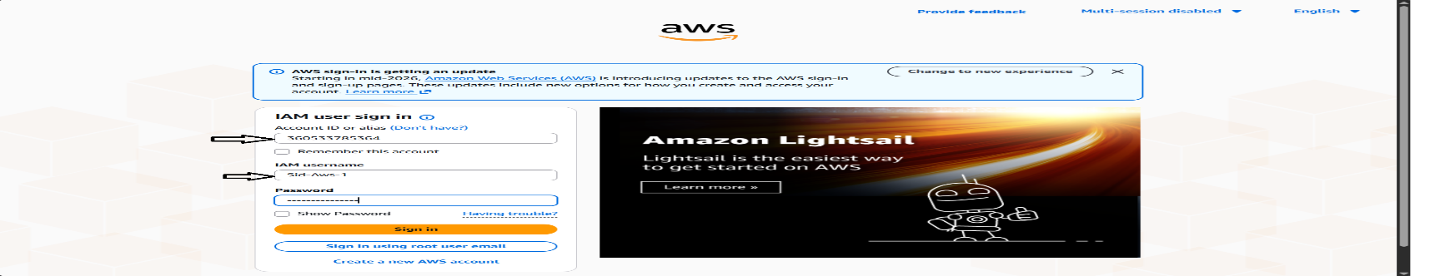
15.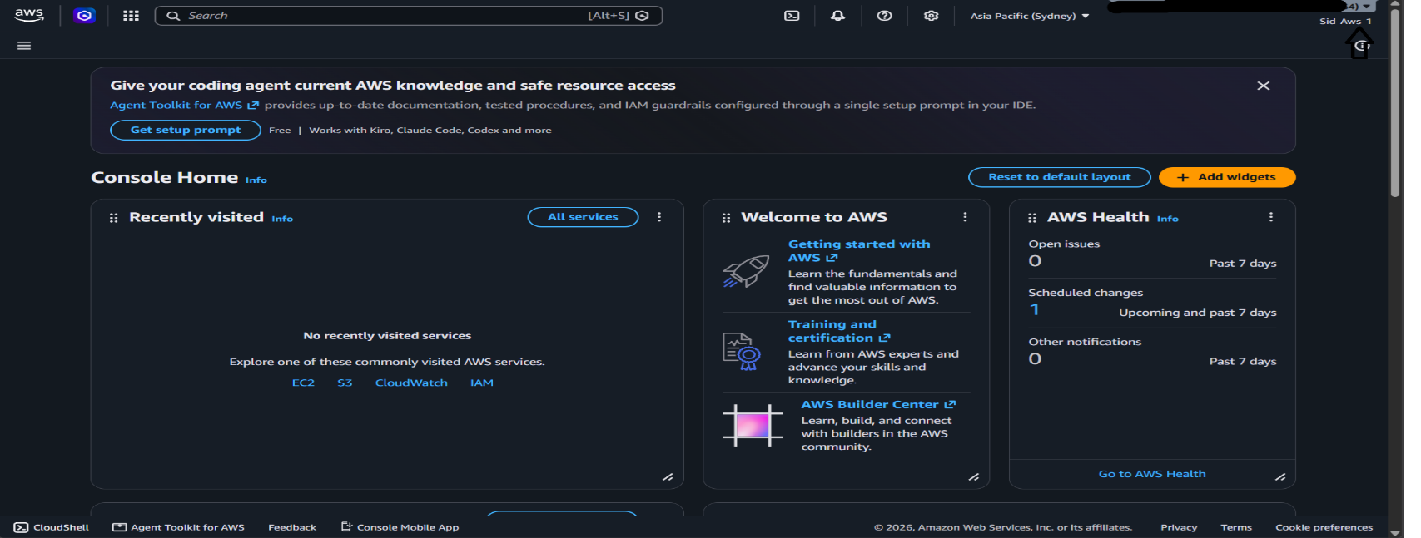
16. Role and Policy:
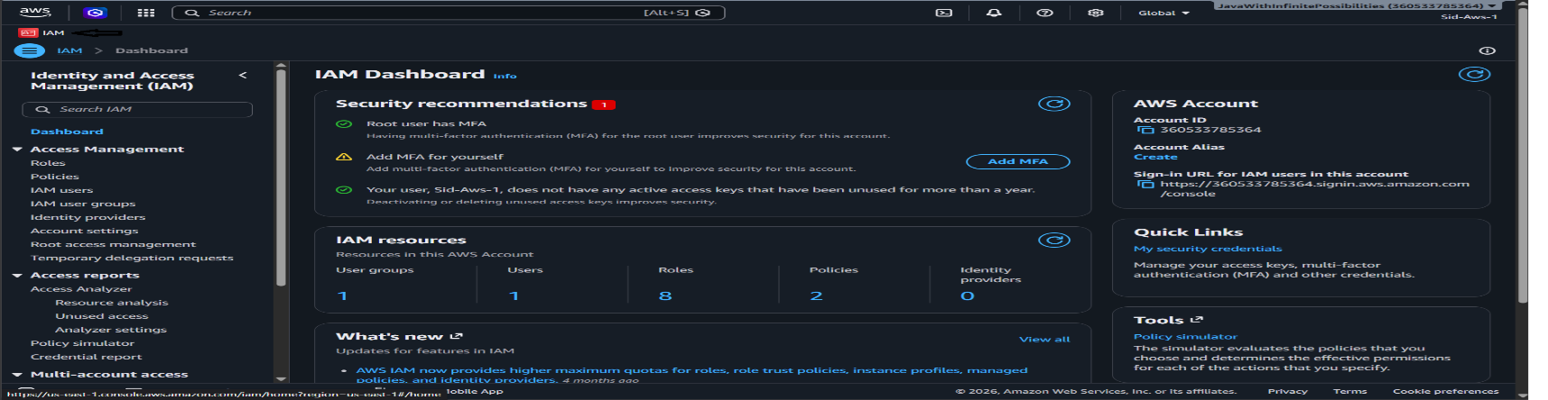
17. Create a new IAM User: <Note: follow the previous steps to create a new IAM User>
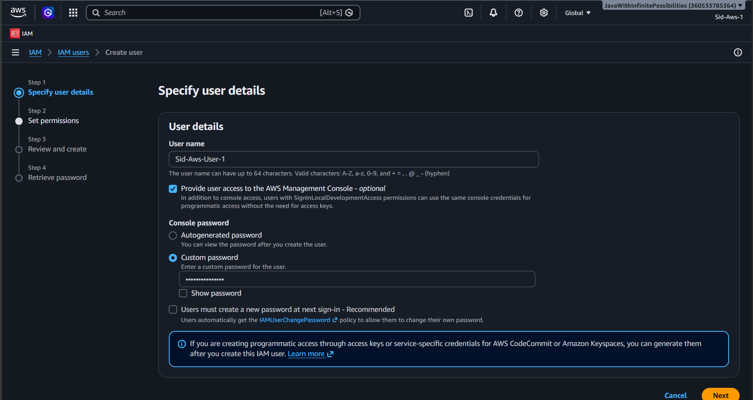
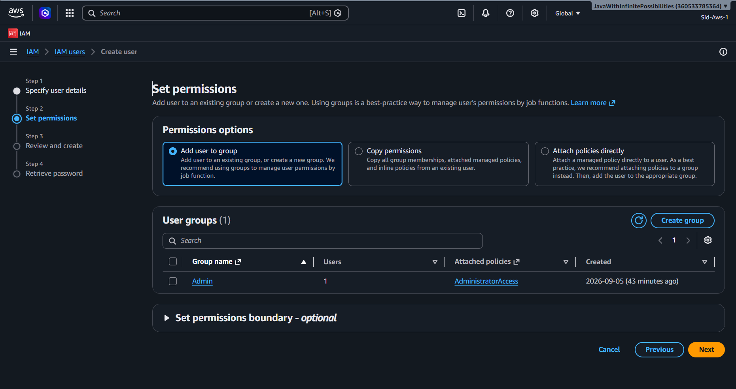
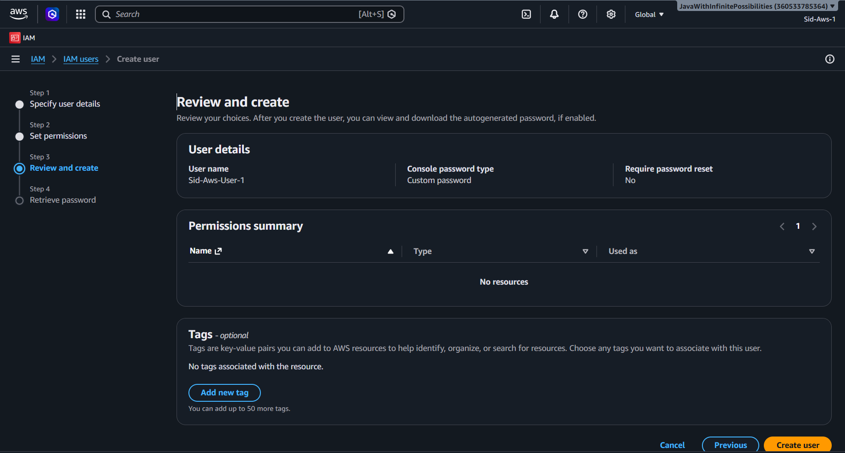
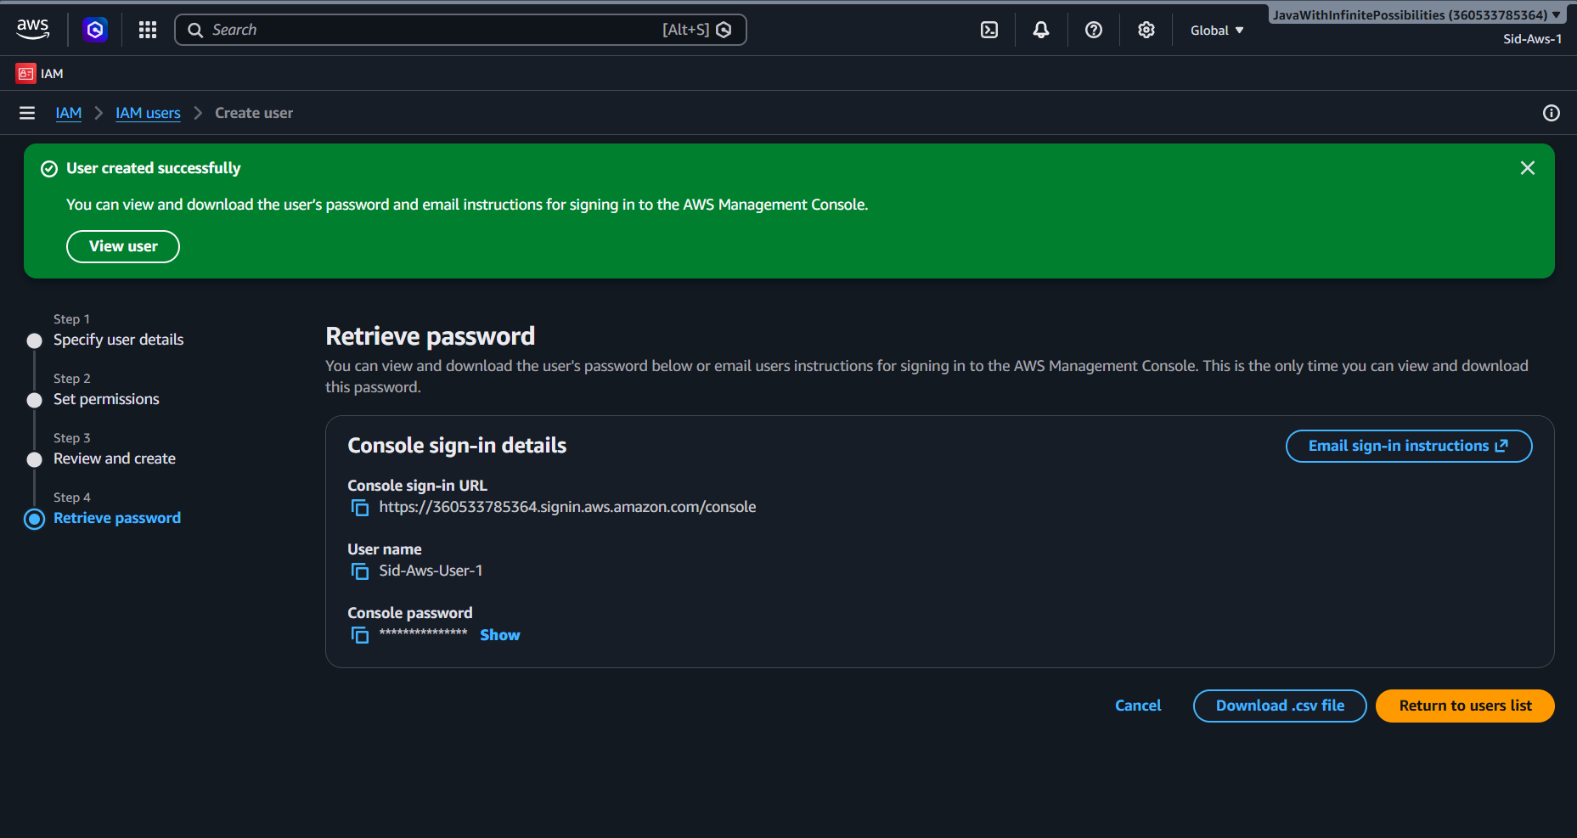
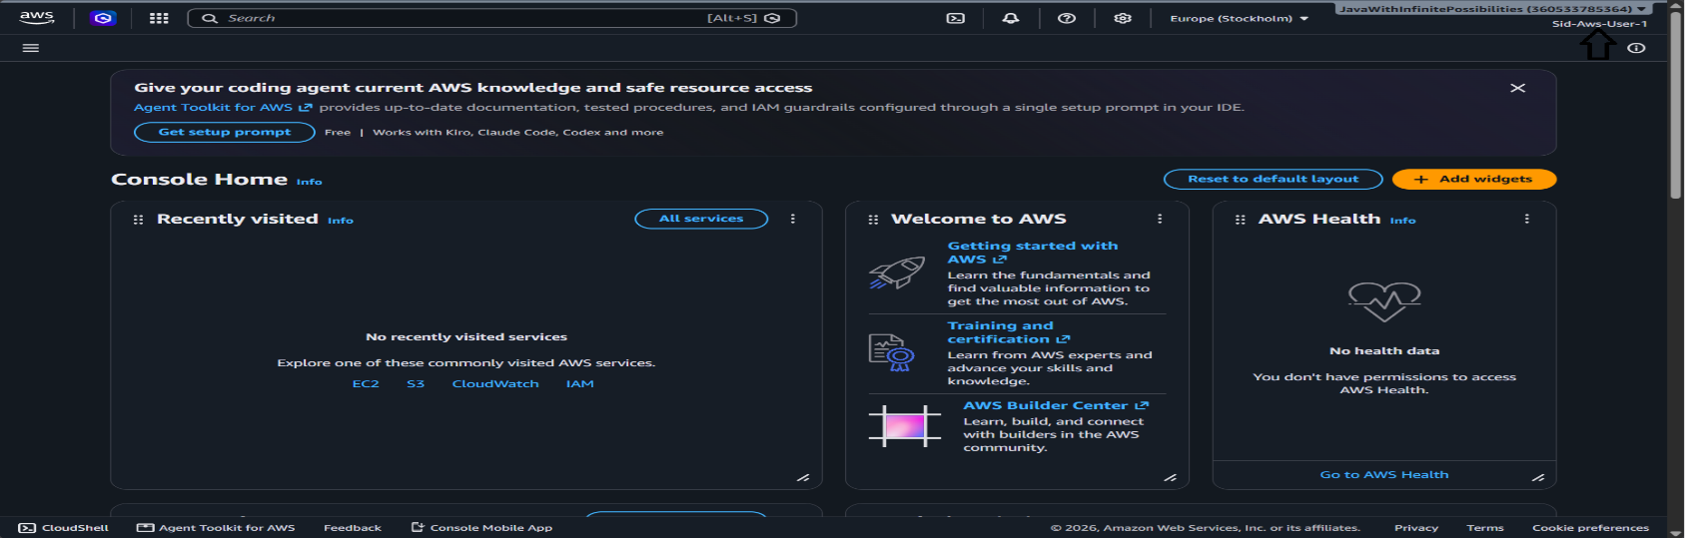
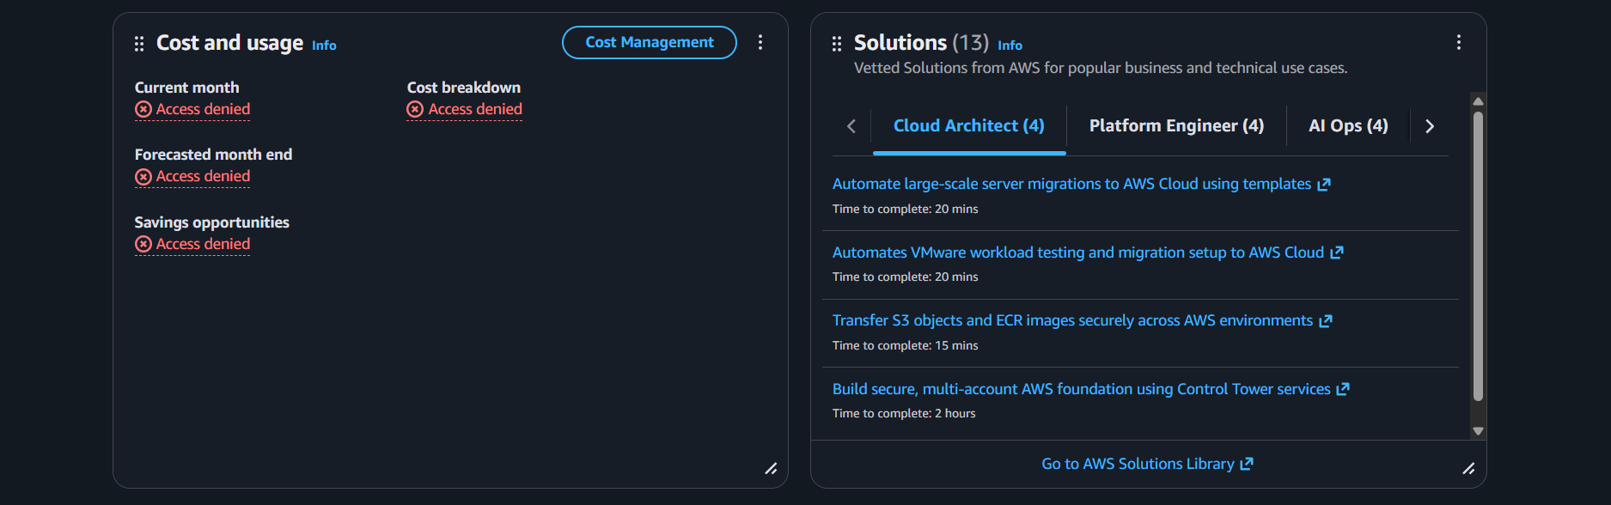
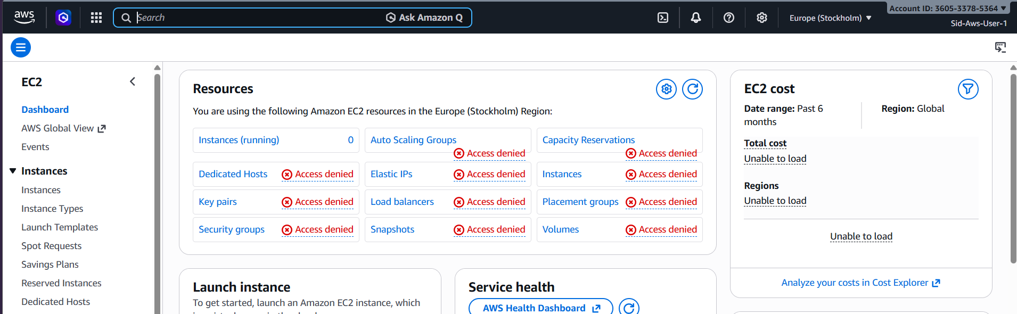
Don’t have any access. EC2 is on Access denied.
18. Roles:
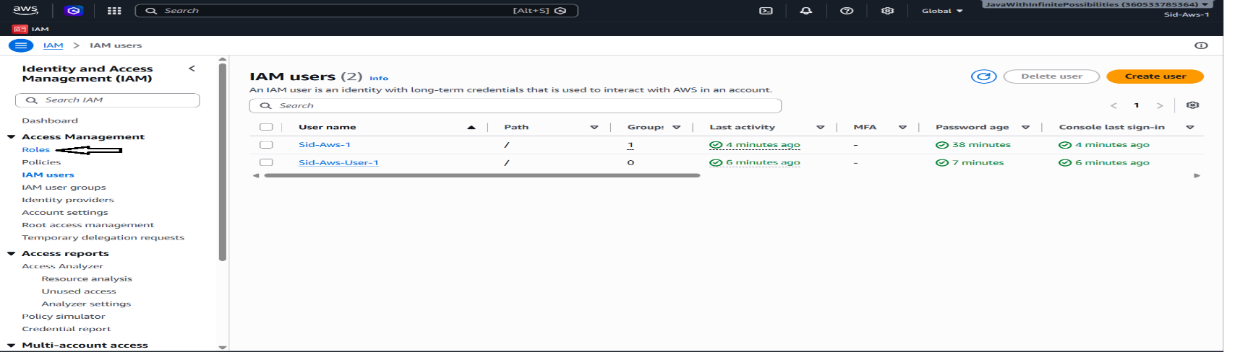
19. 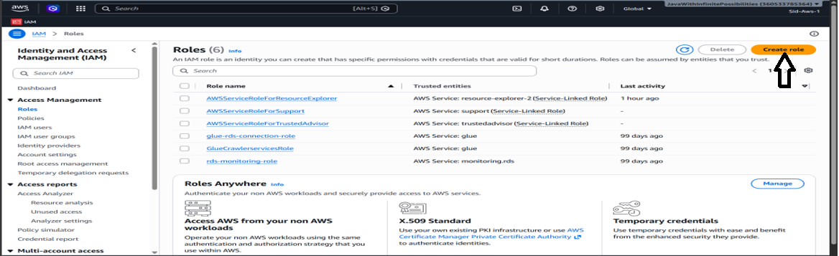
20. 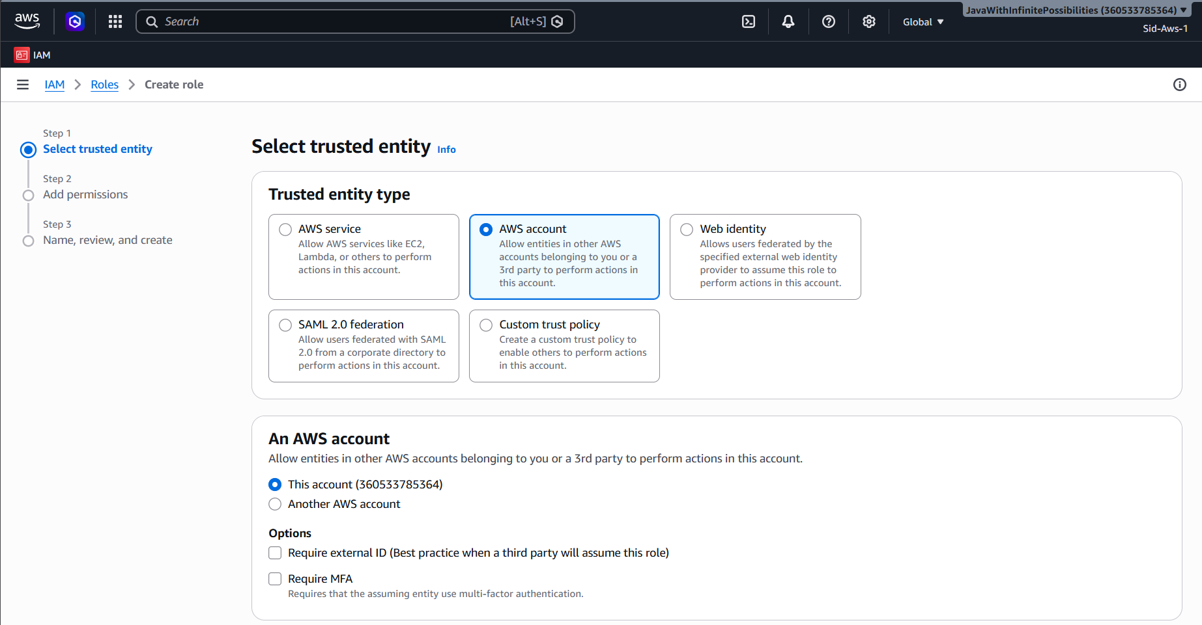
21.
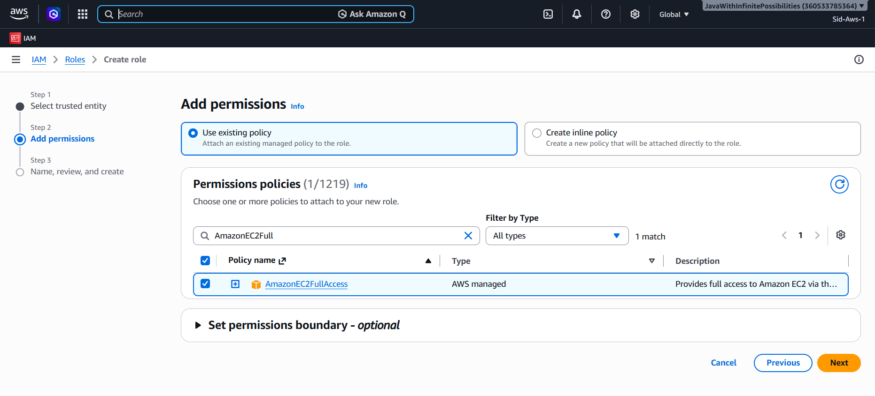
22. 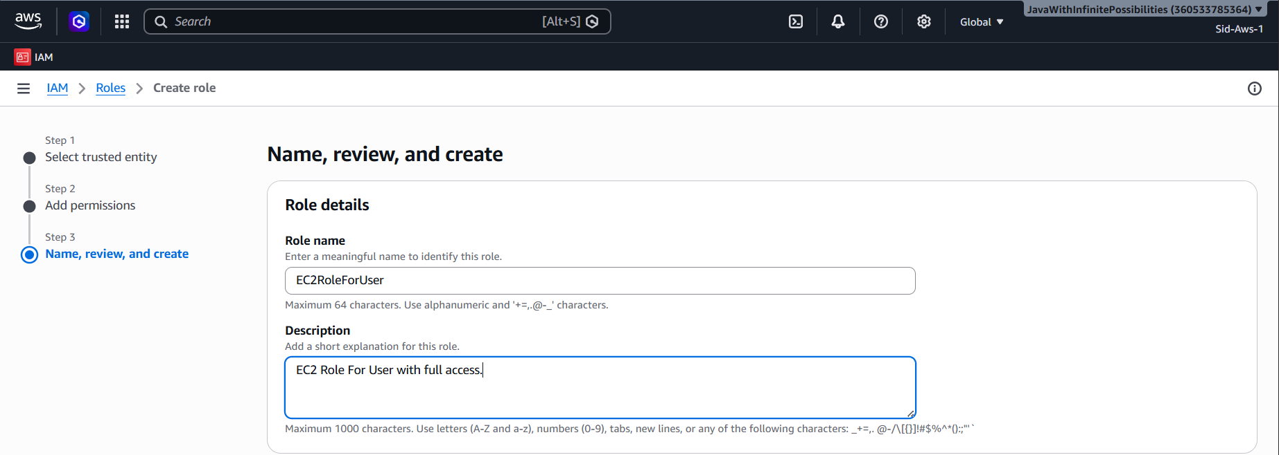
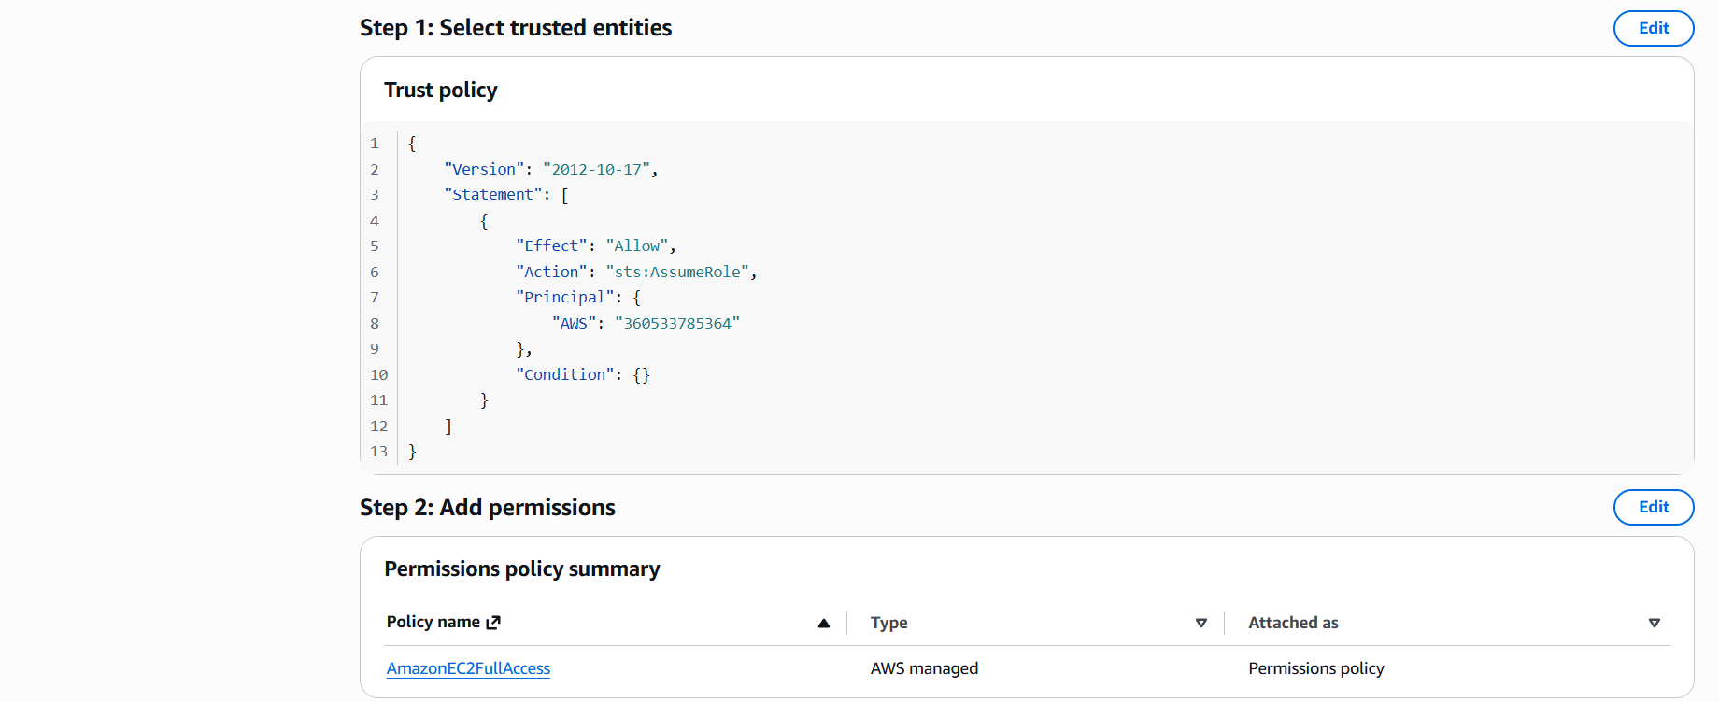

23. Add a one more permission:
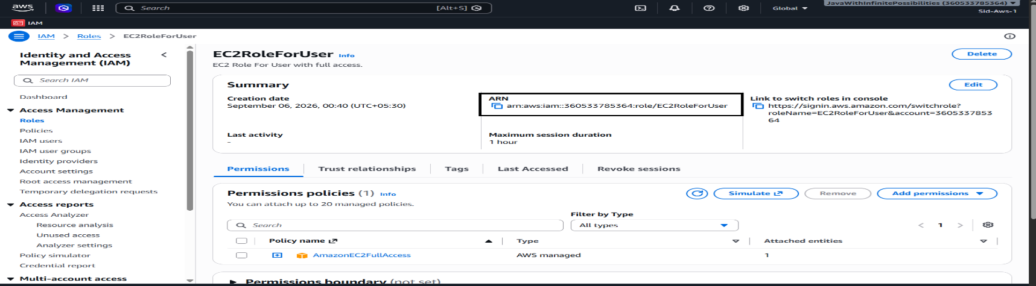
Note: Use the ARN in the Resourse
{
"Version": "2012-10-17",
"Statement": {
"Effect": "Allow",
"Action": "sts:AssumeRole",
"Resource": "arn:aws:iam::360533785364:role/EC2RoleForUser"
}
}
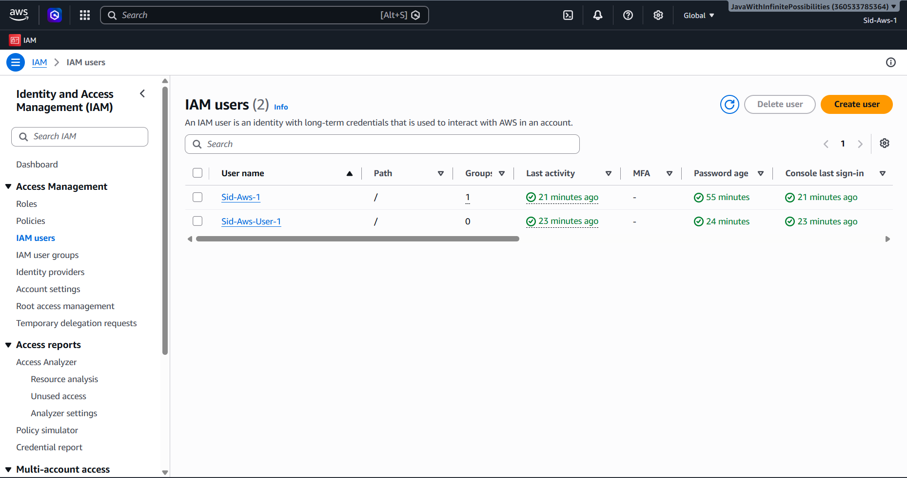
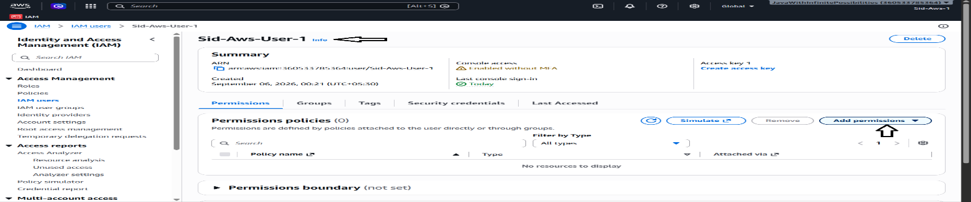
24.
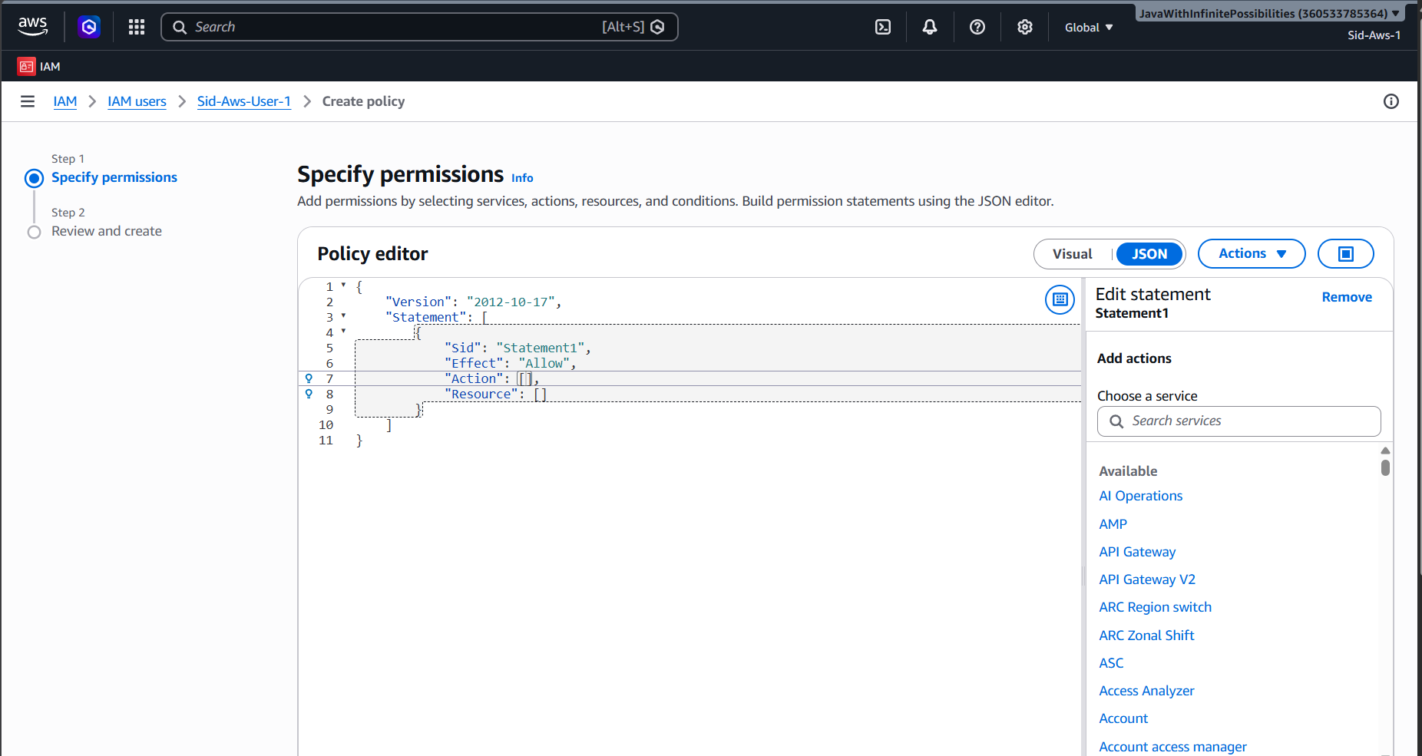
Use the JSON in the policy Editor:
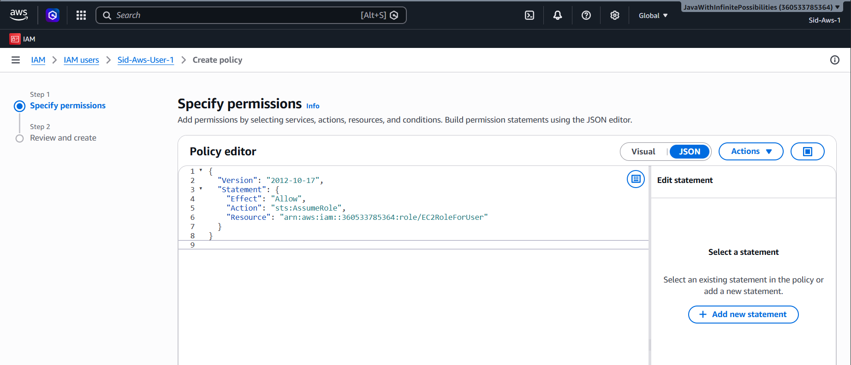
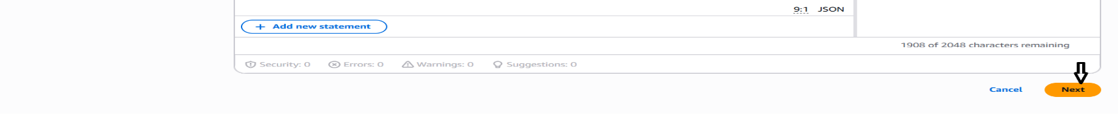

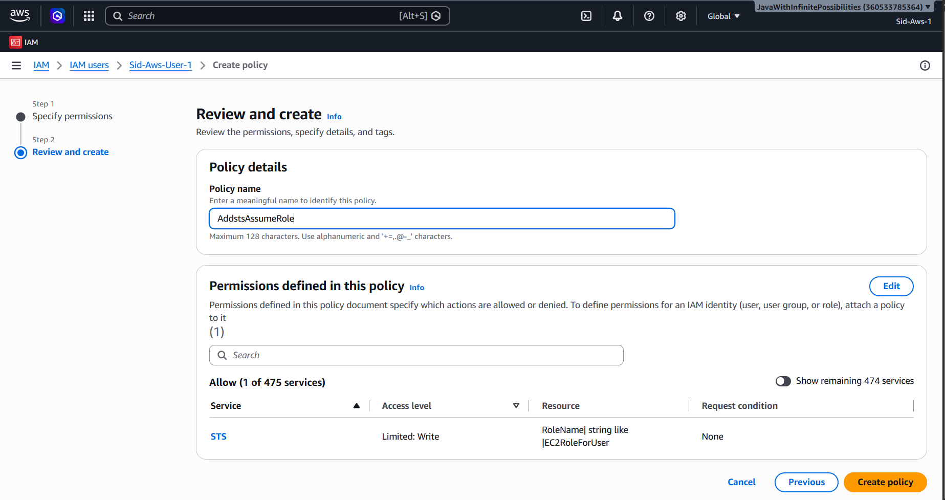
Click on Create policy:
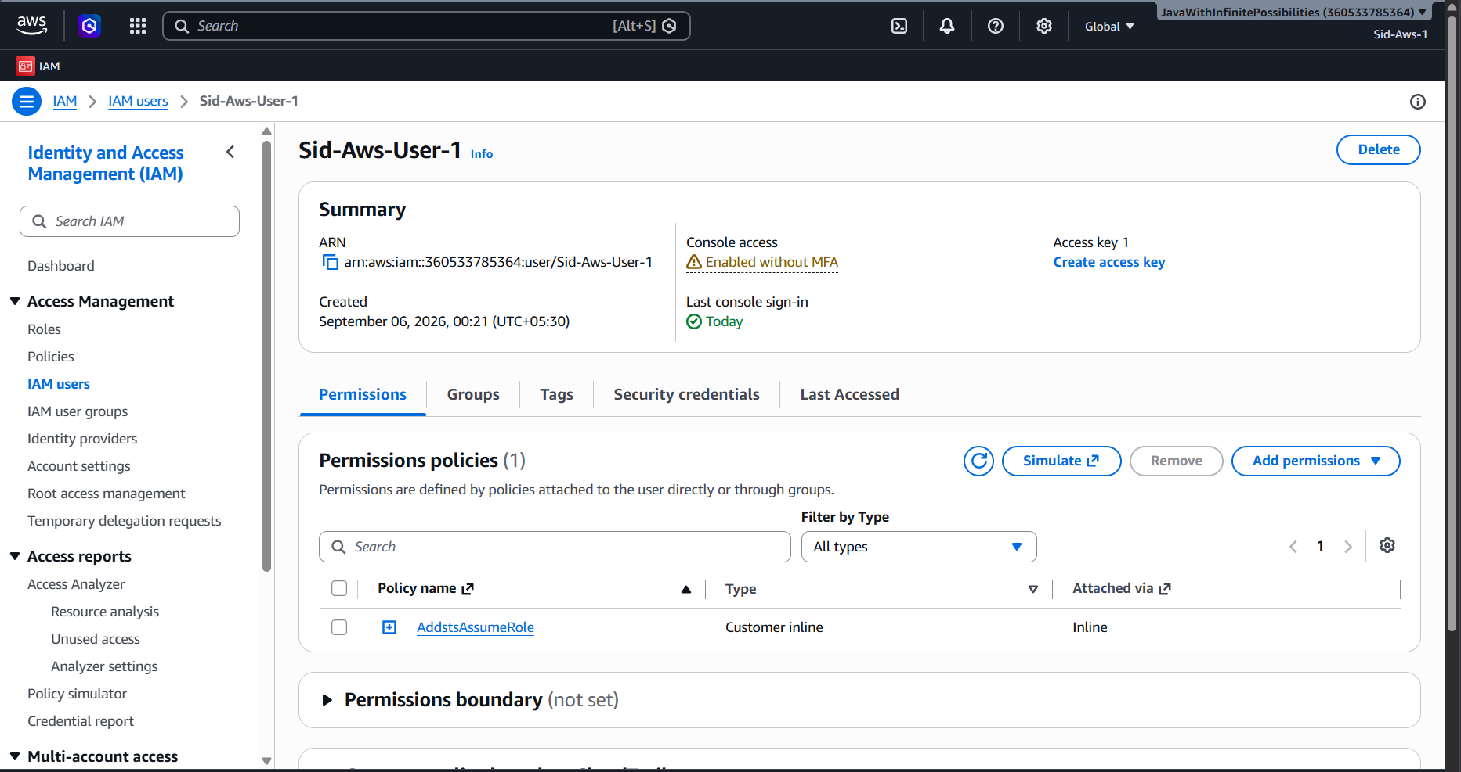
25.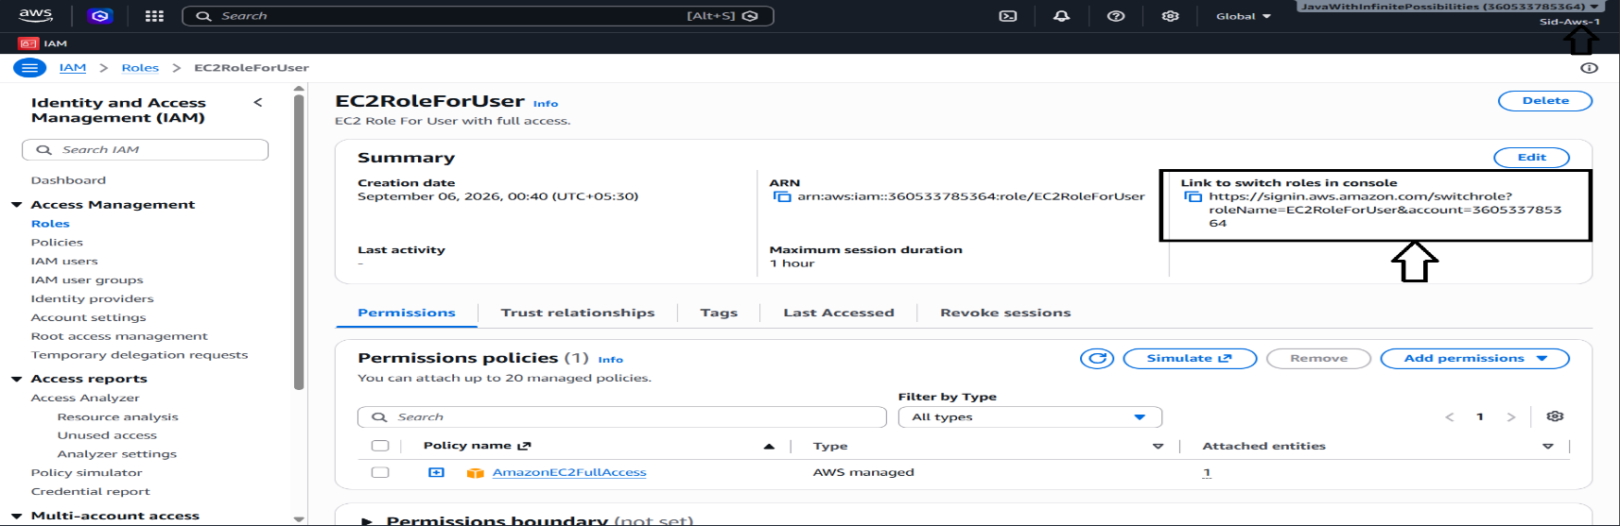
26.
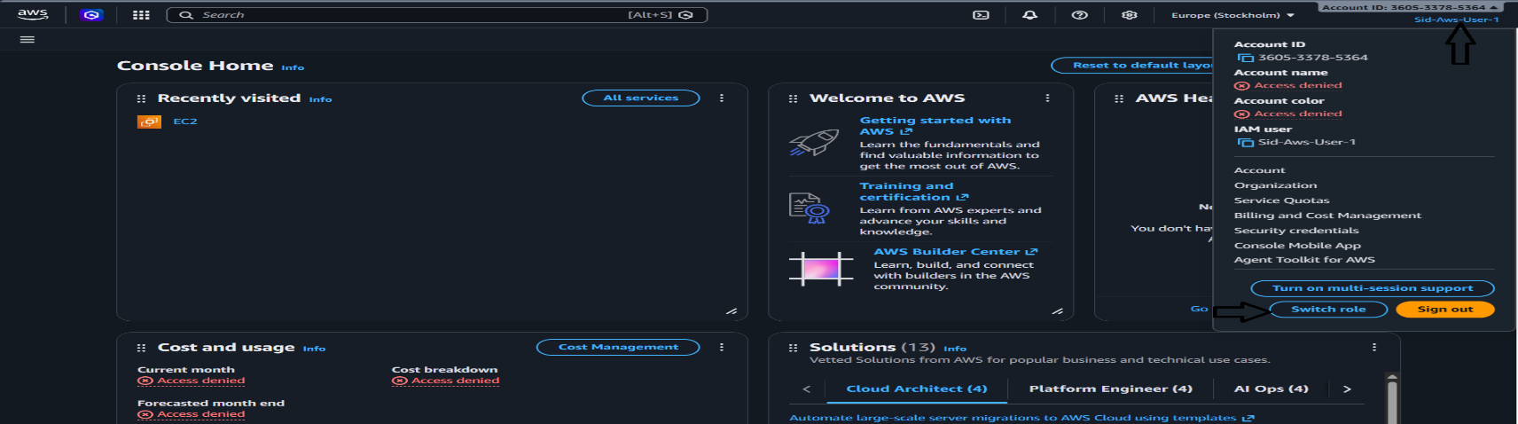
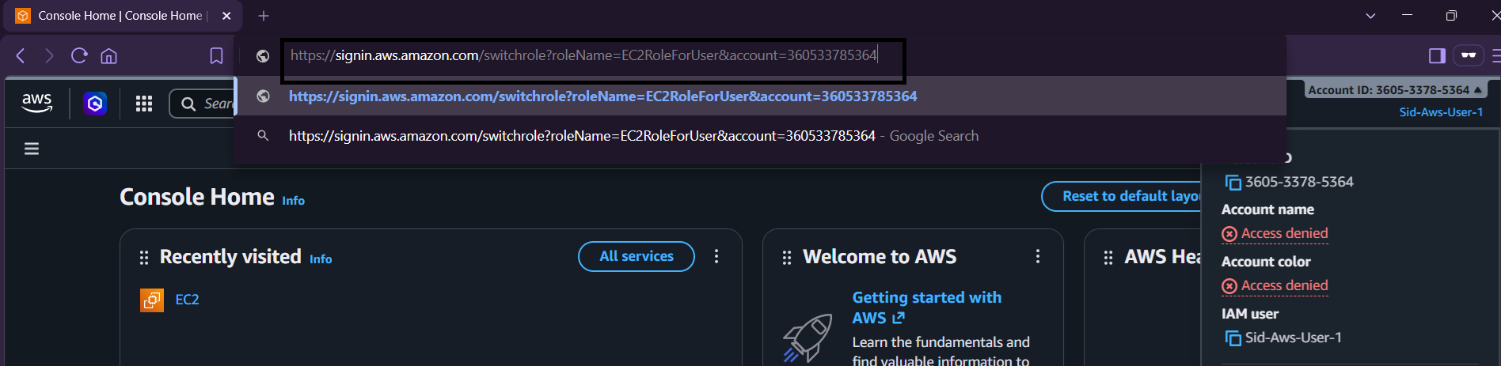
27.
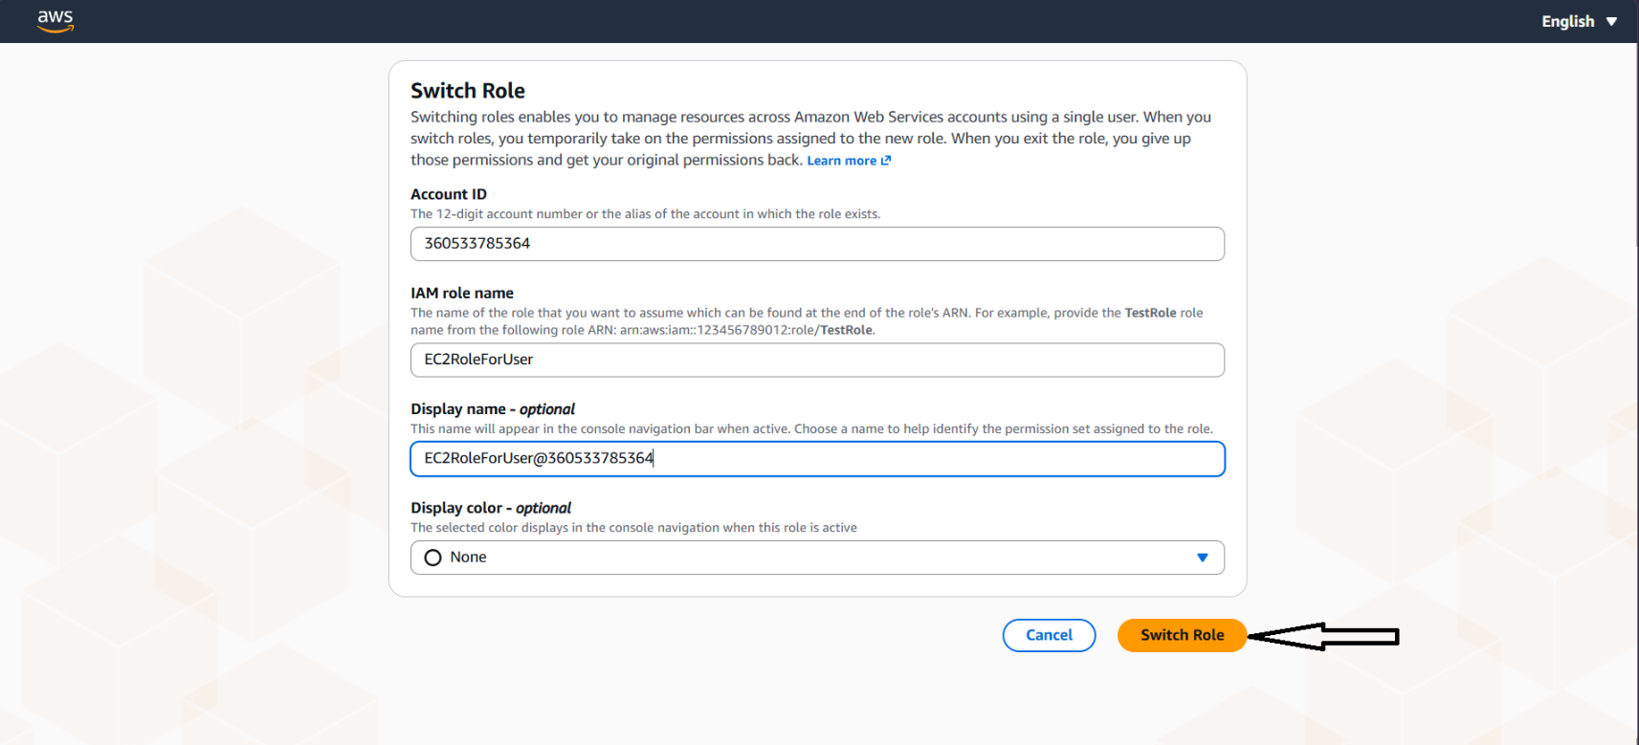
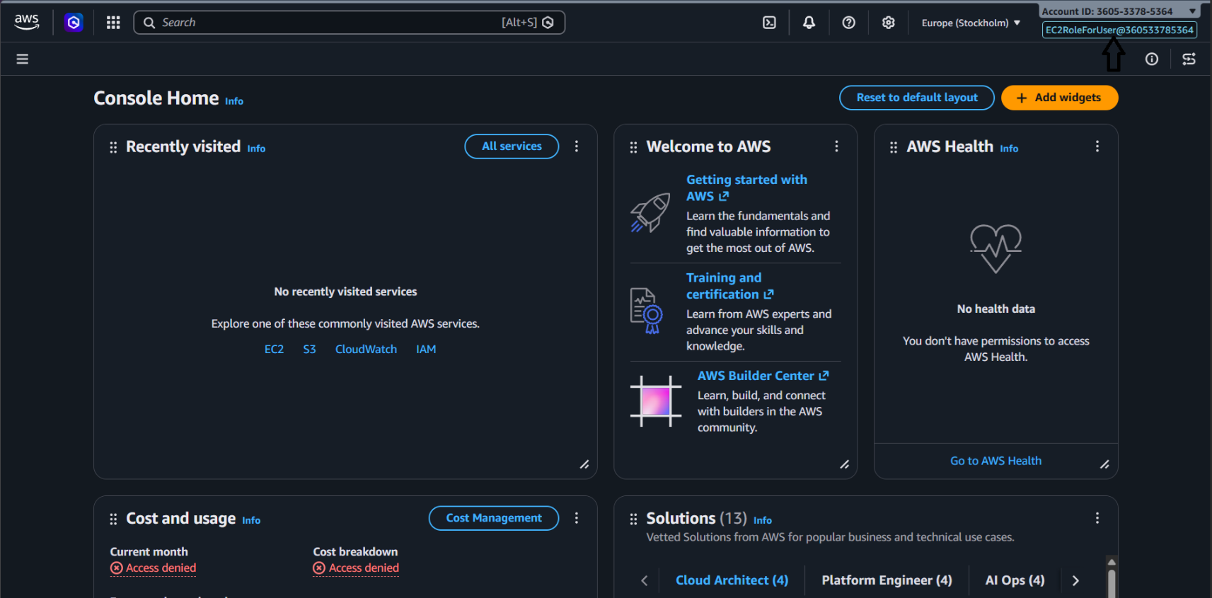
Now got the access to EC2:
