Install the AWS CLI
Follow the below URLs:
Getting started with the AWS CLI - AWS Command Line Interface
Installing or updating to the latest version of the AWS CLI - AWS Command Line Interface
1. 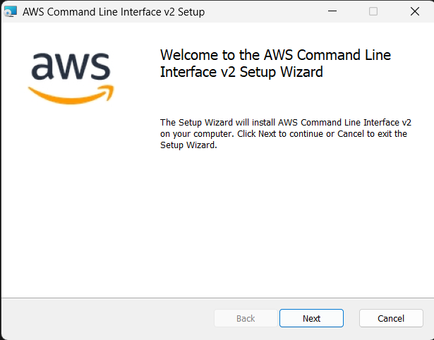
2. 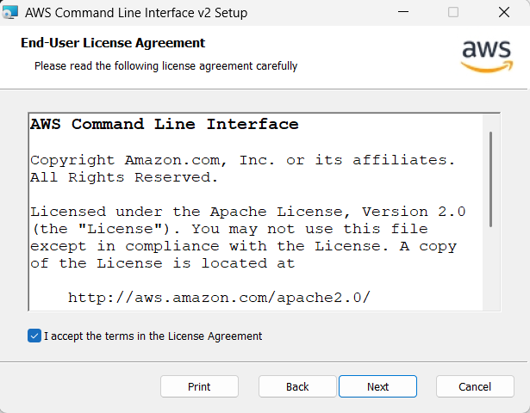
3. 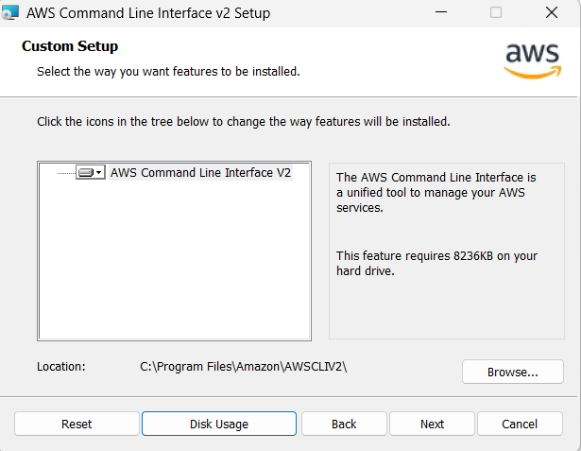
4. 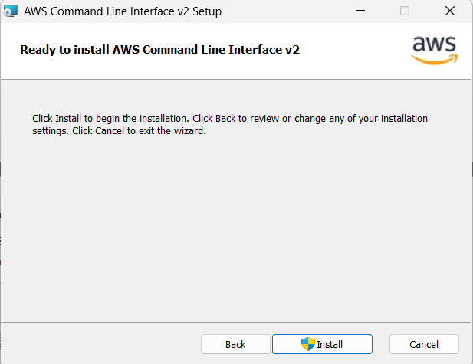
5. 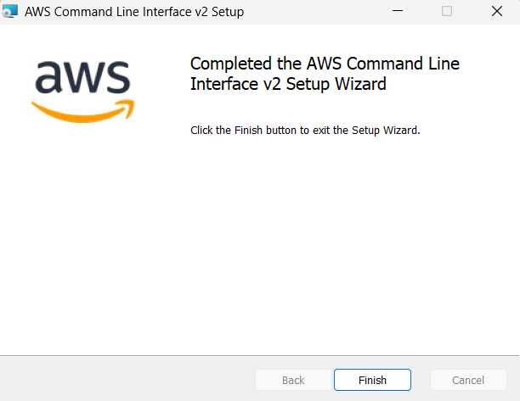
6. aws --version