Section-02-EC2-Elastic-Computing-Cloud
How to set MFA () for the root account
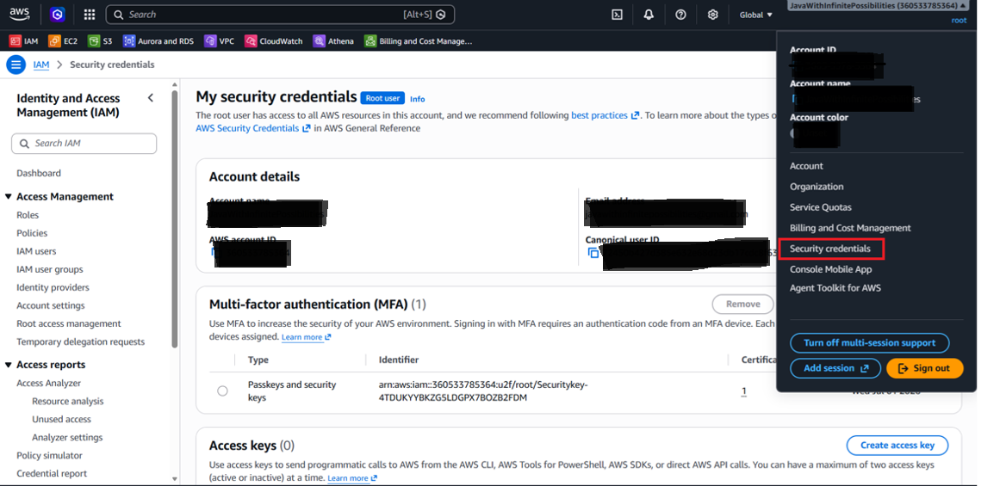
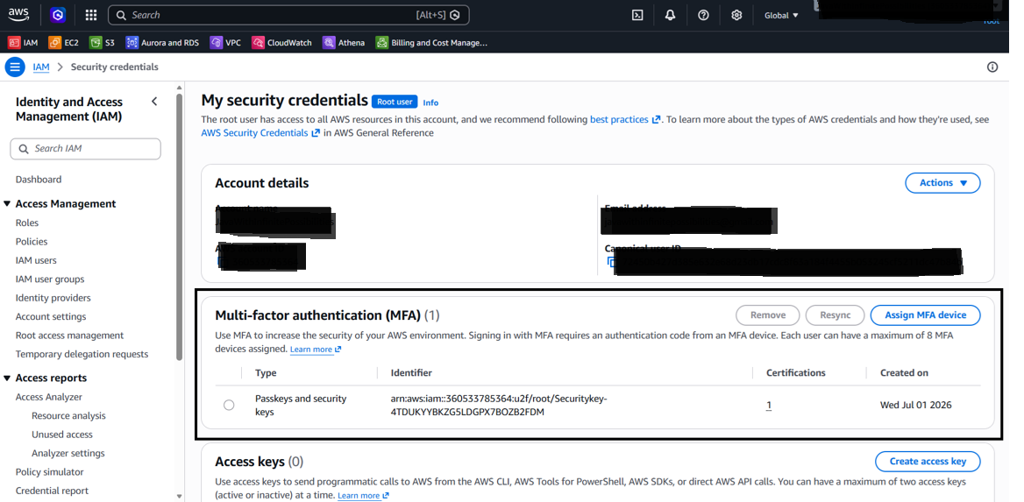
EC2 Instance Lunch:
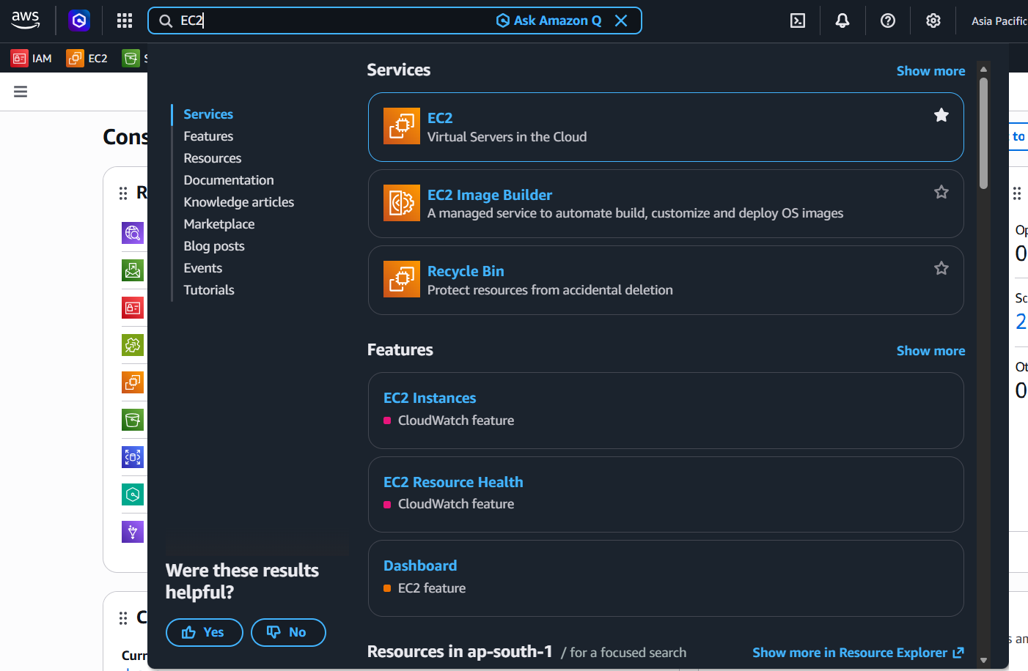
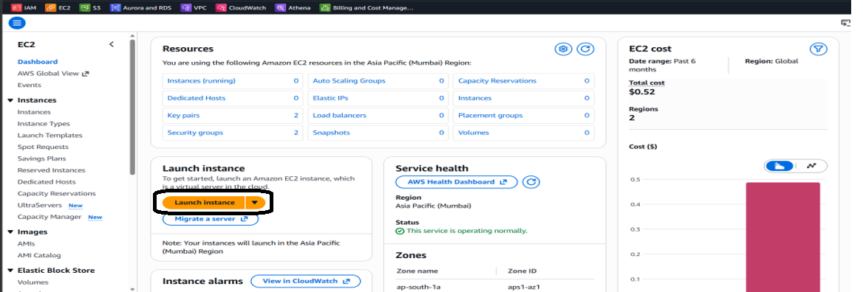

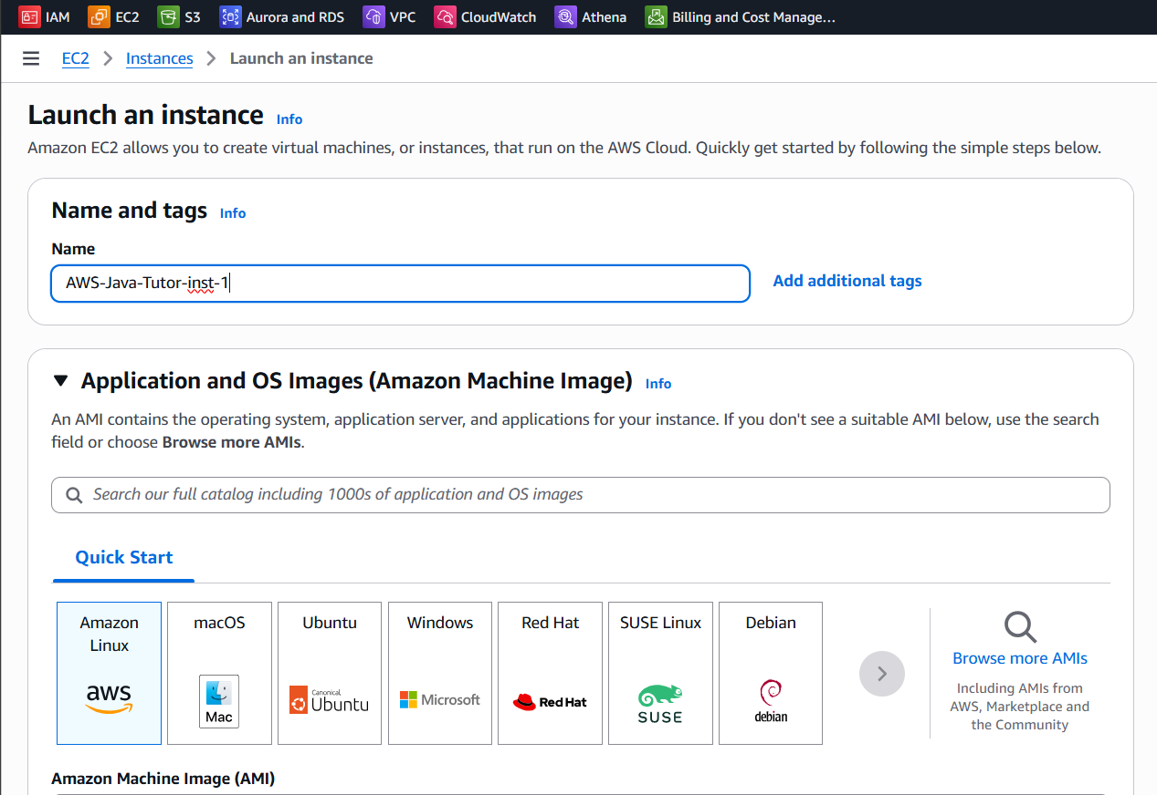
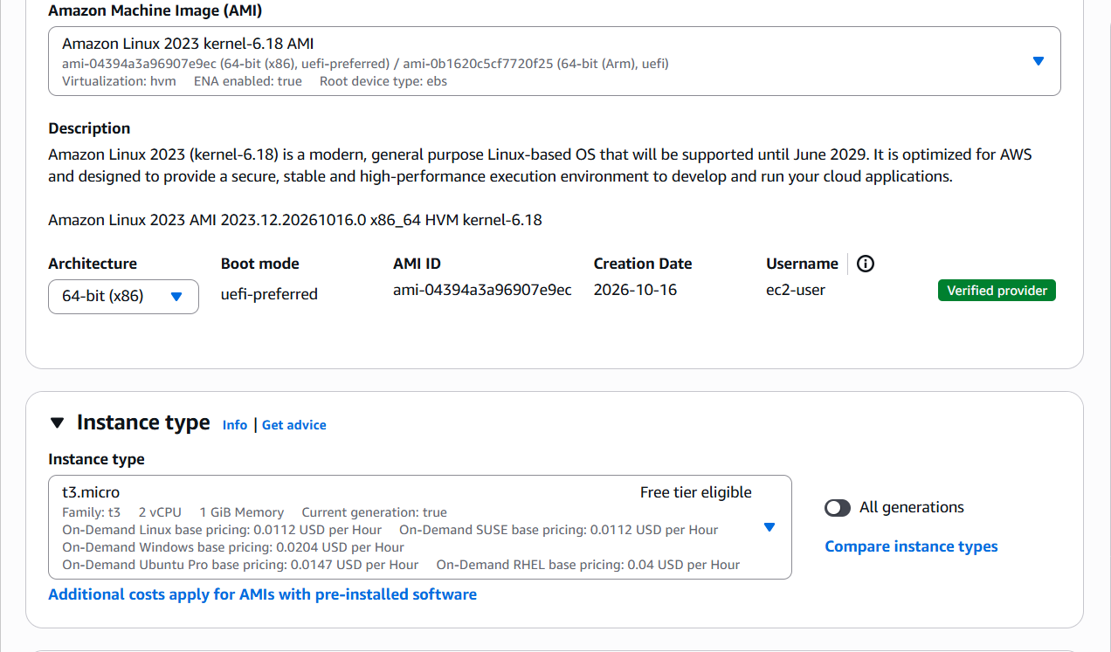
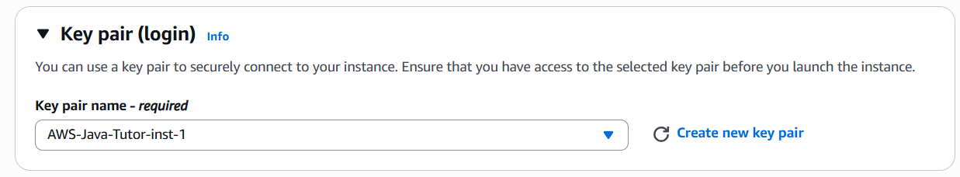
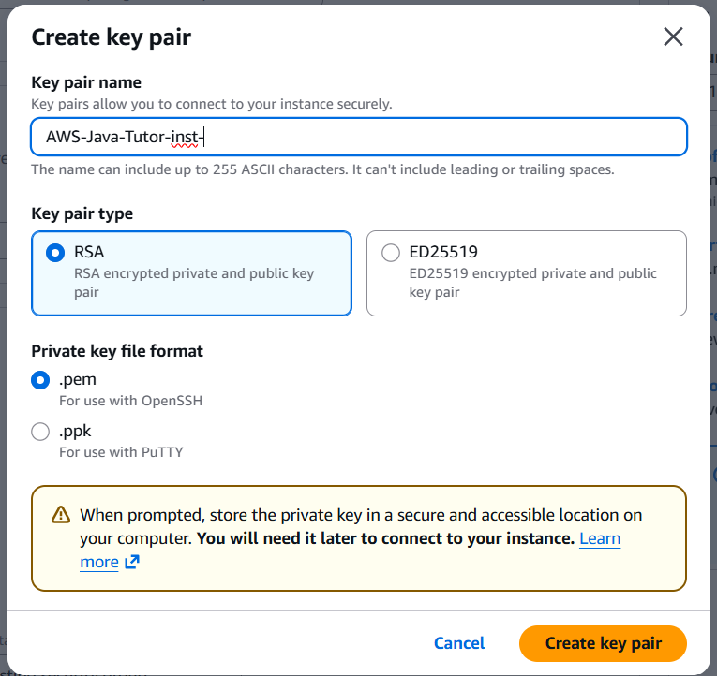
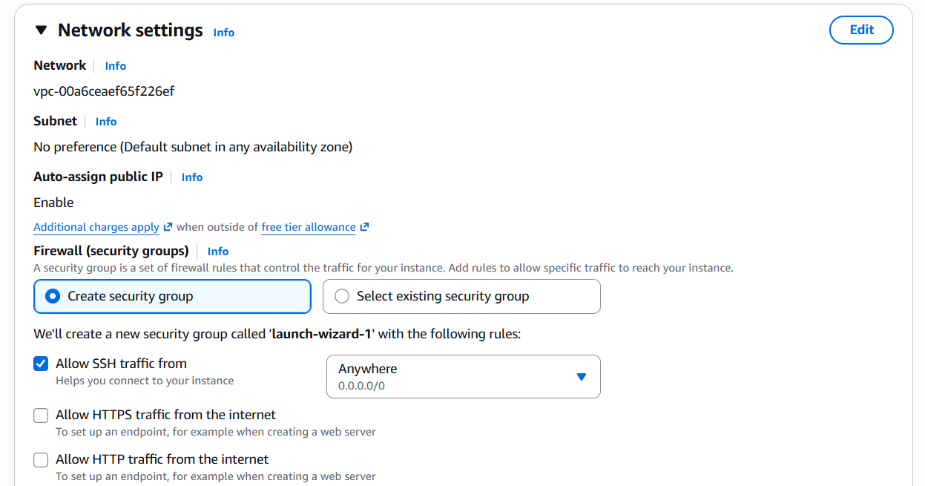
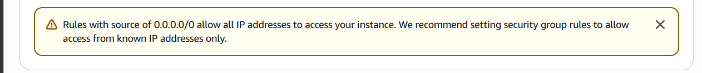
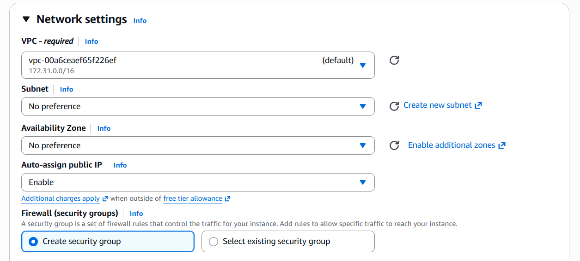
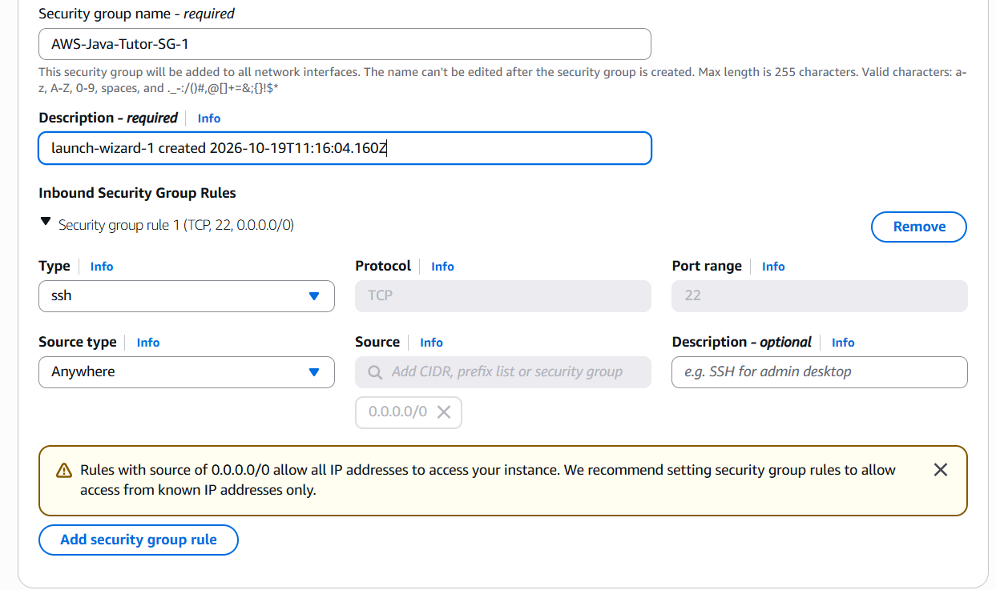
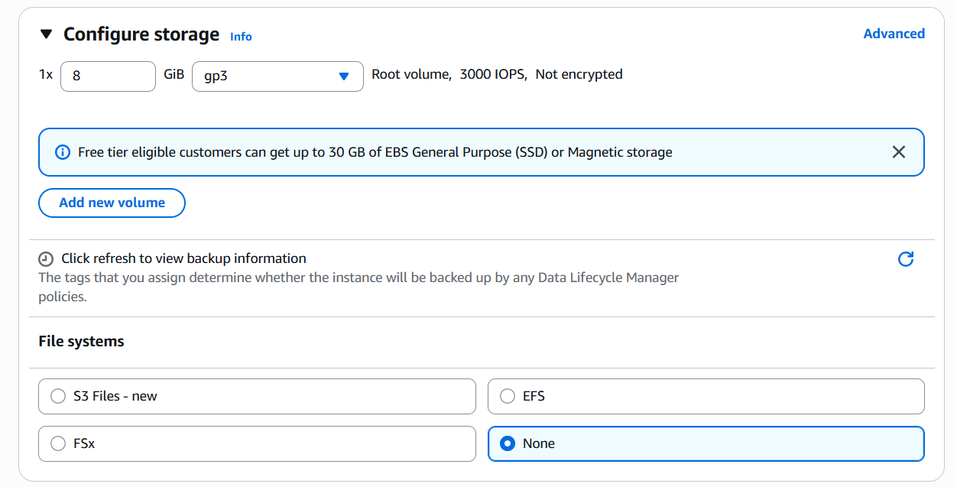
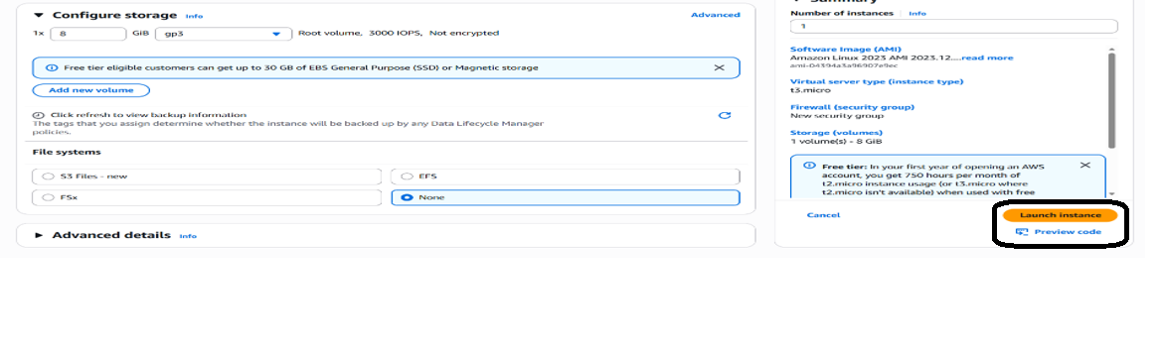
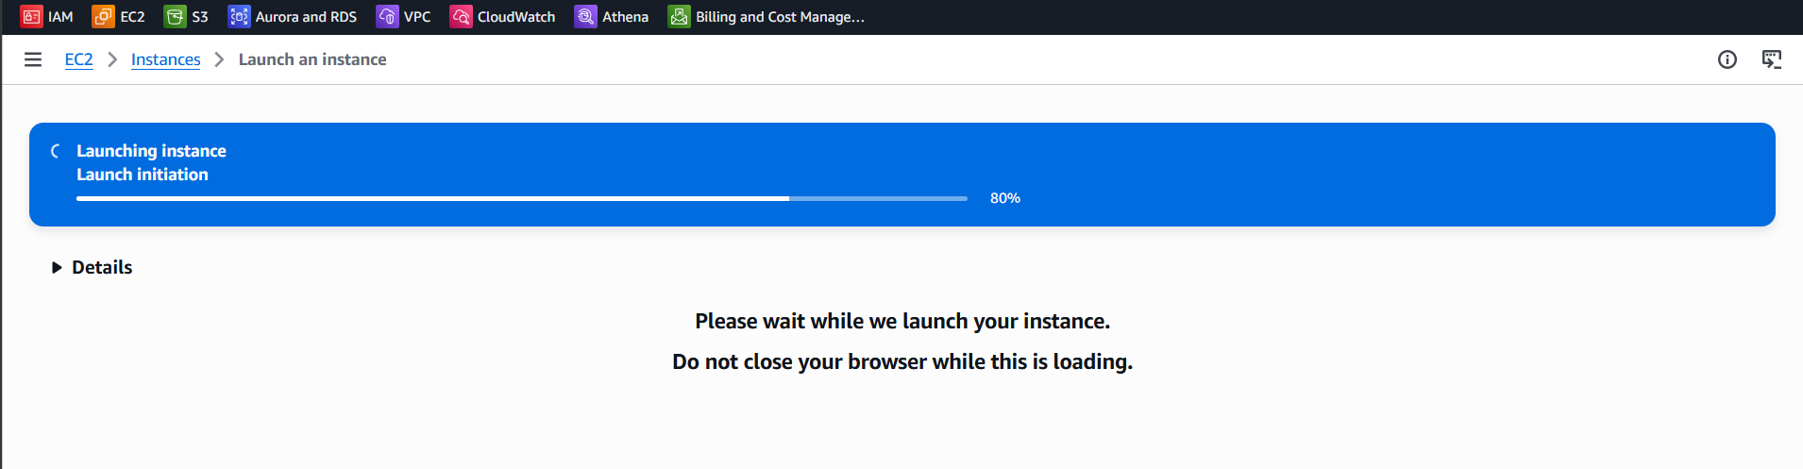
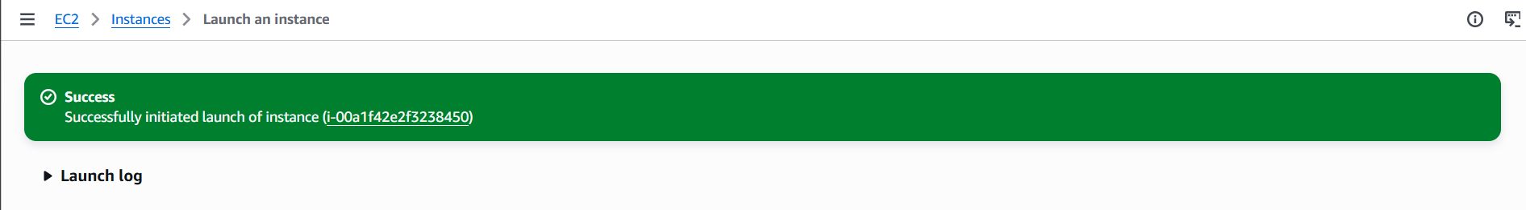
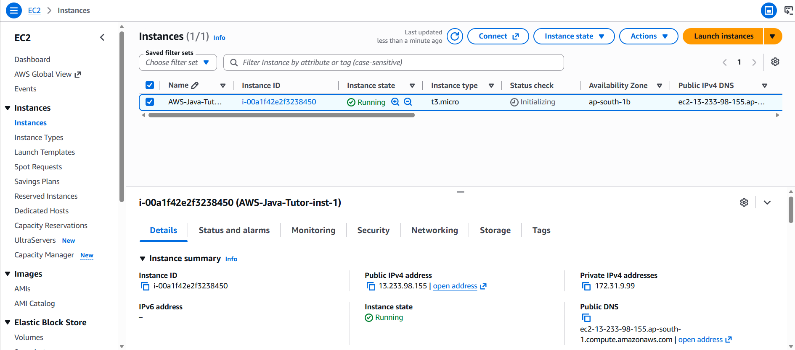
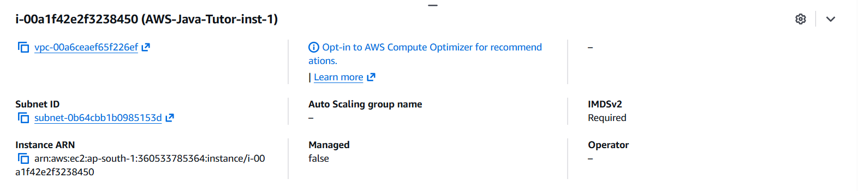
Docker Installation:
$sudo yum install java docker postgresql15 -y
$sudo systemctl start docker.service
$sudo systemctl enable docker
$sudo usermod -aG docker $USER

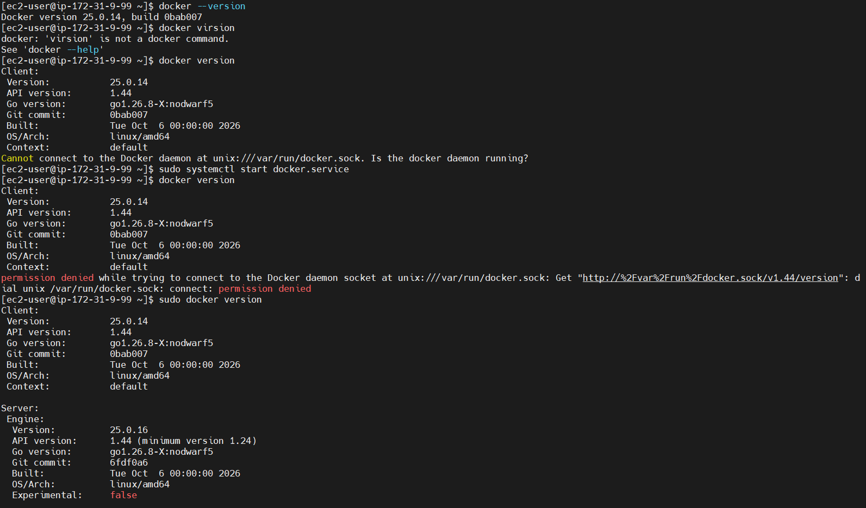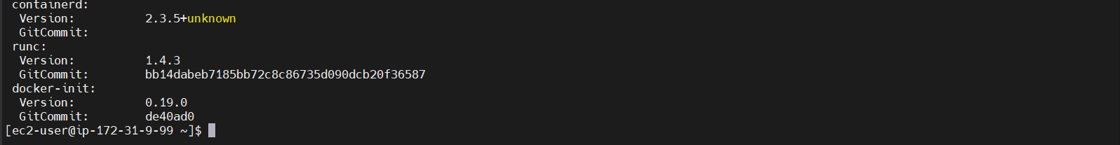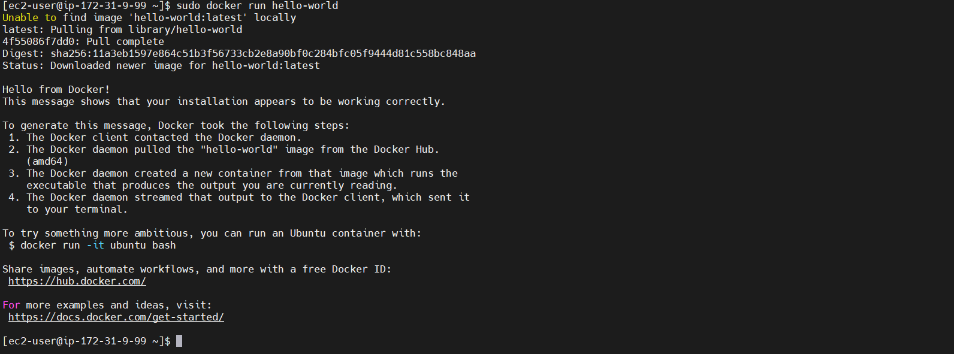
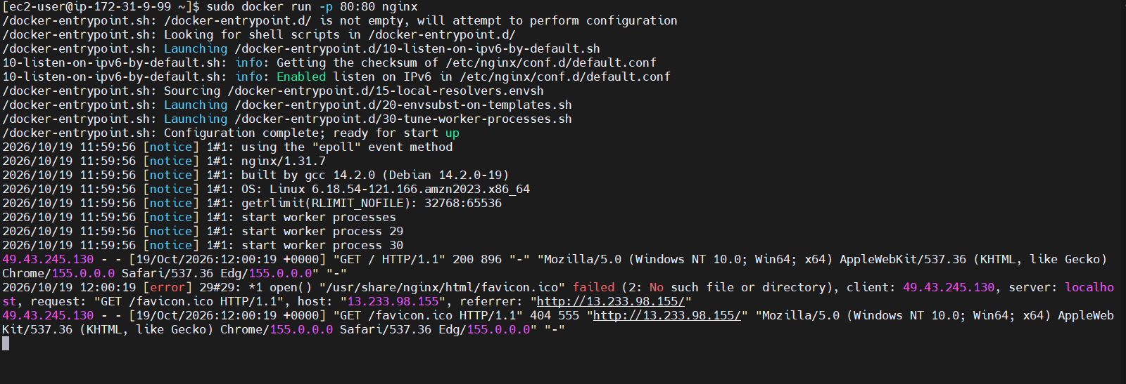
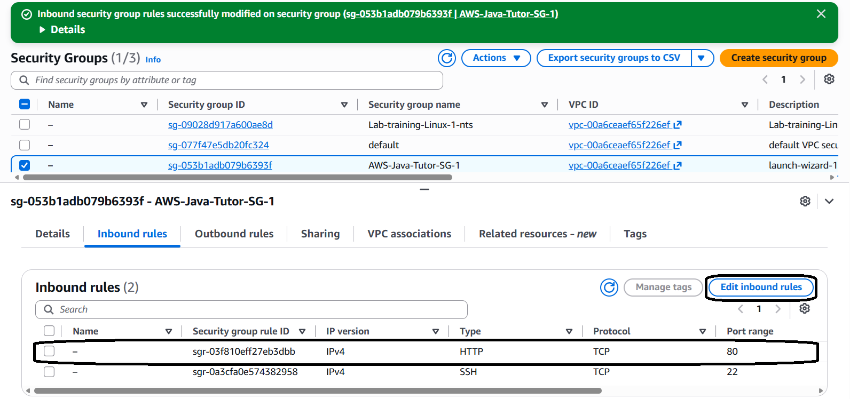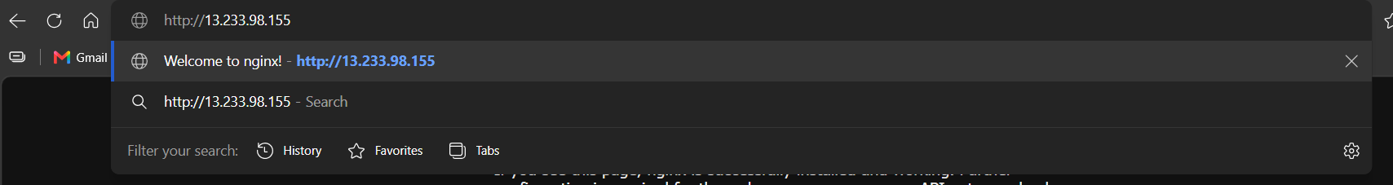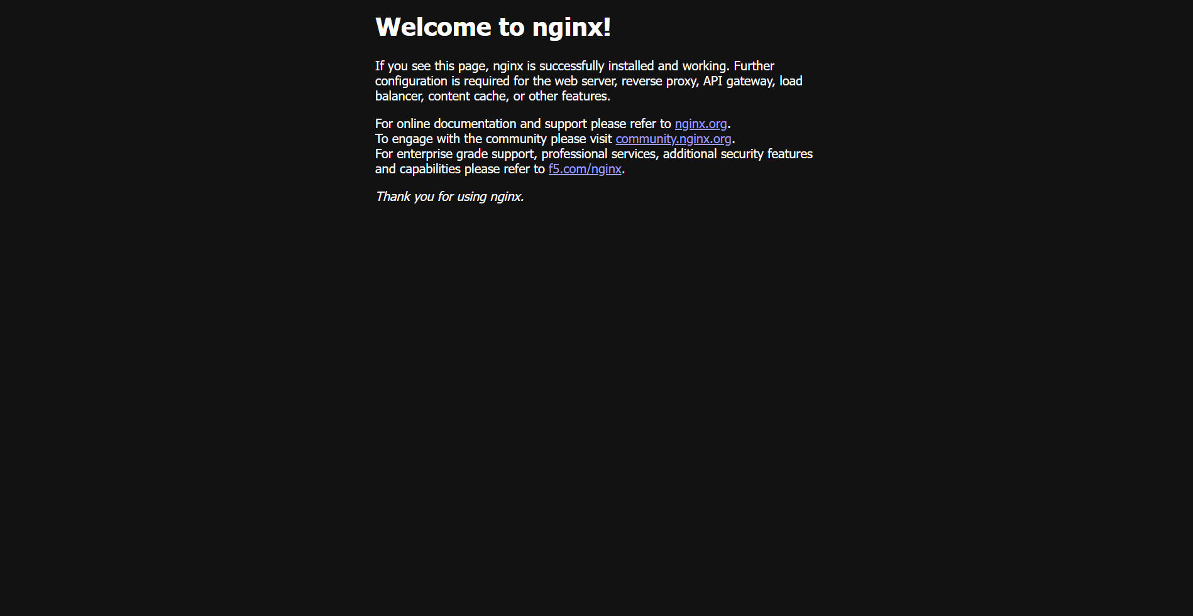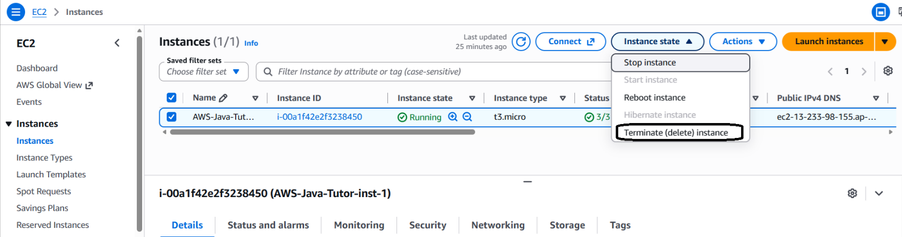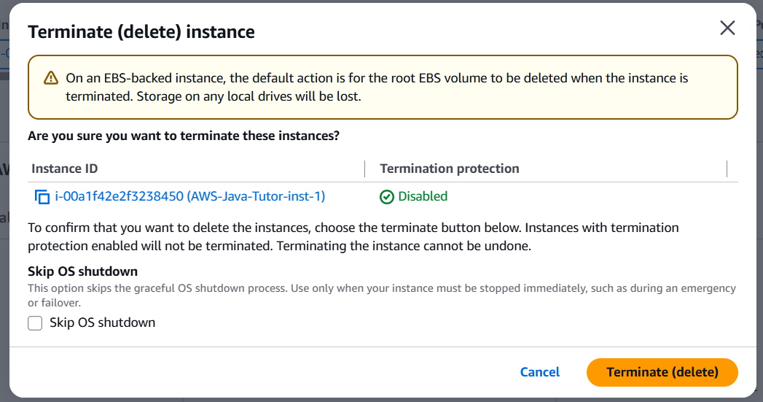
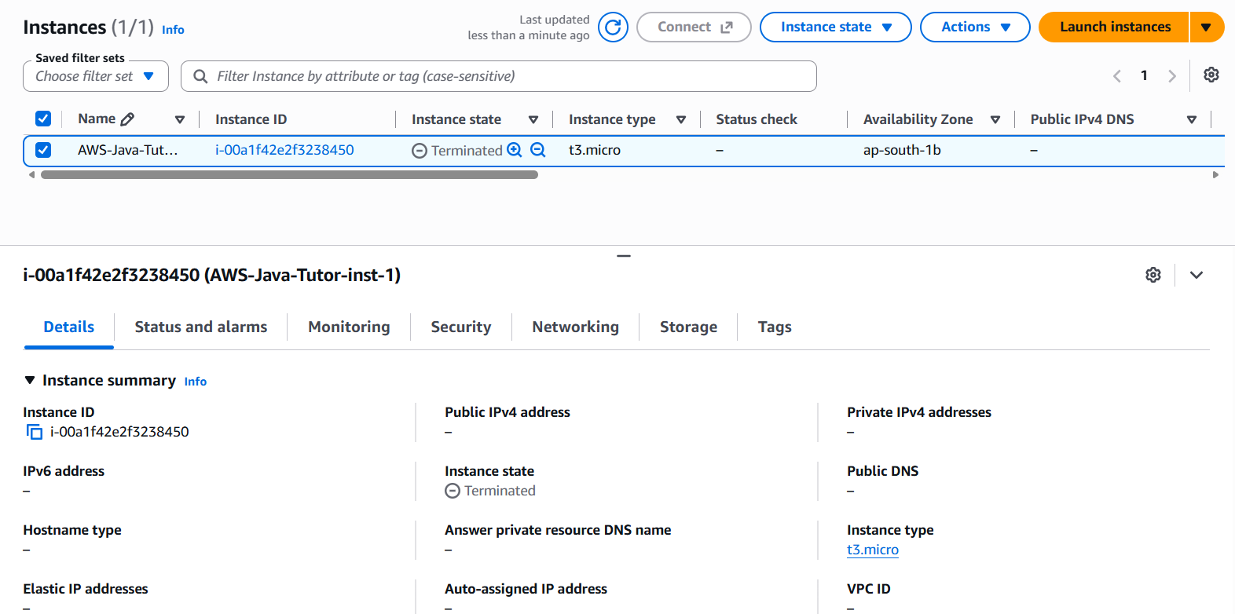
Create AMI (Amazon Machine Image):
Step-1: Create a EC2 instance using below commend
$sudo yum install java docker postgresql15 -y
$sudo systemctl start docker.service
$sudo systemctl enable docker
$sudo usermod -aG docker $USER
Step-2: Check all the services are running or not.
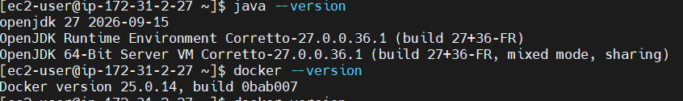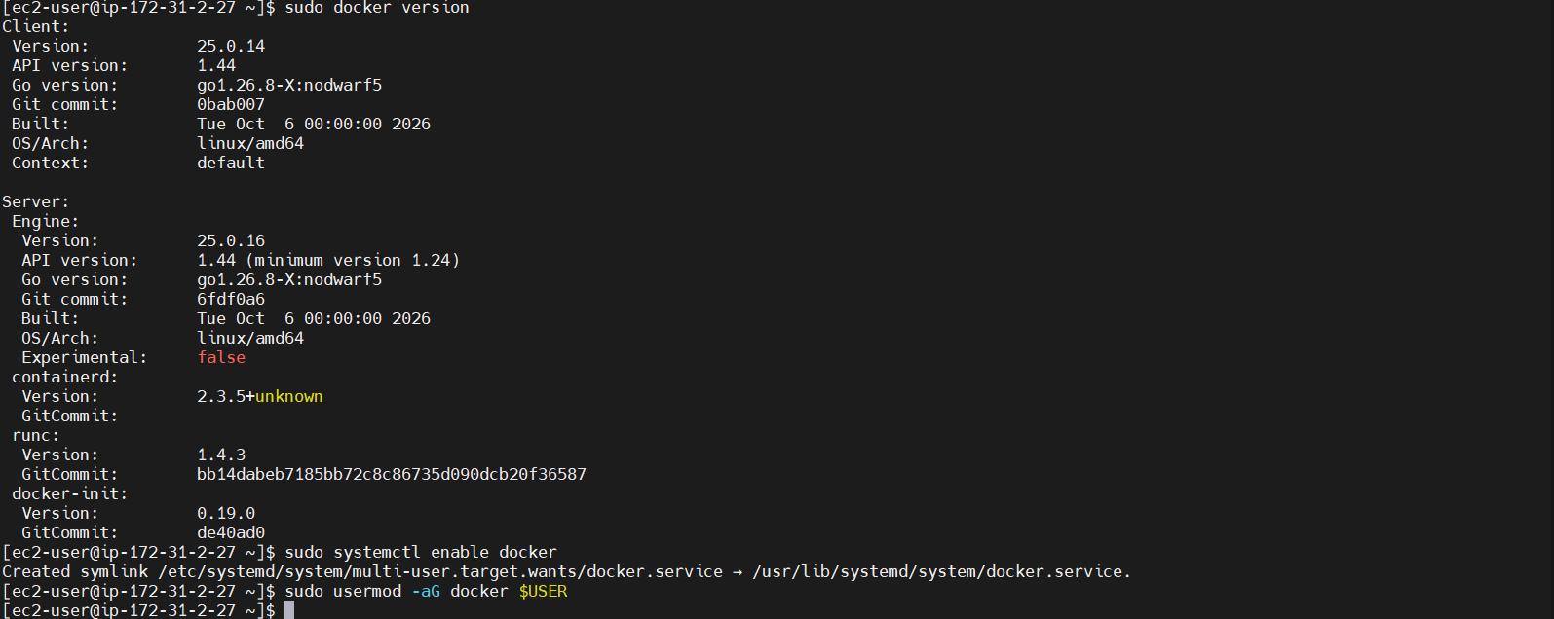
Step-3: Now create the image from existing Instance:
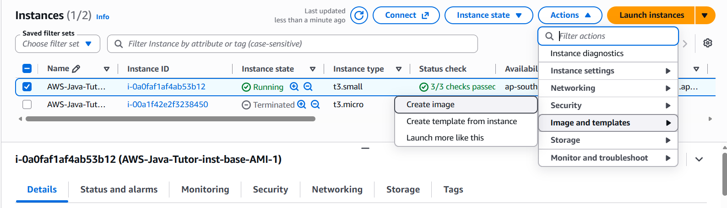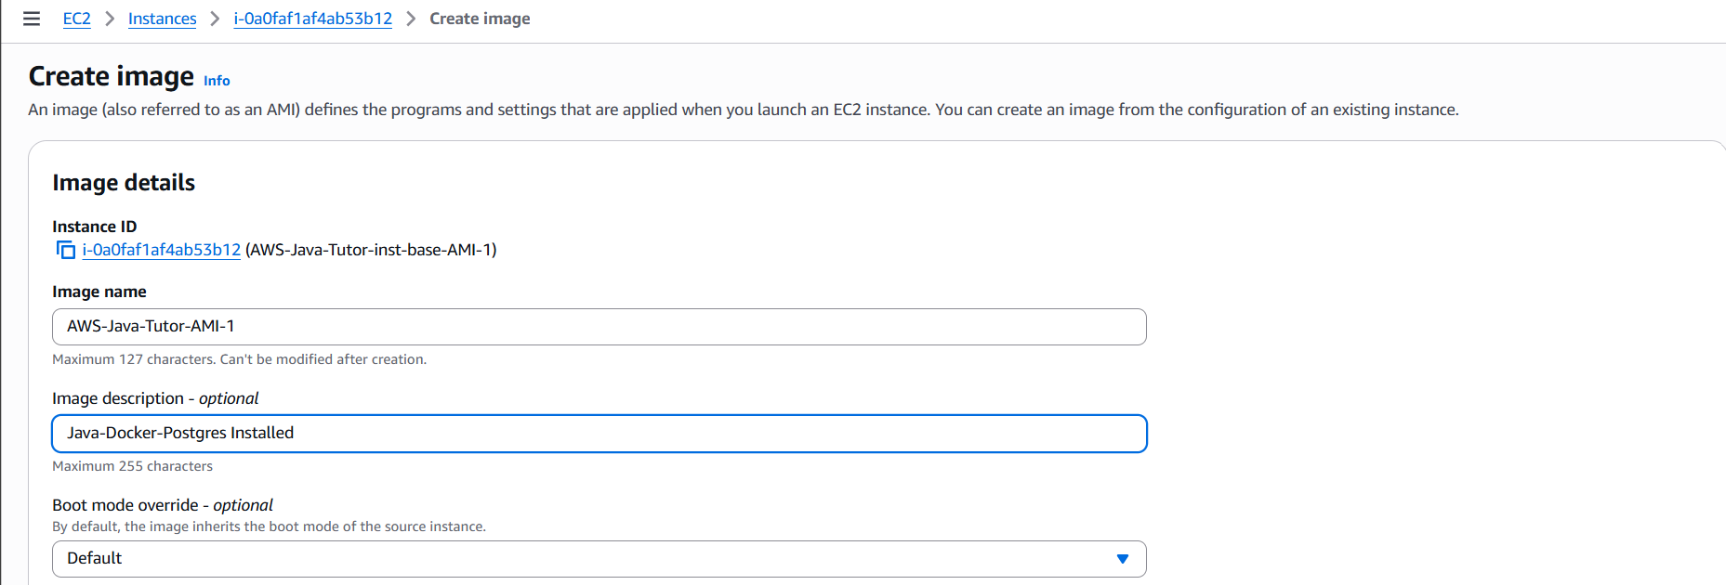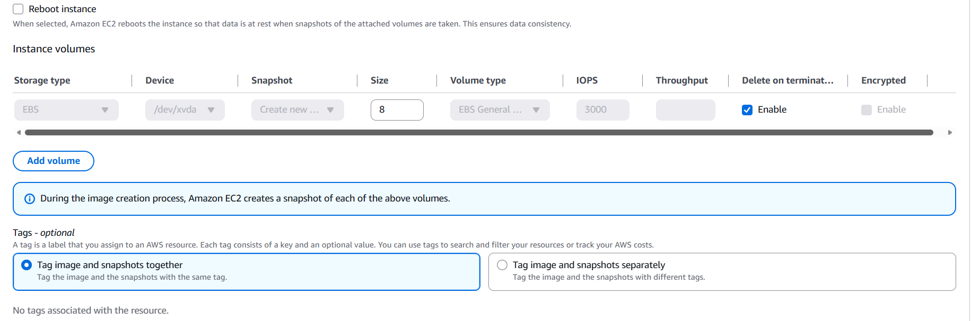
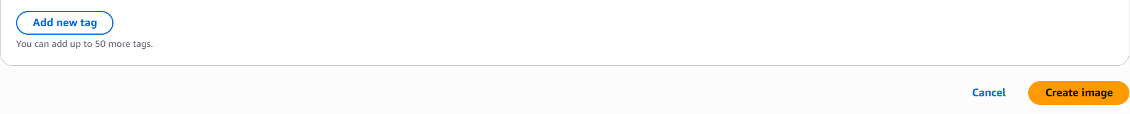
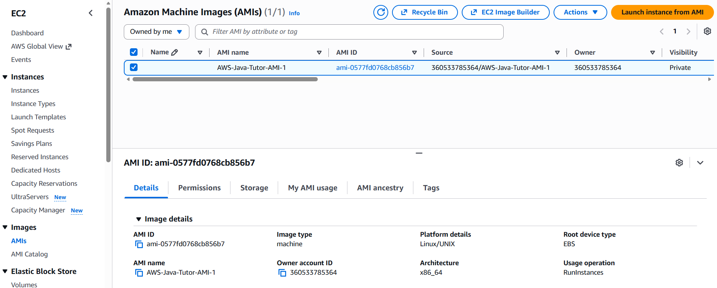
Step-4: Create the Instance from the custom AMI
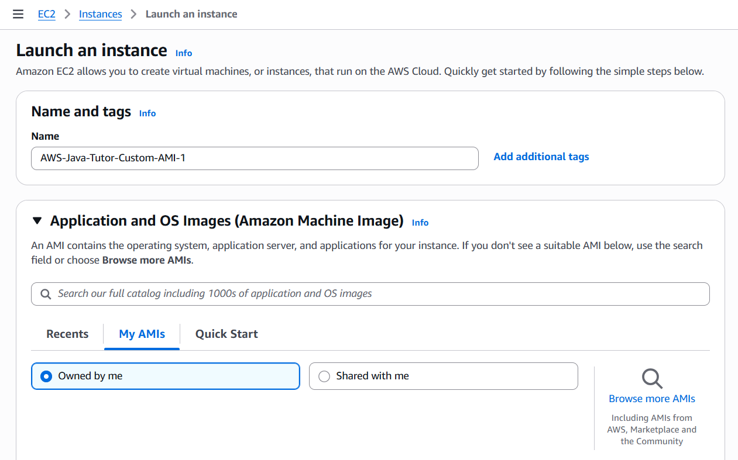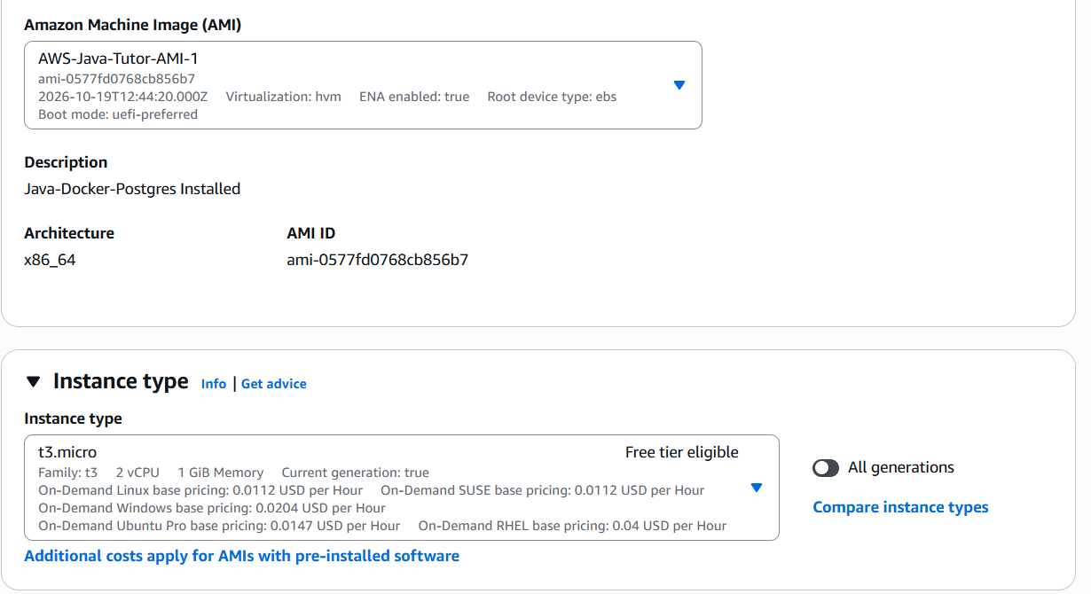
Step-5: Check the services
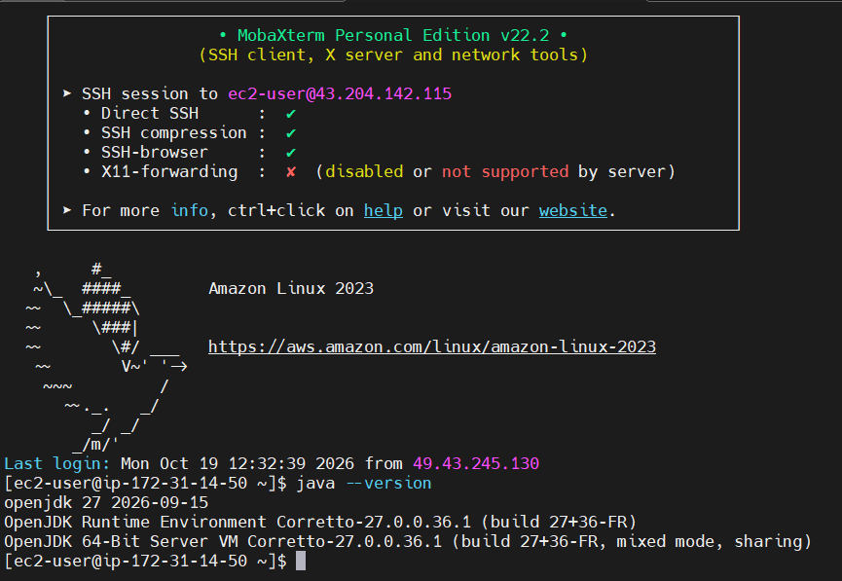
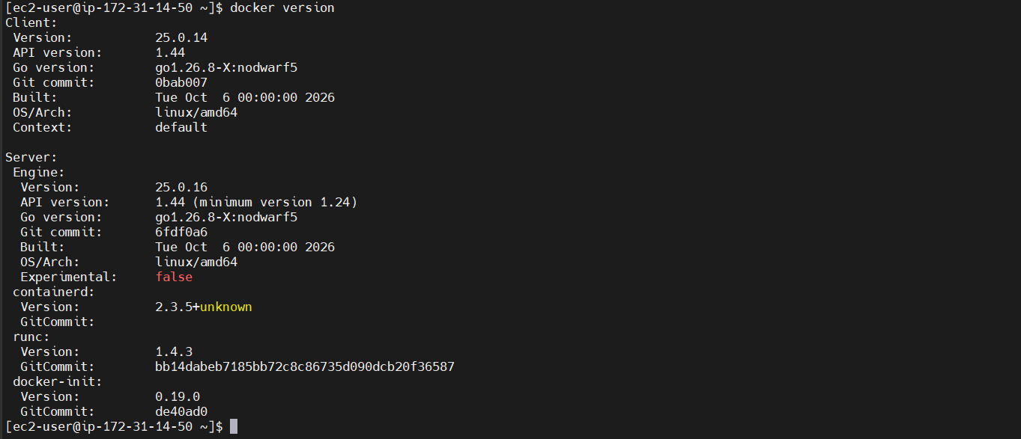
Step-6: Run nginx
$docker run -p 80:80 nginx
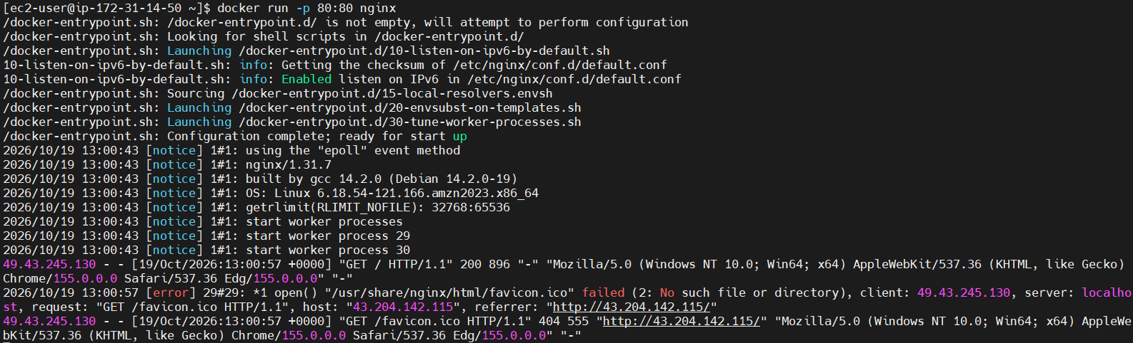
Step-7: Run Postgres
$docker run -p 5432:5432 -e POSTGRES_PASSWORD=password postgres
$docker run -d --name postgres-db -p 5432:5432 -e POSTGRES_PASSWORD=password postgres

Create the Instances:
Note: Use the custom AMI for the instance and the AWS-Java-SSH-SG(SG-1) for the security group.
Run Postgres:
Step-1: Test Internet Access from the EC2 Terminal
curl -I https://registry-1.docker.io/v2/
No Internate access to Docker repository then do this below exercise :
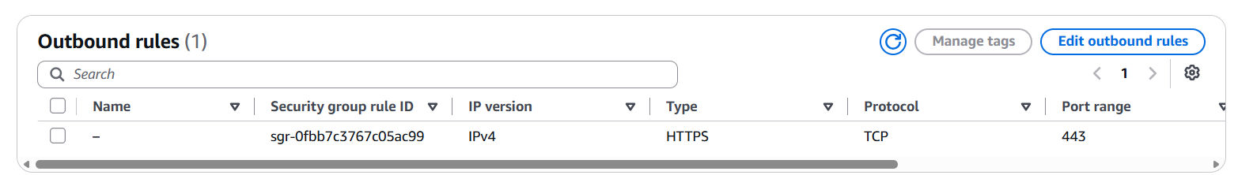
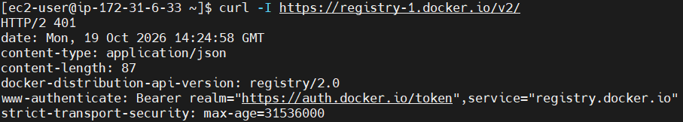

Now run the Postgres commend:
$docker run -d --name postgres-db -p 5432:5432 -e POSTGRES_PASSWORD=password postgres
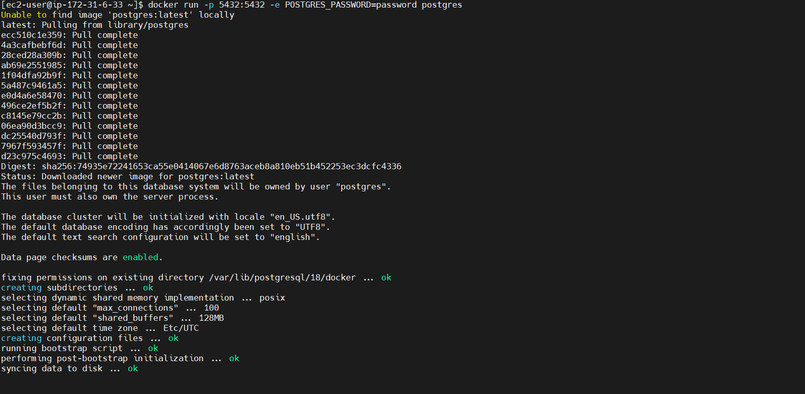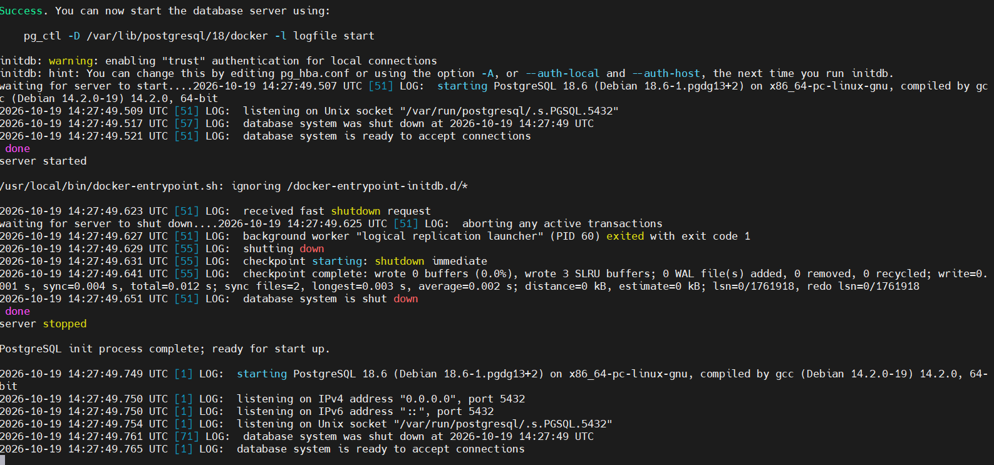
Now Postgres is ready to use.
Note : To check the containter details :
$docker ps
Step-2: Connect from App Ec2 instances
Note: Check the postgres client:
Note: Useful Commands to Interact with It
- Enter the PostgreSQL CLI (psql) inside the container:
$docker exec -it <Docker_Container_Name OR ID> psql -U postgres
$docker exec -it sweet_brahmagupta psql -U postgres
Note: If you want to see all databases
SELECT datname FROM pg_database;
- Check container logs:
$docker logs -f <Docker_Container_Name OR ID >
$docker logs -f sweet_brahmagupta
- Stop or restart if needed:
$docker stop <Docker_Container_Name OR ID >
$docker start <Docker_Container_Name OR ID >
$docker stop sweet_brahmagupta
$docker start sweet_brahmagupta
Now connect to the DB
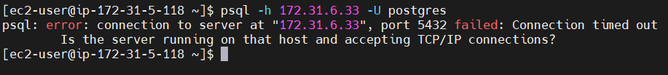

Security Group:
SG-1:
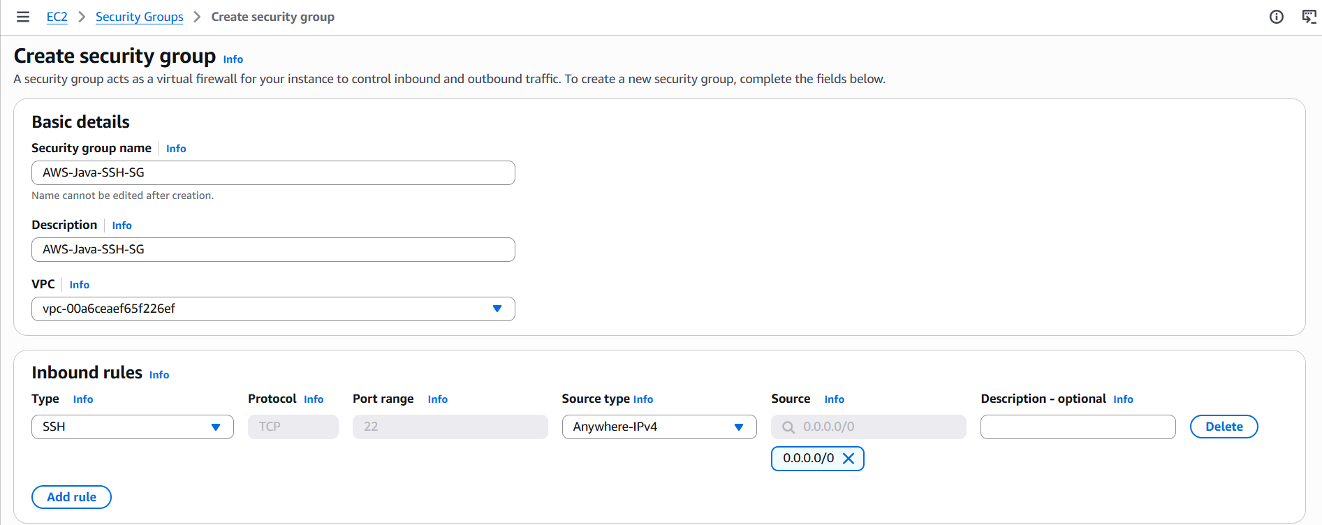
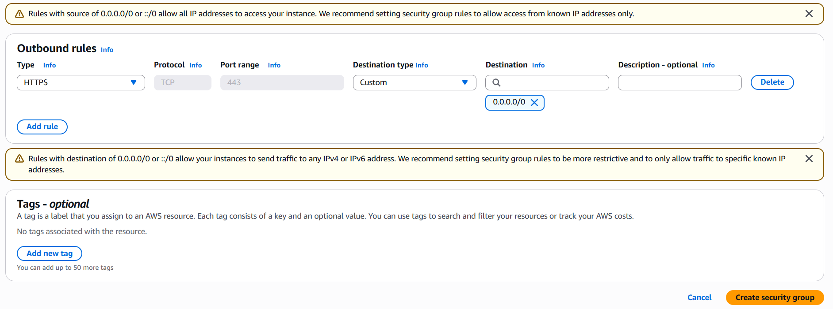
Step-2:
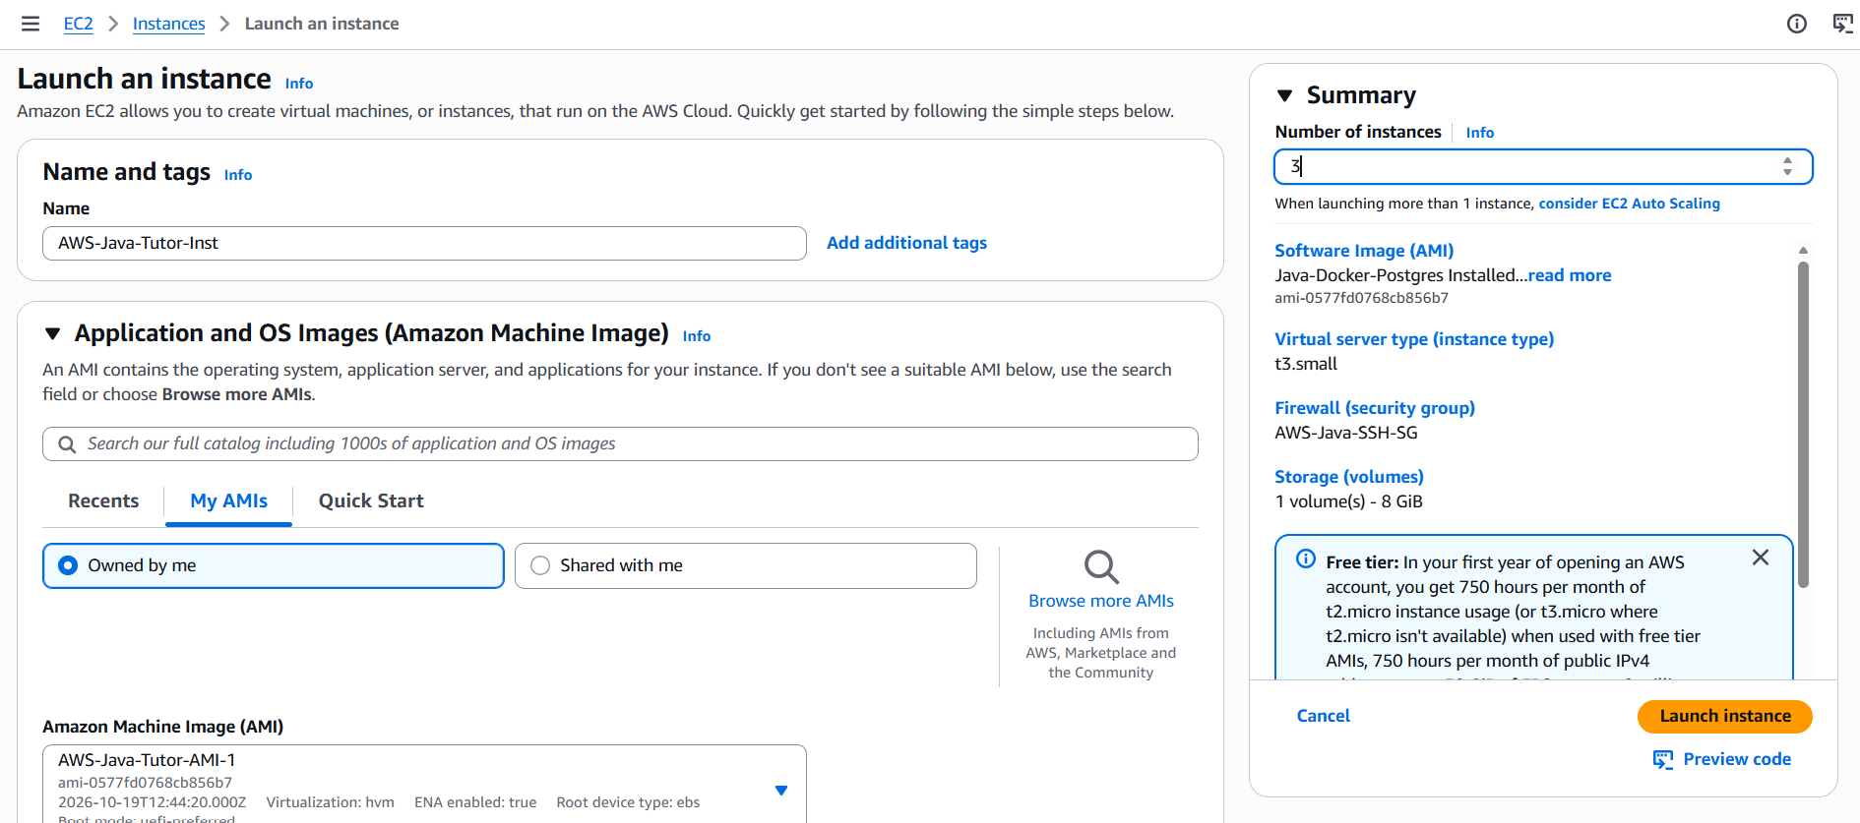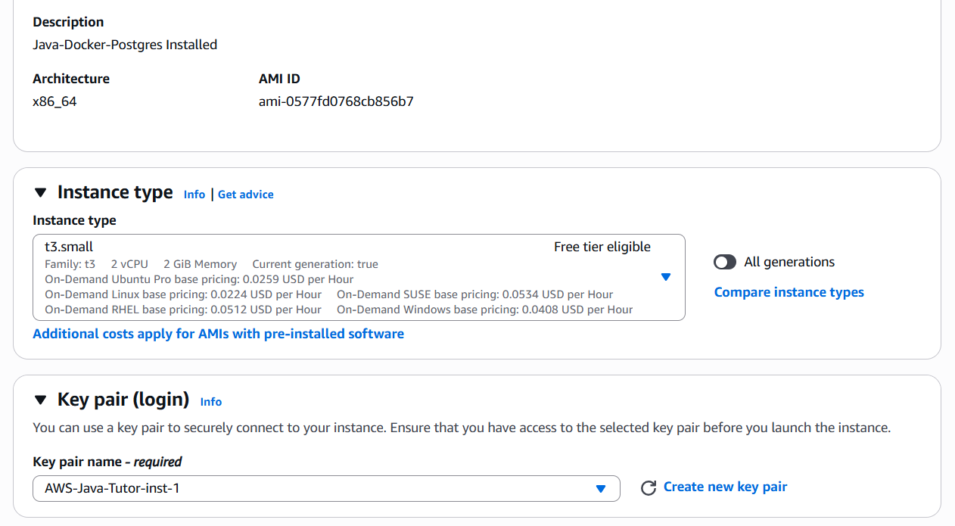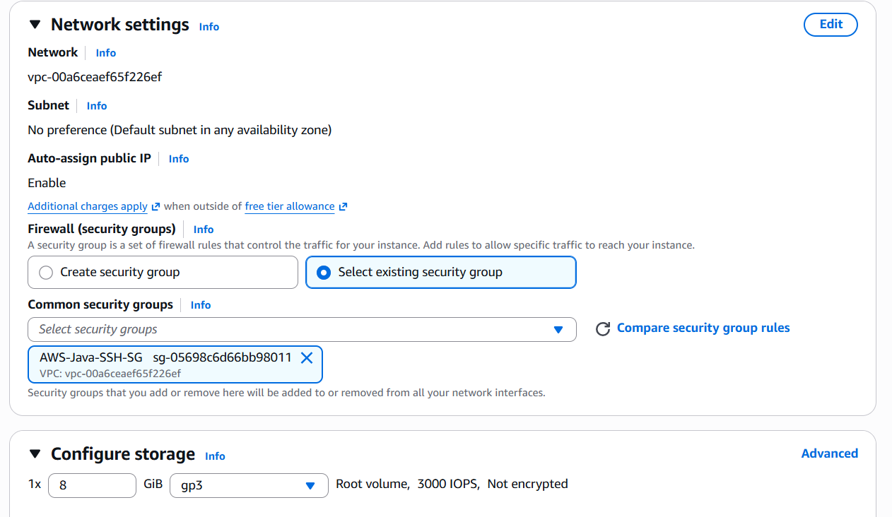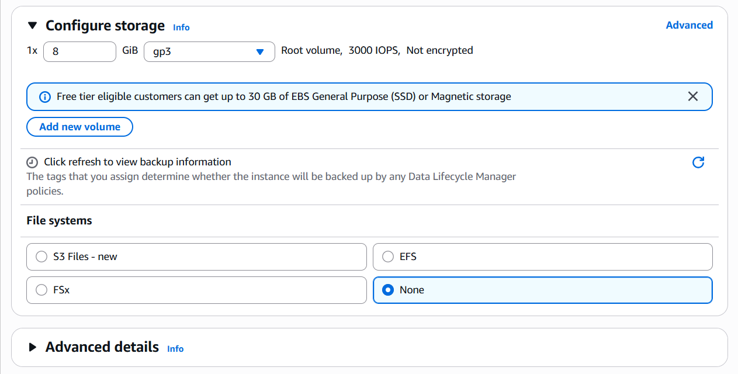
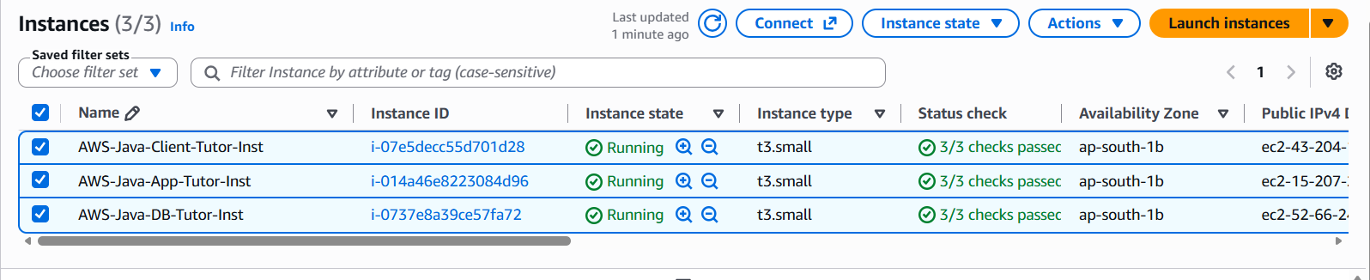
DB | APP | Client
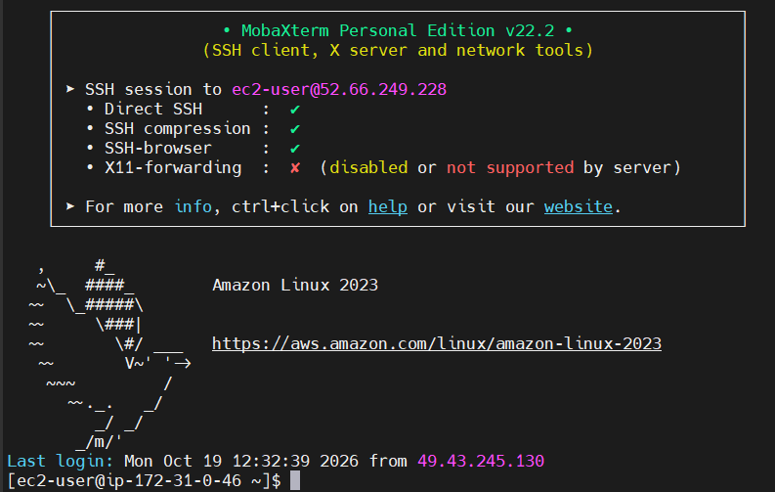 | 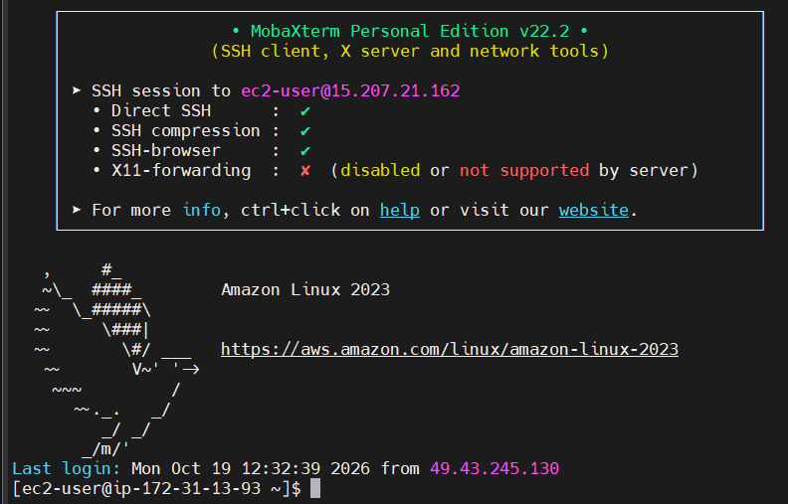 | 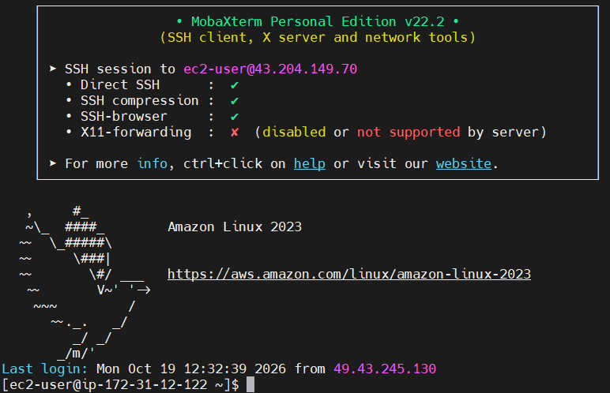
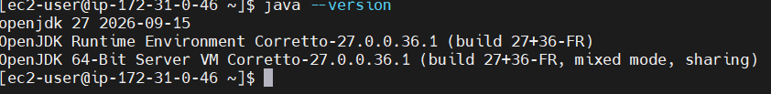 | 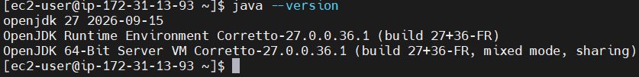 | 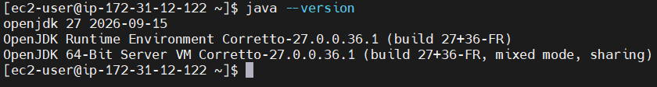
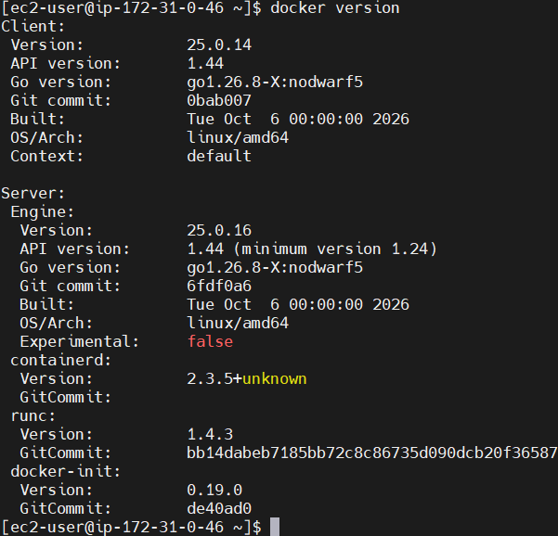 | 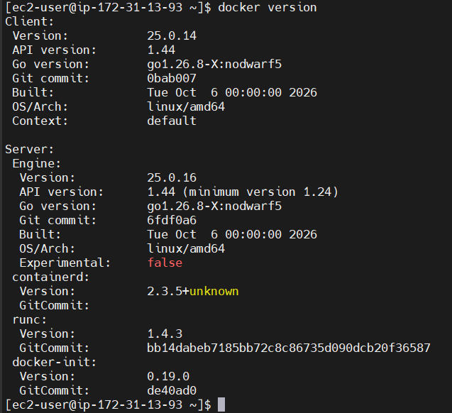 | 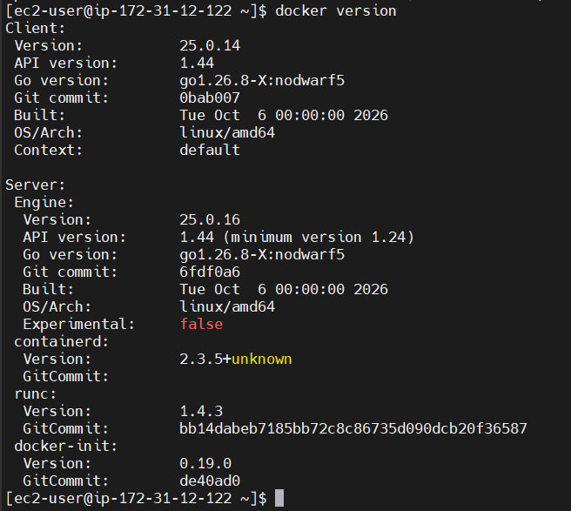
Step-1
docker run -d --name postgres-db -p 5432:5432 -e POSTGRES_PASSWORD=password postgres | psql -h 172.31.0.46 -U postgres | psql -h 172.31.0.46 -U postgres
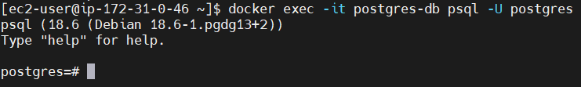 |  | 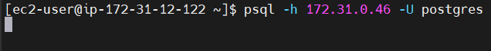
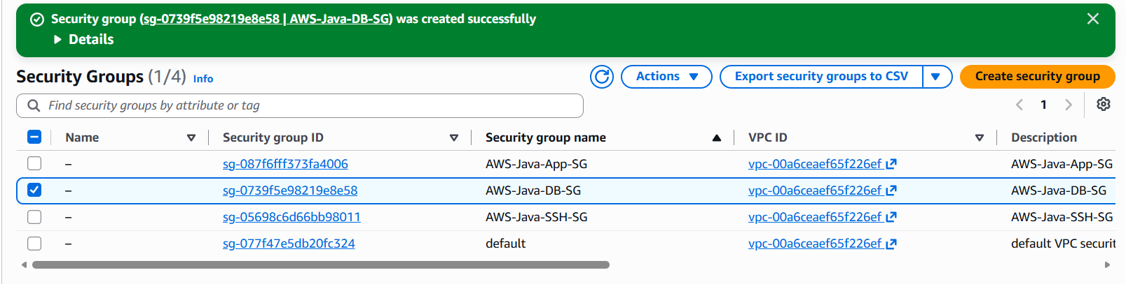 | 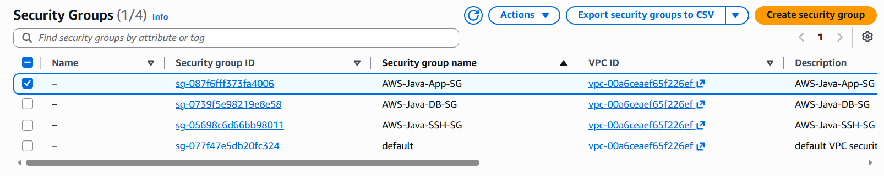
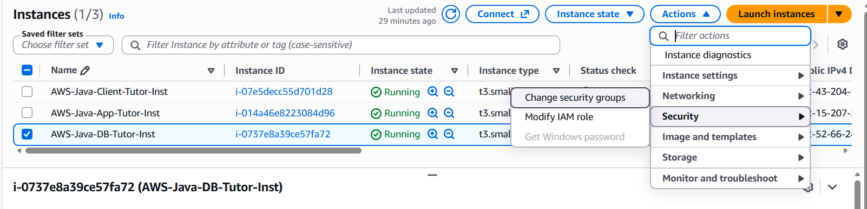 | 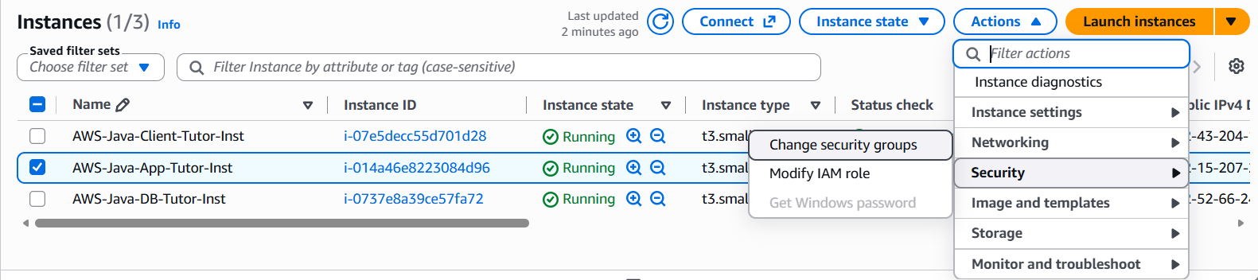
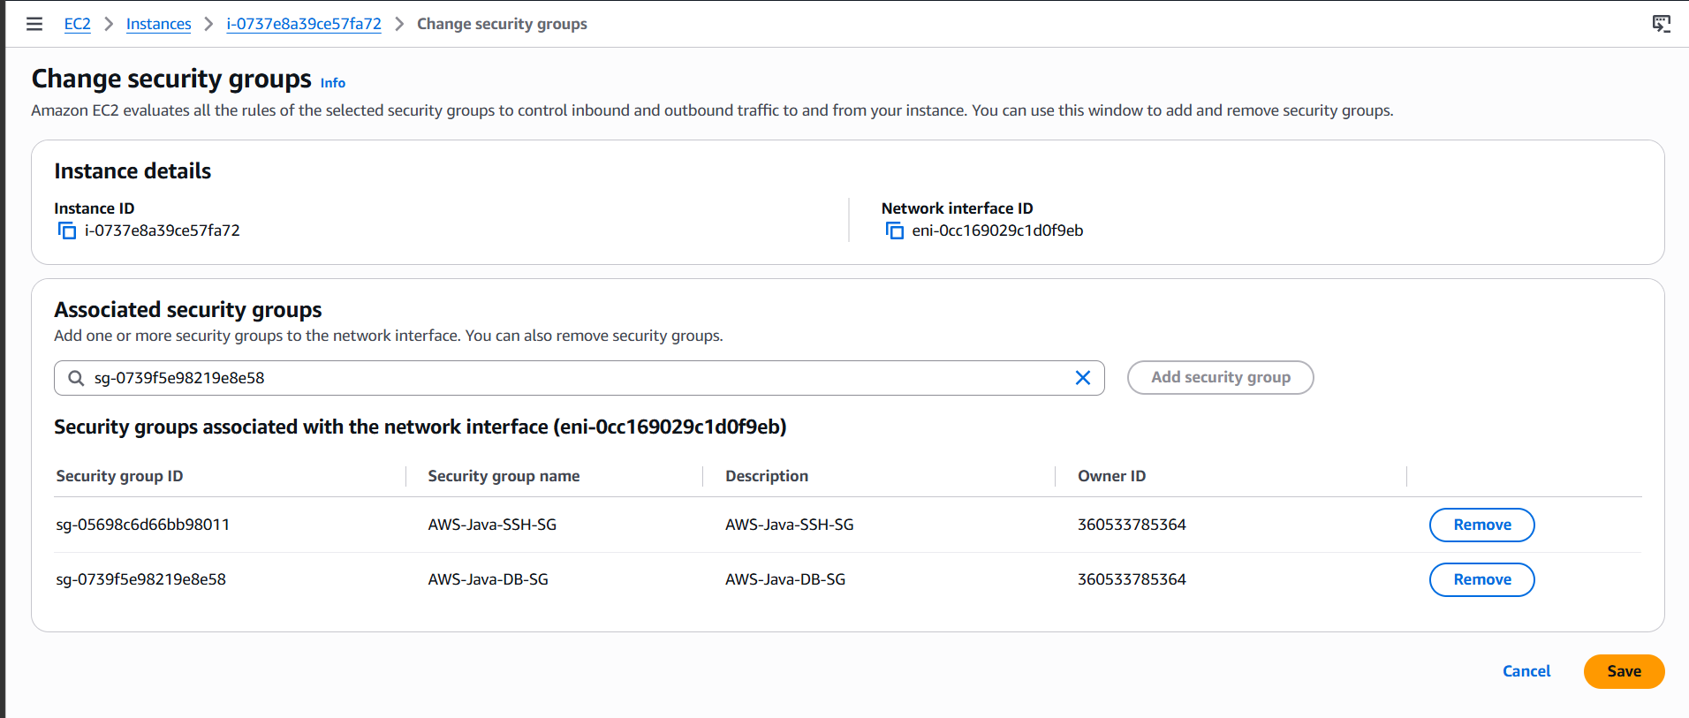 | 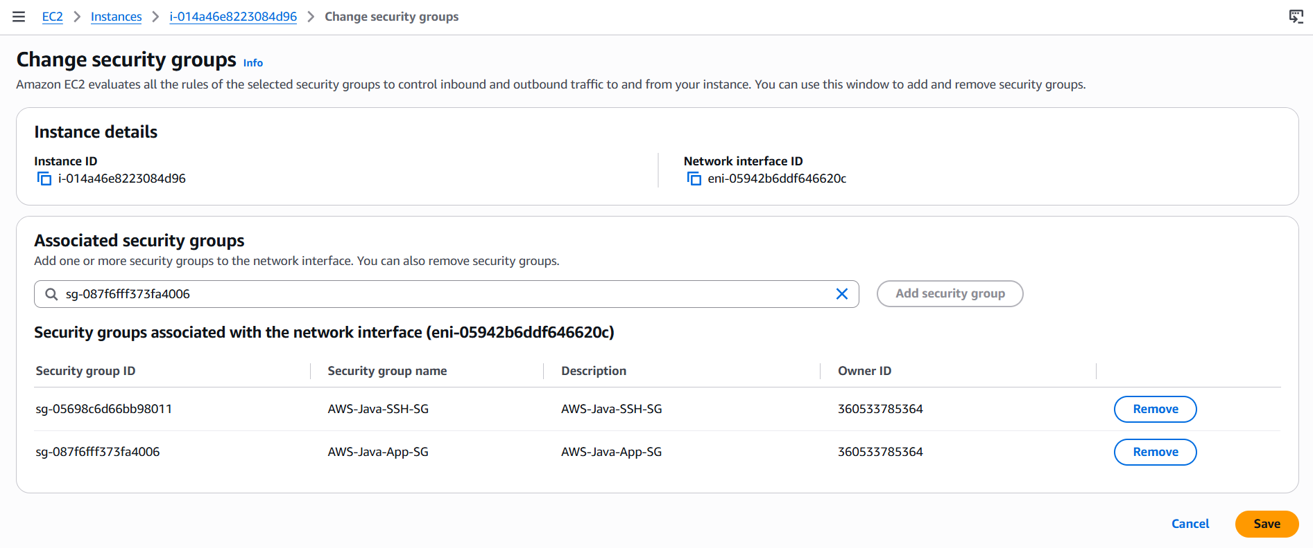
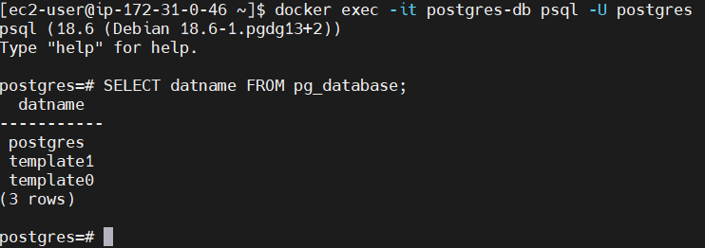 | 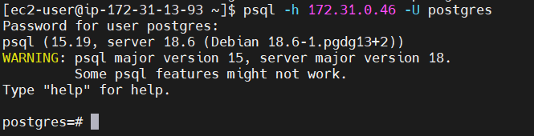
Step-2 | docker run -d --name my-nginx -p 80:80 nginx
 | 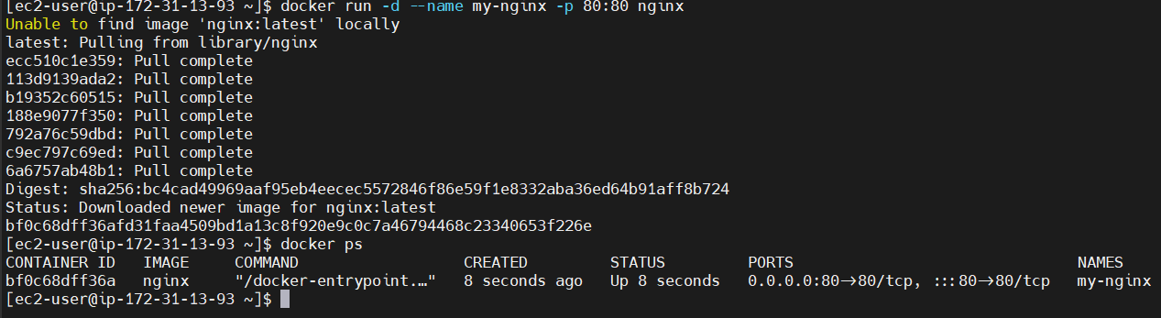
 | curl http://localhost
 | 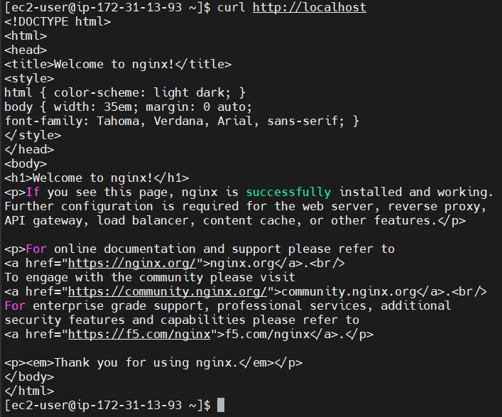 | 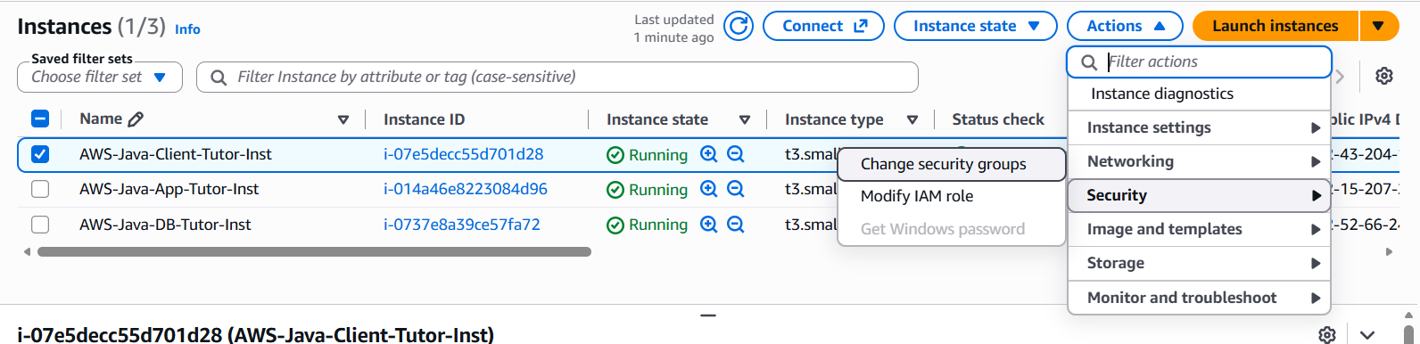
 |  | 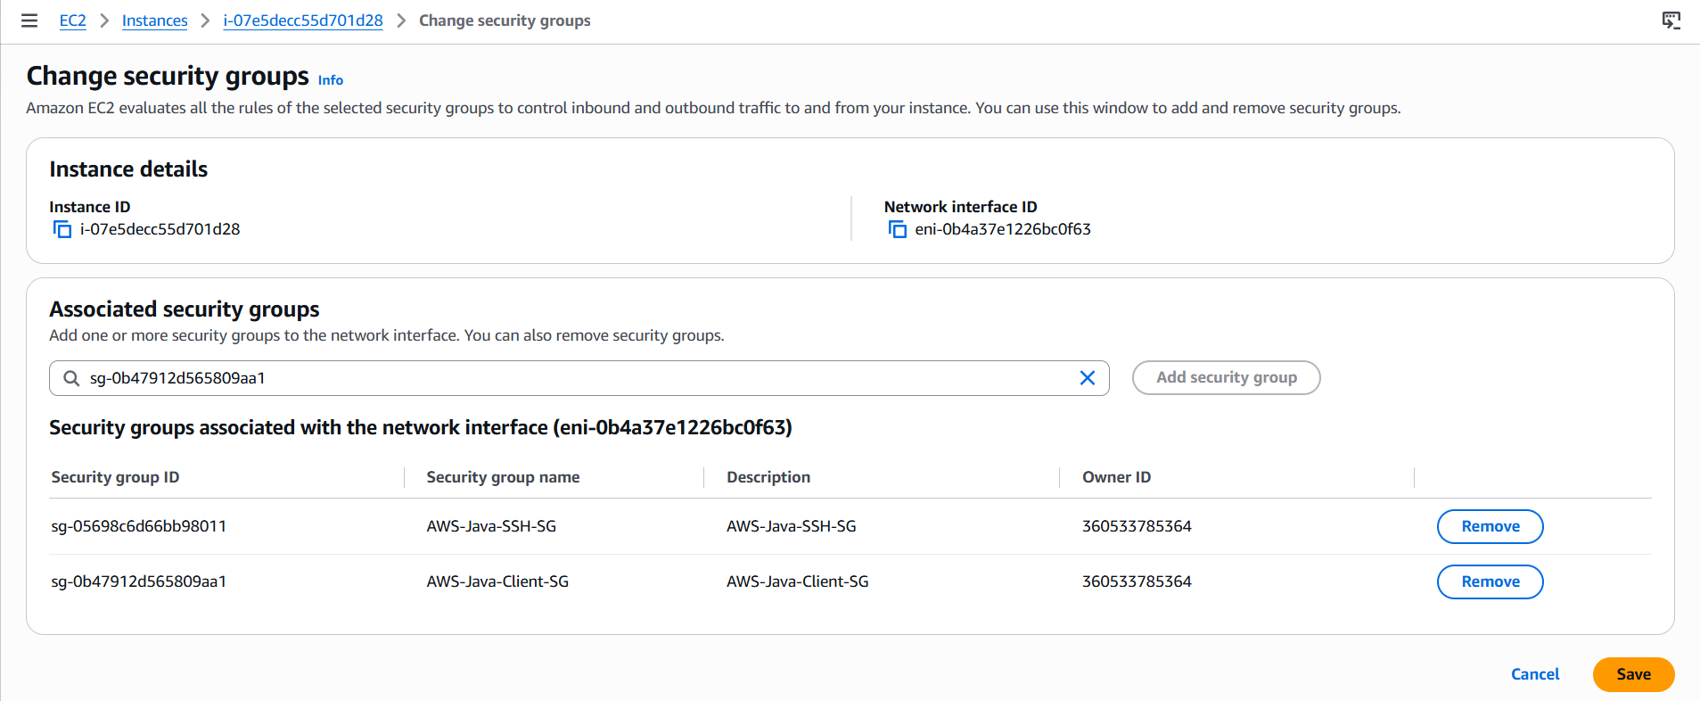
 |  | curl -I http://172.31.13.93
 |  | 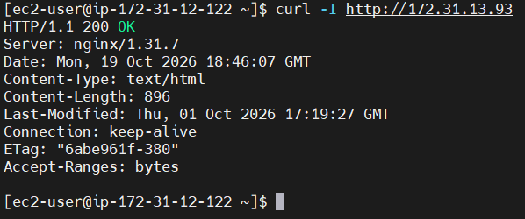
 |  | 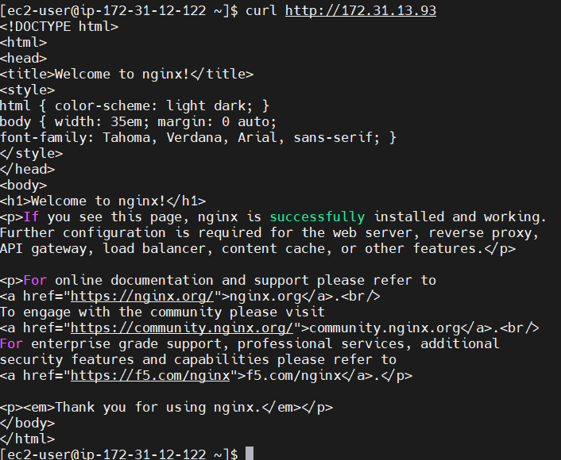

SG-2:
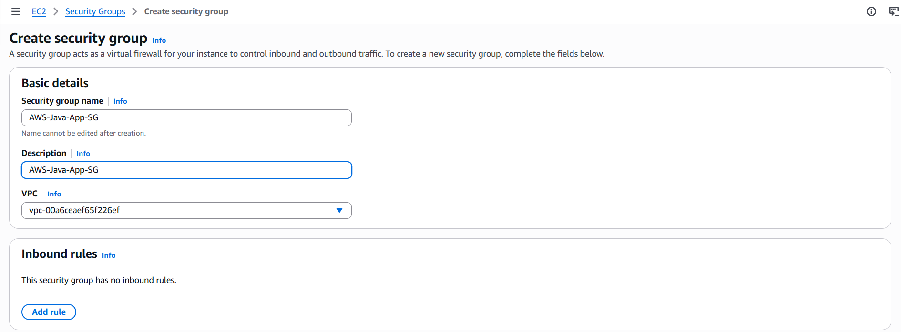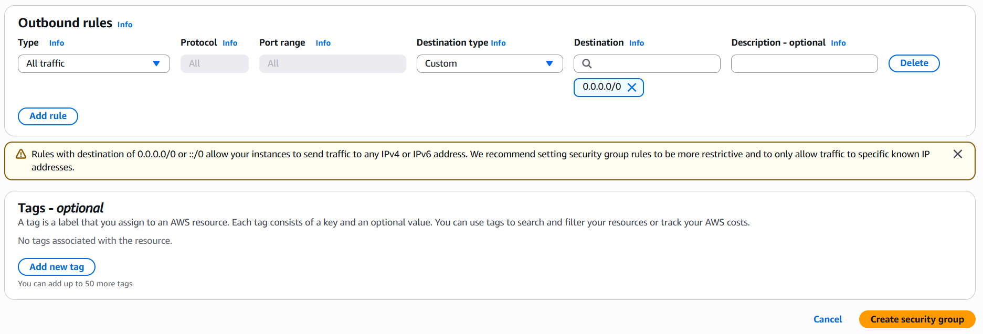
SG-3:
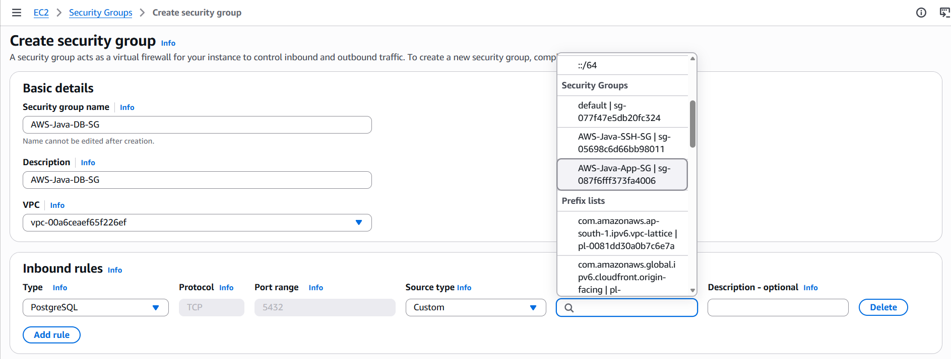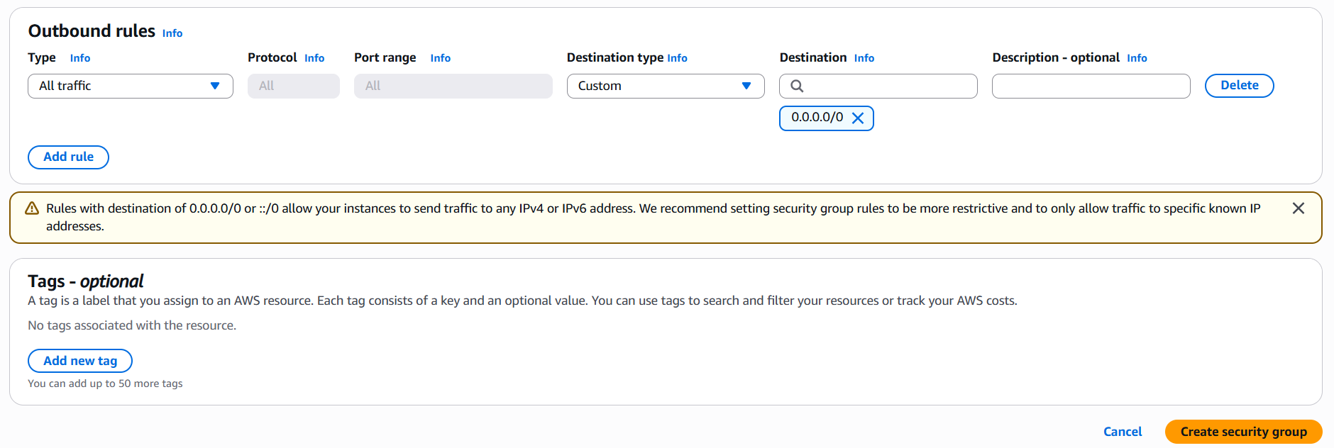
SG-4:
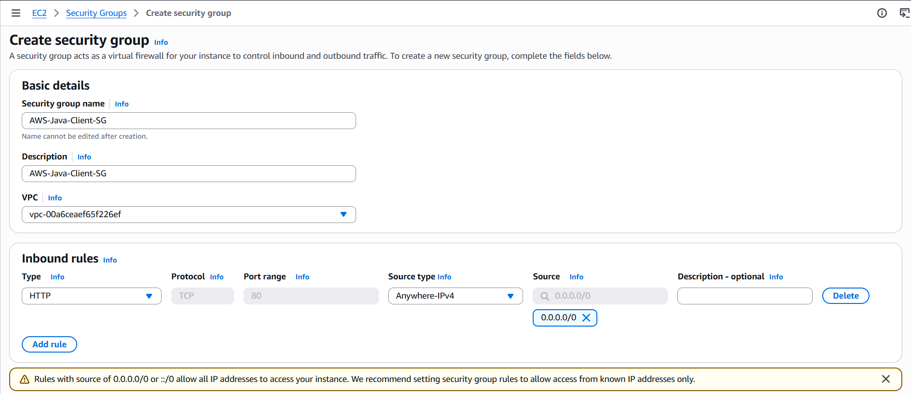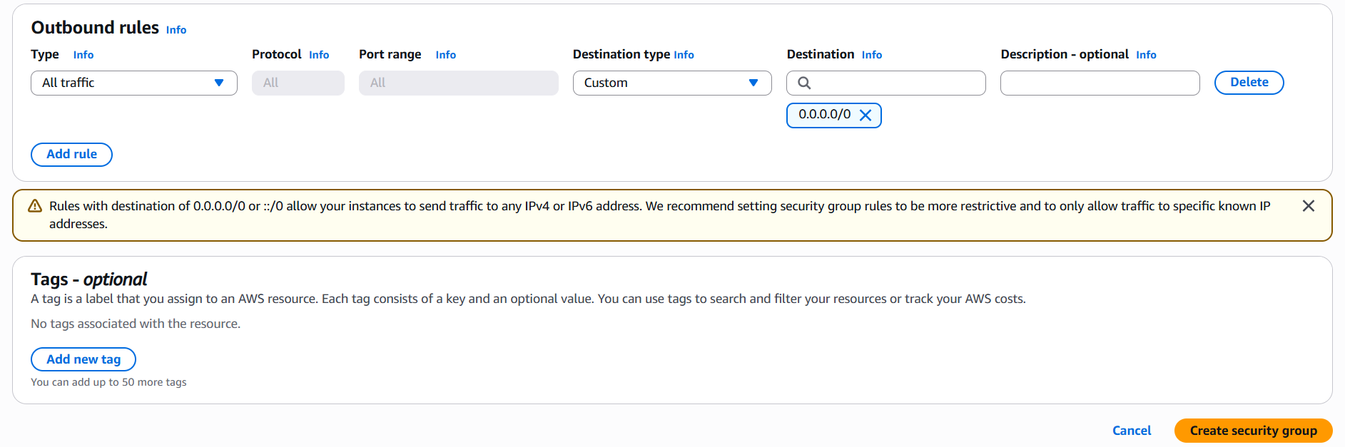
SG-2:
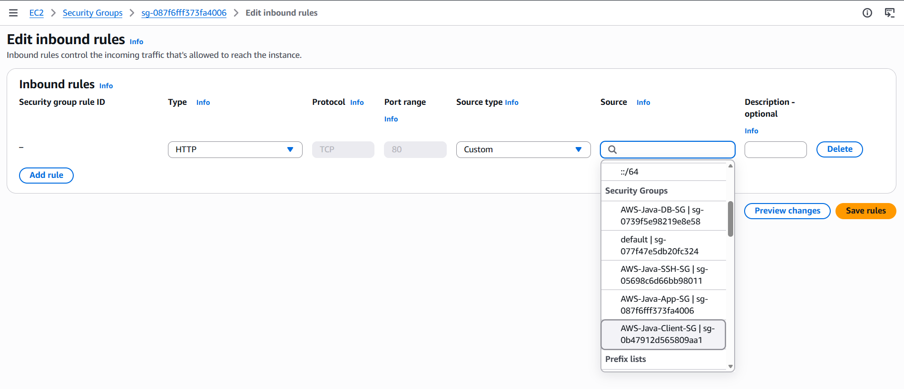
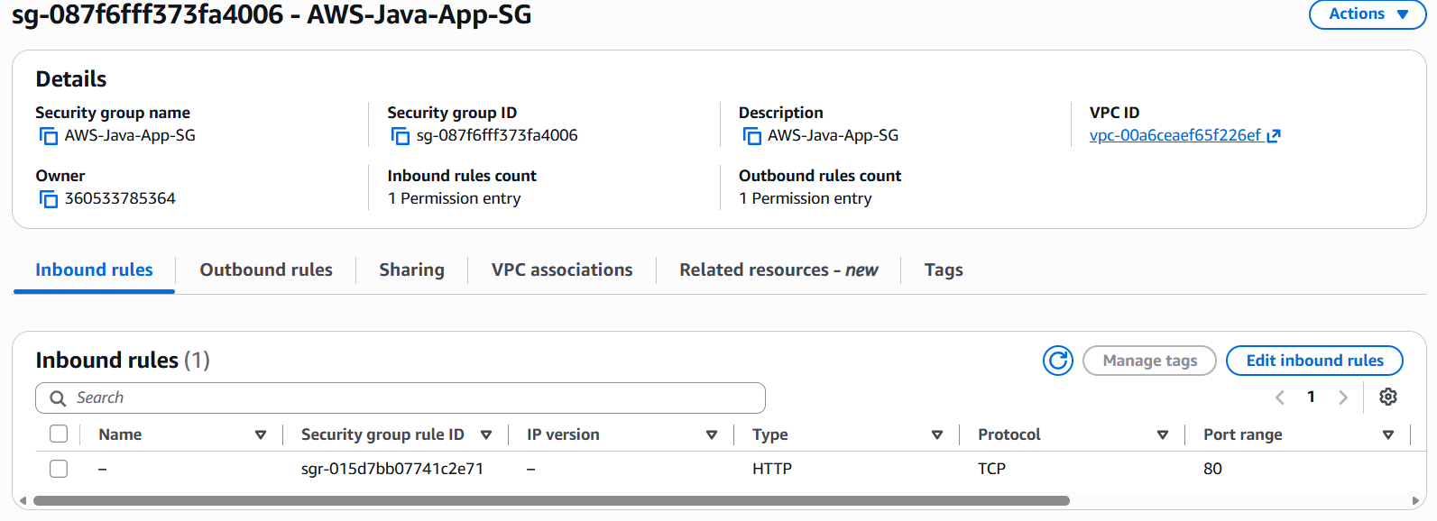

All the SG :
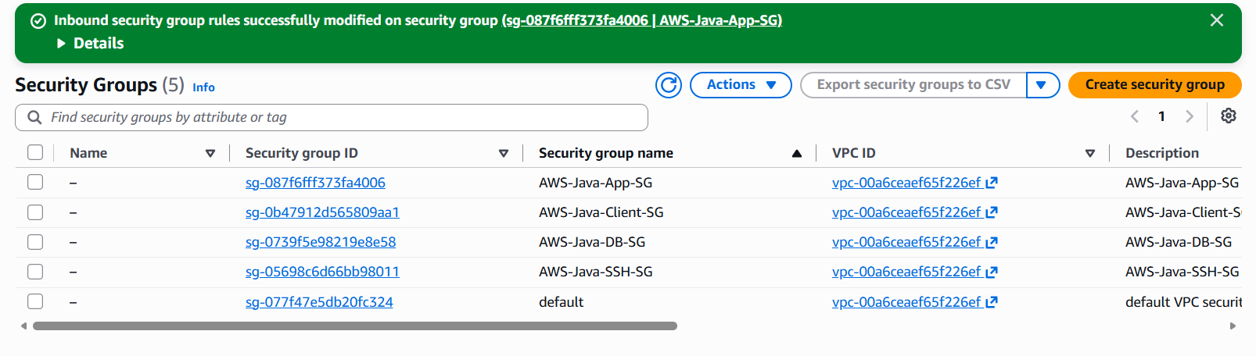

Note: We can create SG for same port:
