**Easy_WES tools by Cao Yujie 2017-11-29**

* Upload your Raw_data to the project folder naming the folder Raw_data as show below:

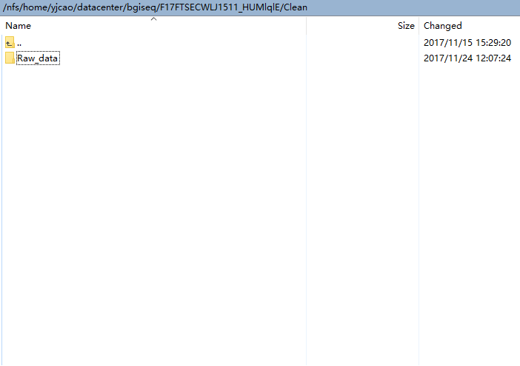

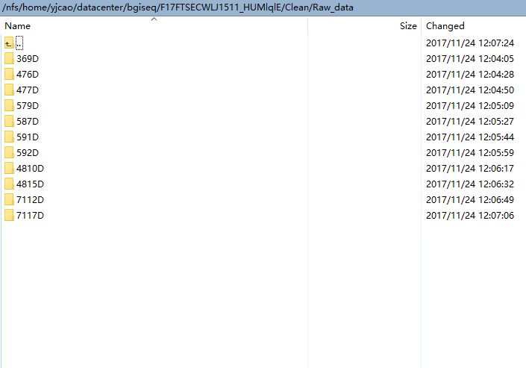

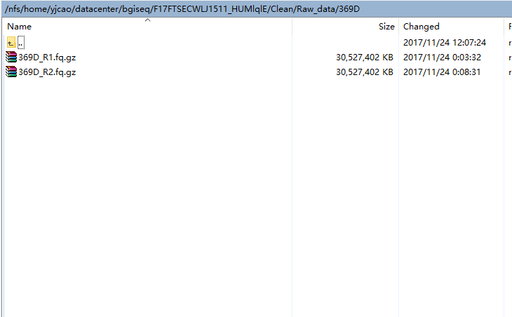

* Your file name should be in the format of SampleID+R1orR2.fq.gz, otherwise you need to rename file name using bash command mv.
* Upload Easy_WES folder to the project folder, same folder as Raw_data folder as show below:

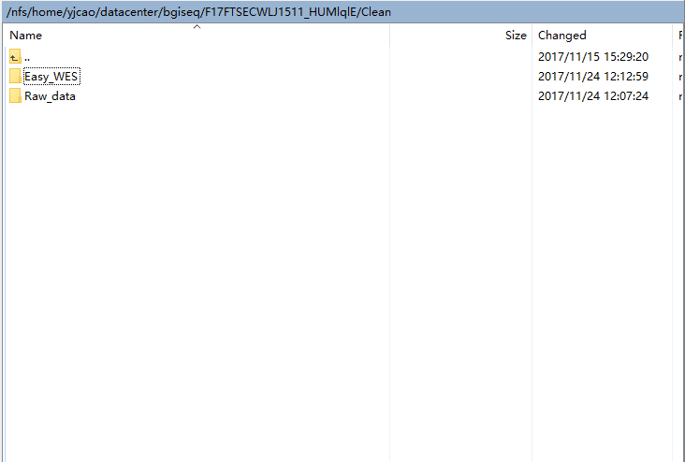

* Then, cd Easy_WES

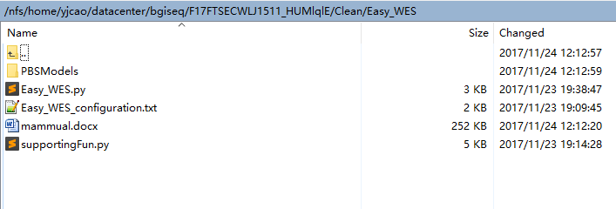

* Then, change configures in file Easy_WES_configuration.txt, such as working path, software path, sample name list and PBSscripts lists:

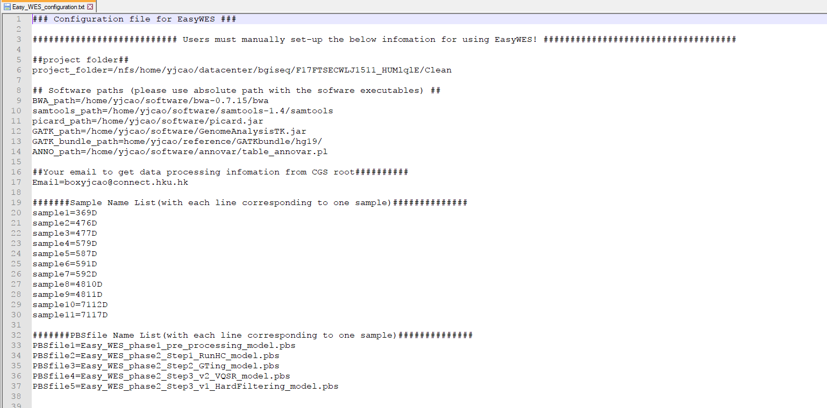

* Then, cd Easy_WES, run the scripts:

python Easy_WES.py

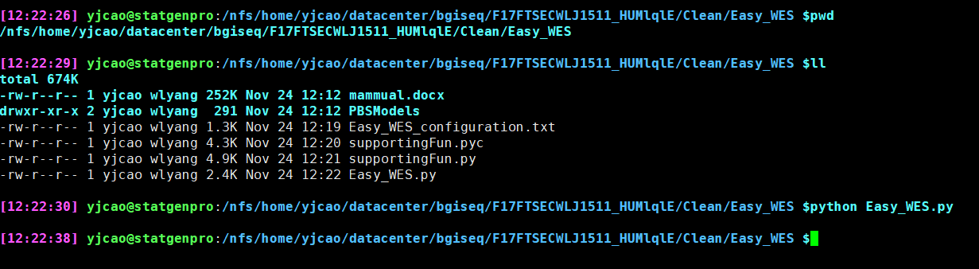

* You will get:

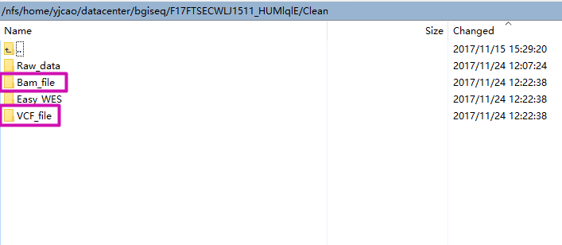

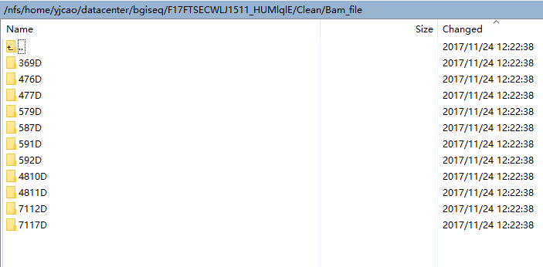

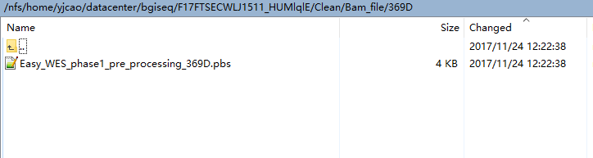

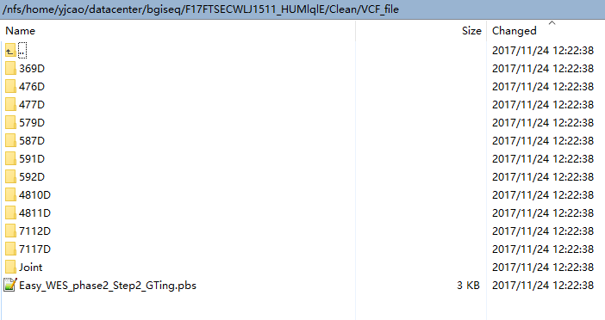

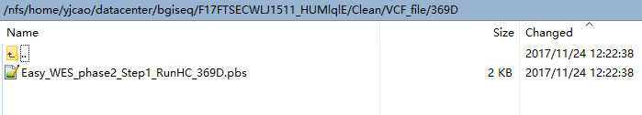

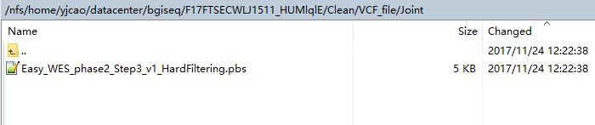

* And under each Raw_data sample folder, you will get fastqc pbs files, such as this case, under /Raw_data/369D/:

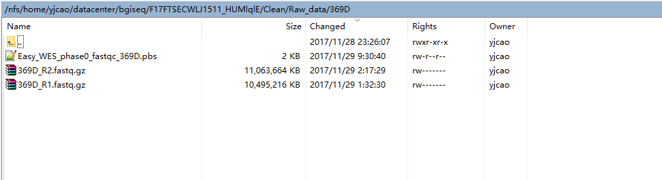

* If necessary, run fastqc for each sample. In the reporter of fastqc, you need to make sure base quality for fastq files should be Illumina 1.8+ Phred+33(https://en.wikipedia.org/wiki/FASTQ_format). Otherwise you need to correct it use tools like seqtk.

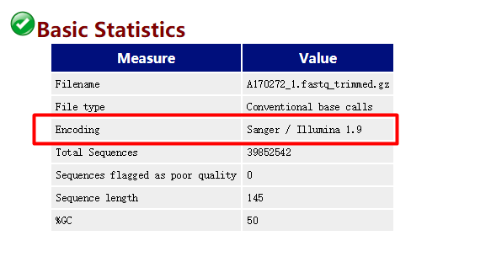

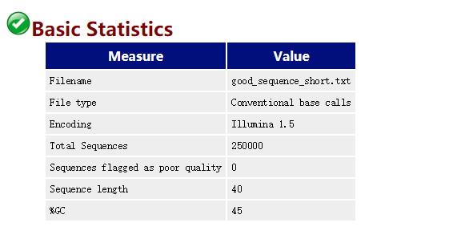

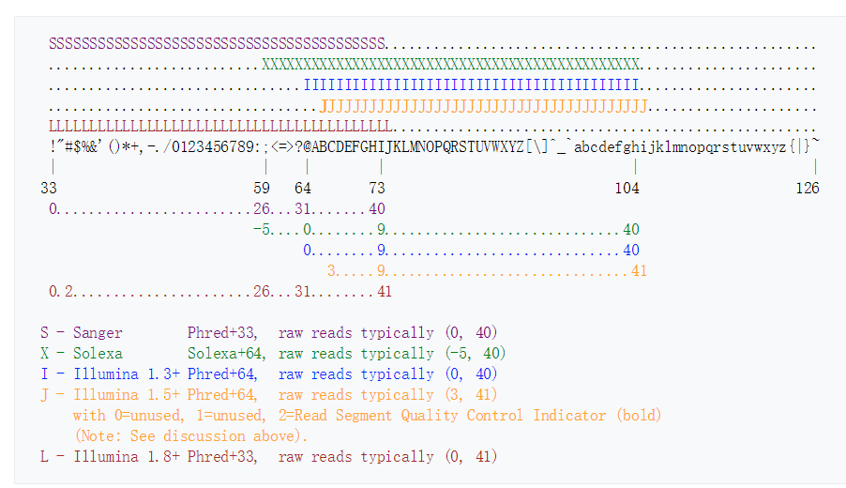

* Submit your tasks to CGS queen

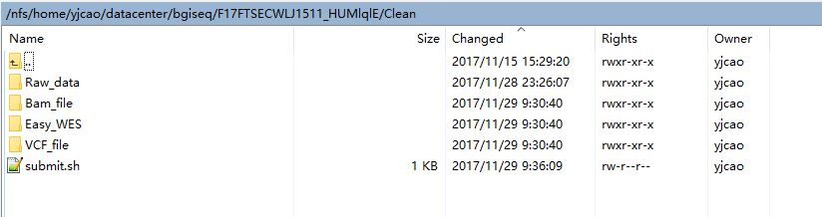

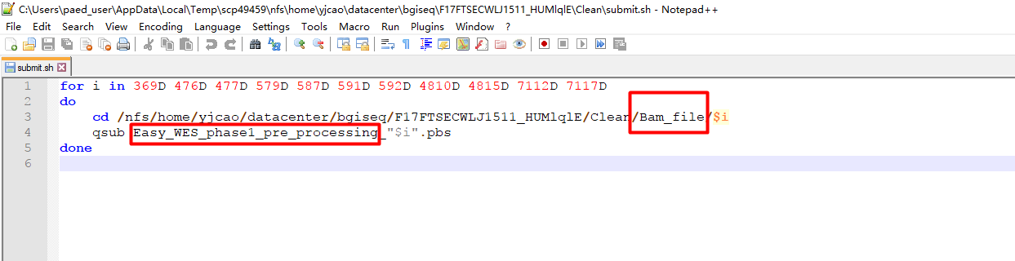

* Only manually change the highlighted folders or prefix, and run the following bash commands:

sh submit.sh

in the following orders:

cd /path/to/projectfolder/Raw_data/$i

qsub Easy_WES_phase0_Fastqc_"$i".pbs

cd /path/to/projectfolder/Bam_file/$i

qsub Easy_WES_phase1_pre_processing_"$i".pbs

cd /path/to/projectfolder/VCF_file/$i

qsub Easy_WES_phase2_Step1_RunHC_"$i".pbs

Under VCF_file folder, qsub Easy_WES_phase2_Step2_GTing.pbs, then under /VCF_file/Joint there will be a file named All_Genotyping.vcf.

Then if your sample size is large than 30, qsub the Easy_WES_phase2_Step3_v2_VQSR.pbs, otherwise qsub Easy_WES_phase2_Step3_v1_HardFiltering.pbs

Both of them will perform filtering on the callset, and do the genotype refinement, followed by annotate the callset.

