FAZAIA BILQUIS COLLEGE OF EDUCATION FOR
WOMEN PAF NUR KHAN, RWP

Parallel Distributed Computing (LAB)
Home Task
Submitted to
Ma’am Iffat

Submitted by
Javeria Fazal
BSCS 7th B
F21-62

- Source Code (Screenshot):
Problem Statement
Develop a Client–Server application in C# using TCP sockets that supports both Sign Up (new
user registration) and Login (existing user authentication).
The server stores user credentials in memory and allows new users to register dynamically.
When a client connects, they can choose to either sign up or log in.
This task builds understanding of stateful communication, dynamic data handling, and
socket-based authentication protocols.
Features
➔ Client chooses: 1. Sign Up or 2. Login
➔ The server maintains a dictionary of users (username → password).
➔ New users can be added at runtime.
➔ Existing users can log in after successful authentication.
➔ Responses are sent back to the client accordingly.
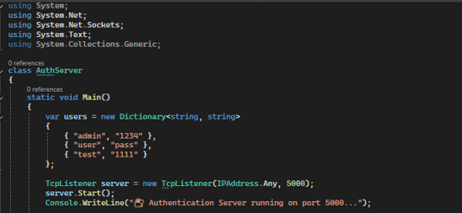
- Server Side:

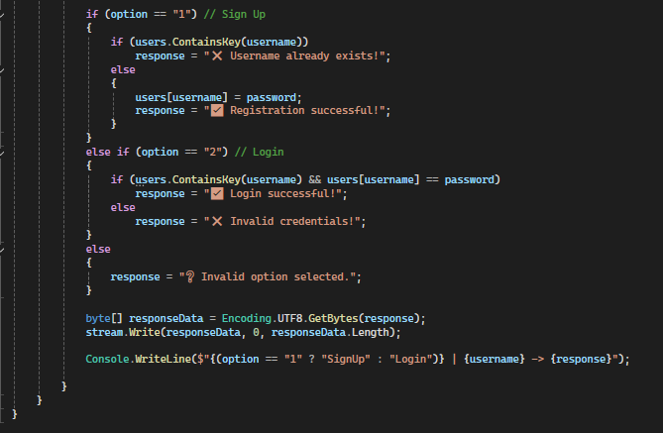
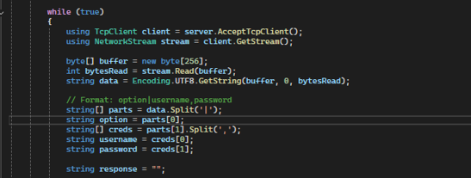
Figure 1
- Client Side (Screenshot):
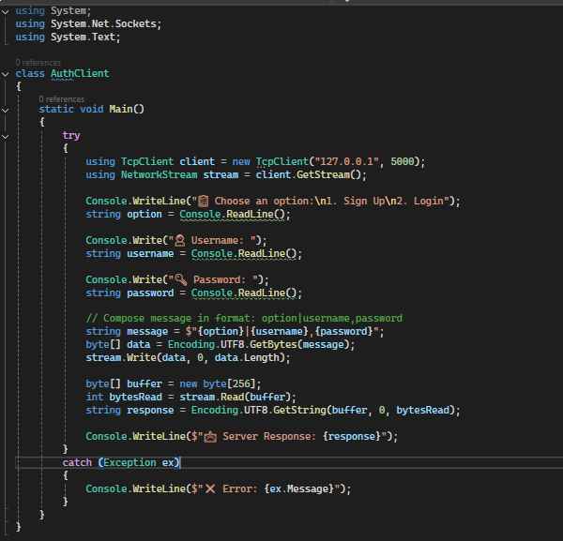
Figure 2
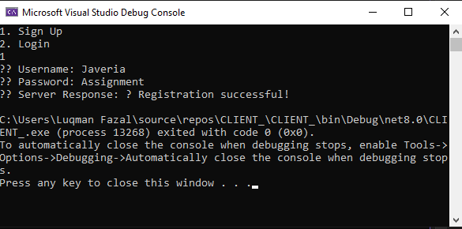
- Output,When choosing Option 1 (Sign up):
Figure 3: Client side

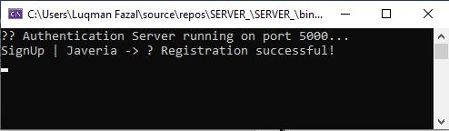
- Output, When choosing option 2 (login):
Figure 4: Server Side
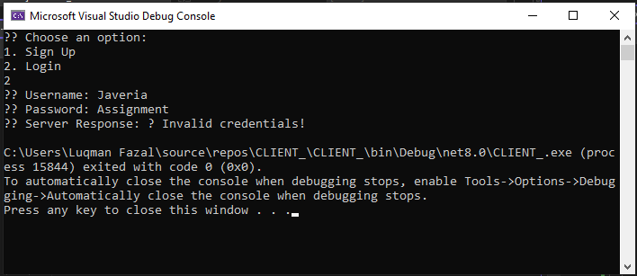
Figure 5: Client Side
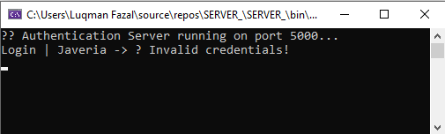
Figure 6: Server Side

