The University of Azad Jammu and Kashmir, Muzaffarabad
Department of Software Engineering
COMPETITION REPORT
BirdCLEF+ 2026
Acoustic Species Identification in the Pantanal, South America

Course / Assignment | Machine Learning / Kaggle Competition
Competition | BirdCLEF+ 2026
Team Size | 2 Students
Submitted By | 1. Javeria Yousaf Mughal  2. Arooj Hafeez
Roll Numbers | 2023-SE-15, 2023-SE-25
Submitted To | Engr. Khawaja Ahmed

Submission Date: _20-09-2026____

1. Introduction
BirdCLEF+ 2026 is a Kaggle research-code competition focused on identifying wildlife species from their sounds. The competition uses acoustic recordings collected in the Brazilian Pantanal and asks participants to build machine-learning systems that can recognize species in continuous soundscape recordings. The target classes include birds, amphibians, mammals, reptiles, and insects.
Our group participated in this competition as a practical machine-learning activity. The main purpose of the participation was to understand the complete workflow of a real Kaggle competition: understanding the problem, exploring the dataset, preparing audio data, developing a prediction pipeline, generating a submission file, and evaluating the result on the Kaggle leaderboard.
The competition was particularly useful because it connected machine learning with a real-world environmental problem. Automatic acoustic monitoring can help researchers process large amounts of recorded audio and support biodiversity monitoring.

2. Competition Overview
Item | Details
Competition Name | BirdCLEF+ 2026
Platform | Kaggle
Host | Cornell Lab of Ornithology
Main Task | Acoustic species identification
Study Area | Pantanal wetlands, Brazil / South America
Input | Wildlife audio recordings
Output | Probability of species presence for each 5-second audio window
Target Classes | 234 species / sonotype classes
Evaluation | Macro-averaged ROC-AUC variant
Competition Dates | 11 March 2026 – 3 June 2026
Code Environment | Kaggle Notebook; CPU submission requirement
According to Kaggle, each test soundscape is approximately one minute long and is evaluated in 5-second windows. The submission contains a probability for each target class for every window. The official competition evaluation uses a macro-averaged ROC-AUC measure that skips classes with no true positive labels.

3. Problem Statement
Manual analysis of large volumes of environmental audio is difficult and time-consuming. A single recording may contain multiple animal sounds, background noise, and overlapping calls. The problem addressed by BirdCLEF+ 2026 is therefore to develop an automated machine-learning approach that can detect and identify wildlife species from acoustic recordings.
In this project, our task was to work with the official competition data, develop a reproducible notebook-based workflow, make predictions for the hidden test soundscapes, and submit the generated predictions to Kaggle.

4. Objectives
- Understand a real-world audio classification problem.
- Explore and understand the structure of the BirdCLEF+ 2026 dataset.
- Prepare audio data for machine-learning analysis.
- Build and execute a Kaggle Notebook for prediction.
- Generate the required submission.csv file.
- Submit the model output to Kaggle and observe the leaderboard score.
- Gain practical experience with machine learning, audio data, and Kaggle competitions.
- Practice teamwork by dividing tasks among three group members.

5. Dataset Description
The competition provides several important files and folders. The training data contains short wildlife recordings together with metadata, while soundscape data provides recordings from the field environment. Kaggle also provides a taxonomy file and a sample submission file to define the target classes and required submission format.
Dataset Component | Purpose
train_audio/ | Short training recordings associated with individual labels.
train_soundscapes/ | Additional soundscape recordings from field locations.
train_soundscapes_labels.csv | Labels for selected 5-second soundscape segments.
test_soundscapes/ | Hidden test soundscapes used for final scoring.
train.csv | Training metadata and primary/secondary labels.
taxonomy.csv | Information about the 234 target classes.
sample_submission.csv | Template showing the required prediction format.

6. Methodology
Our competition workflow followed the general machine-learning pipeline required for a Kaggle audio classification task. The exact model and parameters used by the team should be kept consistent with the submitted notebook.
Stage | Work Performed
Step 1 – Problem Understanding | Reviewed the competition objective, target classes, submission format, and evaluation metric.
Step 2 – Data Exploration | Inspected the training metadata, labels, audio files, soundscape information, and class structure.
Step 3 – Audio Preparation | Prepared audio inputs in the format required by the notebook and prediction pipeline.
Step 4 – Feature / Model Processing | Processed the audio information and applied the machine-learning approach implemented in the Kaggle notebook.
Step 5 – Prediction | Generated probability predictions for the target classes and test audio windows.
Step 6 – Submission Creation | Formatted the predictions according to sample_submission.csv and created submission.csv.
Step 7 – Kaggle Evaluation | Submitted the notebook/predictions on Kaggle and recorded the resulting leaderboard score.

7. Tools and Technologies
- Python
- Jupyter / Kaggle Notebook
- Kaggle platform
- Pandas and NumPy for data handling
- Audio-processing libraries used in the submitted notebook
- Machine-learning / deep-learning libraries used in the submitted notebook
- GitHub for organizing and submitting the assignment files
Note: The final report should list the exact libraries and model names that appear in the team's submitted Python notebook. This keeps the report consistent with the actual implementation.

8. Competition Workflow
The complete workflow started with understanding the competition requirements. After exploring the available data, the team prepared a notebook that could run within Kaggle's competition constraints. The notebook generated predictions for the hidden test soundscapes and produced the required CSV submission. The final output was then submitted to Kaggle for scoring.
Problem Understanding → Data Exploration → Preprocessing → Model/Prediction → Submission.csv → Kaggle Score

9. Results
The final result must be reported from the team's own Kaggle submission. The fields below are left editable so the exact score and rank can be entered from the team's Kaggle page without inventing results.
Result | Team Information
Kaggle Username / Team | Javeria Yousaf Mughal, Arooj Hafeez, Asbah Sajjad
Submission / Notebook Name | Bird-clef-2026______
Public Score (if available) | _____0.538___________
Final / Private Score (if available) | ___0.538_____________
Final Rank (if available) | ___3767_____________
Number of Submissions | _____1___________

10. Kaggle Score Screenshot
.
KAGGLE SCORE SCREENSHOT
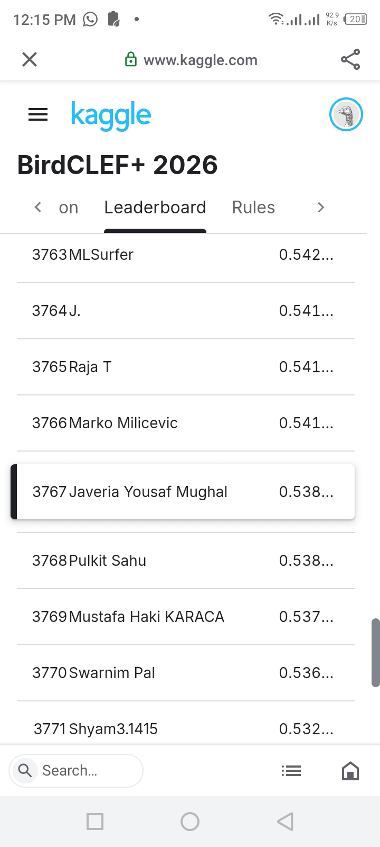

11. Team Contribution
Team Member | Contribution
Member 1 | Data exploration / notebook work / Report, GitHub organization, submission and documentation  Javeria Yousaf Mughal
Member 2 | Model or prediction work / testing /  ____Arooj Hafeez

12. GitHub Organization
As instructed by the teacher, the GitHub repository should contain a separate folder for the assignment/competition. The folder should include the Python notebook containing the code and the final PDF report containing the introduction, methodology, results, and Kaggle score screenshot.
GitHub Repository
│
└── Assignment/
└── BirdCLEF_Plus_2026/
├── BirdCLEF_Plus_2026_Notebook.ipynb
├── BirdCLEF_Plus_2026_Report.pdf
└── README.md (optional)
GitHub Repository Link: _____ https://github.com/competitions/Javeria-Yousaf-Offical
Kaggle Competition Link: https://www.kaggle.com/competitions/birdclef-2026

13. Challenges Faced
- Working with audio data is more complex than working with simple tabular datasets.
- The competition contains many target classes and real-world background sounds.
- The hidden test set means that final performance cannot be completely known before submission.
- Kaggle code competitions have runtime and environment constraints.
- CPU-only submission constraints require attention to runtime and efficient inference.
- Understanding the submission format and avoiding prediction-format errors is important.
- As a beginner team, understanding advanced audio models and competition notebooks required additional learning.

14. Learning Outcomes
- Learned how a real Kaggle competition is structured.
- Improved understanding of machine-learning workflow from data to final submission.
- Gained practical exposure to audio classification and environmental sound data.
- Learned how Kaggle notebooks are used for reproducible experiments and submissions.
- Practiced interpreting leaderboard results and competition evaluation metrics.
- Improved teamwork, task division, documentation, and GitHub organization.
- Developed confidence in participating in machine-learning competitions.

15. Conclusion
Participation in BirdCLEF+ 2026 provided practical experience in solving a real-world machine-learning problem. The competition connected software engineering and artificial intelligence with biodiversity monitoring. Through this activity, the team learned how to understand a competition problem, work with audio data, develop a notebook-based prediction workflow, prepare a valid submission, and evaluate the result on Kaggle.
The project also demonstrated the importance of reproducibility and clear documentation. By placing the Python notebook and report in the required GitHub folder, the complete work can be reviewed and reused for academic learning. The final Kaggle score and screenshot should be inserted from the team's actual submission before the report is converted to PDF and uploaded.

16. References
- Kaggle. BirdCLEF+ 2026 – Overview, Evaluation, Timeline and Code Requirements. https://www.kaggle.com/competitions/birdclef-2026/overview/citation
- Kaggle. BirdCLEF+ 2026 – Dataset Description and Files. https://www.kaggle.com/competitions/birdclef-2026/data
- Kaggle. BirdCLEF+ 2026 – Leaderboard. https://www.kaggle.com/competitions/birdclef-2026/leaderboard

End of Report

