CY-110

Semi-Conductors

**ABSTRACT:**

A semi-conductor is neither a good insulator nor a very good conductor of electric current. The electrical resistivity of semi-conductor generally decreases strongly with increasing temperature, whereas the resistivity of a metal increases weakly with increasing temperature.

A semi-conductor can be an element, such as Si or Ge, or a compound, such as GaAs or InSb. Solid semi-conductors can exist in the crystalline or amorphous form. The bonding between atoms in a semi-conductor can be covalent, ionic, or mixed.

**Telecommunications dept.**

***ali ahson (tc-061)***

***kevin ashton (tc-045)***

***javeria shamim (tc-007)***

**Table of Contents**

**Types of materials…………………………………………………………....2**

**Insulators, Conductors, Semi-conductors……………………………2**

**Band Theory………………………………………………………………….2**

**Semi-conductors……………………………………………………….3**

**Types of Semi-conductors…………………………………………………...3**

**Extrinsic Semi-conductors……………………………………………3**

**Intrinsic Semi-conductors…………………………………………….4**

**N-type semi-conductor………………………………………………………4**

**P-type semi-conductor……………………………………………………….4**

**Doping………………………………………………………………………..5**

**Types of Doping……………………………………………….……………..6**

**N-type or Donor Doping……………………………………………..6**

**P-type or Acceptor Doping……………………………………….…..7**

**Properties of a semi-conductor………………………………………….…...8**

**Temperature and Conductivity………………………………….……8**

**P-n Diode or p-n Junction……………………………………………….…...8**

**Biasing……………………………………………………………………..….9**

**Types of Biasing………………………………………………………….….10**

**Forward Biasing………………………………………………….…..10**

**Reverse Biasing………………………………………………………11**

**Zero Bias……………………………………………………….……..12**

**Semi-conductor Devices………………………………………………….…13**

**Advantages/ Disadvantages…………………………………….…..13**

**Reference Index…………………………………………………….……….14**

**Types of Materials:**

**Insulator:**

***“It is a material that does not conduct electric current under normal conditions, having high resistivity. Valence electrons are tightly bound to the atoms, therefore there are very few free electrons in an insulator.”***

**Conductor:**

***“Conductors easily conduct electric current because they have very loosely bound valence electrons.”***

**Semi-Conductor:**

***“It is between insulator and conductor in its ability to conduct electrical current e.g. Silicon and Germanium.”***

**Band Theory:**

Free electron theory can explain the conductivity of solid metals only. Conductivity of semi-conductors could not be explained by the free electron theory. To explain the conductivity of semi-conductors as well as of solid metals, a theory from modern physics is made which is called as ***Band Theory of Solids***.

According to the band theory of solids, atoms are said to be initially in the ground state called valence band. With the gain of energy atoms reach a higher state called the conduction band. Between conduction band and valence band, there is a forbidden gap.

Those substances in which there is a wide forbidden gap between valence band and conduction band are called the insulators. In insulator, there is an empty conduction band and electrons reside in the valence band only. Those substances in which there is no forbidden gap, are called conductors. In conductors, both conduction and valence bands overlap on each other and hence there is an empty valence band, and electrons reside in the conduction band.

Those substances in which there is a medium or narrow forbidden gap, are called semi-conductors. In semi-conductors there are partially filled valence band and conduction band.

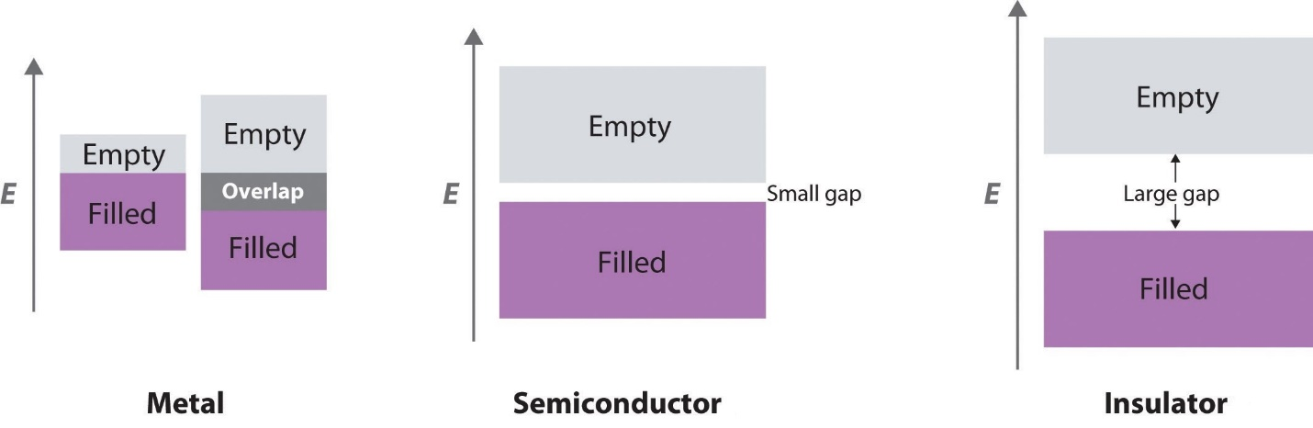

**Semi-conductor**:

***“Those substances in which there is a narrow or forbidden***

***Gap between valance band and conduction band are called Semi-conductors.”***

The most usual semiconductors are the elemental ones, Si and Ge (and diamond C). They are tetrahedrally bonded, and thus, fourfold coordinated with sp^3 hybridization.

**Types of Semi-conductors:**

* Extrinsic semiconductors.
* Intrinsic semiconductors.

**Extrinsic Semiconductors:**

An extrinsic semiconductor is a semiconductor doped by a specific impurity which is able to deeply modify its electrical properties, making it suitable for electronic applications (diodes, transistors, etc.) or optoelectronic applications (light emitters and detectors).

**Intrinsic Semiconductors:**

An intrinsic semiconductor is an un-doped semiconductor. This means that holes in the valence band are vacancies created by electrons that have been thermally excited to the conduction band, as opposed to doped semiconductors where holes or electrons are supplied by a “foreign” atom acting as an impurity.

**N-type Semiconductor:**

N-type semiconductors are a type of extrinsic semiconductor in which the dopant atoms are capable of providing extra conduction electrons to the host material (e.g. phosphorus in silicon). This creates an excess of negative (n-type) electron charge carriers.

Doping atom usually have one more valence electron than one type of the host atoms. The most common example is atomic substitution in group-IV solids by group-V elements. The situation is more uncertain when the host contains more than one type of atom. For example, in III-V semiconductors such as gallium arsenide, silicon can be a donor when it substitutes for gallium or an acceptor when it replaces arsenic. Some donors have fewer valence electrons than the host, such as alkali metals, which are donors in most solids.

**P-type Semiconductor:**

A p-type (p for “positive”) semiconductor is created by adding a certain type of atom to the semiconductor in order to increase the number of free charge carriers. When the doping material is added, it takes away (accepts) weakly bound outer electrons from the semiconductor atoms. This type of doping agent is also known as an acceptor material, and the vacancy left behind by the electron is known as a hole. The purpose of p-type doping is to create an abundance of holes.

In the case of silicon, a trivalent atom is substituted into the crystal lattice. The result is that one electron is missing from one of the four covalent bonds normally part of the silicon lattice. Therefore the dopant atom can accept an electron from a neighboring atom’s covalent bond to complete the fourth bond. This is why these dopants are called acceptors.

When the dopant atom accepts an electron, this causes the loss of half of one bond from the neighboring atom, resulting in the formation of a hole. Each hole is associated with a nearby negatively charged dopant ion, and the semiconductor remains electrically neutral overall. However, once each hole has wandered away into the lattice, one proton in the atom at the hole’s location will be “exposed” and no longer cancelled by an electron. This atom will have three electrons and one hole surrounding a particular nucleus with four protons.

For this reason a hole behaves as a positive charge. When a sufficiently large number of acceptor atoms are added, the holes greatly outnumber thermally excited electrons. Thus, holes are the majority carriers, while electrons become minority carriers in p-type materials.

**Doping:**

Doping means the introduction of impurities into a semiconductor crystal to the defined modification of conductivity. Two of the most important materials silicon can be doped with, are boron (3 valence electrons 3-valent) and phosphorus (5 valence electrons =5-valent). Other materials are aluminium indium (3-valent) and arsenic, antinomy (5-valent). The dopant is the integrated into the lattice structure of the semiconductor crystal, the number of outer electrons define the type of doping. Elements with valence electrons are used for p-type doping, 5-valued elements for n-doping. The conductivity of a deliberately contaminated silicon crystal can be increased by a factor of 10^6.

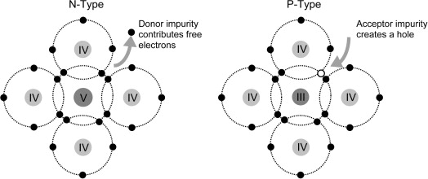

**Types of doping:**

* N-type or Donor doping

.

* P-type or Acceptor doping.

**N-type or Donor doping:**

***“The process in which the impurity of pentavalent element of group V is added into tetravalent elements of group IV is called donor doping & the resultant extrinsic semi-conductor is called n-type substance.”***

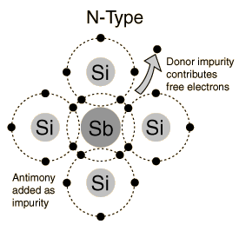

In semiconductor physics, a donor is a dopant atom that, when added to a semiconductor, can form a n-type region.

***Example:***

When silicon (Si), having four valence electrons, needs to be doped as a n-type semiconductor, elements from group V like phosphorus (P) or arsenic (As) can be used because they have five valence electrons. A dopant with five valence electrons is also called a pentavalent impurity. Other pentavalent dopants are antimony (Sb) and bismuth (Bi).

**P-type or Acceptor doping:**

***“The process in which an impurity of trivalent element of group III is added into tetravalent element of group IV is called Acceptor Doping and the resultant extrinsic semi-conductor is called p-types substance.”***

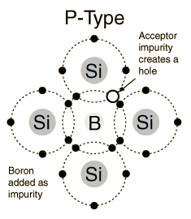

In semi-conductor physics, an acceptor is a dopant atom that when added to a semi-conductor can form a p-type region.

***Example:***

When silicon (Si), having four valence electrons, needs to be doped as a p-type semiconductor, elements from group III like boron(B) or aluminium(Al), having three valence electrons, can be used. The latter elements are also called trivalent impurities. Other trivalent dopants include indium (In) and gallium (Ga).

**Properties of a semi-conductor:**

Semiconductor possess specific electrical properties. Electrical properties can be indicated by resistivity. Conductors such as gold, silver and copper have low resistance and conduct electricity easily. Insulator such as rubber, glass and ceramics have high resistance and are difficult for electricity to pass through them. Semi-conductors have properties somewhere between these two. Their resistivity might change according to the temperature for example as temperature rises, electricity passes through them easily. Semi-conductors containing almost no impurities conduct almost no electricity. But when some elements are added to the semi-conductors, electricity passes through them easily.

**Temperature and Conductivity:**

Because thermal energy can excite electrons across the band gap in a semiconductor, increasing the temperature increases the number of electrons that have sufficient kinetic energy to be promoted into the conduction band. The electrical conductivity of a semiconductor therefore increases rapidly with increasing temperature, in contrast to the behavior of a purely metallic crystal. In a metal, as an electron travels through the crystal in response to an applied electrical potential, it cannot travel very far before it encounters and collides with a metal nucleus. The more often such encounters occur, the slower the *net* motion of the electron through the crystal, and the *lower* the conductivity. As the temperature of the solid increases, the metal atoms in the lattice acquire more and more kinetic energy. Because their positions are fixed in the lattice, however, the increased kinetic energy increases only the extent to which they vibrate about their fixed positions. At higher temperatures, therefore, the metal nuclei collide with the mobile electrons more frequently and with greater energy, thus *decreasing* the conductivity. This effect is, however, substantially smaller than the increase in conductivity with temperature exhibited by semiconductors. For example, the conductivity of a tungsten wire decreases by a factor of only about two over the temperature range 750–1500 K, whereas the conductivity of silicon increases approximately 100-fold over the same temperature range.

**P-n diode or P-n junction:**

***“A PN-junction diode is formed when a p-type semiconductor is fused to an n-type semiconductor creating a potential barrier voltage across the diode junction”***

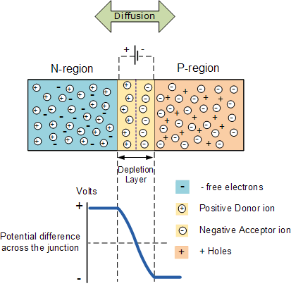

A junction between p-type and n-type substance is formed where holes and electrons diffuse into each other thereby forming a “Depletion layer”. The thickness of depletion layer provides potential barrier which prevent further migration of holes and electrons through depletion layer. Thickness of depletion layer could be increased or decreased by varying the potential of potential barrier, which decreases or increases the conductivity of diode. A p-n junction diode could be used in an electrical circuit across a battery, as it permits the flow of current in one direction only.

**Biasing:**

***“Biasing in the process of applying potential difference to the semiconductor .Biasing is achieved by applying EMF across the P-N junction diode.”***

***OR***

***“Biasing is a method of changing the height of potential barrier or the thickness of depletion layer of p-n diode”***

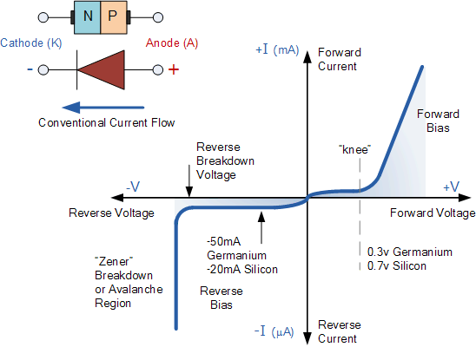

**Types of Biasing:**

Biasing can be of two types:

* Forward biasing.
* Reverse biasing.

**Forward Biasing:**

***“When external voltage is applied to p-n junction in such a direction that it cancels the potential barrier, thus permitting the flow of current is called forward biasing.”***

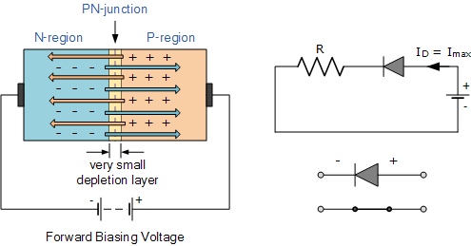

In forward biasing p-type substance is connected with positive terminal of source and n-type substance is connected with negative terminal of source. Due to electrostatic repulsion carrier of n-type cross over the depletion layer, thereby reducing its thickness, as a result of which, height of potential barrier decreases and small voltage is sufficient to completing eliminate the barrier. Once the potential difference is eliminated a low resistance path is established for the entire circuit. Therefore electronic current flow in the circuit.

**Reverse Biasing:**

***“When an external voltage is applied to the p-n junction in such a direction that potential barrier is increased, thus forbidding the flow of current is called reverse biasing.”***

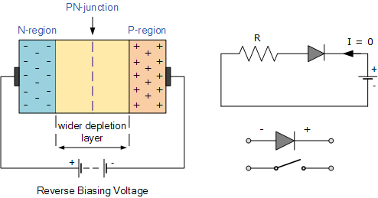

In reverse biasing p-type substance is connected with negative terminal of source and n-type substance is connected with positive terminal of source. Due to electrostatic attraction holes and carrier of p-type & n-type move away from depletion layer, thereby, increasing its thickness. As a result of which, height of potential barrier increases, which prevents the flow of charge across the junction. Thus a high resistance path is established for the entire circuit. As p-n diode behaves like a resistor, therefore no current flows through circuit.

**Zero Bias:**

***“In a semiconductor P-N junction, forward bias occurs when the P-type material is positive with respect to the N-type material; in reverse bias, the P-type material is negative with respect to the N-type material. When two electrodes are at the same potential, they are said to be at zero bias.”***

**Semi-conductor Devices:**

Any of a class of crystalline solids intermediate in electrical conductivity between a conductor and an insulator. Semiconductors are employed in the manufacture of various kinds of electronic devices, including diodes, transistors, and integrated circuits. Such devices have found wide application because of their compactness, reliability, power efficiency, and low cost. As discrete components, they have found use in power devices, optical sensors, and light emitters, including solid-state lasers.

In a pure semiconductor only a few electors have enough energy to jump from valance band to conduction band. So, there will be a small amount of conductivity. If the temperature is raised, more electrons will have enough energy to jump the gap, which decreases the resistivity. In doped semiconductor the impurity provides additional energy states between the bands thus increasing the electrical conductivity.

**Advantages:**

* Semiconductor devices are set into operation as soon as the circuit is switched on
* During operation, semiconductor devices do not produce any humming noise
* Long service life (thousands of hours)
* Shock proof
* Semiconductor devices are cheaper
* Devices are very compact

**Disadvantages:**

* Deterioration in performance with time (ageing); higher noise level than in electronic devices
* Low input resistance
* Inability to handle large power
* Deterioration in performance after exposure to radioactive emissions

***Reference Index***

**Chemistry for Cambridge O Level……………………………McMonagle, D**

**Cambridge IGCSE Chemistry 3rd Edition………Earl, B and Wilford, L D R**

**Intermediate notes(2018)……………………………………………Dr. Fayyaz**