BSCS FINAL PROJECT
<Requirements Specification>

Secure Prompting and Simulation based Learning through Avatar Guidance


Project Advisor
Mr. Hafiz Usama Ishtiaq

Presented by:
Group ID: S26CS038
Student Reg# | Student Name
L1S23BSCS0119 | Faiqa Abid
L1S23BSCS0266 | Jawaria Tassawar
L1S23BSCS0129 | Rana Shahzaib Naseem Khan

Faculty of Information Technology & Computer Science

University of Central Punjab

Software Requirements Specification

Version 1.0

Secure Prompting and Simulation based Learning through Avatar Guidance

Advisor: Mr. Hafiz Usama Ishtiaq

Group S26CS038
Member Name | Primary Responsibility
Faiqa Abid | Frontend & UI
Jawaria Tassawar | Backend & Management
Rana Shahzaib Naseem Khan | ML & Deployment

Table of Contents
Abstract 3
1. Introduction and Background 1
1.1 Product (Problem Statement) 1
1.2 Background 2
1.3 Scope 3
1.4 Objective(s)/Aim(s)/Target(s) 4
1.5 Challenges 5
1.6 Learning Outcomes 5
1.7 Nature of End Product 6
1.8 Completeness Criteria 6
1.9 Business Goals 7
1.10 Related Work/ Literature Survey/ Literature Review 8
1.11 Document Conventions 10
2. Overall Description 11
2.1 Product Features 11
2.2 User Classes and Characteristics 14
2.3 Operating Environment 17
2.4 Design and Implementation Constraints 18
2.5 Assumptions and Dependencies 20
3. Functional Requirements 22
3.1 User Registration and Authentication 23
3.2 Submit Prompt for Analysis 24
3.3 Detect Prompt Injection Attack 24
3.4 Classify Prompt Type 25
3.5 Identify Attack Sub Type 26
3.6 Display Detection Result 27
3.7 Apply Prompt Mitigation 28
3.8 Show Warning Message 29
3.9 Provide Safe Prompt Suggestion 30
3.10 Interact with Avatar Guidance Module 30
3.11 Use Simulation Sandbox 31
3.12 View Prompt History 32
3.13 View Analytics Dashboard 33
3.14 Access System via API Integration 34
3.15 Logout User 35
3.16 Requirements Analysis and Modeling 35
4. Nonfunctional Requirements 42
4.1 Performance Requirements 42
4.2 Safety Requirements 43
4.3 Security Requirements 44
4.4 Additional Software Quality Attributes 45
5. Other Requirements 46
6. Revised Project Plan 47
7. References 47
Appendix A: Glossary 49
Appendix B: IV & V Report 51

Revision History
Name | Date | Reason For Changes | Version

Previous Phases Feedback

Idea Defence Feedback (Screenshot)

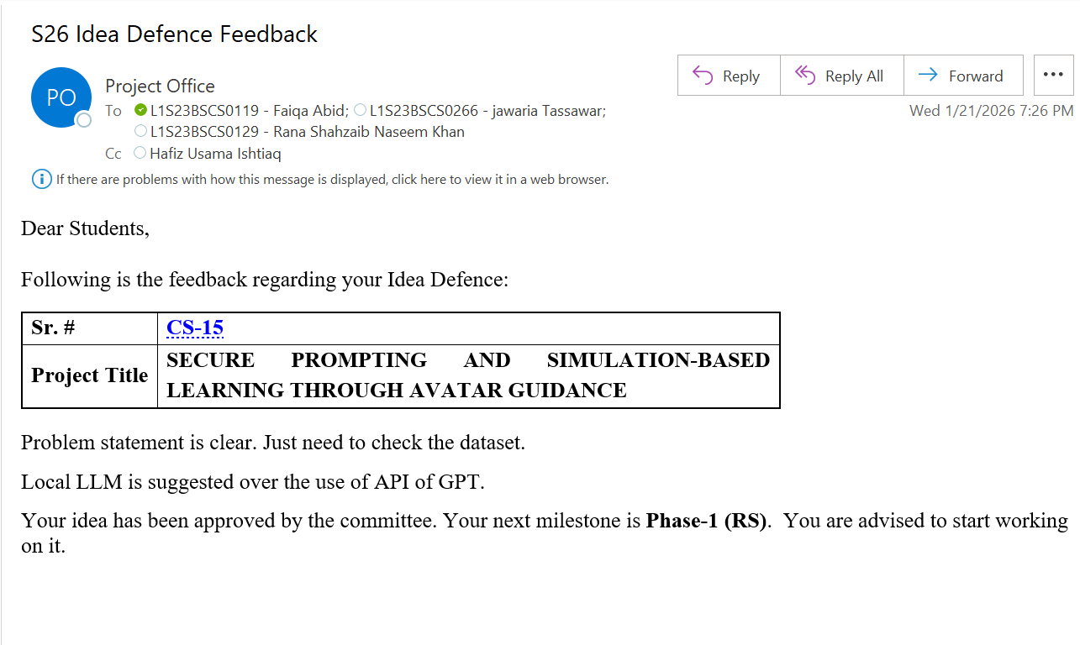

Abstract
Large language models (LLMs) are being rapidly integrated into applications ranging from customer support to education, yet they remain highly vulnerable to prompt injection attacks. These attacks can manipulate models to bypass rules, reveal sensitive information, or assume unauthorized roles, creating serious security, privacy, and ethical risks. Existing tools and research prototypes mostly address prompt injection through isolated detectors or academic demonstrations; they rarely provide real time prevention, user training, or realistic simulation environments that help developers understand how attacks evolve in practice. Our project proposes a web-based platform that monitors user prompts and model responses to detect, classify, and mitigate prompt injection attacks as they occur. The system first determines whether an input is a prompt injection attempt or a safe (benign) prompt. If unsafe, it identifies the attack type and sub type, focusing on two high risk categories: Direct Jailbreak Attacks (such as Policy Evasion, Multi Turn Manipulation, Role Override, Persona Hijacking, and System Prompt Overwrite) and Indirect Prompt Injection Attacks (where malicious instructions are embedded in retrieved documents, webpages, or external tool outputs). A lightweight multi class classifier will flag suspicious prompts, label them as Safe, Direct Jailbreak, or Indirect Injection, estimate severity, and trigger mitigation actions such as filtering, warning messages, or safe rewrites before harmful output is produced. To close the awareness gap, an avatar-based guidance module will provide real time explanations, examples of unsafe patterns, and best practice alternatives for secure prompting. By combining technical defense with interactive learning, we aim to measurably improve prompt safety through higher prevention rates, reduced attack success, and stronger understanding among developers and end users. Expected outcomes include a robust prompt injection classifier, a simulation driven learning module with curated attack scenarios, and a practical tool for securing AI applications in both academic and industrial settings.

Introduction and Background
Large Language Models (LLMs) are now an essential part of current intelligent systems, allowing for applications in areas like content creation, customer service, and education. Both the academic and industrial sectors have quickly embraced them due to their capacity to process and produce human-like language. However, despite their capabilities, LLMs remain highly vulnerable to prompt injection attacks, which exploit the model’s instruction-following behavior to produce unintended or harmful outputs [1].
By inserting malicious instructions into prompts, prompt injection attacks give adversaries the ability to alter LLMs, bypass safety constraints, overrule system policies, and retrieve private data [1][2]. Security, privacy, and the ethical use of AI are all seriously threatened by these attacks, especially as LLMs are being incorporated more and more into practical applications. Research has demonstrated that skillfully crafted prompts can damage even well-designed systems, highlighting the seriousness of the problem [2].
Previous studies have mostly concentrated on identifying these assaults or exposing weaknesses in controlled environments. Nevertheless, these methods frequently lack user-centered learning aids, thorough attack type classification, and real-time protection mechanisms, rendering them inadequate for practical implementation [1][3]. Because of this, users and developers are still not prepared to recognize and address emerging quick injection risks.
This project proposes a web-based platform for secure prompting and simulation-based learning through avatar guidance to tackle these challenges. The system is intended to identify, categorize, and reduce prompt injection attacks in real time, all the while offering interactive learning assistance. The proposed solution seeks to improve prompt safety, lower the success rates of attacks, and boost awareness among users and developers by merging technical defense methods with user education.

Product (Problem Statement)
Large Language Models (LLMs) are commonly utilized in modern applications; however, they are extremely vulnerable to prompt injection attacks. Such attacks involve the manipulation of the model through harmful directives, resulting in violations of safety protocols, exposure of confidential data, or execution of actions that were not intended [1]. These assaults can manifest directly or indirectly and have been noted in actual systems, underscoring significant security and privacy threats [2][3]. While current solutions try to identify these threats, they frequently do not include real-time prevention, thorough classification, or mechanisms for user awareness. Moreover, new methods of assault like cognitive jailbreaks and multimodal injections further increase the complexity of securing LLMs [4][5]. Consequently, it is necessary to have a thorough system that detects and reduces prompt injection attacks while also informing users about secure prompting practices.
Several critical challenges contribute to this issue:
- Inability to distinguish malicious and benign inputs
Because LLMs process all instructions the same way, it is challenging to distinguish between trusted system prompts and injected harmful content [1][3].
- Lack of real-time detection and prevention
Most existing solutions focus on offline analysis or post-processing, failing to stop prompt injection attacks before harmful output is generated [2].
- Limited classification of evolving attack types
Current systems have difficulty in accurately recognizing a variety of attack types, including direct jailbreaks, indirect injections, and advanced methods such as cognitive and multimodal attacks [3][4][5].
- Absence of user awareness and training mechanisms
As current tools do not offer interactive learning or guidance for secure prompting practices, users and developers often do not comprehend the dangers of prompt injection [3].

Given these challenges, we explore the following questions:
- In what way can prompt injection attacks be identified and categorized in real time?
- What is the best way to accurately identify different kinds of attacks (direct, indirect, sub-types)?
- Which methods can be employed to stop or lessen the impact of unsafe prompts before they are executed?
- In what ways can interactive learning and simulation serve to educate users?
How can a real-world system achieve a balance among security, accuracy, and low latency?
Project Vision
The vision of this project is to develop of a secure and intelligent platform that safeguards Large Language Models (LLMs) from prompt injection attacks and fosters safe and responsible AI use. By means of simulation and avatar guidance, the system seeks to bring together real-time detection, prevention of attacks, and education of users. This will allow users to engage with AI systems in a secure manner and with assurance.

Background
Large Language Models (LLMs) are extensively utilized in modern artificial intelligence applications, including chatbots, virtual assistants, and systems for generating content [6][21]. These models utilize natural language prompts to produce responses, which makes them very adaptable and engaging. This flexibility does, however, open the door to significant security weaknesses, especially prompt injection attacks in which harmful directives influence how the model acts [7][18].
The domain of LLM security focuses on detecting and preventing such attacks. Research indicates that prompt injection can manifest in both direct forms (such as jailbreaks and role overrides) and indirect forms (like hidden instructions within web content or documents), complicating detection efforts [10][12]. Research also points out that LLMs frequently struggle to distinguish between valid and harmful instructions, which heightens the risk of policy violations and data leaks.

Moreover, recent developments have uncovered more advanced attack strategies, such as jailbreak techniques, optimization-based attacks, and indirect injections, which can have a significant effect on real-world AI systems [17][19]. Despite existing efforts, most solutions focus only on detection or theoretical analysis and lack real-time prevention and user awareness mechanisms.

With the ongoing integration of LLMs into practical applications, guaranteeing their secure and dependable use has emerged as a vital field of research. This necessitates systems that integrate technical defense, real-time tracking, and user education to effectively counter prompt injection threats.

Scope
The Secure Prompting and Simulation-based Learning through Avatar Guidance platform is a web system that detects, classifies, and mitigates prompt injection attacks in real time [3][12], while offering an interactive learning environment [9][15]. Through simulation and avatar guidance, it allows users to analyze prompts, comprehend security risks, and enhance safe prompting practices.
In Scope Features

Prompt Analysis & Detection
- Prompt injection attacks detected in real time [3].
- Categorization of prompts as safe, direct jailbreak, or indirect injection [17][19].
- Determination of attack sub-types like policy evasion and role override [15].
Mitigation & Safety Mechanisms
- Filtering and prevention of unsafe prompts [8][20].
- Automatic transformation of prompts into safer variants.
- Show of alerts and risk signs.
Simulation & Learning
- Simulated environment for trialing adversarial prompts [9].
- Monitored setting to watch prompt behavior.
- Explanation and best practice avatar-based guidance.
System Interaction & Monitoring
- Web-based interface for submitting prompts and visualizing results.
- Control panel for monitoring detected outcomes and operational activity of the system.
- Incorporation of machine learning models for processing in real-time.
Out of Scope Features
The following elements will not be part of the platform's initial version:
- Assistance for multimodal inputs like visual materials, sound, or video cues.
- Comprehensive enterprise rollout and production-grade integration.
- Customization or training of advanced deep learning models beyond predefined pipelines.
- Continuous prompt monitoring systems or real-time streaming.

Objective(s)/Aim(s)/Target(s)
Real-Time Detection Engine:
- Develop a system capable of detecting prompt injection attacks in real time with a latency threshold of <200ms [1][3][12].
Granular Attack Classification:
- Categorize user prompts into Direct Jailbreak, Indirect Injection, and Benign categories to ensure precise mitigation strategies [1][2][6].
Machine Learning Implementation:
- Design and implement a multi-class machine learning classifier (e.g., DistilBERT or specialized SLMs) for high dimensional text analysis [3][13][16].
Preventative Middleware:
- Apply automated mechanisms including token level blocking, perplexity filtering, and proactive warning messages before LLM execution [3][8][11].
Safe Simulation Sandbox:
- Build a controlled, simulation-based environment where users can experiment with adversarial prompts without risking production data [2][9].
Pedagogical Guidance:
- Create an avatar-based guidance system that utilizes Explainable AI (XAI) to foster user education and security awareness [9][15].
Performance Benchmarking:
- Achieve a classification accuracy exceeding 90% and an F1-score above 0.85 on standard adversarial datasets [1][13].

Challenges
Dataset Diversity & Scarcity:
- Generating high quality datasets that cover the full spectrum of attacks, including "in-the-wild" jailbreaks and synthetic adversarial examples [1][5][14].
Evolving Adversarial Techniques:
- Detecting advanced, obfuscated, or multimodal instructions hidden in image pixels or document metadata that bypass traditional text filters [5][7][10].
Optimization of Latency:
- Maintaining the critical balance between deep architectural inspection and the requirement for sub second response times in live environments [3][12].
Model Generalization:
- Ensuring the classifier remains robust against unseen attack patterns and "zero-day" exploits like cognitive self-persuasion [4][7][14].
Architectural Integration:
- Complexities involved in bridging Python based ML backends (FastAPI) with real time frontend frameworks (React) while maintaining stateful security [11].
Instruction-Data Confusion:
- Overcoming the fundamental LLM limitation where the model cannot inherently distinguish between trusted system instructions and untrusted user inputs [2][6][8].

Learning Outcomes
Vulnerability Analysis:
- Mastery in identifying the core security flaws in Transformer-based architectures, specifically Prompt Leaking and Goal Hijacking [1][2].
Adversarial Strategy Insight:
- Ability to analyze complex attack vectors including Payload Splitting, Token Smuggling, and Indirect Injections [4][6][13].
Advanced ML Development:
- Practical experience in designing, training, and deploying real-time classification models for cybersecurity applications [3][12].
Full-Stack Security Engineering:
- Proficiency in building end to end web applications that integrate AI driven security layers with modern backend APIs [11].
Pedagogical System Design:
- Understanding how to translate complex technical threats into interactive, avatar led educational modules for non-technical users [9][15].
Quantitative Evaluation:
- Competence in using standard metrics Accuracy, Precision, Recall, and F1 score to validate the efficacy of defensive models [1][13].

Nature of End Product
The final product is a Web Based Intelligent Security Platform consisting of the following integrated modules:
Prompt Analyzer System: A real-time monitoring layer that intercepts and inspects every user interaction before it reaches the core LLM [1][12].
Multi-Class ML Classifier: A fine-tuned engine that labels prompts as Safe, Direct Jailbreak, or Indirect Injection based on semantic intent [3][13][16].
Adversarial Simulation Module: A dedicated "sandbox" where developers and students can test the limits of LLM safety filters in a risk free environment [2][9].
Avatar-Based Guidance Interface: An interactive educational component that provides real-time explanations and suggests secure prompting alternatives [9][15].
System Middleware (FastAPI): A high performance backend that handles the data flow between the ML model and the user interface, ensuring low-latency processing [11][12].
Compliance Dashboard: A visual interface that tracks detection rates and aligns with the OWASP Top 10 for LLM Applications (LLM01) security standards [8][11].

Completeness Criteria
The Completeness Criteria define the essential deliverables and performance benchmarks required Secure Prompting and Simulation based Learning through Avatar Guidance to be considered a fully functional, deployable system [11][13]. These criteria will ensure that all technical, usability, and performance goals are met.

S.No. | Criteria | Weightage (%)
1 | User Interface Design (UI/UX) | 15%
2 | Frontend Development (React) | 10%
3 | Backend Development (FastAPI) | 15%
4 | Prompt Submission & Preprocessing Functionality | 10%
5 | Prompt Injection Detection & Classification Model | 20%
6 | Mitigation & Safety Mechanisms Implementation | 10%
7 | Model Evaluation and Performance Metrics | 10%
8 | Simulation Sandbox & Avatar Guidance Features | 5%
9 | System Integration & Deployment | 5%
10 | Documentation and User Manual | 5%

Business Goals
The primary business goal of this project is to develop a practical and scalable solution that enhances the security of large language model (LLM) applications against prompt injection attacks while creating value for both developers and organizations [8][21].
Key business objectives include:
- Design a deployable and scalable platform that can be integrated into AI based systems for real time prompt validation [12].
- Minimize risks associated with data leakage, unauthorized outputs and misuse of AI systems
- Provide a cost-effective security solution compared to existing enterprise level AI safety tools
- Improve trust, reliability and compliance of LLM powered applications in real world deployments
- Enable organizations to implement proactive defense mechanisms instead of reactive security measures
- Develop an educational layer that can be adopted by universities and training institutions for AI security learning
- Establish a foundation for future monetization through API services, SaaS subscriptions or enterprise licensing models
- Differentiate from existing solutions by combining detection, prevention and user education in a single unified platform

Related Work/ Literature Survey/ Literature Review
Recent advancements in large language models (LLMs) have significantly enhanced natural language processing capabilities, enabling applications in customer support, education, and content generation. However, these models remain highly vulnerable to prompt injection and jailbreak attacks, which can manipulate outputs, bypass safety mechanisms, and expose sensitive information.
Liu et al. [1] formalized prompt injection attacks and emphasized the importance of benchmarking LLM vulnerabilities. Chao et al. [2] introduced JailbreakBench to evaluate model robustness against adversarial prompts. Similarly, Jacob et al. [3] proposed PromptShield for detecting malicious prompts in real time. Xu et al. [4] conducted a comparative study of jailbreak attacks and defenses, highlighting the limitations of current approaches. Shi et al. [5] demonstrated optimization-based attacks capable of bypassing safeguards, while Chen et al. [6] explored defense mechanisms based on attack pattern recognition.
Despite these contributions, most existing solutions focus primarily on detection or theoretical analysis. They lack real-time prevention, multi-class classification, and user-centered educational support. This creates a significant gap between research and practical implementation.
To better understand existing approaches and their limitations, a comparative analysis is presented below:

Reference | Paper | Contribution | Limitations | Relevance to our Project
[1] | Liu et al. – Prompt Injection Benchmarking | Formalized prompt injection attacks and evaluation methods | Focuses only on benchmarking, lacks real-time implementation | Provides foundation for attack understanding and evaluation
[2] | Chao et al. – JailbreakBench | Introduced benchmark for testing jailbreak robustness | No real-time defense or user interaction | Helps evaluate robustness of our system
[3] | Jacob et al. – PromptShield | Real-time detection of malicious prompts | Limited to detection, no prevention or education | Supports detection module design
[4] | Xu et al. – Jailbreak vs Defense Study | Comparison of attack techniques and defense strategies | Defense mechanisms not practical for real-world systems | Helps identify attack categories and gaps
[5] | Shi et al. – Optimization-based Attack | Demonstrates advanced attack strategies | Focuses only on attack generation | Helps improve robustness of classifier
[6] | Chen et al. – Defense Techniques | Proposes defense using attack patterns | Mostly theoretical, lacks deployment | Supports development of mitigation strategies

The above analysis highlights that existing research primarily focuses on isolated aspects such as detection, benchmarking, or theoretical defense strategies. However, there is a lack of integrated systems that combine real time detection, prevention, classification and user education in a single platform.
This project addresses these gaps by proposing a comprehensive solution that not only detects and classifies prompt injection attacks but also prevents harmful outputs and educates users through simulation based learning and avatar guidance. This integrated approach differentiates the proposed system from existing solutions and enhances its practical applicability in real-world AI environments.

Document Conventions
Convention | Description | Example
Font | Standard text uses Arial.  Times New Roman (for names) | Body paragraphs
Heading Font | Headings use Arial. | Section titles
Font Sizes | - Main headings: 14pt  - Subheadings: 12pt  - Sub-subheadings: 11pt | 1.1 Scope
Text Style | Bold for headings or key terms  Underline the text for emphasis | Sections Heading  Vision
Capitalization | Acronyms in uppercase; titles in sentence case | ML, API
Citations | Intext citation are used for references | See: sections text and References
Bullet Points | Used for clear listing and readability. | - Support for CSV, Excel uploads
Tables | Used for structured data and summaries. | See: Appendix A , Use Cases
Line & Paragraph Spacing | Used 1.5 line space | Whole Document except Table of Content

Overall Description

Product Features
Below is a high level summary of the major features of the suggested Prompt Injection Detection and Prevention Platform. Through real-time monitoring, attack detection and prevention, as well as interactive learning, these features help developers, students, and organizations to secure applications based on LLMs.

Prompt Monitoring & Analysis

- Brief Description: Before user prompts are processed by the LLM, they are monitored and analyzed in real time.
- Functionalities:
- Capture user prompts prior to LLM execution
- Conduct real-time input examination
- Examine the structure and purpose of prompts
- Ensure processing with low latency (less than 1 s)
- User Benefit: Prevent harmful prompts from getting to the system and guarantees safe AI engagement.
- Dependencies: Requires backend middleware integration and a classifier module.
- Priority: Essential

Prompt Injection Detection

- Brief Description: Identifies if a prompt is safe or has a prompt injection attack.
- Functionalities:
- Classify prompts into Safe, Direct Jailbreak, or Indirect Injection categories
- Utilize machine learning models (e.g., DistilBERT)
- Recognize suspicious patterns and harmful motives
- Help in identifying developing attack methods

- User Benefit: Helps users and systems in rapidly recognizing harmful inputs prior to any damage happening.
- Dependencies: Needs a labeled dataset and a trained ML classifier.
- Priority: Essential

Attack Classification (Sub-Type Detection)

- Brief Description: Recognizes detailed classifications of prompt injection attacks.
- Functionalities:
- Identify Policy Evasion attacks
- Identify Role Override and Persona Hijacking
- Recognize Multi-turn Manipulation
- Detect System Prompt Overwrite attempts
- User Benefit: Offers deeper knowledge of attack types to enhance security analysis.
- Dependencies: Depends on prompt detection module.
- Priority: High

Mitigation System

- Brief Description: Uses automated techniques to prevent unsafe prompts from resulting in harmful outputs.
- Functionalities:
- Prevent harmful tokens or instructions
- Turn unsafe prompts into safe versions
- Show warning and alert messages
- Use filtering before LLM execution
- User Benefit: Guarantees system safety by preventing attacks before execution.
- Dependencies: Require classification and detection module.
- Priority: Essential

Simulation Sandbox Environment

- Brief Description: Gives a secure platform for testing and simulating prompt injection attacks.
- Functionalities:
- Enable users to assess adversarial prompts
- Offer a regulated testing environment
- Simulate real world attack scenarios
- Prevent impact on real systems
- User Benefit: Helps users in learning and trying things out without risk.
- Dependencies: It is an independent module but uses detection system.
- Priority: High

Avatar-Based Guidance System

- Brief Description: A guiding interactive assistant that clarifies security issues for users.
- Functionalities:
- Offer immediate feedback on prompts
- Explain why the prompt is unsafe
- Propose alternatives that are secure
- Utilize methods from Explainable AI
- User Benefit: Enhance user awareness and understanding of AI security.
- Dependencies: Depends on detection and classification outputs.
- Priority: High
Backend Middleware (FastAPI System)

- Brief Description: Manages the communication among frontend, ML models, and system components.
- Functionalities:
- Handle API requests and responses
- Link frontend to ML classifier
- Guarantee a real time data flow
- Preserve the performance and scalability of the system
- User Benefit: Delivers a fast and seamless functioning of the system.
- Dependencies: Core system components.
- Priority: Essential

Dashboard & Analytics

- Brief Description: Shows insights into security and system performance.
- Functionalities:
- Display detection rates and statistics
- Monitor attack trends
- Illustrate classification results
- User Benefit: Assists users and organizations in tracking and enhancing security.
- Dependencies: Needs information from detection system.
- Priority: Medium

User Interface (Web Application)

- Brief Description: Offers an interactive platform for users to engage with the system.
- Functionalities:
- Enter prompts and see results
- Show classification and alerts
- Integrate avatar system
- Provide responsive UI
- User Benefit: User-friendly interface suitable for users with and without technical expertise.
- Dependencies: Linked to backend and middleware.
- Priority: Essential

Educational & Awareness Module

- Brief Description: Offers educational materials on prompt injection and secure prompting.
- Functionalities:
- Display instances of attacks
- Provide best practice for secure prompting
- Provide learning materials that promote interactivity
- User Benefit: Improves expertise and minimizes user errors.
- Dependencies: Compatible with simulation and avatar modules.
- Priority: Medium
Together, these features constitute a thoroughgoing AI security platform that combines detection, prevention, simulation, and education into one system, tackling major shortcomings of current solutions.

User Classes and Characteristics
The proposed system is structured around a multi-user model, allowing various user groups to engage with the platform according to their level of expertise, usage needs, and security requirements. By offering suitable features and access levels tailored to each user category, the system guarantees flexibility. The user classes that have been identified, along with their traits and significance levels, are listed below:
Students and Learners

- Differentiator: Users with a focus on learning and a technical understanding ranging from beginner to intermediate who want to gain insight into AI security and prompt injection.
- Frequency of Use: Moderate to high levels, particularly during learning, assignments, and experimentation.
- System Featured Used: Prompt testing, simulation sandbox, avatar guidance, basic detection results, educational modules.
- Access Level: Basic/free access, which includes a limited number of advanced features.
- Characteristics: Require simple and intuitive UI, guided workflows, explanations, and interactive learning support.
- Importance: High – Important target social group for educational influence and awareness development.

Developers and AI Engineers

- Differentiator: Users with technical expertise who concentrate on developing and safeguarding applications based on LLMs.
- Frequency of Use: High (ongoing integration and testing).
- System Featured Used: Real-time detection system, API integration, attack categorization, mitigation tools, analytics dashboard.
- Access Level: Premium or full access for advanced features and integration capabilities.
- Characteristics: Need to be highly precise, have little delay, offer options for customization, and provide in-depth technical analyses.
- Importance: High – Essential for practical implementation and acceptance of the system

Researchers and Security Analysts

- Differentiator: Advanced users concentrating on researching prompt injection attacks and AI weaknesses.
- Frequency of Use: Moderate to high (according to research activities).
- System Featured Used: Simulation sandbox, thorough attack categorization, dataset examination, performance indicators, reporting instruments.
- Access Level: Premium/research-level access that includes advanced analytical features.
- Characteristics: Require transparency, detailed outputs, experimental flexibility, and access to advanced data
- Importance: Medium to High Crucial for enhancing system robustness and innovation.

Organizations and Businesses (SMEs / Enterprises)

- Differentiator: Users with a business focus who are intent on securing AI systems that are already deployed and reducing risk.
- Frequency of Use: Moderate (ongoing observation in production settings).
- System Featured Used: Real time monitoring, automated mitigation, compliance dashboard, API integration, reporting tools.
- Access Level: Paid subscription options that include enterprise-grade features.
- Characteristics: Favor dependability, scalability, adherence to security standards, and limited manual involvement.
- Importance: High Crucial for commercialization, scalability, and practical implementation.

General Users / Non-Technical Users

- Differentiator: Minimal users of AI systems with little to no technical background.
- Frequency of Use: Ranges from low to moderate.
- System Featured Used: Basic prompt verification, alerts, avatar direction, safe prompt recommendations.
- Access Level: Free/Basic access.
- Characteristics: Require highly simplified interface, clear instructions, and minimal complexity.
- Importance: Medium Crucial for raising awareness and enhancing general AI safety practices.

By providing role-specific functionality, customizable access levels, and personalized user experiences, the system accommodates a wide variety of users and guarantees both usability and effectiveness in educational, technical, and industrial fields.

Operating Environment
The platform is designed to run in a cloud-native architecture using Amazon Web Services (AWS) to ensure high availability, auto-scaling for ML workloads, and global accessibility. 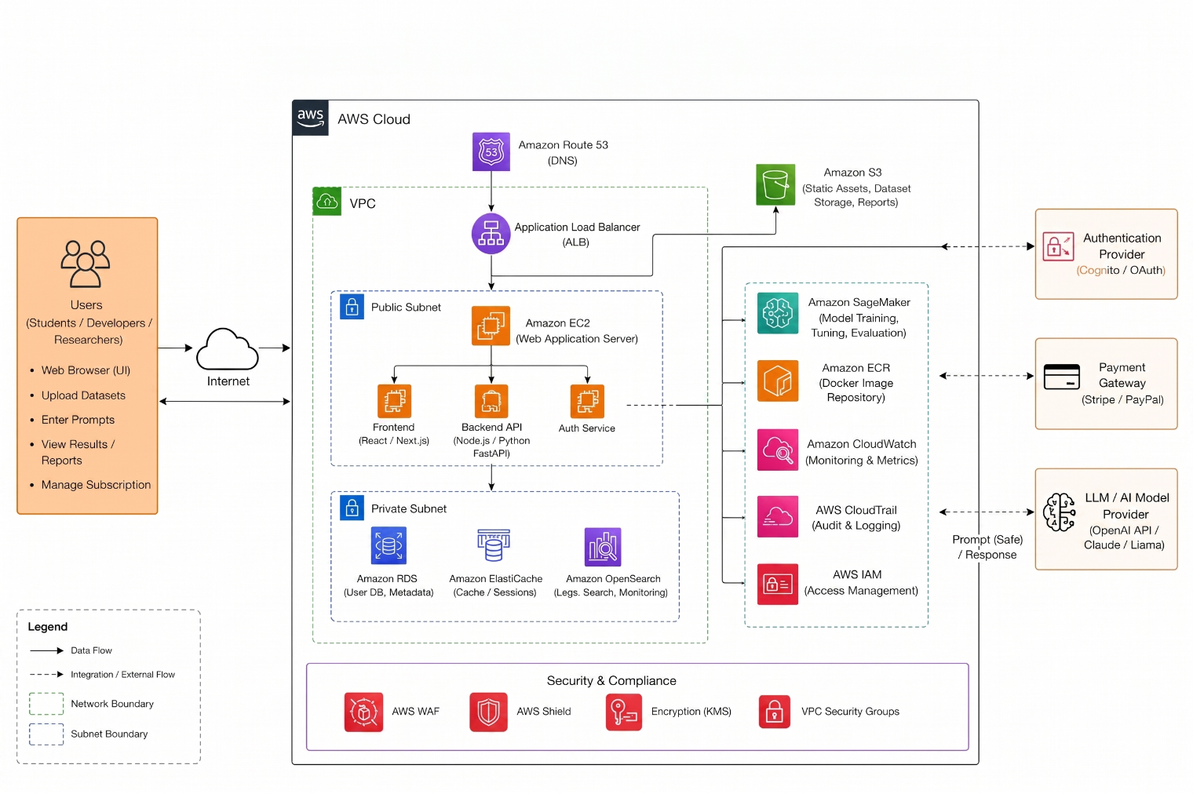
- Hardware Platform
- Client Side: Modern computing devices including desktops, laptops, and mobile smartphones (iOS/Android) with standard internet connectivity.
- Server Side (AWS Infrastructure): Compute Instance: AWS EC2 (Elastic Compute Cloud) t3.large or m5.large instances for general backend hosting (min 8GB RAM).
- ML Acceleration: AWS EC2 G4ad instances (with GPU support) for low-latency transformer model inference and fine-tuning.
- Storage: AWS EBS (Elastic Block Store) for system files and AWS S3 for long-term storage of attack prompt datasets.

- Operating System & Runtime
- Client OS: Platform-independent; supports Windows 10/11, macOS, Linux, and mobile OS (Android/iOS) via web browser.
- Server OS: Amazon Linux 2 or Ubuntu Server 22.04 LTS running on AWS EC2 instances.
- Runtime Environment: Python 3.10+ for backend logic and Machine Learning execution.
- Node.js 18+ for the React/Next.js frontend build process.
- Docker: Used for containerizing the FastAPI backend and ML services to ensure consistent deployment across AWS environments.

- Software Components
- Frontend Framework: React.js or Next.js styled with Tailwind CSS for a responsive user interface.
- Backend API: Python FastAPI to handle asynchronous requests between the user and the ML classifier with minimal latency.
- Database Management: AWS RDS (PostgreSQL): For structured user data, session management, and logs.
- AWS DocumentDB (MongoDB compatible): For flexible storage of unstructured prompt and attack pattern libraries.
- AI/ML Libraries: Hugging Face Transformers, PyTorch, and Scikit-learn for real-time prompt classification.
- LLM Integration: Amazon Bedrock or OpenAI API for generating simulations and model responses in a controlled sandbox.
- Communication: RESTful APIs utilizing JSON for data exchange between the frontend and the AWS-hosted backend.

Design and Implementation Constraints
The development of this system is subject to several constraints that may influence design decisions and implementation strategies.
Technical Constraints
- Real-Time Performance: The system must achieve real-time prompt analysis with a response latency below one second while maintaining high classification accuracy.
- Resource Management: Limited computational resources may restrict the use of large-scale transformer models, requiring the selection of lightweight alternatives.
- Data Dependency: Model performance is heavily dependent on the availability of diverse and high-quality datasets.
Security Constraints
- Adversarial Resilience: The system must effectively handle adversarial inputs and continuously evolving prompt injection techniques.
- Attack Coverage: It must ensure protection against jailbreak attacks, indirect injections, and other malicious patterns.
- Data Integrity: Secure API communication and the prevention of data leakage are essential requirements for maintaining system trust.
Integration Constraints
- API Flexibility: The platform must support integration with external LLM APIs, such as OpenAI, or locally deployed models like LLaMA.
- Asynchronous Processing: The architecture must support asynchronous communication between the frontend, backend, and machine learning components to handle live data streams.
- Architectural Compatibility: The system must ensure compatibility across different system architectures and cloud environments.
Data Constraints
- Dataset Scarcity: The limited availability of labeled datasets for prompt injection requires the use of synthetic data generation and intensive preprocessing.
- Safe Handling: The system must safely handle sensitive or malicious inputs during both the training and deployment phases to avoid accidental execution.
Tool and Technology Constraints
- Predefined Stack: The system must be implemented using specific technologies: Python for the backend, React or Next.js for the frontend, and libraries such as Scikit-learn or Hugging Face Transformers.
- Third-Party Reliance: The platform depends on the consistent availability and functionality of third-party APIs and external open-source libraries.
Usability Constraints
- User Diversity: The platform must remain simple and intuitive for non-technical users while providing advanced technical features for developers and researchers.
- Actionable Feedback: The interface must clearly communicate detected threats and provide concrete recommended actions through the avatar guidance module.
Development Constraints
- Timeline: The project must be completed within a two-semester timeline, requiring strict adherence to milestones.
- Expertise: Development is limited to the current team's expertise in AI, machine learning, and full-stack web development.
- Continuous Iteration: Frequent testing and evaluation cycles are required throughout the development lifecycle to ensure system stability.
Ethical and Regulatory Constraints
- Responsible AI: The system must ensure responsible AI usage, maintain user privacy, and prevent the platform itself from being misused to generate harmful prompts.
- Standard Compliance: The project should follow established AI security best practices and emerging industry guidelines for Large Language Model security.

Assumptions and Dependencies
This section outlines the assumptions made during the development of the system and the external dependencies that may influence its functionality and performance.
Assumptions:
The following assumptions have been made while designing and developing the proposed system:
- Users of the system (students, developers and researchers) possess basic knowledge of AI systems and prompting techniques
- Users will interact with the platform through a stable internet connection and modern web browsers
- The input prompts provided by users will be primarily text based and in English language, ensuring compatibility with the classification model
- The dataset used for training the prompt injection classifier will be sufficiently diverse and properly labeled to represent real world attack scenarios
- The selected machine learning model (e.g., transformer based classifier) will achieve acceptable performance (≥80% accuracy) for detecting and classifying prompt injections
- The avatar-based guidance system will be capable of delivering basic explanatory feedback and secure prompting suggestions
- The system will be used in a controlled environment for educational and research purposes, not in high-risk production environments during initial deployment
- Required development tools, frameworks and APIs will remain available and functional throughout the development lifecycle
Dependencies:
The successful operation of the system depends on the following external components and factors:
- Availability of machine learning frameworks and libraries such as Python, Scikit-learn, or Hugging Face Transformers for model development
- Integration with LLM APIs or local models (e.g., OpenAI API or LLaMA) for simulation and prompt evaluation
- Dependence on frontend and backend technologies, including React (frontend) and FastAPI (backend), for system implementation
- Use of a database system (MongoDB, MySQL, or PostgreSQL) for storing prompts, results, and user interactions
- Access to a reliable dataset source for training and testing prompt injection detection models
- Dependence on cloud or local hosting infrastructure for deployment and scalability of the web platform
- Compatibility with modern web browsers (Chrome, Edge, Firefox) for proper system functionality
- Continuous availability of internet connectivity for API communication and real-time processing
- Proper integration between system modules, including classification engine, simulation module, and avatar guidance system

Functional Requirements

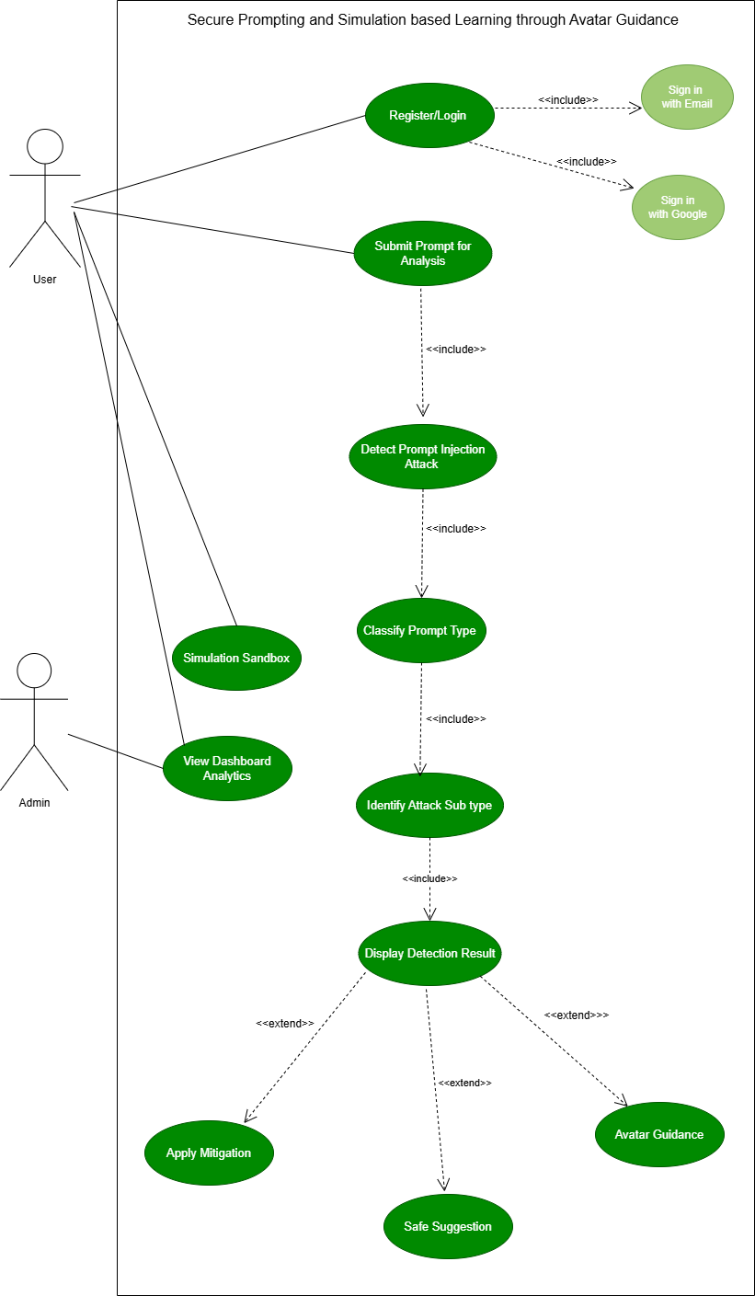

User Registration and Authentication
Identifier |  | UC-1
Purpose |  | To allow a user to register and authenticate using email and passwords.
Priority |  | High
Pre-conditions |  | User is not authenticated.
Post-conditions |  | User is authenticated and can access simple and subscription-based features.
Typical Course of Action
S# | Actor Action |  | System Response
1 | User selects “Register” or “Login” and enter credentials. |  | System displays authentication interface and validates input
2 | User submits the credentials |  | System checks email/account and verifies credentials
3 | User waits for response |  | System validates password using secure hashing and authenticates user
4 | User gain access |  | System creates session/token and redirects to main dashboard
Alternate Course of Action
S# | Actor Action |  | System Response
1 | User enters invalid or incomplete credentials |  | System rejects request with validation feedback
2 | User attempts login with incorrect password |  | System denies access and displays error message
3 | Multiple failed login attempts |  | System temporarily restricts access (basic protection)
4 | User attempts to register with existing email |  | System prevents duplication and prompts login
5 | System detects abnormal activity |  | Authentication attempt is logged and flagged
Table 1: UC-1

Submit Prompt for Analysis
Identifier |  | UC-2
Purpose |  | To allow the user to submit a prompt to the system for real time security analysis.
Priority |  | High
Pre-conditions |  | The user is registered and logged into the system and can access the prompt input interface.
Post-conditions |  | The submitted prompt is forwarded to the analysis module for detection and classification.
Typical Course of Action
S# | Actor Action |  | System Response
1 | The user types a prompt into the input box. |  | System logs the prompt that was entered
2 | User presses the analyze button |  | The prompt is sent by the system to the backend analysis module
3 | User is waiting for a reply |  | System begins processing the prompt
4 | User observes progress or holds on |  | System sends the prompt for detection and classification
Alternate Course of Action
S# | Actor Action |  | System Response
1 | User submits an empty prompt |  | System displays a message that the prompt cannot be empty
2 | User provides input that is either unsupported or in an invalid format |  | The user is prompted by the system to fix their input.
3 | User submits the prompt |  | System shows an error message if submission fails
Table 2: UC-2

Detect Prompt Injection Attack
Identifier |  | UC-3
Purpose |  | To detect whether the submitted prompt contains a prompt injection attack or is safe.
Priority |  | High
Pre-conditions |  | The system has successfully received a submitted prompt.
Post-conditions |  | The prompt is labeled as safe or suspicious for additional classification.
Typical Course of Action
S# | Actor Action |  | System Response
1 | User provides a prompt for examination |  | The prompt is received by the system from the input interface
2 | User waits for result |  | The detection engine is used by the system to analyze the prompt.
3 | User waits for result |  | System checks for malicious patterns and suspicious instructions
4 | User waits for result |  | System determines whether the prompt is safe or unsafe
5 | User views detection status |  | The detection result is forwarded by the system to the classification module.
Alternate Course of Action
S# | Actor Action |  | System Response
1 | The user submits a prompt that includes unclear or ambiguous elements. |  | The system flags the prompt as suspicious and moves forward carefully.
2 | User waits for result |  | When the confidence score is low, the system asks for a re analysis.
3 | User waits for result |  | System displays an error message if detection module fails
Table 3: UC-3

Classify Prompt Type
Identifier |  | UC-4
Purpose |  | For the submitted prompt to be classified into a high-level category like Safe, Direct Jailbreak, or Indirect Injection.
Priority |  | High
Pre-conditions |  | The prompt has been processed by the detection engine.
Post-conditions |  | A classification label is assigned to the prompt for further processing.
Typical Course of Action
S# | Actor Action |  | System Response
1 | User submits a prompt |  | The detection output is received by the system
2 | User waits for classification |  | The system utilizes the classification model on the prompt and assigns one of the main prompt categories to which the prompt belongs
3 | User waits for response |  | System stores the classification result
4 | User views status |  | System displays the classification result
Alternate Course of Action
S# | Actor Action |  | System Response
1 | User submits a prompt that follows an uncertain pattern |  | System labels it as suspicious or requires deeper analysis
2 | User waits for response |  | System retries classification if confidence is too low
3 | User waits for response |  | If the classification model is unavailable, the system shows an error.
Table 4: UC-4

Identify Attack Sub Type
Identifier |  | UC-5
Purpose |  | To determine the specific subtype of a detected prompt injection attack.
Priority |  | Medium
Pre-conditions |  | The prompt has been classified as malicious.
Post-conditions |  | Attack subtype is identified and recorded.
Typical Course of Action
S# | Actor Action |  | System Response
1 | User waits for result |  | System retrieves classified malicious prompt
2 | User waits for result |  | System analyzes structural and linguistic patterns
3 | User waits for result |  | System matches patterns with known attack categories
4 | User waits for result |  | System identifies subtype (e.g., Jailbreak, Role Override, Instruction Override)
5 | User views result |  | Subtype information is stored and forwarded
Alternate Course of Action
S# | Actor Action |  | System Response
1 | Unknown or novel attack pattern detected |  | System labels prompt as “Unrecognized Threat”
2 |  |  | System logs case for future analysis
  User waits for result
Table 5: UC-5

Display Detection Result
Identifier |  | UC-6
Purpose |  | To present the complete analysis results of the submitted prompt in a clear and interpretable format.
Priority |  | High
Pre-conditions |  | Detection, classification, and subtype identification processes are completed.
Post-conditions |  | The user is informed about the prompt’s safety status and associated insights.
Typical Course of Action
S# | Actor Action |  | System Response
1 |  |  | System compiles all outputs
  User requests analysis result
2
  User waits for output
  System displays classification and risk level
3 |  |  | System provides explanation of detected behavior
  User waits for output
4 |  |  | System highlights potential vulnerabilities
  User waits for output
5 | User views result |  | System enables further actions (mitigation, suggestions)
Alternate Course of Action
S# | Actor Action |  | System Response
1 | Partial system failure occurs |  | System displays simplified result
2 | _ |  | System logs error for debugging
Table 6: UC-6

Apply Prompt Mitigation
Identifier |  | UC-7
Purpose |  | To neutralize or modify unsafe prompts in order to prevent harmful or unintended outputs.
Priority |  | High
Pre-conditions |  | Prompt is identified as unsafe or malicious.
Post-conditions |  | A sanitized or blocked version of the prompt is generated.
Typical Course of Action
S# | Actor Action |  | System Response
1 | User submits unsafe prompt |  | System identifies risky components
2 | User submits unsafe prompt |  | System applies predefined mitigation rules
3 | User submits unsafe prompt |  | System removes or rewrites harmful instructions
4 | User submits unsafe prompt |  | System generates a safe version of the prompt
5 | User views updated prompt |  | System returns sanitized output
Alternate Course of Action
S# | Actor Action |  | System Response
1 | Prompt cannot be safely modified |  | System blocks execution
2 | User notified |  | System displays restriction message
Table 7: UC-7

Show Warning Message
Identifier |  | UC-8
Purpose |  | To alert users when a submitted prompt contains potentially harmful or suspicious elements.
Priority |  | Medium
Pre-conditions |  | The system detects unsafe or suspicious prompt behavior.
Post-conditions |  | The user is informed and prompted to take corrective action.
Typical Course of Action
S# | Actor Action |  | System Response
1 | User submits a prompt |  | System evaluates prompt risk level
2 | User submits prompt |  | System generates contextual warning message
3 | User submits prompt |  | System highlights problematic sections
4 | User submits prompt |  | System suggests corrective action
5 | User reviews warning |  | System awaits user decision
Alternate Course of Action
S# | Actor Action |  | System Response
1 | Low-risk prompt detected |  | System displays advisory message
2 | User proceeds |  | System continues processing
Table 8: UC-8

Provide Safe Prompt Suggestion
Identifier |  | UC-9
Purpose |  | To generate a secure and context-preserving alternative for prompts identified as unsafe or vulnerable to manipulation.
Priority |  | High
Pre-conditions |  | Prompt has been classified as unsafe or suspicious.
Post-conditions |  | A refined and secure version of the prompt is presented to the user.
Typical Course of Action
S# | Actor Action |  | System Response
1 | _ |  | System analyzes original prompt for unsafe constructs and intent conflicts
2 | _ |  | Risky segments (e.g., override instructions, hidden directives) are isolated
3 | _ |  | System applies prompt restructuring and sanitization strategies
4 | _ |  | A context preserving, safe alternative is generated
5 | User reviews Suggestion |  | System displays refined prompt with explanation of changes
Alternate Course of Action
S# | Actor Action |  | System Response
1 | Prompt intent cannot be safely preserved |  | System avoids rewriting and provides structured guidance instead
2 | _ |  | User is advised to reformulate input manually
Table 9: UC-9

Interact with Avatar Guidance Module
Identifier |  | UC-10
Purpose |  | To provide interactive, educational feedback explaining prompt risks and best practices through an AI-driven avatar interface.
Priority |  | Medium
Pre-conditions |  | System analysis is completed and guidance module is active.
Post-conditions |  | User gains contextual understanding of prompt security issues.
Typical Course of Action
S# | Actor Action |  | System Response
1 | User initiates guidance interaction |  | System activates avatar interface
2 | User queries or selects explanation option |  | System processes query contextually
3 | _ |  | Avatar generates explanation of detected issue
4 | _ |  | System provides best practice recommendations
5 |  |  | System maintains conversational learning flow
  User continues interaction
Alternate Course of Action
S# | Actor Action |  | System Response
1 | User provides unclear query |  | System responds with general guidance prompts
2 | _ |  | Interaction fallback ensures continuity
Table 10: UC-10

Use Simulation Sandbox
Identifier |  | UC-11
Purpose |  | To evaluate prompt behavior in a controlled environment to observe potential risks before real-world execution.
Priority |  | Medium
Pre-conditions |  | Prompt is available for testing and sandbox environment is operational.
Post-conditions |  | Simulated output and behavior analysis are presented.
Typical Course of Action
S# | Actor Action |  | System Response
1 | User enters prompt into sandbox |  | System captures and isolates input
2 | User initiates simulation |  | System executes prompt in controlled environment
3 | _ |  | System monitors response behavior and model reactions
4 | _ |  | Output is analyzed for anomalies or unsafe patterns
5 |  |  | System displays behavior insights and risk indicators
  User reviews simulation result
Alternate Course of Action
S# | Actor Action |  | System Response
1 | Simulation environment error |  | System halts execution and notifies user
2 | _ |  | User is prompted to retry
Table 11: UC-11

View Prompt History
Identifier |  | UC-12
Purpose |  | To allow users to review previously submitted prompts along with their analysis results and risk evaluations.
Priority |  | Low
Pre-conditions |  | User is authenticated and historical data exists.
Post-conditions |  | Prompt history is retrieved and displayed.
Typical Course of Action
S# | Actor Action |  | System Response
1 | User accesses history section |  | System retrieves stored prompt records
2 | _ |  | System loads associated classification and risk data
3 | _ |  | Data is organized chronologically
4 | User selects a specific entry |  | Detailed analysis view is presented
5 |  |  | System enables comparison and insights
  User reviews history
Alternate Course of Action
S# | Actor Action |  | System Response
1 | No history available |  | System displays empty state message
2 | _ |  | User encouraged to submit prompts
Table 12: UC-12

View Analytics Dashboard
Identifier |  | UC-13
Purpose |  | To provide administrators with insights into system usage, attack patterns, and detection performance.
Priority |  | Medium
Pre-conditions |  | Admin access is verified and data is available.
Post-conditions |  | Analytical insights are displayed through visual representations.
Typical Course of Action
S# | Actor Action |  | System Response
1 | Admin accesses dashboard |  | System retrieves aggregated data
2 | _ |  | System processes metrics (attack frequency, types, trends)
3 | _ |  | Data is visualized through charts and summaries
4 | Admin reviews insights |  | System supports data interpretation
5 |  |  | System logs interactions for tracking
  Admin takes action
Alternate Course of Action
S# | Actor Action |  | System Response
1 |  |  | System displays placeholder analytics
  Insufficient data available
2 | _ |  | Admin notified of limited dataset
Table 13: UC-13

Access System via API Integration
Identifier |  | UC-14
Purpose |  | To enable external systems to utilize prompt analysis functionality through secure API endpoints.
Priority |  | High
Pre-conditions |  | Valid API credentials and network connectivity are established.
Post-conditions |  | Structured response containing analysis results is returned.
Typical Course of Action
S# | Actor Action |  | System Response
1 |  |  | System validates API credentials
  External system sends API request
2 | _ |  | Request payload is parsed and verified
3 | _ |  | Prompt is processed through analysis pipeline
4 | _ |  | Structured response (classification, risk score) is generated
5 |  |  | System logs request for monitoring
  External system receives response
Alternate Course of Action
S# | Actor Action |  | System Response
1 |  |  | System rejects request with error response
  Invalid API key provided
2 | _ |  | Access attempt is logged
Table 14: UC-14

Logout User
Identifier |  | UC-15
Purpose |  | To securely terminate the active user session and prevent unauthorized access.
Priority |  | Low
Pre-conditions |  | User is currently logged into the system.
Post-conditions |  | Session is invalidated and access is revoked.
Typical Course of Action
S# | Actor Action |  | System Response
1 |  |  | System receives termination request
  User initiates logout
2 | User confirms logout action |  | Session tokens are invalidated
3 | User waits for process completion |  | Active session data is cleared
4 | User is redirected to login page |  | User is redirected to authentication page
5 |  |  | Logout is confirmed
  User exits system
Alternate Course of Action
S# | Actor Action |  | System Response
1 |  |  | System automatically logs out user
  Session expires due to inactivity
2 | User is redirected to login page |  | System clears session data and displays authentication page
3 | User attempts to access system after timeout |  | User prompted to re authenticate

Table 15: UC-15

Requirements Analysis and Modeling
    - Entity-Relationship Diagram
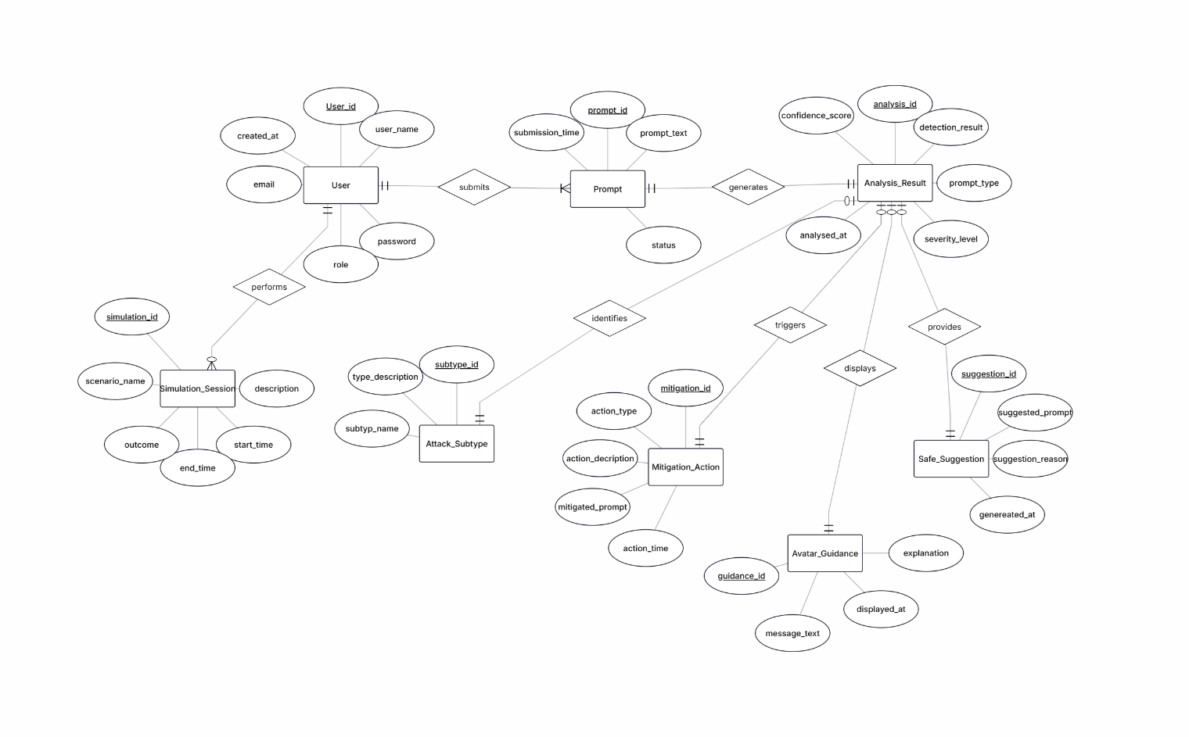

    - Abstract Class Diagram

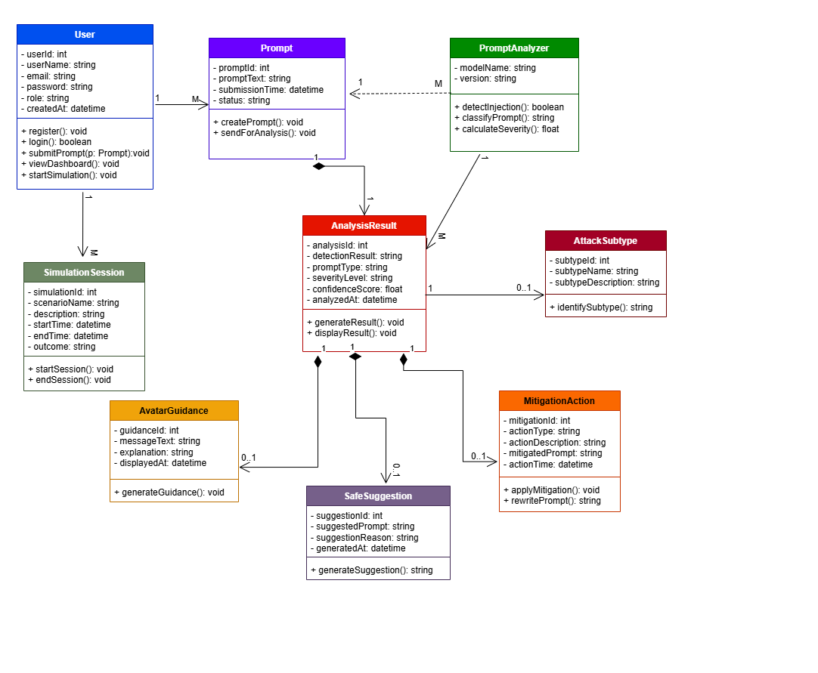
    - Sequence Diagram
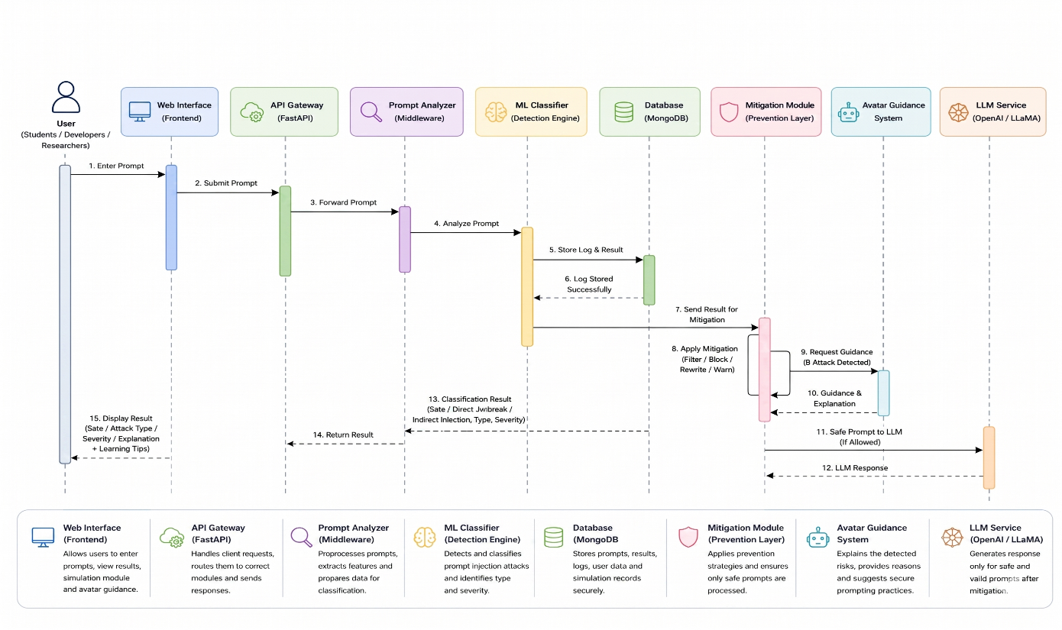
    - State Diagram
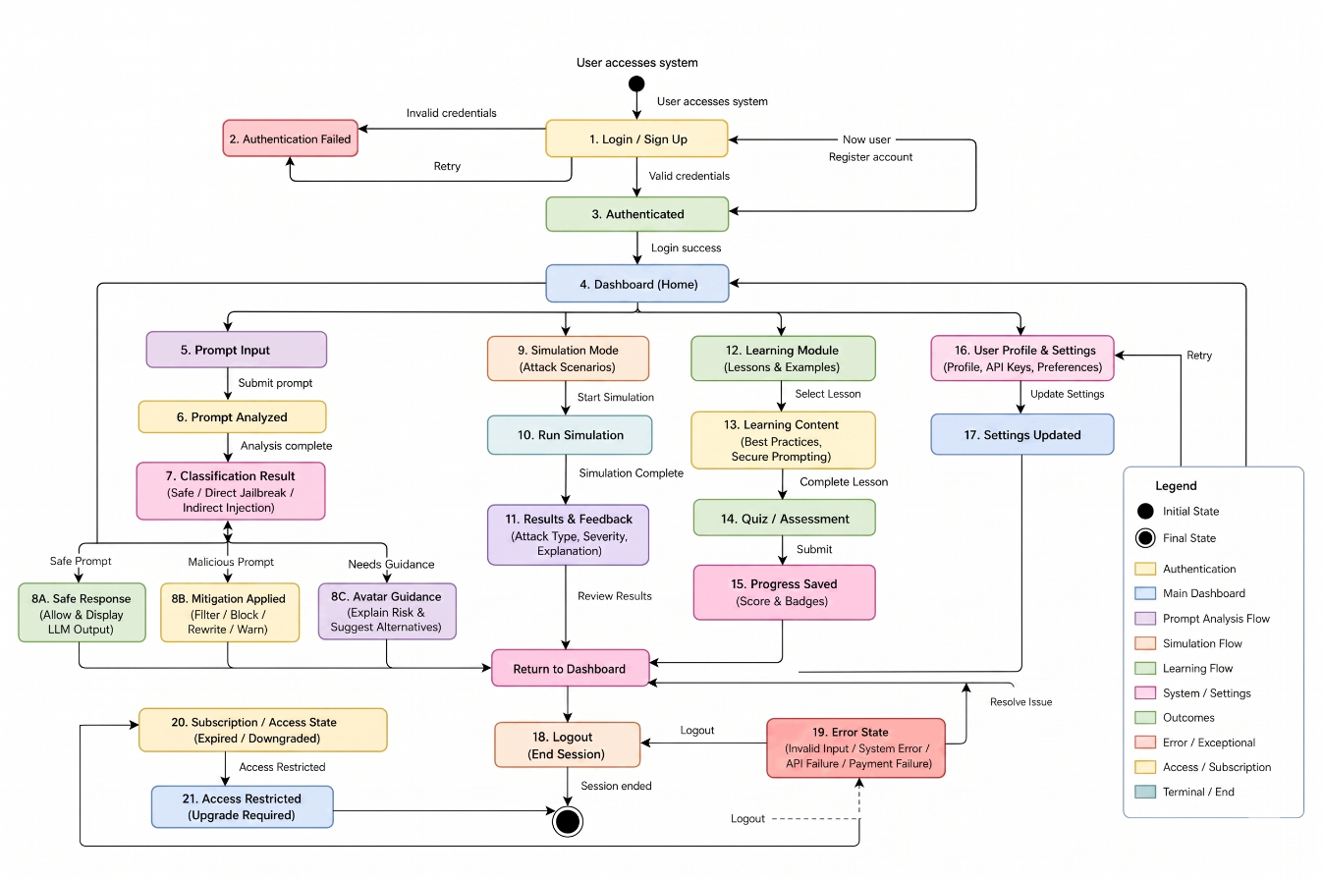
    - Data Flow Diagram
Context Level DFD

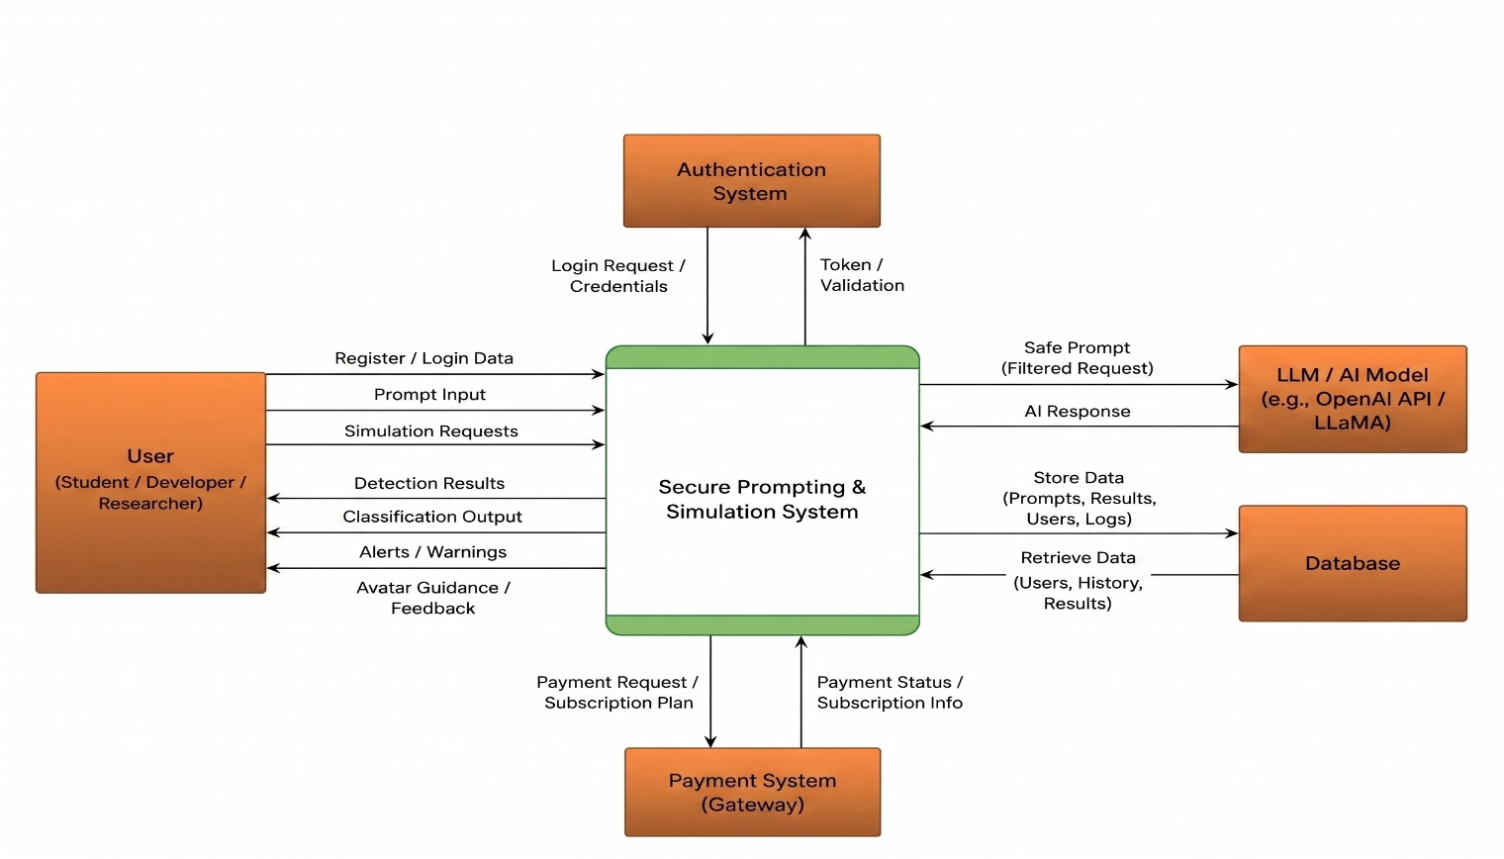

Level 01 DFD
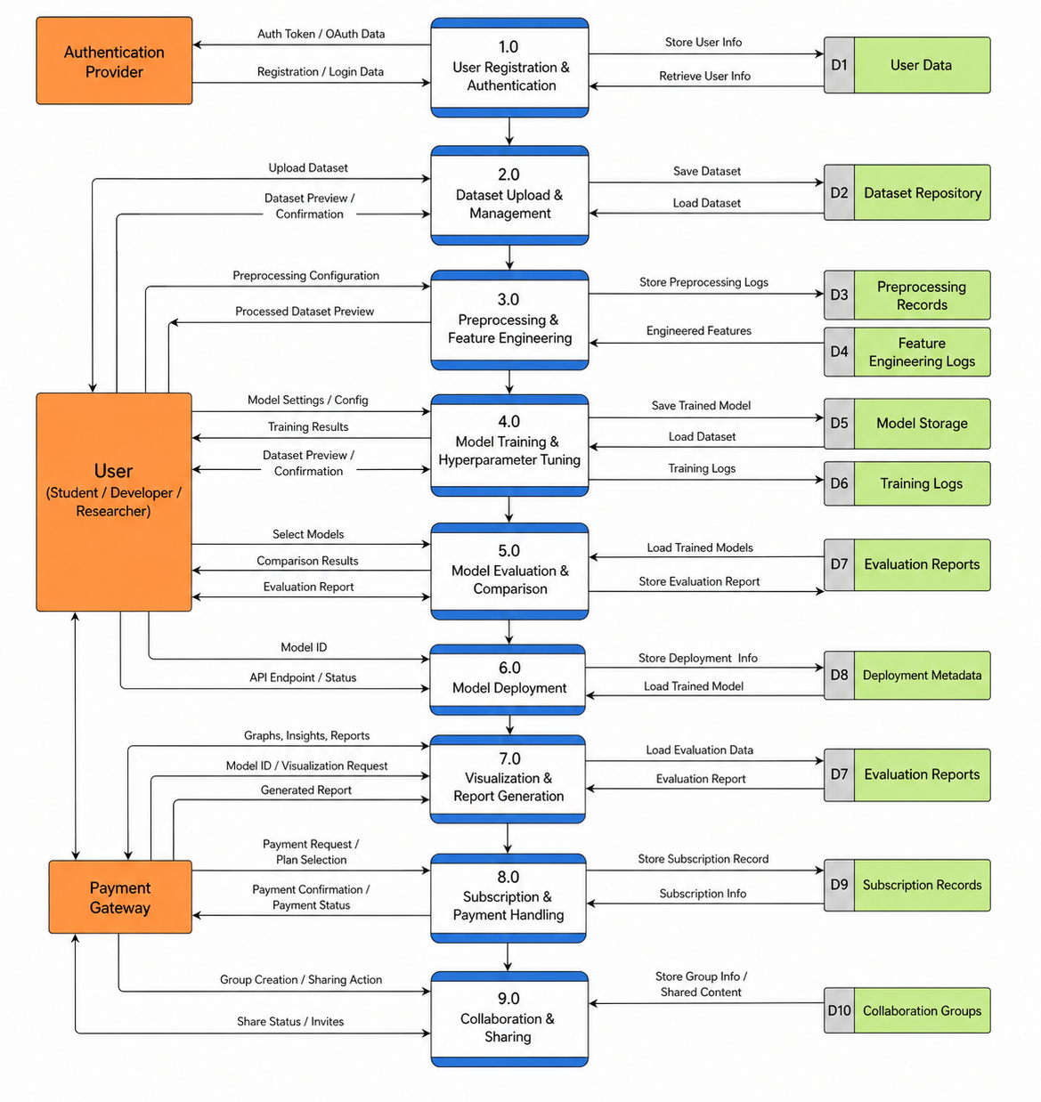

Level 02 DFD
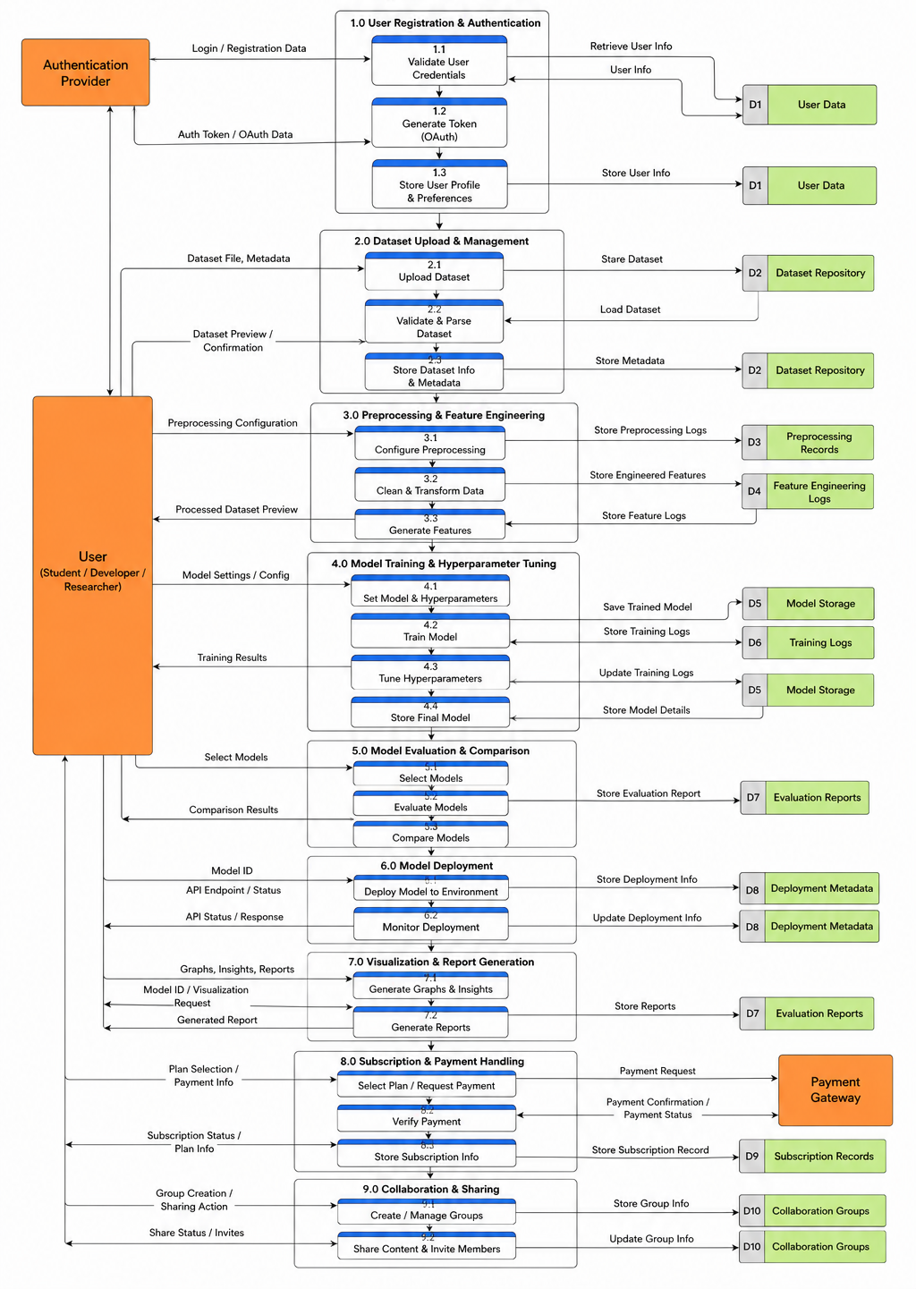

    - Decision Table
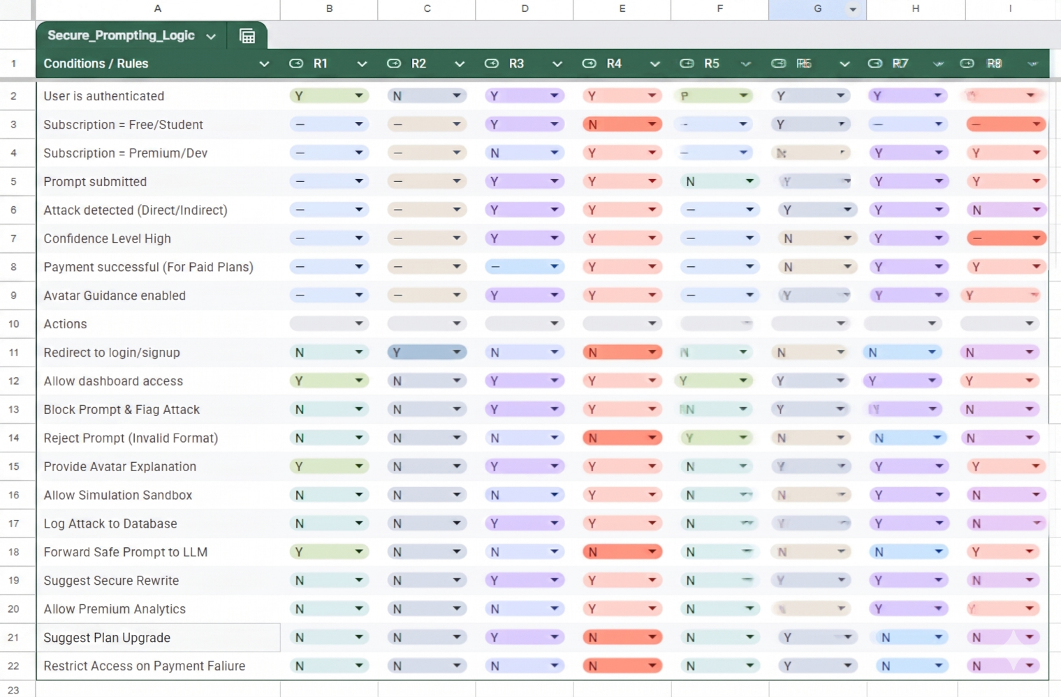
    - Event Trace Diagram

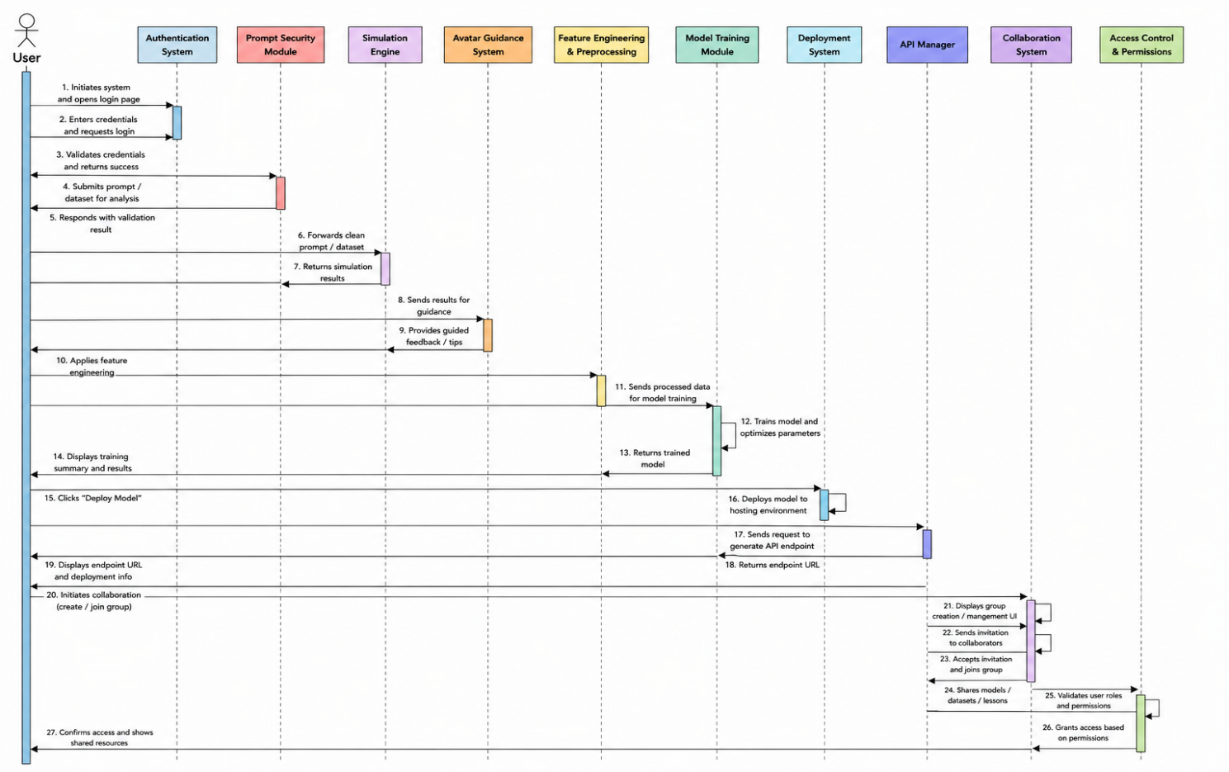

Nonfunctional Requirements
This section describes the nonfunctional requirements that are essential for ensuring high performance, safety, security, and software quality for the Secure Prompting and Simulation-based Learning through Avatar Guidance platform. These prerequisites are crucial to keeping the system reliable, user-friendly, and scalable, as well as safeguarding users against prompt injection threats.

Performance Requirements
The system has to offer real-time prompt analysis and effective processing, all the while accommodating numerous users at once. Essential performance requirements consist of:
Real Time Processing:
- Under normal conditions, the system should analyze and classify prompts with a response time of less than one second.
- For prompt evaluation, the core detection and classification module should target a latency of under 200ms.
System Responsiveness:
- User interface actions, include submitting prompts and showing results, ought to finish in 1–2 seconds.
- It should take no more than 2–3 seconds to load the analytics and visualization pages of the dashboard.
Concurrency & Scalability:
- The system must accommodate multiple concurrent users (at least 50) without a decline in performance.
- The backend architecture must be able to support scalable deployment, whether in the cloud or on a local server, to accommodate an increased load.
Model Performance:
- The classification model needs to identify safe and malicious prompts across various attack categories with high accuracy.
- The system needs to ensure a dependable and uniform prediction performance for both recognized and new prompt injection patterns.
- To facilitate effective real-time processing, model inference needs to be optimized for low latency and high throughput.

Resource Efficiency:
- During prompt processing, the system should make efficient use of CPU and memory resources.
- To keep the system efficient, unused resources should be released automatically.

Safety Requirements
The system has to guard against damage from harmful prompts and guarantee secure engagement with AI systems.
Prompt Safety Control:
- Before reaching the LLM or execution stage, the system needs to block or filter unsafe prompts.
- Warning messages and mitigation actions must be triggered by high-risk prompts.
Simulation Safety:
- To ensure that no actual system or data is impacted, the simulation sandbox needs to function within a controlled environment.
- Adversarial prompt testing should be conducted separately from production environments.
User Protection:
- Outside of the controlled simulation module, the system should not generate or show harmful, unethical, or exploitative content.
- Users should be alerted when dealing with potentially harmful or malicious inputs.
Error Handling & Fail Safe Mechanism:
- In the event of a failure in detection or processing, the system should offer secure fallback responses.
- No failure in analysis should lead to unsafe output generation.
Compliance & Ethical Safety:
- The system should adhere to AI safety guidelines.
- It ought to advance responsible practices for AI use and secure prompting.

Security Requirements
The system must ensure strong protection of user data, system integrity, and resistance against malicious activities, especially prompt injection attacks and unauthorized access. Key security requirements include:
Authentication & Access Control:
- User authentication must be required by the system prior to granting access to essential functions like prompt submission, simulation, and dashboard analytics.
- The platform ought to adopt role-based access control, differentiating between general users and administrators.
Data protection:
- User credentials should be stored securely through encryption and hashing methods to prevent exposure of sensitive information.
- It is essential to safeguard all prompt data, analysis results, and logs against unauthorized access and alterations.
Secure Communication:
- To prevent data interception, all exchanges between client and server must utilize secure communication protocols.
- To guarantee that only authorized requests are handled, API interactions must be secured.
Input Invalidation & Threat Prevention:
- To avoid the entry of harmful or incorrectly formatted data, the system has to authenticate every user input.
- The platform needs to proactively identify and lessen:
- Prompt injection attacks
- Jailbreak attempts
- Indirect malicious instructions
Session Management:
- The system needs to uphold secure session management, guaranteeing correct login/logout operations.
- To avert unauthorized access, sessions ought to expire automatically after a certain duration of inactivity.
Logging & Monitoring
- The system should log security-related events such as:
- Failed sign-in attempts
- Prompt activities that raise suspicion
- Attempts to gain access without authorization
- Logs should be kept in a secure location and utilized for monitoring and auditing.
Compliance & Standards
- It is important that the system conforms to security standards and guidelines prevalent in the industry.
- It has to guarantee the safeguarding of privacy and the responsible use of AI.

Additional Software Quality Attributes
To guarantee reliability, usability, and maintainability, the system must meet further quality attributes. These features improve user experience as well as system performance.

Usability:
- The system should offer an intuitive, user-friendly interface that is easy to use for both technical and non-technical users. It should provide clear feedback, warnings, and guidance to enhance understanding.
Reliability & Availability:
- The system needs to function in a consistent and reliable manner, delivering precise outcomes while guaranteeing ongoing availability and reducing downtime to a minimum during standard operation.
Scalability & Flexibility:
- The platform ought to accommodate a growing number of users and data volume without any decline in performance, while facilitating the straightforward integration of new features, models, and system components.
Robustness & Portability:
- The design of the system should be modular and well-documented, allowing for easy updates and maintenance, as well as efficient testing of individual components.
Maintainability & Testability:
- The system must manage unforeseen inputs and mistakes with composure, all the while upholding consistent performance and guaranteeing compatibility across various platforms and settings.

Other Requirements
There may be further requirements necessary for the system’s overall functionality, integration, and compliance that are not addressed in earlier sections of this document. These requirements include:
Database Requirement:
- The system should utilize a dependable database management system for the efficient storage of user data, prompts, analysis results, and logs.
- Data storage must guarantee consistency and integrity while allowing for easy retrieval to facilitate system operations and analytics.

External Interface Requirements:
- The system ought to facilitate communication between the frontend and backend using standard protocols like REST APIs.
- It should be able to work with external AI models or local LLMs for prompt processing and simulation.
Communication Requirements:
- Standard formats like JSON should be used for data exchange between system components.
- The system must guarantee that communication between services and modules is both stable and efficient.
Legal and Ethical Requirements:
- User data privacy and confidentiality must be guaranteed by the system, in accordance with applicable data protection policies.
- It should prevent abuse by limiting the generation or promotion of content that is harmful, unethical, or malicious.
Reuse and Extensibility Requirements:
- The system needs to be designed in a way that enables the reuse of components like the prompt analyzer and simulation modules in future projects.
- It should facilitate straightforward extensions and adjustments to include new functionalities and enhancements.

Revised Project Plan
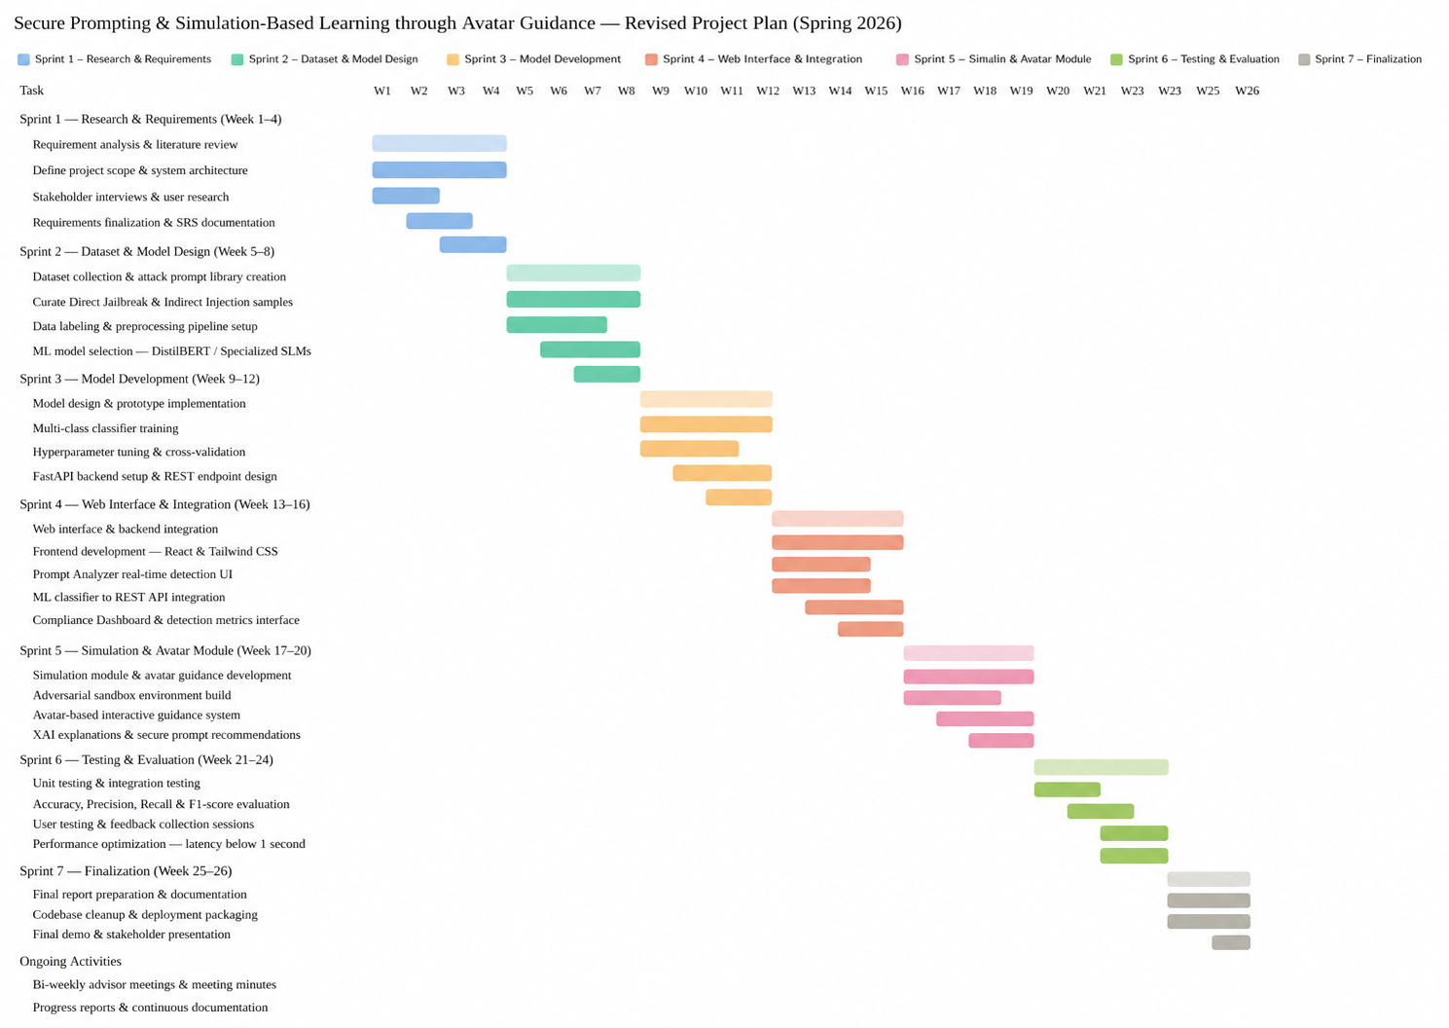

References
[1] Y. Liu et al., Formalizing and Benchmarking Prompt Injection Attacks and Defenses
[2] Y. Liu et al., Prompt Injection Attack against LLM-integrated Applications
[3] Y. Chen et al., Defense Against Prompt Injection Attack by Leveraging Attack Techniques
[4] Z. Wang et al., Exploring Cognitive Vulnerabilities: Self-Persuasion in Jailbreaking LLMs
[5] S. Lee et al., Visual Prompt Injection Attacks in Modern Large Language Models
[6] K. Greshake et al., "Not What You've Signed Up For: Indirect Prompt Injection," arXiv:2302.12173, 2023.
[7] L. Labunets et al., "How Vulnerable Are AI Agents to Indirect Prompt Injections?," arXiv preprint arXiv:2603.15714, 2026.
[8] O. Mayraz, "EchoLeak: The First Real-World Zero-Click Prompt Injection Exploit," arXiv:2509.10540, 2025.
[9] E. Sharma et al., "The Pedagogy of AI Security: Using Interactive Avatars," arXiv:2501.14285, 2025.
[10] F. Gong et al., "Multimodal Stealth: Advanced Visual Prompt Injections," arXiv:2502.08910, 2025.
[11] OWASP Foundation, "OWASP Top 10 for Large Language Model Applications v2.0," 2025.
[12] M. J. Inan et al., "Llama Guard: LLM-based Input-Output Safeguard," arXiv:2312.06674, 2024.
[13] S. Lee et al., "Taxonomy of Prompt Injection Defenses," IEEE Access, vol. 14, 2026.
[14] S. Sasal and Ö. Can, "Multi-Model Security Analysis," in Proc. 17th IC3K, 2025.
[15] E. Sharma et al., "Experience Report: Integrating Adversarial Scenarios," J. Cyber. Ed., 2026.
[16] A. Gupta, "Prompt Injection Generation Using Small Models," MIT/IEEE Research, 2025.
[17] G. Deng et al., "Masterkey: Automated Jailbreaking of Large Language Model Chatbots," in Proc. 31st NDSS, 2024.
[18] X. Zou et al., "Universal and Transferable Adversarial Attacks on Aligned Language Models," arXiv:2307.15043, 2023.
[19] K. Wei et al., "Jailbroken: How Does LLM Safety Training Fail?," in Advances in Neural Information Processing Systems (NeurIPS), 2024.
[20] A. Robey et al., "SmoothLLM: Defending Large Language Models Against Adversarial Attacks," arXiv:2310.03684, 2024.
[21] L. Simon et al., "Prompt Injection Attacks and Defenses in LLM-Integrated Applications," in Proc. 33rd USENIX Security Symposium, 2024.
[22] T. Geiping et al., "Coercing LLMs to do Your Bidding: Recursive Prompt Injection," arXiv:2402.06614, 2024.
[23] N. Jain et al., "Baseline Defenses for Adversarial Prompts Against LLMs," arXiv:2309.10253, 2023.
[24] J. Hayase et al., "Spectre: Defending Against Prompt Injection via Latent Space Analysis," arXiv:2404.10103, 2024.

Appendix A: Glossary
Term/Acronym | Description
AI | Artificial Intelligence – machines simulating human intelligence.
LLM | Large Language Model – An AI model that is trained on extensive datasets to comprehend and produce text resembling human writing.
API | Application Programming Interface – facilitates interaction between various software systems.
SRS | Software Requirements Specification – a document that specifies the functionality and requirements of the system.
ML | Machine Learning – A subset of AI that allows systems to learn from data and enhance their performance.
NLP | Natural Language Processing – A field of AI dedicated to comprehending and handling human language.
FastAPI | A high-performance Python framework used for building APIs and backend services.
XAI | Explainable Artificial Intelligence – Approaches that allow users to comprehend AI decisions.
React | A JavaScript library used for building interactive user interfaces.
UI/UX | User Interface/User Experience – Design and interaction aspects that determine how users interact with the system.
JSON | JavaScript Object Notation – A lightweight format for exchanging data between systems.
UAT | User Acceptance Testing – The concluding phase of software testing in which end users confirm that the system fulfills requirements and is prepared for deployment.
OWASP | Open Web Application Security Project – An organization that provides guidelines, tools, and best practices to improve the security of web applications.
OpenAI | A company focused on researching and implementing artificial intelligence, which creates sophisticated AI models (like GPT) for natural language processing, automation, and smart applications.
LLaMA | Large Language Model Meta AI – A set of AI language models created by Meta, intended for research and practical use in natural language understanding and generation.
Tailwind CSS | A utility-first CSS framework used for designing responsive user interfaces.
DistilBERT | A model based on transformers that is lightweight and used for efficient text classification tasks.
Dashboard | A visual platform showcasing system data, analytics, and performance metrics.
Prompt Injection | A form of attack in which harmful inputs affect how an AI model behaves.
Direct Jailbreak  Attack | A prompt injection attack that explicitly seeks to circumvent system rules or limitations.
Indirect Prompt Injection | A hidden attack where malicious instructions are embedded in external content.
Classifier | A machine learning model for classifying data into predefined categories (e.g., safe or malicious).

Appendix B: IV & V Report
(Independent verification & validation)
IV & V Resource

Name Signature

S# | Defect Description | Origin Stage | Status | Fix Time
 |  |  |  | Hours | Minutes
1
2
3
…
Table 3: List of non-trivial defects

Semester wise SDP Meeting Report
Project Title: Secure Prompting and Simulation Based Learning through Avatar Guidance Semester: _____S26_____
Group ID | Student Registration Number | Student Name and Signatures | Advisor
S26CS038 | L1S23BSCS119 | Faiqa Abid | Mr. Hafiz Usama Ishtiaq
S26CS038 | L1S23BSCS0266 | Jawaria Tassawar | Mr. Hafiz Usama Ishtiaq
S26CS038 | L1S23BSCS0129 | Rana Shahzaib Naseem | Mr. Hafiz Usama Ishtiaq

Sr. | Date | Status (P/A/L) |  |  | Agenda Items | Notes
 |  | Student 1 | Student 2 | Student 3
1 | 04-03-2026 | P | P | P | Kick off Meeting: Project scope, roles, initial timeline.
2 | 02-04-2026 | P | P | P | Requirement Finalization: Use cases, system modules, tech stack.
3 | 13-04-2026 | P | P | P | Design Phase Review: Class diagrams, ERD, DFDs discussion.
4 | 29-04-2026 | P | P | P | Development Planning: Sprint breakdown, milestones till June.

Date: 30-04-26 Advisor's Signatures: ______________________________

