For the solution of the exercise I propose 3 entities in the database.

* **Customers**, which stores customer information
* **Purchases**, which stores purchase information
* **Strategies**, which stores strategies for calculating scores. An entity is created in the database in order to allow an easy extension of new strategies or, failing that, remove one of them.

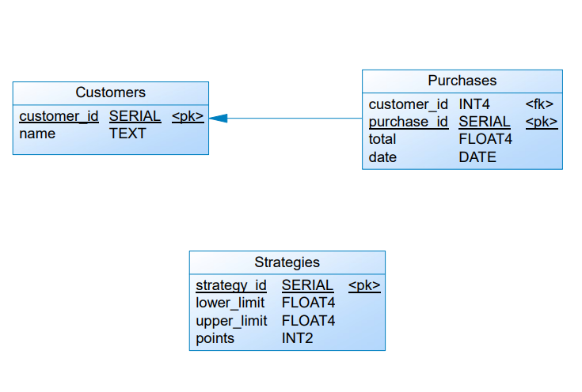

**For the following test data**

--Customers

insert into customers (customer_id, name) values (1,'Customer 1');

insert into customers (customer_id, name) values (2,'Customer 2');

insert into customers (customer_id, name) values (3,'Customer 3');

insert into customers (customer_id, name) values (4,'Customer 4');

insert into customers (customer_id, name) values (5,'Customer 5');

insert into customers (customer_id, name) values (6,'Customer 6');

--Strategies

insert into strategies (strategy_id, points, lower_limit) values (1, 2, 100);

insert into strategies (strategy_id, points, lower_limit, upper_limit) values (2, 1, 50,100);

--Purchases to test

insert into purchases (purchase_id, customer_id, total, date) values (1,1,120, '2021-09-01');

insert into purchases (purchase_id, customer_id, total, date) values (2,2,102, '2021-09-01');

insert into purchases (purchase_id, customer_id, total, date) values (3,2,120, '2021-08-01');

insert into purchases (purchase_id, customer_id, total, date) values (4,2,120, '2021-07-01');

insert into purchases (purchase_id, customer_id, total, date) values (5,2,110, '2021-07-01');

insert into purchases (purchase_id, customer_id, total, date) values (6,3,100, '2021-09-01');

insert into purchases (purchase_id, customer_id, total, date) values (7,3,100, '2021-04-01');

insert into purchases (purchase_id, customer_id, total, date) values (8,3,100, '2021-03-01');

insert into purchases (purchase_id, customer_id, total, date) values (9,4,65, '2021-07-01');

insert into purchases (purchase_id, customer_id, total, date) values (10,5,20, '2021-07-01');

insert into purchases (purchase_id, customer_id, total, date) values (11,6,140, '2021-07-01');

**You get the following answer**

**http://localhost:8001/api/customer/last-quarter**

[

    {

        "id": 1,

        "name": "Customer 1",

        "points": 90,

        "pointsPerMonth": {

            "septiembre": 90

        }

    },

    {

        "id": 2,

        "name": "Customer 2",

        "points": 304,

        "pointsPerMonth": {

            "agosto": 90,

            "septiembre": 54,

            "julio": 160

        }

    },

    {

        "id": 3,

        "name": "Customer 3",

        "points": 0,

        "pointsPerMonth": {

            "septiembre": 0

        }

    },

    {

        "id": 4,

        "name": "Customer 4",

        "points": 15,

        "pointsPerMonth": {

            "julio": 15

        }

    },

    {

        "id": 5,

        "name": "Customer 5",

        "points": 150,

        "pointsPerMonth": {

            "septiembre": 150,

            "julio": 0

        }

    },

    {

        "id": 6,

        "name": "Customer 6",

        "points": 130,

        "pointsPerMonth": {

            "julio": 130

        }

    }

]