Milestone-1: Questions & Answers

(210932-Abdul Javid)

# 1. **Write a Java Program to reverse a string without using String inbuilt function reverse ().**

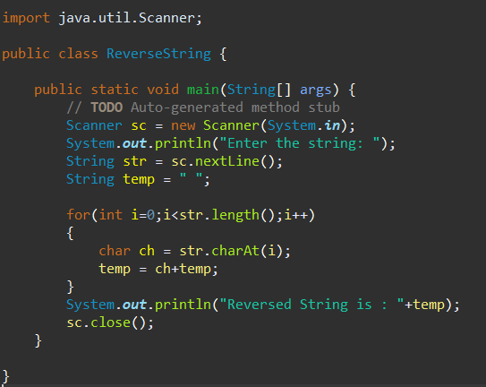

Output:

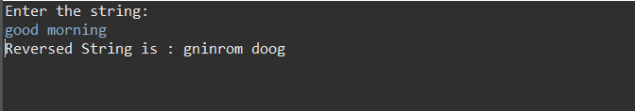

# 2. **Write a program to take an input number from the programmer and calculate all the prime numbers from 0 to that number. Store all the prime numbers in an array and display the array elements.**

# **Example: Input=10**

# **Output:**

# **1,2,3,5,7**

## 

Output:

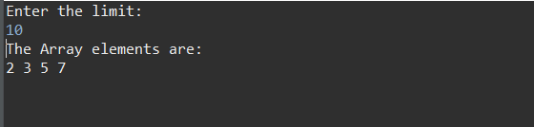

# **3. Write a Java Program to find whether a string or number is palindrome or not.**

# **Note: input can be a number or a String.**

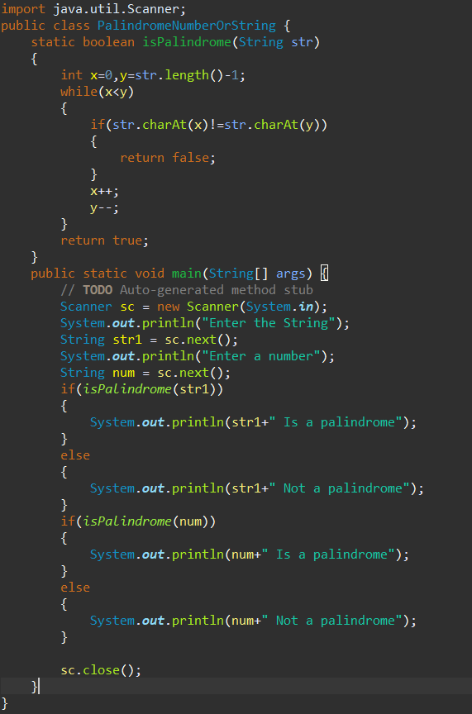

Output:

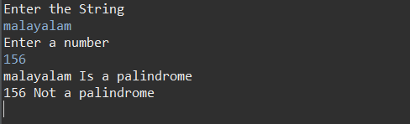

# **4. Write a Java Program to find the duplicate characters in a string.**

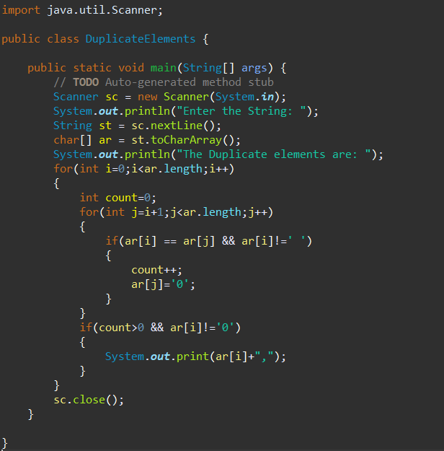

Output:

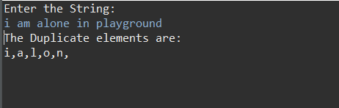

# **5. Write a Java Program to find the second-highest number in an array.**

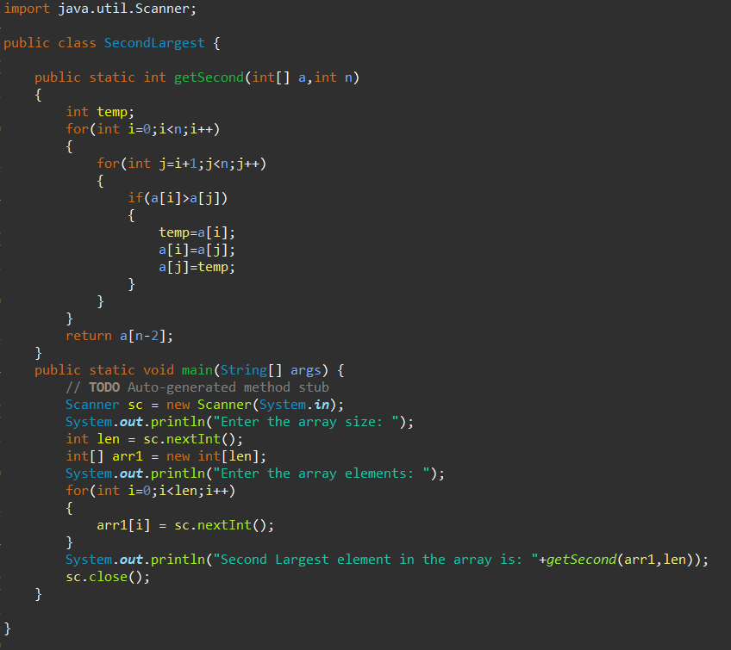

Output:

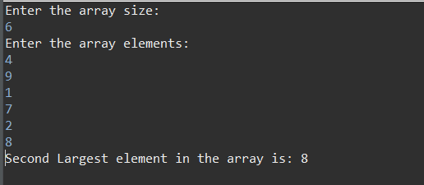

# **6. Write a java program to subtract two matrices. Take the input of the matrices from the user.**

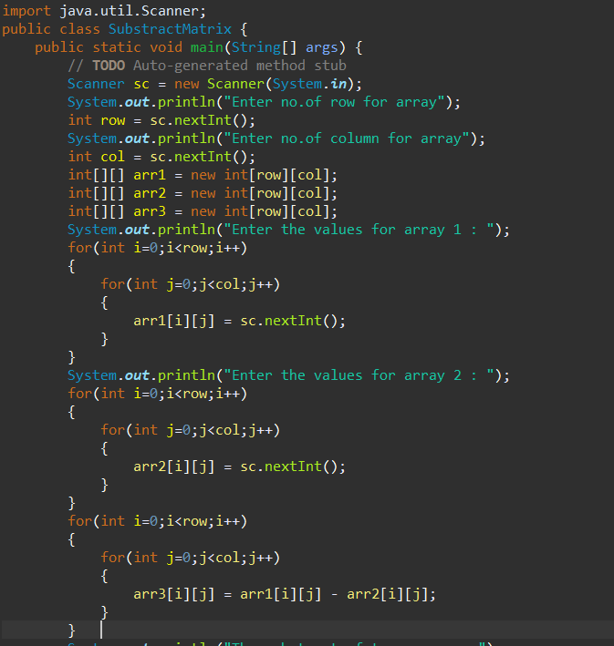

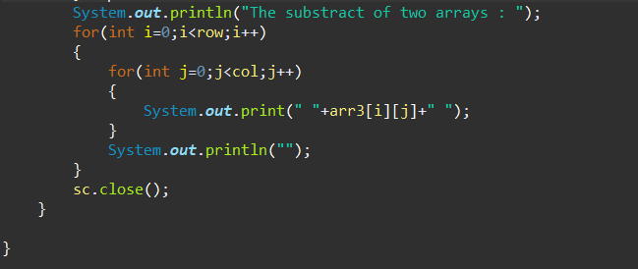

Output:

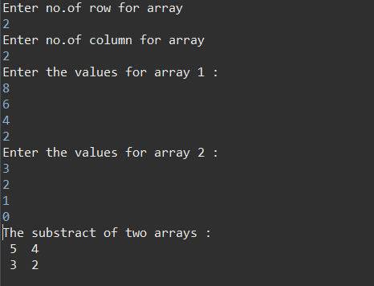

# **7. Write a java program to take a string input from the user. Convert all the uppercase letters to lowercase and vice-versa.**

# **Example:**

# **Input:**

# **MIcroSoft**

# **Output:**

# **miCROsOFT**

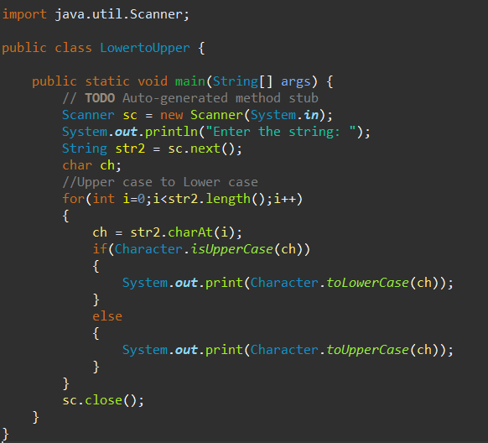

Output:

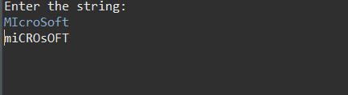

# **8. Write a java program to take an input array of integers and sort the array using insertion sort.**

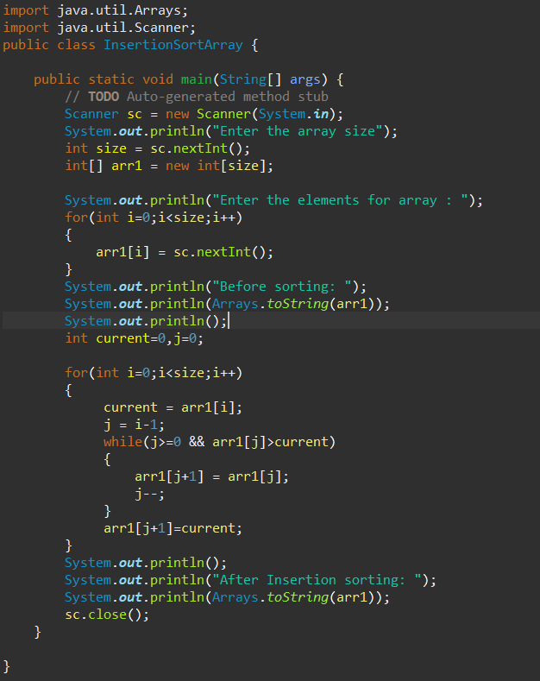

Output:

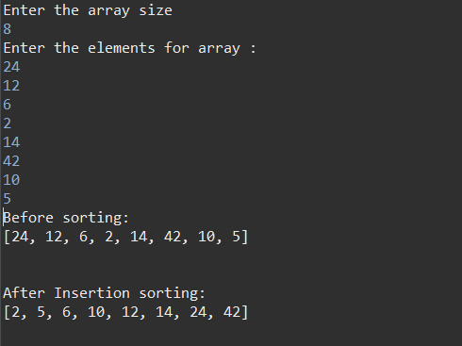

# **9. Write a java program to take an input array of integers and search for a particular number given by the user. Use binary search algorithm.**

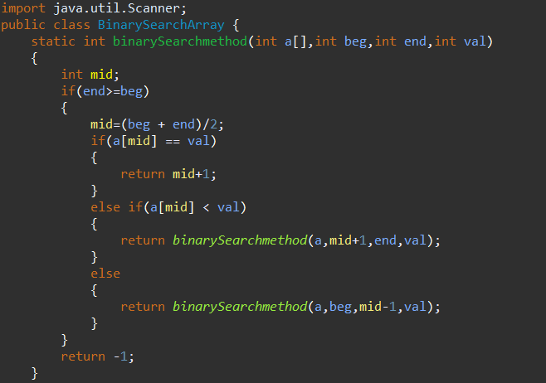

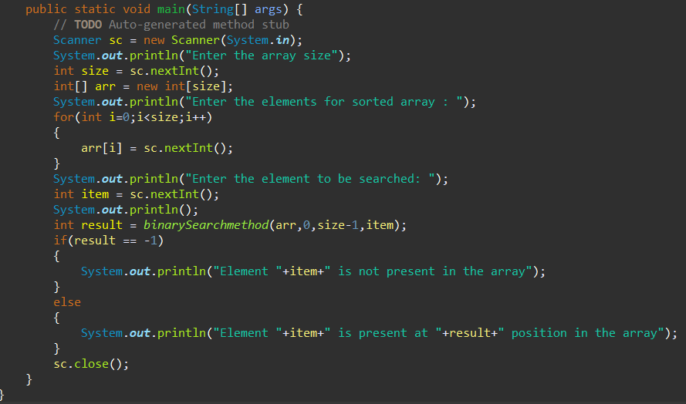

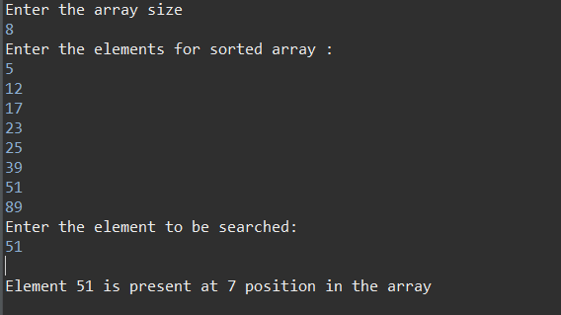

# **10. Write a java program to take an input array of integers and sort the elements in a descending order using selection sort.**

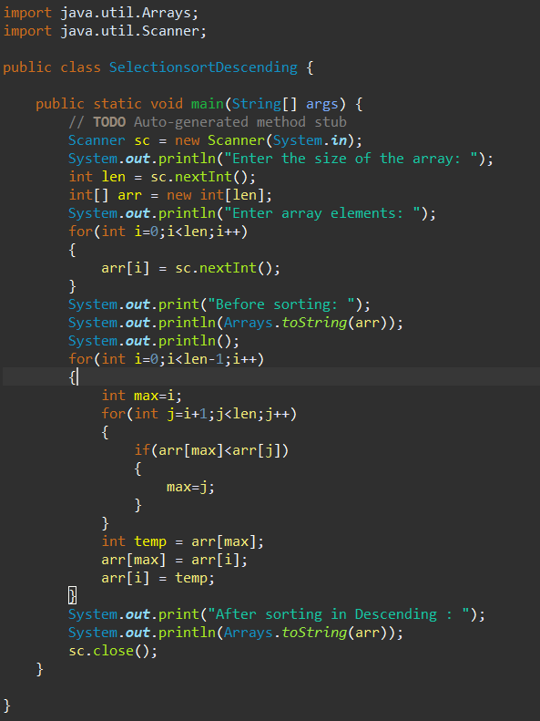

Output:

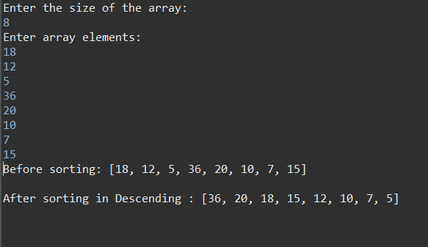

# **11. Write a java program to achieve 100% abstraction.**

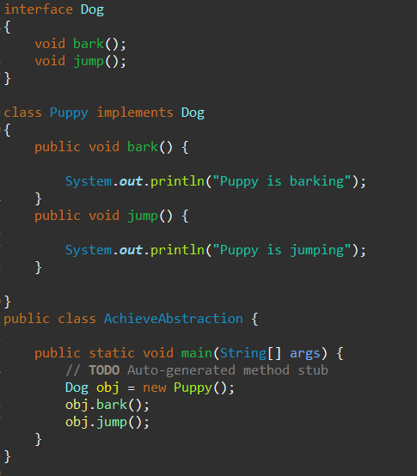

Output:

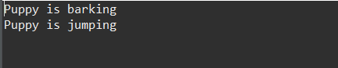

# **12. Write a java program to implement method overloading.**

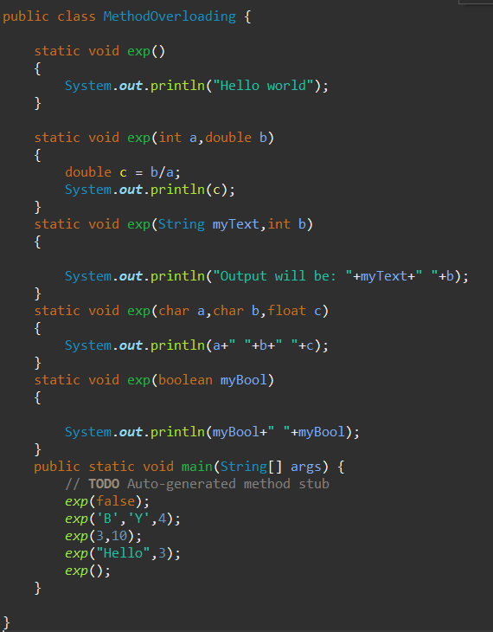

Output:

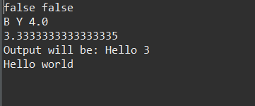

# **13. Write a java program to implement method overriding.**

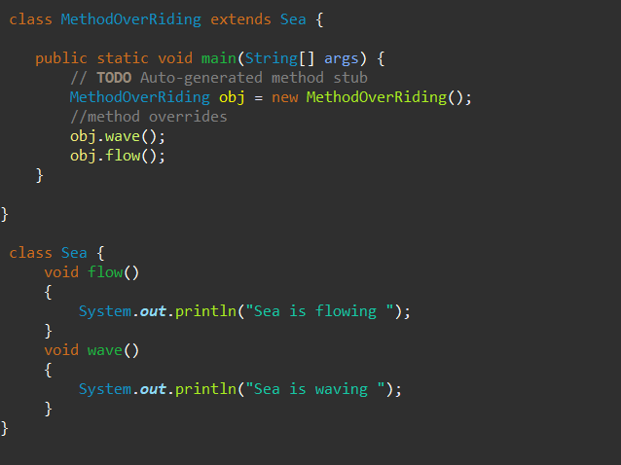

Output:

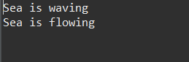

# **14. Write a java program to implement Hybrid Inheritance.**

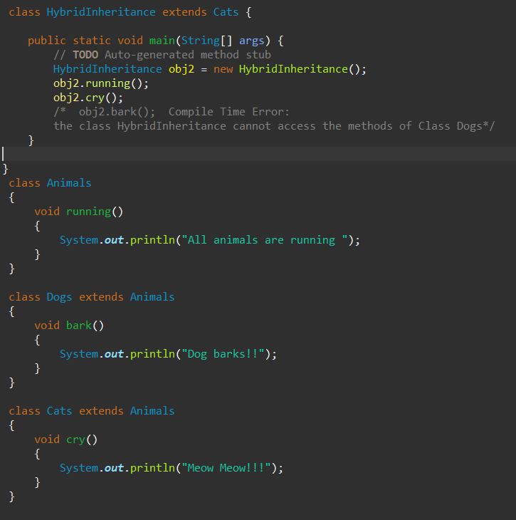

Output:

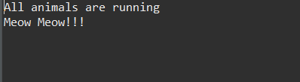

# **15. Write a java program to implement multilevel inheritance.**

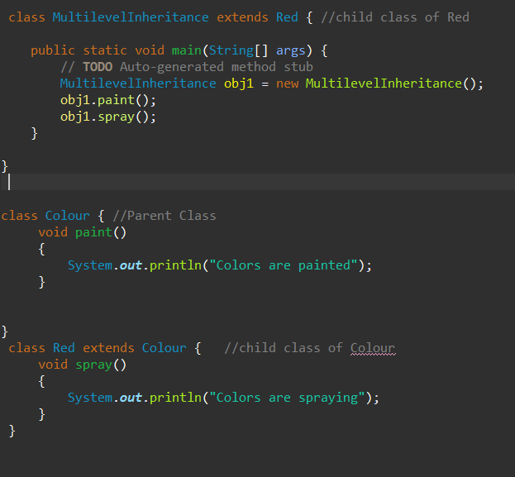

Output:

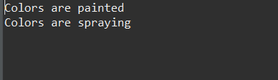

# **16. Write a java program to take input of integer array elements from the user and divide each element by the smallest element of the array and store the result in a resultant array. Implement Try- catch-finally block to counter null pointer divide by zero error.**

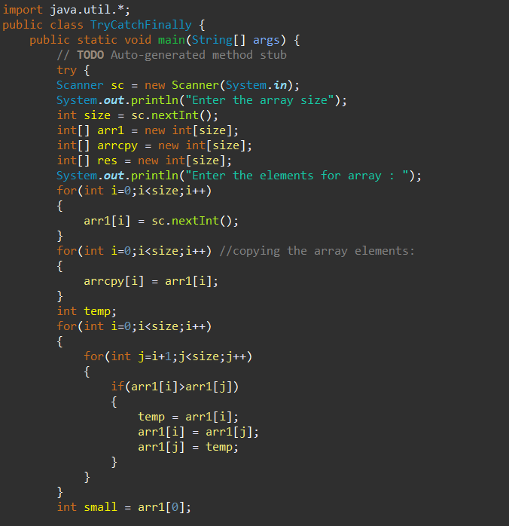

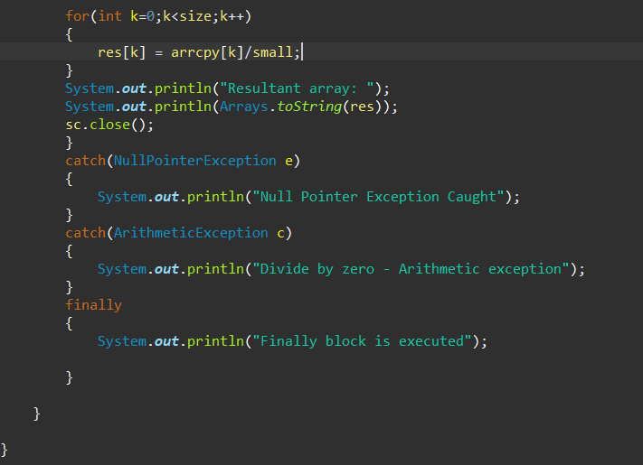

Output:

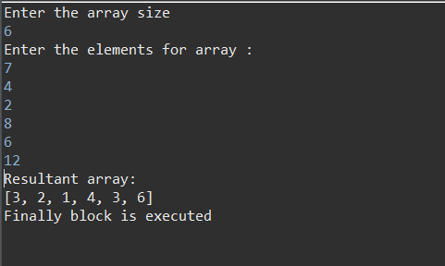

# **17. Write a java program to implement a constructor of the class, to print the instance variables value with respect to different objects.**

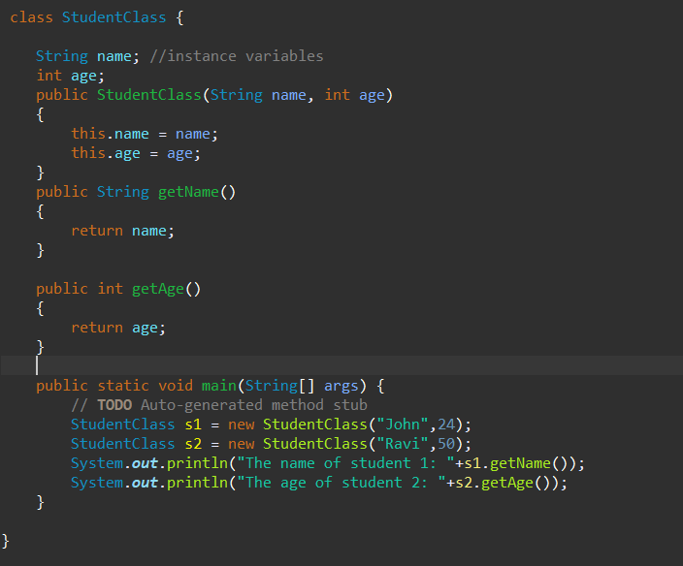

Output:



# **18. Write a java program to create a File at a particular location and to write to that particular file a String data which is taken as input from the user.**

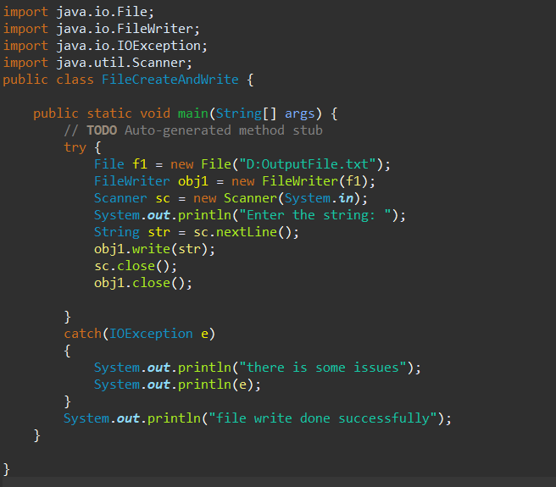

Output:

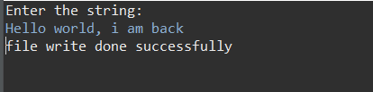

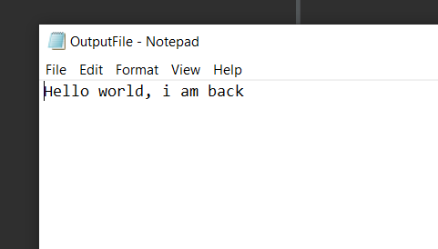

# **19. Write a program to read a file from a particular location and determine the number of vowels in that file.**

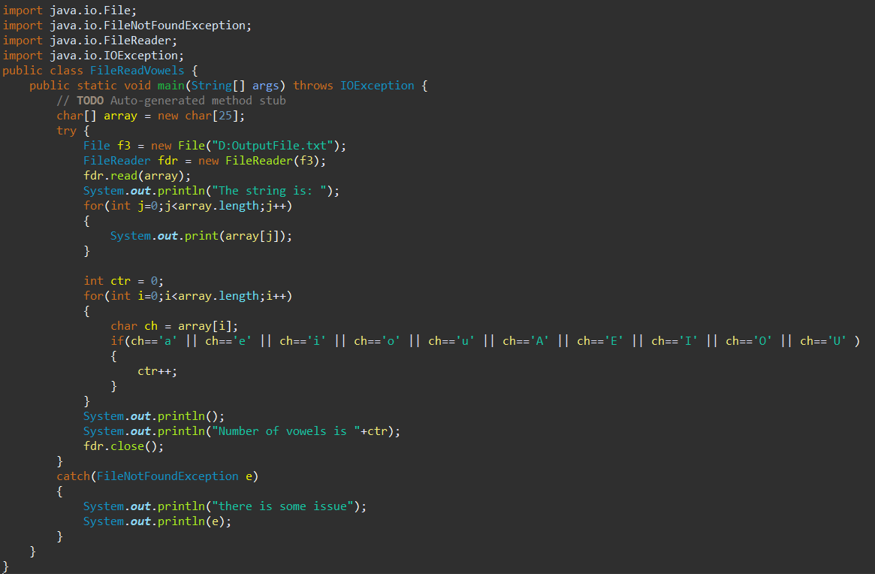

Output:

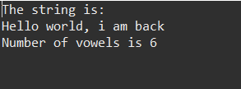

# **20. Write a program to take input of two numbers from the user. Now perform the particular arithmetic operation specified by the user and display the result.**

# **Hint: use Switch case.**

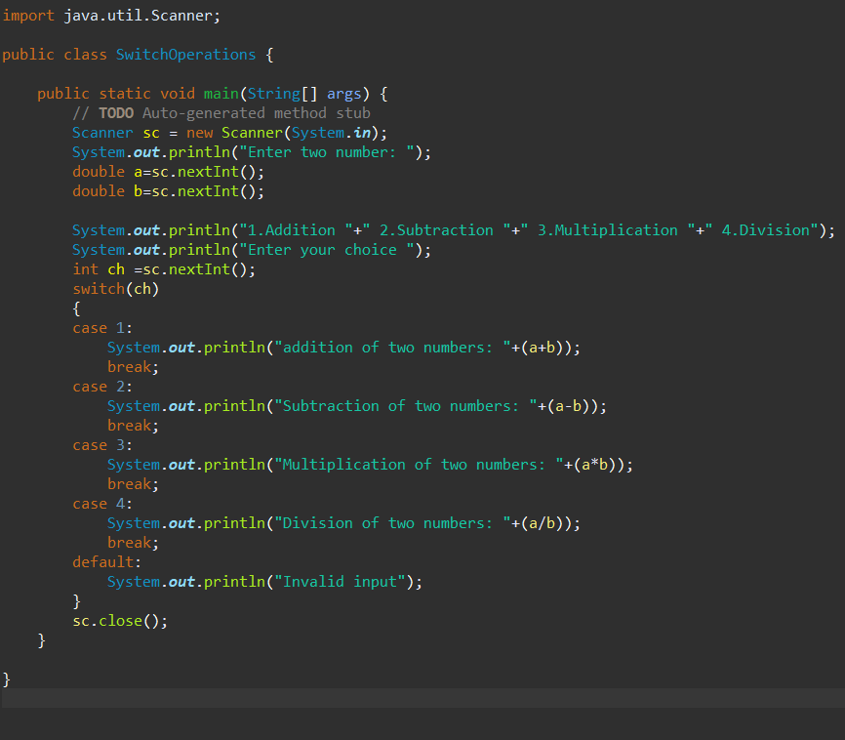

Output:

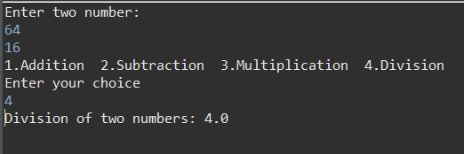

# **21. Create an array of 10 elements and print them using the for each loop.**

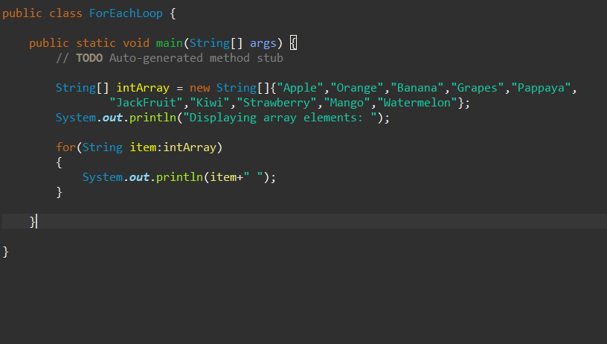

Output:

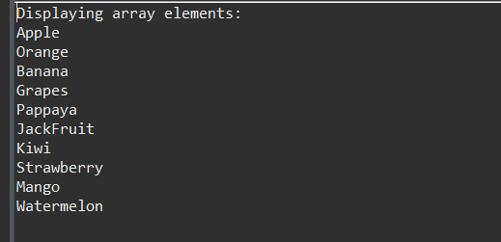

# **22. Take the number input from the console and add all the positive numbers. (Not to consider the negative number if entered)**

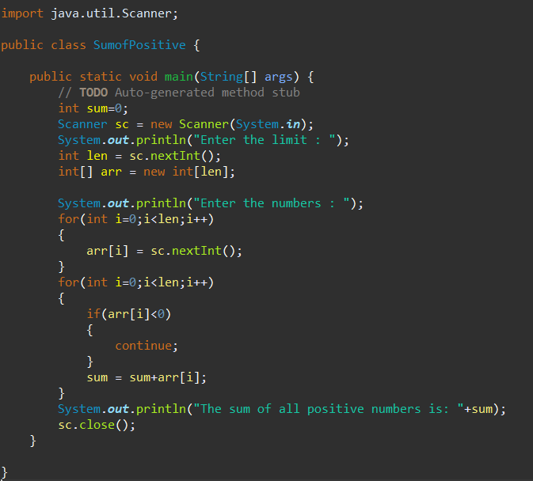

Output:

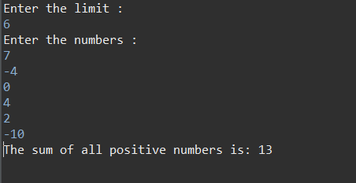

# **23. Create a labelled break and write a simple logic and execute the program.**

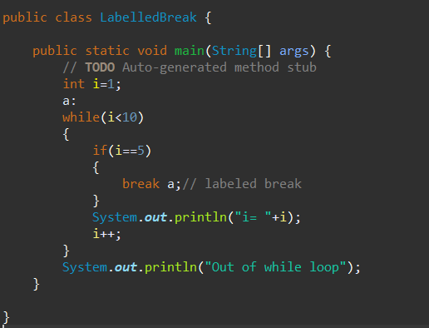

Output:

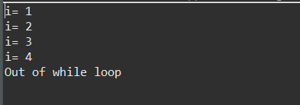

# **24. Do the addition of around 10 even numbers, but use the continue statement in the logic.**

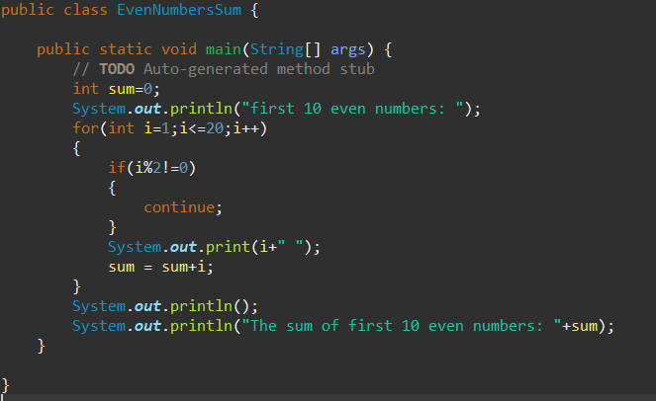

Output:

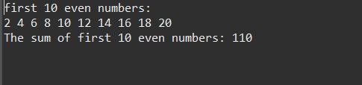

# **25. Write a program to reverse the String (use char [] or String built in method)**

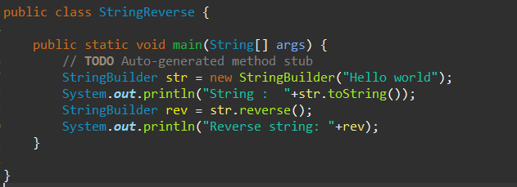

Output:

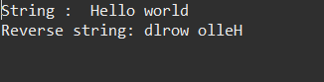

# **26. Write programs to depict the usage of contains (), length (), replace (), concat (), equals ()**

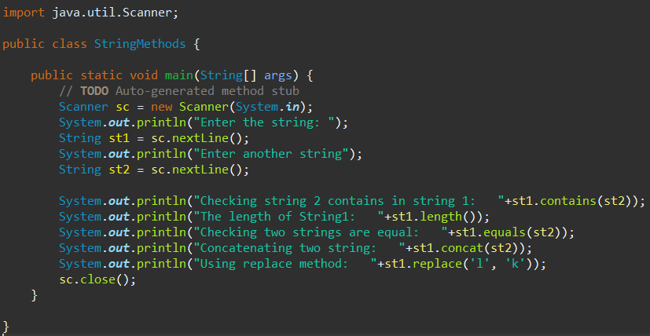

Output:

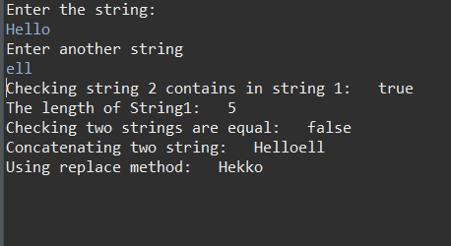

# **27. Create an inheritance class. (Super class as Vehicle and 2 subclasses Car and Bike and inherit the Vehicle class methods)**

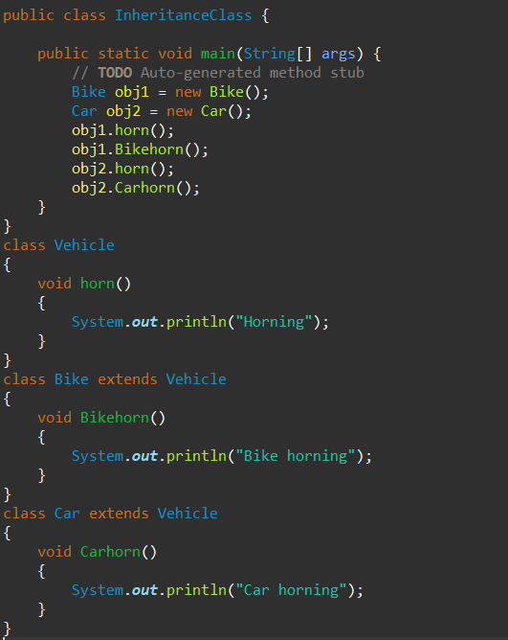

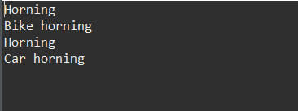

# **28. Depict programmatically the Method overloading and Method overriding concepts.**

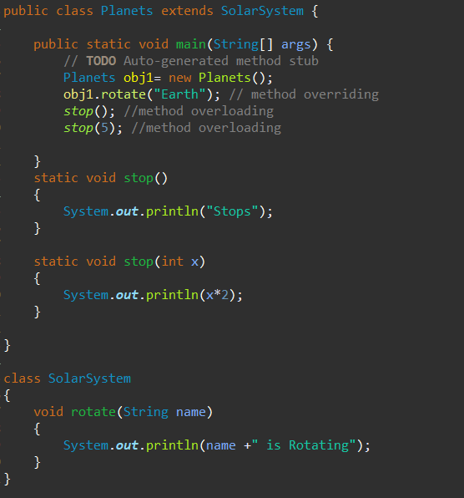

Output:

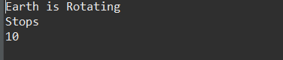

# **29. Create an abstract class and extend that class and try to create the object of the abstract class in a program and execute.**

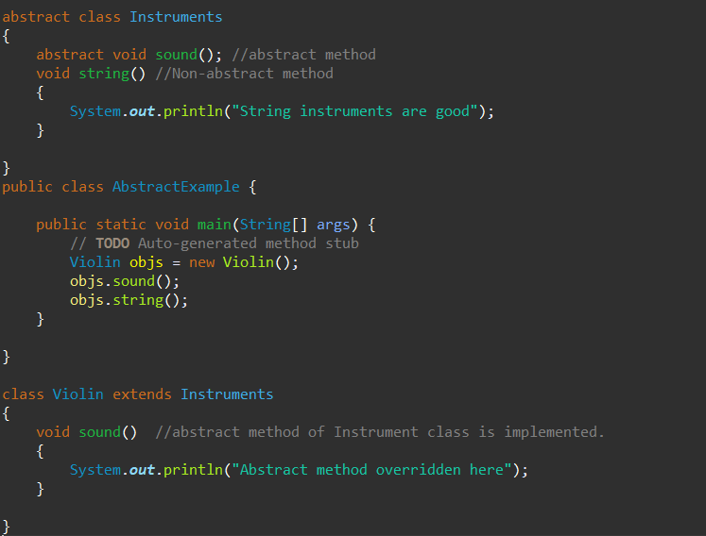

Output:

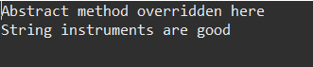

# **30. Write a java program to write the data into a file and read back using FileOutputStream/FileInputStream and also try the same using the BufferedReader and BufferedWriter**

Using FileInputStream and FileOutputStream.

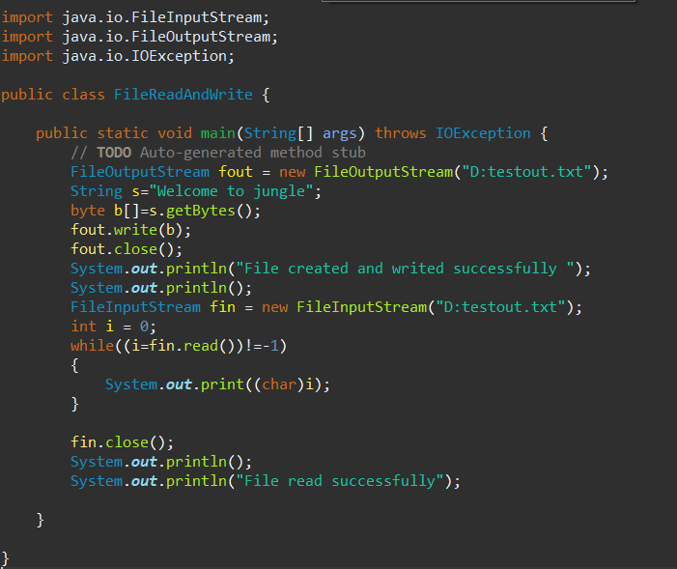

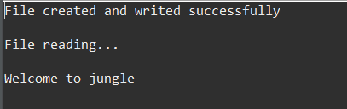

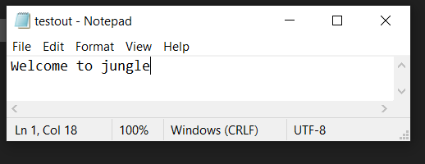

Using BufferedWriter and BufferedReader

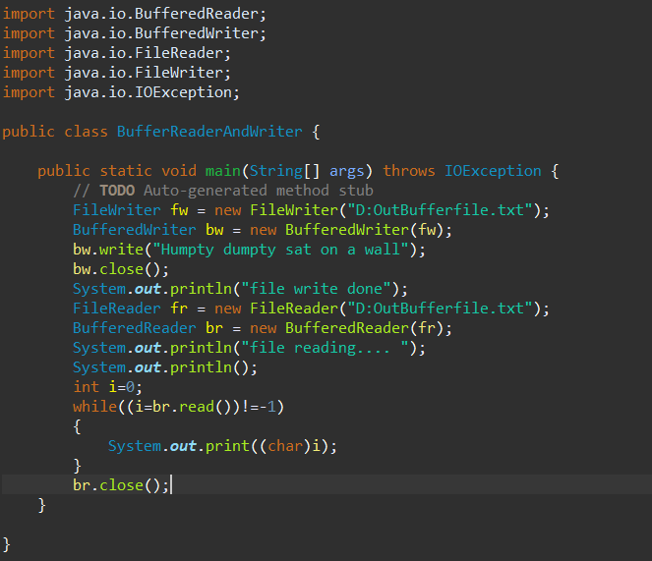

Output:

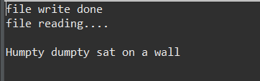

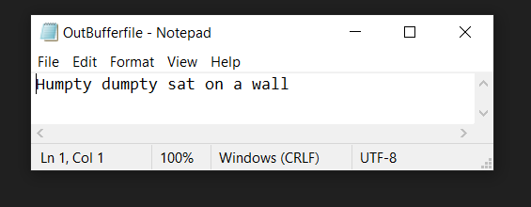

# **31. Write a java program to check the file owner details.**

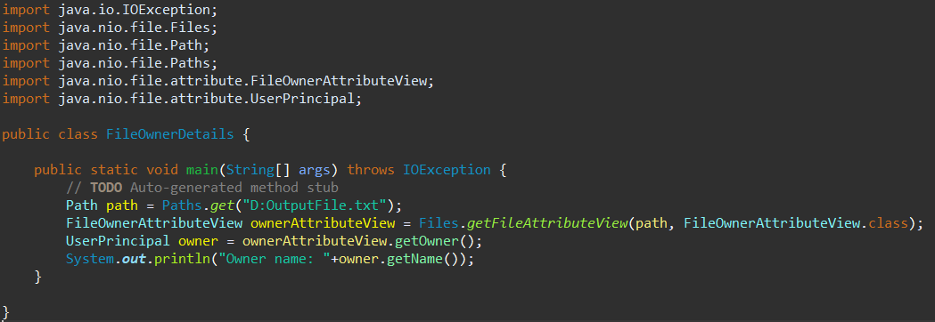

Output:



# **32. Write a java program to copy data from one file to another file.**

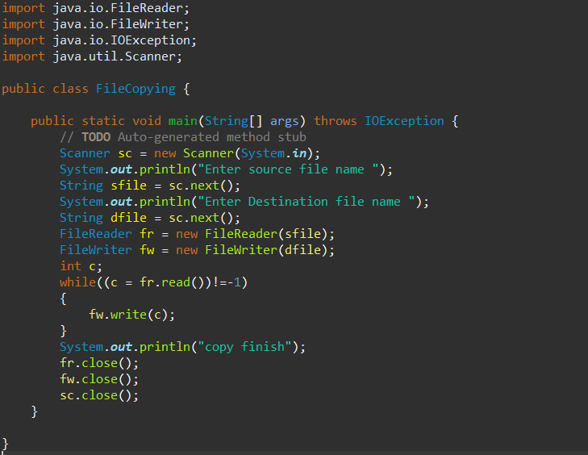

Output:

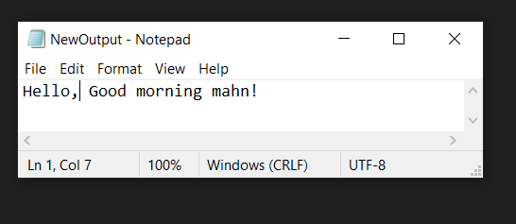

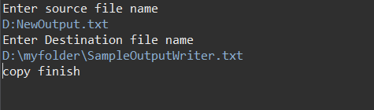

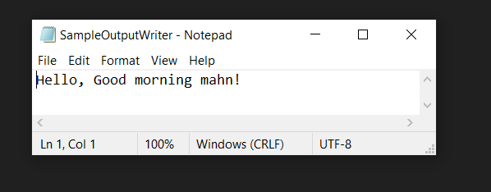

# **33. How to add an element at a specific position in an ArrayList (create using <>)**

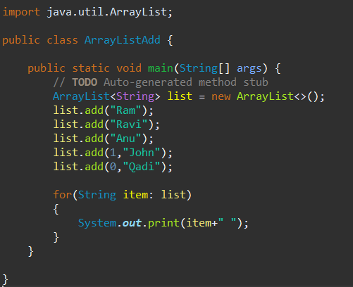

Output:



# **34. Create an array of employee objects and iterate through it and remove the object at the 2nd position.**

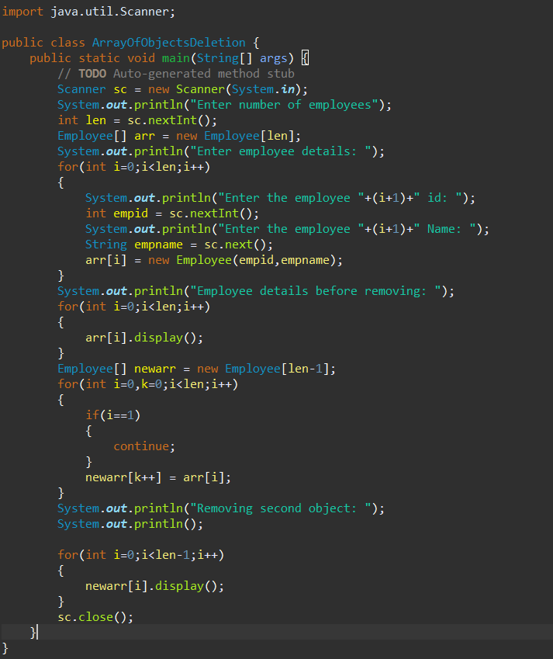

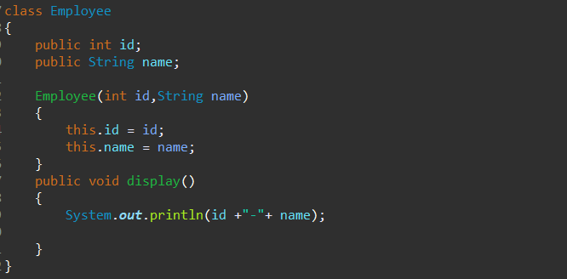

Output:

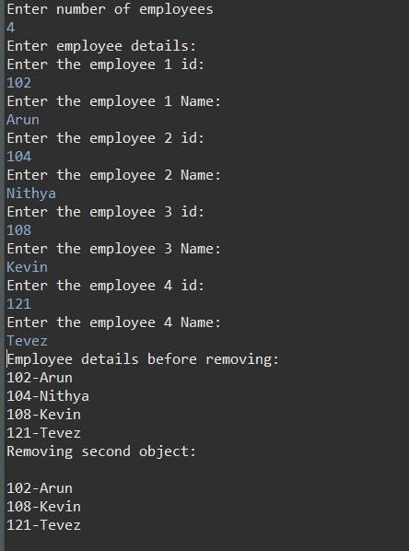

# **35. Create a HashMap type and display the elements using the keyset ()**

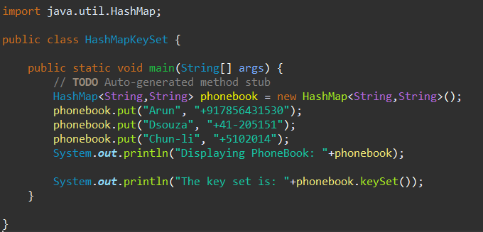

Output:

