**SBA-3 ABDUL JAVID 210932**

1. Create Database project_movie_data and deploy table data according to ER diagram.

2. Create 9 tables which are presented in ER model and load the data with their foreign key and primary key values.

**Creating Databases and Tables**

* create database project_movie_data;
* use project_movie_data;
* create table actor ( act_id int not null, act_fname char(20), act_lname char(20), act_gender char(1), primary key (act_id));
* create table director ( dir_id int not null, dir_fname char(20), dir_lname char(20), primary key (dir_id));
* create table genres ( gen_id int not null, gen_title char(20), primary key(gen_id));
* create table reviewer ( rev_id int not null, rev_name char(30), primary key(rev_id));
* create table movie ( mov_id int not null, mov_title char(50), mov_year int, mov_time integer, mov_lang char(50), mov_dt_rel date, mov_rel_country char(5),primary key(mov_id));
* create table movie_cast ( act_id int not null, mov_id int not null, role char(30), foreign key(act_id) references actor(act_id), foreign key(mov_id) references movie(mov_id));
* create table movie_direction (dir_id int not null, mov_id int not null, foreign key(dir_id) references director(dir_id), foreign key(mov_id) references movie(mov_id));
* create table rating ( mov_id int not null, rev_id int not null, rev_stars decimal(8,2), num_o_ratings int, foreign key(mov_id) references movie(mov_id), foreign key(rev_id) references reviewer(rev_id));
* create table movie_genres ( mov_id int not null, gen_id int not null, foreign key(mov_id) references movie(mov_id), foreign key(gen_id) references genres(gen_id));

**Query for inserting on table actor:**

insert into actor (act_id, act_fname, act_lname, act_gender) values (101, 'James', 'Stewart', 'M'),(102, 'Deborah', 'Kerr', 'F'),(103, 'Peter', 'OToole', 'M'),(104, 'Robert', 'De Niro', 'M'),

(105, 'F. Murray', 'Abraham', 'M'),(106, 'Harrison', 'Ford', 'M'),(107, 'Nicole', 'Kidman', 'F'),

(108, 'Stephen', 'Baldwin', 'M'),(109, 'Jack', 'Nicholson', 'M'),(110, 'Mark', 'Wahlberg', 'M'),

(111, 'Woody', 'Allen', 'M'),(112, 'Claire', 'Danes', 'F'),(113, 'Tim', 'Robbins', 'M'),(114, 'Kevin', 'Spacey', 'M'),(115, 'Kate', 'Winslet', 'F'),(116, 'Robin', 'Williams', 'M'),(117, 'Jon', 'Voight', 'M'),

(118, 'Ewan', 'McGregor', 'M'),(119, 'Christian', 'Bale', 'M'),(120, 'Maggie', 'Gyllenhaa', 'F'),(121, 'Dev', 'Patel', 'M'),(122, 'Sigourney', 'Weaver', 'F'),(123, 'David', 'Aston', 'M'),(124, 'Ali', 'Astin', 'F');

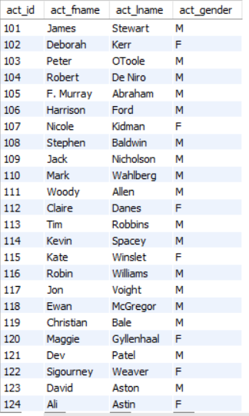

**Query for inserting on table director:**

insert into director (dir_id, dir_fname, dir_lname) values (201, 'Alfred', 'Hitchcock'),(202, 'Jack', 'Clayton'),(203, 'David', 'Lean'),(204, 'Michael', 'Cimino'),(205, 'Milos', 'Forman'),(206, 'Ridley', 'Scott'),(207, 'Stanley', 'Kubrick'),(208, 'Bryan', 'Singer'),(209, 'Roman', 'Polanski'),(210, 'Paul', 'Thomas Anderson'),(211, 'Woody', 'Allen'),(212, 'Hayao', 'Miyazaki'),(213, 'Frank', 'Darabont'),

(214, 'Sam', 'Mendes'),(215, 'James', 'Cameron'),(216, 'Gus', 'Van Sant'),(217, 'John', 'Boorman'),

(218, 'Danny', 'Boyle'),(219, 'Christopher', 'Nolan'),(220, 'Richard', 'Kelly'),(221, 'Kevin', 'Spacey'),

(222, 'Andrei', 'Tarkovsky'),(223, 'Peter', 'Jackson');

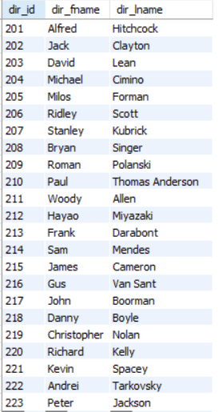

**Query for inserting on table genres:**

insert into genres (gen_id, gen_title) values (1001, 'Action'),(1002, 'Adventure'),

(1003, 'Animation'),(1004, 'Biography'),(1005, 'Comedy'),(1006, 'Crime'),(1007, 'Drama'),

(1008, 'Horror'),(1009, 'Music'),(1010, 'Mystery'),(1011, 'Romance'),(1012, 'Thriller'),(1013, 'War');

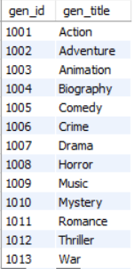

**Query for inserting on table movie:**

insert into movie (mov_id, mov_title, mov_year, mov_time, mov_lang, mov_dt_rel, mov_rel_country) values (901, 'Vertigo', 1958, 128, 'English', '1958-08-24', 'UK'),

(902, 'The Innocents', 1961, 100, 'English', '1962-02-19', 'SW'),(903, 'Lawrence of Arabia', 1962, 216, 'English', '1962-12-11', 'UK'),(904, 'The Deer Hunter', 1978, 183, 'English ', '1979-03-08', 'UK'),

(905, 'Amadeus', 1984, 160, 'English', '1985-01-07', 'UK'),(906, 'Blade Runner', 1982, 117, ' English', '1982-09-09', 'UK'),(907, 'Eyes Wide Shut', 1999, 159, 'English', null, 'UK'),

(908, 'The Usual Suspects', 1995, 106, 'English', '1995-08-25', 'UK'),(909, 'Chinatown', 1974, 130, 'English', '1974-08-09', 'UK'),(910, 'Boogie Nights', 1997, 155, 'English', '1998-02-16', 'UK'),

(911, 'Annie Hall', 1977, 93, 'English', '1977-04-20', 'USA'),(912, 'Princess Mononoke', 1997, 134, 'Japanese', '2001-10-19', 'UK'),(913, 'The Shawshank Redemption', 1994, 142, 'English', '1995-02-17', 'UK'),(914, 'American Beauty', 1999, 122, 'English', null, 'UK'),(915, 'Titanic', 1997, 194, 'English', '1998-01-23', 'UK'),(916, 'Good Will Hunting', 1997, 126, 'English', '1998-06-03', 'UK'),

(917, 'Deliverance', 1972, 109, 'English', '1982-10-05', 'UK'),(918, 'Trainspotting', 1996, 94, 'English', '1996-02-23', 'UK'),(919, 'The Prestige', 2006, 130, 'English', '2006-11-10', 'UK'),

(920, 'Donnie Darko', 2001, 113, 'English', null, 'UK'),(921, 'Slumdog Millionaire', 2008, 120, 'English', '2009-01-09', 'UK'),(922, 'Aliens', 1986, 137, 'English', '1986-08-29', 'UK'),(923, 'Beyond the Sea', 2004, 118, 'English', '2004-11-26', 'UK'),(924, 'Avatar', 2009, 162, 'English', '2009-12-17', 'UK'),(926, 'Seven Samurai', 1954, 207, 'Japanese', '1954-04-26', 'JP'),

(927, 'Spirited Away', 2001, 125, 'Japanese', '2003-09-12', 'UK'),(928, 'Back to the Future', 1985, 116, 'English', '1985-12-04', 'UK'),(925, 'Braveheart', 1995, 178, 'English ', '1995-09-08', 'UK');

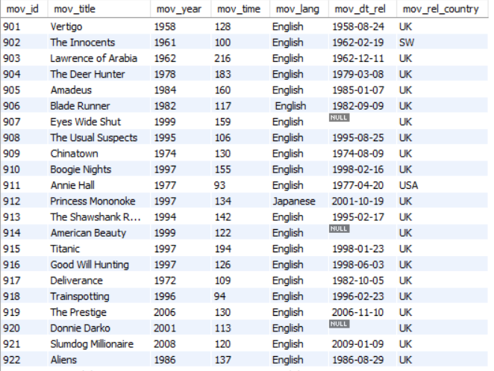

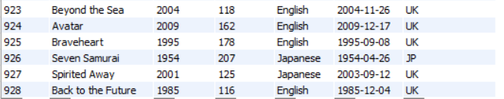

**Query for inserting on table movie_cast:**

INSERT INTO movie_cast (act_id, mov_id, role) VALUES (101, 901, 'John Scottie Ferguson'),

(102, 902, 'Miss Giddens'),(103, 903, 'T.E. Lawrence'),(104, 904, 'Michael'),(105, 905, 'Antonio Salieri'),(106, 906, 'Rick Deckard'),(107, 907, 'Alice Harford'),(108, 908, 'McManus'),(110, 910, 'Eddie Adams'),(111, 911, 'Alvy Singer'),(112, 912, 'San'),(113, 913, 'Andy Dufresne'),(114, 914, 'Lester Burnham'),(115, 915, 'Rose DeWitt Bukater'),(116, 916, 'Sean Maguire'),(117, 917, 'Ed'),

(118, 918, 'Renton'),(120, 920, 'Elizabeth Darko'),(121, 921, 'Older Jamal'),(122, 922, 'Ripley'),(114, 923, 'Bobby Darin'),(109, 909, 'J.J. Gittes'),(119, 919, 'Alfred Borden');

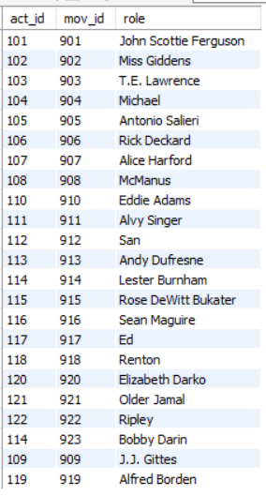

**Query for inserting on table movie_direction:**

INSERT INTO movie_direction (dir_id, mov_id) VALUES (201, 901),(202, 902),(203, 903),

(204, 904),(205, 905),(206, 906),(207, 907),(208, 908),(209, 909),(210, 910),(211, 911),

(212, 912),(213, 913),(214, 914),(215, 915),(216, 916),(217, 917),(218, 918),(219, 919),(220, 920),

(218, 921),(215, 922),(221, 923);

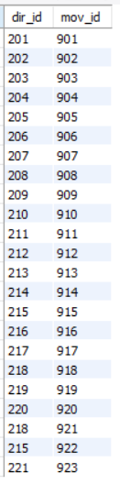

**Query for inserting on table movie_genres:**

INSERT INTO movie_genres (mov_id, gen_id) VALUES (922, 1001),(917, 1002),(903, 1002),

(912, 1003),(911, 1005),(908, 1006),(913, 1006),(926, 1007),(928, 1007),(918, 1007),

(921, 1007),(902, 1008),(923, 1009),(907, 1010),(927, 1010),(901, 1010),(914, 1010),

(906, 1012),(904, 1013);

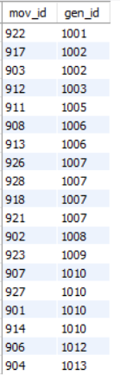

**Query for inserting on table reviewer:**

insert into reviewer (rev_id, rev_name) values (9001, 'Righty Sock'),(9002, 'Jack Malvern'),

(9003, 'Flagrant Baronessa'),(9004, 'Alec Shaw'),(9005,null),(9006, 'Victor Woeltjen'),(9007, 'Simon Wright'),(9008, 'Neal Wruck'),(9009, 'Paul Monks'),(9010, 'Mike Salvati'),(9011,null),

(9012, 'Wesley S. Walker'),(9013, 'Sasha Goldshtein'),(9014, 'Josh Cates'),(9015, 'Krug Stillo'),

(9016, 'Scott LeBrun'),(9017, 'Hannah Steele'),(9018, 'Vincent Cadena'),

(9019, 'Brandt Sponseller'),(9020, 'Richard Adams');

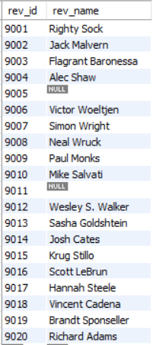

**Query for inserting on table rating:**

INSERT INTO rating (mov_id, rev_id, rev_stars, num_o_ratings) VALUES (901, 9001, 8.4, 263575),(902, 9002, 7.9, 20207),

(903, 9003, 8.3, 202778),(906, 9005, 8.2, 484746),(924, 9006, 7.3, null),(908, 9007, 8.6, 779489),(909, 9008, null, 227235),

(910, 9009, 3, 195961),(911, 9010, 8.1, 203875),(912, 9011, 8.4, null),(914, 9013, 7, 862618),(915, 9001, 7.7, 830095),

(916, 9014, 4, 642132),(925, 9015, 7.7, 81328),(918, 9016, null, 580301),(920, 9017, 8.1, 609451),(921, 9018, 8, 667758),

(922, 9019, 8.4, 511613),(923, 9020, 6.7, 13091);

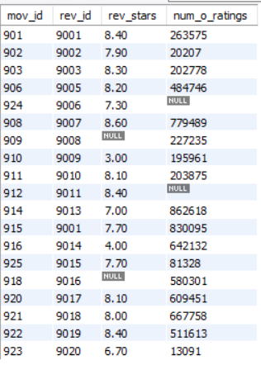

3. Write a query in SQL to list the Horror movies?

SELECT mov_title

FROM movie WHERE mov_id=(SELECT mov_id FROM movie_genres

WHERE gen_id in (SELECT gen_id FROM genres WHERE gen_title='Horror'));



4. Write a query in SQL to find the name of all reviewers who have rated 8 or more stars?

select rev_name from reviewer rv INNER JOIN rating rt on rv.rev_id = rt.rev_id

where rt.rev_stars >= 8.00;

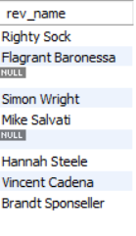

5. Write a query in SQL to list all the information of the actors who played a role in the movie ‘Deliverance’

select a.act_id,a.act_fname,a.act_lname,a.act_gender,m.mov_title

from actor a INNER JOIN movie_cast mc on a.act_id = mc.act_id

INNER JOIN movie m on m.mov_id = mc.mov_id where m.mov_title = 'Deliverance';

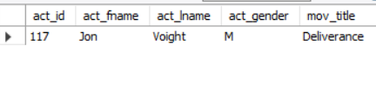

6. Write a query in SQL to find the name of the director (first and last names) who directed a movie that casted a role for ‘Eyes Wide Shut’. (using subquery)

select dir_fname, dir_lname from director

where dir_id in ( select dir_id from movie_direction where mov_id in

(select mov_id from movie m where mov_title = 'Eyes Wide Shut'));

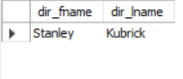

7. Write a query in SQL to find the movie title, year, date of release, director and actor for those movies which reviewer is ‘Neal Wruck’

select mov_title, mov_year, mov_dt_rel, dir_fname, dir_lname, act_fname, act_lname

from movie m, director d, actor a, movie_direction md, rating rt, reviewer rv, movie_cast mc

where md.dir_id = d.dir_id

and mc.act_id = a.act_id

and m.mov_id = md.mov_id

and m.mov_id = mc.mov_id

and m.mov_id = rt.mov_id

and rt.rev_id = rv.rev_id

and rv.rev_name = 'Neal Wruck';

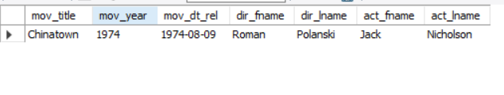

8. Write a query in SQL to find all the years which produced at least one movie and that received a rating of more than 4 stars.

select DISTINCT mov_year

from movie where mov_id in (select mov_id from rating where rev_stars>4.00);

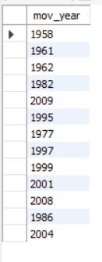

9. Write a query in SQL to find the name of all movies who have rated their ratings with a NULL value

select mov_title from movie

where mov_id in (select mov_id from rating where rev_stars is null);

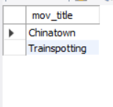

10. Write a query in SQL to find the name of movies who were directed by ‘David’

select mov_title

from movie m inner join movie_direction md on m.mov_id = md.mov_id

inner join director d on md.dir_id = d.dir_id

where dir_lname = 'david' or dir_fname = 'david';

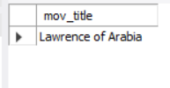

11. Write a query in SQL to list the first and last names of all the actors who were cast in the movie ‘Boogie Nights’, and the roles they played in that production.

select a.act_fname, a.act_lname ,mc.role

from actor a inner join movie_cast mc on a.act_id = mc.act_id

inner join movie m on mc.mov_id = m.mov_id

where mov_title = 'Boogie Nights';

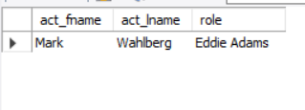

12. Find the name of the actor who have worked in more than one movie

select mov_title from movie

where mov_id in (select mov_id from movie_cast

where act_id in (select act_id from actor

where act_id IN (select act_id from movie_cast group by act_id having COUNT(act_id)>1)));

