**Proceedings of the ASME 2021**

**International Design Engineering Technical Conferences and   
Computers and Information in Engineering Conference**

**IDETC/CIE2021  
August 17-20, 2021, Virtual, Online**

DETC2021-XXXX

PLACE TITLE HERE: PLACE SUBTITLE AFTER COLON (USE ARIAL 11)

|  |  |  |  |
| --- | --- | --- | --- |
| First Author  Affiliation Here  New York, NY | Second Author  Affiliation Here  Beijing, China | Third Author Affiliation Here  Warsaw, Poland | Fourth Author Affiliation Here  Hyderabad, India |
| Fifth Author  Affiliation Here  Accra, Ghana | | Sixth Author Affiliation Here  Rome, Italy | |

Abstract

*Abstracts should be about 200 words. All running text, including the abstract, should be right-justified, in two columns, single-spaced, and in Times New Roman size 10 font.*

Keywords: Place any keywords here

1. INTRODUCTION

Additive Manufacturing (AM), also known as 3D printing, is one of the most promising manufacturing technologies. It shows excellent potential in cost and energy reduction compared with other manufacturing techniques [1]. It has an incomparable advantage in fabricating parts with complex structures. However, the process robustness, repeatability, and stability restrict the development of AM technologies. Therefore, the process monitoring and anomaly detection become the pre-requisite of quality assurances for AM technologies.

Several in-situ process monitoring solutions have been presented to improve the part quality [2-6]. Due to the characteristics of AM parts and in-situ monitoring requirements, the non-contact and non-destructive sensors, like vision-based monitoring technologies, are widely utilized for AM systems. Yi et al. [4] used a single camera on the top of a Fused Filament Fabrication (FFF) machine. The upper surface of each layer was captured by the camera and analyzed using machine vision and statistical process to detect the contour profile defects. The single-camera cannot capture the depth information accurately of fabricated parts. Hence, Li et al. [5] applied two camera stereo vision systems to obtain the fabricated parts’ surface topography in the Powder Bed Fusion system. With the structure light method, they could identify the big valley of parts. But the monitoring system is fixed on the top of the chamber. The robustness and reliability of the monitoring system highly rely on the environmental light intensity. The light condition could significantly change the parameters in the machine vision algorithm. The laser-based 3D scanner shows the better capability in obtaining comprehensive and accurate information of the target. The laser scanner operates typically with a laser stripe emitter and a camera according to the principle of optical triangulation. Jorge et al. [6] implemented a laser scanner on a Laser Metal Deposition (LMD) machine to obtain the point cloud data of the fabricated part surface. Since the camera only receives the known laser line, the laser scanner has better repeatability on the fine-detailed shape measurements.

Different methods have been applied in laser-based sensor data processing for surface quality. Machine Learning (ML) algorithms help researchers analyze the sensor data and identify the surface anomalies of the fabrication process. Scime and Beuth [7] proposed a defect classification model for Laser Powder Bed Fusion (L-PBF) machine. The powder bed process’s captured images were used as training data for a Convolutional Neural Network (CNN) model. The algorithm can extract the key features from the raw data and classify them accordingly. The classification model showed 84% classification accuracy. [Needs more references]

In this study, an in-site laser-based process monitoring and anomaly identification system is developed for FFF-type machines to promote AM process quality assurance. During the FFF fabrication process, the non-optimal process parameters and accumulation of process uncertainties could cause the bad interior structure of parts, leading to weak mechanical properties or even fabrication failures. By monitoring the layer in-plane surface, the anomalies can be identified in the first place. Further controlling actions can be taken to operate the machine accordingly. To find the best anomalies classification model, several ML models are compared, and the classification results are validated.

1. **METHODOLOGY**

The proposed in-situ laser-based process monitoring and anomaly identification system is designed for the FFF machine. Equipping with a non-contact laser scanner, each layer’s top surface profile can be captured during the FFF fabrication process. With the integrated ML algorithm, the anomalies of the top surface can be identified.

**2.1 System Setup**

The monitoring system is built on a modified Creality Ender 5, an open-source FFF printer, shown in Fig. 1. Merlin firmware with a bootloader and real-time communication capability of the workstation through the serial port are among the reasons to choose this printer. The laser scanner system used in the study is a KEYENCE high-speed Laser Profiler LJ-V7000 series mounted on the extra frame, which is rigidly connected to the FFF printer. The sensor can move in a plane that is parallel with the FFF printer plane. The distance (in direction) between sensor and target surface is calculated with a resolution of 1 µm based on the laser-based 3D triangulation principle. The communication between the workstation and laser scanner is established via TCP/IP.

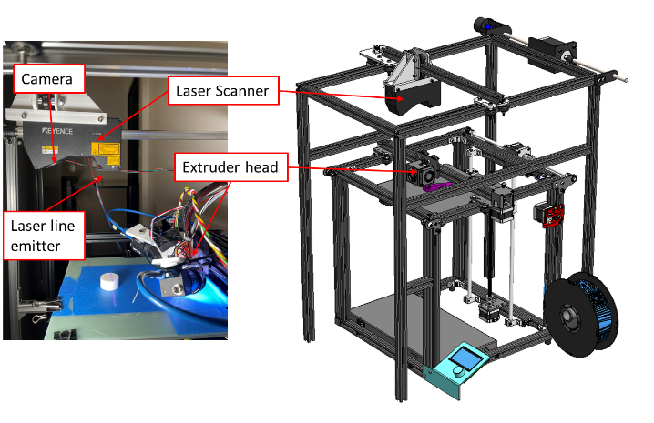

**FIGURE** **1**: THE HARDWARE SETUP OF MONITORING SYSTEM FOR FFF

**2.2 Data Processing and Communication Architecture**

The data processing and communication architecture for the in-situ laser-based process monitoring and anomaly identification system is demonstrated in Fig. 2. The application is established using the Python programming language. The slicer algorithm slices the CAD model based on the fabrication requirement in the workstation. After generating the g-code, the multiprocessing software initializes the communication between the workstation, and FFF printer, and laser scanner. The g-code is sent to the buffer memory of the FFF printer line by line. During the fabrication process, the extruder head needs to move aside to clean the nozzle after each layer. Simultaneously, the scanner frame motion mechanism drives the sensor to move above the fabricating layer. The laser controller continuously triggers the laser emitter and built-in camera. When the predefined batch size is reached, the 2D laser line profiles are combined and published as a raw point cloud dataset. Then Three subprocesses of point cloud processing are executed successively. The raw point cloud dataset is pre-processed by noise removing algorithms and transforms from sensor local coordinate to printer Tool Centre Point (TCP). Then the upper surface is segmented from the pre-processed dataset and converted to a 2D depth image. Finally, the image is fed to an integrated pre-trained classification model, and the anomalies can be identified.



**FIGURE 2**. DATA PROCESSING AND COMMUNICATION ARCHITECTURE DIAGRAM

**2.3 Point Cloud Processing**

The raw point cloud dataset subscribed from the laser scanner includes noise which is commonly caused by the mechanical vibration and the shadow effect characteristics of optical scanning sensor. To obtain a clean dataset, replacing the missing measurement values and removing the outliers are necessary.

A batch of raw point clouds acquired from the sensor is formed as a 2D depth matrix. During the scanning process, if the target is out of the scanning range (in direction) or the built-in camera cannot capture sufficient laser line information, the corresponding pixels are flagged as missing measurement, as NaN in this paper. The median interpolation operator with a window is used to replace the missing measurements, which better perform step-like features[8]. The laser scanner calculates the distance from the target based on the 3D triangulation method. Therefore, the shadow effect causes the sensor to be sensitive to the abrupt change of height, as shown in Fig. 3. The boundary area of the target could be recognized as outliers algorithmically. The statistical outlier removal method modified from the point cloud library (PCL) [9] is used to remove the noise. The neighbor points whose distance from the center point is over the threshold are eliminated. The comparison between raw point cloud dataset and cleaned dataset is shown in Fig. 4.

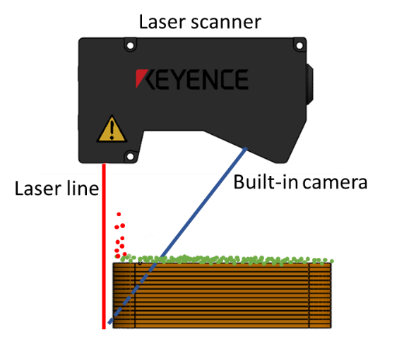

**FIGURE 3**. NOISE CAUSED BY SHADOW EFFECT (GREEN DOTS REPRESENT NORMAL POINT CLOUD AND RED DOTS REPRESENT NOISE)

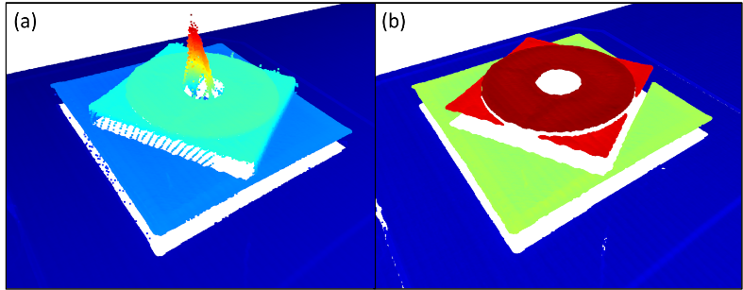

**FIGURE 4**. EFFECTS OF FILTERING FOR RAW POINT CLOUD DATASET

After removing the dataset’s noise, it is necessary to perform calibration to find the FFF printer and laser scanner’s spatial relationship. In this paper, the fabricated spherical target is used for calibration. Compared with the conventional referencing marker, the fabricated target has a determined position on a 3D printer platform. Meanwhile, the spherical target’s point cloud can be identified accurately and robustly by the algorithm [10]. The spherical segmentation algorithm is modified from PCL to obtain the center coordinates. As shown in Fig. 5., Four hemispheres are designed and fabricated. The transformation matrix from laser scanner coordinate to printer TCP can be represented as 3D affine geometric transformation. The iterative closest point (ICP) algorithm is widely used to minimize the differences between two point clouds for registering two coordinates. To reduce the computational burden, only the centers of four hemispheres are selected as key points of two coordinates. The platform’s point cloud needs to be removed first using random sample consensus (RANSAC) to reduce sphere segmentation consequences. After setting the spherical model parameters, the four hemispheres can be segmented. The center coordinates of scan data and designed position are used to calculate the transformation matrix using the ICP algorithm.

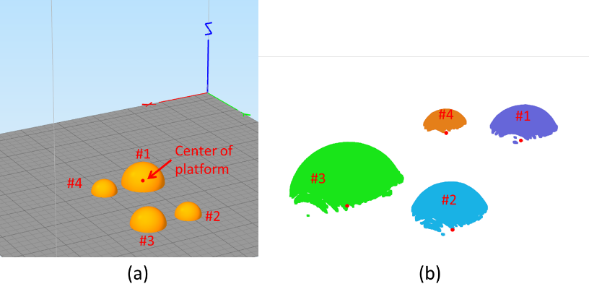

**FIGURE 5.** HEMISPHERE CALIBRATION TARGET

**2.4 Upper Surface Depth Image Generation**

After pre-processing the raw dataset, the point cloud dataset needs to be segmented. The 2D depth images are used as training data for the ML classification algorithm to identify the upper surface in-plane anomalies. The 2D depth image shows better computational efficiency than the 3D point cloud in the classification process. The rasterization method is used to project the 3D point cloud onto a 2D image, as shown in Fig. 6. The upper surface’s inliers can be segmented using the RANSAC algorithm, and the upper surface virtual plane is obtained, shown in Fig. 6(a). Then the inliers are projected on the virtual plane. Every projected point finds the nearest grid node using the K-dimensional tree (Kd-Tree) method and calculates the distance between them, shown as Fig. 6(c). The grid node has projected points around. The depth of the grid node is calculated by the depth between point cloud to virtual plane, shown in Fig. 6(b). The depth is weighted by the distance . The accumulated depth of the grid node is calculated by,

where .

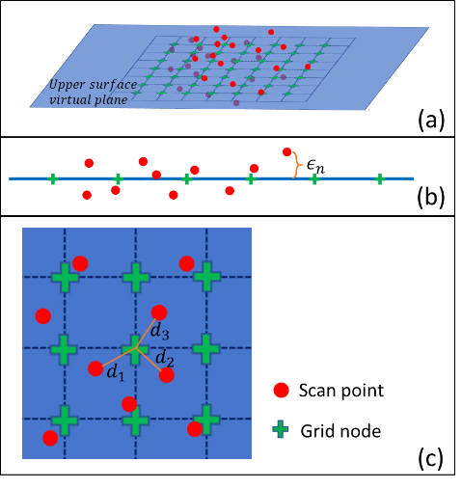

**FIGURE 6.** POINT CLOUD RASTERIZATION METHOD (A) 3D VIEW (B) SIDE VIEW (C) TOP VIEW

Subsequently, the colors of the depth image are mapped based on the grid depth . To represent the bulge anomaly caused by over extrusion, and dent anomaly, and gaps caused by under extrusion, the RGB color space is selected to show both depth information and empty area. One point that needs to be emphasized is the color mapping standard must be constant to ensure an accurate classification result. The ratio of depth to designed layer thickness (which is 0.3mm in this paper) is mapped to the color space. To further improve the computation speed, the only six levels of color are selected and shown in Fig. 7.

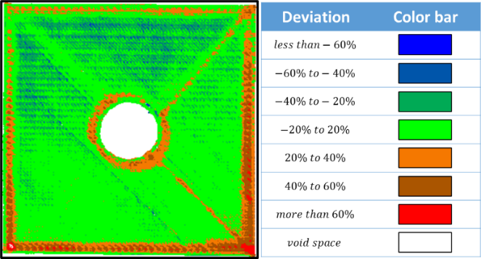

**FIGURE 7**. RGB DEPTH IMAGE MAPPING RULE

**2.5 Classification algorithms**

In this research, four different classification algorithms are trained and compared for accuracies in surface anomaly identification. The Support Vector Machine (SVM), K-Nearest Neighbors (KNN), CNN, and hybrid Convolutional Auto Encoder (HCAE). The open-source TensorFlow 2.1.0 [11] and Scikit-learn 0.22.1 [12] libraries are used to implement these algorithms. The hyperparameter tuning for SVM and KNN is conducted by grid search, an exhaustive method to compare all the possible combinations of hyperparameters. It takes longer computational time than the alternative random search method but ensures the optimal hyperparameters can be identified [13]. During the grid search, each classifier candidate is trained, and the performance is evaluated by k-fold cross-validation to avoid overfitting. The F-score metric with range 0-1 is used to quantify the accuracy of each classification algorithm. The F-score is a way to combine the precision and recall of a model, and it is defined as the harmonic mean of the model’s precision and recall. The precision measures the proportion of true positives among test outcome positives and recall measures the fraction of samples classified as positive among the total number of positive samples. The F-score is calculated by,

The most accurate classification model can be selected to perform the surface anomaly identification as the third subprocess of the point cloud process, as illustrated in Fig. 2.

1. **RESULTS AND DISCUSSION**

The experimental verification of the proposed in-site laser-based process monitoring and anomaly identification system has been conducted. To train the classifier models, for in-plane surface anomaly classification, the 73 test artifacts in different sizes, shapes, and process parameters are fabricated by the FFF machine to manipulate possible in-plane surface anomalies. Based on operation experience, the feed rate and extruder temperature are modified from 50% to 150% and 180°C to 250°C, respectively. The layer thickness is set as 0.3mm, and infill density is set as 100%. All other process parameters are kept constant. During the fabrication process, the in-situ monitoring system captures each layer’s in-plane surface and converts the layer and convert the point cloud into a depth image of size . Judging on the rendering of depth image, the in-plane surface identification results are classified into four classes, namely empty region, normal region, bulge region, and dent region, as illustrated in Fig. 8.

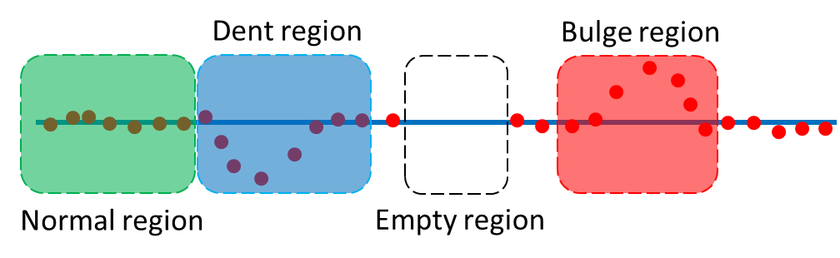

**FIGURE 8**. FOUR CLASSES OF IN-PLANE SURFACE IDENTIFICATION RESULTS

In order to identify the anomalies in a surface, the depth image is segmented into 100 sections with , as shown in Fig. 9. The images are labeled by a designed Graphical User Interface (GUI). Half of images are labeled manually, and the rest are auto labeled by the AE which are checked by human and reclassified if necessary.

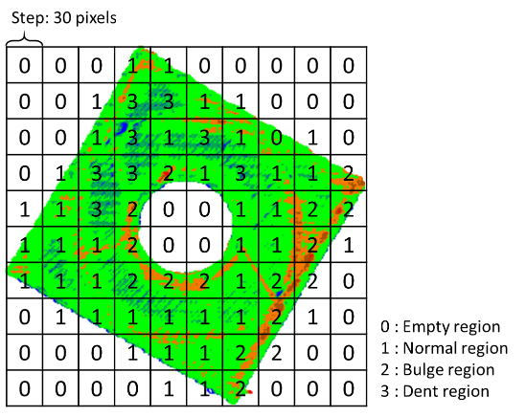

**FIGURE 9.** EXAMPLE OF DEPTH IMAGE LABELING

1. **CONCLUSION**

Place 3-4 line conclusion here.

**ACKNOWLEDGEMENTS**

Place any acknowledgements here.  
  
**REFERENCES**

[1] Nearing, Anne G. *ASME Style Guide*, 2018

[2] No more than 15 references.

[1] Frazier, W. E., “Metal Additive Manufacturing: A Review,” J Mater Eng Perform, 23(6), (2014), pp. 1917-1928.

[2] Liu, J., Hu, Y. M., Wu, B., and Wang, Y., “An improved fault diagnosis approach for FDM process with acoustic emission,” J Manuf Process, 35, (2018), pp. 570-579.

[3] Tapia, G., and Elwany, A., “A Review on Process Monitoring and Control in Metal-Based Additive Manufacturing,” J Manuf Sci E-T Asme, 136(6), (2014).

[4] Wu, Y., He, K. T., Zhou, X. M., and Ding, W. Y., “Machine Vision based Statistical Process Control in Fused Deposition Modeling,” C Ind Elect Appl, (2017), pp. 936-941.

[5] Li, Z. W., Liu, X. J., Wen, S. F., He, P. Y., Zhong, K., Wei, Q. S., Shi, Y. S., and Liu, S., “In Situ 3D Monitoring of Geometric Signatures in the Powder-Bed-Fusion Additive Manufacturing Process via Vision Sensing Methods,” Sensors-Basel, 18(4), (2018).

[6] Rodríguez-Araújo, J., and Rodríguez-Andina, J. J., “ROS-based 3D on-line monitoring of LMD robotized cells,” Proc. 2015 IEEE 13th International Conference on Industrial Informatics (INDIN), IEEE, pp. 308-313,

[7] Scime, L., and Beuth, J., “A multi-scale convolutional neural network for autonomous anomaly detection and classification in a laser powder bed fusion additive manufacturing process,” Addit Manuf, 24, (2018), pp. 273-286.

[8] Senin, N., Blunt, L., and Tolley, M., “The use of areal surface topography analysis for the inspection of micro-fabricated thin foil laser targets for ion acceleration,” Meas Sci Technol, 23(10), (2012).

[9] Rusu, R. B., and Cousins, S., “3D is here: Point Cloud Library (PCL),” Ieee Int Conf Robot, (2011).

[10] Ruan, M., and Huber, D., “Calibration of 3D sensors using a spherical target,” Proc. 2014 2nd International Conference on 3D Vision, IEEE, pp. 187-193, 2014.

[11] Abadi, M., Barham, P., Chen, J., Chen, Z., Davis, A., Dean, J., Devin, M., Ghemawat, S., Irving, G., and Isard, M., “Tensorflow: A system for large-scale machine learning,” Proc. 12th {USENIX} symposium on operating systems design and implementation ({OSDI} 16), pp. 265-283,

[12] Pedregosa, F., Varoquaux, G., Gramfort, A., Michel, V., Thirion, B., Grisel, O., Blondel, M., Prettenhofer, P., Weiss, R., and Dubourg, V., “Scikit-learn: Machine learning in Python,” the Journal of machine Learning research, 12, (2011), pp. 2825-2830.

[13] Bergstra, J., and Bengio, Y., “Random search for hyper-parameter optimization,” Journal of machine learning research, 13(2), (2012).