Report

Code Implementation

We implemented our project in python programming language. We start our implementation by generating first possible trips. As you know we have four routes (A, B, C, D) and 9 working hours FROM 9 AM to 9 PM for each route. Based on this information we generate possible trips. We put all trips into a list as a tuple data structure in python.
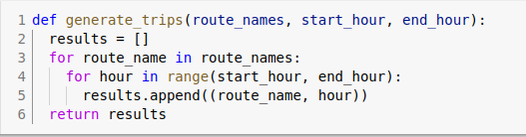

Trips

Then according to those generated trips we created duties. In our implementation same trip can’t be repeated twice and more inside same duty. We considered such cases in our implementation. We randomly chose trips for each duty. After that we chose actual time (hours) for those trips. At the end for each trip. we randomly chose the routes. You can see real implementation result in below figure.
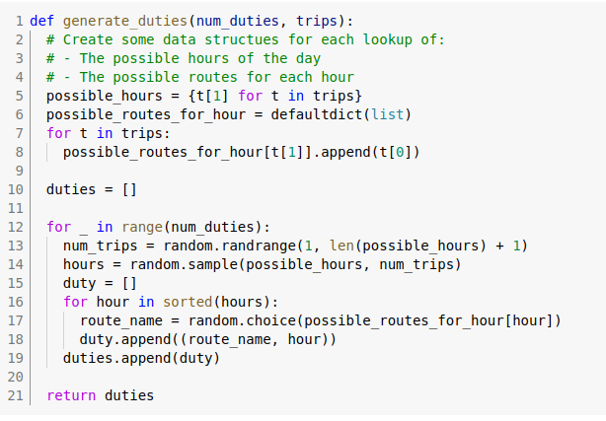

Duties:
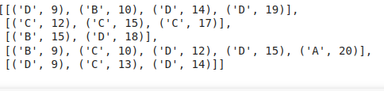
Next part in our implementation is to calculate cost for each duty. We have some predetermined rules for calculating duties cost. Such as following:

1. Bus drivers get payment only for working hours, not other things like break and etc.
2. If driver come to work even he worked less than eight our then he get payment for eight working our. It doesn’t matter if it worked 1 our or eight he will get minimum payment as 8 working hours.
3. If driver worked more than height hours then for every additional hour he will get 50% bonus payment.
4. Bus driver must have a break after each four working hours.
Implementation part is in the below figure. You can analyze it.

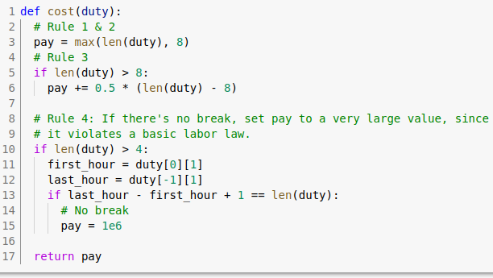

I would say that more interesting part starts from here. Next and last part of our implementation actually using pulp module from python solve the bus scheduling problem. In our case we used integer programming. You can see detail implementation from below figure.

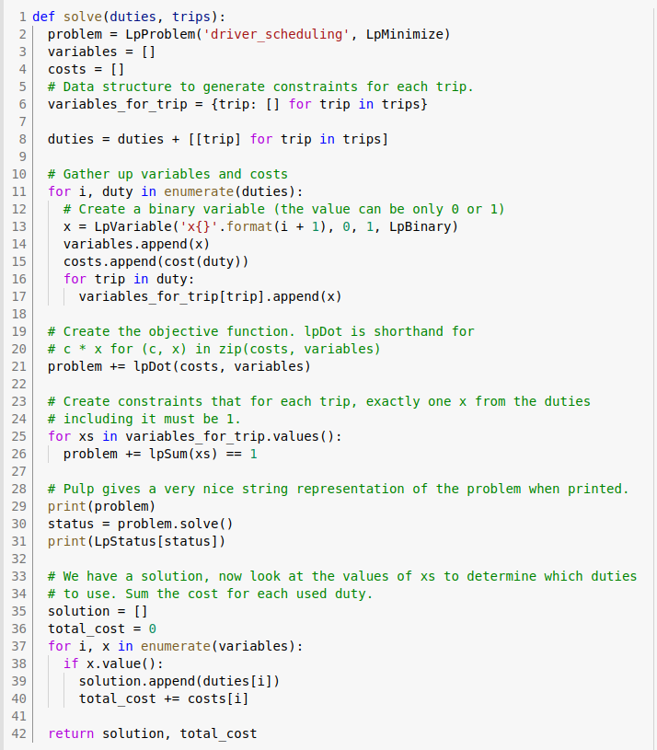
In our case re run it for 1000 duties and returned us good result. Yes it is true that runtime of the program took a little bit long time. This is because of number of duties that we generated. We have the total cost 71.5 which is excellent result.

