Simplified Bus Scheduling

Introduction- In this project work we coordinate bus drivers lunch breaks. We worked with Python programming language in Colab. Let’s explain our problem statement. We have four bus routes. Lets assume that all routes take 1 hour to complete and all routes start and end at the same point. In all these 4 routes have buses from 9 am to 9 pm. It can be seen that, there are 12 full trips for every route. We assume that all of the following conditions are true.

1. Every bus driver have a break in the end of 4 hours
2.All drivers get minimum pay of eight hоurs if they come to work
3. If they work more than 8 hours for a day, they receive 50% more per hour

We solve this problem as integer programming problem and let’s first give some information about linear programming and then integer programming. Linear programming is an optimization technique for a system of constraints and a linear objective function. The goal of Linear programming is to minimize or maximize some objective function[1].
It is determined by the following formula

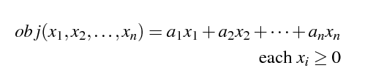

In linear programming we can also have one or more constraints and they are simply other linear expression. Constraints equal or less to zero in below example.
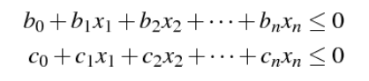

We can say that Integer programming is absolutely same with linear programming and it need extra constraints for example, all x are integer.

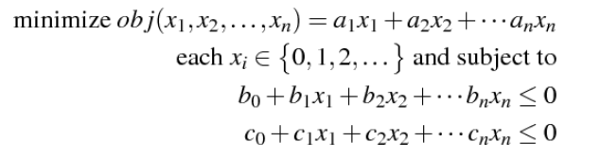

PULP is integer programming solver in Python programming language and we have to install it at the first step. Defining problem in Pulp, we use LpProblem function. It needs two parameters which the first parameter is argument and second one define problem such as minimize or maximize objective function [2].

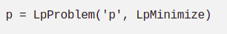

Initially we have to define a new set partitioning problem which it find the smallest sets number. These sets contain all the possible points and these points should not overlap. For this reason we have to minimize the total of set of value. In our case, the points are duties and points in the partitioning diagram are busses' trips. We want to minimize the total of each drivers' costs with the partitioning problem according to the above conditions. As mention above, in integer programming have some additional conditions and we defined that x are integer. Therefore x can get one of the two value such as zero or one. If the solver decides that using the duty is part of the optimal solution and otherwise x equal to zero.
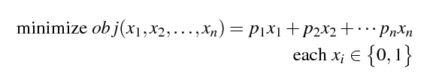

In this equation, n is duties, p is driver pay of the duty. We want Pulp to choose value of x is 1 sometimes and sometimes 0. We want to minimize our objective function which it will be some of total payments. To minimize objective function Pulp will set all x to zero.

Code Implementation

We implemented our project in python programming language. We start our implementation by generating first possible trips. As you know we have four routes (A, B, C, D) and 9 working hours FROM 9 AM to 9 PM for each route. Based on this information we generate possible trips. We put all trips into a list as a tuple data structure in python.

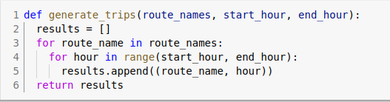

Trips
Then according to those generated trips we created duties. In our implementation same trip can’t be repeated twice and more inside same duty. We considered such cases in our implementation. We randomly chose trips for each duty. After that we chose actual time (hours) for those trips. At the end for each trip. we randomly chose the routes. You can see real implementation result in below figure.

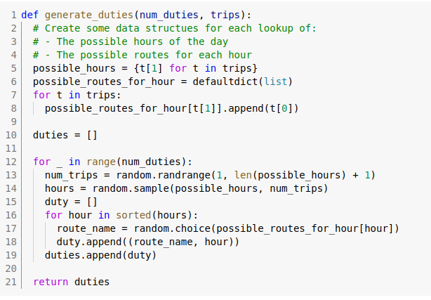

Duties:
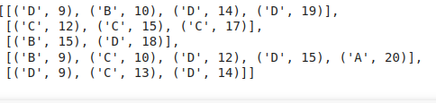

Next part in our implementation is to calculate cost for each duty. We have some predetermined rules for calculating duties cost. Such as following:

1. Bus drivers get payment only for working hours, not other things like break and etc.
2. If driver come to work even he worked less than eight our then he get payment for eight working our. It doesn’t matter if it worked 1 our or eight he will get minimum payment as 8 working hours.
3. If driver worked more than height hours then for every additional hour he will get 50% bonus payment.
4. Bus driver must have a break after each four working hours.
Implementation part is in the below figure. You can analyze it.

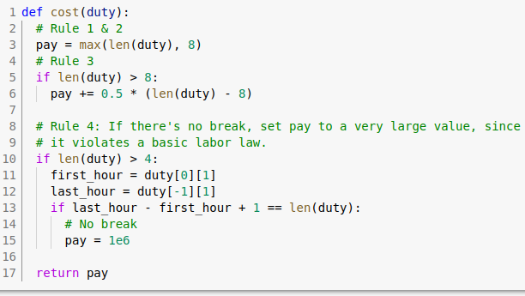
I would say that more interesting part starts from here. Next and last part of our implementation actually using pulp module from python solve the bus scheduling problem. In our case we used integer programming. You can see detail implementation from below figure.

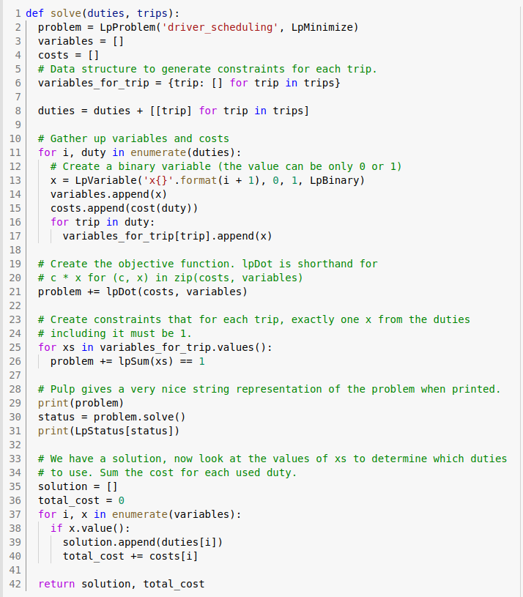

In our case re run it for 1000 duties and returned us good result. Yes it is true that runtime of the program took a little bit long time. This is because of number of duties that we generated. We have the total cost 67 which is excellent result.

Conclusion
At last we solved bus scheduling problem using integer programming. It worked very nice in our problem. We found solution which cost 67 which is very less. Integer programming is also useful for other kind of real life problems.

References
[1] https://brilliant.org/wiki/linear-programming/
[2] https://www.coin-or.org/PuLP/CaseStudies/index.html

