

Done By: Kishan Lutchman (812003797) & Javier Rojas (812003809)

Course: COMP 3275

Project: Student ID Roll Image Capture

Title: Developer Documentation

GitHub Link: https://github.com/Javier-Rojas/Android-project

**Explanation of Code**

Class Name: ScanAndSubmit.java

Description: Initiating a Scan

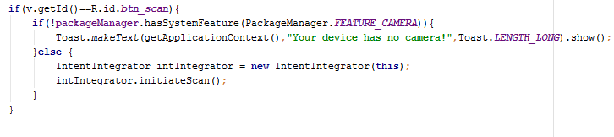

In the above code we are check to see if the user’s mobile phone has a camera equipped so that they can scan the barcode. If the check returns false then the user is presented with a toast that tells them that their phone does not have a camera. If it does have a camera then an “IntentIntegrator” object is created and via this a scan is initiated.

Class Name: ScanAndSubmit.java

Description: Upon receiving a result from the Scan

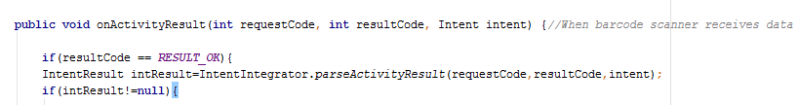

When the scan is finished, we must first check to see if the user interrupted the scanner during the scanning process (resultCode == RESULT_OK) if this is not the case, the user is presented with a toast stating that the process was interrupted by the user. If the scanning process completed successfully we must then check if anything was returned before we can begin processing it. That is why we check to see if the result is not equal to null (intResult! =null). If this statement returns true then we can begin analyzing the result and begin to process and upload the students ID to the database. If the statement is false, then the user is presented with a toast informing them that no data was received.

Class Name: ChangeUserPass.java

Description: Changes the default username and password

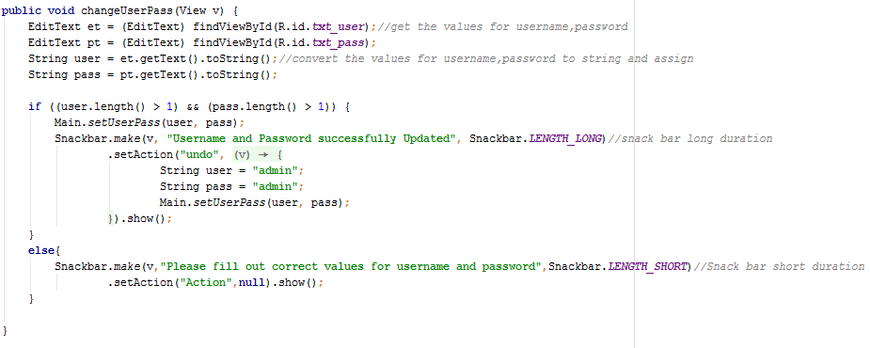

The above code takes the text from the two edit texts (Username & Password) and stores them in two separate Strings. The code then ensures that they are not smaller than 2 characters long. It then calls a static method created within the Main.java class called”setUserPass “and then passes the two Strings to this method which then overwrites the username and password for the administrator within the app.

Class name: Student Provider

Description: creation of studentProvider class with setter and getter methods

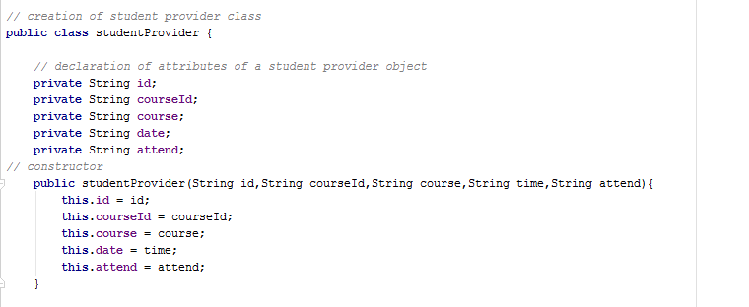

The code above creates a student provider class to store the data retrieved from the database ( id,CourseId,course,time,attend) and stores them as a studentProvider data structure.

Class:DeleteStudentRec

Description: deletes the record of a student for a particular course

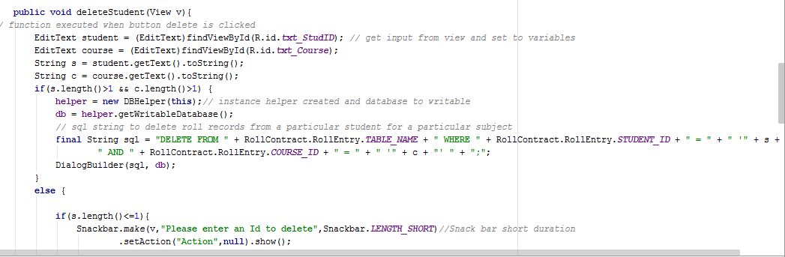

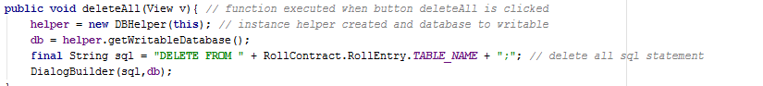

The code above gets the student name and course from an EditText txt_StudID and txt_Course and converts it to a string. If it is valid then it is concatenated to an sql delete statement then executed using the DialogBuilder function containing the db.exec() function. The function below deletes all records using the same DialogBuilder function.

Class Name: Main

Description: create alert box for user admin logging.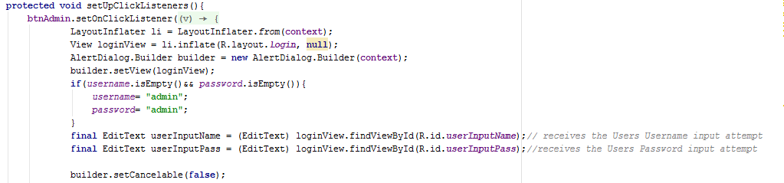

The above code uses a layout inflator login layout to enter username and password

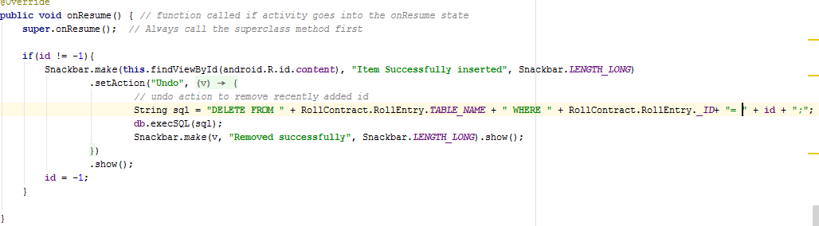

The above code allows the user to undo their submission of attendance in the event that they made the wrong course selection.

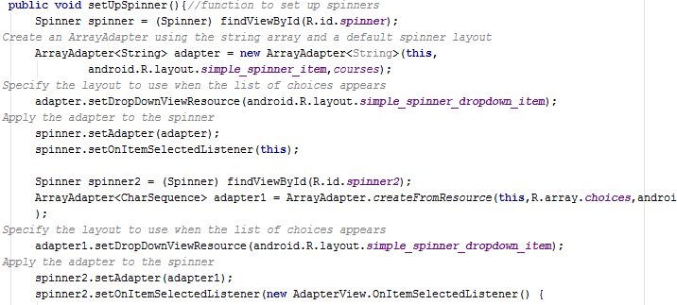

The above code sets up a spinner that will create a drop down menu that displays the various courses that a user can select from.

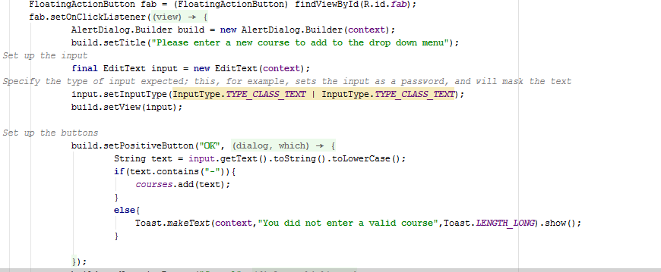

The code displayed above allows the user to enter their own course that will be added to the dropdown menu.