Javier Arguijo

Cmst 386

Instructor Leslie Allen

Project 2 Principles of Web Design and Technology II

1. Client-topic
   1. A website for reviewing coffee related topics. The website will be similar to beer advocate or ratemybeer. The website will be home-base and will expand latter on.
2. Development process
   1. The website will be home-base but will require users to collect data. Before reviewing coffee, information about coffee connoisseur world is critical. Familiarizing the different tasting notes of coffee is important for describing coffee. Discovering different brew methods of coffee is also important. The important thing in end is to try everything that is related to coffee such as: machine, shops, cups, grinders, history, laws, roast and much more.
3. Testing
   1. In order to test the website, there are several things that are required for such as making sure all inputs are correct. Making a review means users are having an easy time locating what they are searching for. Making sure there are no repeat entries in the website. The review will be judged out of 100 so the mathematics of website must be correct.
4. Description
   1. The goal of the website is to make a database of review for users to look over.
   2. The purpose of the website is to create a platform for coffee connoisseurs and casual coffee drinkers to embrace. The most probable users will be connoisseurs and coffee companies. Coffee companies will likely use the cite to promote their products.
   3. The clients will likely be the younger adults, because they are most probable to go out and experience new things.
   4. The website will have a lot of infographics, such as pie charts and bar graphs, for the clients to look over.
   5. Research from numerous websites is required to input in the website such as: hyperlinks, descriptions, prices, origins and locations.
   6. The website will be uploaded frequently because the more data is always better.
5. Growth
   1. The website will grow overtime depending mostly on the client’s input. The growth of website will grow eventually to crossover to the app department.
   2. The website can grow very slowly or exponentially so being adaptable to client is crucial.
   3. Maintenance of the website is essential to monitor the users input, so having more IT support will be needed. Task such as censorship and web issues should be monitored.
   4. The inputs are continuous so daily at the very least is important to monitor.
6. Organization
   1. The website will be organized based hierarchy. Several pages however will link to each other for reference.
   2. The website links will cover.
      1. Coffee beans
      2. products
      3. Roasters
      4. Shops
   3. The other web links will be:
      1. About
      2. Brew methods
      3. Contacts
      4. Subscriptions
      5. Blog
      6. Articles
   4. There will be other links as well such as a blog and weekly articles.
   5. There will be also links to subscriptions services such as Trade coffee.
   6. The roaster and coffee beans will be interconnected because of content.
   7. The navigation section of each webpage will be the same.
   8. The review pages will have infographics for the users to see accurately.

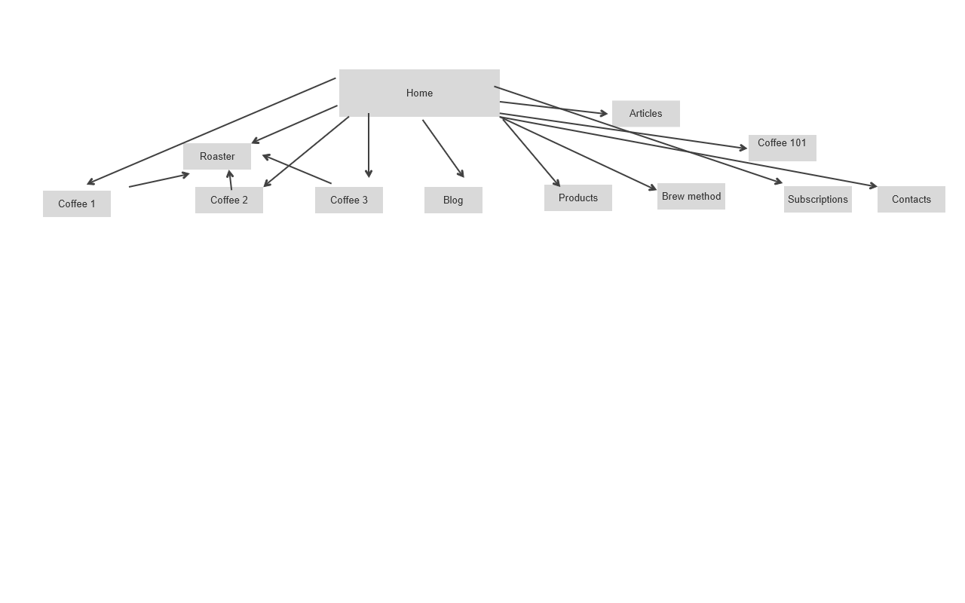

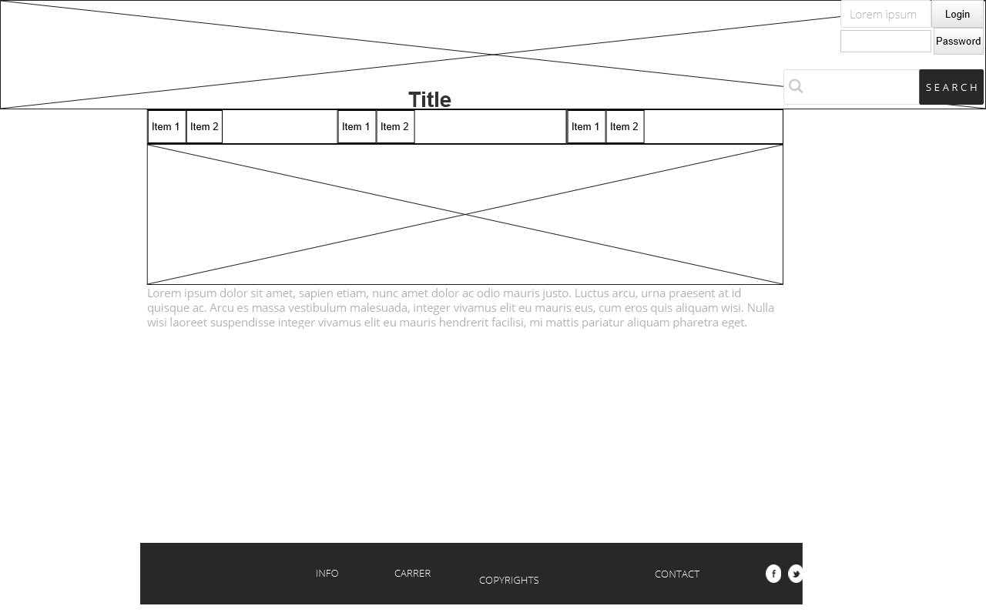

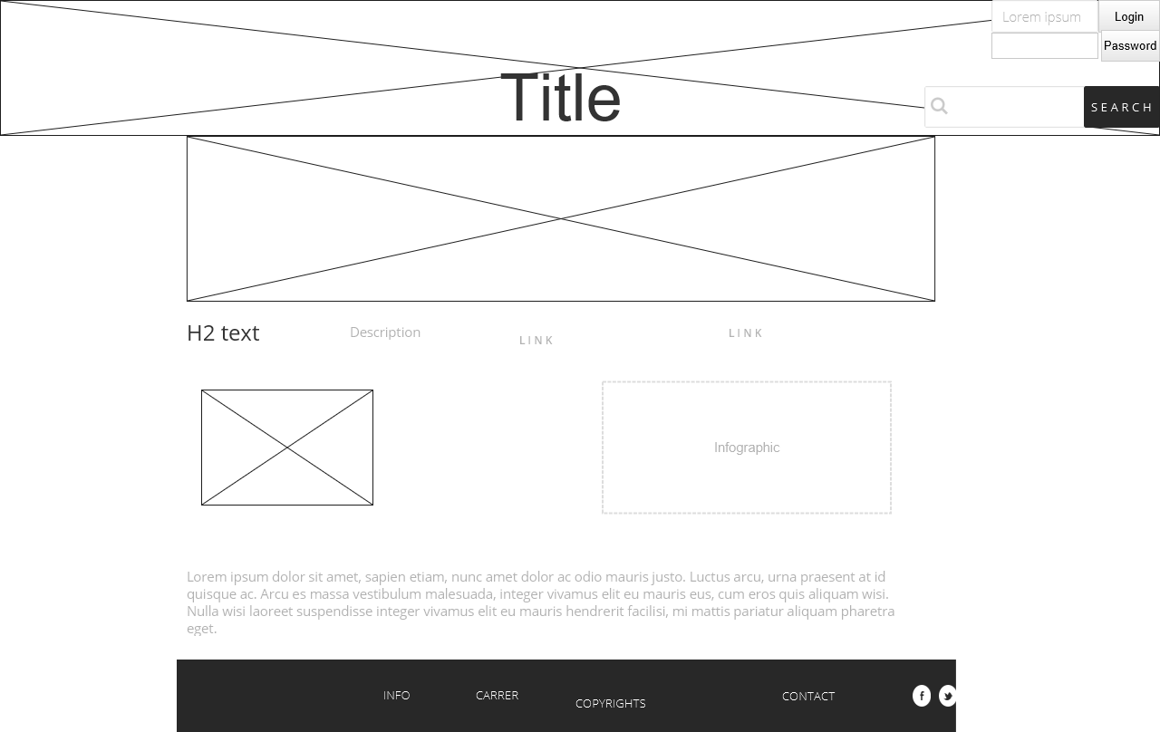

1. Security
   1. The website will not have an e-commerce component because reviews should just be free; the website will have affiliate link program.
   2. The website will have logins and passwords but they are not required. Only the login in users can comment or input feedback.
   3. The website will have a secure HTTPS certificate, and an SSL server certificate. The passwords will be encrypted and will not have an auto-login. The user inputs will be reviewed constantly because data is uploaded continuously.
2. Web hosting
   1. A shared hosting service at first will do but will then transition into a vps server. SSL certificate will be a must for web hosting service.
   2. The hosting service will likely have to be compatible with WordPress. WordPress will be important feature for blogging and articles in the website.
   3. The infographics in the website will likely use JavaScript and CSS. The stats in website will likely be handled by JavaScript.
   4. Since there will be a large collection of data in the website, the website will have to use database languages such as SQL. The website will have forms so php is also required.
   5. There three web domains that seem possible at the time and the are:
      1. jitterreviews.com
      2. jittercoffeereviews.com
      3. coffeertings.com
3. Marketing
   1. The website meta data will be very crucial for the affiliate commissions. Negotiating affiliate commissions will be the main way to produce income.
   2. Marketing different coffee products requires a very deliberate focus on key words and descriptions. SEO tactics will be crucial for the website to prosper. Social websites such as Facebook and Instagram will be important to catch a viewer’s attention.

**Reflection**

The project had me think on what is really important for a website. Focusing on project is hard when there is no direction. Asking a lot question and having them answered will likely lead to more questions. The overwhelming feeling of have a big project is sometimes stressful.

The wireframe and flowchart were helpful in finding the right direction for the website. I observed several review websites such as: rtings, beer advocate, rate my beer and coffee review. The flowchart was very simple and help me find out how the navigation menu will work for the website. I used justinmind software to make the wireframe and the flowchart. I was surprise to find out justinmind is so simple to use and free. I observed several websites to find out how the wireframe should look. The wire frame was very simple because it is easier to navigate. The wireframe for the simple the homepage mostly consists of one picture because appeal precedes content. The review pages were the hardest page to design. I had a whiteboard in my room that I used to draw examples. I took a long time to finally decide how the review page will be designed. I do not like how most review pages online look because it usually goes into two different ways. The first way a review page is done is a long detained boring and complex content that most people will ignore. The second style of a review page is when a page is too simple to point it adds no value in a person’s decision. I will likely make even more changes but I believe the layout is mostly done.

References

Oktoberfest (2021): Sierra Nevada Brewing Co.. BeerAdvocate. (n.d.). Retrieved October 4, 2021, from https://www.beeradvocate.com/beer/profile/140/560917/.

Reviews and ratings. RTINGS.com. (n.d.). Retrieved October 4, 2021, from https://www.rtings.com/.

Shop Gourmet Coffee: Klatch Coffee Roasting: Best espresso. Klatch Coffee Roasting. (n.d.). Retrieved October 4, 2021, from <https://www.klatchroasting.com/>.

The world's leading Coffee Guide. Coffee Review. (2021, September 9). Retrieved October 4, 2021, from <https://www.coffeereview.com/>.

Wertz, J. (2019, May 29). The business and monetization of product review sites. Forbes. Retrieved October 4, 2021, from https://www.forbes.com/sites/jiawertz/2019/05/28/the-business-and-monetization-of-product-review-sites/?sh=3cc4eed45d4b.