**MODELOS Y BASES DE DATOS**

**SQL Básico**

**2019-2**

**Laboratorio 02**

**Autores: Ricardo Amaya Rivera & Javier Esteban López Peña MBDA – 1**

**PARTE UNO. Refactorización**

**A. Modelo conceptual**

**1) Revisen su modelo conceptual y perfecciónenlo. ¿Cuáles fueron los cambios realizados?**

Se realizaron los cambios pertinentes que el monitor sugirió, se agregaron los conceptos que hacian falta y la multiplicidad en las relaciones

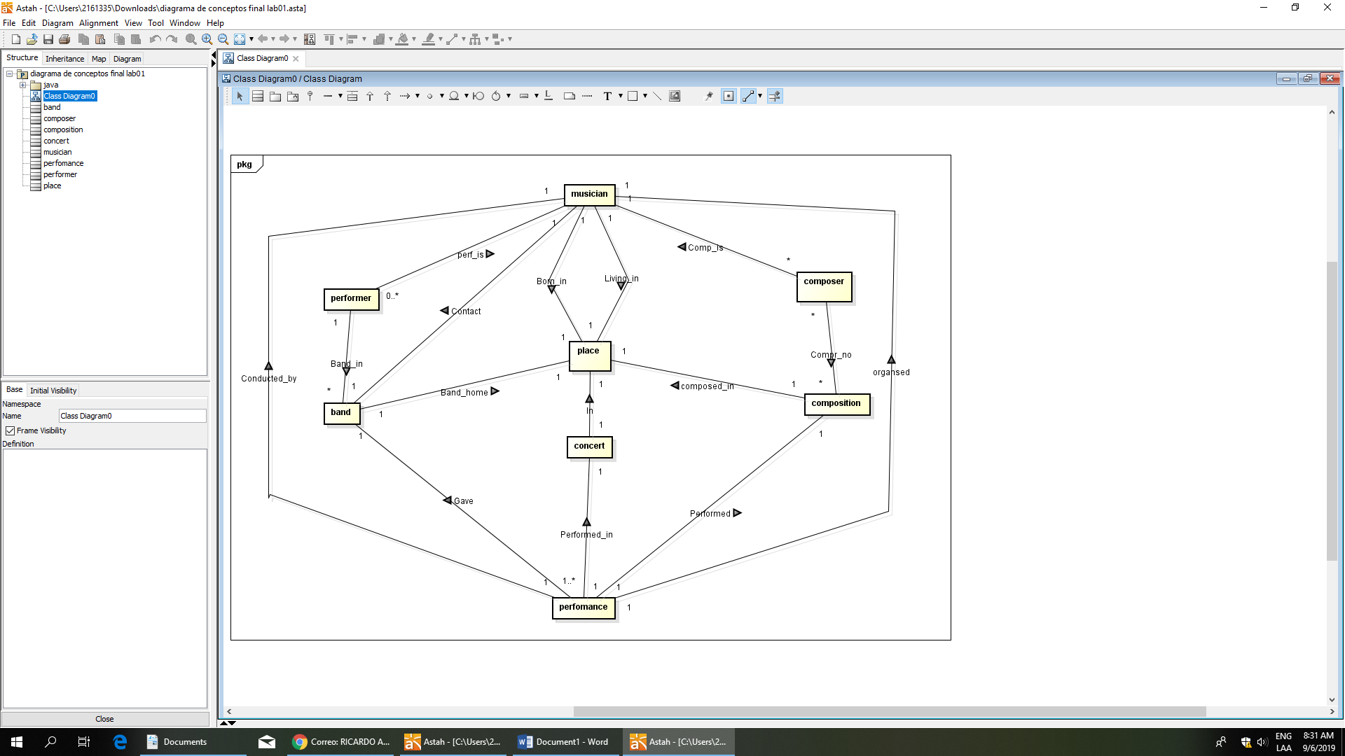

**2) Señalen los grandes conceptos con colores diferentes (CRUD : Conceptos + Relaciones)**

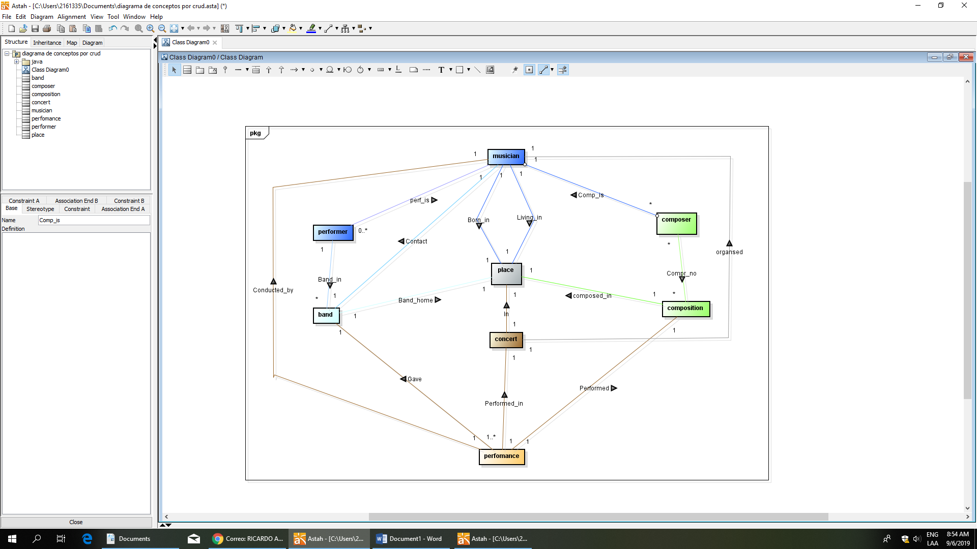

**B. Modelo lógico**

**1) Revisen su modelo lógico y perfecciónenlo. ¿Cuáles fueron los cambios realizados?**

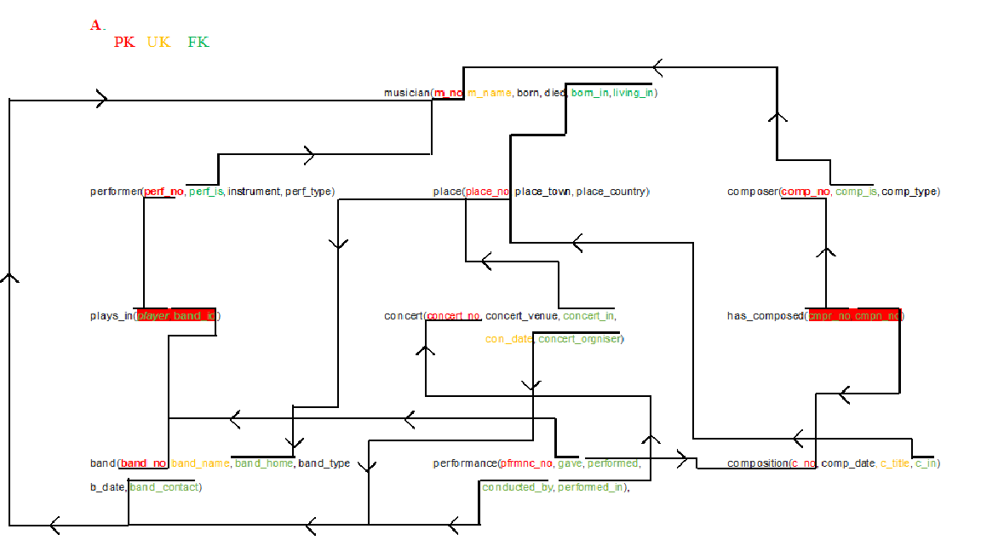

No se realizaron cambios en el modelo logico

**2) Señalen los grandes conceptos con colores diferentes (CRUD : Tablas)**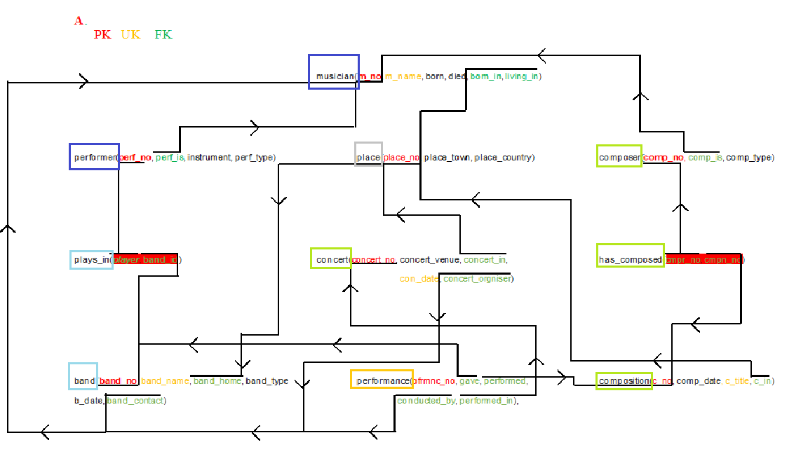

**PARTE TRES.**

**C. Modelo conceptual. Consultas. (¿qué ofrece?)**

**• El número de bandas de cada uno de los países. [país, bandas] (Ordenado alfabéticamente)**

SELECT place_country , (count(band_name)) AS bands FROM band

RIGHT JOIN place ON (place_no=band_home)

GROUP BY place_country

**• El número de músicos que toca cada uno de los instrumentos. [instrumento, número] (Ordenado de mayor a menor)**

SELECT instrument, (count(m_name)) AS musicos FROM musician

RIGHT JOIN performer ON (perf_is=m_no)

GROUP BY instrument

**• Países que más músicos tienen ordenados alfabéticamente. [país ,número] (Mayor que el promedio)**

SELECT place_country , (count(m_name)) AS musicos FROM musician

RIGHT JOIN place ON (place_no=m_no)

GROUP BY place_country

HAVING COUNT(m_name) > 9/5

**• Posibles dúos que tocan diferentes instrumentos [Los dos nombres y los dos instrumentos] (Ordenamos alfabéticamente)**

SELECT A.m_name, B.m_name, A.instrument, B.instrument FROM

(SELECT * FROM performer JOIN musician ON (perf_is=m_no)) AS A,

(SELECT * FROM performer JOIN musician ON (perf_is=m_no)) AS B

JOIN plays_in ON perf_no=player

JOIN band ON band_no=band_id

WHERE A.m_name <> B.m_name

ORDER BY A.m_name, B.m_name

**• Los roles de los músicos. [Nombre y roles] (Compositor, interprete, director, organizador]**

SELECT DISTINCT m_name,(case when perf_is is not null and band_contact is not null and comp_is is not null and concert_orgniser is not null then 'All'

WHEN perf_is is null and band_contact is null and comp_is is null and concert_orgniser is null then 'None'

WHEN perf_is is not null and band_contact is null and comp_is is null and concert_orgniser is null then 'Performer'

WHEN perf_is is not null and band_contact is not null and comp_is is null and concert_orgniser is null then 'Performer, Director'

WHEN perf_is is not null and band_contact is null and comp_is is not null and concert_orgniser is null then 'Performer, Composer'

WHEN perf_is is not null and band_contact is null and comp_is is null and concert_orgniser is not null then 'Performer, Organizer'

WHEN perf_is is not null and band_contact is not null and comp_is is not null and concert_orgniser is null then 'Performer, Director, Composer '

WHEN perf_is is not null and band_contact is null and comp_is is not null and concert_orgniser is not null then 'Performer, Composer, Organizer'

WHEN perf_is is not null and band_contact is not null and comp_is is null and concert_orgniser is not null then 'Performer, Director, Organizer'

WHEN perf_is is null and band_contact is not null and comp_is is null and concert_orgniser is null then 'Director'

WHEN perf_is is null and band_contact is not null and comp_is is not null and concert_orgniser is null then 'Director, Composer '

WHEN perf_is is null and band_contact is not null and comp_is is null and concert_orgniser is not null then 'Director, Organizer'

WHEN perf_is is null and band_contact is not null and comp_is is not null and concert_orgniser is not null then 'Director, Composer, Organizer'

WHEN perf_is is null and band_contact is null and comp_is is not null and concert_orgniser is null then ' Composer'

WHEN perf_is is null and band_contact is null and comp_is is not null and concert_orgniser is not null then 'Composer, Organizer '

when perf_is is null and band_contact is null and comp_is is null and concert_orgniser is not null then 'Organizer' end ) as role from musician

left join performer on perf_is=m_no

left join composer on comp_is=m_no

left join band on band_contact=m_no

left join concert on concert_orgniser=m_no

**PARTE CUATRO. Ciclo dos**

**• Conciertos en que hayan participado músicos que ya murieron.[Concierto, músico] (NOTA: Concierto es lugar + fecha)**

SELECT m_name,concert_venue,con_date FROM concert,musician

WHERE died IS NOT NULL

**• Nombre de los compositores que interpretan sus canciones. [Canción, músico, instrumento]**

No se logro realizer

**•** **Los cinco canciones que más se han interpretado en los conciertos dados. [Canción, veces, fecha primera interpretación, fecha última interpretación]**

SELECT c_title,COUNT(concert_venue),MIN(con_date),MAX(con_date) FROM composition

JOIN performance ON performed = c_no

JOIN concert ON concert_no = performed_in

GROUP BY c_title

HAVING MIN(con_date) != MAX(con_date)

**• El compositor líder de los conciertos. (El compositor líder de un concierto es la que compuso el mayor**

**número de canciones del concierto ).**

SELECT m_name FROM musician

JOIN composer ON comp_is = m_no

JOIN has_composed ON cmpr_no = comp_no

JOIN composition ON c_no = cmpn_no

JOIN performance ON performed = c_no

JOIN concert ON concert_no = performed_in

GROUP BY m_name

**• Conciertos con canciones compuestas en el mismo país del evento. [Concierto, cancion, país]**

SELECT concert_venue,c_title,place_country FROM place

JOIN concert ON concert_in = place_no

JOIN performance ON concert_no = performed_in

JOIN composition ON c_no = performed

JOIN has_composed ON c_no = cmpn_no

JOIN composer ON cmpr_no = comp_no

JOIN musician ON comp_is = m_no

WHERE c_in = concert_in