Exploratory Data Analysis (EDA) Findings – American Express Default Prediction
Purpose and metric
This analysis prepares a customer-level dataset for modeling the American Express Default Prediction task. The competition is scored with the AMEX metric, which prioritizes correct rank-ordering of high-risk customers. Our EDA emphasizes distribution separation and validation choices that protect against leakage.
Raw data overview (monthly time series)
The raw training data contains monthly records per customer keyed by customer_ID with a statement date S_2. Features are anonymized and grouped into families (D_, S_, P_, B_, R_*). A small subset is categorical, notably B_30, B_38, D_63, D_64, D_66, D_68.
Customer-level aggregation
We created one row per customer. For numeric columns we computed mean, std, min, max, and last. For categorical columns we kept the last observed category and the number of unique categories (nunique). This yields interpretable snapshots of each customer’s recent state plus longer-term summaries.
Feature engineering we followed (v4_lgbm_features.ipynb)
we referenced the 1st-place public solution’s feature engineering and reproduced the core steps in our v4_lgbm_features.ipynb:
- denoising: floor numerical features ×100 to reduce floating noise.
- categorical mapping: convert D_63 and D_64 text codes to small integers.
- time-series features before aggregation: create within-customer diff(1) and rank(pct=True) features.
- aggregation windows: compute aggregates over the entire history plus the most recent windows (last3 and last6 statements). We produce mean, std, min, max, sum, and last for numeric, last and nunique for categoricals, and last for rank features.
outputs: train_fe.parquet and test_fe.parquet. on the full training set this results in about 7000+ columns; on our sampled customer-level subset used for the EDA tables above, it shows ~900 columns (the difference is expected).
Categorical signal by target
We examined how aggregated categorical features differ between defaulters and non-defaulters.
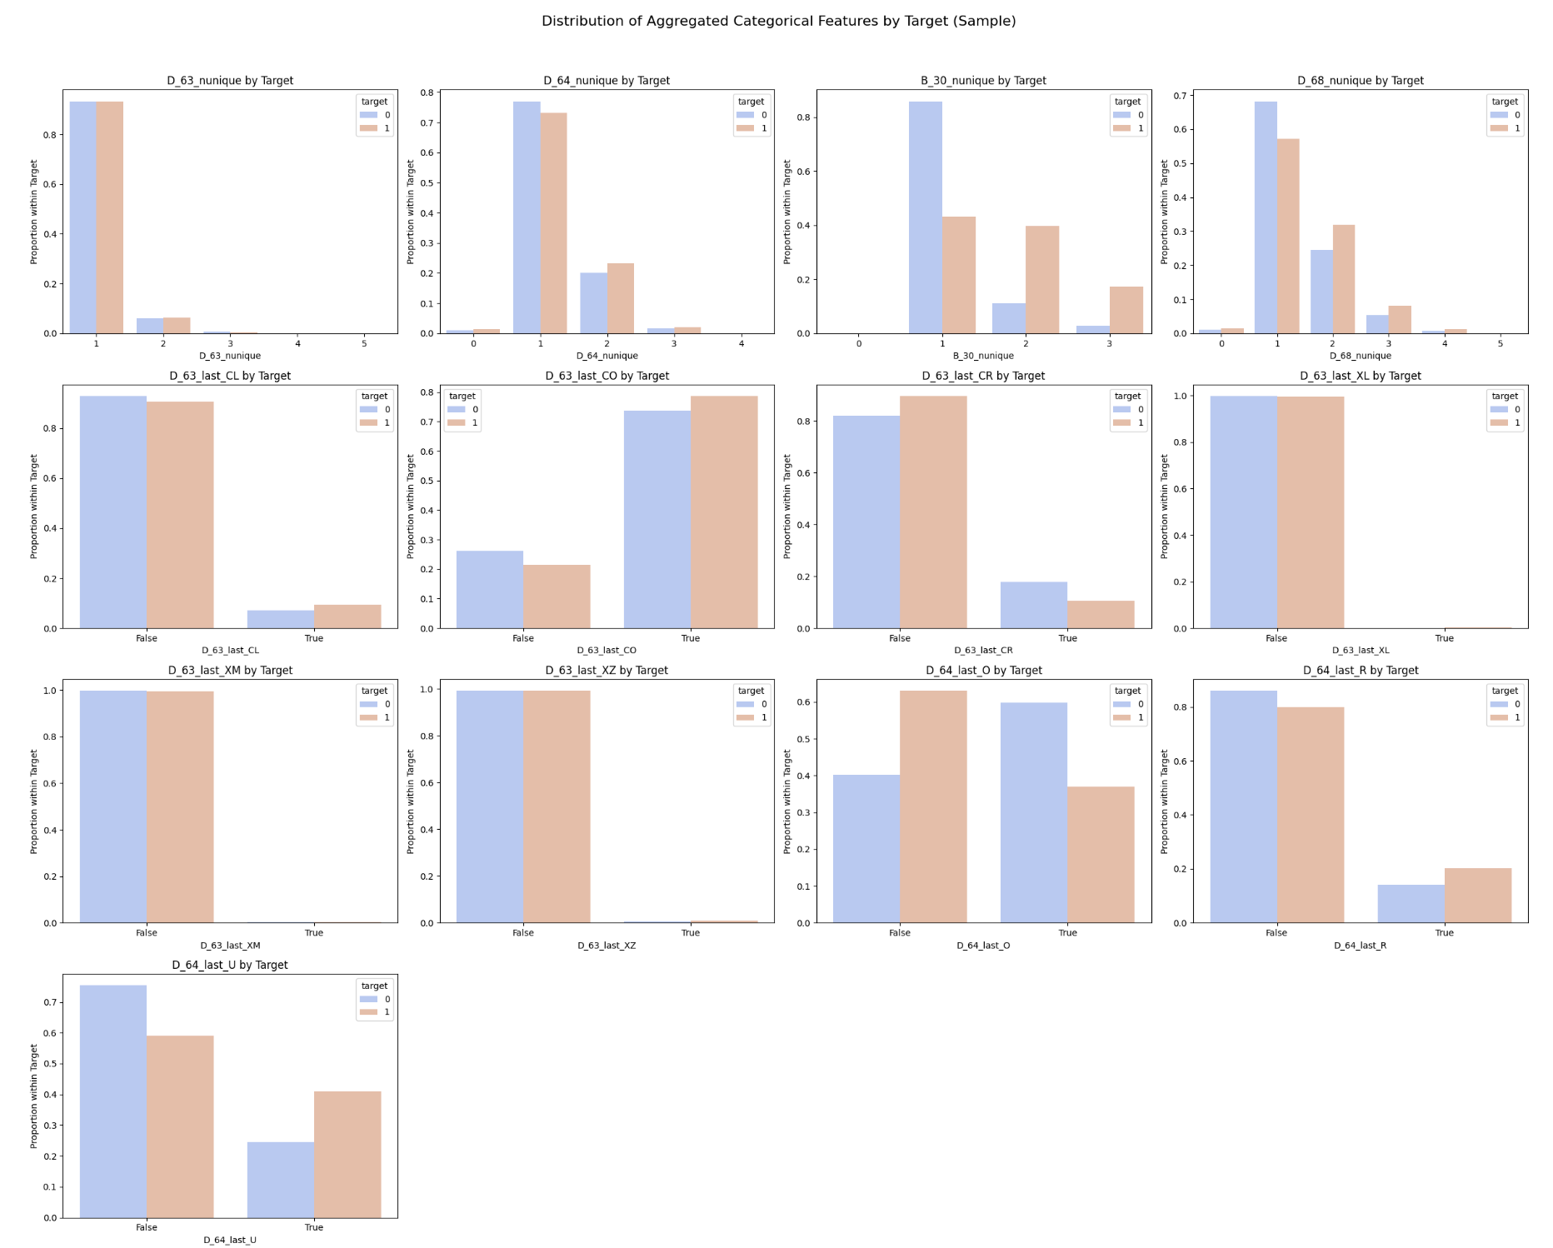
Aggregated categorical distributions (D_63_last_, D_64_last_, *_nunique) show measurable shifts by target.
Customer table and label alignment
After aggregation we produced a features table with 45,891 customers and ~900+ columns and verified a one-to-one match with the target table by customer_ID.
Missingness profile and imputation plan
Missingness is heavy in several families (e.g., D_87, D_88, D_110, D_111).
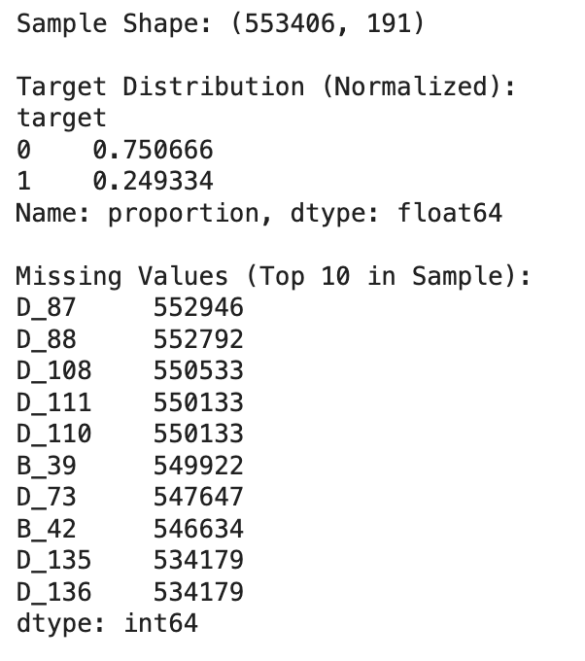
Sample-level view confirming minority positives and listing the most missing raw fields in the sample.
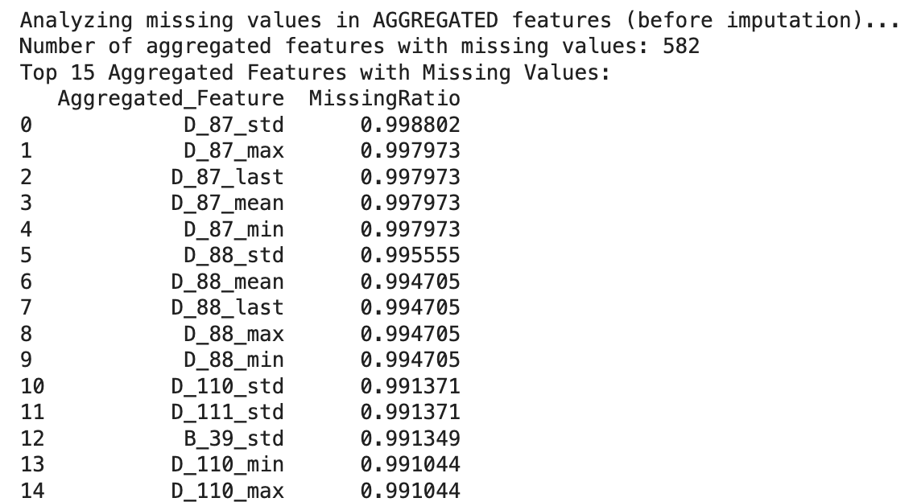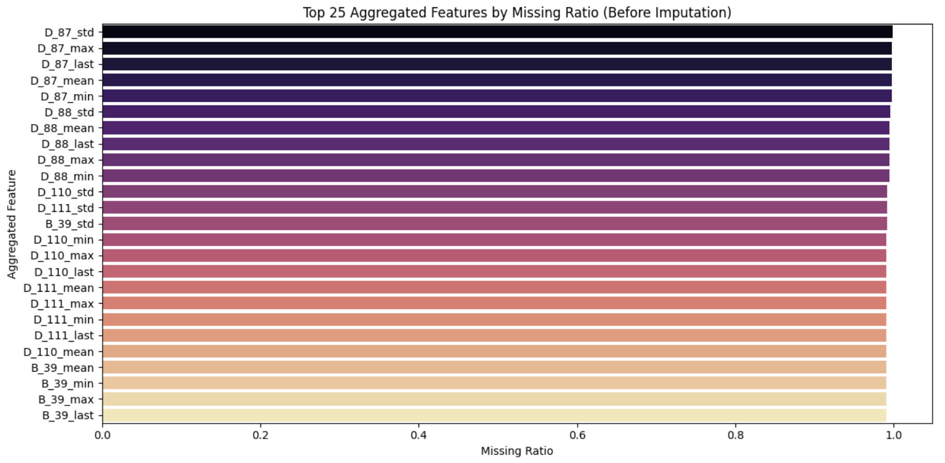
Top aggregated features ranked by missing ratio before imputation.
Plan: benchmark zero vs median imputation under group cross-validation; drop near-completely missing aggregates if they show no CV benefit.
Preprocessing we followed (v5_lgbm_preprocessing.ipynb)
We used a memory-safe preprocessing pass that loads the parquet schema first, then processes features in column-wise chunks of 500. steps per chunk: fillna, label-encode object columns (about 11), and downcast numerics (≈6900) to float16 where safe. chunk outputs are concatenated, customer_id and target are merged, and artifacts are saved for reuse.
Outputs: train_processed.parquet, test_processed.parquet, and preprocessors/column_lists.json (lists include all_features, categorical_cols_for_lgb, obj_cols_to_encode, numeric_cols_to_downcast).
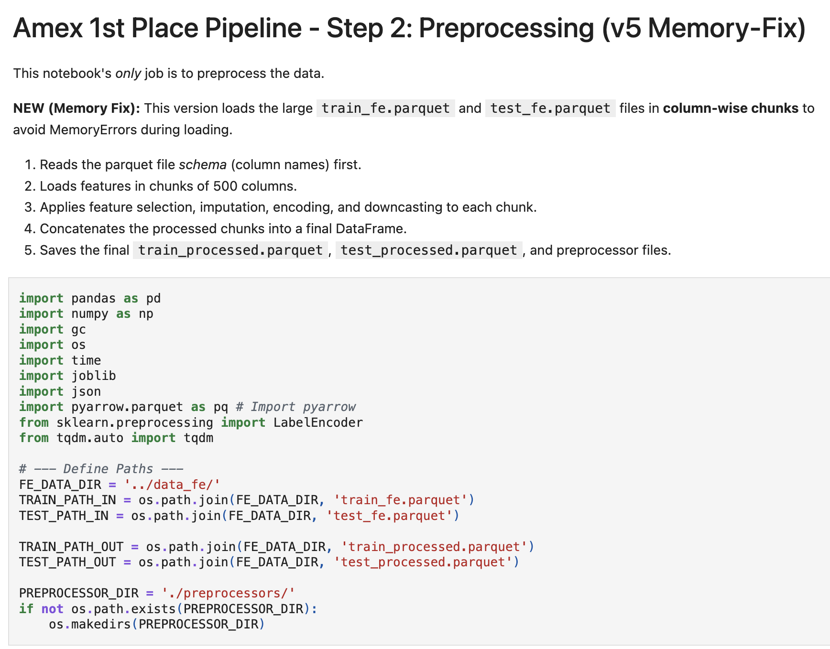
v5 overview: schema-first, 500-column chunks, fillna + label encoding + downcasting, and saved artifacts.
Numerical signal example
We inspected representative numeric features against the target.
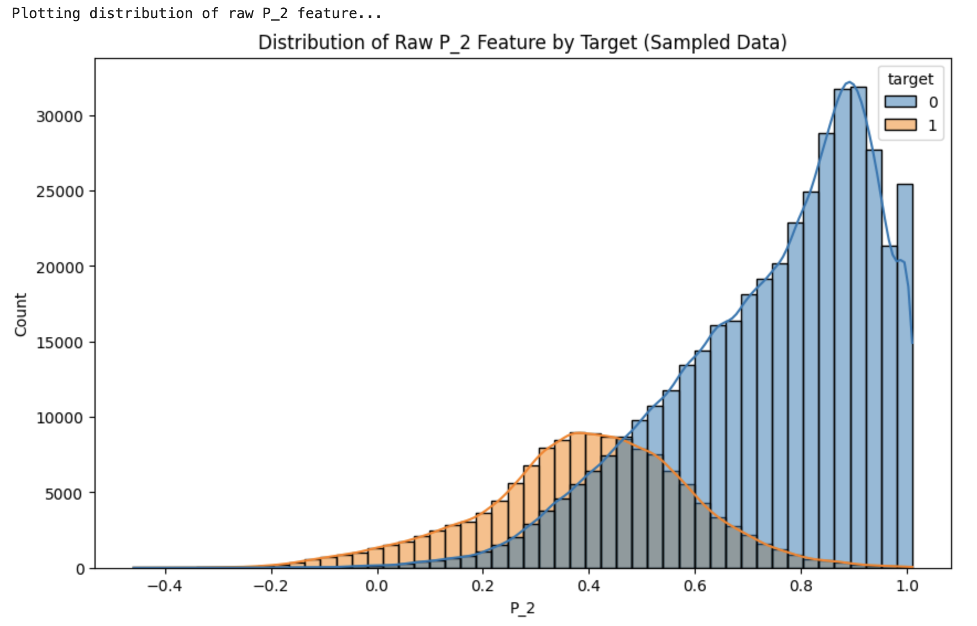
Raw P_2 distribution by target shows strong separation (defaulters concentrate at lower P_2; non-defaulters at higher values).
Feature separability (KS statistic)
We quantified separation using the Kolmogorov–Smirnov (KS) statistic on each aggregated feature.
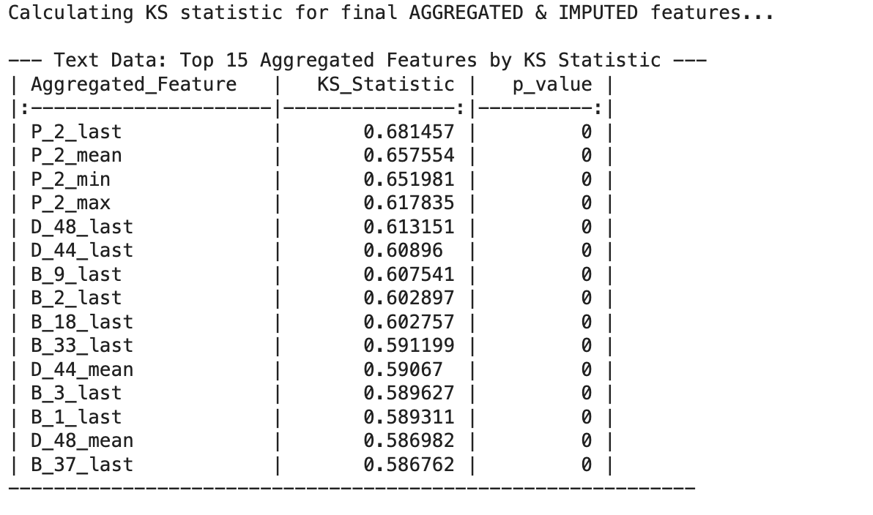
Top 15 features by KS; P_2 variants dominate, followed by “last” values tied to delinquency/balance behavior.
Baseline model importance
We trained a small baseline tree model on the aggregated table to see whether model importances agree with KS.
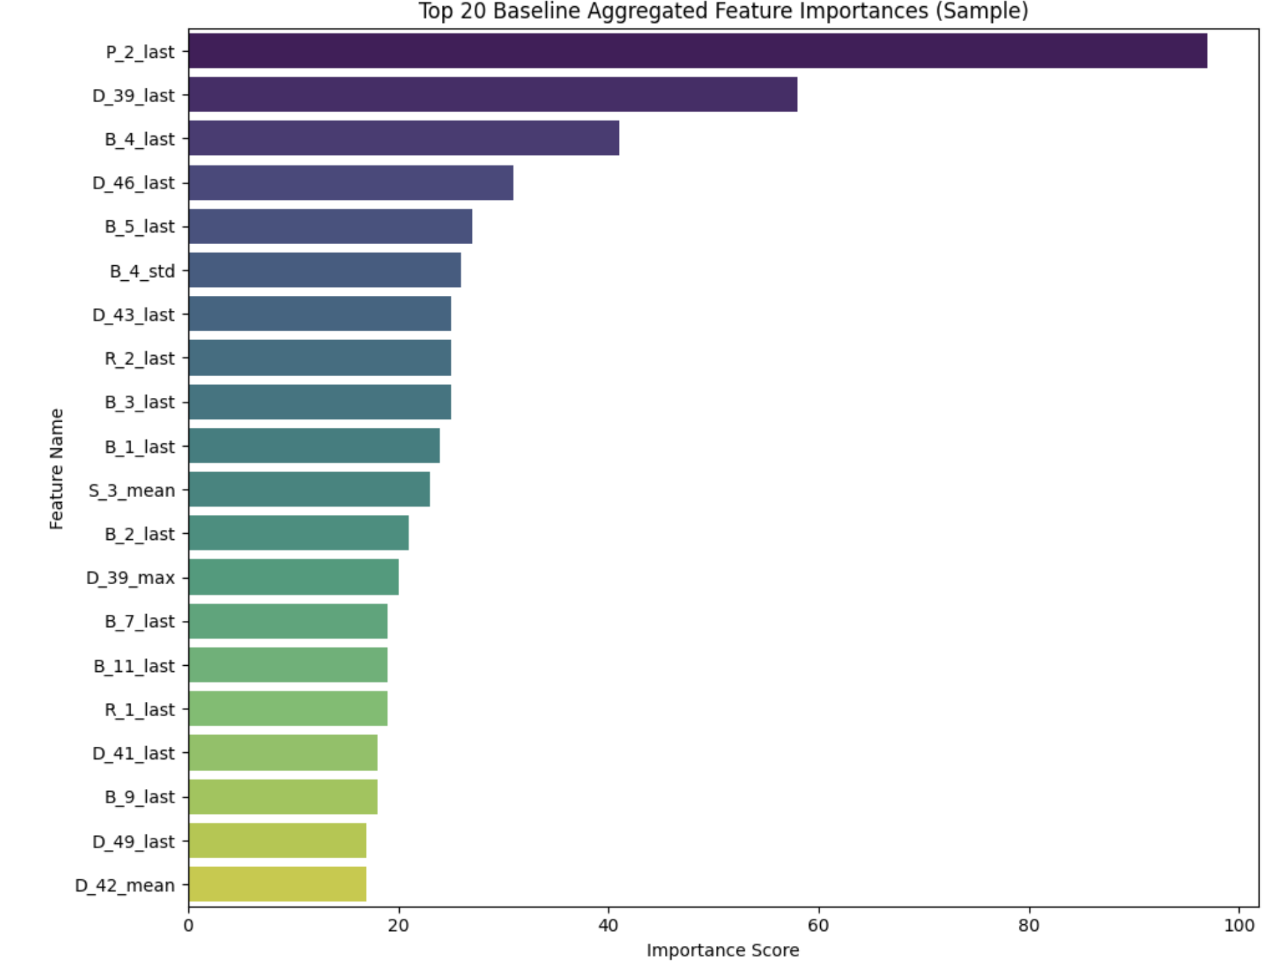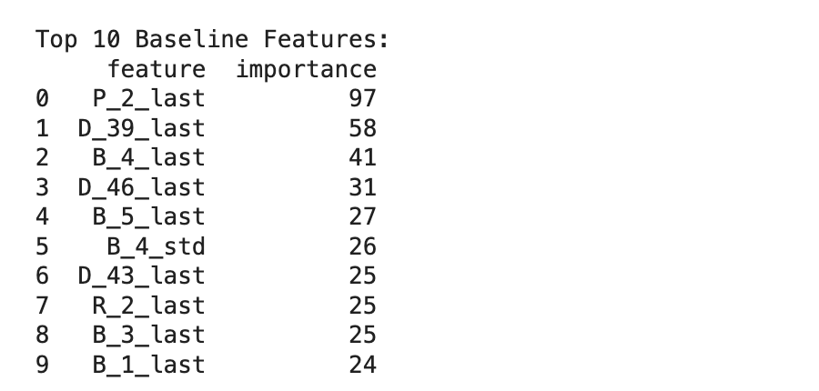
Baseline importances (and top-10 table) align with KS: P_2_last is strongest; D_39_last and several B_last and D_last also rank highly.
Class imbalance and validation choices
The task is imbalanced (defaults are the minority). For modeling we will:
- use GroupKFold with groups = customer_ID, stratified by target,
- prefer a time-aware validation scheme that respects S_2 ordering so future months for a customer never leak into training,
- consider class weighting or a loss tuned for the AMEX metric.
How the eda feeds the pipeline
The customer-level features described in the eda map directly onto the v4 feature engineering (which adds last3/last6 windowed aggregates and diff/rank signals) and then flow through the v5 preprocessing (chunked encoding and downcasting) to produce the train_processed.parquet used for training.
Key findings
- Customer-level aggregation yields a clean 45,891-row table aligned with labels.
- Missingness is concentrated in a handful of feature families; simple imputation strategies should be benchmarked.
- P_2 statistics—especially P_2_last—show the strongest class separation; categorical D_63/D_64 aggregates also carry signal.
- KS rankings and baseline model importances are consistent, increasing confidence in these features.
This EDA delivers a reliable customer-level dataset, highlights the most informative features, documents missingness and validation constraints, and defines concrete next actions aligned with the competition’s rank-focused objective.

