Mendoza Sánchez Javier Alberto. 3TM3
Aplicaciones distribuidas
Evidencia Practica 3
- mascaracteres
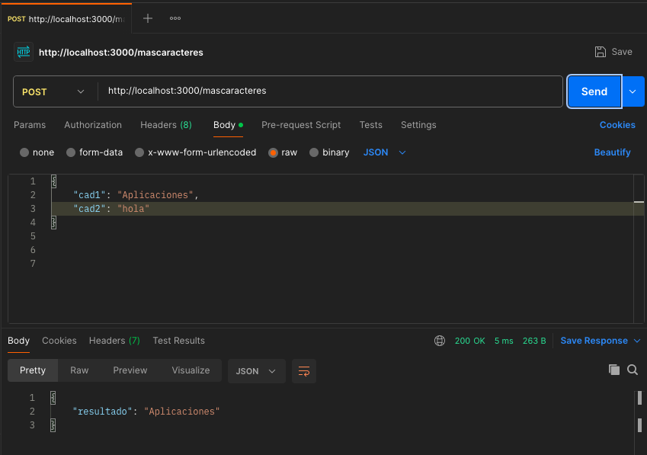

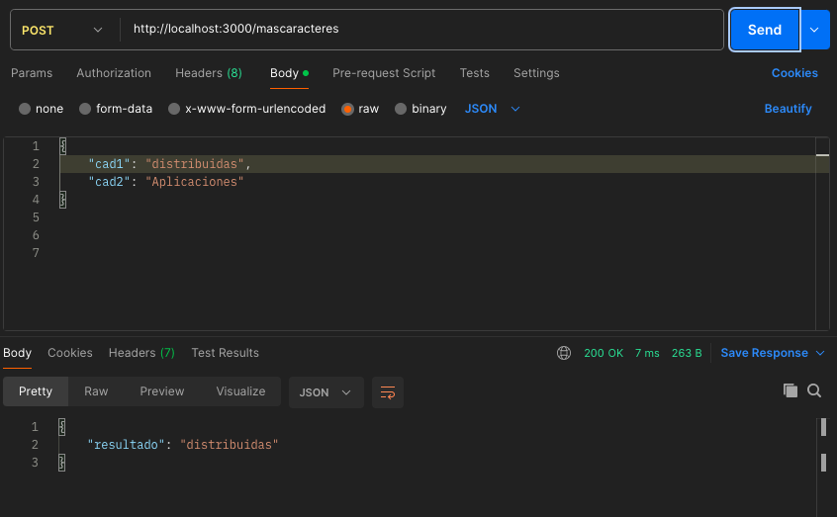

- menoscaracteres
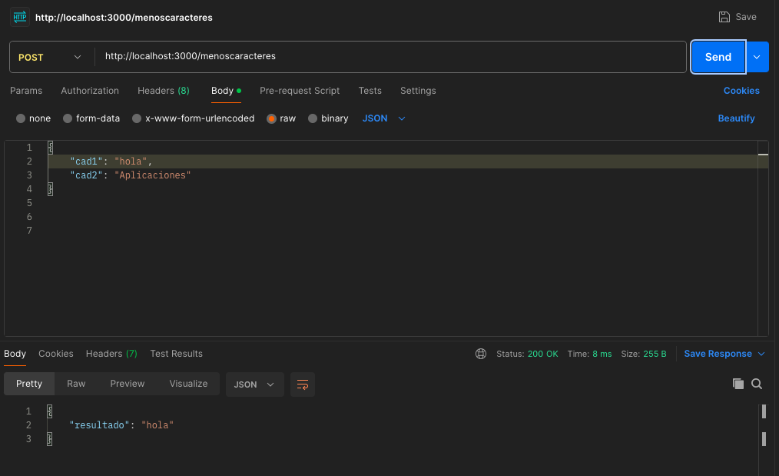
- numcaracteres
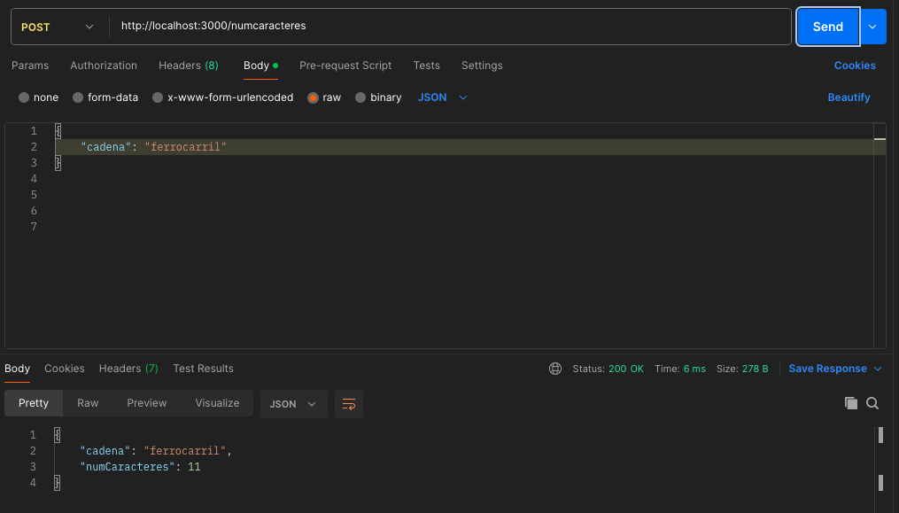

- palindroma
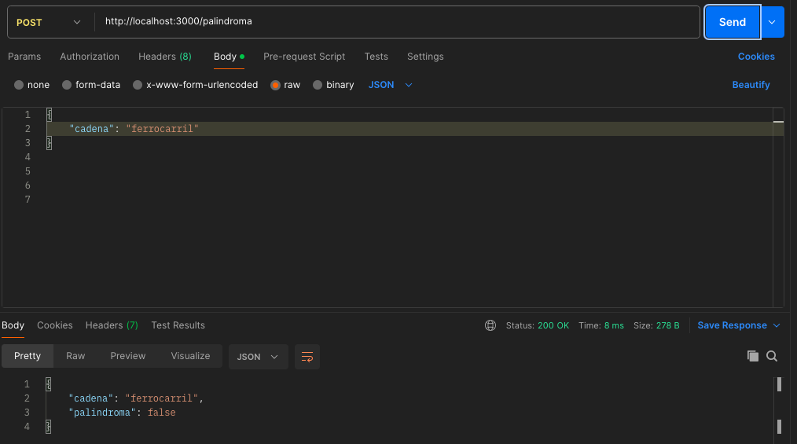

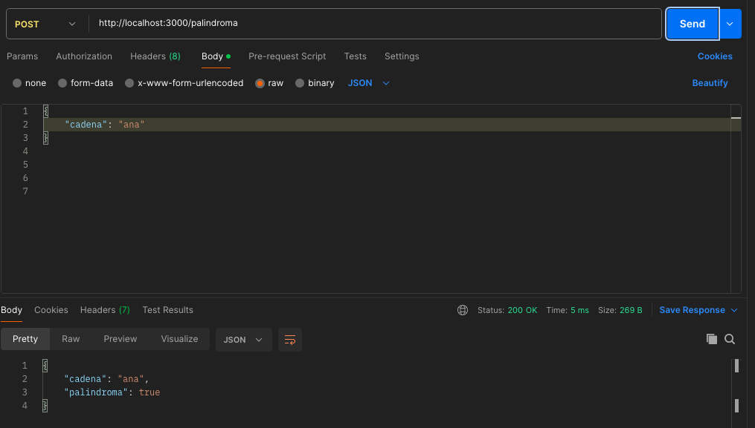
- concat
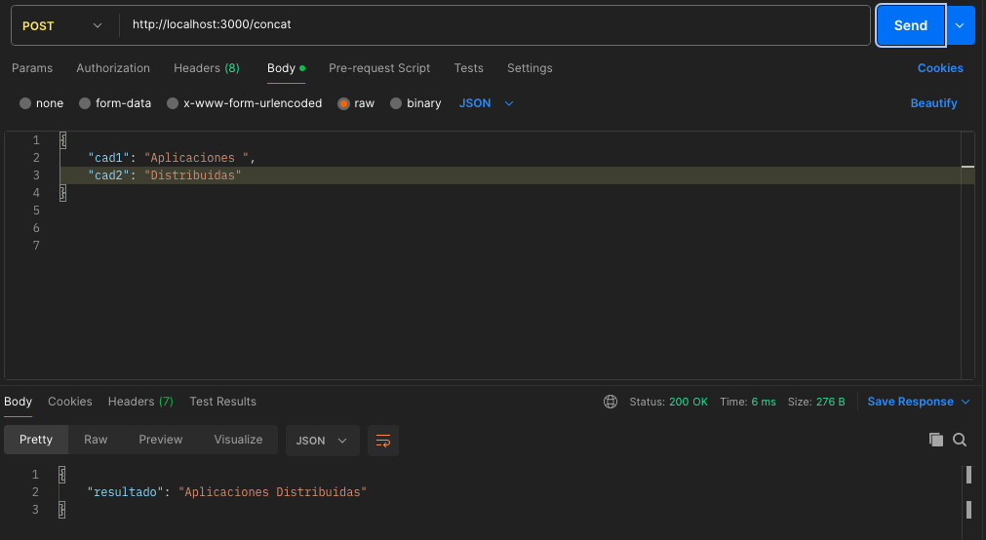
- applysha256
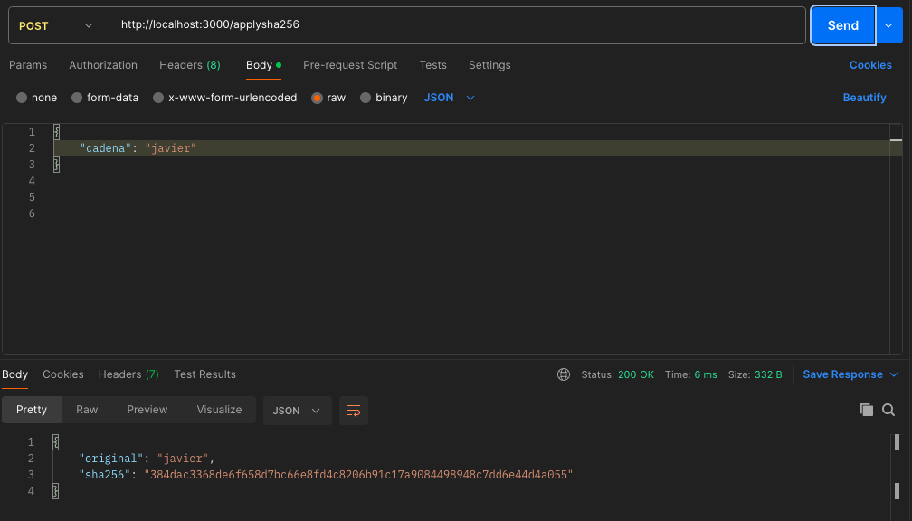
- verifysha256
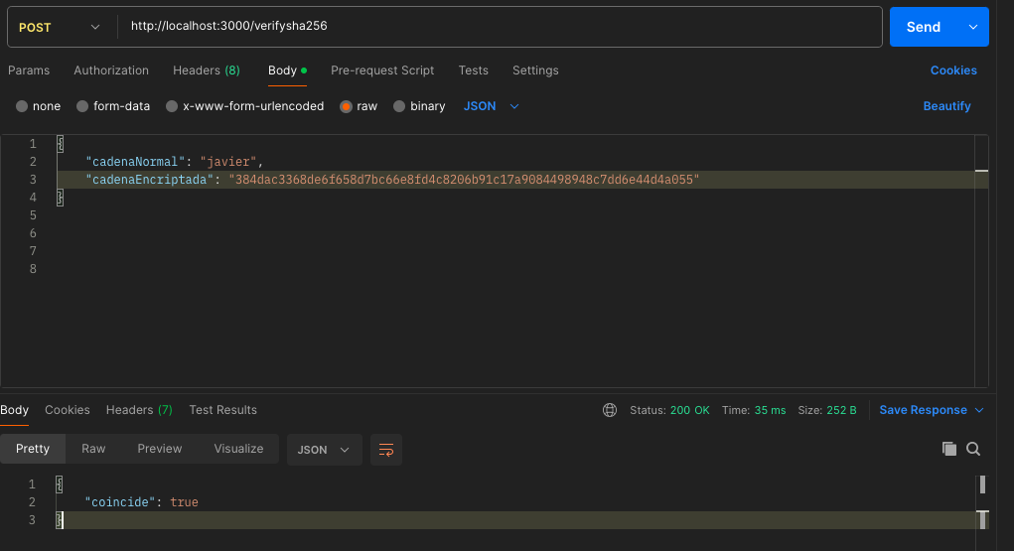
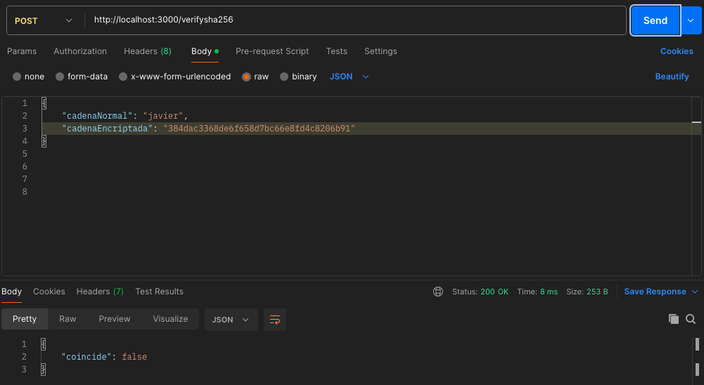
Código
const express = require("express");
const crypto = require("crypto");
const app = express();

app.use(express.json());

/* -------------------------------------------
Función auxiliar para validar cadenas
--------------------------------------------*/
function validarCadenas(req, res, campos) {
for (let campo of campos) {
if (!(campo in req.body)) {
res.json({
error: `El parámetro '${campo}' es requerido`
});
return false;
}
if (typeof req.body[campo] !== "string") {
res.json({
error: `El parámetro '${campo}' debe ser una cadena`
});
return false;
}
}
return true;
}

/* -------------------------------------------
i. mascaracteres
--------------------------------------------*/
app.post("/mascaracteres", (req, res) => {
if (!validarCadenas(req, res, ["cad1", "cad2"])) return;

const { cad1, cad2 } = req.body;

const resultado = cad1.length >= cad2.length ? cad1 : cad2;

res.json({ resultado });
});

/* -------------------------------------------
ii. menoscaracteres
--------------------------------------------*/
app.post("/menoscaracteres", (req, res) => {
if (!validarCadenas(req, res, ["cad1", "cad2"])) return;

const { cad1, cad2 } = req.body;

const resultado = cad1.length <= cad2.length ? cad1 : cad2;

res.json({ resultado });
});

/* -------------------------------------------
iii. numcaracteres
--------------------------------------------*/
app.post("/numcaracteres", (req, res) => {
if (!validarCadenas(req, res, ["cadena"])) return;

res.json({
cadena: req.body.cadena,
numCaracteres: req.body.cadena.length
});
});

/* -------------------------------------------
iv. palindroma
--------------------------------------------*/
app.post("/palindroma", (req, res) => {
if (!validarCadenas(req, res, ["cadena"])) return;

const cad = req.body.cadena.toLowerCase();
const invertida = cad.split("").reverse().join("");

res.json({
cadena: req.body.cadena,
palindroma: cad === invertida
});
});

/* -------------------------------------------
v. concat
--------------------------------------------*/
app.post("/concat", (req, res) => {
if (!validarCadenas(req, res, ["cad1", "cad2"])) return;

res.json({
resultado: req.body.cad1 + req.body.cad2
});
});

/* -------------------------------------------
vi. applysha256
--------------------------------------------*/
app.post("/applysha256", (req, res) => {
if (!validarCadenas(req, res, ["cadena"])) return;

const hash = crypto.createHash("sha256")
.update(req.body.cadena)
.digest("hex");

res.json({
original: req.body.cadena,
sha256: hash
});
});

/* -------------------------------------------
vii. verifysha256
--------------------------------------------*/
app.post("/verifysha256", (req, res) => {
if (!validarCadenas(req, res, ["cadenaNormal", "cadenaEncriptada"])) return;

const hash = crypto.createHash("sha256")
.update(req.body.cadenaNormal)
.digest("hex");

res.json({
coincide: hash === req.body.cadenaEncriptada
});
});

/* -------------------------------------------
Servidor
--------------------------------------------*/
app.listen(3000, () => {
console.log("Servidor ejecutándose en http://localhost:3000");
});

