WEEK5
QUIZ
- Approximation quality: Assume you run a factor-2 approximation algorithm for vertex cover and it returns an answer with 100 vertices.
  - What is the maximum number of vertices in an optimum solution? 100
  - What is the minimum number of vertices in an optimum solution? 50

- Take-2 approximation algorithm for vertex cover is as described below:
//Approximation algorithm Take-2
while some edges uncovered:
e = an uncovered edge
put both vertices of e into the vertex cover

- how many vertices from the minimum vertex cover does this algorithm put into its solution each time it repeats the while loop?
a.1 it depends on the edge
a.2 at least 1
a.3. at most 1
a.4 exactly 1
a.5 exactly 2

- if n is the number of vertices of the input graph and k is the size of the minimum vertex covers how often is the while loop of the algorithm executed:
b.1 up to n times
b.2 at most k times
b.3.at least k time
c. How many vertices the algorithm puts in its solution (there might be more correct answers) :
c.1 at most k
c.2 at most 2k
c.3 at least k
c.4 at least 2k
c.5 approximately 2k
d. What is the approximation factor of this algorithm?

Factor 2 approximation

- What is the size of the solution of the Take-2 algorithm for the following graphs:

 4

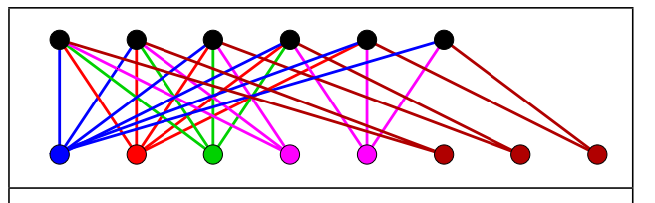

- A greedy approximation algorithm for vertex cover is as described below:
//Approximation algorithm Greedy
while some edges uncovered:
v = vertex that could cover the most uncovered edges
put v into the vertex cover

What is the size of the solution of this algorithm for the following graphs:

2

- An approximation algorithm for shortest tour is based on finding a minimum spanning tree and making a walk along the tree (Udacity course). What is the approximation factor of this algorithm? 2

- Give an example of a graph for which the approximation algorithm for the shortest tour (see 5) give the optimal solution. When the input graph already is an spanning tree.

- Apply the approximation algorithm for shortest tour from question 5 to the following graph:

Mst = b-d-e-c-a
e-f
weight = 4 + 1+ 1 +6+2=14
walk = 24
- Travelling salesman problem (TSP) is described as: “Given a list of cities and the distances between each pair of cities, what is the shortest possible route that visits each city exactly once and returns to the origin city?” [source] and it has been shown that it is an NP-hard problems. There are the double-tree and the Christofides approximation algorithms for finding a TSP route.
The points below represent 10 cities.
1
2
3
4
5
6
8
9
10
7

  - apply the double-tree approximation algorithm (similar to the greedy algorithm for on the graph above. What is the approximation factor of this algorithm?
  - apply the Christofides approximation algorithm on the graph above. What is the approximation factor of this algorithm?
  - What does “metric travelling salesman problem” mean?
  - Is there a known approximation algorithm for “non-metric” travelling salesmen problem?

- Knowing that there is a 2-factor approximation algorithms for vertex cover and knowing that vertex cover problem is closely related to the maximum independent set problem does it follow that there is a 2-factor approximation algorithm for the maximum independent set problem as well? Yes/No? Why? Because we are using min. in rtex cover and max. in independent set, which changes the factor approx.

- Is there a constant factor approximation algorithm for the clique problem for a general graph? No

- Is the knapsack problem NP-hard?

- What does a pseudo-polynomial algorithm mean?

- Knowing that there is a pseudo-polynomial algorithm for the knapsack problem, does not imply P=NP. Why?

- What are the two key elements of the FPTAS for the knapsack problem?

- If 1/c is the approximation factor of the FPTAS for the knapsack problem and n is the number of items, then the running time of the FPTAS algorithm is:
  - polynomial on n and exponential on c
  - polynomial on c and exponential on c
  - polynomial on both n and c
  - exponential on both n and c

- You have implemented the FPTAS algorithm for the knapsack problem which takes a set of n items and the approximation factor c as input. First you run your program on a given n items and c = 0.5. Afterwards you run the program on the same n items but with c=0.9. Which execution takes longer time, the first one (with c=0.5) or the second one (with c =0.9)? Why?

- Assume you have a randomized algorithm that give the optimal solution with probability 0.75. How many times you need to run the algorithm to be 99.9% sure that the output is the right answer?

- There is a polynomial algorithm for minimum vertex cover on a tree. Investigate the algorithm, and shortly describe it. Apply it to an example of your choice with 15 vertices. [a possible source slides 10-12]

