HW1: Task 8

Implement the function

find_peaks_image(image : np.ndarray, thres : float, in_place : bool = False) -> np.ndarray

to find the peaks of edge responses perpendicular to the edges. The edge magnitude and orientation at each pixel are to be computed using the Sobel operators. The original image is again converted into grayscale in the starter code. A peak response is found by comparing a pixel's edge magnitude to that of the two samples perpendicular to the edge at a distance of one pixel, which requires the BilinearInterpolation function (**Hint**: You need to create an image of magnitude values at each pixel to send as input to the interpolation function). If the pixel's edge magnitude is e and those of the other two are e1 and e2, e must be larger than "thres" (threshold) and also larger than or equal to e1 and e2 for the pixel to be a peak response. Assign the peak responses a value of 255 and everything else 0. Compute e1 and e2 as follows: 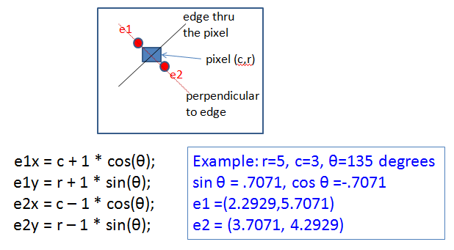

***To do*:** Find the peak responses in "Circle.png" with thres = 40.0 and save as "task8.png". Note that you may get double edges at the bottom of the circles because they are slightly flat at the bottom in the original image.