DOCUMENTACION
Practica 1
Francisco Javier Griñan Martinez
url: https://github.com/JavierGrinanMartinez/pcd_entregable1_JavierGri-an

Capturas Git:
Ramas:
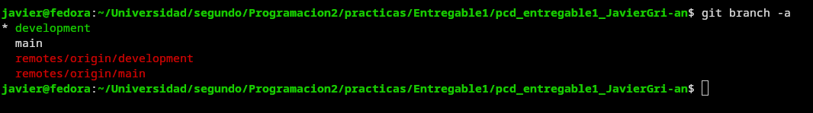
Tags:
Merge:
