

Subscribe to DeepL Pro to edit this document.  
Visit www.DeepL.com/Pro for more information.

**RoboMaster**

C610 brushless motor speed governor

Instructions for use

# V1. 02018.01

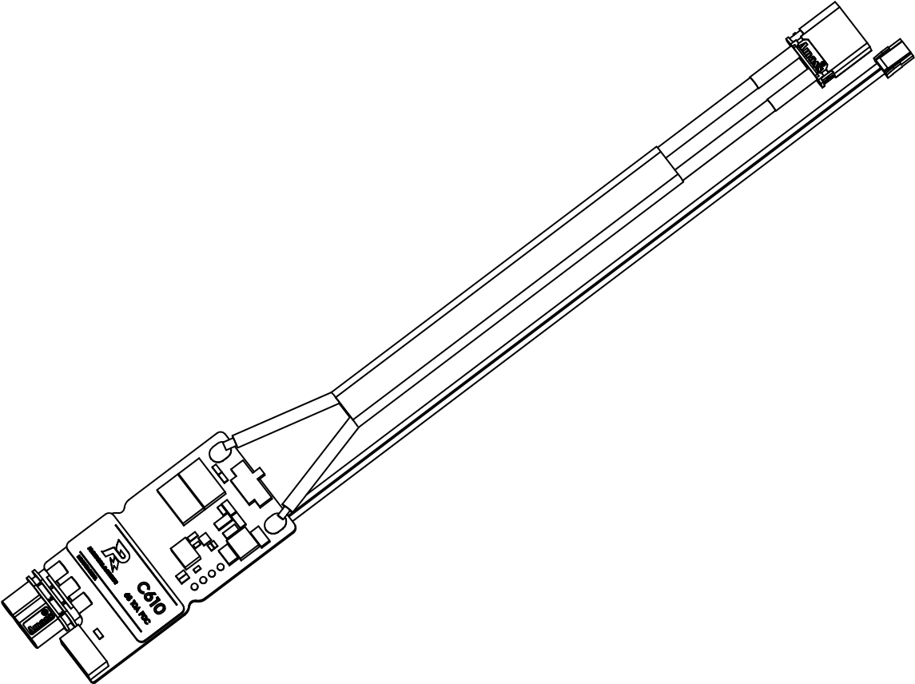

# Disclaimers

Thank you for purchasing the RoboMaster™ C610 Brushless Motor Speed Controller (hereinafter referred to as ESC). Please read this statement carefully before use, and by using it, you are deemed to acknowledge and accept the entire contents of this statement. Please install and use the product in strict compliance with the manual, product descriptions and relevant laws, regulations, policies and guidelines. In the process of using the product, the user promises to be responsible for his or her own actions and all consequences arising therefrom. Any damage caused by improper use, installation or modification by the user

DJI™ will not be held liable.

DJI and RoboMaster are trademarks of Shenzhen DJI ™ Innovation Technology Co. The product names and brands appearing herein are trademarks of their respective companies. This product and manual are copyrighted by DJI Innovation. Reproduction in any form without permission is prohibited.

The final interpretation of the disclaimer is the property of DJI Innovation.

# Precautions for product use

1. Ensure that the circuit is free of short circuits and that the interfaces are properly connected as required.
2. When the ESC high power output, there will be heat, please use carefully to avoid burns.
3. Please check if the heat shrink tube is intact before use. If it is broken, please replace it in time.
4. The serial port and the CAN communication port cannot be connected at the same time. If you need to switch, please disconnect the ESC power and then change the port you need to use.
5. Please use strictly in accordance with the operating environment (such as voltage, current, temperature and other parameters) specified in this document, otherwise it will affect the life of the product or cause permanent damage.

# Introduction

The C610 ESC uses a 32-bit custom motor driver chip with Field Oriented Control (FOC) technology to achieve precise control of motor torque, and is paired with the RoboMaster M2006 DC brushless geared motor ("M2006 motor")* to form a powerful power package. The RoboMaster Assistant software can be used for parameterization and firmware upgrades.

# Product Features

* CAN bus command control
* Supports up to 10A continuous current
* Supports fast ID setting for ESCs on the CAN bus
* Supports the acquisition of rotor position and rotor speed information via CAN bus

* For the use of RoboMaster M2006 DC brushless geared motor, please refer to "RoboMaster M2006 DC Brushless Geared Motor Instructions for Use".

# List of items

C610 ESC x 1 Heat shrink tube x 1

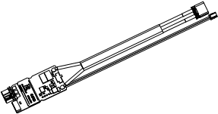

# Interface and wire sequence description ESC interface

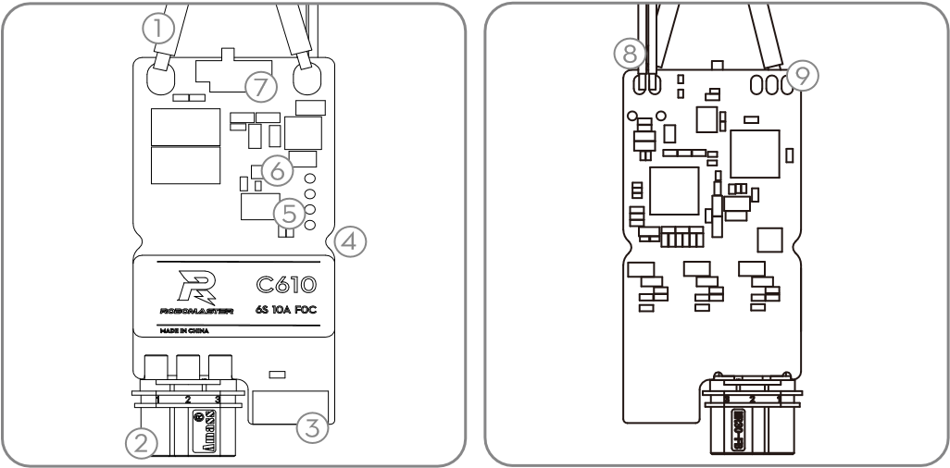

1. Power cord

Connect a power supply (rated at 24V) to power the C610 ESC.

1. Three-phase power connector

Please make sure the ESC and motor are connected correctly (make sure the non-reversible connector is correctly connected) when connecting.

1. 4-Pin Position Sensor Data Port Connects the M2006 motor 4-Pin position sensor data cable to obtain position sensor data.
2. ESC fixing slot

There are two fixing slots in the symmetrical position of the ESC. The ESCs can be fixed with M2 screws through these slots.

1. SET button

Configure the ESC, see "SET button operation" for details

1. Indicator light

Indicates the current ESC operating status, see "Description of Indicators" for details.

1. CAN Terminating Resistor Selector Switch

The 120Ω terminating resistor can be switched on/off by toggling the switch to the ON/NC position (the user can refer to the specifications for CAN bus wiring and terminating resistor selection to select whether the terminating resistor is on or off).

1. CAN signal cable

Connect the CAN signal line to the control board to receive CAN control commands with a CAN bus bit rate of 1Mbps.

1. Serial port for reference

Connect the USB to serial module to the ESC by soldering wires or other means, and then connect the USB to serial module to the

PC, use RoboMaster Assistant to upgrade firmware and set parameters for ESC.

When using CAN bus command control, the user can obtain key parameters such as rotor position and speed via the CAN bus. When using the CAN bus, please consider the bus bandwidth and use the bus resources wisely.

## Serial port line sequence

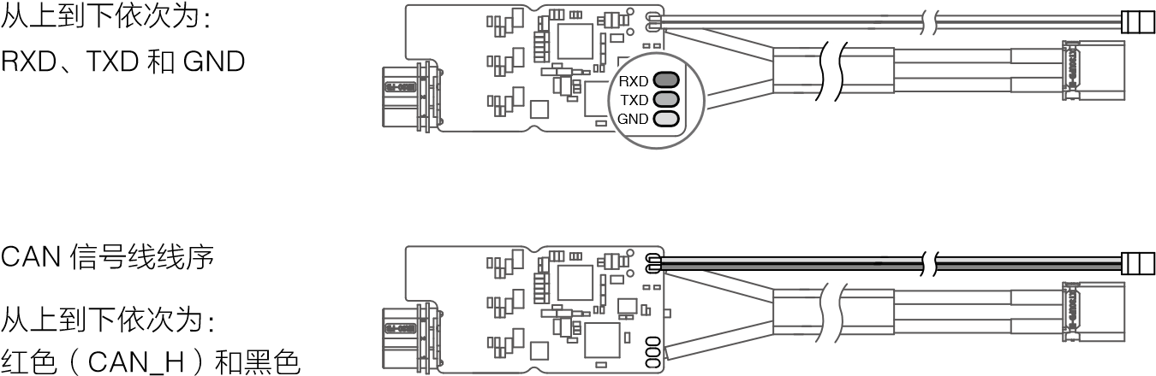

(CAN_L).

# Installation Connection

1. Plug the motor's 4-Pin position sensor data cable into the ESC's 4-Pin position sensor data port.
2. Connect the three-phase power cable of the motor to the three-phase power connector of the ESC. When connecting, please make sure the ESC and the motor are connected correctly (ensure the irreversible connector is correctly matched), do not connect wrongly.
3. Connect the CAN signal cable to the CAN signal interface of the control board.
4. Connect the power cable to the power supply to power the ESC.

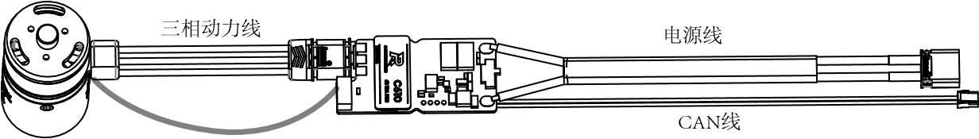

4-Pin Position Sensor Data Cable

# ESC size

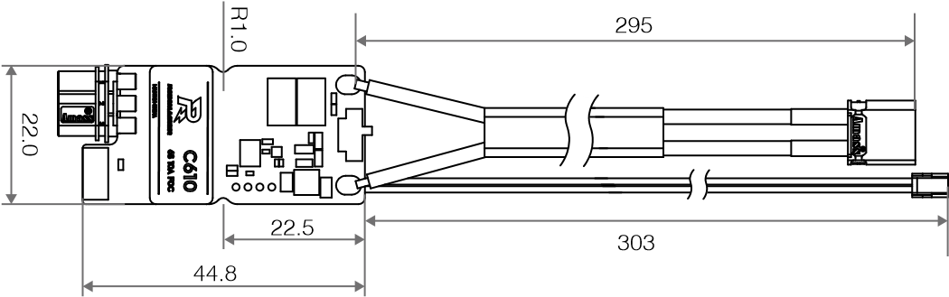



# Unit: mm Fixed ESC

There are 2 semi-circular grooves on the side of the ESC, which can be used to fix the ESC, the inner groove hole is 2mm in diameter. When using, you can cut the heat shrink tube by yourself, but DJI will not be responsible for any damage caused by this.

# Using the Tuning Software

Use a USB to serial tool (e.g. DJI Takyon ESC Upgrader) to connect your ESC to your computer in order to use RoboMaster Assistant to set parameters or upgrade firmware on your ESC. The figure below shows the use of Taykon ESC upgrader as

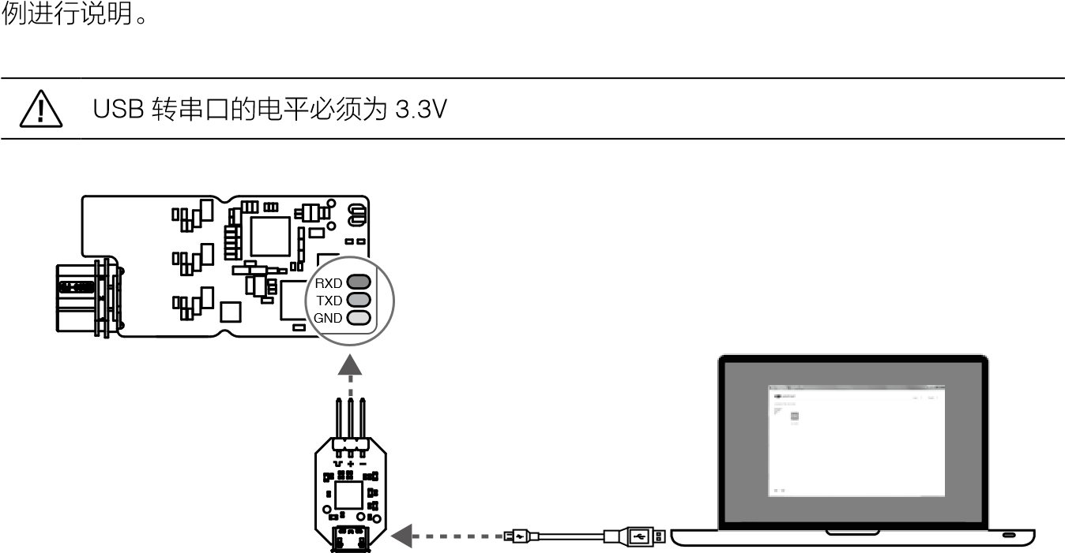

1. Download and run RoboMaster Assistant from the RoboMaster website.

https://www.robomaster.com/zh-CN/products/components/assitant

1. Connect the USB to serial module to the C610 ESC according to the wire order, and connect the ESC GND, TXD, and RXD to the C610 ESC respectively.

Taykon ESC Upgrader with "-", "+", and " " connected. Then connect the USB to serial module to your computer.

1. Connect the power supply to power the ESC, do not disconnect the power or connection before setting is completed.
2. Run the RoboMaster Assistant tuning software. The software interface shows that the device is connected, which means the ESC is connected to the software and can communicate normally.
3. Use the RoboMaster Assistant setup screen to set the basic parameters.
4. Click the Firmware Upgrade button to upgrade the corresponding firmware version, and RoboMaster Assistant will download and upgrade the firmware itself. Indicator Description

Please judge the ESC working condition according to the ESC indicator status. When both warning and abnormal conditions occur at the same time, the ESC indicator will only indicate the abnormal condition. If more than one warning or abnormal condition exists at the same time, the ESC status indicator will indicate the condition with the least number of blinks. In the abnormal condition, the ESC will turn off the output.

|  |  |
| --- | --- |
| Normal state | Description |
| Green light flashes N times every 1 second | The ID of the current ESC is N. The ESC ID ranges from 1 to 8 |
| Quickly set ID status | Description |
| Orange light is always on | Current ESC is in the Quick Set ID state |
| Motor calibration status | Description |
| Green light flashing fast | Current ESC is in calibration mode |
| Warning Status | Description |
| Orange light flashes 2 times every 1 second | Devices with the same ID on the bus |
| Abnormal Status | Description |
| Red light flashes once every 1 second | ESC power supply voltage is too high (only once for power-on self-test) |
| Red light flashes 2 times every 1 second | Motor three-phase line is not connected |
| Red light flashes 3 times every 1 second | Loss of signal on the 4-pin position sensor data line connected to the motor |
| Red light flashing | Motor calibration failure |

Beep Description When using, please judge whether the product is working properly according to the motor beep. If there is an abnormal state chirp, please troubleshoot.

|  |  |
| --- | --- |
| Normal state tones | Description |
| Power on sound | System Ready |
| Abnormal state beep | Description |
| BB--BB--BB | Motor blocking |
| BBB--BBB--BBB | Loss of signal on the 4-pin position sensor data line connected to the motor |

# SET button operation

1. Independent setting ID

The user sets the ID (supported range 1-8) for individual C610 ESCs as follows.

* 1. Under the normal operation of ESC, press SET button once to enter the independent setting ID mode, and the indicator will be off.
  2. In independent setting ID mode, the number of short presses of the SET button (no more than 8) is the set ID number. The indicator flashes orange once for each valid short press.
  3. If the SET button is not operated for 3 seconds, the ESC will automatically save the current setting ID number. After setting the ID, the ESC needs to be re-powered to enter the normal operation.

ID duplication cannot occur on the same bus, otherwise the ESC with conflicting IDs will prompt a warning and turn off the output.

1. Quick Setup ID

The user quickly numbers all C610 ESCs on the bus (no more than 8) as follows.

* 1. Under normal operation, 1 short press of the SET button of any 1 C610 ESC on the bus will enter the independent

After ID setting mode, press and hold SET button again, then all ESCs on the bus will be in Quick Set ID mode, and all ESC indicators will be on in orange.

* 1. When the rotor of the M2006 motor corresponding to the C610 ESC is rotated manually (at least half a turn in any direction), the ESCs will be numbered from 1 in the rotation order.

If a device with the same ID is present on the same bus*, the ESC will not work.

1. Motor Calibration

After the ESC motor is connected and powered on, the user calibrates the motor's position sensor parameters to ensure that the motor can work properly, as follows.

* 1. Press and hold the SET button until the indicator light turns green and flashes, and release the SET button.
  2. The motor enters the automatic calibration mode, and automatically exits the calibration mode when the calibration is completed.

Be sure to run the motor calibration procedure after initial use and after replacing the motor or ESC. The motor will rotate during calibration, do not touch it, and it is recommended that this operation be performed under no load. If the calibration fails several times, please replace the motor.

* Please pay attention to the correct selection of accessing or disconnecting termination resistors according to the specifications of CAN bus wiring and termination resistor selection, so that the CAN bus communication does not work properly and the above functions cannot be used normally.

# CAN communication protocol

1. ESC receive message format

Two identifiers (0x200 and 0x1FF) are used to send control commands to the ESC to control the current output of the ESC, each corresponding to the 4 IDs of the ESC. The control torque current value ranges from -10000 to 0~10000, corresponding to the torque current output of the ESC.

Range -10~0~10A.

Identifier: 0x200 Frame format: DATA Frame type: standard frame DLC: 8 bytes

|  |  |  |
| --- | --- | --- |
| Data Fields | Content | ESC ID |
| DATA[0] | Control current value 8 bits higher | 1 |
|  |  |
| DATA[1] | Control current value 8 bits lower |  |
| DATA[2] | Control current value 8 bits higher | 2 |
|  |  |
| DATA[3] | Control current value 8 bits lower |  |
| DATA[4] | Control current value 8 bits higher | 3 |
|  |  |
| DATA[5] | Control current value 8 bits lower |  |
| DATA[6] | Control current value 8 bits higher | 4 |
|  |  |
| DATA[7] | Control current value 8 bits lower |  |

Identifier: 0x1FF Frame format: DATA Frame type: Standard frame DLC: 8 bytes

|  |  |  |
| --- | --- | --- |
| Data Fields | Content | ESC ID |
| DATA[0] | Control current value 8 bits higher | 5 |
|  |  |
| DATA[1] | Control current value 8 bits lower |  |
| DATA[2] | Control current value 8 bits higher | 6 |
|  |  |
| DATA[3] | Control current value 8 bits lower |  |
| DATA[4] | Control current value 8 bits higher | 7 |
|  |  |
| DATA[5] | Control current value 8 bits lower |  |
| DATA[6] | Control current value 8 bits higher | 8 |
|  |  |
| DATA[7] | Control current value 8 bits lower |  |

1. ESC feedback message format

The feedback data sent by the ESC to the bus.

Identifier: 0x200 + ESC ID (e.g., if ID is 1, the identifier is 0x201) Frame format: DATA

Frame type: standard frame

DLC: 8 bytes

|  |  |  |  |
| --- | --- | --- | --- |
| Data Fields | Content | Data Fields | Content |
| DATA[0] | Rotor mechanical angle 8 positions high | DATA[4] | Actual output torque 8 bits higher |
| DATA[1] | Rotor mechanical angle 8 positions lower | DATA[5] | Actual output torque 8 bits lower |
| DATA[2] | Rotor speed 8 bits higher | DATA[6] | Null |
| DATA[3] | Rotor speed 8 bits lower | DATA[7] | Null |

Transmitting frequency: 1KHz (default value, transmitting frequency can be modified in RoboMaster Assistant software) Rotor mechanical angle value range: 0 ~ 8191 (corresponding to rotor mechanical angle of 0~360°) Rotor speed value in rpm

# Motor performance curve with M2006 motor

90

20

450

300

0

50

150

250

350

200

400

0.5

1

1.5

2

0

10

30

50

70

40

60

80

100

0

10

20

30

40

50

60

70

0

1

2

3

4

5

6

P(W)

I(A)

T(N-m)

η

)

%

(

n(rpm)

P

n

η

I

The above data are obtained under the input voltage of 24V, room temperature of 25℃, and well ventilated experimental environment, and are for reference only. In actual use, please use according to the actual conditions such as working environment temperature and heat dissipation condition control.

# Product Specifications

|  |  |  |  |
| --- | --- | --- | --- |
| Projects | Parameters | Projects | Parameters |
| Rated voltage (DC) | 24 V | Weight | 17 g |
| Maximum allowable current * (continuous) | 10 A | Dimension (L×W×H) | 50 × 22 × 7.3 mm |
| CAN bus bit rate | 1Mbps | Operating ambient temperature range | 0 to 55 °C |

* Measured at room temperature of 25°C in a well-ventilated experimental environment.

WWW.ROBOMASTER.COM

and are trademarks of DJI.

Copyright © 2018 DJI Innovation All Rights Reserved