**TECHNICAL UNIVERSITY OF AMBATO**

**ENGLISH CLASS**

Name: Javier López

Level: B1+

Date: December 22, 2020

**RENTAL HOUSE**

The house is located in Ambato in a very nice and quiet area, the house is in an easy to reach location, with shopping centers, parks and other attractions.

It is on Manuelita Saenz Avenue a few meters from the "Paseo Shopping" shopping center.

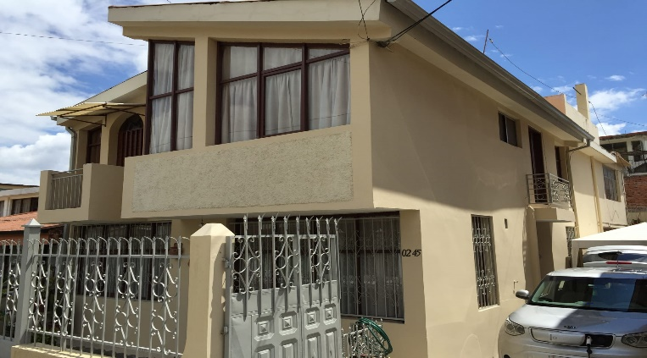

The house has two floors, on the first floor there is a small kitchen and a large living room, it also has a laundry room with connection for washing machine and dryer and a bathroom with a bathtub, in the exterior of the house there is a system for heat the water.

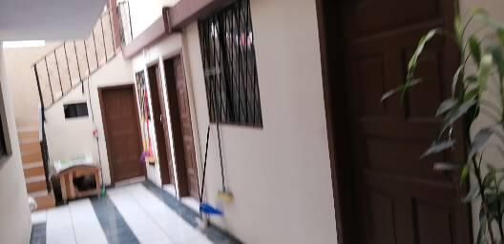

On the second floor there are 3 bedrooms, 1 large room and 2 small rooms but it does not have terraces. There is a small patio in the back but there is no space for a garage.

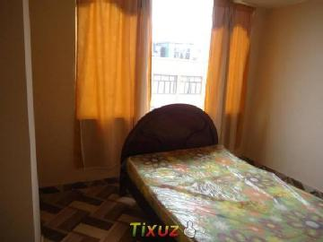

If you need to see the photos of the house you can find it on the internet or if you want to visit the house you can send a text message to the number 0984964421.

The rental cost is cheap and comfortable, also the house is very nice and I think it is the ideal house for your family.