*Homework 1*

*Emotional event:* Getting angry at a classmate.

*Factors triggering anger:* Classmate asking for help on project when he was irresponsible.

*Strongly felt emotions:* anger.

*Situation description:* When taking a time-consuming class, I worked on a long project by myself at Leavey Library several nights. I was supposed to collaborate (not copy) with a classmate, but his girlfriend was in town for that week. Thus, he decided to skip classes throughout the entire week and have fun with her doing tourist activities all over Southern California. A few of the leisure activities they did, while I was programming at Leavey Library until three in the morning, were going to Disneyland and renting a Cadillac to drive to San Diego. At San Diego, they went shopping to Las Americas Premium Outlets. His girlfriend left on a Friday, so my classmate expected I helped him with the project on Saturday and Sunday. I had other projects and a midterm coming up, so I was planning on working on my other assignments on Saturday and Sunday. Additionally, I was going to meet with my girlfriend and her brother on Sunday for dinner in Little Tokyo because we were going to celebrate my girlfriend’s brother birthday. On Saturday, I started studying for the midterm. I told my classmate that if he made progress on the project, I would eventually help him out with his questions or to fix his errors in the program. However, he wanted to be physically right next to me when programming because he pretty much wanted that I help him in every single line of code. I rejected his request and started studying for my midterm. Instead of working on the project, my classmate started studying for a midterm he was going to have the following week as well. Later that Saturday, I saw on his Instagram story that he went to a rock concert and, later that night, he texted me videos of the concert. Next day, he kept texting me to help him out on the project. I invented excuses to not help him and, then, I went for dinner to Little Tokyo. He kept asking for help while I was having dinner. Since I did not want to help him, I told him I was not coming back from Little Tokyo before midnight (the homework was due on midnight). The following week he repeated to me multiple times that it was my fault he did not do his project. At first, I laughed because I thought it was ironic. However, he actually believed that it was my fault he did not turn in his assignment because I did not help him, but realistically he started the project the same day it was due. I worked on the same project for six days; thus, it was unrealistic to blame me for his failure. After a few times he told me it was my fault that he did not finish his project, I got devoured by the spirit of anger and started yelling at him in public. I could not stop getting angry because he sincerely perceived himself as the victim of the situation, so I kept getting angrier and angrier. At the end, I decided to finish conversation (I told him to stop talking about the project) and, eventually, left the scene. Up to this day he still believes he is the victim. My solution is just to ignore him because his negative attitude towards responsibility is not going to help him at all on his professional and personal life.

*Part I:*

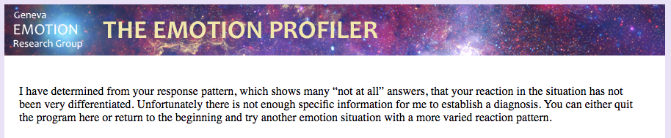

My impression of the Emotion Analyst is that it needs more testing to improve its empirical database. Thus, the Emotion Profiler questions miss the point. They are not designed for situations when clearly a situation is justifiable. The response was not sensible.

*Part II:*

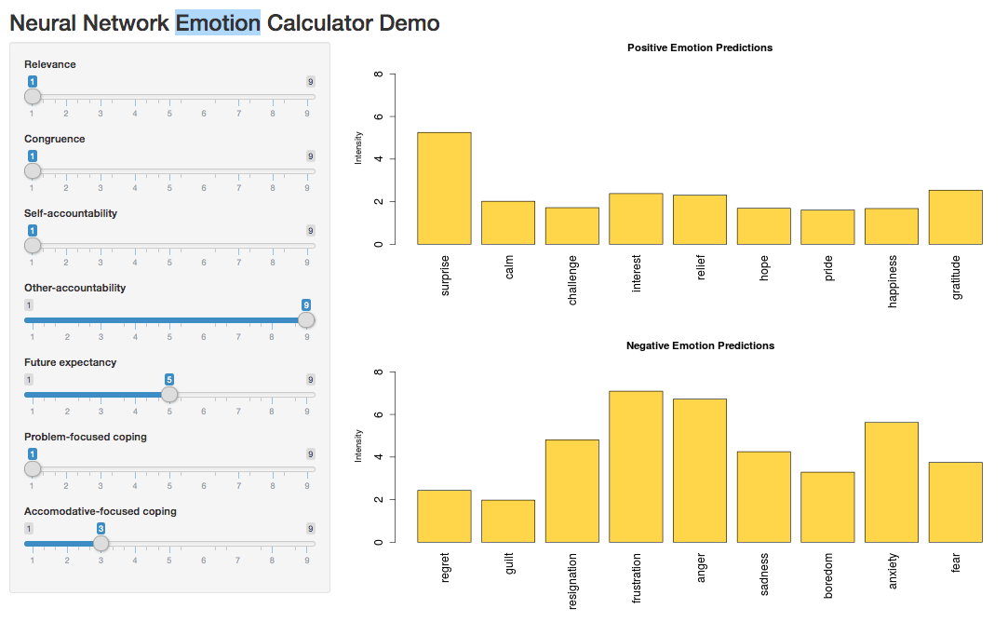

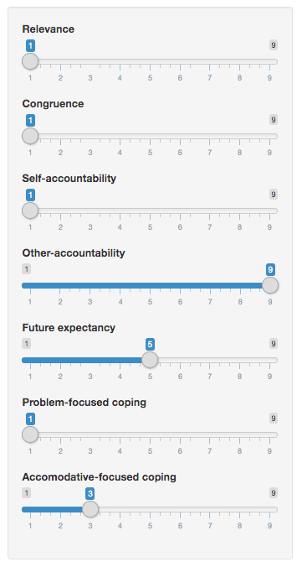

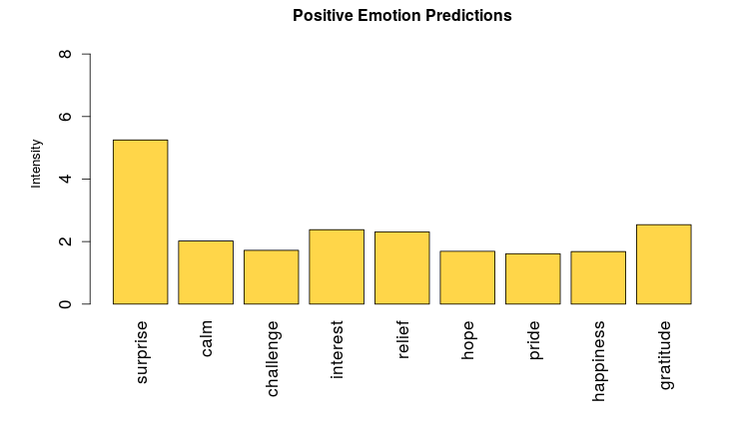

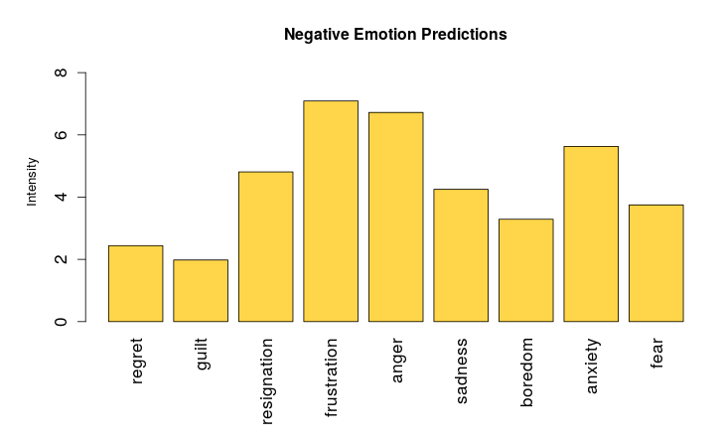

The Emotion Calculator is extremely accurate. I was definitely surprised when my classmate told me I was responsible for not helping him do the project a day or two days before the deadline. Furthermore, I was frustrated with his way of perceiving the situation and, as a result, that frustration turned into anger.

The Emotion Calculator differs from the Emotion Analyst because the Emotion Analyst was not able to interpret my emotions. I believe this is caused by the fact of not having enough dataset to do a thorough training. In contrast, the Emotion Calculator gave me an accurate description of the emotions I felt in that situation.

*Which software better described your feelings at the time?*

The Emotion Calculator better described my feelings at the time.