*Homework 6*

1) a) Cooperative

b) Extortion

c) US

2)

a)

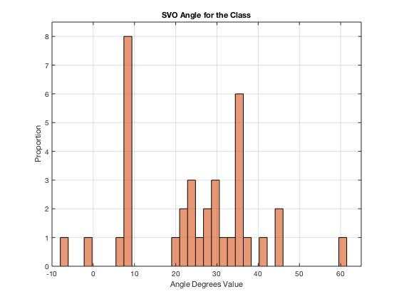

b) The distribution I just calculated looks very similar to the distribution in figure 4. It seems both of them follow the same trend. I am convinced if the sample size was bigger in our classroom, then the distribution would look closer to the one form distribution in figure 4.

c) My SVO score is 7.81529355 and my category is Individualistic.

d) Yes, I completely agree with my results. I consider myself individualistic; however, I am always conscious of my surroundings and help people in need.

3) It was extremely easy to predict both opponents’ choices. The first agent seemed egocentric, so I always picked the blue ball. However, the second agent cooperated with me and after I selected the green ball and the agent selected the blue ball, the agent seemed regretful. Then, the following round the agent picked the green ball and we kept using green ball the entire game. I completely disliked the first agent because it always had a negative face. In contrast, the second agent always had a happy face and it actually evoked happiness in me.

4)

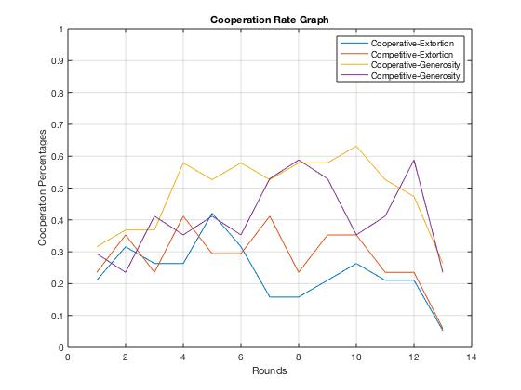

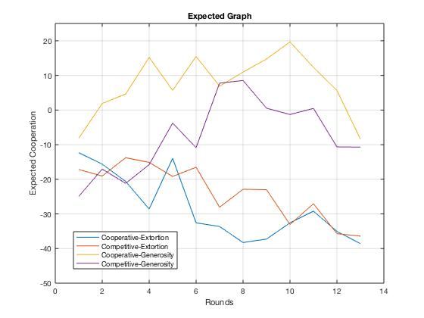

5) a) It can be perceived on the first graph Cooperative-Generosity emotion and decision-policy created the greatest average cooperation.

b) It seems that emotion is the factor that had greater influence because on the graph it can be seen that Cooperative-Generosity and Competitive-Generosity have greater averages.

c) This pattern of results occurred because the agents realized the user was been generous and decided to cooperate as well.

6) a) As seen on my graph, the combination of emotion and decision-policy that created the greatest expectation of cooperation is Cooperative-Generosity.

b)

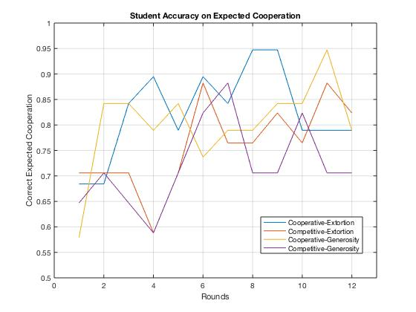

c) For the Competitive-Extortion and Competitive-Generosity improved. It seems the accuracy improved in general over time and it pretty much converted to 0.8 (80%). From my results, it can be seen the Extortion Agent was more predictable because the user knew the agent was going to make a competitive and aggressive decision.

7)

a)

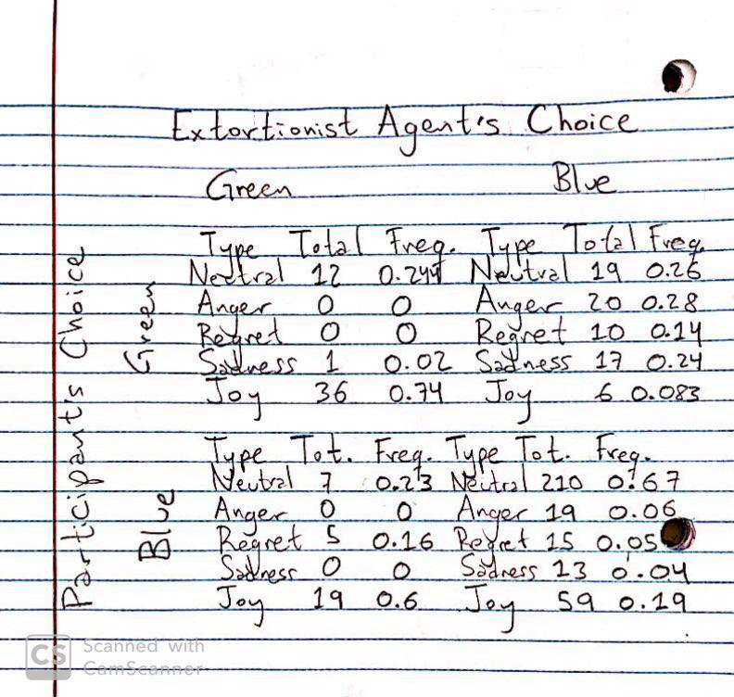

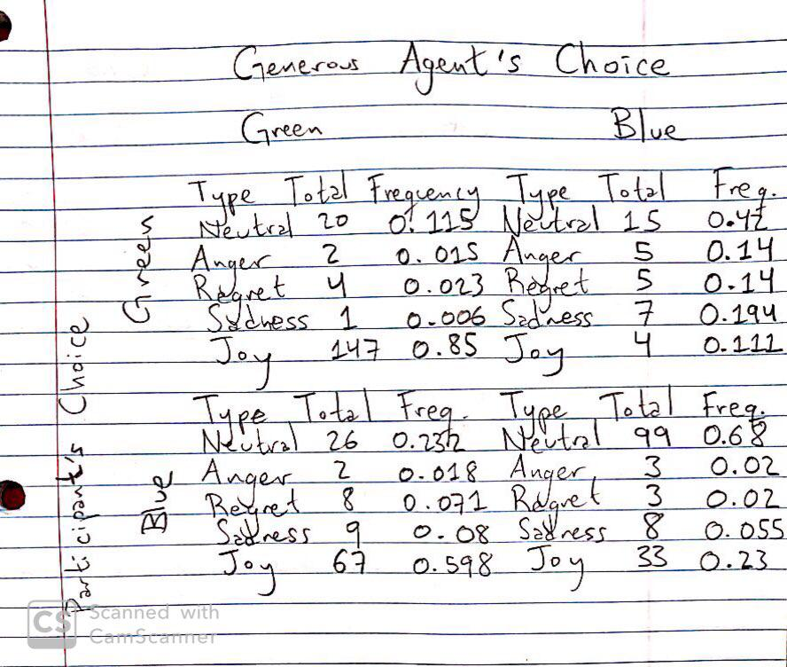

b) Yes, the results are influenced by the agent’s decision policy. As clearly seen in the tables above, the Generous Agent generated neutral to positive emotions. The emotions were either Neutral or Joy. In contrast, the Extortion Agent generated more neutral to negative emotions. In most of the cases, it generated Neutral, Anger, and Regret emotions. However, there is the outlier when both the participant and the agent picked the Green ball resulting in 74% of Joy.

Yes, this answer makes sense to me because positive emotions are generated when negotiating with generous people in comparison to negotiating with extortionist people.

c) To be honest, I felt I was not able to influence any agents because they are programmed to be either generous and extortionist. Furthermore, the agent’s decisions were based on the participant’s previous decisions. Thus, my emotional expressions did not have any influence in the agents resulting in null influence in the results.

8) Extra-credit: Based on SVO scores, the group that earned the most points across the two games is Social (Altruistic + Prosocial) because social people were more prone to collaborate with the agent. For the Extortion Agent (the first agent), social people earned 1188 points and selfish people earned 682 points. For the Generous Agent (the second agent), social people earned 1484 points and selfish people earned 826 points.