**Part 1: Appraisal (i.e. Forward Inference)**

1.a [2.63, 1.76, 1.21]

1.b 0.11, pleased

2 0.23, welcome

3.a [-1.35, -1.93, 0.28]

3.b 0.54, scared

4 0.62, soothe

5 EMA predicts Dr. Tom will feel anger after his advice is ignored. However, the simulation shows Dr. Tom’s emotion to be exasperated (2.00). I believe the simulator is not as accurate as the experiment done and referenced in Gratch & Marsella 2004 paper. A proof the simulator is not accurate is due to the big distance between the EPA dimensions and the exasperated emotion, which is 2.00. In my answers for 1.b, 3.b, and 4 all the distances are less than 1.00. However, both anger and exasperated are negative emotions with high arousal. Nevertheless, anger has a higher intensity of arousal than exasperated.

**Part 2: Reverse Appraisal (e.g. Reverse Inference)**

6.a Deflection = 1.8

6.b Deflection = 13.9

6.c Measured by deflection, the second event is less expected than the first event because the deflection is a larger number in the second situation.

7.a scared

7.b suicidal

8.a rude

8.b overwhelmed

9.a 6.8

9.b The deflection value is less compared to the answer in 6.b because the event is expected. The reason the event is expected is due to Jimmy’s mom personality trait, which is suicidal. Of course, this is the doctor’s perspective; thus, he has a better understanding of the situation and the mother’s decision.

10 The killing event is more expected because the personality trait of Jimmy’s mother, which is suicidal. Thus, a person can understand better a situation and avoid getting caught of guard if the environment or personality trait of the object is completely understood.

**Part 3: Decision Making**

11.a lovesick

11.b 11

12.a horrified

12.b 29.4

13.a horrified

13.b 40.7

14 devil

15

Giving Morphine

A1 = Give morphine to Jimmy and die (95% of dying). Deflection = 40.7

A2 = Give morphine to Jimmy and soothe (5% of living). Deflection = 6.6

Expected Deflection = (40.7 * 0.95) + (6.6 * 0.05) = 38.995

Not Giving Morphine

A1 = 70% of Jimmy dying. Deflection = 35.3

A2 = 30% of Jimmy living. Deflection = 17.3

Expected Deflection = (35.3 * 0.7) + (17.3 * 0.3) = 29.9

Assuming the mother decides by minimizing expected deflection, the mother will follow the doctor’s advice because the deflection value is 29.9, which is smaller than the expected deflection of 38.995 if the mother gives Jimmy morphine.

**Part 4: Decision Making**

16 Description of the original event from HW1

*Emotional event:* Getting angry at a classmate.

*Factors triggering anger:* Classmate asking for help on project when he was irresponsible.

*Strongly felt emotions:* anger.

*Situation description:* When taking a time-consuming class, I worked on a long project by myself at Leavey Library several nights. I was supposed to collaborate (not copy) with a classmate, but his girlfriend was in town for that week. Thus, he decided to skip classes throughout the entire week and have fun with her doing tourist activities all over Southern California. A few of the leisure activities they did, while I was programming at Leavey Library until three in the morning, were going to Disneyland and renting a Cadillac to drive to San Diego. At San Diego, they went shopping to Las Americas Premium Outlets. His girlfriend left on a Friday, so my classmate expected I helped him with the project on Saturday and Sunday. I had other projects and a midterm coming up, so I was planning on working on my other assignments on Saturday and Sunday. Additionally, I was going to meet with my girlfriend and her brother on Sunday for dinner in Little Tokyo because we were going to celebrate my girlfriend’s brother birthday. On Saturday, I started studying for the midterm. I told my classmate that if he made progress on the project, I would eventually help him out with his questions or to fix his errors in the program. However, he wanted to be physically right next to me when programming because he pretty much wanted that I help him in every single line of code. I rejected his request and started studying for my midterm. Instead of working on the project, my classmate started studying for a midterm he was going to have the following week as well. Later that Saturday, I saw on his Instagram story that he went to a rock concert and, later that night, he texted me videos of the concert. Next day, he kept texting me to help him out on the project. I invented excuses to not help him and, then, I went for dinner to Little Tokyo. He kept asking for help while I was having dinner. Since I did not want to help him, I told him I was not coming back from Little Tokyo before midnight (the homework was due on midnight). The following week he repeated to me multiple times that it was my fault he did not do his project. At first, I laughed because I thought it was ironic. However, he actually believed that it was my fault he did not turn in his assignment because I did not help him, but realistically he started the project the same day it was due. I worked on the same project for six days; thus, it was unrealistic to blame me for his failure. After a few times he told me it was my fault that he did not finish his project, I got devoured by the spirit of anger and started yelling at him in public. I could not stop getting angry because he sincerely perceived himself as the victim of the situation, so I kept getting angrier and angrier. At the end, I decided to finish conversation (I told him to stop talking about the project) and, eventually, left the scene. Up to this day he still believes he is the victim. My solution is just to ignore him because his negative attitude towards responsibility is not going to help him at all on his professional and personal life.

17.a The actors are a classmate and me.

17.b Both actors are males and students.

17.c The action are ask about something and ignore. The actors are the classmate and me. The objects are the classmate and me. The actions are described as the following:

First action: Me[_,student], as about something, Classmate[_,student]

Second action: Classmate[_,student], ignore, Me[_,student]

First action:

18.a Actor emotions: euphoric. Object emotions: contented.

18.b Actor attributes: virtuous, affectionate, patient. Object attributes: feminine, idealistic, dependent.

18.c Actor behaviors: chitchat with, show something to, answer. Object behaviors: chichat with, show something to, answer.

18.d These predictions match somewhat how the situation unfolded. They give the general answer to what happened next (the second situation). However, they are not very accurate.

Second action:

18.a Actor emotions: terrified, impatient, nervous. Object emotions: exasperated, contrite, nervous.

18.b Actor attributes: suicidal, unambitious, cowardly, lazy. Object attributes: insensitive, prejudiced, selfish.

18.c Actor behaviors: confer with, answer, make up with. Object behaviors: answer, glance at, confer with.

18.d These predictions match with the situation unfolded because my classmate answered to my request with a “no.” Furthermore, he is unambitious and lazy. Additionally, I have to recognize that I am prejudiced and selfish as well. Finally, I felt exasperated. The deflection on my perspective is a larger number in the second situation when I am ignored with a value of 4.7. In the first situation the deflection is 0.7. Thus, the simulator is right.

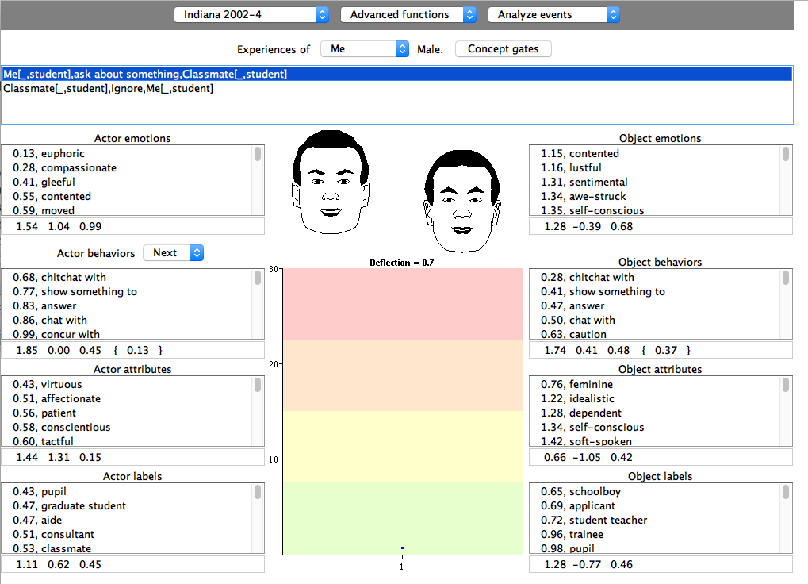

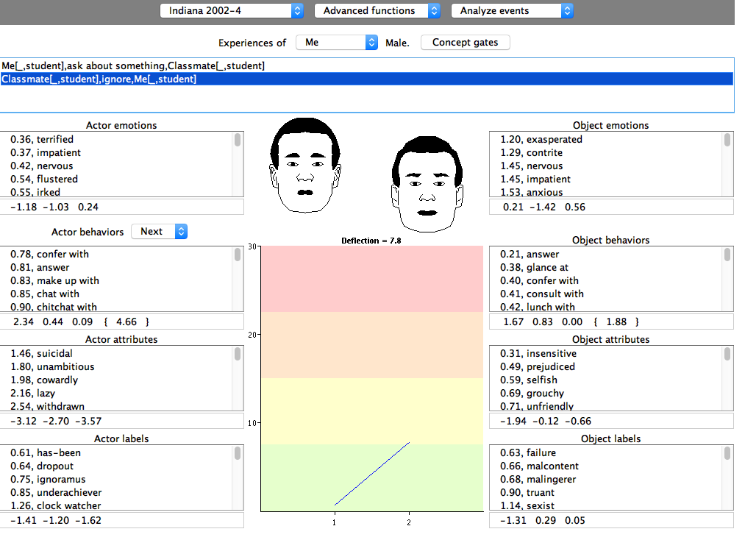

19 I performed reverse inference and the Interact predicted the changes from answer 18.

Reverse inference:

First event deflection: 0.7

Second event deflection: 7.8

Large deflection means a situation is out of balance and the event that cause this situation is unexpected; thus, according to this simulator the second situation was not expected in my perceptive, which is correct.

My classmate could have felt contented (satisfied) with his grades in the semester to produce his action of ignoring my request of doing homework together. Furthermore, the attribute of my classmate that would explain such an action is idealistic and dependent. Finally, I believe the best emotional label it characterizes how my classmate felt is contented.

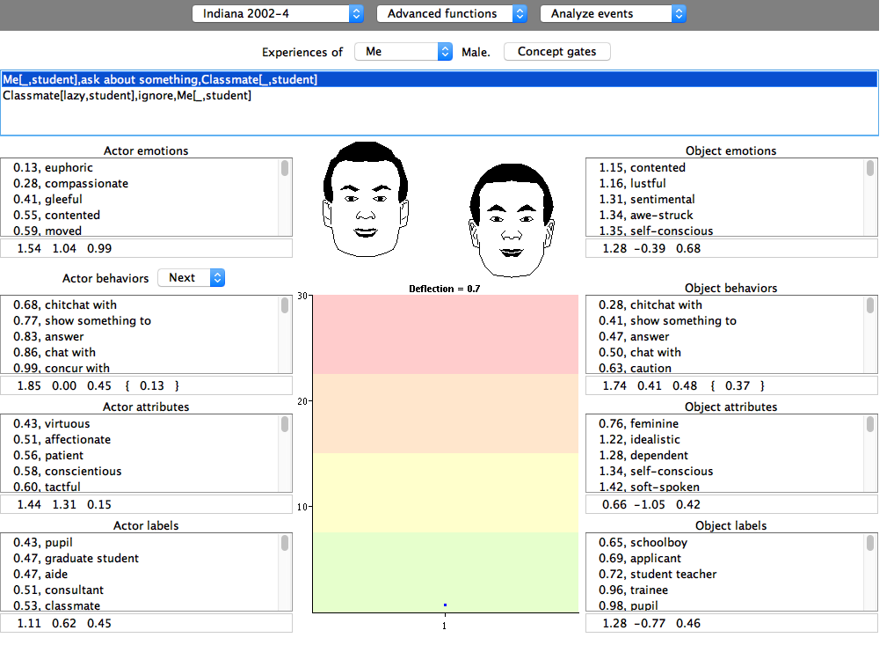

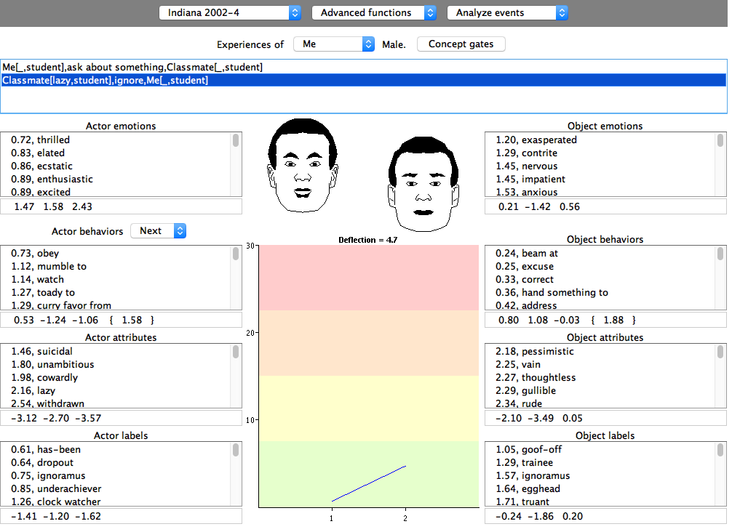

After adding the attribute of lazy, the deflection of the second event is 4.7, which is smaller than 7.8. The deflection is less when taking into consideration the attribute of my classmate because, as mentioned before in my responses, a person can understand better a situation and avoid getting caught of guard if the environment or personality trait of the object is completely understood.

20 I think Interact captured my sense of the situation efficiently; nevertheless, it lacked a significant amount of actions when I tried to define the event. Unfortunately, I had to use synonyms to define the events. From my homework 1, I know that the Geneva Emotion Profiler needs more testing to improve its empirical database. It is not designed for situations when clearly a situation is justifiable.

In the case of the Emotion Calculator, it is extremely accurate. The Emotion Calculator differs from the Emotion Analyst because the Emotion Analyst was not able to interpret my emotions. I believe this is caused by the fact of not having enough data to do a thorough training. In contrast, the Emotion Calculator gave me an accurate description of the emotions I felt in that situation.

I believe the Emotion Calculator is more accurate than the Interact used in this homework because the Interact did not have enough actions when I tried to define the event accurately with the right verbs.