1)

Before Shock Graph

After Shock Graph

Bug 1 Graph

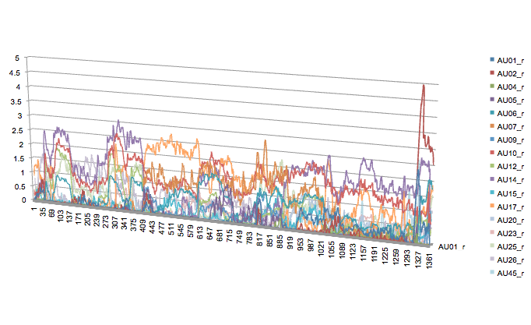

Bug 2 Graph

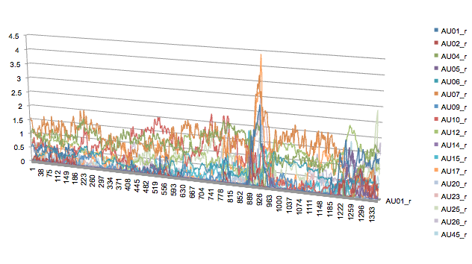

2)

* The most intense action unit is AU25_r in the shock before graph.
* The most intense action unit is AU15_r in the shock after graph due to its peak; however, on average it should be AU25_r.
* The most intense action unit is AU2_r in the bug 1 graph due to its peak; however, on average it should be AU05_r or AU17_r.
* The most intense action unit is AU17_r in the bug 2 graph due to its peak; however, on average it should be AU07_r.

3) There is evidence of the software losing track of the face. What happened in the video that cause losing track of the face is the students moving their face from the camera, creating a non-favorable angle for the software or hiding a part of their face with either the glasses or just turning their face around. Also, the glasses might cause some errors in the software due to the glare of the glasses.

4)

Before Shock Graph 1

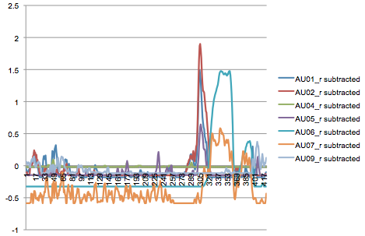

Before Shock Graph 2

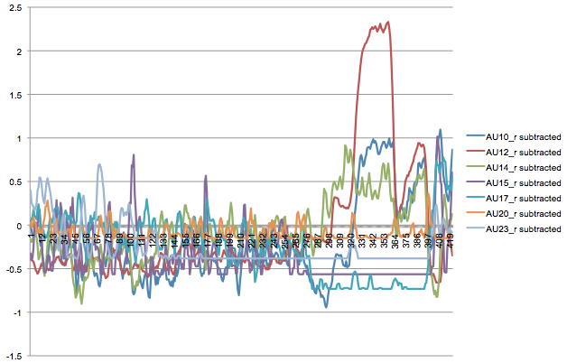

Before Shock Graph 3

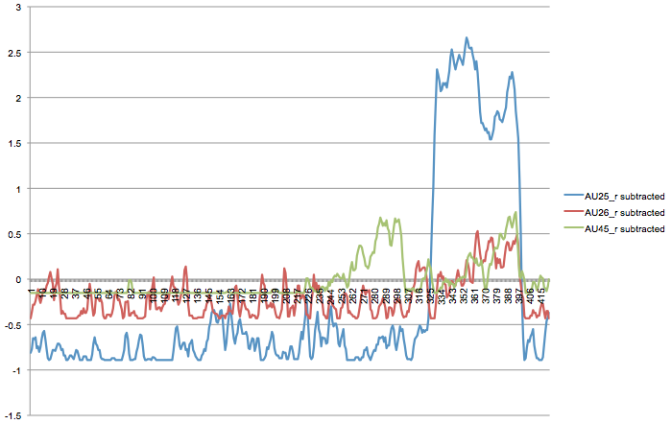

After Shock Graph 1

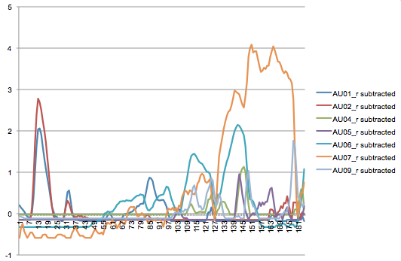

After Shock Graph 2

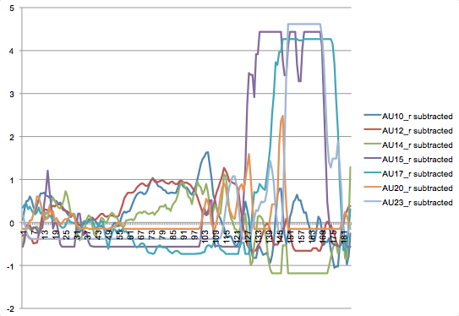

After Shock Group 3

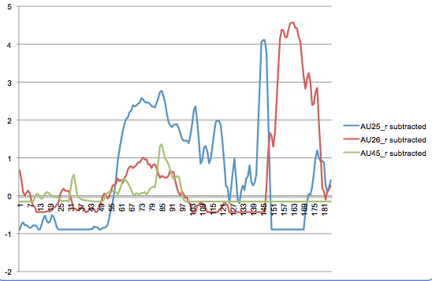

Extra Credit:

Before Shock Graph 1

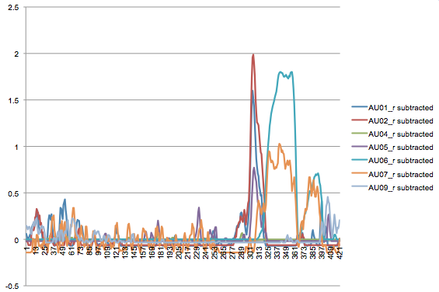

Before Shock Graph 2

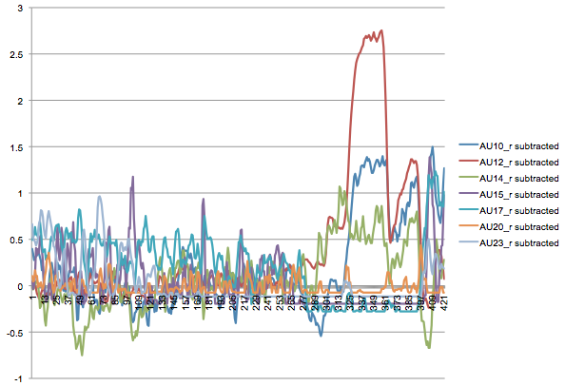

Before Shock Graph 3

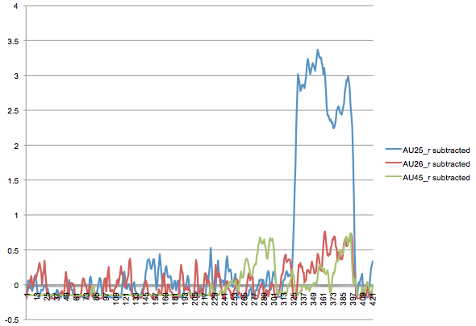

After Shock Graph 1

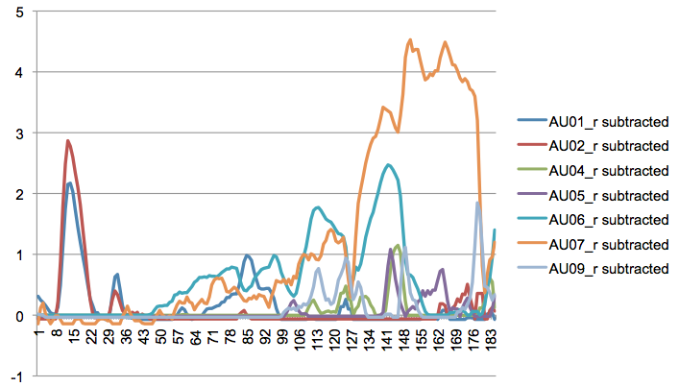

After Shock Graph 2

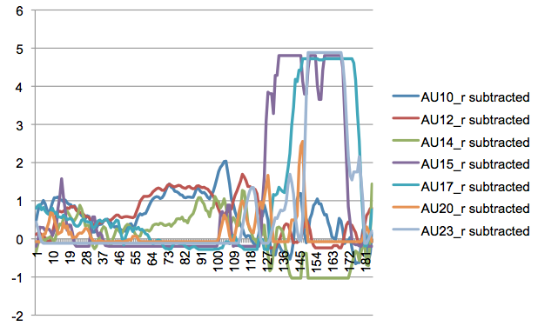

After Shock Graph 3

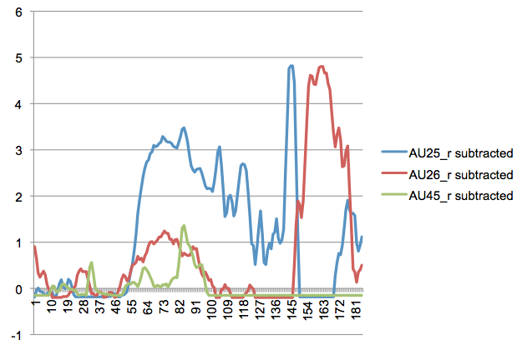

5)

Before Shock

|  |  |  |
| --- | --- | --- |
| **Emotion** | **Action Units** | **Result** |
| Happiness | 6+12 | -0.09306493 |
| Sadness | 1+4+15 | -0.143216 |
| Surprise | 1+2+5+26 | -0.1116624 |
| Fear | 1+2+4+5+7+20+26 | -0.12936808 |
| Anger | 4+5+7+23 | -0.18244066 |
| Disgust | 9+15 | -0.2073421 |

After Shock

|  |  |  |
| --- | --- | --- |
| **Emotion** | **Action Units** | **Result** |
| Happiness | 6+12 | 0.21508692 |
| Sadness | 1+4+15 | 0.26345426 |
| Surprise | 1+2+5+26 | 0.13365949 |
| Fear | 1+2+4+5+7+20+26 | 0.20383839 |
| Anger | 4+5+7+23 | 0.30177732 |
| Disgust | 9+15 | 0.3666358 |

In shock_before.mp4 the most common emotions are 1) Happiness and 2) Surprise.

In shock_after.mp4 the most common emotions are 1) Disgust and 2) Anger.

6) According to my results, the emotions are disgust and anger, which is opposite to positive affect. The data should show the student was happy and/or surprised. I believe this incorrect result is due to the fact the student turned his head to the left (the student’s left) when he won the game. Possibly, OpenFace cannot get an accurate analysis due to the students movement resulting in a lack of accuracy of the data.

7)

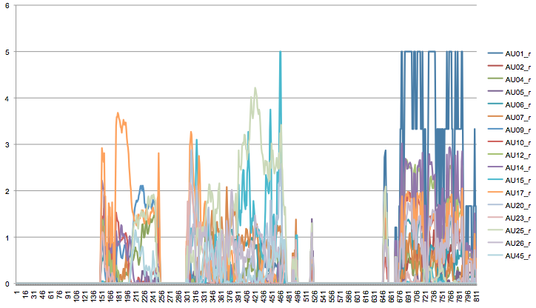

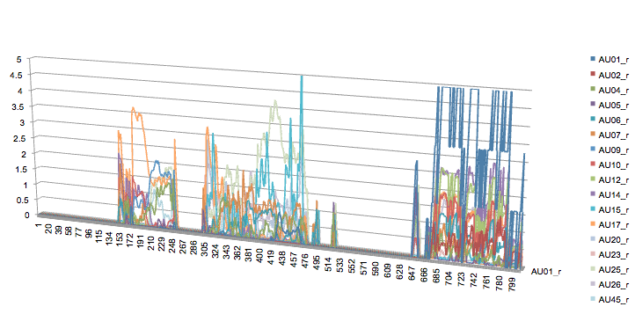

8) In my perception, the software performed really well. The student turning his head to his left after he won the game (after the shock happened) produced errors in the data collected through the software. Thus, I got errors in my data analysis. Consequently, the software could not analyze his facial expression correctly. Head movements, glasses, and shadows seem to affect the software analysis.