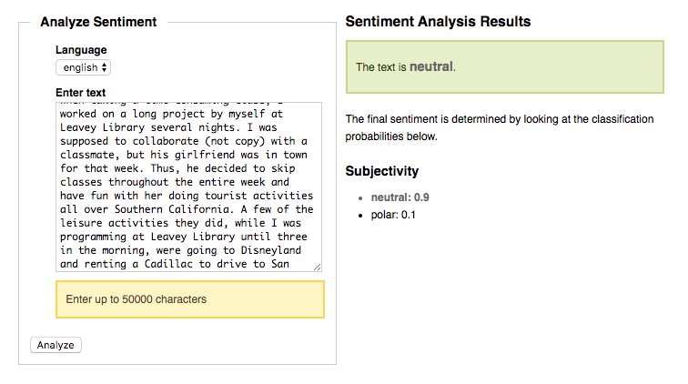

My text is neutral and the polarity is 0.1.

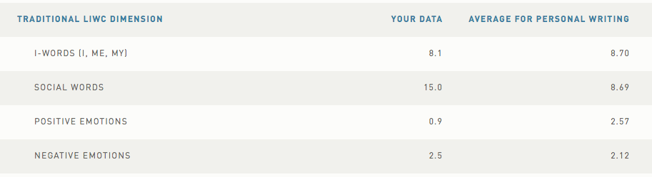

My positive emotions are 0.9 on my text. The average for personal writing is 2.57. Thus, my text is lacking positive emotions than the average text. In contrast, my negative emotions are 2.5 on my text. The average for personal writing is 2.12. Thus, my text has more negative emotions than the average text.

3)

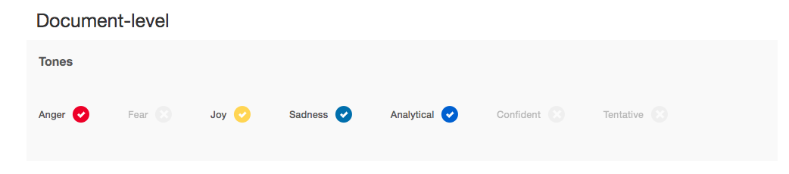

My basic emotions are anger, joy, sadness, and analytical. I believe this analysis is really accurate. I can find all of these emotions on my text.

4) My summary sentence is: A friend ignored me and blamed me for his failure.

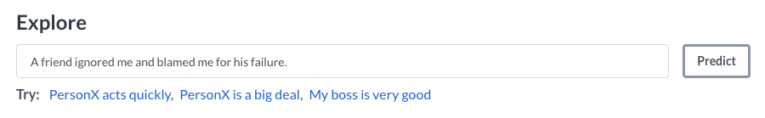

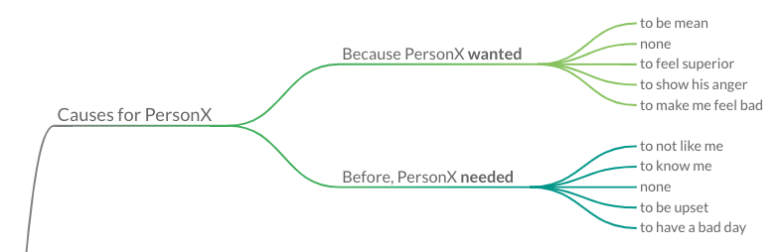

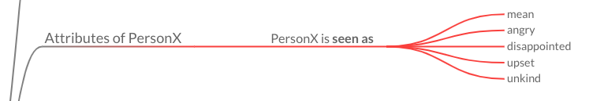

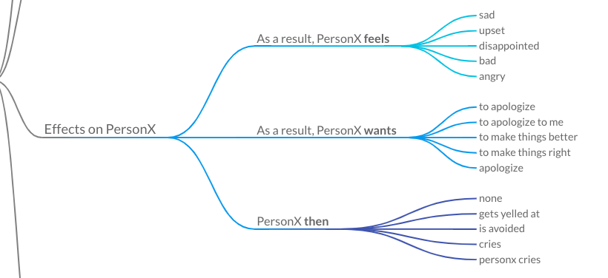

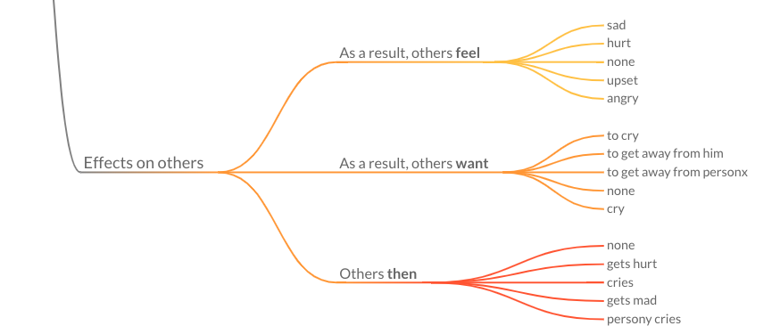

5) The tool that came closest to the emotions I felt during my event is IBM Watson Tone Analyzer used in problem 3. The best one is IBM Watson Tone Analyzer because it gives you feedback on emotions for every single line of the text. The second best emotion analyzer tool is Linguistic Inquiry and Word Count (LIWC) because it gives a percentage of positive and negative emotions. In contrast, NLTK Sentiment Analysis Demo is extremely inaccurate because it does not give me results of my positive and emotional emotions. It just probably averages out all the emotions and it gives me a “neutral” feedback. Finally, the COMonsensE Transformers on ATOMIC (COMeT) is extremely general and it gives too many options in the results. Thus, it seems it is merely guessing the emotions.