Javier Jesús Macossay Hernández

ITP 250

HW 9

1) Query:

:Screen Shot 2018-04-05 at 3.37.31 PM.png

Result:

:Screen Shot 2018-04-05 at 3.37.36 PM.png

2) Query:

:Screen Shot 2018-04-05 at 3.40.22 PM.png

Result:

Screen Shot 2018-04-05 at 3.40.28 PM.png

3) Query:

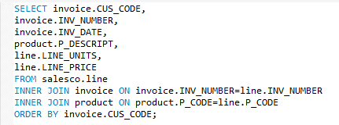

Result:

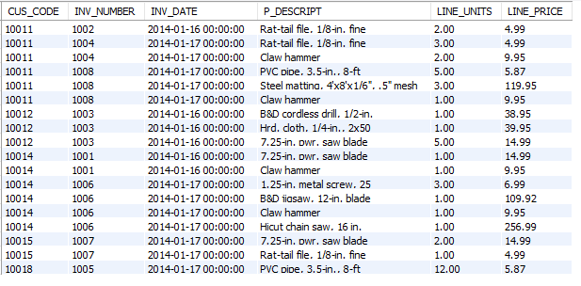

4) Query:

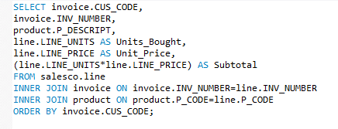

Result:

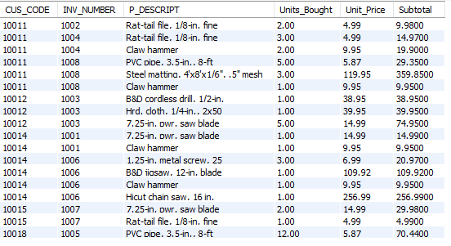

5) Query:

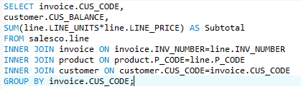

Result:

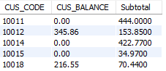

6) Query:

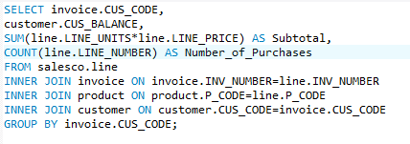

Result:

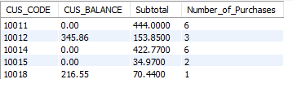

7) Query:

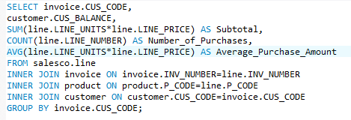

Result:

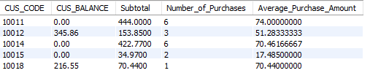

8) Query:

:Screen Shot 2018-04-05 at 1.48.49 PM.png

Result:

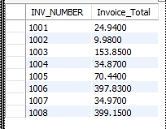

9) Query:

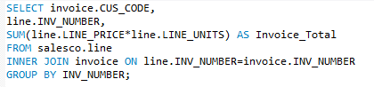

Result:

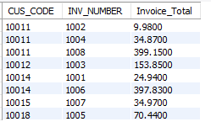

10) Query:

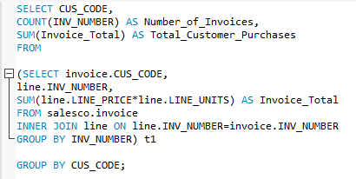

Result:

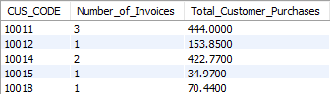

11) Query:

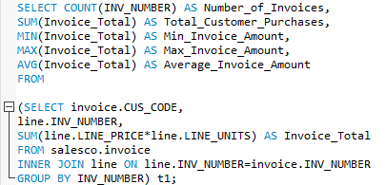

Result:

:Screen Shot 2018-04-05 at 3.01.13 PM.png

12) Query:

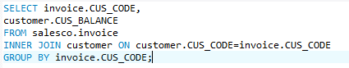

Result:

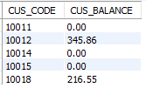

13) Query:

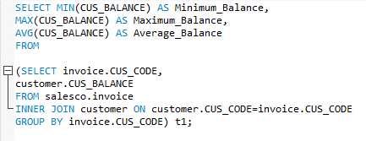

Result:

:Screen Shot 2018-04-05 at 4.12.18 PM.png

14) Query:

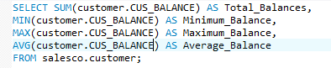

Result:

:Screen Shot 2018-04-05 at 2.13.10 PM.png

15) Query:

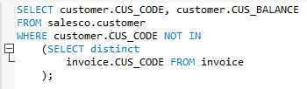

Result:

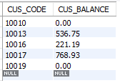as

16) Query:

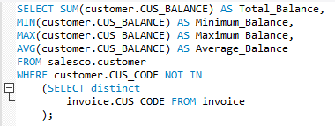

Result:

:Screen Shot 2018-04-05 at 2.36.08 PM.png

17) Query:

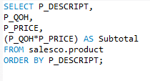

Result:

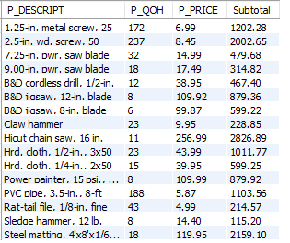

18) Query:

:Screen Shot 2018-04-05 at 4.18.58 PM.png

Result:

:Screen Shot 2018-04-05 at 4.19.05 PM.png